Table of Contents

1 Relevant Confluence Links 7

2 CodeCommit Repositories 8

3 VPCs MAIN CIDR 9

4 EKS Deployment Account 12

4.1 VPCs MAIN CIDR 12

5 TRANSIT FRANKFURT - VPCs MAIN CIDR 14

6 00 VF IE SHARED SERVICES 15

6.1 00 VF IE TRANSIT GATEWAY 15

6.1.1 1.Resource Attachments 15

6.1.2 2.Routing 16

6.1.3 3.Prerequisites 17

6.1.4 4.To create a transit gateway 17

6.1.5 CONNECTIVITY TEST 18

6.1.6 CURRENT DESIGN AND ROUTE TABLES 31

6.1.7 TGW IMPLEMENTATION: HOW TO 39

6.2 01 VF IE SHARED SERVICES VPC 49

6.2.1 49

6.2.2 1. INTRODUCTION 49

6.2.3 2. DESIGN 49

6.2.4 3. CONFIGURATION AND IMPLEMENTATION 51

6.2.5 4. DNS 52

6.2.6 5. NLB 52

6.2.7 HAPROXY AMI 53

6.2.8 HAPROXY CONFIG AUTOMATION 60

6.2.9 HAPROXY-EC2 IMPLEMENTATION 73

6.2.10 HAPROXY-ECS IMPLEMENTATION* 142

6.2.11 HAPROXY TROUBLESHOOTING 155

6.3 02 VF IE SHARED SERVICES VPC (MYST) 157

6.4 03 VF IE CENTRALIZED INTERNET ACCESS VPC 157

6.4.1 1. INTRODUCTION 157

6.4.2 2. CONFIGURATION 158

6.4.3 3. VPC CIDR 158

6.4.4 4. Intercepting traffic 159

6.4.5 5. Certificate 160

6.4.6 6.  Squid configuration 160

6.4.7 7.  White List 161

6.4.8 8. Iptables 161

6.4.9 RELEASE 1 161

6.4.10 1.CHANGES 168

6.4.11 Transparant Proxy Whitelist 169

6.5 04 VF IE PORT RANGES 170

6.6 05 VF IE NLB DESIGN 172

6.6.1 Overview 173

6.6.2 Solution Design 173

6.6.3 DNS Configuration 173

6.6.4 NLB Configuration 174

6.6.5 Open Queries 222

7 01 VF IE SANDBOX VPC 223

8 02 VF IE TEST VPCs 225

8.1 1. Introduction 225

8.2 2. Design of TEST VPC's 225

8.3 00 VF IE SIT4 - HOW TO 228

8.3.1 PHASE 1 228

8.3.2 PHASE 2 233

8.3.3 01 SIT4 SERVERS 236

8.3.4 02 SIT4 SECURITY GROUPS 241

8.3.5 03 EFS Volumes 273

8.3.6 04 ALB 276

8.3.7 05 RDS 284

9 03 VF IE PRE-PROD VPCs 293

9.1 1. Introduction 293

9.2 2. Design of PRE-PROD VPC's 293

9.3 3. Subnet CIDR range 294

9.3.1 PRD1 294

9.3.2 PRD2 295

10 04 VF IE DNS 297

10.1 297

10.2 1.Route53 Hosted Zones 297

10.3 2.AWS TO GDC 301

10.4 3.GDC TO AWS 302

10.5 4.TGW 303

10.6 5.SS VPC 303

10.7 6. AWS Address Resolution 303

10.8 DNS TROUBLESHOOTING 307

10.8.1 POINT 1: GDC domain name resolution 307

11 04 VF IE PROD VPC 311

11.1 1. Introduction 311

11.2 2. Design of PROD VPC 311

11.3 3. Subnet CIDR range 312

12 05 VFIE INFRA MONITORING 314

12.1 1.     Logging and Monitoring created by default when an AWS account is created via PCS: 314

12.2 2.     Logging and Monitoring created when PCS receives the demand and manages the account: 315

12.3 3. Centralized logging / monitoring ( https://confluence.sp.vodafone.com/x/FmNhC ) 316

12.4 AWS LOGGING 317

12.4.1 VPC Flow Logs 317

12.4.2 Instance Logs - CloudWatch Agent 318

12.5 AWS Monitoring: CW alarms 321

12.5.1 EC2 Monitoring: alarms and notifications 321

12.5.2 RDS monitoring: alarms and notifications 321

13 06 VF IE FIREWALL RULES 322

13.1 Production 322

13.2 PRE-PRODUCTION 334

14 07 VFIE EC2 Image Builder 345

14.1 INTRODUCTION 345

14.2 PREREQUISITES 346

14.3 COMPONENTS 346

14.3.1 Image pipeline 347

14.3.2 Image recipe 347

14.3.3 Source image 347

14.3.4 Build components 348

14.3.5 Test components 348

14.3.6 Document 348

14.4 IMPLEMENTATION 348

14.4.1 CLOUDFORMATION STACK 349

14.4.2 SSM DOCUMENTS 352

14.4.3 AWS CONSOLE RESOURCES 353

14.5 HOW TO: NEW AMI 354

14.5.1 PERMISSIONS TO NEW AMI 355

15 08 VFIE OVERALL NETWORK DESIGN 358

15.1 Network Diagram 358

15.2 Advertised Subnets 358

15.3 GDC & VFIE Integration Points 359

15.3.1 TNSNAMES.ORA (PROD) 359

15.3.2 GUI URL List 359

16 09 VFIE SQUID PROXY 361

17 10 VFIE Network Integration 362

18 11 VFIE - Frankfurt Transit Gateway Solution 368

18.1 Overview 368

18.2 Network Design 369

18.2.1 SIT3 Design (encompasses PROD) 369

18.2.2 Overall Design 369

18.2.3 Network Design 370

18.3 AWS Design 370

18.3.1 Network Load Balancer 370

18.3.2 Target Groups 371

18.3.3 Transit Gateway 372

18.3.4 Endpoints 372

18.4 Supporting Documentation 372

18.4.1 DXL / TAAS Roadmap 372

18.4.2 TAAS Documentation 372

18.4.3 CAAS NEL mServices 372

18.5 01 - VFIE TAAS Integration 373

18.5.1 Overview 373

18.5.2 Design 373

18.5.3 Connectivity 374

18.5.4 Supporting Documentation 374

18.6 02 - VFIE mTAS - CaaS NEL Integration 374

18.6.1 Overview 374

18.6.2 Design 374

18.6.3 Connectivity 376

18.6.4 Supporting Documentation 377

18.7 03 - VFIE OSB - CAAS / TAAS Integration 377

18.7.1 Overview 378

18.7.2 Design 378

18.7.3 TAAS Route 53 380

18.7.4 Supporting Documentation 380

18.7.5 PROJECT DELIVERY RACI/TASK LIST - Flow1 380

18.8 04 - VFIE CIAM Webgate - CAAS Integration 382

18.8.1 Overview 382

18.8.2 Design 382

18.8.3 AWS Design 383

18.8.4 Firewall Connectivity 385

18.8.5 Connectivity Set-up Example 386

18.8.6 CaaS Ticket 386

18.8.7 Supporting Documentation 386

18.9 05 - VFIE WEF SSR - TaaS Integration 386

18.9.1 Overview 386

18.9.2 Design 386

18.9.3 AWS Design 387

19 12 VFIE NAT Gateway 391

19.1 Overview 391

19.2 High Level Design 392

19.3 Subnets 392

19.3.1 AWS Shared Services Subnets 392

19.3.2 Destination Subnets 393

19.4 NAT Gateway 394

19.5 Routing Tables 394

19.6 High-Level Implementation Steps 395

* 00 VF IE SHARED SERVICES
  + 00 VF IE TRANSIT GATEWAY
    - CONNECTIVITY TEST
    - CURRENT DESIGN AND ROUTE TABLES
    - TGW IMPLEMENTATION: HOW TO
  + 01 VF IE SHARED SERVICES VPC
    - HAPROXY AMI
    - HAPROXY CONFIG AUTOMATION
    - HAPROXY-EC2 IMPLEMENTATION
    - HAPROXY-ECS IMPLEMENTATION*
    - HAPROXY TROUBLESHOOTING
  + 02 VF IE SHARED SERVICES VPC (MYST)
  + 03 VF IE CENTRALIZED INTERNET ACCESS VPC
    - RELEASE 1
    - RELEASE 2
    - Transparant Proxy Whitelist
  + 04 VF IE PORT RANGES
  + 05 VF IE NLB DESIGN
* 01 VF IE SANDBOX VPC
* 02 VF IE TEST VPCs
  + 00 VF IE SIT4 - HOW TO
    - 01 SIT4 SERVERS
    - 02 SIT4 SECURITY GROUPS
    - 03 EFS Volumes
    - 04 ALB
    - 05 RDS
* 03 VF IE PRE-PROD VPCs
* 04 VF IE DNS
  + DNS TROUBLESHOOTING
* 04 VF IE PROD VPC
* 05 VFIE INFRA MONITORING
  + AWS LOGGING
  + AWS Monitoring: CW alarms
    - EC2 Monitoring: alarms and notifications
    - RDS monitoring: alarms and notifications
* 06 VF IE FIREWALL RULES
* 07 VFIE EC2 Image Builder
* 08 VFIE OVERALL NETWORK DESIGN
* 09 VFIE SQUID PROXY
* 10 VFIE Network Integration
* 11 VFIE - Frankfurt Transit Gateway Solution
  + 01 - VFIE TAAS Integration
  + 02 - VFIE mTAS - CaaS NEL Integration
  + 03 - VFIE OSB - CAAS / TAAS Integration
  + 04 - VFIE CIAM Webgate - CAAS Integration
  + 05 - VFIE WEF SSR - TaaS Integration
* 12 VFIE NAT Gateway

# Relevant Confluence Links

* Haproxy - https://confluence.sp.vodafone.com/x/qNxOCg
* DNS strategy - https://confluence.sp.vodafone.com/x/1HUlCg
* Routing in Transit Gateway - https://confluence.sp.vodafone.com/x/idlOCg
* How to update configuration of Transit Gateway - https://confluence.sp.vodafone.com/x/6RsCCg
* Shared Service VPC design -  https://confluence.sp.vodafone.com/x/73MCCg
* AWS Image Builder - <https://confluence.sp.vodafone.com/x/79NoCg>

# CodeCommit Repositories

* Centralized internet -  <https://eu-west-1.console.aws.amazon.com/codesuite/codecommit/repositories/vf-iedelivery-centralized-internet/browse?region=eu-west-1>
* Shared Services VPC - <https://eu-west-1.console.aws.amazon.com/codesuite/codecommit/repositories/vf-iedelivery-sharedservices-vpc/browse?region=eu-west-1>
* AWS Infrastructure (a branch for each environment) - <https://eu-west-1.console.aws.amazon.com/codesuite/codecommit/repositories/vf-iedelivery-infrastructure/browse?region=eu-west-1>
* Cloud9 Environment - <https://eu-west-1.console.aws.amazon.com/codesuite/codecommit/repositories/vf-iedelivery-cloud9/browse?region=eu-west-1>
* Myst VPC - <https://eu-west-1.console.aws.amazon.com/codesuite/codecommit/repositories/vf-iedelivery-myst/browse?region=eu-west-1>
* CF Stacksets (monitoring, iam roles, etc.) - <https://eu-west-1.console.aws.amazon.com/codesuite/codecommit/repositories/vf-iedelivery-stacksets/browse?region=eu-west-1>
* DNS - <https://eu-west-1.console.aws.amazon.com/codesuite/codecommit/repositories/vf-iedelivery-dns/browse?region=eu-west-1>
* Transit GW - <https://eu-west-1.console.aws.amazon.com/codesuite/codecommit/repositories/vf-iedelivery-transit-gateway/browse?region=eu-west-1>
* Pipelines for AWS - <https://eu-west-1.console.aws.amazon.com/codesuite/codecommit/repositories/vf-iedelivery-pipelines/browse?region=eu-west-1>

# VPCs MAIN CIDR

Context:

* Range ./19 or ./23  per VPC
* Myst VPC : ./24
* Test to talk with each other, nothing to talk with production
* Stx -> separate oracle database

Number of VPC's:

* Sandbox: TRN1, TRN2
* Test: ST1, ST2, ST3, ST4
* Pre-prod: PRD1, PRD2
* Prop: PROD
* Shared Service:  Myst, SS

If we split 10.181.0.0/16 in ./19 -> 8 different ranges:

* 10.181.0.0/19
* 10.181.32.0/19
* 10.181.64.0/19
* 10.181.96.0/19
* 10.181.128.0/19
* 10.181.160.0/19
* 10.181.192.0/19
* 10.181.224.0/19

|  |  |  |  |  |  |  |  |  |
| --- | --- | --- | --- | --- | --- | --- | --- | --- |
| **VPC** | Environment | **Account Name** | **Account ID** | **Subnet address** | **Netmask** | **Range of addresses** | **Useable IPs** | **Hosts** |
| **TRN2-PoC** | Sandbox | vf-iedelivery-sandbox-01 | 299879056526 | 10.181.0.0/20 | 255.255.240.0 | 10.181.0.0 -   10.181.15.255 | 10.181.0.1 -   10.181.15.254 | 4094 |
| **Myst** | Prod-SS | vf-iedelivery-prod-ss-01 | 267040142128 | **10.181.16.0/23** | 255.255.254.0 | 10.181.16.0 - 10.181.17.255 | 10.181.16.1 - 10.181.17.254 | 510 |
| **SS** | Prod-SS | vf-iedelivery-prod-ss-01 | 267040142128 | **198.19.220.0/23**  **46.108.156.0/27** |  |  |  |  |
| **TRN1** | Sandbox | vf-iedelivery-sandbox-01 | 299879056526 | **10.181.20.0/23** | 255.255.254.0 | 10.181.20.0 - 10.181.21.255 | 10.181.20.1 -   10.181.21.254 | 510 |
| **Centralized Internet Access** | Prod-SS | vf-iedelivery-prod-ss-01 | 267040142128 | 10.181.22.0/23 | 255.255.254.0 | 10.181.22.0 -   10.181.23.255 | 10.181.22.1 -   10.181.23.254 | 510 |
| **Network Firewall VPC** | Prod-SS | vf-iedelivery-prod-ss-01 | 267040142128 | 10.181.25.128/25 | 255.255.255.128 | 10.181.25.128 -   10.181.25.255 | 10.181.25.129 -   10.181.25.254 | 126 |
| **Dev** | Dev | vf-iedelivery-dev-01 | 17361906891 | **10.181.30.0/23** | 255.255.254.0 | 10.181.30.0 - 10.181.31.255 | 10.181.30.1 -   10.181.31.254 | 510 |
| **PROD** | Production | vf-iedelivery-prod-01 | 323874256692 | **10.181.32.0/19** | 255.255.224.0 | 10.181.32.0 - 10.181.63.255 | 10.181.32.1 - 10.181.63.254 | 8190 |
| **PRD1** | Pre-Prod | vf-iedelivery-preprod-01 | 046978237480 | **10.181.64.0/19** | 255.255.224.0 | 10.181.64.0 - 10.181.95.255 | 10.181.64.1 - 10.181.95.254 | 8190 |
| **PRD2** | Pre-Prod | vf-iedelivery-preprod-01 | 046978237480 | **10.181.96.0/19** | 255.255.224.0 | 10.181.96.0 - 10.181.127.255 | 10.181.96.1 - 10.181.127.254 | 8190 |
| **SIT1** | Test | vf-iedelivery-test-01 | 046978237480 | **10.181.128.0/19** | 255.255.224.0 | 10.181.128.0 - 10.181.159.255 | 10.181.128.1 - 10.181.159.254 | 8190 |
| **SIT2** | Test | vf-iedelivery-test-01 | 046978237480 | **10.181.160.0/19** | 255.255.224.0 | 10.181.160.0 - 10.181.191.255 | 10.181.160.1 - 10.181.191.254 | 8190 |
| **SIT3** | Test | vf-iedelivery-test-01 | 046978237480 | **10.181.192.0/19** | 255.255.224.0 | 10.181.192.0 - 10.181.223.255 | 10.181.192.1 - 10.181.223.254 | 8190 |
| **SIT4** | Test | vf-iedelivery-test-01 | 046978237480 | **10.181.224.0/19** | 255.255.224.0 | 10.181.224.0 - 10.181.255.255 | 10.181.224.1 - 10.181.255.254 | 8190 |

# EKS Deployment Account

## VPCs MAIN CIDR

Context:

* Range ./19 or ./23  per VPC
* Test to talk with each other, nothing to talk with production

Number of VPC's:

* Test: ST1, ST2, ST3, ST4
* Pre-prod: PRD1, PRD2
* Prop: PROD

If we split 10.182.0.0/16 in ./19 -> 8 different ranges:

* 10.182.0.0/19
* 10.182.32.0/19
* 10.182.64.0/19
* 10.182.96.0/19
* 10.182.128.0/19
* 10.182.160.0/19
* 10.182.192.0/19
* 10.182.224.0/19

|  |  |  |  |  |  |  |  |  |
| --- | --- | --- | --- | --- | --- | --- | --- | --- |
| **VPC** | Environment | **Account Name** | **Account ID** | **Subnet address** | **Netmask** | **Range of addresses** | **Useable IPs** | **Hosts** |
| **PROD** | Production | vf-iedelivery-eks-prod | 466441119255 | **10.182.0.0/19** | 255.255.224.0 | 10.182.0.0 - 10.182.31.255 | 10.182.0.1 - 10.182.31.254 | 8190 |
| **PRD1** | Pre-Prod | vf-iedelivery-eks-preprod | 387095844067 | **10.182.32.0/19** | 255.255.224.0 | 10.182.32.0 - 10.182.63.255 | 10.182.32.1 - 10.182.63.254 | 8190 |
| **PRD2** | Pre-Prod | vf-iedelivery-eks-preprod2 | 762937892420 | **10.182.64.0/19** | 255.255.224.0 | 10.182.64.0 - 10.182.95.255 | 10.182.64.1 - 10.182.95.254 | 8190 |
| **SIT1** | Test | vf-iedelivery-eks-test-01 | 687158677620 | **10.182.96.0/19** | 255.255.224.0 | 10.182.96.0 - 10.182.127.255 | 10.182.96.1 - 10.182.127.254 | 8190 |
| **SIT2** | Test | vf-iedelivery-eks-test-02 | 617458290184 | **10.182.128.0/19** | 255.255.224.0 | 10.182.128.0 - 10.182.159.255 | 10.182.128.1 - 10.182.159.254 | 8190 |
| **SIT3** | Test | vf-iedelivery-eks-test-03 | 483246254322 | **10.182.160.0/19** | 255.255.224.0 | 10.182.160.0 - 10.182.191.255 | 10.182.160.1 - 10.182.191.254 | 8190 |
| **SIT4** | Test | vf-iedelivery-eks-test-04 | 701287184434 | **10.182.192.0/19** | 255.255.224.0 | 10.182.192.0 - 10.182.223.255 | 10.182.192.1 - 10.182.223.254 | 8190 |
| DEV1 | DEV | vf-iedelivery-eks-dev-01 | 607188850947 | **10.182.224.0/19** | 255.255.224.0 | 10.182.224.0-10.182.255.255 | 10.182.224.1 - 10.182.255.254 | 8190 |

# TRANSIT FRANKFURT - VPCs MAIN CIDR

10.190.0.0/22

|  |  |  |  |  |  |  |  |  |
| --- | --- | --- | --- | --- | --- | --- | --- | --- |
| **VPC** | Environment | **Account Name** | **Account ID** | **Subnet address** | **Netmask** | **Range of addresses** | **Useable IPs** | **Hosts** |
| **PROD** | Prod-SS  (frankfurt) | vf-iedelivery-prod-ss-01 | 267040142128 | **10.190.0.0/22** |  | 10.190.0.0 - 10.190.3.255 | 10.190.0.1 - 10.190.3.254 | 1022 |

# 00 VF IE SHARED SERVICES

* 00 VF IE TRANSIT GATEWAY
* 01 VF IE SHARED SERVICES VPC
* 02 VF IE SHARED SERVICES VPC (MYST)
* 03 VF IE CENTRALIZED INTERNET ACCESS VPC
* 04 VF IE PORT RANGES
* 05 VF IE NLB DESIGN

## 00 VF IE TRANSIT GATEWAY

INTRODUCTION

A *transit gateway* is a network transit hub that you can use to interconnect your virtual private clouds (VPC) and on-premises networks. It acts as a Regional virtual router for traffic flowing between your virtual private clouds (VPC) and VPN connections. A transit gateway scales elastically based on the volume of network traffic. Routing through a transit gateway operates at layer 3, where the packets are sent to a specific next-hop attachment, based on their destination IP addresses

The following are the key concepts for transit gateways:

* **attachment** — You can attach a VPC, an AWS Direct Connect gateway, a peering connection with another transit gateway, or a VPN connection to a transit gateway.
* **transit gateway route table** — A transit gateway has a default route table and can optionally have additional route tables. A route table includes dynamic and static routes that decide the next hop based on the destination IP address of the packet. The target of these routes could be a VPC or a VPN connection. By default, transit gateway attachments are associated with the default transit gateway route table.
* **associations** — Each attachment is associated with exactly one route table. Each route table can be associated with zero to many attachments.
* **route propagation** — A VPC or VPN connection can dynamically propagate routes to a transit gateway route table. With a VPC, you must create static routes to send traffic to the transit gateway. With a VPN connection, routes are propagated from the transit gateway to your on-premises router using Border Gateway Protocol (BGP). With a peering attachment, you must create a static route in the transit gateway route table to point to the peering attachment.

### 1.Resource Attachments

A transit gateway attachment is both a source and a destination of packets. You can attach the following resources to your transit gateway:

* One or more VPCs
* One or more VPN connections
* One or more AWS Direct Connect gateways
* One or more transit gateway peering connections

If you attach a transit gateway peering connection, the transit gateway must be in a different Region.

When you attach a VPC to a transit gateway, you must enable one or more Availability Zones to be used by the transit gateway to route traffic to resources in the VPC subnets. To enable each Availability Zone, you specify exactly one subnet. The transit gateway places a network interface in that subnet using one IP address from the subnet. After you enable an Availability Zone, traffic can be routed to all subnets in that Availability Zone, not just the specified subnet. Resources that reside in Availability Zones where there is no transit gateway attachment will not be able to reach the transit gateway.

We recommend that you enable multiple Availability Zones to ensure availability.

### 2.Routing

Your transit gateway routes IPv4 and IPv6 packets between attachments using transit gateway route tables. You can configure these route tables to propagate routes from the route tables for the attached VPCs and VPN connections. You can also add static routes to the transit gateway route tables. When a packet comes from one attachment, it is routed to another attachment using the route table that matches the destination IP address.

For transit gateway peering attachments, only static routes are supported.

#### Route Tables

Your transit gateway automatically comes with a default route table. By default, this route table is the default association route table and the default propagation route table. Alternatively, if you disable route propagation and route table association, we do not create a default route table for the transit gateway.

You can create additional route tables for your transit gateway. This enables you to isolate subnets of attachments. Each attachment can be associated with one route table. An attachment can propagate their routes to one or more route tables.

You can create a blackhole route in your transit gateway route table that drops traffic that matches the route.

When you attach a VPC to a transit gateway, you must add a route to your subnet route table for traffic to route through the transit gateway.

#### Route Table Association

You can associate a transit gateway attachment with a single route table. Each route table can be associated with zero to many attachments and forward packets to other attachments.

#### Route Propagation

Each attachment comes with routes that can be installed to one or more transit gateway route tables. When an attachment is propagated to a transit gateway route table, these routes are installed in the route table.

For a VPC attachment, the CIDR blocks of the VPC are propagated to the transit gateway route table.

For a VPN connection attachment, routes in the transit gateway route table propagate to and from the transit gateway and your on-premises router using Border Gateway Protocol (BGP). The prefixes that are advertised over the BGP session are propagated to the transit gateway route table.

#### Routes for Peering Attachments

You can peer two transit gateways and route traffic between them. To do this, you create a peering attachment on your transit gateway, and specify the peer transit gateway with which to create the peering connection. You then create a static route in your transit gateway route table to route traffic to the transit gateway peering attachment. Traffic that's routed to the peer transit gateway can then be routed to the VPC and VPN attachments for the peer transit gateway.

### 3.Prerequisites

* The VPCs cannot have overlapping CIDRs. Launch one EC2 instance in each VPC.
* You must enable resource sharing from the master account for your organization.
* You cannot have identical routes pointing to two different VPCs. A transit gateway does not propagate the CIDRs of a newly attached VPC if an identical route exists in the transit gateway route tables.
* Verify that you have the permissions required to work with transit gateways.

### 4.To create a transit gateway

* For Amazon side ASN, type the private Autonomous System Number (ASN) for your transit gateway. This should be the ASN for the AWS side of a Border Gateway Protocol (BGP) session. The range is 64512 to 65534 for  16-bit ASNs. The range is 4200000000 to 4294967294 for 32-bit ASNs.
* For DNS support, choose enable if you need the VPC to resolve public IPv4 DNS host names to private IPv4 addresses when queried from instances in another VPC attached to the transit gateway.
* For VPN ECMP  support, choose enable if you need Equal Cost Multipath (ECMP) routing support between VPN connections. If connections advertise the same CIDRs, the traffic is distributed equally between them. When you select this option, the advertised BGP ASN, the BGP attributes such as the AS-path and the communities for preference must be the same.
* For Default route table association, choose enable to automatically associate transit gateway attachments with the default route table for the transit gateway.
* For Default route table propagation, choose enable to automatically propagate transit gateway attachments to the default route table for the transit gateway.
* For Auto accept shared attachments, choose enable to automatically accept cross-account attachments.

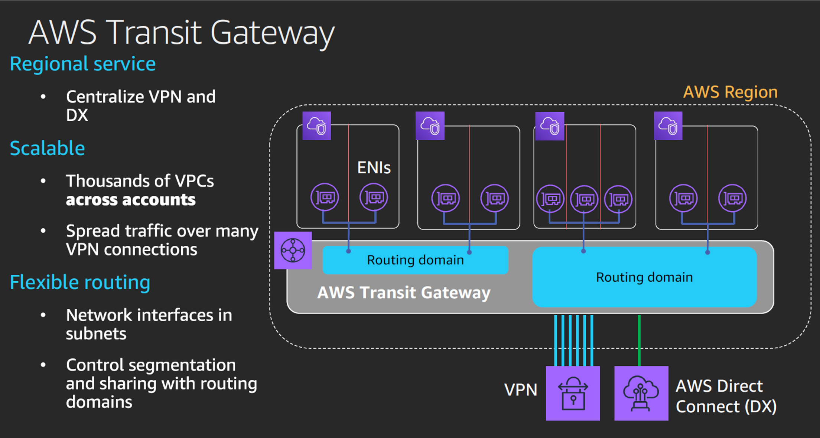

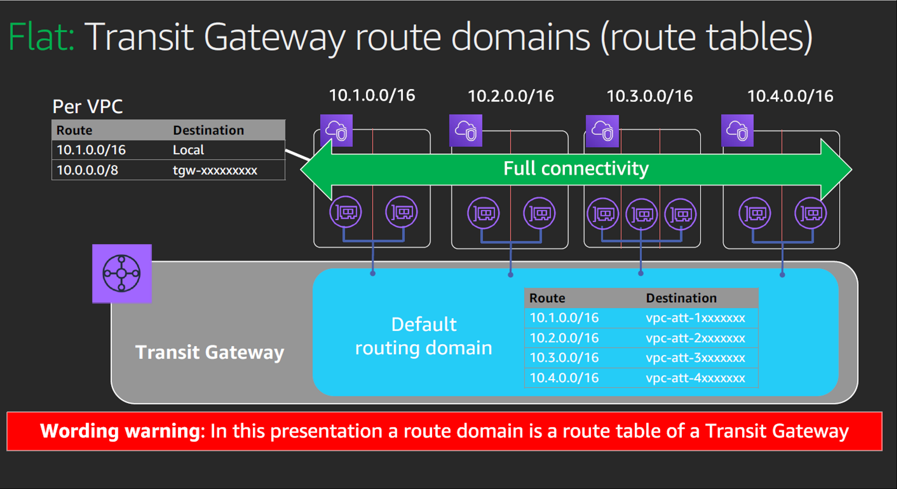

### CONNECTIVITY TEST

* 1.TRANSIT GATEWAY CONFIGURATION (TEST-SS connectivity, release 1)
* 2. SHARED SERVICE VPC CONFIGURATION (TEST-SS connectivity, release 1)
* 3. TEST VPC CONFIGURATION
* 4. RESULTS TEST-SS CONNECTIVITY- PHASE 1
  + 4.1 ST1 to SS
  + Solution: Add route to TGW in all subnets
  + 4.2 SOLUTION: ROUTE TO TGW - PHASE 1
* 5. RESULTS TEST-SS CONNECTIVITY - PHASE 2
  + 5.1 ST1 to SS and to ST2
* 6.TRANSIT GATEWAY CONFIGURATION (release 2)
  + 6.1 TGW VPC attachments
  + 6.2 TGW Route tables
* 7. CONNECTIVITY TEST (TEST-PREPROD-PROD-SS)
  + 7.1 Prod web ec2 (10.181.39.200)
  + 7.2 Pre-Prod web ec2 (10.181.71.39)
  + 7.3 SS private EC2 (10.181.18.126)

This page will show the tests executed to check the connectivity between vpc's in different aws accounts through the transit gateway. For that purpose, the following resources will be created in the different vpc's:

* EC2 instances in different subnets ( with / without TGW ENI) of the specific vpc's.
* Security groups to allow the communication between the vpc's (inbound/outbound rules to allow traffic from/to specific cidr).
* SSM endpoints and SSM security groups to connect to EC2 instances.

ICMP ping messages are used as the method use to confirm that EC2 instances in different vpcs can communicate between them.

These are the scenarios that have been analysed:

1. Connectivity between TEST environment and Shared Service VPC. (Release 1)
2. Connectivity between TEST environments. (Release 1)
3. Connectivity between PRE-PROD and SS VPC. (Release 2)
4. Connectivity between PROD and SS VPC. (Release 2)

**Sections 1 to 5 were done before release 2, meaning that pre-prod and prod vpc's were not associated with the TGW.**

The diagram below shows the EC2 instances that have been deployed for TEST and SS VPC. The same logic has been followed for PRE-PROD and PROD, but it is not shown for simplicity reasons.

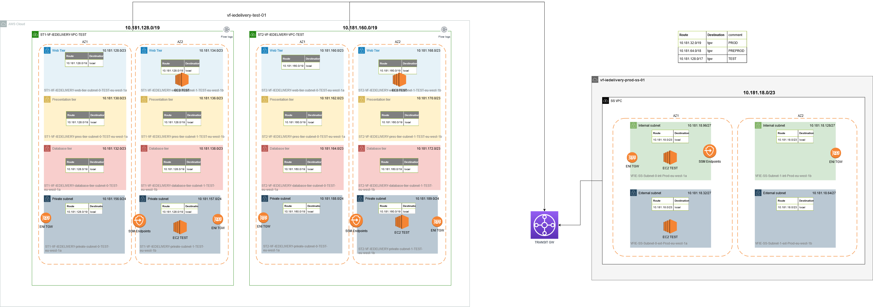

#### 1.TRANSIT GATEWAY CONFIGURATION (TEST-SS connectivity, release 1)

This is the transit gateway created in SS Account:

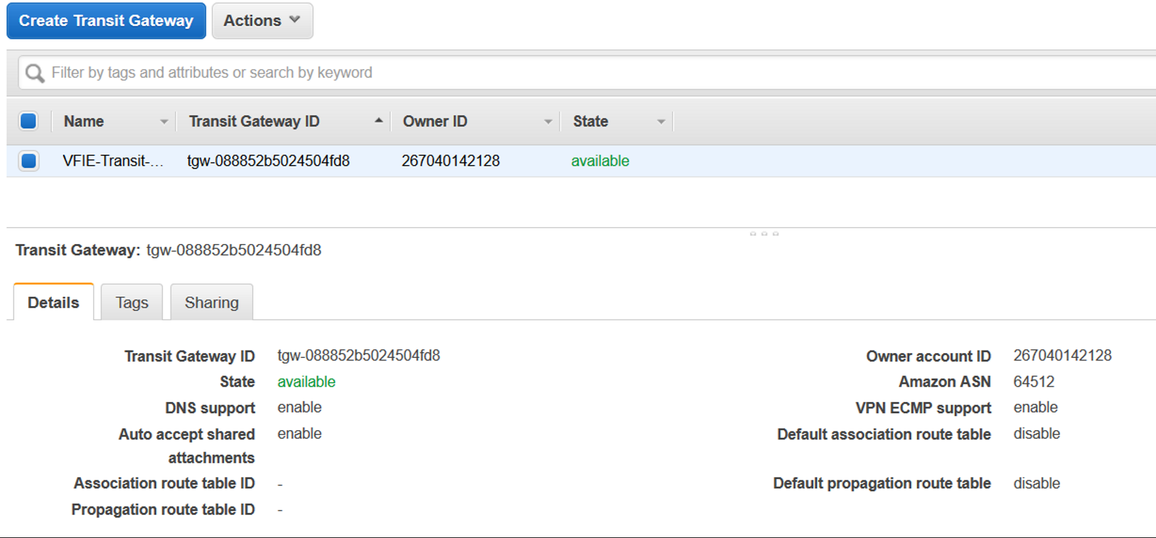

These are the attachments that have been deployed. Right now, the transit gateway allows connectivity between TEST VPC's and SS VPC:

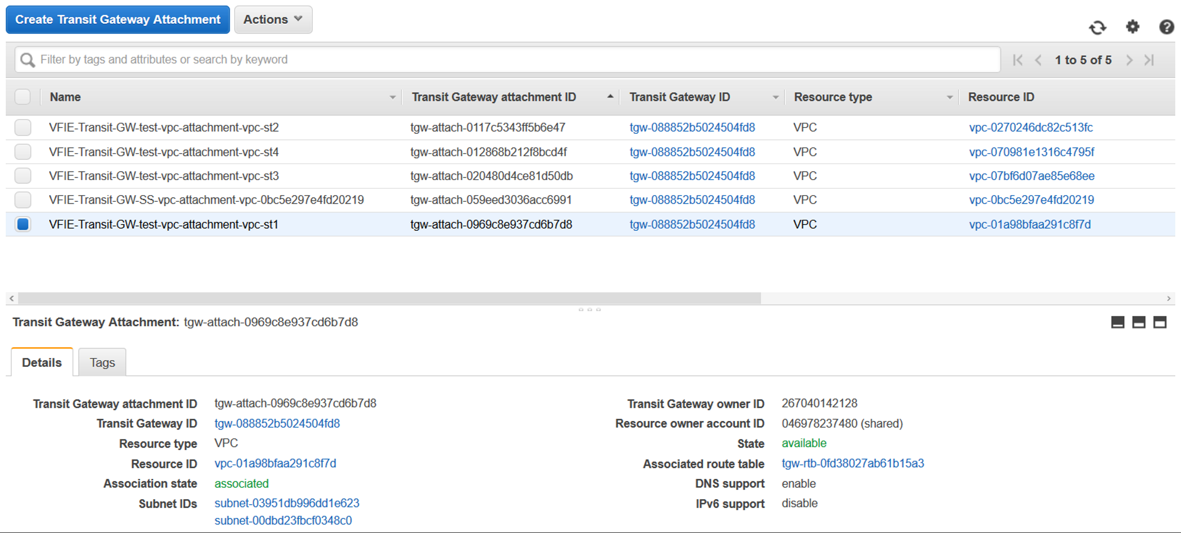

For the SS VPC, a TGW route table have been created with the following configuration:

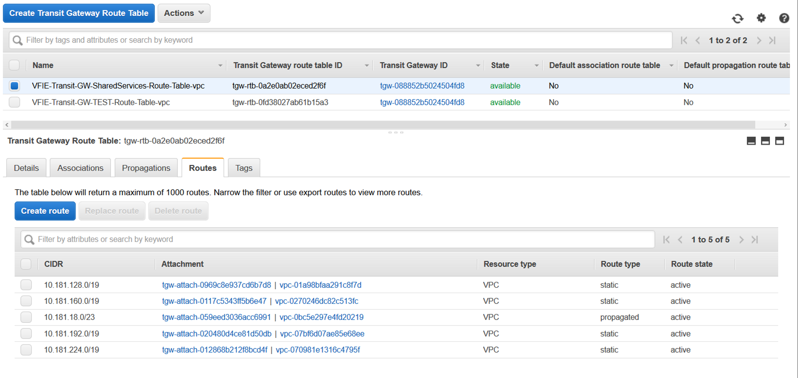

For all TEST VPC's, a TGW route table have been created with the following configuration:

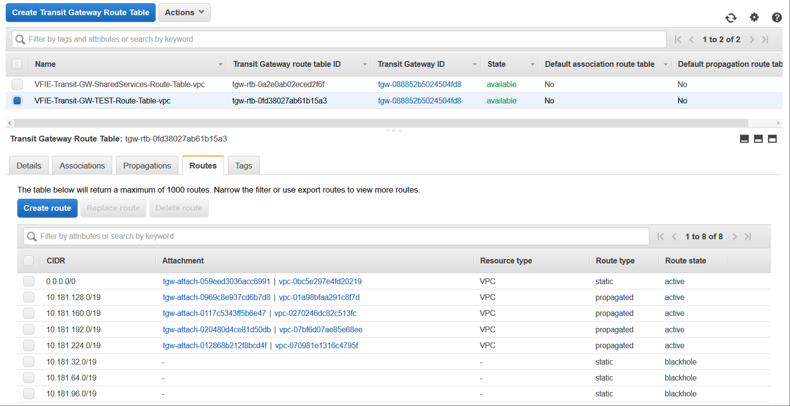

#### 2. SHARED SERVICE VPC CONFIGURATION (TEST-SS connectivity, release 1)

In the SS VPC, 2 EC2 instances have been created, in different subnets. According to AWS documentation, to provide connectivity to a AZ in a VPC just one subnet needs to be defined. Also, the route table of the subnet attached with the Transit GW (VFIE-SS-Subnet-0-int-Prod-eu-west-1a) were modified when the TGW deployment happened, adding a new route to the transit GW. This test will provide more clarity if all route tables on a VPC attached to a TGW need this modification, or not. In order to do that, one EC2 instance has been created in the subnet with the TGW ENI (VFIE-SS-Subnet-0-int-Prod-eu-west-1a) and another EC2 instance has been deployed in a different one (VFIE-SS-Subnet-0-ext-Prod-eu-west-1a).

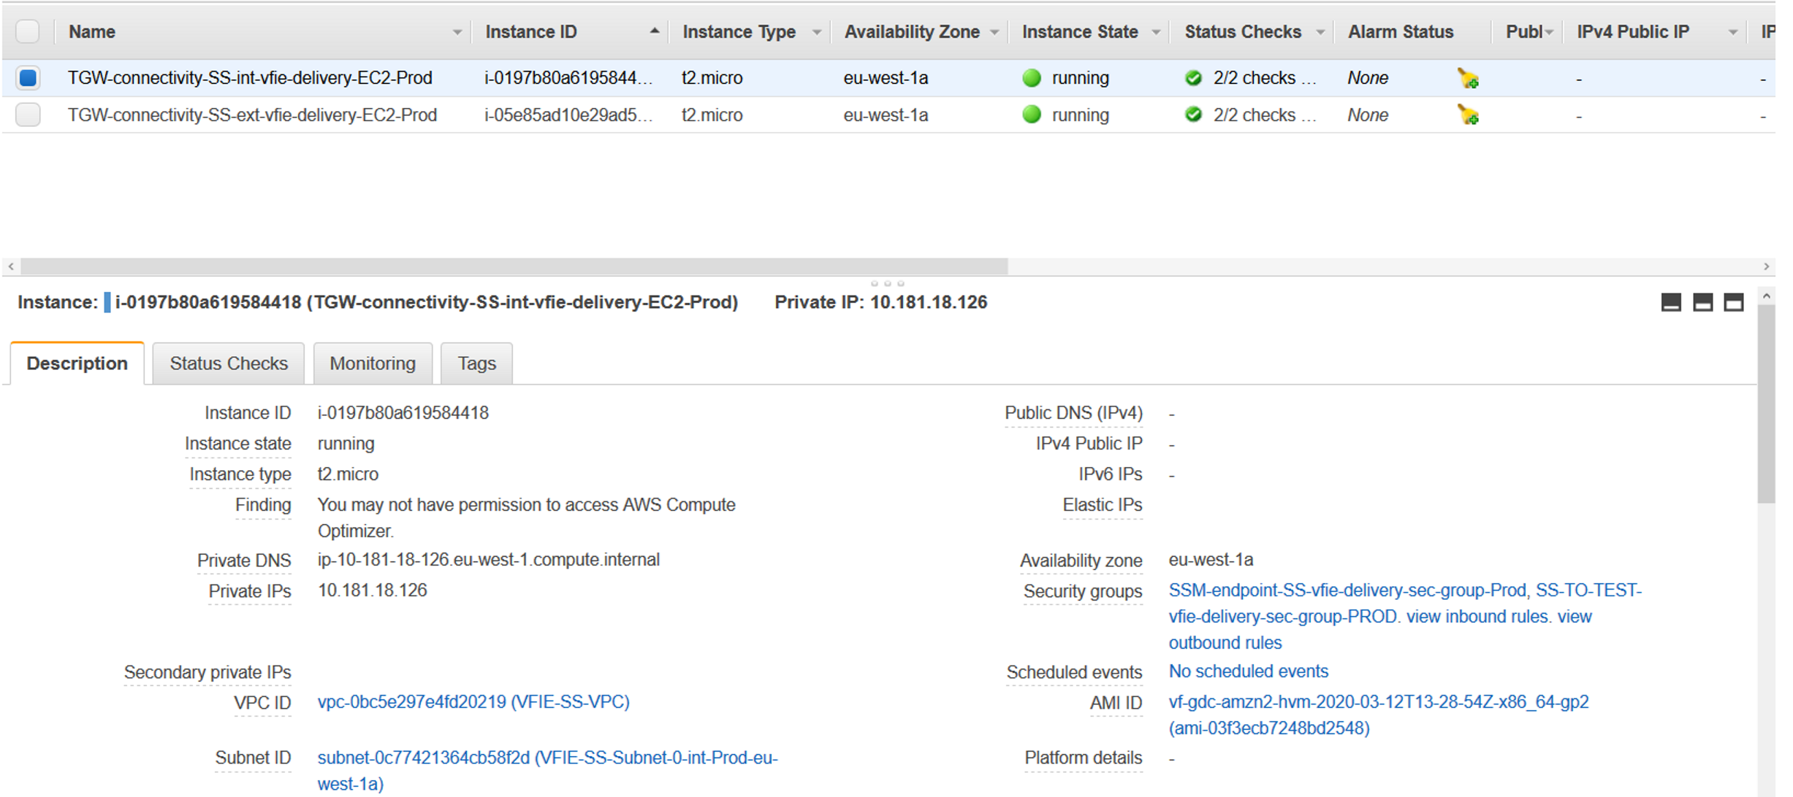

A security group called "SS-TO-TEST-vfie-delivery-sec-group-PROD" has been created to allow traffic to test environment (cidr = 10.181.128.0/17):

  ingress {  
    description = "All traffic from TEST"  
    from_port   = 0  
    to_port     = 0  
    protocol    = -1  
    cidr_blocks = ["10.181.128.0/17"]  
  }

  egress {  
    description = "All traffic to TEST"  
    from_port   = 0  
    to_port     = 0  
    protocol    = -1  
    cidr_blocks = ["10.181.128.0/17"]  
  }

#### 3. TEST VPC CONFIGURATION

In the ST1 VPC, 2 EC2 instances have been created, in different subnets. According to AWS documentation, to provide connectivity to a AZ in a VPC just one subnet needs to be defined. Also, the route table of the subnet attached with the Transit GW (ST1-VF-IEDELIVERY-private-subnet-3-TEST-eu-west-1b) were modified when the TGW deployment happened, adding a new route to the transit GW. This test will provide more clarity if all route tables on a VPC attached to a TGW need this modification, or not. In order to do that, one EC2 instance has been created in the subnet with the TGW ENI (ST1-VF-IEDELIVERY-private-subnet-3-TEST-eu-west-1b) and another EC2 instance has been deployed in a different one (ST1-VF-IEDELIVERY-web-tier-subnet-1-TEST-eu-west-1b).

In the ST2 VPC, 2 EC2 instances have been created, one in the subnet with the TGW ENI (ST2-VF-IEDELIVERY-private-subnet-3-TEST-eu-west-1b) and another EC2 instance has been deployed in a different one (ST2-VF-IEDELIVERY-web-tier-subnet-1-TEST-eu-west-1b).

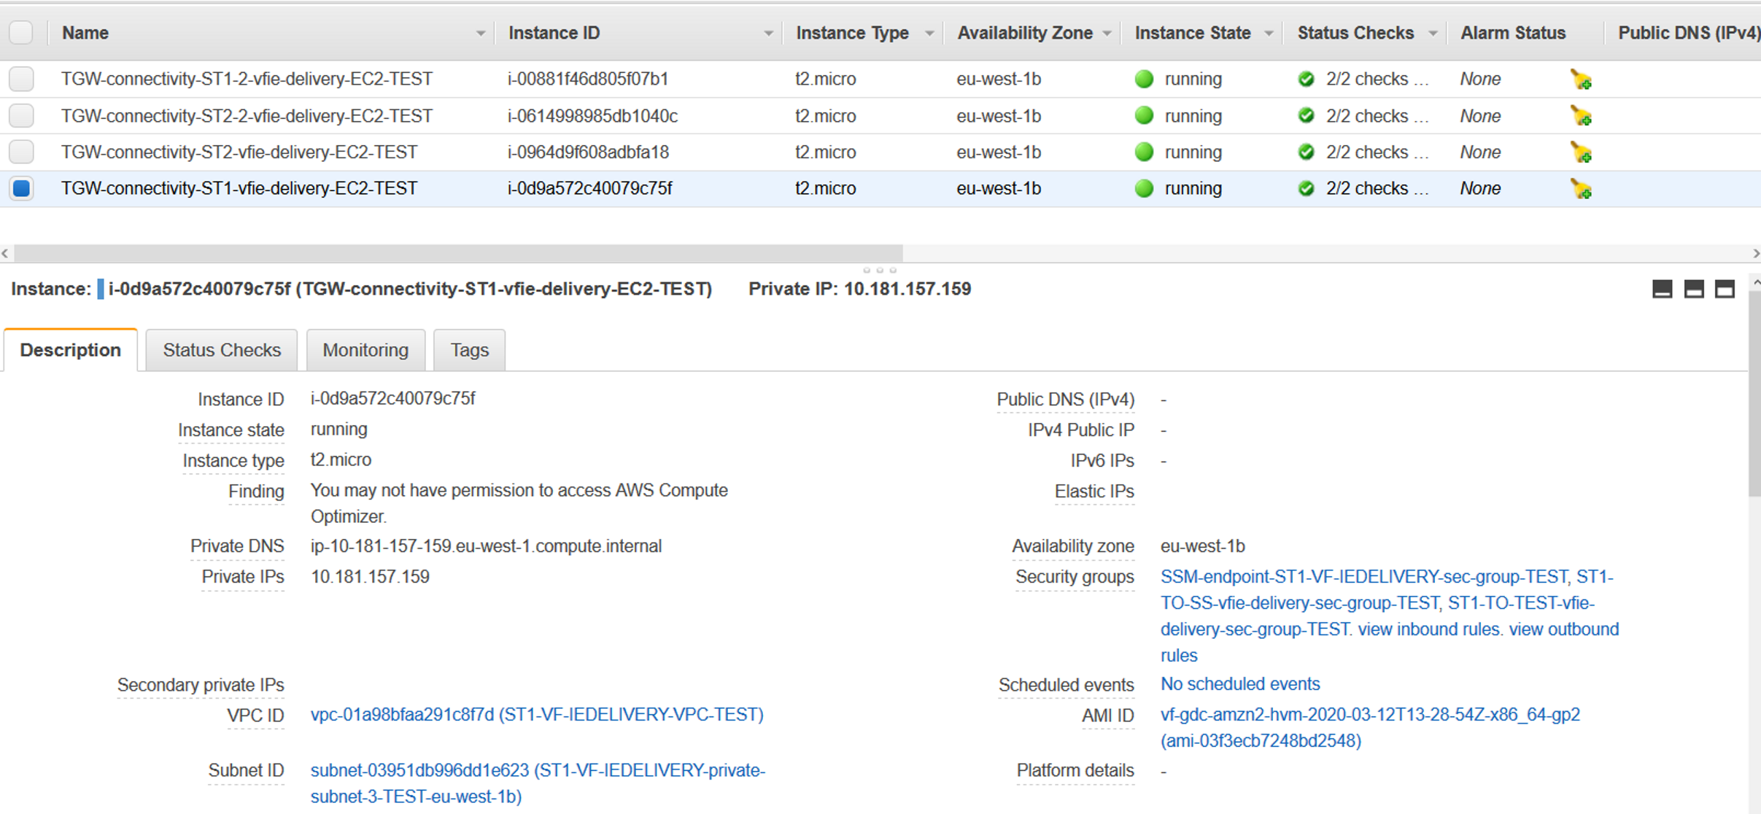

In both ST1 and ST2, the following security groups have been created: 1) security group to allow SSM traffic, 2) security group to allow traffic from/to SS account (10.181.18.0/23) and 3) security group to allow traffic to/from TEST environments (10.181.128.0/17).

**Example for ST1:**

* ST1-TO-TEST-vfie-delivery-sec-group-TEST:
  + ingress {     description = "All traffic from TEST"     from_port   = 0     to_port     = 0     protocol    = -1     cidr_blocks = ["10.181.128.0/17"]
  + egress {     description = "All traffic to TEST"     from_port   = 0     to_port     = 0     protocol    = -1     cidr_blocks = ["10.181.128.0/17"]   }
* ST1-TO-SS-vfie-delivery-sec-group-TEST:
  + ingress {     description = "All traffic from SS VPC"     from_port   = 0     to_port     = 0     protocol    = -1     cidr_blocks = ["10.181.18.0/23"]   }
  + egress {     description = "All traffic to SS VPC"     from_port   = 0     to_port     = 0     protocol    = -1     cidr_blocks = ["10.181.18.0/23"]   }

#### 4. RESULTS TEST-SS CONNECTIVITY- PHASE 1

* Test st1:
* EC2 in Subnet with TGW attach. **Private IP: 10.181.157.159**
* EC2 in Subnet without TGW attach. **Private IP: 10.181.135.130**
* Test st2:
* EC2 in Subnet with TGW attach. **Private IP:** 10.181.189.84
* EC2 in Subnet without TGW attach. **Private IP:** 10.181.169.179
* SS:
* EC2 in Subnet with TGW attach. **Private IP: address: 10.181.18.126**
* EC2 in Subnet without TGW attach. **Private IP: 10.181.18.52**

|  |  |  |  |  |
| --- | --- | --- | --- | --- |
| CONNECTIVITY | SS {with TGW ENI} | SS {without TGW ENI} | ST1 {with TGW ENI} | ST1 {without TGW ENI} |
| ST1 {with TGW ENI} | YES | NO |  |  |
| ST1 {without TGW ENI} | NO | NO |  |  |
| ST2 {with TGW ENI} | YES | NO | YES | NO |
| ST2 {without TGW ENI} | NO | NO | NO | NO |

##### 4.1 ST1 to SS

 EC2 in Subnet with TGW attach trying to communicate with SS VPC EC2 instances:

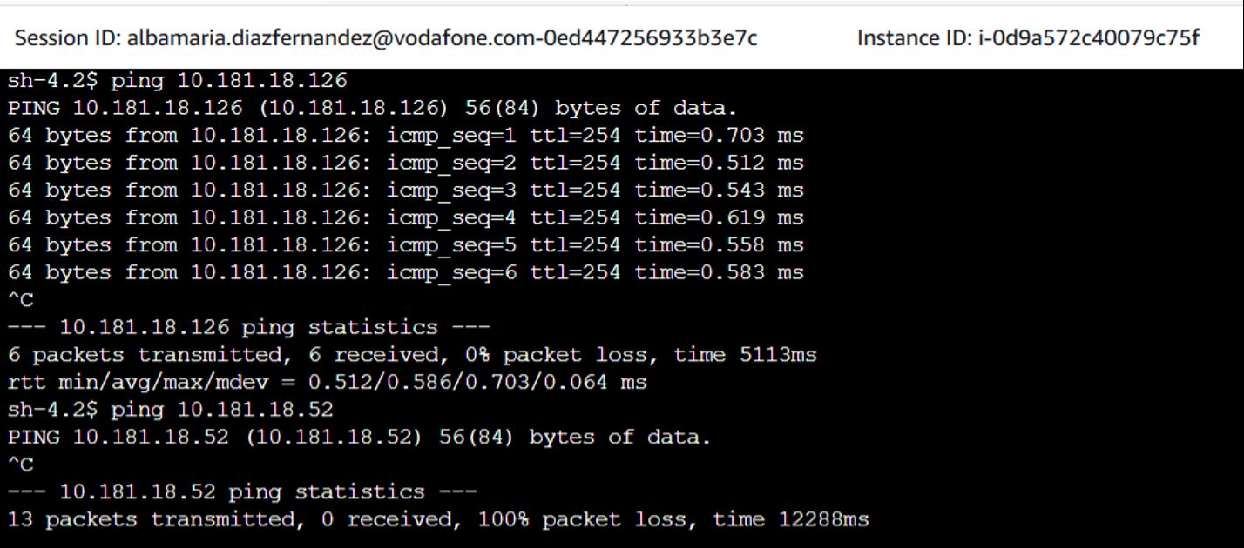

**Problem**: EC2 instance in SS VPC where there is not the TGW attachment does not receive any packet from TEST.

##### Solution: Add route to TGW in all subnets

##### 4.2 SOLUTION: ROUTE TO TGW - PHASE 1

Because of the results in the previous section, it is clear now that all subnets need a route to send traffic to transit GW. A data source will be created in terraform for each VPC with a TGW attachment, to collect all route tables ids, and add a new route. At the moment, for TEST VPC's, this route is going to be the default route, "0.0.0.0/0". With this methodology, we avoid adding manually the route table ids. This is a sample of the terraform code added to do this:

#getting route table  
ids for st1

data  
"aws_route_tables" "rts_st1" {

  provider = "aws.test"

  vpc_id =  
var.test_vpc_attachments["st1"].vpc_id

}

#converting set into  
list

locals {

  aws_route_table_st1_list =  
tolist(data.aws_route_tables.rts_st1.ids)

…

}

resource  
"aws_route" "test_vpc_route_st1" {

  provider = "aws.test"

  depends_on =  
["aws_ram_principal_association.ram_principal",  
"aws_ram_resource_association.ram_assoc"]

  count =  
length(local.aws_route_table_st1_list)

  route_table_id            =  
element(local.aws_route_table_st1_list, count.index)

  destination_cidr_block    = "0.0.0.0/0"

  transit_gateway_id        = aws_ec2_transit_gateway.transit_gw.id

}

#### 5. RESULTS TEST-SS CONNECTIVITY - PHASE 2

* Test st1:
  + EC2 in Subnet with TGW attach. **Private IP: 10.181.157.159**
  + EC2 in Subnet without TGW attach. **Private IP: 10.181.135.130**
* Test st2:
  + EC2 in Subnet with TGW attach. **Private IP: 10.181.189.84**
  + EC2 in Subnet without TGW attach. **Private IP:** 10.181.169.179
* SS:
  + EC2 in Subnet with TGW attach. **Private IP: address: 10.181.18.126**
  + EC2 in Subnet without TGW attach. **Private IP: 10.181.18.52**

|  |  |  |  |  |  |  |
| --- | --- | --- | --- | --- | --- | --- |
| CONNECTIVITY | SS {with TGW ENI} | SS {without TGW ENI} | ST1 {with TGW ENI} | ST1 {without TGW ENI} | ST2 {with TGW ENI} | ST2 {without TGW ENI} |
| ST1 {with TGW ENI} | YES | YES |  |  | YES | YES |
| ST1 {without TGW ENI} | YES | YES |  |  | YES | YES |
| ST2 {with TGW ENI} | YES | YES | YES | YES |  |  |
| ST2 {without TGW ENI} | YES | YES | YES | YES |  |  |

##### 5.1 ST1 to SS and to ST2

EC2 in Subnet without TGW attach. Private IP: 10.181.135.130

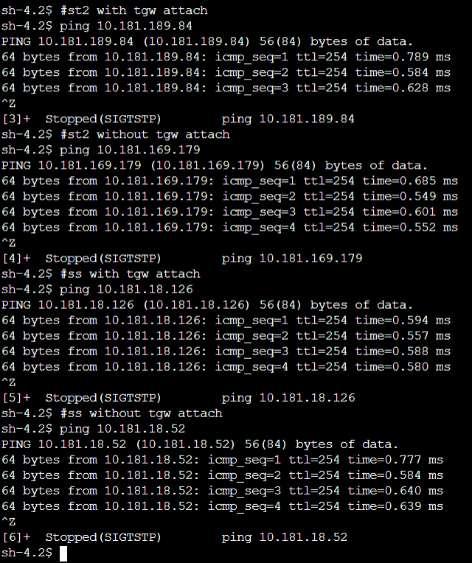

5.2 SS to TEST

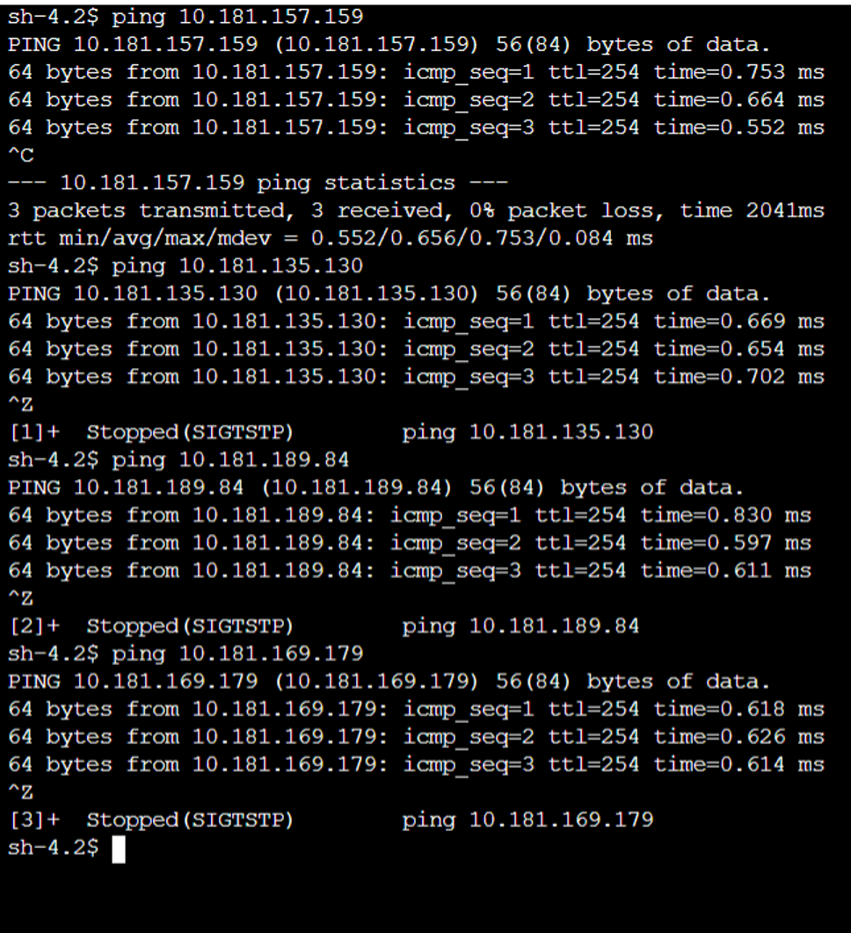

#### 6.TRANSIT GATEWAY CONFIGURATION (release 2)

This is the configuration of the TGW after adding pre-prod and prod vpc's to the configuration:

##### 6.1 TGW VPC attachments

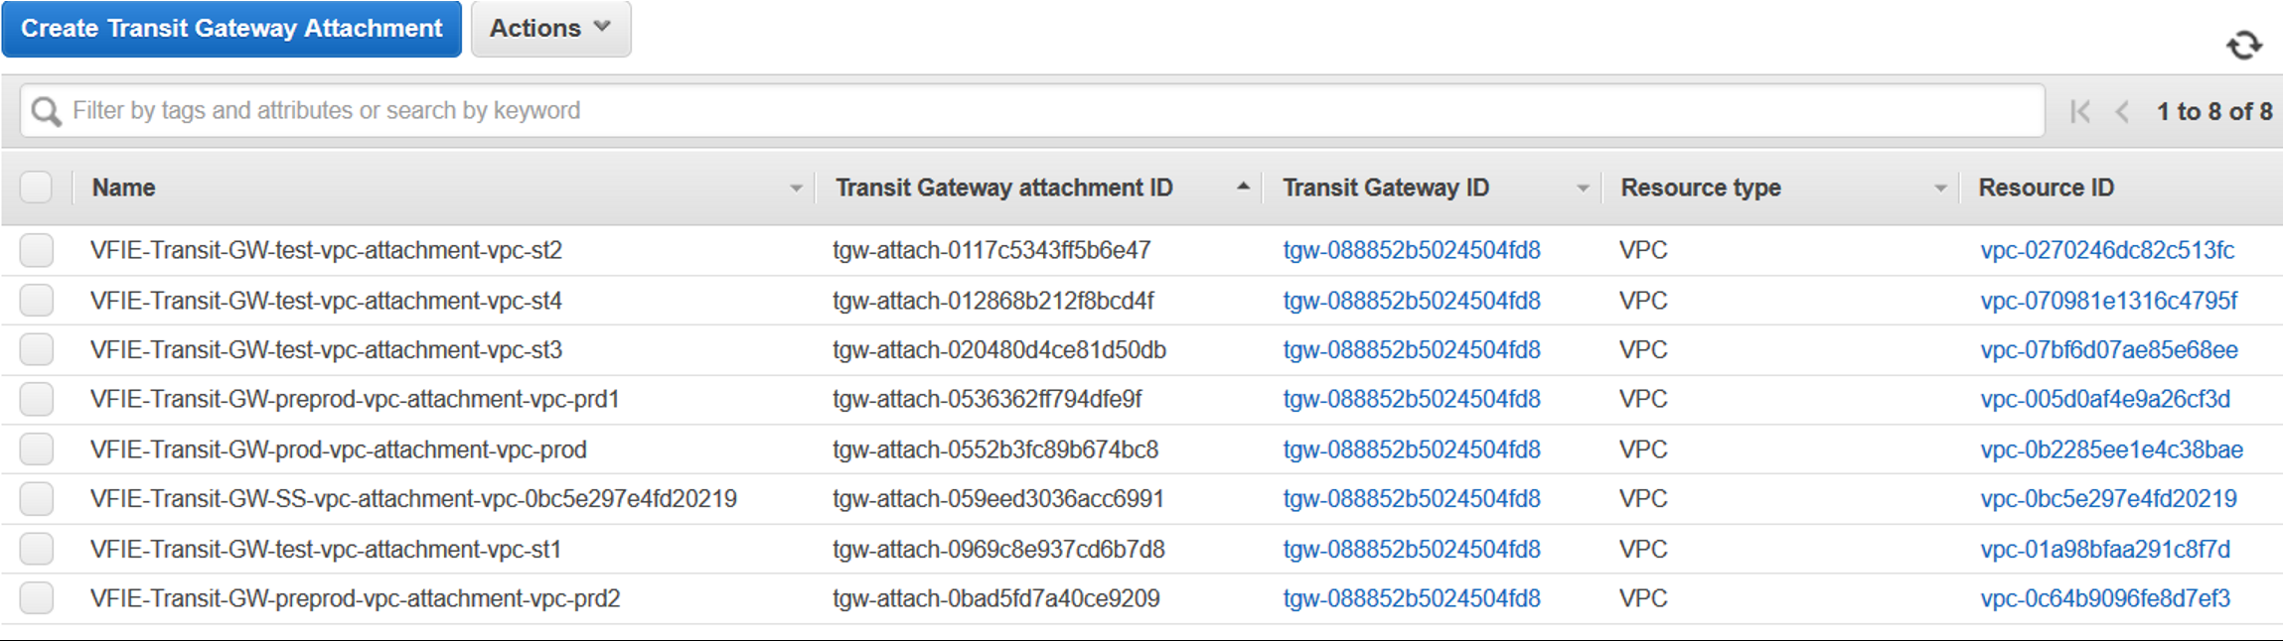

##### 6.2 TGW Route tables

**Pre-prod TGW route table:**

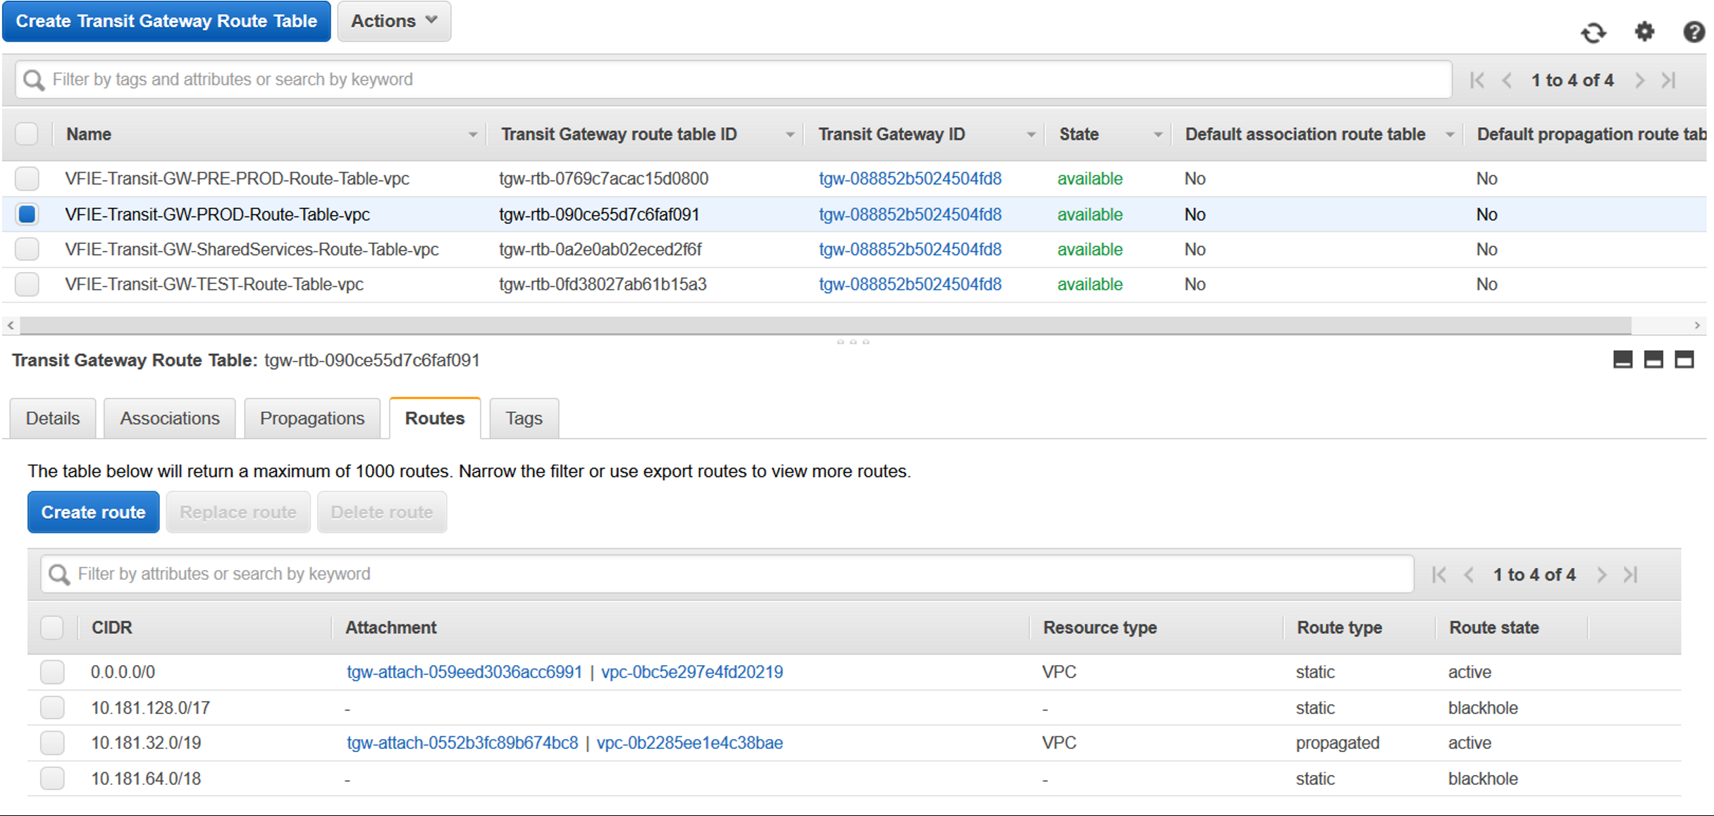

**Prod TGW route table:**

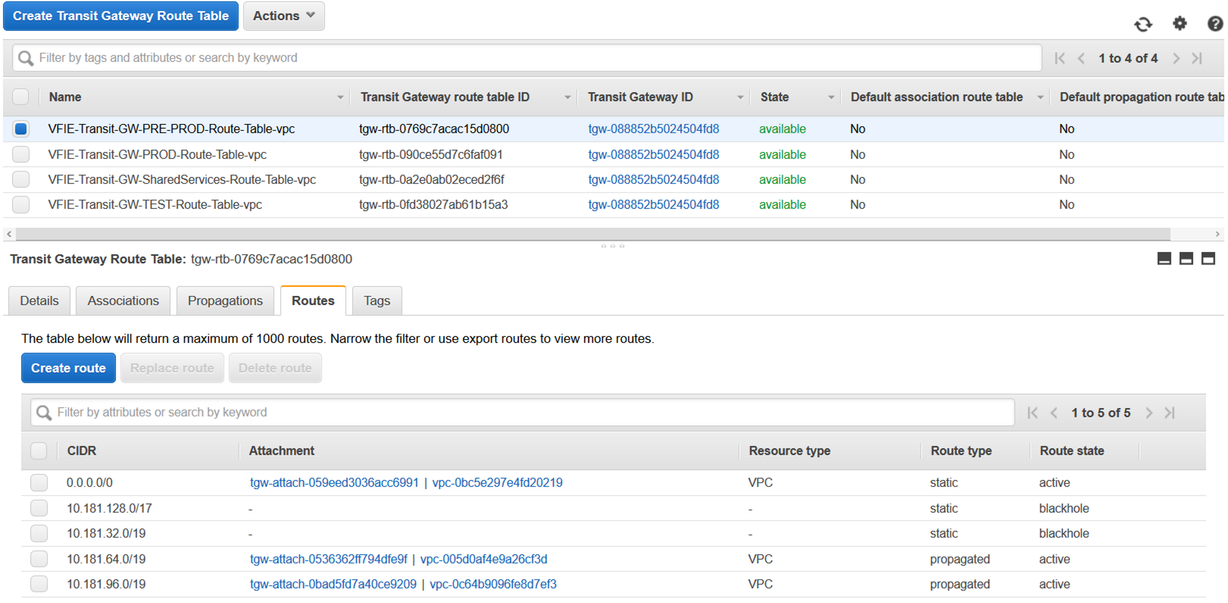

#### 7. CONNECTIVITY TEST (TEST-PREPROD-PROD-SS)

In pre-prod and prod the same logic than the one deployed in TEST have been followed. SSM endpoints have been enabled in a private subnet of each vpc (prd1, prd2 and prod) that is involved in this test, as well as security groups to allow the required traffic.

* Test st1:
* EC2 in Subnet with TGW       attach. Private IP: 10.181.157.159
* EC2 in Subnet without TGW       attach. Private IP: 10.181.135.130
* Test st2:
* EC2 in Subnet with TGW       attach. Private IP: 10.181.189.84
* EC2 in Subnet without TGW       attach. Private IP: 10.181.169.179
* SS:
* EC2 in Subnet with TGW       attach. Private IP: address: 10.181.18.126
* EC2 in Subnet without TGW       attach. Private IP: 10.181.18.52
* Pre-prod
* PRD1
* EC2 in Subnet with TGW        attach. Private IP: address: 10.181.93.37
* EC2 in Subnet without TGW attach. Private IP: 10.181.71.39
* PRD2
* EC2 in Subnet with TGW        attach. Private IP: address: 10.181.125.144
* EC2 in Subnet without TGW        attach. Private IP: 10.181.103.153
* Prod
* EC2 in Subnet with TGW       attach. Private IP: address: 10.181.61.230
* EC2 in Subnet without TGW       attach. Private IP: 10.181.39.200

##### 7.1 Prod web ec2 (10.181.39.200)

Prod can talk with SS, but it cannot talk with any other environment.

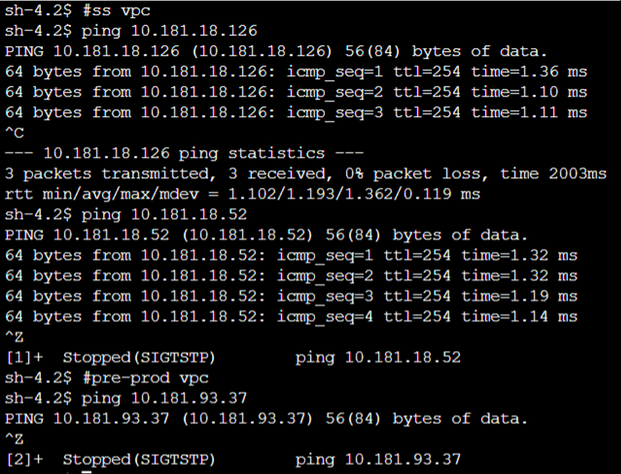

##### 7.2 Pre-Prod web ec2 (10.181.71.39)

Pre-Prod can talk with SS, but it cannot talk with any other environment (prod, test).

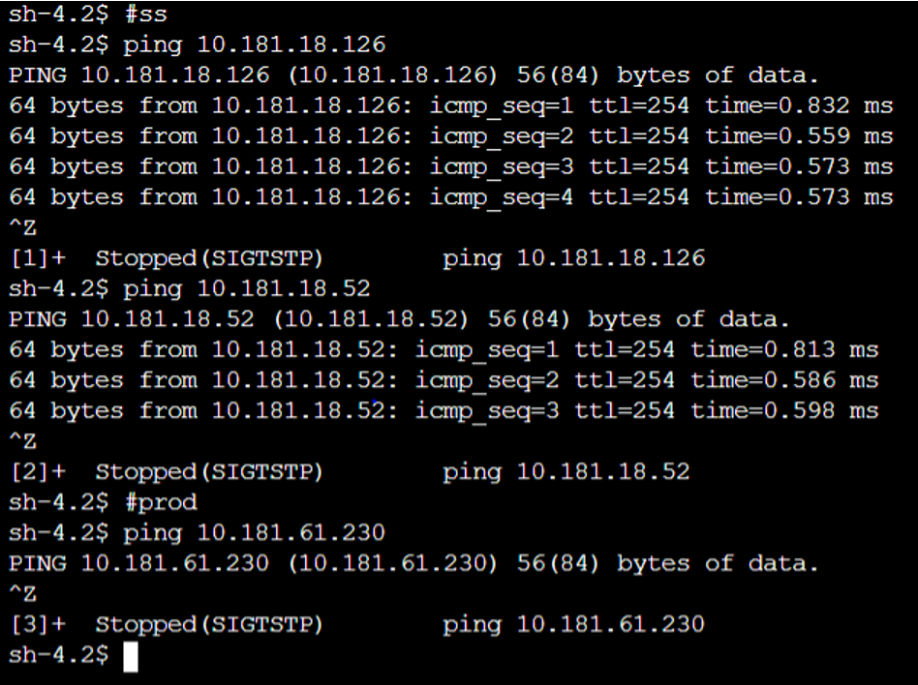

##### 7.3 SS private EC2 (10.181.18.126)

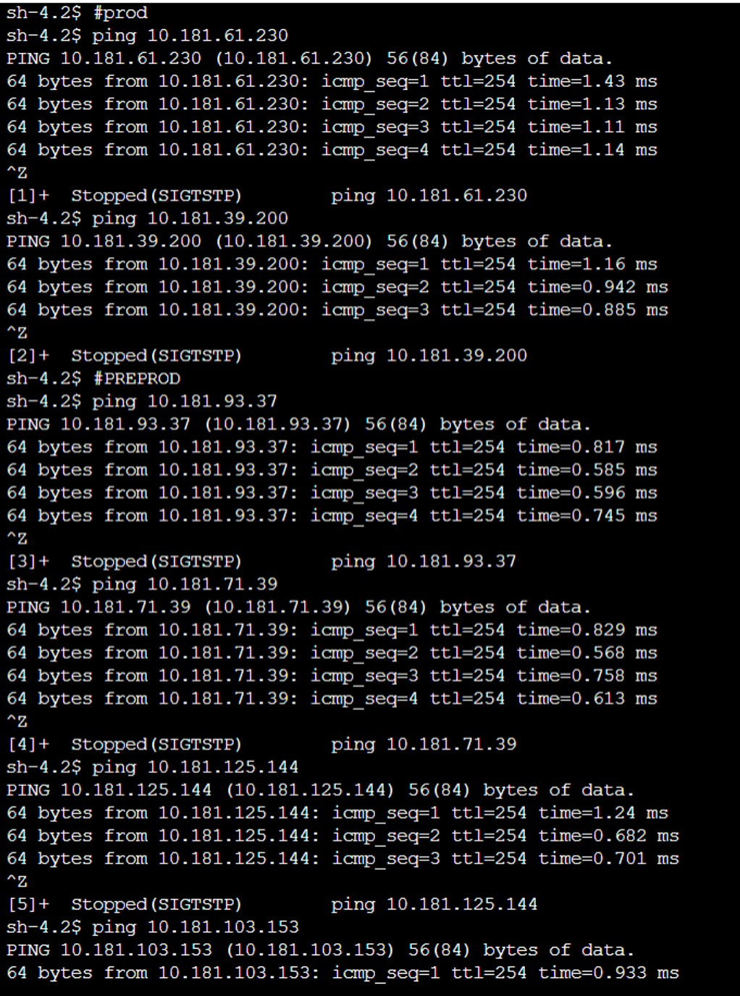

### CURRENT DESIGN AND ROUTE TABLES

#### 

* 1.INTRODUCTION
* 2.ARCHITECTURE
* 3.TGW ROUTE TABLE
  + 3.1 sandbox TGW route table
  + 3.2 Test TGW route table
  + 3.3 Pre-Prod TGW route table
  + 3.4 Prod TGW route table
  + 3.5 SS TGW route table
  + 3.5 Internet TGW route table
  + 3.6 Myst TGW route table
* 4. GDC CONNECTIVITY DETAILS
  + 4.1 DIRECT CONNECT GW AND VIF
  + 4.2 ROUTE PROPAGATION IN TGW
  + 4.4 DX TGW ROUTE TABLE
* 5. NETWORK MANAGER

#### 1.INTRODUCTION

This section shows the current design for VFIE regarding the TGW and the routing in place. See the table with the details about CIDR IP address per AWS VPC here.

#### 2.ARCHITECTURE

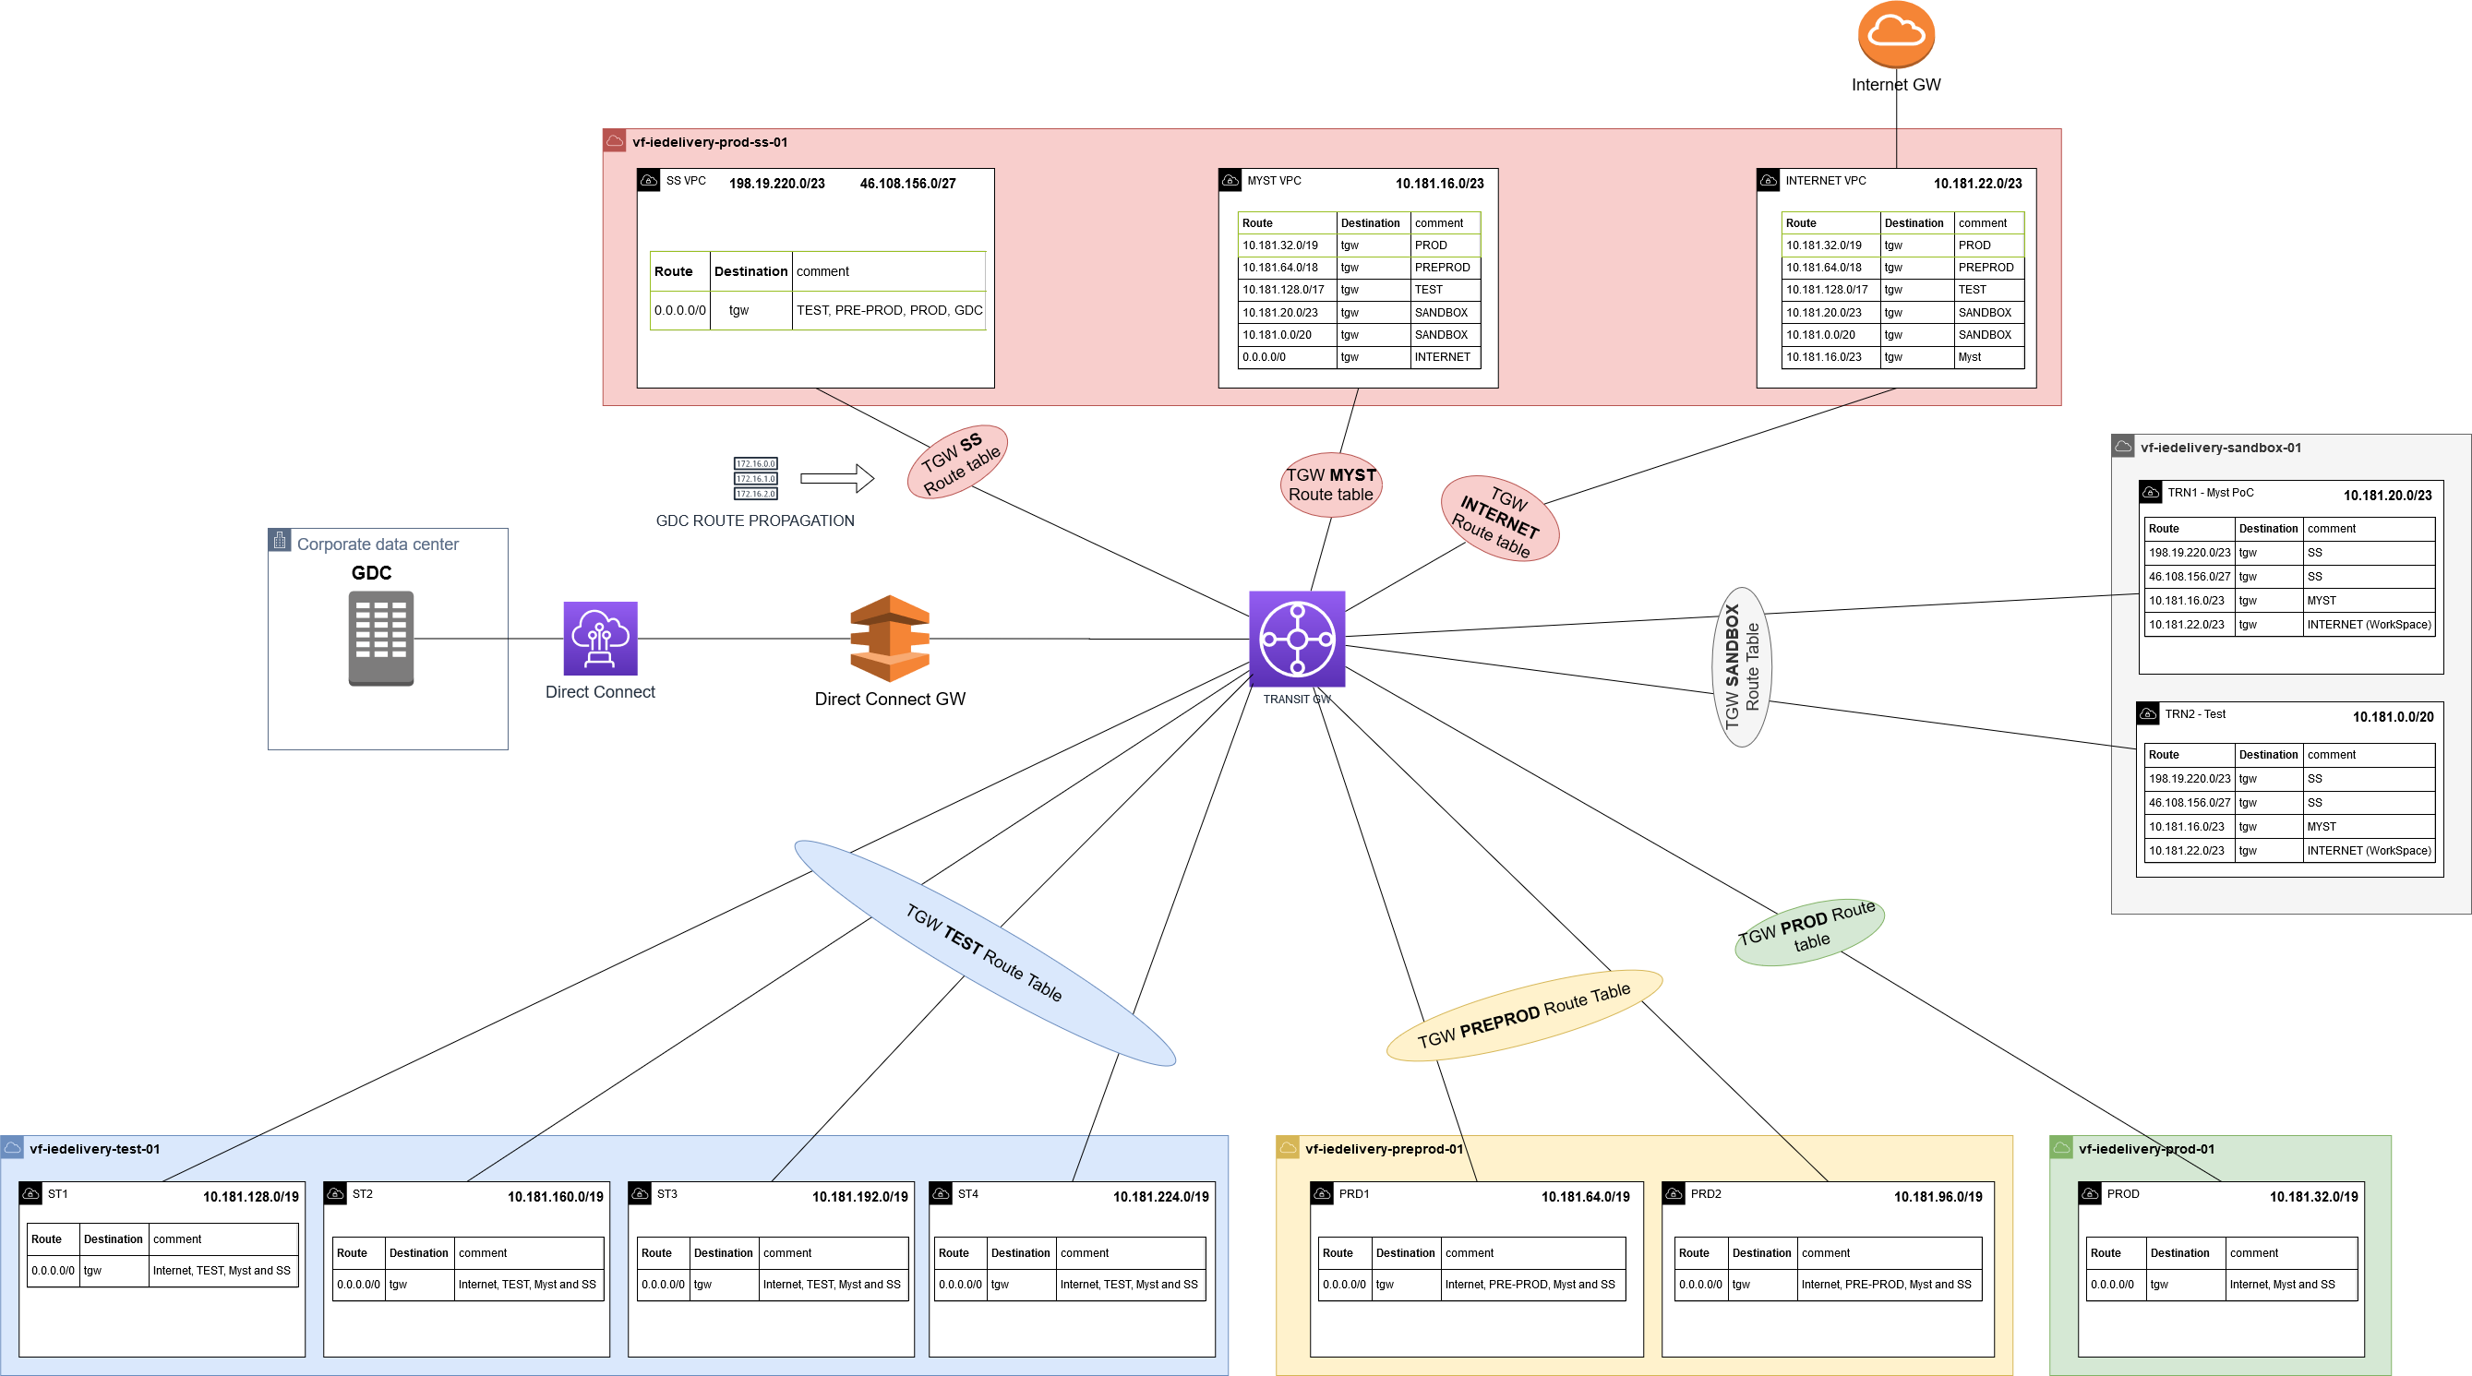

#### 3.TGW ROUTE TABLE

##### 3.1 sandbox TGW route table

|  |  |  |
| --- | --- | --- |
| Route | Destination | Type |
| 10.181.16.0/23 | myst vpc attach | STATIC |
| 198.19.220.0/23 | ss vpc attach | STATIC |
| 10.181.22.0/23 | Internet vpc attach | STATIC |
| 10.181.32.0/19 | DROP PROD | STATIC |
| 10.181.64.0/19 | DROP PRE-PROD | STATIC |
| 10.181.96.0/19 | DROP PRE-PROD | STATIC |
| 10.181.0.0/20 | sandbox | PROPAGATED |
| 10.181.20.0/23 | sandbox | PROPAGATED |

##### 3.2 Test TGW route table

|  |  |  |
| --- | --- | --- |
| Route | Destination | Type |
| 10.181.16.0/23 | myst vpc attach | STATIC |
| 198.19.220.0/23 | ss vpc attach | STATIC |
| 10.181.22.0/23 | Internet vpc attach | STATIC |
| 10.181.32.0/19 | DROP PROD | STATIC |
| 10.181.64.0/19 | DROP PRE-PROD | STATIC |
| 10.181.96.0/19 | DROP PRE-PROD | STATIC |
| 10.181.128.0/19 | Test | PROPAGATED |
| 10.181.128.0/19 | Test | PROPAGATED |
| 10.181.192.0/19 | Test | PROPAGATED |
| 10.181.224.0/19 | Test | PROPAGATED |

##### 3.3 Pre-Prod TGW route table

|  |  |  |
| --- | --- | --- |
| Route | Destination | Type |
| 10.181.16.0/23 | myst vpc attach | STATIC |
| 198.19.220.0/23 | ss vpc attach | STATIC |
| 0.0.0.0/0 | Internet vpc attach | STATIC |
| 10.181.32.0/19 | DROP PROD | STATIC |
| 10.181.128.0/17 | DROP TEST | STATIC |
| 10.181.64.0/19 | pre-prod | PROPAGATED |
| 10.181.96.0/19 | pre-prod | PROPAGATED |

##### 3.4 Prod TGW route table

|  |  |  |
| --- | --- | --- |
| Route | Destination | Type |
| 10.181.16.0/23 | myst vpc attach | STATIC |
| 198.19.220.0/23 | ss vpc attach | STATIC |
| 0.0.0.0/0 | Internet vpc attach | STATIC |
| 10.181.64.0/18 | DROP PRE-PROD | STATIC |
| 10.181.128.0/17 | DROP TEST | STATIC |

##### 3.5 SS TGW route table

|  |  |  |
| --- | --- | --- |
| Route | Destination | Type |
| 10.181.32.0/19 | prod vpc attach | STATIC |
| 10.181.64.0/19 | pre-prod1 vpc attach | STATIC |
| 10.181.96.0/19 | pre-prod2 vpc attach | STATIC |
| 10.181.128.0/19 | test1 vpc attach | STATIC |
| 10.181.160.0/19 | test2 vpc attach | STATIC |
| 10.181.192.0/19 | test3 vpc attach | STATIC |
| 10.181.224.0/19 | test4 vpc attach | STATIC |
| 10.181.0.0/20 | sandbox vpc attach | STATIC |
| 10.181.20.0/23 | sandbox vpc attach | STATIC |

##### 3.5 Internet TGW route table

|  |  |  |
| --- | --- | --- |
| Route | Destination | Type |
| 10.181.32.0/19 | prod vpc attach | STATIC |
| 10.181.64.0/19 | pre-prod1 vpc attach | STATIC |
| 10.181.96.0/19 | pre-prod2 vpc attach | STATIC |
| 10.181.128.0/19 | test1 vpc attach | STATIC |
| 10.181.160.0/19 | test2 vpc attach | STATIC |
| 10.181.192.0/19 | test3 vpc attach | STATIC |
| 10.181.224.0/19 | test4 vpc attach | STATIC |
| 10.181.0.0/20 | sandbox vpc attach | STATIC |
| 10.181.20.0/23 | sandbox vpc attach | STATIC |
| 10.181.16.0/23 | myst vpc attach | STATIC |

##### 3.6 Myst TGW route table

|  |  |  |
| --- | --- | --- |
| Route | Destination | Type |
| 10.181.32.0/19 | prod vpc attach | STATIC |
| 10.181.64.0/19 | pre-prod1 vpc attach | STATIC |
| 10.181.96.0/19 | pre-prod2 vpc attach | STATIC |
| 10.181.128.0/19 | test1 vpc attach | STATIC |
| 10.181.160.0/19 | test2 vpc attach | STATIC |
| 10.181.192.0/19 | test3 vpc attach | STATIC |
| 10.181.224.0/19 | test4 vpc attach | STATIC |
| 10.181.0.0/20 | sandbox vpc attach | STATIC |
| 10.181.20.0/23 | sandbox vpc attach | STATIC |
| 0.0.0.0/0 | internet vpc attach | STATIC |

#### 4. GDC CONNECTIVITY DETAILS

The connectivity between GDC and AWS will be managed by PCS. Following that principle, the direct connect configuration will be done in a PCS's managed AWS account (VF-PC-SSNET-IRE-DUB-001). We have created a direct connect that enables you to create a single connection to your Direct Connect connection that all of your VPCs can use. The direct connect gateway will be associated with the transit gateway as shown in this picture:

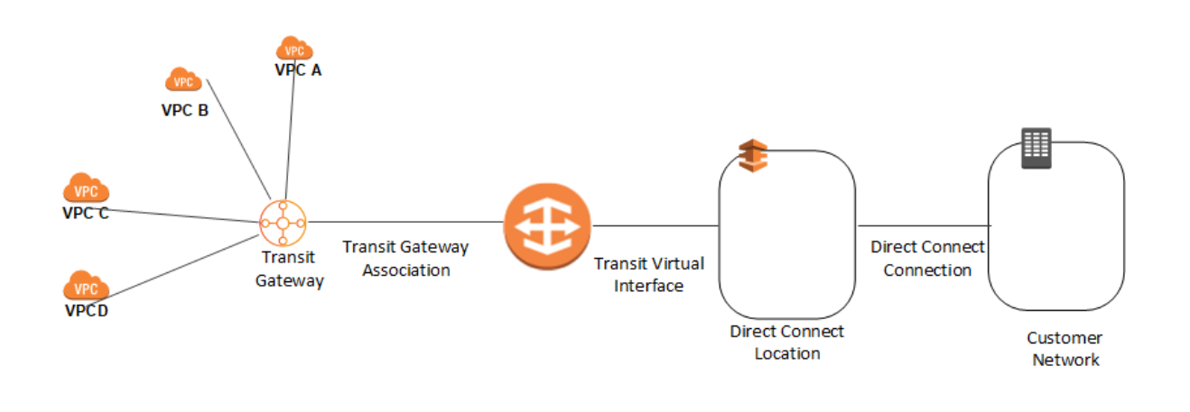

##### 4.1 DIRECT CONNECT GW AND VIF

This is our direct connect gateway configuration in VF-PC-SSNET-IRE-DUB-001 account:

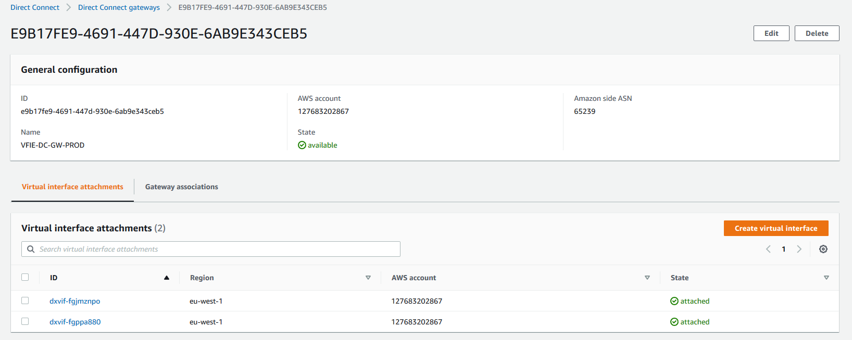

The direct connect gateway has two virtual interfaces (transit type) attached:

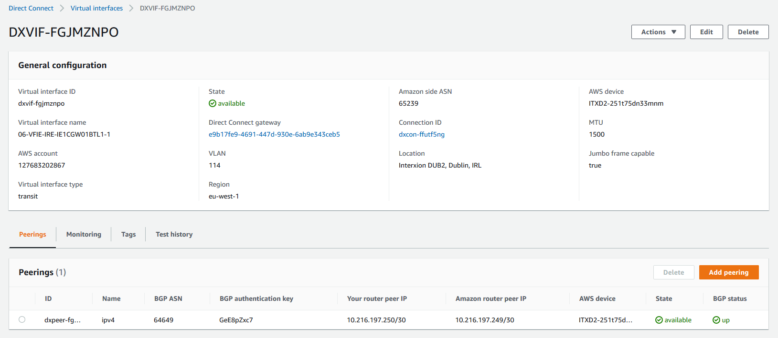

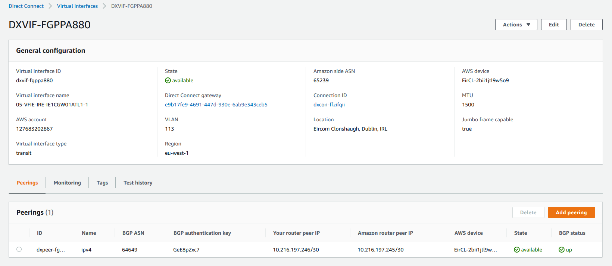

##### 4.2 ROUTE PROPAGATION IN TGW

In VFIE SS account (vf-iedelivery-prod-ss-01) we need to associate for the direct connect gateway (this step was made after creating the direct connect gateway). The allowed prefixes are the ones we are propagating from AWS to on-premise:

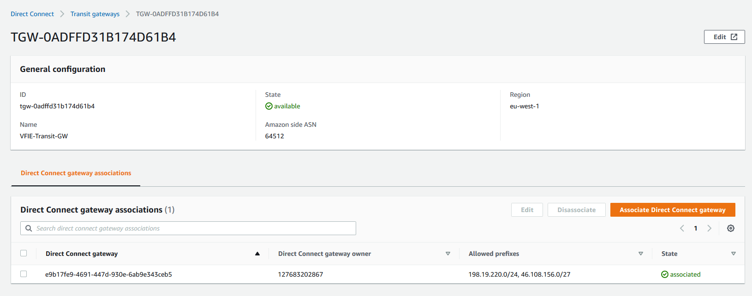

For our scenario, we just want SS VPC to have access to GDC. So, we will need to modify TGW SS Route table and allow propagation from GDC:

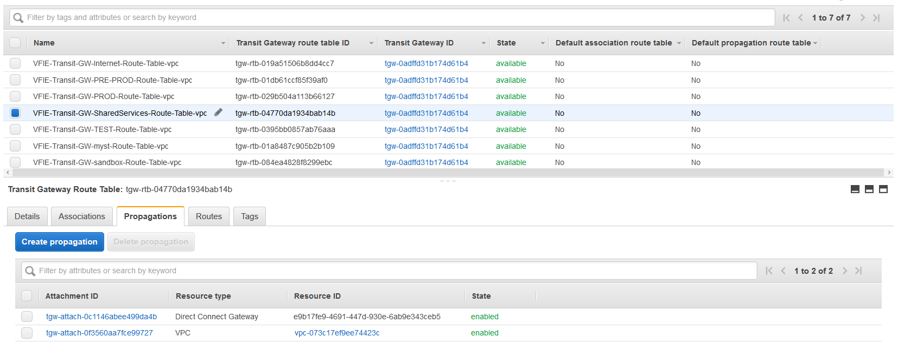

This is the result:

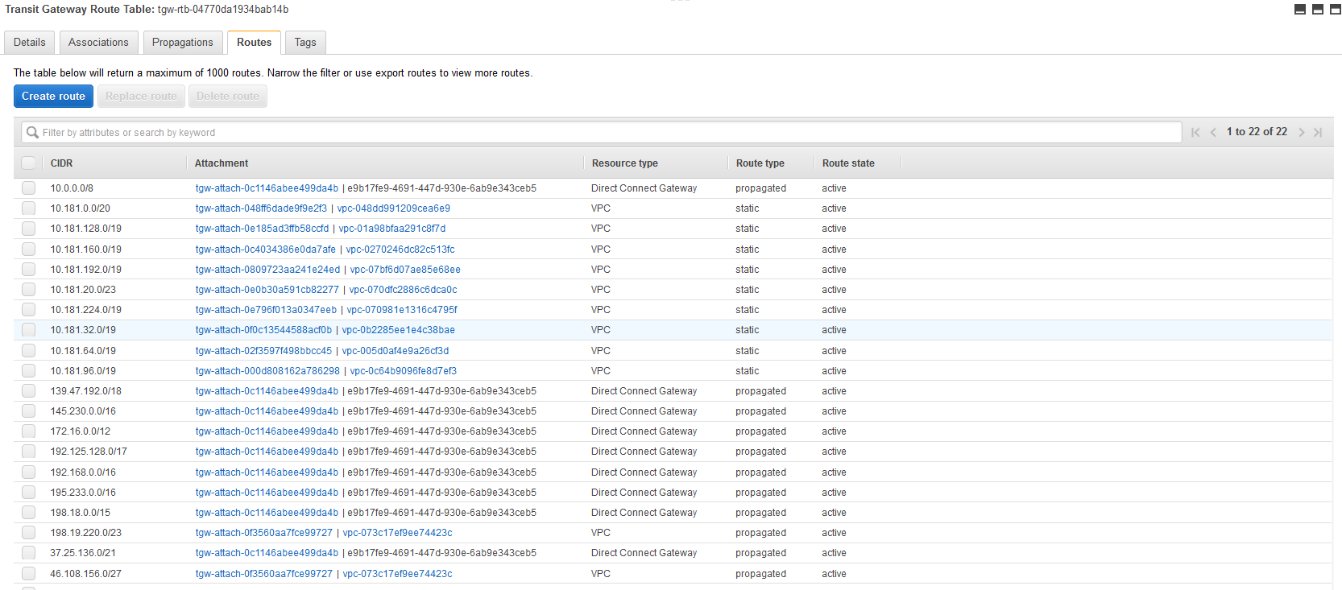

##### 4.4 DX TGW ROUTE TABLE

We can see the direct connect association in the tab Transit Gateway Attachments:

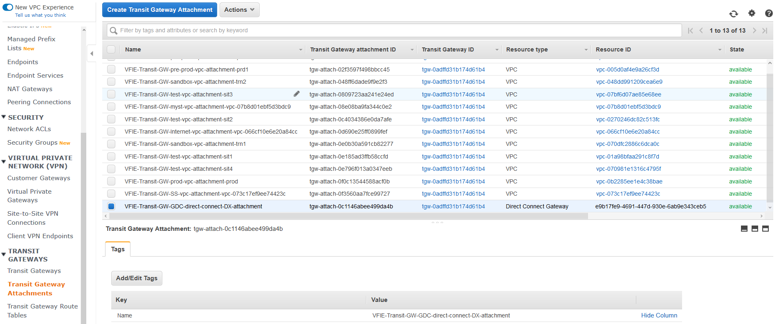

We need to create a TGW Route Table for this attachment. DX can just communicate with SS, so the routes from SS VPC will be propagated to this route table.

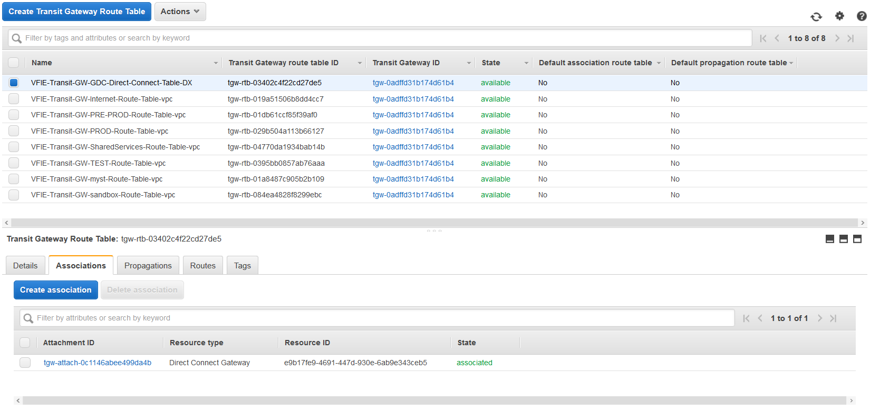

For that case, in propagations, we will add the vpc attachment of SS VPC. These are the routes we received:

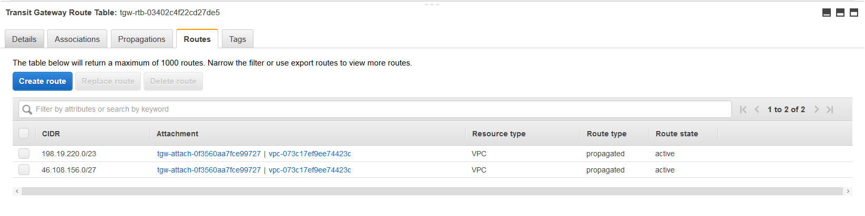

#### 5. NETWORK MANAGER

I have created a Global Network in Network Manager to analyze the routes we have configured and monitoring the TGW behaviour. Check [here](https://us-west-2.console.aws.amazon.com/networkmanager/home?region=eu-west-1#/networks).

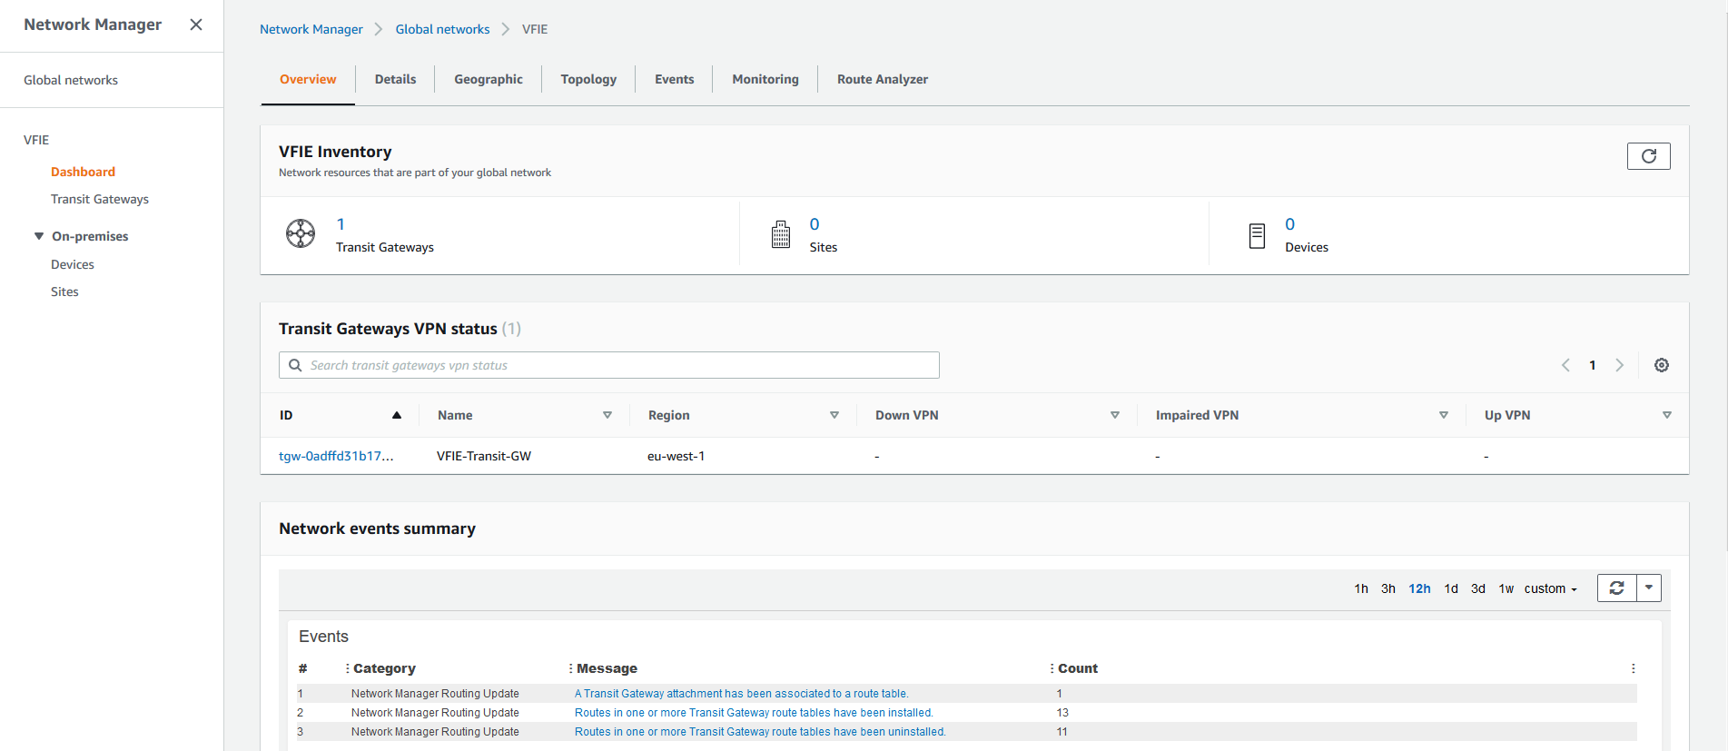

We can see in above picture the TGW that we are using, as well as last events. This is the topology to our network:

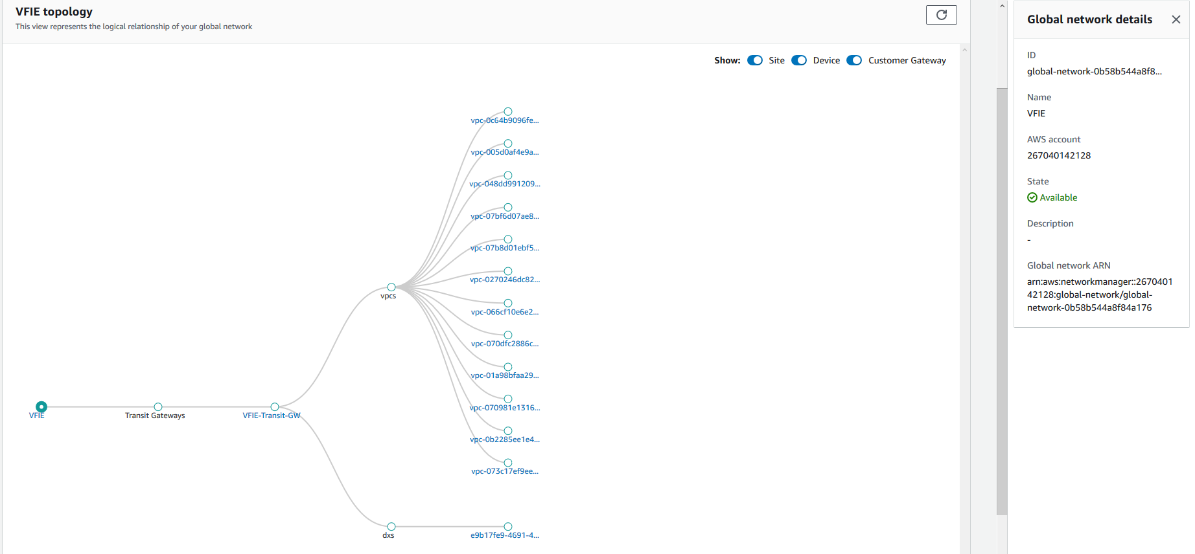

We can analyze routes [here](https://us-west-2.console.aws.amazon.com/networkmanager/home?region=eu-west-1#/networks/arn:aws:networkmanager::267040142128:global-network:global-network-0b58b544a8f84a176/routeanalyzer). This is an example from SS VPC to GDC network:

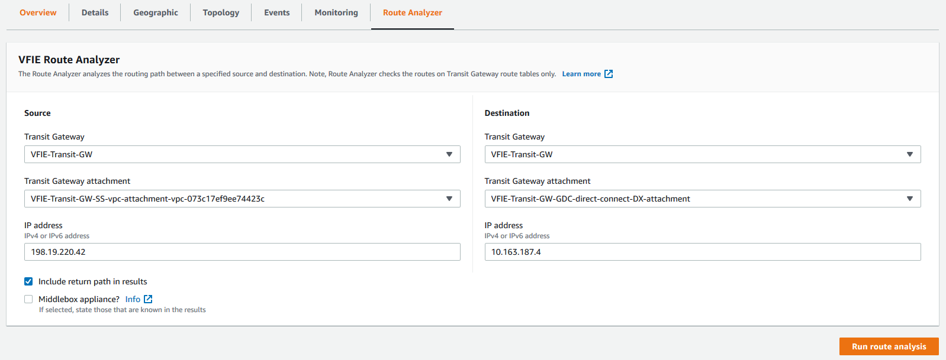

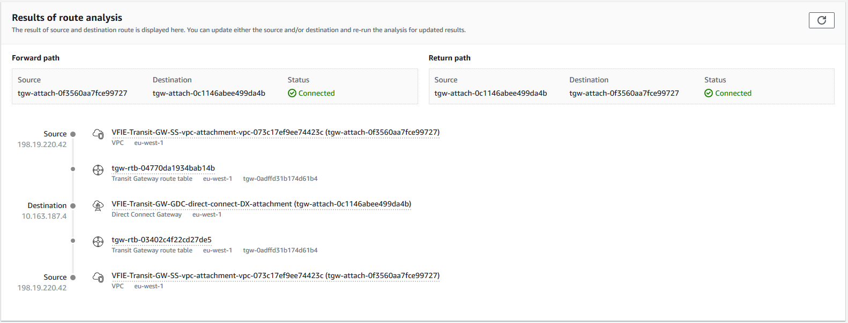

### TGW IMPLEMENTATION: HOW TO

* 1. Introduction. Code and resources
* 2. TGW Design
  + 2.1 Design of the attachment and route table for a AWS Transit GW.
  + 2.3 Design of the attachments for VF IE VPCs
* 3. TGW implementation
  + 3.1 TGW resources
  + 3.2 TGW configuration
* 4. TGW: How to add a new VPC to the implementation
  + 4.1 New AWS account
  + 4.2 New VPC
  + 4.3 New AWS provider
  + 4.4 New VPC attachment(s) and VPC accepter
  + 4.5 TGW Route table
  + 4.6 TGW Route table association and propagation
  + 4.7 VPC route tables
  + 4.8 TGW INVITATION

Please, follow the instructions here to modify/update entries in TGW.

#### 1. Introduction. Code and resources

The transit gateway implementation and the corresponding CI/CD methodology (CodePipeline) have been done using Terraform. All the code is stored in the management account (vf-iedelivery-mgmt), in a codecommit repository:

* Code: Terraform
* Repository: <https://git-codecommit.eu-west-1.amazonaws.com/v1/repos/vf-iedelivery-transit-gateway>
* AWS account: vf-iedelivery-mgmt -  831341508773
* CI/CD: CodePipeline <https://eu-west-1.console.aws.amazon.com/codesuite/codepipeline/pipelines/vf-iedelivery-transit-gateway--cross-account-prod-tf/view?region=eu-west-1>

These are the key resources for the implementation:

* **Codepipeline** for cross-account terraform code, where there are more than one provider. The code can be found in the repository called "vf-iedelivery-pipelines", where the file "[5-vf-iedelivery-transit-gateway.tf](https://eu-west-1.console.aws.amazon.com/codesuite/codecommit/repositories/vf-iedelivery-pipelines/browse/refs/heads/master/--/5-vf-iedelivery-transit-gateway.tf?region=eu-west-1)" describes the pipeline associated with the transit gateway infrastructure. The resulting pipeline can be found here: <https://eu-west-1.console.aws.amazon.com/codesuite/codepipeline/pipelines/vf-iedelivery-transit-gateway--cross-account-prod-tf/view?region=eu-west-1>
* **Transit Gateway Infrastructure**: For each VPC that we want to connect to the transit GW, we will create one VPC attachment. Because of availability reasons, we will select 1 subnet per AZ available in the chosen VPC, providing connectivity through the transit GW to the whole AZ. We will follow a cross-account strategy because the vpc's we want to connect are in different accounts. We will create:
  + **In Shared Service Account** ( vf-iedelivery-prod-ss-01): Transit GW, Transit GW route tables; AWS RAM resource share; VPC Attachment accepter for test, pre-prod and prod VPC's (until the attachment is available in the target account); VPC Attachment for Shared Service VPC; new route in Shared Service VPC route tables to send traffic to Transit GW.
  + **Test, Pre-prod and Prod Accounts:** TGW VPC Attachment for test, pre-prod and prod VPC's; shared resource transit GW; new route in each VPC route table to send traffic to Transit GW.

#### 2. TGW Design

##### 2.1  Design of the attachment and route table for a AWS Transit GW.

When you attach a VPC to a transit gateway, you must enable one or more Availability Zones to be used by the transit gateway to route traffic to resources in the VPC subnets. To enable each Availability Zone, you specify exactly one subnet. The transit gateway places a **network interface** in that subnet using one IP address from the subnet. After you enable an Availability Zone, traffic can be routed to all subnets in that Availability Zone, not just the specified subnet. Resources that reside in Availability Zones where there is no transit gateway attachment will not be able to reach the transit gateway.

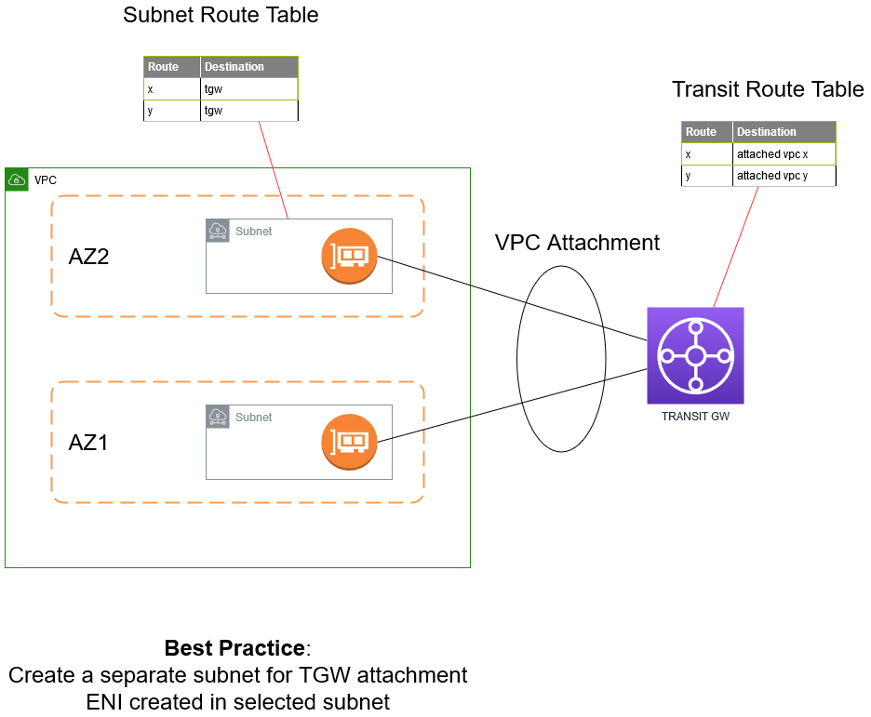

##### 2.3   Design of the attachments for VF IE VPCs

As specified here, the CIDR for the environments are:

* **10.181.32.0/19** for PROD
* **10.181.64.0/18** for PRE-PROD
* **10.181.128.0/17** for TEST

The requirements for the connection between different environments are:

* Allow communication between different TEST VPC's
* Allow communication between different PRE-PROD VPC's.
* Deny communication to PROD if it does not come from SS VPC.
* SS can communicate with PROD, PRE-PROD and TEST.

To achieve those requirements, a different TGW route table has been created for each environment:

* TGW Route table for **Shared Service VPC**: it has specific routes to send traffic to TEST, PRE-PROD and PROD VPC's.
* TGW Route table for **TEST VPC's**: it has a route to send traffic to SS VPC (static route) and to TEST VPC's (propagated route), but it blocks (blackhole) traffic to PRE-PROD and PROD.
* TGW Route table for **PRE-PROD VPC's**: it has a route to send traffic to SS VPC (static route) and to PRE-PROD VPC's (propagated route), but it blocks (blackhole) traffic to TEST and PROD.
* TGW Route table for **PROD VPC's:** it has a route to send traffic to SS VPC (static route), but it blocks (blackhole) traffic to TEST and PRE-PROD.

With the blackhole routes to drop the traffic that goes to a specific location, we isolate the environments by not allowing communication between test and pre-prod, test and prod, and pre-prod and prod.

Additionally to TGW route tables, to route traffic from VPC's to TGW, a route that points to the TGW needs to be added. For TEST, PRE-PROD and PROD, the destination will be the default route (0.0.0.0/0) for simplicity reasons, as we will implement a centralized internet access in the SS Account. So, traffic that goes either to the internet or to SS VPC, will be sent to the TGW. This route ( 0.0.0.0/0 → TGW) has to be added to each VPC route table inside a VPC. For SS VPC, the CIDR for the different environments will be set as the destination.

(THIS DESIGN IS NOT THE CURRENT ONE)

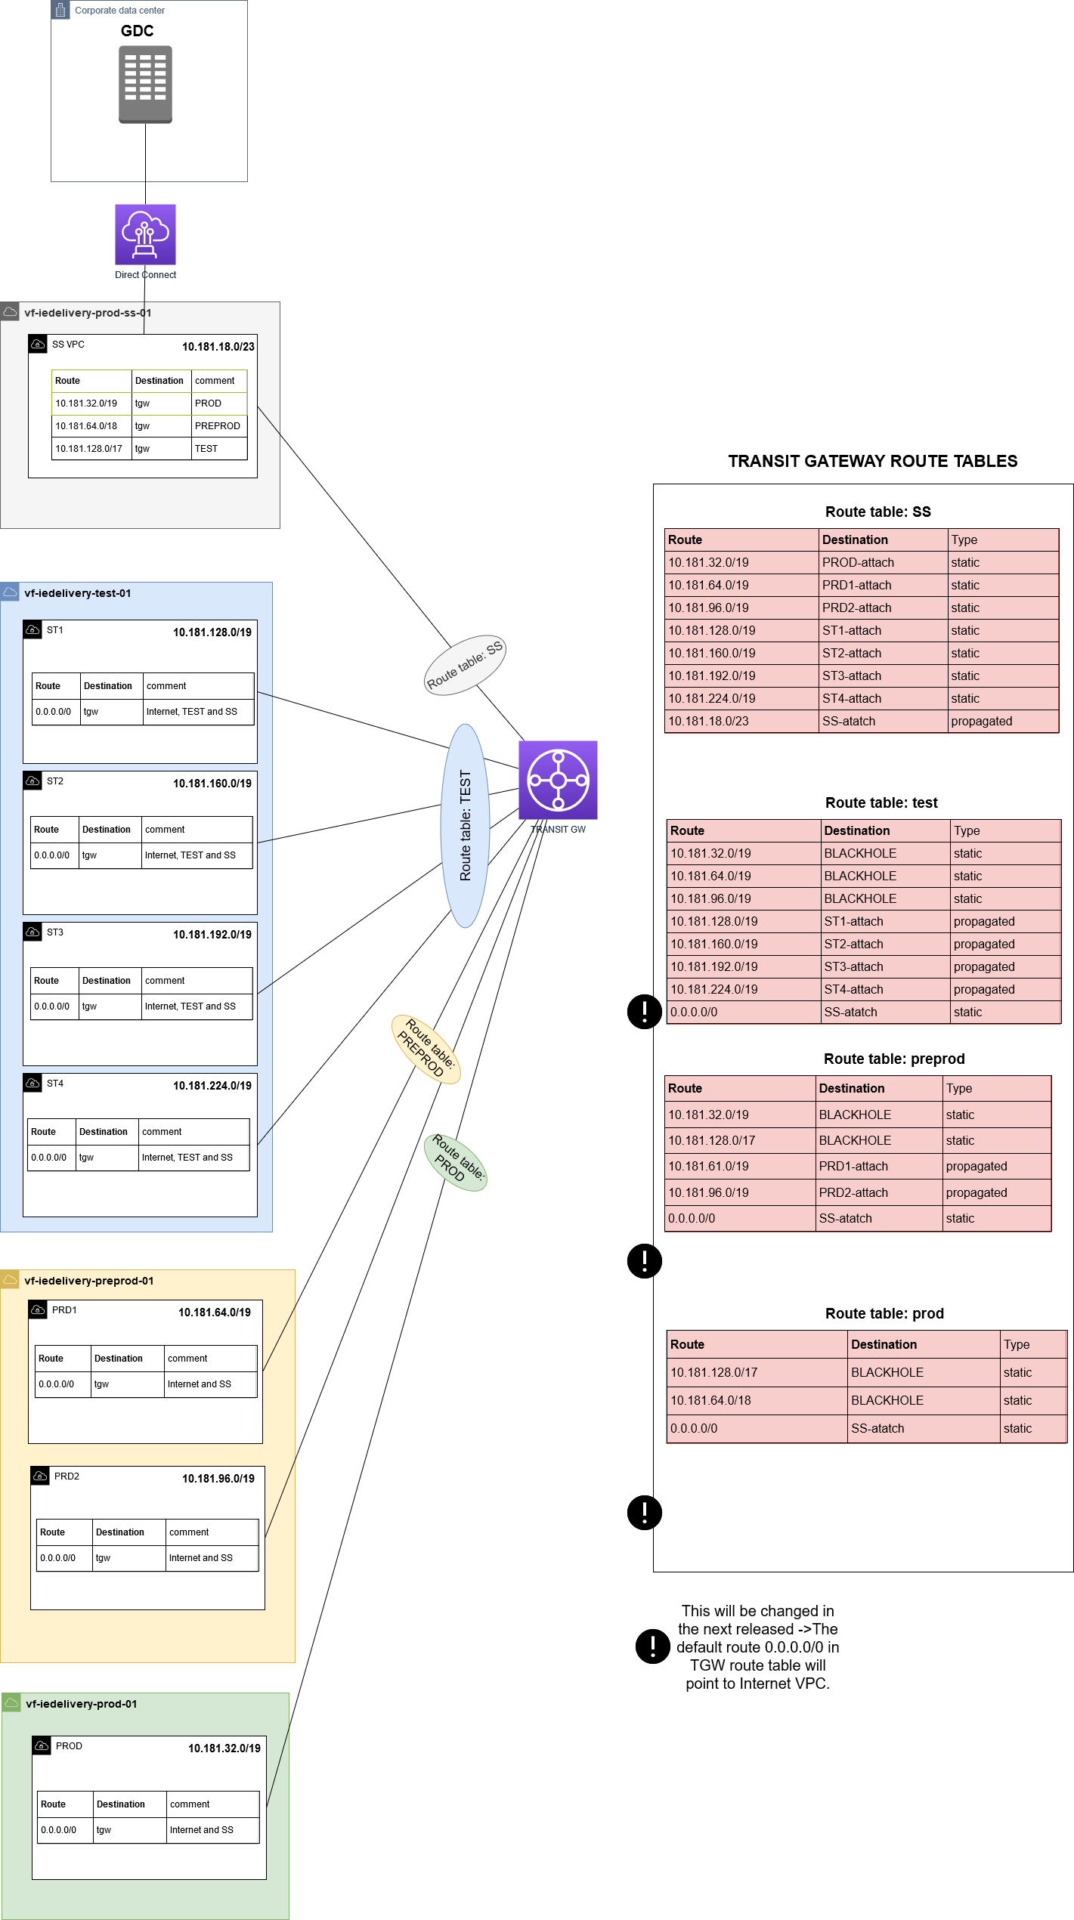

#### 3. TGW implementation

##### 3.1 TGW resources

The transit gw infrastructure is defined in the file called transitgw.tf, and these are the resources created:

* aws_ec2_transit_gateway: created in ss account, without a default route table and with auto_accept_shared_attachments, vpn_ecmp_support and dns_support enabled.
* aws_ram_resource_share, aws_ram_resource_association and aws_ram_principal_association: created in ss account to share transit gw with other accounts.
* aws_ec2_transit_gateway_vpc_attachment: created in each account depending on the vpc. A corresponding vpc accepter is creating while the invitation for the shared resource Is pending.
* aws_ec2_transit_gateway_route_table: created in ss account.
* aws_ec2_transit_gateway_route_table_association and aws_ec2_transit_gateway_route_table_propagation: created in ss account.
* aws_ec2_transit_gateway_route: created in ss account.
* aws_route: created in each account, modifying the VPC route tables of the target vpc.

##### 3.2 TGW configuration

The variables used to customized the TGW implementation for VFIE has been declared in a file called "variables.tf", in the root folder (repository). The values for the desired configuration are defined in the config file called "PROD.tfvars", stored under the folder "vars". Basically, we are specifying the "vpc-id" for each vpc that we want to associate with the transit gw, the subnets from that vpc where the tgw eni is going to be placed (1 subnet / AZ) and the cird of the vpc. A different variable has been created for test, pre-prod, prod and ss. The principals to associate with the resource share (TGW) are defined in the variable called ram_principals (test account, pre-prod account and prod account).

**test_vpc_attachments** = {  
      "st1" = {  
            "vpc_id"         = "vpc-01a98bfaa291c8f7d"    
            "subnet_ids"     =  ["subnet-00dbd23fbcf0348c0","subnet-03951db996dd1e623"]  
            "cidr"           = "10.181.128.0/19"  
      },  
      "st2" = {  
            "vpc_id"         = "vpc-0270246dc82c513fc"    
            "subnet_ids"     =  ["subnet-0bc39ff0595463183","subnet-063adc8e44098bebe"]  
            "cidr"           = "10.181.160.0/19"  
      },  
      "st3" = {  
            "vpc_id"         = "vpc-07bf6d07ae85e68ee"    
            "subnet_ids"     =  ["subnet-053aab44cdffdbf78","subnet-0e716209201476ebb"]  
            "cidr"           = "10.181.192.0/19"  
      },  
      "st4" = {  
            "vpc_id"         = "vpc-070981e1316c4795f"    
            "subnet_ids"     =  ["subnet-0e89dcb4921397833","subnet-0be50912ce6807467"]  
            "cidr"           = "10.181.224.0/19"  
      }  
       
}

**preprod_vpc_attachments** = {  
      "prd1" = {  
            "vpc_id"         = "vpc-005d0af4e9a26cf3d"    
            "subnet_ids"     =  ["subnet-073128e09985a2702","subnet-035edcb630e7407f0"]  
            "cidr"           = "10.181.64.0/19"  
      },  
      "prd2" = {  
            "vpc_id"         = "vpc-0c64b9096fe8d7ef3"    
            "subnet_ids"     =  ["subnet-04aa54593c7cf4f21","subnet-02d672f19551a8c59"]  
            "cidr"           = "10.181.96.0/19"  
      }

}

**prod_vpc_attachments** = {  
      "prod" = {  
            "vpc_id"         = "vpc-0b2285ee1e4c38bae"    
            "subnet_ids"     =  ["subnet-04769a1c07c576288","subnet-03b0e53501550bd92"]  
            "cidr"           = "10.181.32.0/19"  
      }  
}

**ss_vpc_attachments** = {  
      "vpc_id"         = "vpc-0bc5e297e4fd20219"    
      "subnet_ids"     =  ["subnet-0f592101bf294734d","subnet-0c77421364cb58f2d"]  
}

**ram_principals** = ["046978237480", "612841682649", "323874256692"]

#### 4. TGW: How to add a new VPC to the implementation

The deployment of the TGW has been accomplished in 2 releases:

1. **RELEASE 1.** SS VPC and TEST VPC's configuration
2. **RELEASE 2.** PRE-PROD abd PROD VPC'S configuration

This section explains the process of the second release to repeat it if any new environment/vpc needs to be added.

##### 4.1 New AWS account

If the new vpc(s) is in a different aws account than the ones that already are defined, the variable "**ram_principals**" needs to be modified.

For release 1. **ram_principals** = ["046978237480"]

For release 2. Adding pre-prod and prod aws accounts. **ram_principals** = ["046978237480","612841682649", "323874256692"]

##### 4.2 New VPC

If it is a new environment (one or more new vpc's to be associated with TGW), create a new variable for the information required to create the vpc attachments.

For release 2, **preprod_vpc_attachments** and **prod_vpc_attachments** were created, with the vpc's details (vpc id, vpc cidr, vpc subnets id).

If the vpc that is going to be added belongs to an environment with this variable (for example, a new prod vpc), then the corresponding variable needs to be updated (for example, prod_vpc_attachments).

##### 4.3 New AWS provider

If the new vpc(s) is in a different aws account than the ones that already are defined, a new aws provider needs to be defined in the file "providers.tf". Different aws providers are needed because there will be resources (tgw vpc attachments, route in vpc route tables) created in those accounts. The pipeline created to implement the TGW infrastructure will assume the role vf-iedelivery-ci-cd-deploy-role in each account when needed.

For release 1.

provider "aws" {   **alias = "SS"**   region = "eu-west-1"   assume_role {     role_arn = "arn:aws:iam::267040142128:role/vf-iedelivery-ci-cd-deploy-role"   } }

provider "aws" {   **alias = "test"**   region = "eu-west-1"   assume_role {     role_arn = "arn:aws:iam::046978237480:role/vf-iedelivery-ci-cd-deploy-role"   } }

For release 2.

provider "aws" {   **alias = "preprod"**   region = "eu-west-1"   assume_role {     role_arn = "arn:aws:iam::612841682649:role/vf-iedelivery-ci-cd-deploy-role"   } }

provider "aws" {   **alias = "prod"**   region = "eu-west-1"   assume_role {     role_arn = "arn:aws:iam::323874256692:role/vf-iedelivery-ci-cd-deploy-role"   } }

##### 4.4 New VPC attachment(s) and VPC accepter

A new TGW VPC attachment (aws_ec2_transit_gateway_vpc_attachment) will be created in the account where the new vpc belongs. Until the VPC attachment status is available, an aws_ec2_transit_gateway_vpc_attachment_accepter is needed in the TGW account (SS account).

For Release 2. Example for pre-prod (same logic for prod):

**resource "aws_ec2_transit_gateway_vpc_attachment" "preprod_vpc_attachment**" {  
  provider = "aws.preprod"  
  depends_on = ["aws_ram_principal_association.ram_principal", "aws_ram_resource_association.ram_assoc"]  
  for_each = var.preprod_vpc_attachments  
  transit_gateway_id = aws_ec2_transit_gateway.transit_gw.id  
  vpc_id             = each.value["vpc_id"]  
  subnet_ids         = each.value["subnet_ids"]

  transit_gateway_default_route_table_association = false  
  transit_gateway_default_route_table_propagation = false

  tags = merge(  
    local.common_tags,  
    {  
      "Purpose" = "EC2 Transit Gateway attachment to preprod vf ie vpc's "  
      "Name"    = join("-",[each.key,"VFIE-Transit-GW-pre-prod-vpc-attachment", each.value["vpc_id"]])  
    },  
  )  
}

**resource "aws_ec2_transit_gateway_vpc_attachment_accepter" "preprod_vpc_accepter" {**  
  provider = "aws.SS"  
  for_each = var.preprod_vpc_attachments  
  transit_gateway_attachment_id = aws_ec2_transit_gateway_vpc_attachment.preprod_vpc_attachment[each.key].id  
  
 tags = merge(  
    local.common_tags,  
    {  
      "Purpose" = "EC2 Transit Gateway attachment to preprod vf ie vpc's "  
      "Name"    = join("-",[each.key,"VFIE-Transit-GW-pre-prod-vpc-attachment", each.key, each.value["vpc_id"]])  
    },  
  )  
}

##### 4.5 TGW Route table

In the design that we are following for VFIE we decided to create one TGW route table per environment (one for test, one for pre-prod and one for prod). If a new environment is added, then a new route table has to be created.

In release 2, prod TGW route table and pre-prod TGW route table were created. Example for pre-prod:

resource **"aws_ec2_transit_gateway_route_table" "transit_gw_route_table_preprod_vpc"** {  
  provider = "aws.SS"  
  transit_gateway_id = aws_ec2_transit_gateway.transit_gw.id

  tags = merge(  
    local.common_tags,  
    {  
      "Purpose" = "EC2 Transit Gateway Route Table associated to VF IE VPC's preprod"  
      "Name"    = "VFIE-Transit-GW-PRE-PROD-Route-Table-vpc"  
    },  
  )  
}

##### 4.6 TGW Route table association and propagation

In both cases where either a new environment is going to be associated to TGW, or a new vpc, a TGW route table association has to be created. This association will link the vpc and the TGW route table. In case we want the vpc to propagate its cidr to the TGW, a TGW route table propagation has to be created.

In release 2, association and prograpation between pre-prod and prod route tables and pre-prod and prod vpc's were created. This is an example for pre-prod:

resource "**aws_ec2_transit_gateway_route_table_association" "preprod_vpc_route_table_association"** {  
  provider = "aws.SS"  
  for_each = var.preprod_vpc_attachments

  transit_gateway_attachment_id  = aws_ec2_transit_gateway_vpc_attachment.preprod_vpc_attachment[each.key].id  
  transit_gateway_route_table_id = aws_ec2_transit_gateway_route_table.transit_gw_route_table_preprod_vpc.id  
}

resource **"aws_ec2_transit_gateway_route_table_propagation" "preprod_vpc_route_table_propagation"** {  
  provider = "aws.SS"  
  for_each = var.preprod_vpc_attachments  
  transit_gateway_attachment_id  = aws_ec2_transit_gateway_vpc_attachment.preprod_vpc_attachment[each.key].id  
  transit_gateway_route_table_id = aws_ec2_transit_gateway_route_table.transit_gw_route_table_preprod_vpc.id  
}

##### 4.7 VPC route tables

All subnets inside the target vpc will need a route to the TGW. To do that, a new route that points to the TGW needs to be added. For VFIE, this route will be the default one in the environment vpc's. In addition, if a new environment is added, in SS a new route to the cidr for that environment will have to be added.

This is the logic for pre-prod:

data **"aws_route_tables" "rts_prd1"** {  
  provider = "aws.preprod"  
  vpc_id = var.preprod_vpc_attachments["prd1"].vpc_id  
}

data **"aws_route_tables" "rts_prd2"** {  
  provider = "aws.preprod"  
  vpc_id = var.preprod_vpc_attachments["prd2"].vpc_id  
}

locals {                                                              
..  
  aws_route_table_prd2_list = **tolist**(data.aws_route_tables.rts_prd2.ids)  
  aws_route_table_prod_list = **tolist**(data.aws_route_tables.rts_prod.ids)  
...  
}

resource "**aws_route" "preprod_vpc_route_prd1**" {  
  provider = "aws.preprod"  
  depends_on = ["aws_ram_principal_association.ram_principal", "aws_ram_resource_association.ram_assoc"]  
  count = length(local.aws_route_table_prd1_list)  
  route_table_id            = element(local.aws_route_table_prd1_list, count.index)  
  destination_cidr_block    = "0.0.0.0/0"  
  transit_gateway_id        = aws_ec2_transit_gateway.transit_gw.id  
}

resource "**aws_route" "preprod_vpc_route_prd2**" {  
  provider = "aws.preprod"  
  depends_on = ["aws_ram_principal_association.ram_principal", "aws_ram_resource_association.ram_assoc"]  
  count = length(local.aws_route_table_prd2_list)  
  route_table_id            = element(local.aws_route_table_prd2_list, count.index)  
  destination_cidr_block    = "0.0.0.0/0"  
  transit_gateway_id        = aws_ec2_transit_gateway.transit_gw.id  
}

##### 4.8 TGW INVITATION

There is one manual step for the TGW configuration, and it is accepting the TGW as a shared resource. When this is done, the TGW VPC attachments will be created in the account that has accepted the invitation, and once those attachments are available, the TGW VPC accepter can be deleted in SS account.

For release 2.

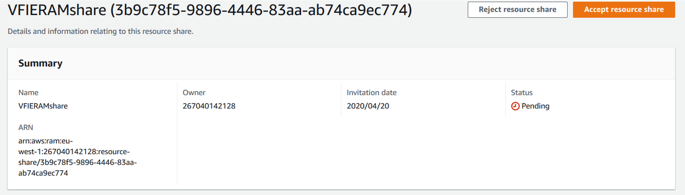

## 01 VF IE SHARED SERVICES VPC

### 

* 1. INTRODUCTION
* 2. DESIGN
* 3. CONFIGURATION AND IMPLEMENTATION
* 4. DNS
* 5. NLB

### 1. INTRODUCTION

The Shared Services VPC will be the connectivity point between GDC datacenter and VFIE AWS. This VPC is created in the SS account for vf ie (vf-iedelivery-prod-ss-01 - 267040142128). The code has been created in terraform, and it is stored in codecommit, in the management account for VFIE (vf-iedelivery-mgmt -  831341508773). This is the codecommit repository: <https://git-codecommit.eu-west-1.amazonaws.com/v1/repos/vf-iedelivery-sharedservices-vpc>

### 2. DESIGN

The VPC design uses the CIDR IP Address range given by GDC and associated with this project:

* AZ1 - Dublin:Test Presentation (T-P):60:: 198.19.220.128/26
* AZ2 - Dublin:Test Presentation (T-P):60:: 198.19.220.192/26
* AZ1 - Dublin:Internal Presentation & Application combined (I-A):60:: 198.19.220.0/26
* AZ2 - Dublin:Internal Presentation & Application combined (I-A):60:: 198.19.220.64/26
* AZ1 - Dublin:Management Systems Zone (M2):16:: 46.108.156.0/28
* AZ2 - Dublin:Management Systems Zone (M2):16:: 46.108.156.16/28

This VPC will be composed of the following subnets:

* IA subnets for PROD and PRE-PROD traffic.
* TP subnets for TEST traffic.
* M2 subnets for MGMT traffic (tbc more details).
* Private subnets for other purposes, as ENI created by AWS TGW or SSM endpoints.

PROD:

["198.19.220.0/27", "198.19.220.64/27"]

PRE-PROD:

["198.19.220.32/27", "198.19.220.96/27"]

The main idea is to use one NLB per tenant (customer requirement for achieving simplicity and port mapping), where the tenants are: SIT1, SIT2, SIT3 and SIT4 as test tenants; PRD1 and PRD2 as pre-prod tenants; and PROD as prod tenant.  The listener of each NLB will depends on the communications we want to allow between each aws tenant and gdc. A list of ports will be added as an input parameter to a terraform module, in order to create the corresponding NLB listeners and NLB target groups (per port). TPC will be the protocol used. The NLB target will be associated with an AutoScaling group, that will manage the HAproxy infrastructure. See below the diagram:

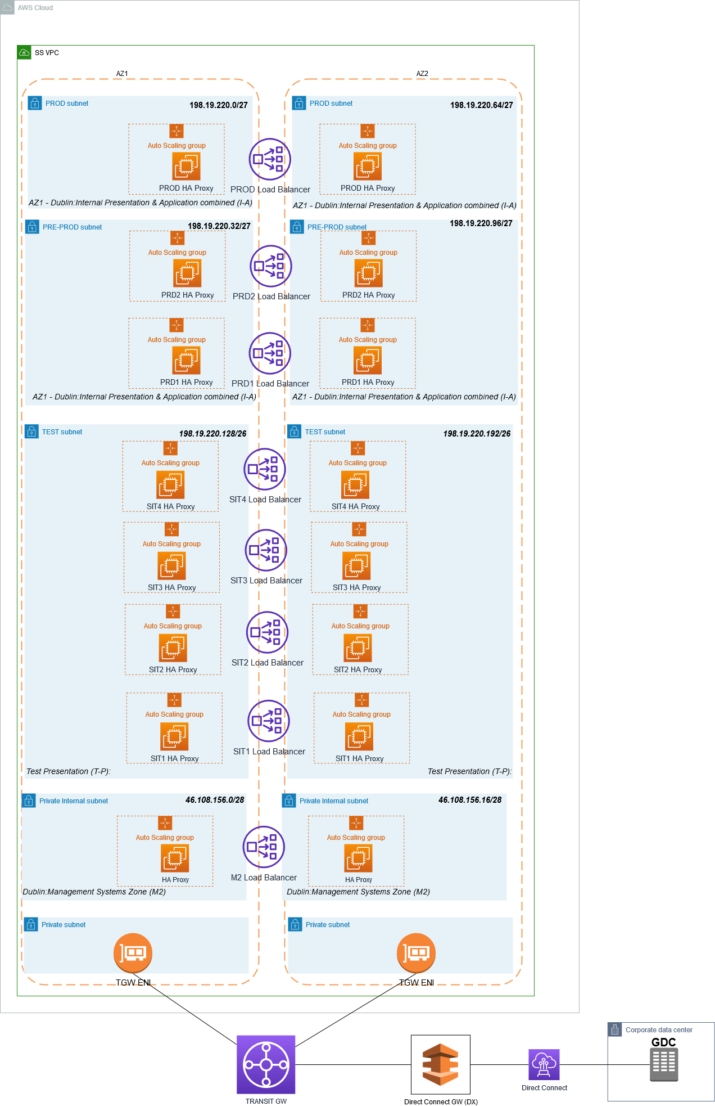

### 3. CONFIGURATION AND IMPLEMENTATION

See here

### 4. DNS

See here

### 5. NLB

There are at the moment 3 NLB created: one for prod, one for prd1 and one for prd2.

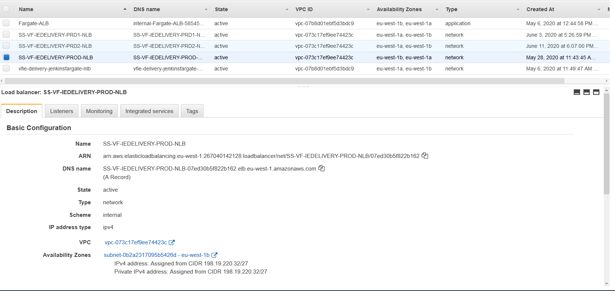

These are the aws nlb domain names:

* [SS-VF-IEDELIVERY-PROD-NLB-07ed30b5f822b162.elb.eu-west-1.amazonaws.com](http://SS-VF-IEDELIVERY-PROD-NLB-07ed30b5f822b162.elb.eu-west-1.amazonaws.com)
* [SS-VF-IEDELIVERY-PRD2-NLB-0896a285b4124ae4.elb.eu-west-1.amazonaws.com](http://SS-VF-IEDELIVERY-PRD2-NLB-0896a285b4124ae4.elb.eu-west-1.amazonaws.com)
* [SS-VF-IEDELIVERY-PRD1-NLB-fff2438b7fa415c1.elb.eu-west-1.amazonaws.com](http://SS-VF-IEDELIVERY-PRD1-NLB-fff2438b7fa415c1.elb.eu-west-1.amazonaws.com)

For each nlb, we will create an ALIAS record:

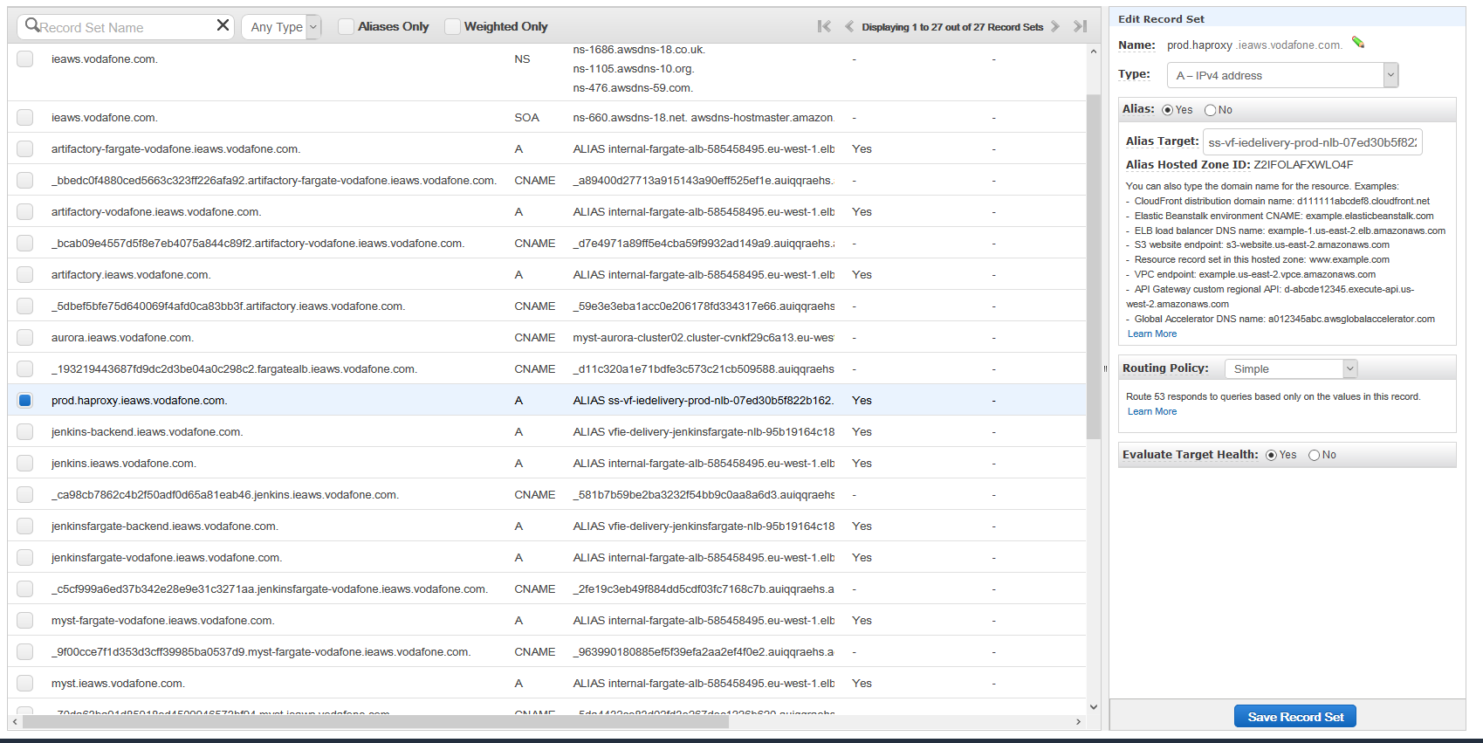

### HAPROXY AMI

#### We will need to install HAproxy software in the ec2 instances that we are going to use. Because the SS VPC does not have internet access, we will create a customized AMI for HAPROXY using AWS IMAGE BUILDER.

The resources needed for AWS IMAGE BUILDER have been created using CloudFormation, as this is a new service in AWS, and terraform does not offer it yet. However, terraform will manage that CF stack. In the same CF Stack we will be creating also the resources for the OFMW domains used in this project, this is out of scope for this documentation.

#### 1. AWS IMAGE BUILDER

Documentation:

* <https://docs.aws.amazon.com/imagebuilder/latest/userguide/image-builder-accessing-prereq.html>
* <https://docs.aws.amazon.com/imagebuilder/latest/userguide/image-builder-setting-up.html>
* <https://docs.aws.amazon.com/imagebuilder/latest/userguide/image-builder-image-deployment-console.html>
* <https://docs.aws.amazon.com/imagebuilder/latest/userguide/what-is-image-builder.html>

##### Image pipeline

An image pipeline is the automation configuration for building secure OS images on AWS. The Image Builder image pipeline is associated with an image recipe that defines the build, validation, and test phases for an image build lifecycle. An image pipeline can be associated with an infrastructure configuration that defines where your image is built. You can define attributes, such as instance type, subnets, security groups, logging, and other infrastructure-related configurations. You can also associate your image pipeline with a distribution configuration to define how you would like to deploy your image.

##### Image recipe

An Image Builder image recipe is a document that defines the source image and the components to be applied to the source image to produce the desired configuration for the output image. You can use an image recipe to duplicate builds. Image Builder image recipes can be shared, branched, and edited using the console wizard, the AWS CLI, or the API. You can use image recipes with your version control software to maintain shareable versioned image recipes.

##### Source image

The source image is the selected image and OS used in your image recipe document along with the components. The source image and the component definitions combined produce the desired configuration for the output image.

##### Build components

Build components are orchestration documents that define a sequence of steps for downloading, installing, and configuring software packages. They also define validation and security hardening steps. A component is defined using a YAML document format (as described in the following Document entry).

##### Test components

Test components are orchestration documents that define tests to run on software packages. A component is defined using a YAML document format (see the following definition for Document).

##### Document

A declarative document that uses the YAML format to list the execution steps for build, validation, and test of an AMI on an instance. The document is input to a configuration management application, which runs locally on an Amazon EC2 instance to execute the document steps.

These are the **steps** to follow:

1. Select source image. You select a source OS image, for example, an existing AMI.
2. Create image recipe. You      add components to create an image recipe for your image pipeline.      Components are the building blocks that are consumed by an image recipe,      for example, packages for installation, security hardening steps, and      tests. The selected OS and components make up an image recipe. Components      are installed in the order in which they are specified and cannot be      reordered after selection.
3. Output. Image      Builder creates an OS image in the selected output format.
4. Distribute. You distribute your image to selected AWS Regions after it      passes tests in the image pipeline.

The images that you build from the golden image are in your AWS account. You can configure your image pipeline to produce updated and patched versions of your AMI by entering a build schedule. When the build is complete, you can receive notification via [Amazon Simple Notification Service (SNS)](https://docs.aws.amazon.com/sns/latest/dg/welcome.html). In addition to producing a final image, Image Builder generates an image recipe that can be used with existing version control systems and continuous integration/continuous deployment (CI/CD) pipelines for repeatable automation. You can share and create new versions of your image recipe.

##### PRE-REQUISITES

he following prerequisites must be verified in order to create an image pipeline with EC2 Image Builder.

###### EC2 Image Builder service-linked role

 EC2 Image Builder uses a service-linked role to grant permissions to other AWS services on your behalf. You don't need to manually create a service-linked role. When you create your first Image Builder resource in the AWS Management Console, the AWS CLI, or the AWS API, Image Builder creates the service-linked role for you. For more information about the service-linked role that Image Builder creates in your account, see [Using service-linked roles for EC2 Image Builder](https://docs.aws.amazon.com/imagebuilder/latest/userguide/image-builder-service-linked-role.html).

###### Auto Scaling groups

EC2 Image Builder uses Auto Scaling groups to launch instances during the build and test phases of the image pipeline. When you use Amazon EC2 Auto Scaling, a required service-linked role is created in your account. If this role is not present in your account when you use Image Builder, the Image Builder service-linked role will create if for you.

###### Configuration requirements

* EC2 Image Builder does not      support encrypted AMIs as the source for or output image of a pipeline.
* You must specify a VPC in the      infrastructure configuration. Image Builder does not support EC2-Classic.
* Image Builder does not      support Amazon VPC endpoints (PrivateLink).
* Instances used to build      images and run tests using Image Builder must have access to the Systems      Manager service. All build activity is orchestrated by SSM Automation. The      SSM Agent will be installed on the source image if it is not already      present, and it will be removed before the image is created.

###### AWS Identity and Access Management (IAM)

The IAM role that you associate with your instance profile must have permissions to run the build and test components included in your image. The following IAM role policies must be attached to the IAM role that is associated with the instance profile: EC2InstanceProfileForImageBuilder and AmazonSSMManagedInstanceCore.

If you configure logging, the instance profile specified in your infrastructure configuration must have s3:PutObject permissions for the target bucket (arn:aws:s3:::BucketName/*).

Select an IAM role to associate with the instance profile or Create a new role. If you create a new role, Image Builder will take you to the IAM console. As a starting point, use the following IAM role policies (you must attach both policies): EC2InstanceProfileForImageBuilder and AmazonSSMManagedInstanceCore.

#### 2. CLOUDFORMATION STACK

The code is stored under the repository "vf-iedelivery-centralized-internet", as we need to have internet access. The stackset is defined in terraform in the file "5-imagebuilder.tf", and the cloudformation code is in the file "5-imagebuilder-stack-template.yml". TO-DO: automate the parameters that are given to the stackset.

First of all, we upload the ssm document that we will be using to create haproxy ami in a S3 bucket:

|  |
| --- |
| #uploading files to s3 bucket  resource "aws_s3_bucket_object" "HAPROXY-SSM-DOCUMENT" {    bucket = "vf-iedelivery-centralized-internet-vpc-267040142128-123456"    key    = "haproxy-ssm.yml"    source = "${path.module}/ssm-documents/haproxy.yml"    etag = "${filemd5("${path.module}/ssm-documents/haproxy.yml")}" #triggered changes  } |

##### SSM DOCUMENT

* Under Build:
  + Install haproxy service - AWS package just provide the version 1.5
  + Update haproxy version from 1.5 to 1.7, as we need to allow a dns feature. This feature will avoid the default behaviour of haporxy where the services fails if haproxy cannot resolve any of the defined backends. Documentation followed:   <https://forums.aws.amazon.com/thread.jspa?threadID=225532> and

<https://www.liulangmao.org/?p=5550>.

* + Start and enable service
  + Logs: HAProxy will emit log message for processing by a **syslog** server (documentation [here](https://www.haproxy.com/blog/introduction-to-haproxy-logging/)).

|  |
| --- |
| name: haproxy-1.0.1  description: Image for haproxy-1.0.1  schemaVersion: 1.0  phases:    - name: build      steps:        - name: InstallPackages          action: ExecuteBash          inputs:            commands:              - yum install -y haproxy        - name: UpdateHAproxyVersion          action: ExecuteBash          inputs:            commands:              - yum info haproxy              - yum install gcc pcre-static pcre-devel openssl-devel -y              - wget https://www.haproxy.org/download/1.7/src/haproxy-1.7.12.tar.gz              - tar xzvf haproxy-1.7.12.tar.gz              - cd haproxy-1.7.12              - make TARGET=linux2628 USE_PCRE=1 USE_OPENSSL=1 USE_ZLIB=1 USE_CRYPT_H=1 USE_LIBCRYPT=1              - make install              - cp /usr/local/sbin/haproxy /usr/sbin/              - cp examples/haproxy.init /etc/init.d/haproxy              - chmod 755 /etc/init.d/haproxy        - name: EnableAndStart          action: ExecuteBash          inputs:            commands:              - systemctl enable haproxy              - systemctl start haproxy || service haproxy start        - name: Logs          action: ExecuteBash          inputs:            commands:              - touch /etc/rsyslog.d/haproxy.conf              - chmod 777 /etc/rsyslog.d/haproxy.conf              - cat > /etc/rsyslog.d/haproxy.conf << 'EOF'              - |                # Collect log with UDP                $ModLoad imudp                $UDPServerAddress 127.0.0.1                $UDPServerRun 514                # Creating separate log files based on the severity                local0.* /var/log/haproxy-traffic.log                local0.notice /var/log/haproxy-admin.log                EOF              - systemctl restart rsyslog    - name: update      steps:        - name: UpdateSoftware          action: ExecuteBash          inputs:            commands:              - yum udpate |

##### CF STACK definition in terraform.

TODO: add parameters to stackset.

|  |
| --- |
| resource "aws_cloudformation_stack" "image_builder_stack" {    depends_on = [aws_s3_bucket_object.OFMW-1213-SSM-DOCUMENT, aws_s3_bucket_object.OFMW-1221-SSM-DOCUMENT, aws_s3_bucket_object.HAPROXY-SSM-DOCUMENT, aws_s3_bucket_object.OFMW-BASE-SSM-DOCUMENT ]    name = "${var.VPC_NAME}-${var.PROJECT}-Image-Builder-Stack-${var.ENV}"    #iam_role_arn = "arn:aws:iam::267040142128:role/DevOps"    #parameters = {      #OFMW1213DOCUMENT = "https://vf-iedelivery-centralized-internet-vpc-267040142128-123456.s3-eu-west-1.amazonaws.com/OFMW_1213.yml"      #}    template_body = "${file("${path.module}/5-imagebuilder-stack-template.yml")}"    capabilities = ["CAPABILITY_IAM",]    tags = merge(      local.common_tags,      {        "Purpose" = "Cloudformation stack for transparent proxies in Internet VPC"      },    )  } |

##### CLOUDFORMATION CODE

Each time the ssm document changed, the version of ImageComponenthaproxy and ImageRecipehaproxy need to be updated. TODO: automate this.

|  |
| --- |
| AWSTemplateFormatVersion: '2010-09-09'  Description: 'VFIE delivery Image Builder'  Parameters:   ...    haproxyDOCUMENT:      Type: String      Description: Uri of SSM document for haproxy uploaded to S3 bucket      Default: "s3://vf-iedelivery-centralized-internet-vpc-267040142128-123456/haproxy-ssm.yml"    SubnetId:      Type: String      Description: Public Subnet ID for the ec2 instance that is created by image builder      Default: "subnet-09a0b331473b23229"    SecurityGroupId:      Type: String      Description: SSM Security group ID      Default: "sg-064be9eac2ccd002c"    InstanceProfileName:      Type: String      Description: Instance profile to associate with the ec2 instance that is created by image builder      Default: "SSM-EC2-CENTRALIZED-INTERNET-IAM-INSTANCE-PROFILE-vfie-delivery-PROD"    AMIid:      Type: String      Description: parent AMI Id for OFMW      Default: "ami-05b44559c008e9b05"    HAProxyAMIid:      Type: String      Description: parent AMI Id for HAPROXY      Default: "ami-01726b7eb435f48b5"  Resources:     ...    ###########HAPROXY    SNSTopichaproxy:      Type: AWS::SNS::Topic      Properties:        Subscription:          - Endpoint: "albamaria.diazfernandez@vodafone.com"            Protocol: "email"        TopicName: "VFIEdelivery-AMI-haproxy"  ImageComponenthaproxy:      Type: AWS::ImageBuilder::Component      Properties:        ChangeDescription: 'fifth version'        Description: 'VFIE delivery haproxy SSM DOCUMENT'        Name: 'VFIE-DELIVERY-haproxy-BUILD'        Platform: 'Linux'        Version: '1.0.5'        Uri: !Ref haproxyDOCUMENT        ImageRecipehaproxy:      Type: AWS::ImageBuilder::ImageRecipe      Properties:        Components:          - ComponentArn: !GetAtt ImageComponenthaproxy.Arn        Description: 'VFIE delivery Image recipe'        Name: 'VFIE-DELIVERY-haproxy'        ParentImage: !Ref HAProxyAMIid        Version: '1.0.5'      ImagePipelinehaproxy:      Type: AWS::ImageBuilder::ImagePipeline      Properties:        Description: 'VFIE delivery haproxy Image pipeline'        #DistributionConfigurationArn: String        ImageRecipeArn: !GetAtt ImageRecipehaproxy.Arn        #ImageTestsConfiguration:        #  ImageTestsConfiguration        InfrastructureConfigurationArn: !GetAtt ImageInfraConfighaproxy.Arn        Name: 'VFIE-DELIVERY-haproxy'        #Schedule:        #  Schedule        Status: 'ENABLED'        #Tags:        #  Key : Value      ImageInfraConfighaproxy:      Type: AWS::ImageBuilder::InfrastructureConfiguration      Properties:        Description: 'VFIE delivery Image haproxy infrastructure config'        InstanceProfileName: !Ref InstanceProfileName        InstanceTypes:          - 't2.medium'        #KeyPair: String        Logging:          S3Logs:            S3BucketName: 's3-access-logs-vf-iedelivery-267040142128-logs'            S3KeyPrefix: 'haproxylogs'        Name: 'VFIE-DELIVERY-haproxy-IMAGE-INFRA'        SecurityGroupIds:          - !Ref SecurityGroupId          - sg-0b85489e5b93501d8        SnsTopicArn: !Ref SNSTopichaproxy        SubnetId: !Ref SubnetId        #Tags:        #  Key : Value        #TerminateInstanceOnFailure: Boolean    Imagehaproxy:      Type: AWS::ImageBuilder::Image      Properties:        ImageRecipeArn: !GetAtt ImageRecipehaproxy.Arn        InfrastructureConfigurationArn: !GetAtt ImageInfraConfighaproxy.Arn        Tags:          Name : "Image-haproxy"    Outputs:  ...    Imagehaproxyarn:      Description: The ARN of the created AMI for haproxy      Value: !Ref Imagehaproxy |

### HAPROXY CONFIG AUTOMATION

* CONFIGURATION
  + Config Variable
  + Config File
  + RESULT
* S3 SYNCHRONIZATION
  + LAMBDA CODE
  + CLOUDWATCH EVENT RULE
  + RESULTS

This section describes the automation provided by PCS to ensure that the HAPROXY will always have the latest configuration. The config file is created by terraform. Because of the complexity of this project and its network design, variables as a single source of truth are used. Each environment will have its own variable for defining the haproxy config. The variable type is a dictionary, with as many objects as ports the haproxy is listening to. Each port configuration has the following attributes: whitelist, port and server.

#### CONFIGURATION

The terraform code is stored in the repository "vf-iedelivery-sharedservices-vpc" in vfie mgmt. account:<https://eu-west-1.console.aws.amazon.com/codesuite/codecommit/repositories/vf-iedelivery-sharedservices-vpc/browse?region=eu-west-1>

##### Config Variable

In the root directory, we can see the variables declared:

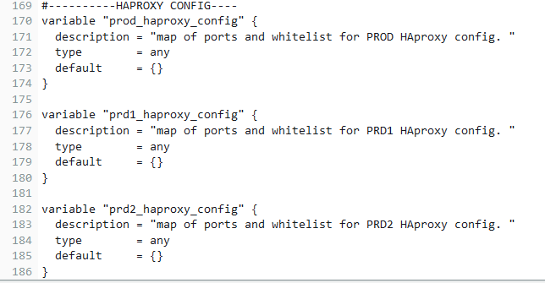

Under the [folder vars](https://eu-west-1.console.aws.amazon.com/codesuite/codecommit/repositories/vf-iedelivery-sharedservices-vpc/browse/refs/heads/master/--/vars?region=eu-west-1) we can see the file PROD.tfvar with the values of haproxy_config variables. Here it's the example for prd2:

|  |
| --- |
| prd2_haproxy_config = {        "aws-1" = {              "port"         =   15101,              "whitelist"     =  "10.181.96.0/19",              "server"       = "esb.app.prd2.equinox.vf-ie.internal.vodafone.com:32007"        },        "aws-2" = {              "port"         =   12101,              "whitelist"     =  "10.181.96.0/19",              "server"       = "meh.prd1.equinox.vf-ie.internal.vodafone.com:22"        },        "aws-3" = {              "port"         =   12103,              "whitelist"     =  "10.181.96.0/19",              "server"       = "meh.prd1.equinox.vf-ie.internal.vodafone.com:16443"        },        "aws-4" = {              "port"         =   22102,              "whitelist"     =  "10.181.96.0/19",              "server"       = "iebpoihr-vip.dc-dublin.de:33001"        },        "aws-5" = {              "port"         =   22103,              "whitelist"     =  "10.181.96.0/19",              "server"       = "iebpojhr-vip.dc-dublin.de:33001"        },        "aws-6" = {              "port"         =   22104,              "whitelist"     =  "10.181.96.0/19",              "server"       = "iebpokhr-vip.dc-dublin.de:33001"        },        "gdc-1" = {              "port"         =   7001,              "whitelist"     =  "37.25.160.19/32 10.74.120.112/28",              "server"       = "cch-sal-alb.prd2.ieaws.vodafone.com:7001"        },        "gdc-2" = {              "port"         =   8011,              "whitelist"     =  "10.109.100.98/32 10.109.100.99/32 10.109.100.184/32 10.109.100.185/32 10.109.100.133/32 10.109.100.134/32 10.109.100.182/32 10.109.100.183/32 10.109.100.142/32 10.109.100.143/32 10.109.100.144/32 10.109.100.145/32 10.109.100.146/32 10.109.100.147/32 10.109.100.148/32 10.109.100.36/32 10.109.100.37/32 37.25.160.19/32",              "server"       = "cch-sal-alb.prd2.ieaws.vodafone.com:8011"        },        "gdc-3" = {              "port"         =    5500,              "whitelist"     =  "37.25.160.19/32 10.74.120.112/28",              "server"       = "cch-sal-alb.prd2.ieaws.vodafone.com:5500"        },        "gdc-4" = {              "port"         =   5501,              "whitelist"     =  "37.25.160.19/32 10.74.120.112/28",              "server"       = "cch-sal-alb.prd2.ieaws.vodafone.com:5501"        },        "gdc-5" = {              "port"         =   10120,              "whitelist"     =  "198.18.65.3/32 198.18.65.4/32 198.18.65.5/32 198.18.65.6/32 198.18.74.200/32 198.18.74.219/32 10.109.100.184/32 10.109.100.185/32 10.109.100.133/32 10.109.100.134/32 10.109.100.182/32 10.109.100.183/32 10.109.100.142/32 10.109.100.143/32 10.109.100.144/32 10.109.100.145/32 10.109.100.146/32 10.109.100.147/32 10.109.100.148/32 10.109.100.36/32 10.109.100.37/32 10.109.100.118/32 10.109.100.119/32 198.18.65.31/32 37.25.160.19/32",              "server"       = "cch-sal-sftp.prd2.ieaws.vodafone.com:22"        }  } |

##### Config File

The config file is defined inside the haproxy module: <https://eu-west-1.console.aws.amazon.com/codesuite/codecommit/repositories/vf-iedelivery-sharedservices-vpc/browse/refs/heads/master/--/modules/lbproxy?region=eu-west-1>

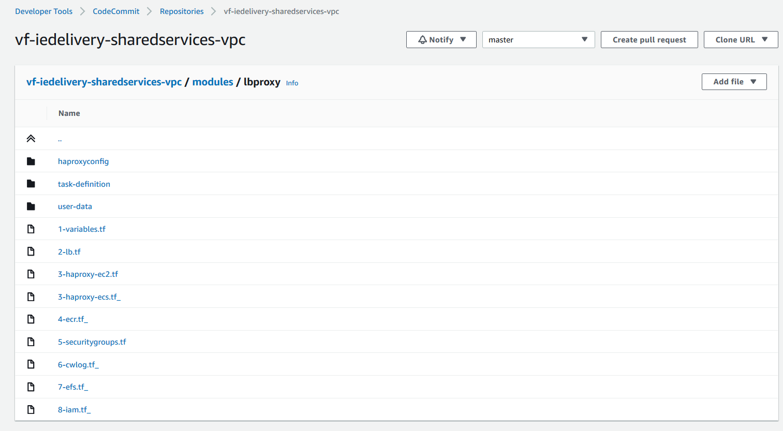

Key files/folders:

* haproxyconfig folder
* user-data
* 3-haproxy-ec2.tf
* 5-securitygroups.tf

In order to create dynamically the haproxy file in terraform, we have used the terraform function "templatefile(path, vars)". Terraform documentation [here](https://www.terraform.io/docs/configuration/functions/templatefile.html). It reads the file at the given path and renders its content as a template using a supplied set of template variables. The template syntax is the same as for string templates in the main terraform language, including interpolation sequences delimited with ${}. In the folder haproxyconfig we can see the templates used, called haproxy-global.tmpl and haproxy.tmpl. The first one is to set the global and default variables of the haproxy config. The second template is used as a template for each port configuration.

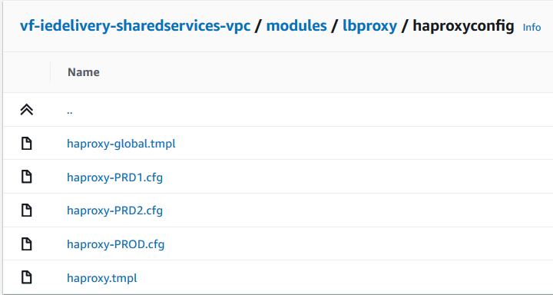

Note: At the moment, haproxy is ready the configuration from the hardcoded config files (*.cfg). This will be deleted once we migrate to the automated config file.

**Global and default variables** template file:

|  |
| --- |
| #HAPROXY CONFIG    global      maxconn 10000 # this would be a very high number of connections from a single microservice  - can be modified      log  127.0.0.1:514 local0  defaults    log            global    option         tcplog    mode           tcp    retries         3    timeout connect 10s # the time that HAProxy will wait for a TCP connection to a backend server to be established    timeout client  ${timeout_client}    timeout server  ${timeout_server}    default-server init-addr none #to avoid the config failing if it cannot resolver one dns server name#END OF GLOBAL AND DEFAULT VARIABLES |

**Port template**

|  |
| --- |
| #configuration for port: ${port}  frontend prod_${port}    bind *:${port}    acl white_list src ${whitelist}    tcp-request connection reject if !white_list    default_backend gdc_${port}    backend gdc_${port}    option tcp-check # perform a simple TCP check of healthiness against the server    server server_name ${server} |

In the file where we defined our haproxy, 3-haproxy-ec2.tf, we created the following local variables:

|  |
| --- |
| locals{    ..    template_text_backend    = [ for p in var.port_listeners: templatefile("${path.module}/haproxyconfig/haproxy.tmpl", { port = p["port"], whitelist = p["whitelist"], server = p["server"] })]    template_text_global    = templatefile("${path.module}/haproxyconfig/haproxy-global.tmpl", {timeout_client = "60s", timeout_server = "60s"})    template_text_join = join("\n", local.template_text_backend)    template_text = join("\n", [local.template_text_global, local.template_text_join])  } |

Where we create a variable with the content (text) corresponding with the configuration of all the ports that the haproxy is going to be listened to. The variable var.port_listener has the value of our haproxy config (port_listeners    =  var.prod_haproxy_config) . We will join all port configuration with the global configuration in the local variable template_text.

We will push that content to s3:

|  |
| --- |
| resource "aws_s3_bucket_object" "haproxy-tmpl" {    bucket = "vf-iedelivery-centralized-internet-vpc-267040142128-123456"    key    = "HAPROXY-${var.nlb_name}//haproxy-template.tmpl"    content= local.template_text  } |

Note: Right now the file is stored as ".tmpl" as haproxy are still reading the old-way hardcoded configuration.

##### RESULT

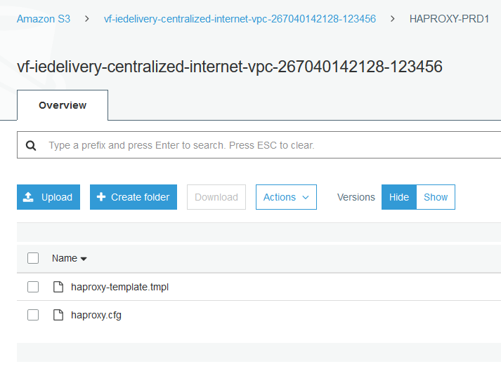

For prd2:

|  |
| --- |
| #HAPROXY CONFIG    global      maxconn 10000 # this would be a very high number of connections from a single microservice  - can be modified      log  127.0.0.1:514 local0  defaults    log            global    option         tcplog    mode           tcp    retries         3    timeout connect 10s # the time that HAProxy will wait for a TCP connection to a backend server to be established    timeout client  60s    timeout server  60s    default-server init-addr none #to avoid the config failing if it cannot resolver one dns server name  #END OF GLOBAL AND DEFAULT VARIABLES    #configuration for port: 15101  frontend prod_15101    bind *:15101    acl white_list src 10.181.96.0/19    tcp-request connection reject if !white_list    default_backend gdc_15101    backend gdc_15101    option tcp-check # perform a simple TCP check of healthiness against the server    server server_name esb.app.prd2.equinox.vf-ie.internal.vodafone.com:32007    #configuration for port: 12101  frontend prod_12101    bind *:12101    acl white_list src 10.181.96.0/19    tcp-request connection reject if !white_list    default_backend gdc_12101    backend gdc_12101    option tcp-check # perform a simple TCP check of healthiness against the server    server server_name meh.prd1.equinox.vf-ie.internal.vodafone.com:22    #configuration for port: 12103  frontend prod_12103    bind *:12103    acl white_list src 10.181.96.0/19    tcp-request connection reject if !white_list    default_backend gdc_12103    backend gdc_12103    option tcp-check # perform a simple TCP check of healthiness against the server    server server_name meh.prd1.equinox.vf-ie.internal.vodafone.com:16443    #configuration for port: 22102  frontend prod_22102    bind *:22102    acl white_list src 10.181.96.0/19    tcp-request connection reject if !white_list    default_backend gdc_22102    backend gdc_22102    option tcp-check # perform a simple TCP check of healthiness against the server    server server_name iebpoihr-vip.dc-dublin.de:33001    #configuration for port: 22103  frontend prod_22103    bind *:22103    acl white_list src 10.181.96.0/19    tcp-request connection reject if !white_list    default_backend gdc_22103    backend gdc_22103    option tcp-check # perform a simple TCP check of healthiness against the server    server server_name iebpojhr-vip.dc-dublin.de:33001    #configuration for port: 22104  frontend prod_22104    bind *:22104    acl white_list src 10.181.96.0/19    tcp-request connection reject if !white_list    default_backend gdc_22104    backend gdc_22104    option tcp-check # perform a simple TCP check of healthiness against the server    server server_name iebpokhr-vip.dc-dublin.de:33001    #configuration for port: 7001  frontend prod_7001    bind *:7001    acl white_list src 37.25.160.19/32 10.74.120.112/28    tcp-request connection reject if !white_list    default_backend gdc_7001    backend gdc_7001    option tcp-check # perform a simple TCP check of healthiness against the server    server server_name cch-sal-alb.prd2.ieaws.vodafone.com:7001    #configuration for port: 8011  frontend prod_8011    bind *:8011    acl white_list src 10.109.100.98/32 10.109.100.99/32 10.109.100.184/32 10.109.100.185/32 10.109.100.133/32 10.109.100.134/32 10.109.100.182/32 10.109.100.183/32 10.109.100.142/32 10.109.100.143/32 10.109.100.144/32 10.109.100.145/32 10.109.100.146/32 10.109.100.147/32 10.109.100.148/32 10.109.100.36/32 10.109.100.37/32 37.25.160.19/32    tcp-request connection reject if !white_list    default_backend gdc_8011    backend gdc_8011    option tcp-check # perform a simple TCP check of healthiness against the server    server server_name cch-sal-alb.prd2.ieaws.vodafone.com:8011    #configuration for port: 5500  frontend prod_5500    bind *:5500    acl white_list src 37.25.160.19/32 10.74.120.112/28    tcp-request connection reject if !white_list    default_backend gdc_5500    backend gdc_5500    option tcp-check # perform a simple TCP check of healthiness against the server    server server_name cch-sal-alb.prd2.ieaws.vodafone.com:5500    #configuration for port: 5501  frontend prod_5501    bind *:5501    acl white_list src 37.25.160.19/32 10.74.120.112/28    tcp-request connection reject if !white_list    default_backend gdc_5501    backend gdc_5501    option tcp-check # perform a simple TCP check of healthiness against the server    server server_name cch-sal-alb.prd2.ieaws.vodafone.com:5501    #configuration for port: 10120  frontend prod_10120    bind *:10120    acl white_list src 198.18.65.3/32 198.18.65.4/32 198.18.65.5/32 198.18.65.6/32 198.18.74.200/32 198.18.74.219/32 10.109.100.184/32 10.109.100.185/32 10.109.100.133/32 10.109.100.134/32 10.109.100.182/32 10.109.100.183/32 10.109.100.142/32 10.109.100.143/32 10.109.100.144/32 10.109.100.145/32 10.109.100.146/32 10.109.100.147/32 10.109.100.148/32 10.109.100.36/32 10.109.100.37/32 10.109.100.118/32 10.109.100.119/32 198.18.65.31/32 37.25.160.19/32    tcp-request connection reject if !white_list    default_backend gdc_10120    backend gdc_10120    option tcp-check # perform a simple TCP check of healthiness against the server    server server_name cch-sal-sftp.prd2.ieaws.vodafone.com:22 |

#### S3 SYNCHRONIZATION

Because our configuration is stored in a s3 bucket, it is difficult to automate the update into ec2. In ec2 user data, we create the following script (depending on the environment):

sudo cat > /etc/haproxy/haproxy-conf-refresh.sh << 'EOF'  
sudo mv /etc/haproxy/haproxy.cfg{,.original}  
sudo aws s3 sync s3://vf-iedelivery-centralized-internet-vpc-267040142128-123456/HAPROXY-**PRD1** /etc/haproxy/s3  
sudo mv /etc/haproxy/s3/haproxy.cfg /etc/haproxy/haproxy.cfg  
sudo systemctl restart haproxy  
EOF

The goal is to automate the execution of this script in the ec2 instance when the s3 object with the configuration for the haproxy changes. Different ways of doing this:

* Using terraform null resource
* Using lambda function

The first trial was using terraform null resource, that will try to connect through ssh to haproxy and run a script that you define. It will be something like this:

resource "null_resource" "haproxy"{  
  # Changes to any instance of the s3 object requires re-provisioning  
  depends_on  = [aws_autoscaling_group.haproxy_AG]  
 count = length(data.aws_instances.haproxy.private_ips)  
  triggers = {  
    s3_object_etag = "${filemd5("${path.module}/haproxyconfig/${local.config_file_name}")}" #triggered changes  
  }

  connection {  
    host = "${element(data.aws_instances.haproxy.public_ips, count.index)}"  
  }

  provisioner "remote-exec" {  
    # Bootstrap script called with private_ip of each node in the clutser  
    inline = [  
      "sudo /etc/haproxy/haproxy-conf-refresh.sh",  
    ]  
  }  
}

However, our haproxy are in a private subnet, and we will need a bastion host to connect to them using ssh. That's why this solution was not implemented.

The second one is based on ssm (in order to avoid ssh). A lambda function and a cloudwatch event rule was created. We can found the code in the root directory of the repository, under the folder "code". Lambda function and cw event has been defined in the file "4-lambda.tf"

##### LAMBDA CODE

It reads haproxy instance ids passing as a parameter the value for the Tag Name. Then, it use ssm send command, passing that instance id and setting the document name to "AWS-RunShellScript".

|  |
| --- |
| import pprint  import boto3  import json  import os  session = boto3.Session(region_name="eu-west-1")    def get_instance_id(ec2_name):      ec2_client = session.client('ec2')      filters = [ {'Name': 'tag:Name',                  'Values': [ ec2_name ]}                 ]      response = ec2_client.describe_instances(Filters=filters)["Reservations"]      instanceid = []      for r in response:          for instance in r['Instances']:              instanceid.append(instance['InstanceId'])      print(instanceid)      return instanceid    def run_ssm_command(Instanceids, command):      ssm_client = session.client('ssm')        response = ssm_client.send_command(                   InstanceIds= Instanceids ,                   DocumentName="AWS-RunShellScript",                   Parameters={                      'commands':[                            command                             ]                         },                   )      command_id = response['Command']['CommandId']        print(command_id)  def handler(event, context):        #GET INSTANCE ID      haproxy_prd1_instanceIds = get_instance_id("AG-PRD1-HAPROXY")      haproxy_prd2_instanceIds = get_instance_id("AG-PRD2-HAPROXY")      haproxy_prod_instanceIds = get_instance_id("AG-PROD-HAPROXY")        #RUN SSM COMMAND      run_ssm_command(haproxy_prd1_instanceIds, "/etc/haproxy/haproxy-conf-refresh.sh")      run_ssm_command(haproxy_prd2_instanceIds, "/etc/haproxy/haproxy-conf-refresh.sh")      run_ssm_command(haproxy_prod_instanceIds, "/etc/haproxy/haproxy-conf-refresh.sh") |

You can see lambda function [here](https://eu-west-1.console.aws.amazon.com/lambda/home?region=eu-west-1#/functions/gdc-pcs-lambda_sync_haproxy_s3-PROD?tab=configuration)

##### CLOUDWATCH EVENT RULE

A cloudwatch event rule has been created to invoke lambda function when a change is done to a defined s3 bucket (where haproxy config is stored).

|  |
| --- |
| resource "aws_cloudwatch_event_rule" "s3_bucket_modification" {    name        = "haproxy-config-change-rule"    description = "Capture changes to haproxy configuration"    event_pattern = <<PATTERN  {    "source": [      "aws.s3"    ],    "detail-type": [      "AWS API Call via CloudTrail"    ],    "detail": {      "eventSource": [        "s3.amazonaws.com"      ],      "eventName": [        "PutObject",        "CompleteMultipartUpload",        "DeleteObject",        "DeleteObjects",        "CreateMultipartUpload",        "PutObjectAcl",        "PutObjectLockLegalHold",        "PutObjectLockRetention",        "RestoreObject",        "UploadPart",        "UploadPartCopy",        "SelectObjectContent"      ],      "requestParameters": {        "bucketName": [          "vf-iedelivery-centralized-internet-vpc-267040142128-123456"        ]      }    }  }  PATTERN  }  resource "aws_cloudwatch_event_target" "lambda" {    rule      = "${aws_cloudwatch_event_rule.s3_bucket_modification.name}"    target_id = "SendToLambda"    arn       = "${aws_lambda_function.gdc_pcs_lambda_sync_haproxy_s3.arn}"  }  resource "aws_lambda_permission" "allow_cloudwatch" {    statement_id  = "AllowExecutionFromCloudWatch"    action        = "lambda:InvokeFunction"    function_name = "${aws_lambda_function.gdc_pcs_lambda_sync_haproxy_s3.function_name}"    principal     = "events.amazonaws.com"    source_arn    = aws_cloudwatch_event_rule.s3_bucket_modification.arn  } |

##### RESULTS

In ssm console we can see the history for the run commands:

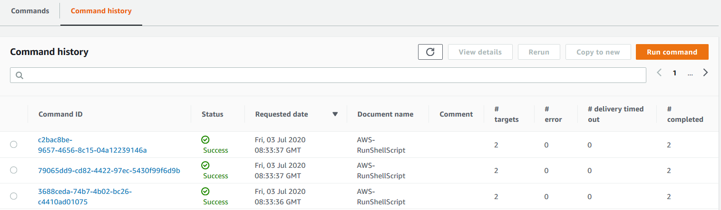

### HAPROXY-EC2 IMPLEMENTATION

#### 

**Error rendering macro 'toc'**

**java.lang.RuntimeException: com.ctc.wstx.exc.WstxUnexpectedCharException: Unexpected character ';' (code 59) expected '=' at [row,col {unknown-source}]: [51,297]**

#### 1. Module Inputs

This section will explain what has been deployed in SS VPC. Following the design showed here, we have a part of the architecture that follows the same pattern: NLB, AutoScaling group and HAproxy. In order to automate and make efficient the deployment and management, a terraform module has been created. This module is called '[lbproxy](https://eu-west-1.console.aws.amazon.com/codesuite/codecommit/repositories/vf-iedelivery-sharedservices-vpc/browse/refs/heads/master/--/modules?region=eu-west-1)', and will have the following inputs:

* Tags
* VPC name
* VPC cidr block
* **NLB name to differenciate AWS tenants. IMPORTANT: this name will be used in the module to look for the config name of the HAPROXY and user data.**
* A boolean variable called 'is_prod' / 'is_test' / 'is_preprod' to true. - deprecated
* A list of subnets where the NLB will be available and the HAProxy will be deployed.
* VPC id
* A dictionary with the ports where we expect the traffic. The key will differenciate the origin of the traffic (aws or gdc) and the value will be the port number.
* SSM security group - needs to be updated

|  |
| --- |
| module "prod-nlHAproxy" {    source            = "./modules/lbproxy"    TAGS              = local.common_tags    ENV               = var.ENV    PROJECT           = var.PROJECT    VPC_NAME          = var.VPC_NAME    main_cidr_block   = aws_vpc.vpc.cidr_block    nlb_name          = "PROD"    is_prod           = true    subnets           = [aws_subnet.subnet_IA_tier[0].id, aws_subnet.subnet_IA_tier[1].id ]    vpc_id            = aws_vpc.vpc.id    ssm_security_group = aws_security_group.ssm_endpoint_sg.id    ssm_instance_profile = aws_iam_instance_profile.ec2_ssm.id    port_listeners    =  {  "aws-1" : 15101,         "aws-2" : 20101,         "aws-3" : 20111,         "aws-4" : 20112,         "aws-5" : 20113,         "aws-6" : 20114,         "aws-7" : 12101,         "aws-8" : 12103,         "aws-9" : 22102,         "aws-10" : 22103,         "aws-11" : 22104,         "gdc-1"  : 7001,         "gdc-2"  : 8011,         "gdc-3"  : 5500,         "gdc-4"  : 5501,         "gdc-5"  : 10120      }  } |

#### 2. NLB

The nlb architecture will be defined in the file ['2-lb.tf'](https://eu-west-1.console.aws.amazon.com/codesuite/codecommit/repositories/vf-iedelivery-sharedservices-vpc/browse/refs/heads/master/--/modules/lbproxy/2-lb.tf?region=eu-west-1). An **internal network load balancer** will be deployed, with the input subnets associated with. The name convention is  "${var.VPC_NAME}-${var.TAGS["Project"]}-${var.nlb_name}-NLB"

One **target group** per port will be created, using a 'for_each' expression, in order to differenciate the target groups with a key. The name convention is ${var.VPC_NAME}-${var.TAGS["Project"]}-${var.nlb_name}-${each.value}. The protocol will be 'TCP' and the target type will be '**instance**', as we are using ec2 instances for HAproxy. For EC2 instance, instead of using a map variable for the ports, we could use just a list, and use "count" expression in the target group resource. However, the goal is to migrate to ECS Fargate when possible, and with ECS fargate it is not possible to use count in target group (as you cannot associate later on ecs service and target group in the dynamic block load balancer).One **lb listener** per port will be created, using a 'for_each' expression (same reasons as above explained). Each listener will have a forward action to the corresponding target group (same port).

For the health check, the configuration right now is using port 443, as we still don't have gdc connectivity, and we will find problems when trying to check traffic port. This will be modified when gdc connectivity is ready.

|  |
| --- |
| #--------------------LB-----------------------  resource "aws_lb" "nlb" {    name        = "${var.VPC_NAME}-${var.TAGS["Project"]}-${var.nlb_name}-NLB"    load_balancer_type = "network"    internal           = true    subnets            = var.subnets    enable_cross_zone_load_balancing = true    enable_deletion_protection       = true      tags = merge(      var.TAGS,      {        "Purpose" = "NLB for SS VPC"        "Name"    = "${var.VPC_NAME}-${var.TAGS["Project"]}-${var.nlb_name}-NLB"      },    )    } |

For the target groups, I found dependency issues when updating ports. This will force me to delete ALL target groups and CREATE them again. This is the issue terraform experiences: Error deleting Target Group: ResourceInUse: Target group 'xxxx' is currently in use by a listener or a rule status code: 400

This could be solved using name_prefix instead of name, but the number of character for that attribute is just 6, what will cause confusions as we had prod, pre-prod and test nlb target groups. Following the [issue opened in terraform](https://github.com/terraform-providers/terraform-provider-aws/issues/636) , the solution is to define a random string and add it to the name of the target group:

*"As you're seeing, the AWS API doesn't allow a Target Group to be deleted when there's a Listener Rule attached to it. When a port number on the Target Group is changed, it forces the Target Group to be re-created. Unfortunately there is currently no way in Terraform to say "also delete this resource when another resource is deleted", but we have*[*some thoughts about how to address it*](https://github.com/hashicorp/terraform/issues/22094#issuecomment-513413803)*. In addition to the*name*argument,*[aws_alb_target_group](https://www.terraform.io/docs/providers/aws/r/lb_target_group.html#argument-reference)*supports*name_prefix*, and will also generate a random name if neither of those is supplied. As suggested in*[*#636 (comment)*](https://github.com/terraform-providers/terraform-provider-aws/issues/636#issuecomment-397459646)*, the name can be set in a*Name*tag instead. Because of how*name_prefix*works and the length limit on Target Group names, the prefix can only be six characters. Some of the other solutions using the*[random*provider*](https://www.terraform.io/docs/providers/random/index.html)*to add uniqueness to the names will work as well. Setting*[lifecycle { create_before_destroy = true }](https://www.terraform.io/docs/configuration/resources.html#create_before_destroy)*is also needed to break the dependency cycle between the resources."*

|  |
| --- |
| resource "random_string" "target_group" {    length = 4    special = false  }      resource "aws_lb_target_group" "ecs_nlb_tg" {    for_each = var.port_listeners    name        = "${var.VPC_NAME}-${var.nlb_name}-${each.value}-${random_string.target_group.result}"    vpc_id      = var.vpc_id    port        = each.value    protocol    = "TCP"    target_type = "instance"    deregistration_delay = 60      health_check {      interval = 30      protocol = "TCP"      port     = 443      healthy_threshold = 2      unhealthy_threshold = 2    }      tags = merge(      var.TAGS,      {        "Purpose" = "PROD NLB Target group for SS VPC"        "Name"    = "${var.VPC_NAME}-${var.TAGS["Project"]}-${var.nlb_name}-${each.value}"      },    )      lifecycle {      create_before_destroy = true      ignore_changes = ["name"]    }  }    resource "aws_lb_listener" "frontend" {    depends_on = [aws_lb_target_group.ecs_nlb_tg]    for_each = var.port_listeners    load_balancer_arn = aws_lb.nlb.arn    port     = each.value    protocol = "TCP"    default_action {        type             = "forward"        target_group_arn = aws_lb_target_group.ecs_nlb_tg[each.key].arn    }  } |

#### 3. LAUNCH CONFIGURATION AND AUTOSCALING GROUP

These are the locals we will be using:

* A list with the target group arn that it will be using by the Auto Scaling Group.
* The customized name for the haproxy config file. It will depend on the nlb name. Right now, available names: PROD, PRD1 and PRD2.
* The customized name for the haproxy user data file, depending also on the nlb name.

|  |
| --- |
| locals{    target_group_arns  = [for k,v in aws_lb_target_group.ecs_nlb_tg : aws_lb_target_group.ecs_nlb_tg[k].arn]    config_file_name = "haproxy-${var.nlb_name}.cfg"    user_data_file   = "haproxy-userdata-${var.nlb_name}.sh"  } |

The config file will be uploaded to an s3 bucket. A folder with the name HAPROXY-nlbName will be created, so each config file will be uploaded there.

|  |
| --- |
| #uploading files to s3 bucket  resource "aws_s3_bucket_object" "haproxy-config" {    bucket = "vf-iedelivery-centralized-internet-vpc-267040142128-123456"    key    = "HAPROXY-${var.nlb_name}//haproxy.cfg"    source = "${path.module}/haproxyconfig/${local.config_file_name}"    etag = "${filemd5("${path.module}/haproxyconfig/${local.config_file_name}")}" #triggered changes  } |

HAProxy EC2 instances will be using a customized AMI creating using AWS IMAGE BUILDER. The details for that will be added in another section.

|  |
| --- |
| #-----data specific ami  data "aws_ami" "haproxy" {    most_recent      = true    owners           = ["self"]    filter {      name   = "name"      values = ["VFIE-DELIVERY-haproxy*"]    }  }  resource "aws_launch_configuration" "haproxy_conf" {    name_prefix   = "HAPROXY-${var.VPC_NAME}-${var.TAGS["Project"]}-${var.nlb_name}"    image_id      = data.aws_ami.haproxy.id    instance_type = "t2.medium"    iam_instance_profile =  var.ssm_instance_profile    security_groups =  [var.ssm_security_group, aws_security_group.haproxy_ec2_sg.id ]    user_data = "${file("${path.module}/user-data/${local.user_data_file}")}"    lifecycle {      create_before_destroy = true    }  } |

These are the details for the user data for PROD. The script function called haproxy-conf-refresh.sh will be used to update the config file in haproxy, synchronized with s3 bucket:

|  |
| --- |
| #!/bin/bash -xe  #haproxy config  sudo systemctl start haproxy || service haproxy start  sudo systemctl enable haproxy  sudo mkdir /etc/haproxy/old  sudo mkdir /etc/haproxy/s3  sudo touch /etc/haproxy/haproxy-conf-refresh.sh  sudo chmod 777 /etc/haproxy/haproxy-conf-refresh.sh  sudo cat > /etc/haproxy/haproxy-conf-refresh.sh << 'EOF'  sudo mv /etc/haproxy/haproxy.cfg{,.original}  sudo aws s3 sync s3://vf-iedelivery-centralized-internet-vpc-267040142128-123456/HAPROXY-PROD /etc/haproxy/s3  sudo mv /etc/haproxy/s3/haproxy.cfg /etc/haproxy/haproxy.cfg  sudo systemctl restart haproxy  EOF  sudo chmod +x /etc/haproxy/haproxy-conf-refresh.sh  sudo /etc/haproxy/haproxy-conf-refresh.sh |

Finally, here the details for the auto Scaling group:

|  |
| --- |
| resource "aws_autoscaling_group" "haproxy_AG" {    depends_on           = [aws_lb_target_group.ecs_nlb_tg]    name                 = "${var.nlb_name}-HAPROXY-${var.VPC_NAME}-${var.TAGS["Project"]}"    launch_configuration = aws_launch_configuration.haproxy_conf.name    min_size             = 1    max_size             = 4    desired_capacity          = 2    health_check_grace_period = 300    health_check_type         = "ELB"    vpc_zone_identifier       = [var.subnets[0], var.subnets[1]]    target_group_arns         = local.target_group_arns      tag {      key                 = "Environment"      value               = "${var.TAGS["Environment"]}"      propagate_at_launch = true    }      tag {      key                 = "Project"      value               = "VF-IEDELIVERY"      propagate_at_launch = true    }      tag {      key                 = "ManagedBy"      value               = "DL-GDC-PLT-SVCS-Public-Cloud-Managed-Services@vodafone.com"      propagate_at_launch = true    }      tag {      key                 = "Confidentiality"      value               = "C3"      propagate_at_launch = true    }      tag {      key                 = "TaggingVersion"      value               = "V2.3"      propagate_at_launch = true    }      tag {      key                 = "SecurityZone"      value               = "A"      propagate_at_launch = true    }      tag {      key                 = "Name"      value               = "AG-${var.nlb_name}-HAPROXY"      propagate_at_launch = true    }    } |

#### 4. HAProxy CONFIG

This section will describe the HAProxy configuration.

##### PRODUCTION

**CodeCommit URL** : <https://eu-west-1.console.aws.amazon.com/codesuite/codecommit/repositories/vf-iedelivery-sharedservices-vpc/browse/refs/heads/master/--/modules/lbproxy/haproxyconfig/haproxy-PROD.cfg?region=eu-west-1>

**Internal Base URL** : prod.haproxy.ieaws.vodafone.com

**External Base URL** : *.prod.ieaws.vodafone.com

|  |  |  |  |  |  |
| --- | --- | --- | --- | --- | --- |
| HAProxy Port | Direction | Source Whitelist | Destination IP | Destination Port | Description |
| 443 | Inbound | N/A | [internal-snd1-CchSalALB-1101482058.eu-west-1.elb.amazonaws.com](http://internal-snd1-CchSalALB-1101482058.eu-west-1.elb.amazonaws.com) | 443 | Health Check |
| 5500 | Inbound | 10.74.120.112/28 37.25.160.19/32 10.109.98.0/24 10.163.78.0/23 195.232.228.93/32 | [cch-sal-alb.prod.ieaws.vodafone.com](http://cch-sal-alb.prod.ieaws.vodafone.com) | 5500 |  |
| 5501 | Inbound | 10.74.120.112/28 37.25.160.19/32 10.109.98.0/24 10.163.78.0/23 195.232.228.93/32 | [cch-sal-alb.prod.ieaws.vodafone.com](http://cch-sal-alb.prod.ieaws.vodafone.com) | 5501 |  |
| 7001 | Inbound | 10.74.120.112/28 37.25.160.19/32 10.109.98.0/24 10.163.78.0/23 47.73.21.74/32 47.73.21.75/32 176.125.13.67/32 176.125.13.68/32 176.125.13.69/32 176.125.13.70/32 195.232.228.93/32 | [cch-sal-alb.prod.ieaws.vodafone.com](http://cch-sal-alb.prod.ieaws.vodafone.com) | 7001 | Weblogic Admin |
| 8011 | Inbound | 37.25.160.19 10.109.100.239 10.109.100.240 10.109.100.241 10.109.100.11 10.109.100.12 10.109.100.13 10.109.100.14 10.109.100.15 10.109.100.16 10.109.100.17 10.109.100.38 10.109.100.39 10.109.100.24 10.109.100.25 10.109.100.181 10.109.100.186 10.151.4.79 10.151.4.82 10.151.4.92 10.151.4.95 10.162.114.10 10.162.114.11 10.162.114.12 10.162.114.13 10.162.114.15 10.162.114.16 10.162.114.18 10.162.114.19 10.162.114.26 10.162.114.25 47.73.21.74 47.73.21.75 176.125.13.67 176.125.13.68 176.125.13.69 176.125.13.70 198.18.65.7 198.18.65.8 198.18.65.9 198.18.65.10 198.18.65.11 198.18.65.12 10.74.120.112/28 195.232.228.93/32 10.109.179.162 10.109.179.163 10.109.179.164 10.109.179.165 10.109.179.166 10.109.179.167 | [cch-sal-alb.prod.ieaws.vodafone.com](http://cch-sal-alb.prod.ieaws.vodafone.com) | 8011 | CCHSAL Exposed APIs |
| 8405 | Inbound | 127.0.0.1/32 | 127.0.0.1 | 8404 | Stats Health Check |
| 8443 | Inbound | 10.74.120.112/28 37.25.160.19/32 195.232.228.93/32 10.78.177.156/32 10.109.100.245/32 10.109.100.246/32 10.109.100.247/32 10.109.100.250/32 10.109.100.251/32 10.109.100.252/32 10.109.100.9/32 10.109.100.10/32 37.25.161.156/32 37.25.161.157/32 | [ieportal-dispatcher.prod.ieaws.vodafone.com](http://ieportal-alb.prod.ieaws.vodafone.com) | 8443 | IE Portal FE GUIs |
| 10120 | Inbound | 37.25.160.19 198.18.65.7 198.18.65.8 198.18.65.9 198.18.65.10 198.18.65.11 10.109.179.146 10.109.179.147 198.18.74.197 192.125.247.100 198.18.65.12 198.18.65.56 198.18.65.57 | [cch-sal-sftp.prod.ieaws.vodafone.com](http://cch-sal-sftp.prod.ieaws.vodafone.com) | 22 | CCHSAL SFTP Endpoint |
| 10301 | Inbound | 37.25.160.19/32 10.74.120.112/28 10.163.78.0/23 10.109.98.0/24 | [jenkins.prod.ieaws.vodafone.com](http://jenkins.prod.ieaws.vodafone.com) | 443 | Jenkins - DevOps Tooling |
| 10302 | Inbound | 37.25.160.19/32 10.74.120.112/28 10.163.78.0/23 10.109.98.0/24 | [artifactory.prod.ieaws.vodafone.com](http://artifactory.prod.ieaws.vodafone.com) | 443 | JFrog Artifactory - DevOps Tooling |
| 10303 | Inbound | 37.25.160.19/32 10.74.120.112/28 10.163.78.0/23 10.109.98.0/24 | [myst.prod.ieaws.vodafone.com](http://myst.prod.ieaws.vodafone.com) | 443 | MyST - DevOps Tooling |
| 10304 | Inbound | 37.25.160.19/32 10.74.120.112/28 10.163.78.0/23 10.109.98.0/24 | [cch-sal-utilities.prod.ieaws.vodafone.com](http://cch-sal-utilities.prod.ieaws.vodafone.com) | 1521 | OCM |
| 10304 | Inbound | 37.25.160.19/32 10.74.120.112/28 10.163.78.0/23 10.109.98.0/24 | [cch-sal-utilities.prod.ieaws.vodafone.com](http://cch-sal-utilities.prod.ieaws.vodafone.com) | 2484 | OCM |
| 13001 | Outbound | 10.181.32.0/19 | 10.78.48.37 | 8005 | UFE |
| 15101 | Outbound | 10.181.32.0/19 | 10.78.48.57 | 30050 | Amdocs OSB |
| 20101 | Outbound | 10.181.32.0/19 | 10.163.187.4 | 6543 | Jinny |
| 20111 | Outbound | 10.181.32.0/19 | 10.163.184.4 | 1040 | SMSC |
| 20112 | Outbound | 10.181.32.0/19 | 10.163.184.4 | 1050 | SMSC |
| 20113 | Outbound | 10.181.32.0/19 | 10.163.184.4 | 1060 | SMSC |
| 20114 | Outbound | 10.181.32.0/19 | 10.163.184.4 | 1070 | SMSC |
| 12103 | Outbound | 10.181.32.0/19 | 198.18.67.252 | 16443 | MEH |
| 22102 | Outbound | 10.181.32.0/19 | 10.109.101.122 | 33001 | MML DB |
| 22103 | Outbound | 10.181.32.0/19 | 10.109.101.123 | 33001 | MML DB |
| 22104 | Outbound | 10.181.32.0/19 | 10.109.101.124 | 33001 | MML DB |
| 22105 | Outbound | 10.181.32.0/19 | 10.109.101.14 | 33001 | UFE DB |
| 27001 | Outbound | 10.181.32.0/19 | 10.109.100.244 | 22 |  |
| 28001 | Outbound | 10.181.32.0/19 | 10.162.66.40 | 22 | Lotus Notes |
| 29001 | Outbound | 10.181.32.0/19 | 47.73.21.74 | 8090 | AppDynamics |
| 29003 | Outbound | 10.181.32.0/19 | 47.73.21.74 | 8181 | AppDynamics |

##### PRE-PRODUCTION 1 (PRD1)

|  |
| --- |
| ## References  # https://www.haproxy.com/blog/the-four-essential-sections-of-an-haproxy-configuration/        # Globals are process wide configuration parameters  global  maxconn 10000 # this would be a very high number of connections from a single microservice - can be modified  log 127.0.0.1:514 local0    # Defaults are configuration parameters which apply to each frontend and backend to reduce/remove configuraiton duplication  # However settings can be overridden at the frontend / backend level  defaults  log global  option tcplog  mode tcp  retries 3  timeout connect 10s # the time that HAProxy will wait for a TCP connection to a backend server to be established  timeout client 60s  timeout server 60s  default-server init-addr last,libc,none #to avoid the config failing if it cannot resolver one dns server name    ##----------------------- ENV: PROD---------------------------------------------    #15101 - FROM PROD  frontend prod_15101  bind *:15101  acl white_list src 10.181.64.0/19  tcp-request connection reject if !white_list  default_backend gdc_15101    backend gdc_15101  option tcp-check # perform a simple TCP check of healthiness against the server  server esb.app.prd1.equinox.vf-ie.internal.vodafone.com 10.78.48.83:32007 # send traffic on host/port; check its port; max connections of the given value    #20101 - FROM PROD  frontend prod_20101  bind *:20101  acl white_list src 10.181.64.0/19  tcp-request connection reject if !white_list  default_backend gdc_20101    backend gdc_20101  option tcp-check # perform a simple TCP check of healthiness against the server  server JINNY-APP-PROD-VF-IE.INTERNAL.VODAFONE.COM 10.163.187.4:6543 # send traffic on host/port; check its port; max connections of the given value    #20111 - FROM PROD  frontend prod_20111  bind *:20111  acl white_list src 10.181.64.0/19  tcp-request connection reject if !white_list  default_backend gdc_20111    backend gdc_20111  option tcp-check # perform a simple TCP check of healthiness against the server  server SMSC-APP-SIT1-VF-IE.INTERNAL.VODAFONE.COM 10.162.229.54:1040 # send traffic on host/port; check its port; max connections of the given value    #20112 - FROM PROD  frontend prod_20112  bind *:20112  acl white_list src 10.181.64.0/19  tcp-request connection reject if !white_list  default_backend gdc_20112    backend gdc_20112  option tcp-check # perform a simple TCP check of healthiness against the server  server SMSC-APP-SIT1-VF-IE.INTERNAL.VODAFONE.COM 10.162.229.54:1050 # send traffic on host/port; check its port; max connections of the given value    #20113 - FROM PROD  frontend prod_20113  bind *:20113  acl white_list src 10.181.64.0/19  tcp-request connection reject if !white_list  default_backend gdc_20113    backend gdc_20113  option tcp-check # perform a simple TCP check of healthiness against the server  server SMSC-APP-SIT1-VF-IE.INTERNAL.VODAFONE.COM 10.162.229.54:1060 # send traffic on host/port; check its port; max connections of the given value    #20114 - FROM PROD  frontend prod_20114  bind *:20114  acl white_list src 10.181.64.0/19  tcp-request connection reject if !white_list  default_backend gdc_20114    backend gdc_20114  option tcp-check # perform a simple TCP check of healthiness against the server  server SMSC-APP-SIT1-VF-IE.INTERNAL.VODAFONE.COM 10.162.229.54:1070 # send traffic on host/port; check its port; max connections of the given value    #12103 - FROM PROD  frontend prod_12103  bind *:12103  acl white_list src 10.181.64.0/19  tcp-request connection reject if !white_list  default_backend gdc_12103    backend gdc_12103  option tcp-check # perform a simple TCP check of healthiness against the server  server meh.prd1.equinox.vf-ie.internal.vodafone.com 198.18.67.253:16443 # send traffic on host/port; check its port; max connections of the given value      #22102 - FROM PROD  frontend prod_22102  bind *:22102  acl white_list src 10.181.64.0/19  tcp-request connection reject if !white_list  default_backend gdc_22102    backend gdc_22102  option tcp-check # perform a simple TCP check of healthiness against the server  server iebeoahr-vip.dc-dublin.de 10.109.101.41:33001 # send traffic on host/port; check its port; max connections of the given value    #22103 - FROM PROD  frontend prod_22103  bind *:22103  acl white_list src 10.181.64.0/19  tcp-request connection reject if !white_list  default_backend gdc_22103    backend gdc_22103  option tcp-check # perform a simple TCP check of healthiness against the server  server iebeobhr-vip.dc-dublin.de 10.109.101.42:33001 # send traffic on host/port; check its port; max connections of the given value    #22104 - FROM PROD  #frontend prod_22104  # bind *:22104  # acl white_list src 10.181.64.0/19  # tcp-request connection reject if !white_list  # default_backend gdc_22104    #backend gdc_22104  # option tcp-check # perform a simple TCP check of healthiness against the server  # server iebpokhr-vip.dc-dublin.de 10.109.101.124:33001 # send traffic on host/port; check its port; max connections of the given value    #5500 - FROM GDC  frontend prod_5500  bind *:5500  acl white_list src 10.74.120.112/28 37.25.160.19  tcp-request connection reject if !white_list  default_backend gdc_5500    backend gdc_5500  option tcp-check # perform a simple TCP check of healthiness against the server  server cch-sal-alb.prd1.ieaws.vodafone.com cch-sal-alb.prd1.ieaws.vodafone.com:5500 # send traffic on host/port; check its port; max connections of the given value      #5501 - FROM GDC  frontend prod_5501  bind *:5501  acl white_list src 10.74.120.112/28 37.25.160.19/32 195.232.228.93/32 10.78.177.156/32  tcp-request connection reject if !white_list  default_backend gdc_5501    backend gdc_5501  option tcp-check # perform a simple TCP check of healthiness against the server  server cch-sal-alb.prd1.ieaws.vodafone.com cch-sal-alb.prd1.ieaws.vodafone.com:5501 # send traffic on host/port; check its port; max connections of the given value    #7001 - FROM GDC  frontend prod_7001  bind *:7001  acl white_list src 10.74.120.112/28 37.25.160.19/32 195.232.228.93/32 10.78.177.156/32  tcp-request connection reject if !white_list  default_backend gdc_7001    backend gdc_7001  option tcp-check # perform a simple TCP check of healthiness against the server  server cch-sal-alb.prd1.ieaws.vodafone.com cch-sal-alb.prd1.ieaws.vodafone.com:7001 # send traffic on host/port; check its port; max connections of the given value    #10120 - FROM GDC  frontend prod_10120  bind *:10120  acl white_list src 37.25.160.19 198.18.65.3 198.18.65.4 198.18.65.5 198.18.65.6 198.18.74.200 198.18.74.219 10.109.100.118 10.109.100.119 198.18.65.31  tcp-request connection reject if !white_list  default_backend gdc_10120    backend gdc_10120  option tcp-check # perform a simple TCP check of healthiness against the server  server cch-sal-sftp.prd1.ieaws.vodafone.com cch-sal-sftp.prd1.ieaws.vodafone.com:22 # send traffic on host/port; check its port; max connections of the given value      #8011 - FROM GDC  frontend prod_8011  bind *:8011  acl white_list src 37.25.160.19 10.109.100.98 10.109.100.99 10.109.100.96 10.109.100.97 10.109.100.179 10.109.100.180 10.109.100.131 10.109.100.132 10.109.100.177 10.109.100.178 10.109.100.135 10.109.100.136 10.109.100.137 10.109.100.138 10.109.100.139 10.109.100.140 10.109.100.141 10.109.100.34 10.109.100.35 10.162.122.16 10.162.122.17 10.162.114.20 10.162.114.21 10.162.111.89 10.162.111.92 10.162.111.81 10.162.111.82 10.78.177.156 10.78.177.156/32 198.18.65.3 198.18.65.4 198.18.65.5 198.18.65.6  tcp-request connection reject if !white_list  default_backend gdc_8011    backend gdc_8011  option tcp-check # perform a simple TCP check of healthiness against the server  server cch-sal-alb.prd1.ieaws.vodafone.com cch-sal-alb.prd1.ieaws.vodafone.com:8011 # send traffic on host/port; check its port; max connections of the given value    # added 22.07  #27001 - FROM PRD1  frontend prod_27001  bind *:27001  acl white_list src 10.181.64.0/19  tcp-request connection reject if !white_list  default_backend gdc_27001    backend gdc_27001  option tcp-check # perform a simple TCP check of healthiness against the server  server IEBSEMN-VIP.dc-dublin.de 10.109.100.105:22 # send traffic on host/port; check its port; max connections of the given value    #10304 - FROM GDC  frontend prod_10304  bind *:10304  acl white_list src 10.109.98.0/24 10.163.78.0/23 37.25.160.19    tcp-request connection reject if !white_list  default_backend gdc_10304    backend gdc_10304  option tcp-check # perform a simple TCP check of healthiness against the server  server cch-sal-utilities.prd1.ieaws.vodafone.com cch-sal-utilities.prd1.ieaws.vodafone.com:1521 # send traffic on host/port; check its port; max connections of the given value      #10305 - FROM GDC  frontend prod_10305  bind *:10305  acl white_list src 10.109.98.0/24 10.163.78.0/23 37.25.160.19/32 10.78.177.156/32  tcp-request connection reject if !white_list  default_backend gdc_10305  backend gdc_10305  option tcp-check # perform a simple TCP check of healthiness against the server  server cch-sal-utilities.prd1.ieaws.vodafone.com cch-sal-utilities.prd1.ieaws.vodafone.com:2484 # send traffic on host/port; check its port; max connections of the given value    #28001 - FROM PROD  frontend prod_28001  bind *:28001  acl white_list src 10.181.64.0/19  tcp-request connection reject if !white_list  default_backend gdc_28001    backend gdc_28001  option tcp-check # perform a simple TCP check of healthiness against the server  server LotusNotes.legacy 10.162.66.40:22 # send traffic on host/port; check its port; max connections of the given value    # 443 -health check  frontend healthcheck  bind *:443  default_backend nodes    backend nodes  balance roundrobin  option ssl-hello-chk  server web01 internal-snd1-CchSalALB-1101482058.eu-west-1.elb.amazonaws.com:443 check |

|  |  |  |  |  |  |
| --- | --- | --- | --- | --- | --- |
| Env | IF-ID | Direction | HAPROXY Config | Description | Status |
| PRD1 | IF354.01 IF354.08 IF354.06 IF354.09 IF354.05 IF354.03 IF354.13 | OUTBOUND | #15101 - FROM PROD frontend prod_15101 bind *:15101 acl white_list src 10.181.64.0/19 tcp-request connection reject if !white_list default_backend gdc_15101  backend gdc_15101 option tcp-check # perform a simple TCP check of healthiness against the server server esb.app.prd1.equinox.vf-ie.internal.vodafone.com 10.78.48.83:32007 | CCH Sync -> OSB -> ANM CCH Sync -> OSB -> CRM CCH Sync -> OSB -> CM CCH Sync -> OSB -> CIAM CCH Sync -> OSB -> OMS CCH Sync -> OSB -> RPL CCH Sync -> OSB -> CCS - SurePay | IN PROGRESS |
| PRD1 | IF354.11 | OUTBOUND | #20101 - FROM PROD frontend prod_20101 bind *:20101 acl white_list src 10.181.64.0/19 tcp-request connection reject if !white_list default_backend gdc_20101  backend gdc_20101 option tcp-check # perform a simple TCP check of healthiness against the server server JINNY-APP-PROD-VF-IE.INTERNAL.VODAFONE.COM 10.163.187.4:6543 | CCH Sync-> Direct -> Jinny | IN PROGRESS |
| PRD1 | IF355.01 | OUTBOUND | #20111 - FROM PROD frontend prod_20111 bind *:20111 acl white_list src 10.181.64.0/19 tcp-request connection reject if !white_list default_backend gdc_20111  backend gdc_20111 option tcp-check # perform a simple TCP check of healthiness against the server server SMSC-APP-SIT1-VF-IE.INTERNAL.VODAFONE.COM 10.162.229.54:1040 | CCH Batch-> Direct -> SMSC | IN PROGRESS |
| PRD1 | IF355.01 | OUTBOUND | #20112 - FROM PROD frontend prod_20112 bind *:20112 acl white_list src 10.181.64.0/19 tcp-request connection reject if !white_list default_backend gdc_20112  backend gdc_20112 option tcp-check # perform a simple TCP check of healthiness against the server server SMSC-APP-SIT1-VF-IE.INTERNAL.VODAFONE.COM 10.162.229.54:1050 | CCH Batch-> Direct -> SMSC | IN PROGRESS |
| PRD1 | IF355.01 | OUTBOUND | #20113 - FROM PROD frontend prod_20113 bind *:20113 acl white_list src 10.181.64.0/19 tcp-request connection reject if !white_list default_backend gdc_20113  backend gdc_20113 option tcp-check # perform a simple TCP check of healthiness against the server server SMSC-APP-SIT1-VF-IE.INTERNAL.VODAFONE.COM 10.162.229.54:1060 | CCH Batch-> Direct -> SMSC | IN PROGRESS |
| PRD1 | IF355.01 | OUTBOUND | #20114 - FROM PROD frontend prod_20114 bind *:20114 acl white_list src 10.181.64.0/19 tcp-request connection reject if !white_list default_backend gdc_20114  backend gdc_20114 option tcp-check # perform a simple TCP check of healthiness against the server server SMSC-APP-SIT1-VF-IE.INTERNAL.VODAFONE.COM 10.162.229.54:1070 | CCH Batch-> Direct -> SMSC | IN PROGRESS |
| PRD1 | IF354.14 | OUTBOUND | #12103 - FROM PROD frontend prod_12103 bind *:12103 acl white_list src 10.181.64.0/19 tcp-request connection reject if !white_list default_backend gdc_12103  backend gdc_12103 option tcp-check # perform a simple TCP check of healthiness against the server server meh.prd1.equinox.vf-ie.internal.vodafone.com 198.18.67.253:16443 | CCH Sync-> Direct -> MEH | IN PROGRESS |
| PRD1 | IF038.15 | OUTBOUND | #22102 - FROM PROD frontend prod_22102 bind *:22102 acl white_list src 10.181.64.0/19 tcp-request connection reject if !white_list default_backend gdc_22102  backend gdc_22102 option tcp-check # perform a simple TCP check of healthiness against the server server iebeoahr-vip.dc-dublin.de 10.109.101.41:33001 | MML DB<- Direct <- File Splitter DB | IN PROGRESS |
| PRD1 | IF038.15 | OUTBOUND | #22103 - FROM PROD frontend prod_22103 bind *:22103 acl white_list src 10.181.64.0/19 tcp-request connection reject if !white_list default_backend gdc_22103  backend gdc_22103 option tcp-check # perform a simple TCP check of healthiness against the server server iebeobhr-vip.dc-dublin.de 10.109.101.42:33001 | MML DB<- Direct <- File Splitter DB | IN PROGRESS |
| PRD1 | IF340.01 | OUTBOUND | #27001 - FROM PRD1 frontend prod_27001 bind *:27001 acl white_list src 10.181.64.0/19 tcp-request connection reject if !white_list default_backend gdc_27001  backend gdc_27001 option tcp-check # perform a simple TCP check of healthiness against the server server IEBSEMN-VIP.dc-dublin.de 10.109.100.105:22 | File Splitter -> Direct -> AR | IN PROGRESS |
| PRD1 | ACCESS | INBOUND | #7001 - FROM GDC frontend prod_7001 bind *:7001 acl white_list src 10.74.120.112/28 37.25.160.19/32 195.232.228.93/32 10.78.177.156/32 tcp-request connection reject if !white_list default_backend gdc_7001  backend gdc_7001 option tcp-check # perform a simple TCP check of healthiness against the server server cch-sal-alb.prd1.ieaws.vodafone.com cch-sal-alb.prd1.ieaws.vodafone.com:7001 | Proxy Access to Weblogic Admin GUI | IN PROGRESS |
| PRD1 | ACCESS | INBOUND | #5500 - FROM GDC frontend prod_5500 bind *:5500 acl white_list src 10.74.120.112/28 37.25.160.19 tcp-request connection reject if !white_list default_backend gdc_5500  backend gdc_5500 option tcp-check # perform a simple TCP check of healthiness against the server server cch-sal-alb.prd1.ieaws.vodafone.com cch-sal-alb.prd1.ieaws.vodafone.com:5500 | Proxy Access to Oracle OEM GUI | IN PROGRESS |
| PRD1 | ACCESS | INBOUND | #5501 - FROM GDC frontend prod_5501 bind *:5501 acl white_list src 10.74.120.112/28 37.25.160.19/32 195.232.228.93/32 10.78.177.156/32 tcp-request connection reject if !white_list default_backend gdc_5501  backend gdc_5501 option tcp-check # perform a simple TCP check of healthiness against the server server cch-sal-alb.prd1.ieaws.vodafone.com cch-sal-alb.prd1.ieaws.vodafone.com:5501 | Proxy Access to Oracle OEM GUI | IN PROGRESS |
| PRD1 | IF138.64 IF356.02 IF173.08 IF220.04 IF175.09 | INBOUND | #8011 - FROM GDC frontend prod_8011 bind *:8011 acl white_list src 37.25.160.19 10.109.100.98 10.109.100.99 10.109.100.96 10.109.100.97 10.109.100.179 10.109.100.180 10.109.100.131 10.109.100.132 10.109.100.177 10.109.100.178 10.109.100.135 10.109.100.136 10.109.100.137 10.109.100.138 10.109.100.139 10.109.100.140 10.109.100.141 10.109.100.34 10.109.100.35 10.162.122.16 10.162.122.17 10.162.114.20 10.162.114.21 10.162.111.89 10.162.111.92 10.162.111.81 10.162.111.82 10.78.177.156 10.78.177.156/32 tcp-request connection reject if !white_list default_backend gdc_8011  backend gdc_8011 option tcp-check # perform a simple TCP check of healthiness against the server server cch-sal-alb.prd1.ieaws.vodafone.com cch-sal-alb.prd1.ieaws.vodafone.com:8011 | CCS - Surepay -> OSB -> CCH Sync UFE-> Direct -> CCH Sync Portal-> Direct -> CCH Sync GISMSH-> Direct -> CCH Sync GIG -> Tibco -> CCH Sync Tibco (old ESB)-> Direct -> CCH Sync | IN PROGRESS |
| PRD1 | IF020.14 IF248.05 IF355.02 IF313.04 IF027.04 IF236.02 IF340.01 IF340.02 IF340.03 IF162.03 IF283.02 IF222.02 IF115.04 IF340.04 | INBOUND | #10120 - FROM GDC frontend prod_10120 bind *:10120 acl white_list src 37.25.160.19 198.18.65.3 198.18.65.4 198.18.65.5 198.18.65.6 198.18.74.200 198.18.74.219 10.109.100.118 10.109.100.119 198.18.65.31 tcp-request connection reject if !white_list default_backend gdc_10120  backend gdc_10120 option tcp-check # perform a simple TCP check of healthiness against the server server cch-sal-sftp.prd1.ieaws.vodafone.com cch-sal-sftp.prd1.ieaws.vodafone.com:22 | MEH -> CCH Outbound/Batch  MCCM<- MFT (Pull)  MFT (Push) -> CCH Batch ANM<- MFT (Pull)  MFT (Push) -> CCH Batch CCH Batch<- MFT (Pull)  MFT (Push) -> MCCM MCO<- MFT (Pull)  MFT (Push) -> CCH Batch AIB -> Legacy Batch -> File Splitter Connect Direct Secure Plus -> Legacy Batch -> File Splitter File Splitter<- MFT (Pull)  MFT (Push) -> AR File Splitter<- MFT (Pull)  MFT (Push) -> Jupiter (ICCS) File Splitter<- MFT (Pull)  MFT (Push) -> SingleServe SEPA Hub -> Group MFT -> Connect Direct -> File Splitter An Post -> Legacy Batch -> File Splitter Kiosk HAND -> Legacy Batch -> File Splitter Jupiter (ICCS)<- MFT (Pull)  MFT (Push) -> File Splitter File Splitter<- MFT (Pull)  MFT (Push) -> RPL | IN PROGRESS |
| PRD1 | OCM | INBOUND | #10304 - FROM GDC frontend prod_10304 bind *:10304 acl white_list src 10.109.98.0/24 10.163.78.0/23 37.25.160.19  tcp-request connection reject if !white_list default_backend gdc_10304  backend gdc_10304 option tcp-check # perform a simple TCP check of healthiness against the server server cch-sal-utilities.prd1.ieaws.vodafone.com cch-sal-utilities.prd1.ieaws.vodafone.com:1521 | Oracle Connection Manager access to DBs | IN PROGRESS |
| PRD1 | OCM (SSL) | INBOUND | #10305 - FROM GDC frontend prod_10305 bind *:10305 acl white_list src 10.109.98.0/24 10.163.78.0/23 37.25.160.19/32 10.78.177.156/32 tcp-request connection reject if !white_list default_backend gdc_10305  backend gdc_10305 option tcp-check # perform a simple TCP check of healthiness against the server server cch-sal-utilities.prd1.ieaws.vodafone.com cch-sal-utilities.prd1.ieaws.vodafone.com:2484 | Oracle Connection Manager access to DBs (SSL) | IN PROGRESS |

##### PRE-PRODUCTION 2 (PRD2)

|  |
| --- |
| ## References  # https://www.haproxy.com/blog/the-four-essential-sections-of-an-haproxy-configuration/        # Globals are process wide configuration parameters  global  maxconn 10000 # this would be a very high number of connections from a single microservice - can be modified  log 127.0.0.1:514 local0    # Defaults are configuration parameters which apply to each frontend and backend to reduce/remove configuraiton duplication  # However settings can be overridden at the frontend / backend level  defaults  log global  option tcplog  mode tcp  retries 3  timeout connect 10s # the time that HAProxy will wait for a TCP connection to a backend server to be established  timeout client 60s  timeout server 60s  default-server init-addr last,libc,none #to avoid the config failing if it cannot resolver one dns server name    ##----------------------- ENV: PROD---------------------------------------------    #15101 - FROM PROD  frontend prod_15101  bind *:15101  acl white_list src 10.181.96.0/19  tcp-request connection reject if !white_list  default_backend gdc_15101    backend gdc_15101  option tcp-check # perform a simple TCP check of healthiness against the server  server esb.app.prd2.equinox.vf-ie.internal.vodafone.com 10.78.48.84:33007 # send traffic on host/port; check its port; max connections of the given value    #12103 - FROM PROD  frontend prod_12103  bind *:12103  acl white_list src 10.181.96.0/19  tcp-request connection reject if !white_list  default_backend gdc_12103    backend gdc_12103  option tcp-check # perform a simple TCP check of healthiness against the server  server meh.prd1.equinox.vf-ie.internal.vodafone.com 198.18.67.253:16443 # send traffic on host/port; check its port; max connections of the given value      #22102 - FROM PROD  frontend prod_22102  bind *:22102  acl white_list src 10.181.96.0/19  tcp-request connection reject if !white_list  default_backend gdc_22102    backend gdc_22102  option tcp-check # perform a simple TCP check of healthiness against the server  server iebeomhr-vip.dc-dublin.de 10.109.101.83:33001 # send traffic on host/port; check its port; max connections of the given value    #22103 - FROM PROD  frontend prod_22103  bind *:22103  acl white_list src 10.181.96.0/19  tcp-request connection reject if !white_list  default_backend gdc_22103    backend gdc_22103  option tcp-check # perform a simple TCP check of healthiness against the server  server iebeonhr-vip.dc-dublin.de 10.109.101.84:33001 # send traffic on host/port; check its port; max connections of the given value    #22104 - FROM PROD  #frontend prod_22104  # bind *:22104  # acl white_list src 10.181.96.0/19  # tcp-request connection reject if !white_list  # default_backend gdc_22104    #backend gdc_22104  # option tcp-check # perform a simple TCP check of healthiness against the server  # server iebpokhr-vip.dc-dublin.de iebpokhr-vip.dc-dublin.de:33001 # send traffic on host/port; check its port; max connections of the given value    #5500 - FROM GDC  frontend prod_5500  bind *:5500  acl white_list src 10.74.120.112/28 37.25.160.19/32 195.232.228.93/32 10.78.177.156/32  tcp-request connection reject if !white_list  default_backend gdc_5500    backend gdc_5500  option tcp-check # perform a simple TCP check of healthiness against the server  server cch-sal-alb.prd2.ieaws.vodafone.com cch-sal-alb.prd2.ieaws.vodafone.com:5500 # send traffic on host/port; check its port; max connections of the given value      #5501 - FROM GDC  frontend prod_5501  bind *:5501  acl white_list src 10.74.120.112/28 37.25.160.19/32 195.232.228.93/32 10.78.177.156/32  tcp-request connection reject if !white_list  default_backend gdc_5501    backend gdc_5501  option tcp-check # perform a simple TCP check of healthiness against the server  server cch-sal-alb.prd2.ieaws.vodafone.com cch-sal-alb.prd2.ieaws.vodafone.com:5501 # send traffic on host/port; check its port; max connections of the given value    #7001 - FROM GDC  frontend prod_7001  bind *:7001  acl white_list src 10.74.120.112/28 37.25.160.19/32 195.232.228.93/32 10.78.177.156/32  tcp-request connection reject if !white_list  default_backend gdc_7001    backend gdc_7001  option tcp-check # perform a simple TCP check of healthiness against the server  server cch-sal-alb.prd2.ieaws.vodafone.com cch-sal-alb.prd2.ieaws.vodafone.com:7001 # send traffic on host/port; check its port; max connections of the given value    #10120 - FROM GDC  frontend prod_10120  bind *:10120  acl white_list src 37.25.160.19 198.18.65.3 198.18.65.4 198.18.65.5 198.18.65.6 198.18.74.200 198.18.74.219 10.109.100.184 10.109.100.185 10.109.100.133 10.109.100.134 10.109.100.182 10.109.100.183 10.109.100.142 10.109.100.143 10.109.100.144 10.109.100.145 10.109.100.146 10.109.100.147 10.109.100.148 10.109.100.36 10.109.100.37 10.109.100.118 10.109.100.119 198.18.65.31  tcp-request connection reject if !white_list  default_backend gdc_10120    backend gdc_10120  option tcp-check # perform a simple TCP check of healthiness against the server  server cch-sal-sftp.prd2.ieaws.vodafone.com cch-sal-sftp.prd2.ieaws.vodafone.com:22 # send traffic on host/port; check its port; max connections of the given value      #8011 - FROM GDC  frontend prod_8011  bind *:8011  acl white_list src 37.25.160.19 10.109.100.98 10.109.100.99 10.109.100.184 10.109.100.185 10.109.100.133 10.109.100.134 10.109.100.182 10.109.100.183 10.109.100.142 10.109.100.143 10.109.100.144 10.109.100.145 10.109.100.146 10.109.100.147 10.109.100.148 10.109.100.36 10.109.100.37 37.25.160.48 37.25.160.49 37.25.160.50 37.25.160.61 10.78.177.156 10.78.177.156  tcp-request connection reject if !white_list  default_backend gdc_8011    backend gdc_8011  option tcp-check # perform a simple TCP check of healthiness against the server  server cch-sal-alb.prd2.ieaws.vodafone.com cch-sal-alb.prd2.ieaws.vodafone.com:8011 # send traffic on host/port; check its port; max connections of the given value    # 22.07 changes    #27001 - FROM PRD2  frontend prod_27001  bind *:27001  acl white_list src 10.181.96.0/19  tcp-request connection reject if !white_list  default_backend gdc_27001    backend gdc_27001  option tcp-check # perform a simple TCP check of healthiness against the server  server IEBSEOP-VIP.dc-dublin.de 10.109.100.109:22 # send traffic on host/port; check its port; max connections of the given value    #10304 - FROM GDC  frontend prod_10304  bind *:10304  acl white_list src 10.109.98.0/24 10.163.78.0/23 37.25.160.19  tcp-request connection reject if !white_list  default_backend gdc_10304    backend gdc_10304  option tcp-check # perform a simple TCP check of healthiness against the server  server cch-sal-utilities.prd2.ieaws.vodafone.com cch-sal-utilities.prd2.ieaws.vodafone.com:1521 # send traffic on host/port; check its port; max connections of the given value    # added 23.07  #29002 - FROM PROD  frontend prod_29002  bind *:29002  acl white_list src 10.181.96.0/19  tcp-request connection reject if !white_list  default_backend gdc_29002    backend gdc_29002  option tcp-check # perform a simple TCP check of healthiness against the server  server smsc-sim.ieaws.vodafone.com smsc-sim.ieaws.vodafone.com:2775 # send traffic on host/port; check its port; max connections of the given value    #10305 - FROM GDC  frontend prod_10305  bind *:10305  acl white_list src 10.109.98.0/24 10.163.78.0/23 37.25.160.19/32 10.78.177.156/32  tcp-request connection reject if !white_list  default_backend gdc_10305  backend gdc_10305  option tcp-check # perform a simple TCP check of healthiness against the server  server cch-sal-utilities.prd2.ieaws.vodafone.com cch-sal-utilities.prd2.ieaws.vodafone.com:2484 # send traffic on host/port; check its port; max connections of the given value      #HEALTH CHECK AND MONITORING  listen stats  bind *:8404  mode http  stats enable  stats hide-version  stats uri /haproxy_stats  stats refresh 30s  #stats admin if LOCALHOST |

|  |  |  |  |  |  |
| --- | --- | --- | --- | --- | --- |
| Env | IF-ID | Direction | HAPROXY Config | Description | Status |
| PRD2 | IF354.01 IF354.08 IF354.06 IF354.09 IF354.05 IF354.03 IF354.13 | OUTBOUND | #15101 - FROM PROD frontend prod_15101 bind *:15101 acl white_list src 10.181.96.0/19 tcp-request connection reject if !white_list default_backend gdc_15101  backend gdc_15101 option tcp-check # perform a simple TCP check of healthiness against the server server esb.app.prd2.equinox.vf-ie.internal.vodafone.com esb.app.prd2.equinox.vf-ie.internal.vodafone.com:33007 | CCH Sync -> OSB -> ANM CCH Sync -> OSB -> CRM CCH Sync -> OSB -> CM CCH Sync -> OSB -> CIAM CCH Sync -> OSB -> OMS CCH Sync -> OSB -> RPL CCH Sync -> OSB -> CCS - SurePay | IN PROGRESS |
| PRD2 | IF354.14 | OUTBOUND | #12103 - FROM PROD frontend prod_12103 bind *:12103 acl white_list src 10.181.96.0/19 tcp-request connection reject if !white_list default_backend gdc_12103  backend gdc_12103 option tcp-check # perform a simple TCP check of healthiness against the server server meh.prd1.equinox.vf-ie.internal.vodafone.com meh.prd1.equinox.vf-ie.internal.vodafone.com:16443 | CCH Sync-> Direct -> MEH | IN PROGRESS |
| PRD2 | IF038.15 | OUTBOUND | #22102 - FROM PROD frontend prod_22102 bind *:22102 acl white_list src 10.181.96.0/19 tcp-request connection reject if !white_list default_backend gdc_22102  backend gdc_22102 option tcp-check # perform a simple TCP check of healthiness against the server server iebeomhr-vip.dc-dublin.de 10.109.101.83:33001 | MML DB<- Direct <- File Splitter DB | IN PROGRESS |
| PRD2 | IF038.15 | OUTBOUND | #22103 - FROM PROD frontend prod_22103 bind *:22103 acl white_list src 10.181.96.0/19 tcp-request connection reject if !white_list default_backend gdc_22103  backend gdc_22103 option tcp-check # perform a simple TCP check of healthiness against the server server iebeonhr-vip.dc-dublin.de 10.109.101.84:33001 | MML DB<- Direct <- File Splitter DB | IN PROGRESS |
| PRD2 | IF340.01 | OUTBOUND | #27001 - FROM PRD2 frontend prod_27001 bind *:27001 acl white_list src 10.181.96.0/19 tcp-request connection reject if !white_list default_backend gdc_27001  backend gdc_27001 option tcp-check # perform a simple TCP check of healthiness against the server server IEBSEOP-VIP.dc-dublin.de 10.109.100.109:22 | File Splitter -> Direct -> AR | IN PROGRESS |
| PRD2 | SMSC SIM | OUTBOUND | #29002 - FROM PROD frontend prod_29002 bind *:29002 acl white_list src 10.181.96.0/19 tcp-request connection reject if !white_list default_backend gdc_29002  backend gdc_29002 option tcp-check # perform a simple TCP check of healthiness against the server server smsc-sim.ieaws.vodafone.com smsc-sim.ieaws.vodafone.com:2775 | UMS to SMSC Simulator | IN PROGRESS |
| PRD2 | ACCESS | INBOUND | #5500 - FROM GDC frontend prod_5500 bind *:5500 acl white_list src 10.74.120.112/28 37.25.160.19/32 195.232.228.93/32 10.78.177.156/32 tcp-request connection reject if !white_list default_backend gdc_5500  backend gdc_5500 option tcp-check # perform a simple TCP check of healthiness against the server server cch-sal-alb.prd2.ieaws.vodafone.com cch-sal-alb.prd2.ieaws.vodafone.com:5500 | Proxy Access to Oracle OEM GUI DB1 | IN PROGRESS |
| PRD2 | ACCESS | INBOUND | #5501 - FROM GDC frontend prod_5501 bind *:5501 acl white_list src 10.74.120.112/28 37.25.160.19/32 195.232.228.93/32 10.78.177.156/32 tcp-request connection reject if !white_list default_backend gdc_5501  backend gdc_5501 option tcp-check # perform a simple TCP check of healthiness against the server server cch-sal-alb.prd2.ieaws.vodafone.com cch-sal-alb.prd2.ieaws.vodafone.com:5501 | Proxy Access to Oracle OEM GUI DB1 | IN PROGRESS |
| PRD2 | ACCESS | INBOUND | #7001 - FROM GDC frontend prod_7001 bind *:7001 acl white_list src 10.74.120.112/28 37.25.160.19/32 195.232.228.93/32 10.78.177.156/32 tcp-request connection reject if !white_list default_backend gdc_7001  backend gdc_7001 option tcp-check # perform a simple TCP check of healthiness against the server server cch-sal-alb.prd2.ieaws.vodafone.com cch-sal-alb.prd2.ieaws.vodafone.com:7001 | Proxy Access to Weblogic Admin GUI | IN PROGRESS |
| PRD2 | TBC  IF020.14 IF248.05 IF355.02 IF313.04 IF027.04 IF236.02 IF340.01 IF340.02 IF340.03 IF162.03 IF283.02 IF222.02 IF115.04 IF340.04 | INBOUND | #10120 - FROM GDC frontend prod_10120 bind *:10120 acl white_list src 37.25.160.19 198.18.65.3 198.18.65.4 198.18.65.5 198.18.65.6 198.18.74.200 198.18.74.219 10.109.100.184 10.109.100.185 10.109.100.133 10.109.100.134 10.109.100.182 10.109.100.183 10.109.100.142 10.109.100.143 10.109.100.144 10.109.100.145 10.109.100.146 10.109.100.147 10.109.100.148 10.109.100.36 10.109.100.37 10.109.100.118 10.109.100.119 198.18.65.31 tcp-request connection reject if !white_list default_backend gdc_10120  backend gdc_10120 option tcp-check # perform a simple TCP check of healthiness against the server server cch-sal-sftp.prd2.ieaws.vodafone.com cch-sal-sftp.prd2.ieaws.vodafone.com:22 | MEH -> CCH Outbound/Batch  MCCM<- MFT (Pull)  MFT (Push) -> CCH Batch ANM<- MFT (Pull)  MFT (Push) -> CCH Batch CCH Batch<- MFT (Pull)  MFT (Push) -> MCCM MCO<- MFT (Pull)  MFT (Push) -> CCH Batch AIB -> Legacy Batch -> File Splitter Connect Direct Secure Plus -> Legacy Batch -> File Splitter File Splitter<- MFT (Pull)  MFT (Push) -> AR File Splitter<- MFT (Pull)  MFT (Push) -> Jupiter (ICCS) File Splitter<- MFT (Pull)  MFT (Push) -> SingleServe SEPA Hub -> Group MFT -> Connect Direct -> File Splitter An Post -> Legacy Batch -> File Splitter Kiosk HAND -> Legacy Batch -> File Splitter Jupiter (ICCS)<- MFT (Pull)  MFT (Push) -> File Splitter File Splitter<- MFT (Pull)  MFT (Push) -> RPL | IN PROGRESS |
| PRD2 | IF138.64 IF356.02 IF173.08 IF220.04 IF175.09 | INBOUND | #8011 - FROM GDC frontend prod_8011 bind *:8011 acl white_list src 37.25.160.19 10.109.100.98 10.109.100.99 10.109.100.184 10.109.100.185 10.109.100.133 10.109.100.134 10.109.100.182 10.109.100.183 10.109.100.142 10.109.100.143 10.109.100.144 10.109.100.145 10.109.100.146 10.109.100.147 10.109.100.148 10.109.100.36 10.109.100.37 37.25.160.48 37.25.160.49 37.25.160.50 37.25.160.61 10.78.177.156 10.78.177.156 tcp-request connection reject if !white_list default_backend gdc_8011  backend gdc_8011 option tcp-check # perform a simple TCP check of healthiness against the server server cch-sal-alb.prd2.ieaws.vodafone.com cch-sal-alb.prd2.ieaws.vodafone.com:8011 | Portal-> Direct -> OAL  UFE-> Direct -> OAL CCS - Surepay -> OSB -> CCH Sync UFE-> Direct -> CCH Sync Portal-> Direct -> CCH Sync GISMSH-> Direct -> CCH Sync GIG -> Tibco -> CCH Sync Tibco (old ESB)-> Direct -> CCH Sync | IN PROGRESS |
| PRD2 | OCM | INBOUND | #10304 - FROM GDC frontend prod_10304 bind *:10304 acl white_list src 10.109.98.0/24 10.163.78.0/23 37.25.160.19 tcp-request connection reject if !white_list default_backend gdc_10304  backend gdc_10304 option tcp-check # perform a simple TCP check of healthiness against the server server cch-sal-utilities.prd2.ieaws.vodafone.com cch-sal-utilities.prd2.ieaws.vodafone.com:1521 | Oracle Connection Manager access to DBs | IN PROGRESS |
| PRD2 | OCM (SSL) | INBOUND | #10305 - FROM GDC frontend prod_10305 bind *:10305 acl white_list src 10.109.98.0/24 10.163.78.0/23 37.25.160.19/32 10.78.177.156/32 tcp-request connection reject if !white_list default_backend gdc_10305 backend gdc_10305 option tcp-check # perform a simple TCP check of healthiness against the server server cch-sal-utilities.prd2.ieaws.vodafone.com cch-sal-utilities.prd2.ieaws.vodafone.com:2484 | Oracle Connection Manager access to DBs (SSL) | IN PROGRESS |

##### SIT1

|  |
| --- |
| ## References  # https://www.haproxy.com/blog/the-four-essential-sections-of-an-haproxy-configuration/        # Globals are process wide configuration parameters  global  maxconn 10000 # this would be a very high number of connections from a single microservice - can be modified  log 127.0.0.1:514 local0    # Defaults are configuration parameters which apply to each frontend and backend to reduce/remove configuraiton duplication  # However settings can be overridden at the frontend / backend level  defaults  log global  option tcplog  mode tcp  retries 3  timeout connect 10s # the time that HAProxy will wait for a TCP connection to a backend server to be established  timeout client 60s  timeout server 60s  default-server init-addr last,libc,none #to avoid the config failing if it cannot resolver one dns server name    ##----------------------- ENV: SIT1---------------------------------------------    #15101 - FROM SIT1 - AMDOCS OSB  frontend prod_15101  bind *:15101  acl white_list src 10.181.128.0/19  tcp-request connection reject if !white_list  default_backend gdc_15101    backend gdc_15101  option tcp-check # perform a simple TCP check of healthiness against the server  server ieesbavr.dc-dublin.de 10.109.96.89:7007 # send traffic on host/port; check its port; max connections of the given value    #20101 - FROM SIT1 - JINNY (PROD - NO TEST AVAILABLE)  frontend prod_20101  bind *:20101  acl white_list src 10.181.128.0/19  tcp-request connection reject if !white_list  default_backend gdc_20101    backend gdc_20101  option tcp-check # perform a simple TCP check of healthiness against the server  server JINNY-APP-PROD-VF-IE.INTERNAL.VODAFONE.COM 10.163.187.4:6543 # send traffic on host/port; check its port; max connections of the given value    #20111 - FROM SIT1 - TEST SMSC  frontend prod_20111  bind *:20111  acl white_list src 10.181.128.0/19  tcp-request connection reject if !white_list  default_backend gdc_20111    backend gdc_20111  option tcp-check # perform a simple TCP check of healthiness against the server  server SMSC-APP-SIT1-VF-IE.INTERNAL.VODAFONE.COM 10.162.229.54:1040 # send traffic on host/port; check its port; max connections of the given value    #20112 - FROM SIT1 - TEST SMSC  frontend prod_20112  bind *:20112  acl white_list src 10.181.128.0/19  tcp-request connection reject if !white_list  default_backend gdc_20112    backend gdc_20112  option tcp-check # perform a simple TCP check of healthiness against the server  server SMSC-APP-SIT1-VF-IE.INTERNAL.VODAFONE.COM 10.162.229.54:1050 # send traffic on host/port; check its port; max connections of the given value    #20113 - FROM SIT1 - TEST SMSC  frontend prod_20113  bind *:20113  acl white_list src 10.181.128.0/19  tcp-request connection reject if !white_list  default_backend gdc_20113    backend gdc_20113  option tcp-check # perform a simple TCP check of healthiness against the server  server SMSC-APP-SIT1-VF-IE.INTERNAL.VODAFONE.COM 10.162.229.54:1060 # send traffic on host/port; check its port; max connections of the given value    #20114 - FROM SIT1 - TEST SMSC  frontend prod_20114  bind *:20114  acl white_list src 10.181.128.0/19  tcp-request connection reject if !white_list  default_backend gdc_20114    backend gdc_20114  option tcp-check # perform a simple TCP check of healthiness against the server  server SMSC-APP-SIT1-VF-IE.INTERNAL.VODAFONE.COM 10.162.229.54::1070 # send traffic on host/port; check its port; max connections of the given value    #12103 - FROM SIT1 - MEH  frontend prod_12103  bind *:12103  acl white_list src 10.181.128.0/19  tcp-request connection reject if !white_list  default_backend gdc_12103    backend gdc_12103  option tcp-check # perform a simple TCP check of healthiness against the server  server meh.sit1.equinox.vf-ie.internal.vodafone.com 198.18.67.221:16443 # send traffic on host/port; check its port; max connections of the given value      #22102 - FROM SIT1 - MML DB  frontend prod_22102  bind *:22102  acl white_list src 10.181.128.0/19  tcp-request connection reject if !white_list  default_backend gdc_22102    backend gdc_22102  option tcp-check # perform a simple TCP check of healthiness against the server  server IEORN5HR-vip.dc-dublin.de 10.106.184.46:33001 # send traffic on host/port; check its port; max connections of the given value    #22103 - FROM SIT1 - MML DB  frontend prod_22103  bind *:22103  acl white_list src 10.181.128.0/19  tcp-request connection reject if !white_list  default_backend gdc_22103    backend gdc_22103  option tcp-check # perform a simple TCP check of healthiness against the server  server IEORN6HR-vip.dc-dublin.de 10.106.184.47:33001 # send traffic on host/port; check its port; max connections of the given value    #5500 - FROM GDC - Weblogic Enterprise Manager  frontend prod_5500  bind *:5500  acl white_list src 10.74.120.112/28 37.25.160.19/32 10.109.98.0/24 10.163.78.0/23 195.232.228.93/32  tcp-request connection reject if !white_list  default_backend gdc_5500    backend gdc_5500  option tcp-check # perform a simple TCP check of healthiness against the server  server cch-sal-alb.sit1.ieaws.vodafone.com cch-sal-alb.sit1.ieaws.vodafone.com:5500 # send traffic on host/port; check its port; max connections of the given value      #5501 - FROM GDC - Weblogic Enterprise Manager  frontend prod_5501  bind *:5501  acl white_list src 10.74.120.112/28 37.25.160.19/32 10.109.98.0/24 10.163.78.0/23 195.232.228.93/32  tcp-request connection reject if !white_list  default_backend gdc_5501    backend gdc_5501  option tcp-check # perform a simple TCP check of healthiness against the server  server cch-sal-alb.sit1.ieaws.vodafone.com cch-sal-alb.sit1.ieaws.vodafone.com:5501 # send traffic on host/port; check its port; max connections of the given value    #7001 - FROM GDC - Weblogic Admin  frontend prod_7001  bind *:7001  acl white_list src 10.74.120.112/28 37.25.160.19/32 10.109.98.0/24 10.163.78.0/23 47.73.21.74/32 47.73.21.75/32 176.125.13.67/32 176.125.13.68/32 176.125.13.69/32 176.125.13.70/32 195.232.228.93/32  tcp-request connection reject if !white_list  default_backend gdc_7001    backend gdc_7001  option tcp-check # perform a simple TCP check of healthiness against the server  server cch-sal-alb.sit1.ieaws.vodafone.com cch-sal-alb.sit1.ieaws.vodafone.com:7001 # send traffic on host/port; check its port; max connections of the given value    #10120 - FROM GDC - CCHSAL SFTP  frontend prod_10120  bind *:10120  acl white_list src 37.25.160.19 10.109.96.88 10.109.96.125 198.18.64.204 198.18.64.205 198.18.64.215 198.18.64.218 198.18.64.222  tcp-request connection reject if !white_list  default_backend gdc_10120    backend gdc_10120  option tcp-check # perform a simple TCP check of healthiness against the server  server cch-sal-sftp.sit1.ieaws.vodafone.com cch-sal-sftp.sit1.ieaws.vodafone.com:22 # send traffic on host/port; check its port; max connections of the given value      #8011 - FROM GDC - Weblogic API  frontend prod_8011  bind *:8011  acl white_list src 37.25.160.19 10.109.96.89 10.109.96.90 198.18.64.196 198.18.64.200 198.18.64.201 198.18.64.203 198.18.64.207 198.18.64.208 198.18.64.209 198.18.64.210 10.109.96.105 10.109.96.106 10.109.96.107 10.109.96.108 10.109.96.109 10.109.96.110 10.109.96.49 10.109.96.47 10.109.96.60 10.109.96.79  tcp-request connection reject if !white_list  default_backend gdc_8011    backend gdc_8011  option tcp-check # perform a simple TCP check of healthiness against the server  server cch-sal-alb.sit1.ieaws.vodafone.com cch-sal-alb.sit1.ieaws.vodafone.com:8011 # send traffic on host/port; check its port; max connections of the given value    #10304 - FROM GDC - OCM  frontend prod_10304  bind *:10304  acl white_list src 10.109.98.0/24 10.163.78.0/23  tcp-request connection reject if !white_list  default_backend gdc_10304    backend gdc_10304  option tcp-check # perform a simple TCP check of healthiness against the server  server cch-sal-utilities.sit1.ieaws.vodafone.com cch-sal-utilities.sit1.ieaws.vodafone.com:1521 # send traffic on host/port; check its port; max connections of the given value    #10305 - FROM GDC - OCM  frontend prod_10305  bind *:10305  acl white_list src 10.109.98.0/24 10.163.78.0/23 37.25.160.19/32  tcp-request connection reject if !white_list  default_backend gdc_10305  backend gdc_10305  option tcp-check # perform a simple TCP check of healthiness against the server  server cch-sal-utilities.sit1.ieaws.vodafone.com cch-sal-utilities.sit1.ieaws.vodafone.com:2484 # send traffic on host/port; check its port; max connections of the given value    #HEALTH CHECK AND MONITORING  listen stats  bind *:8404  mode http  stats enable  stats hide-version  stats uri /haproxy_stats  stats refresh 30s  #stats admin if LOCALHOST |

##### SIT2

|  |
| --- |
| ## References  # https://www.haproxy.com/blog/the-four-essential-sections-of-an-haproxy-configuration/        # Globals are process wide configuration parameters  global  maxconn 10000 # this would be a very high number of connections from a single microservice - can be modified  log 127.0.0.1:514 local0    # Defaults are configuration parameters which apply to each frontend and backend to reduce/remove configuraiton duplication  # However settings can be overridden at the frontend / backend level  defaults  log global  option tcplog  mode tcp  retries 3  timeout connect 10s # the time that HAProxy will wait for a TCP connection to a backend server to be established  timeout client 60s  timeout server 60s  default-server init-addr last,libc,none #to avoid the config failing if it cannot resolver one dns server name    ##----------------------- ENV: SIT2---------------------------------------------    #15101 - FROM SIT2 - AMDOCS OSB  frontend prod_15101  bind *:15101  acl white_list src 10.181.160.0/19  tcp-request connection reject if !white_list  default_backend gdc_15101    backend gdc_15101  option tcp-check # perform a simple TCP check of healthiness against the server  server ieesbbvr.dc-dublin.de 10.109.96.90:11007 # send traffic on host/port; check its port; max connections of the given value    #20101 - FROM SIT2 - JINNY (PROD - NO TEST AVAILABLE)  frontend prod_20101  bind *:20101  acl white_list src 10.181.160.0/19  tcp-request connection reject if !white_list  default_backend gdc_20101    backend gdc_20101  option tcp-check # perform a simple TCP check of healthiness against the server  server JINNY-APP-PROD-VF-IE.INTERNAL.VODAFONE.COM 10.163.187.4:6543 # send traffic on host/port; check its port; max connections of the given value    #20111 - FROM SIT2 - TEST SMSC  frontend prod_20111  bind *:20111  acl white_list src 10.181.160.0/19  tcp-request connection reject if !white_list  default_backend gdc_20111    backend gdc_20111  option tcp-check # perform a simple TCP check of healthiness against the server  server SMSC-APP-SIT1-VF-IE.INTERNAL.VODAFONE.COM 10.162.229.54:1040 # send traffic on host/port; check its port; max connections of the given value    #20112 - FROM SIT2 - TEST SMSC  frontend prod_20112  bind *:20112  acl white_list src 10.181.160.0/19  tcp-request connection reject if !white_list  default_backend gdc_20112    backend gdc_20112  option tcp-check # perform a simple TCP check of healthiness against the server  server SMSC-APP-SIT1-VF-IE.INTERNAL.VODAFONE.COM 10.162.229.54:1050 # send traffic on host/port; check its port; max connections of the given value    #20113 - FROM SIT2 - TEST SMSC  frontend prod_20113  bind *:20113  acl white_list src 10.181.160.0/19  tcp-request connection reject if !white_list  default_backend gdc_20113    backend gdc_20113  option tcp-check # perform a simple TCP check of healthiness against the server  server SMSC-APP-SIT1-VF-IE.INTERNAL.VODAFONE.COM 10.162.229.54:1060 # send traffic on host/port; check its port; max connections of the given value    #20114 - FROM SIT2 - TEST SMSC  frontend prod_20114  bind *:20114  acl white_list src 10.181.160.0/19  tcp-request connection reject if !white_list  default_backend gdc_20114    backend gdc_20114  option tcp-check # perform a simple TCP check of healthiness against the server  server SMSC-APP-SIT1-VF-IE.INTERNAL.VODAFONE.COM 10.162.229.54::1070 # send traffic on host/port; check its port; max connections of the given value    #12103 - FROM SIT2 - MEH  frontend prod_12103  bind *:12103  acl white_list src 10.181.160.0/19  tcp-request connection reject if !white_list  default_backend gdc_12103    backend gdc_12103  option tcp-check # perform a simple TCP check of healthiness against the server  server meh.sit2.equinox.vf-ie.internal.vodafone.com 198.18.67.220:16443 # send traffic on host/port; check its port; max connections of the given value      #22102 - FROM SIT2 - MML DB  frontend prod_22102  bind *:22102  acl white_list src 10.181.160.0/19  tcp-request connection reject if !white_list  default_backend gdc_22102    backend gdc_22102  option tcp-check # perform a simple TCP check of healthiness against the server  server IEORN5HR-vip.dc-dublin.de 10.106.184.46:33001 # send traffic on host/port; check its port; max connections of the given value    #22103 - FROM SIT2 - MML DB  frontend prod_22103  bind *:22103  acl white_list src 10.181.160.0/19  tcp-request connection reject if !white_list  default_backend gdc_22103    backend gdc_22103  option tcp-check # perform a simple TCP check of healthiness against the server  server IEORN6HR-vip.dc-dublin.de 10.106.184.47:33001 # send traffic on host/port; check its port; max connections of the given value    #5500 - FROM GDC - Weblogic Enterprise Manager  frontend prod_5500  bind *:5500  acl white_list src 10.74.120.112/28 37.25.160.19/32 10.109.98.0/24 10.163.78.0/23 195.232.228.93/32  tcp-request connection reject if !white_list  default_backend gdc_5500    backend gdc_5500  option tcp-check # perform a simple TCP check of healthiness against the server  server cch-sal-alb.sit2.ieaws.vodafone.com cch-sal-alb.sit2.ieaws.vodafone.com:5500 # send traffic on host/port; check its port; max connections of the given value      #5501 - FROM GDC - Weblogic Enterprise Manager  frontend prod_5501  bind *:5501  acl white_list src 10.74.120.112/28 37.25.160.19/32 10.109.98.0/24 10.163.78.0/23 195.232.228.93/32  tcp-request connection reject if !white_list  default_backend gdc_5501    backend gdc_5501  option tcp-check # perform a simple TCP check of healthiness against the server  server cch-sal-alb.sit2.ieaws.vodafone.com cch-sal-alb.sit2.ieaws.vodafone.com:5501 # send traffic on host/port; check its port; max connections of the given value    #7001 - FROM GDC - Weblogic Admin  frontend prod_7001  bind *:7001  acl white_list src 10.74.120.112/28 37.25.160.19/32 10.109.98.0/24 10.163.78.0/23 47.73.21.74/32 47.73.21.75/32 176.125.13.67/32 176.125.13.68/32 176.125.13.69/32 176.125.13.70/32 195.232.228.93/32  tcp-request connection reject if !white_list  default_backend gdc_7001    backend gdc_7001  option tcp-check # perform a simple TCP check of healthiness against the server  server cch-sal-alb.sit2.ieaws.vodafone.com cch-sal-alb.sit2.ieaws.vodafone.com:7001 # send traffic on host/port; check its port; max connections of the given value    #10120 - FROM GDC - CCHSAL SFTP  frontend prod_10120  bind *:10120  acl white_list src 37.25.160.19 10.109.96.88 10.109.96.125 198.18.64.204 198.18.64.205 198.18.64.215 198.18.64.218 198.18.64.222  tcp-request connection reject if !white_list  default_backend gdc_10120    backend gdc_10120  option tcp-check # perform a simple TCP check of healthiness against the server  server cch-sal-sftp.sit2.ieaws.vodafone.com cch-sal-sftp.sit2.ieaws.vodafone.com:22 # send traffic on host/port; check its port; max connections of the given value      #8011 - FROM GDC - Weblogic API  frontend prod_8011  bind *:8011  acl white_list src 37.25.160.19 10.109.96.89 10.109.96.90 198.18.64.196 198.18.64.200 198.18.64.201 198.18.64.203 198.18.64.207 198.18.64.208 198.18.64.209 198.18.64.210 10.109.96.105 10.109.96.106 10.109.96.107 10.109.96.108 10.109.96.109 10.109.96.110 10.109.96.49 10.109.96.47 10.109.96.60 10.109.96.79  tcp-request connection reject if !white_list  default_backend gdc_8011    backend gdc_8011  option tcp-check # perform a simple TCP check of healthiness against the server  server cch-sal-alb.sit2.ieaws.vodafone.com cch-sal-alb.sit2.ieaws.vodafone.com:8011 # send traffic on host/port; check its port; max connections of the given value    #10304 - FROM GDC - OCM  frontend prod_10304  bind *:10304  acl white_list src 10.109.98.0/24 10.163.78.0/23  tcp-request connection reject if !white_list  default_backend gdc_10304    backend gdc_10304  option tcp-check # perform a simple TCP check of healthiness against the server  server cch-sal-utilities.sit2.ieaws.vodafone.com cch-sal-utilities.sit2.ieaws.vodafone.com:1521 # send traffic on host/port; check its port; max connections of the given value    #10305 - FROM GDC - OCM  frontend prod_10305  bind *:10305  acl white_list src 10.109.98.0/24 10.163.78.0/23 37.25.160.19/32  tcp-request connection reject if !white_list  default_backend gdc_10305  backend gdc_10305  option tcp-check # perform a simple TCP check of healthiness against the server  server cch-sal-utilities.sit2.ieaws.vodafone.com cch-sal-utilities.sit2.ieaws.vodafone.com:2484 # send traffic on host/port; check its port; max connections of the given value    #HEALTH CHECK AND MONITORING  listen stats  bind *:8404  mode http  stats enable  stats hide-version  stats uri /haproxy_stats  stats refresh 30s  #stats admin if LOCALHOST |

##### SIT3

|  |
| --- |
| ## References  # https://www.haproxy.com/blog/the-four-essential-sections-of-an-haproxy-configuration/        # Globals are process wide configuration parameters  global  maxconn 10000 # this would be a very high number of connections from a single microservice - can be modified  log 127.0.0.1:514 local0    # Defaults are configuration parameters which apply to each frontend and backend to reduce/remove configuraiton duplication  # However settings can be overridden at the frontend / backend level  defaults  log global  option tcplog  mode tcp  retries 3  timeout connect 10s # the time that HAProxy will wait for a TCP connection to a backend server to be established  timeout client 60s  timeout server 60s  default-server init-addr last,libc,none #to avoid the config failing if it cannot resolver one dns server name    ##----------------------- ENV: SIT3---------------------------------------------    #15101 - FROM SIT3 - AMDOCS OSB  frontend prod_15101  bind *:15101  acl white_list src 10.181.192.0/19  tcp-request connection reject if !white_list  default_backend gdc_15101    backend gdc_15101  option tcp-check # perform a simple TCP check of healthiness against the server  server ieesbbvr.dc-dublin.de 10.109.96.90:9007 # send traffic on host/port; check its port; max connections of the given value    #20101 - FROM SIT3 - JINNY (PROD - NO TEST AVAILABLE)  frontend prod_20101  bind *:20101  acl white_list src 10.181.192.0/19  tcp-request connection reject if !white_list  default_backend gdc_20101    backend gdc_20101  option tcp-check # perform a simple TCP check of healthiness against the server  server JINNY-APP-PROD-VF-IE.INTERNAL.VODAFONE.COM 10.163.187.4:6543 # send traffic on host/port; check its port; max connections of the given value    #20111 - FROM SIT3 - TEST SMSC  frontend prod_20111  bind *:20111  acl white_list src 10.181.192.0/19  tcp-request connection reject if !white_list  default_backend gdc_20111    backend gdc_20111  option tcp-check # perform a simple TCP check of healthiness against the server  server SMSC-APP-SIT1-VF-IE.INTERNAL.VODAFONE.COM 10.162.229.54:1040 # send traffic on host/port; check its port; max connections of the given value    #20112 - FROM SIT3 - TEST SMSC  frontend prod_20112  bind *:20112  acl white_list src 10.181.192.0/19  tcp-request connection reject if !white_list  default_backend gdc_20112    backend gdc_20112  option tcp-check # perform a simple TCP check of healthiness against the server  server SMSC-APP-SIT1-VF-IE.INTERNAL.VODAFONE.COM 10.162.229.54:1050 # send traffic on host/port; check its port; max connections of the given value    #20113 - FROM SIT3 - TEST SMSC  frontend prod_20113  bind *:20113  acl white_list src 10.181.192.0/19  tcp-request connection reject if !white_list  default_backend gdc_20113    backend gdc_20113  option tcp-check # perform a simple TCP check of healthiness against the server  server SMSC-APP-SIT1-VF-IE.INTERNAL.VODAFONE.COM 10.162.229.54:1060 # send traffic on host/port; check its port; max connections of the given value    #20114 - FROM SIT3 - TEST SMSC  frontend prod_20114  bind *:20114  acl white_list src 10.181.192.0/19  tcp-request connection reject if !white_list  default_backend gdc_20114    backend gdc_20114  option tcp-check # perform a simple TCP check of healthiness against the server  server SMSC-APP-SIT1-VF-IE.INTERNAL.VODAFONE.COM 10.162.229.54::1070 # send traffic on host/port; check its port; max connections of the given value    #12103 - FROM SIT3 - MEH  frontend prod_12103  bind *:12103  acl white_list src 10.181.192.0/19  tcp-request connection reject if !white_list  default_backend gdc_12103    backend gdc_12103  option tcp-check # perform a simple TCP check of healthiness against the server  server meh.sit3.equinox.vf-ie.internal.vodafone.com 198.18.67.250:16443 # send traffic on host/port; check its port; max connections of the given value      #22102 - FROM SIT3 - MML DB  frontend prod_22102  bind *:22102  acl white_list src 10.181.192.0/19  tcp-request connection reject if !white_list  default_backend gdc_22102    backend gdc_22102  option tcp-check # perform a simple TCP check of healthiness against the server  server IEORN5HR-vip.dc-dublin.de 10.106.184.46:33001 # send traffic on host/port; check its port; max connections of the given value    #22103 - FROM SIT3 - MML DB  frontend prod_22103  bind *:22103  acl white_list src 10.181.192.0/19  tcp-request connection reject if !white_list  default_backend gdc_22103    backend gdc_22103  option tcp-check # perform a simple TCP check of healthiness against the server  server IEORN6HR-vip.dc-dublin.de 10.106.184.47:33001 # send traffic on host/port; check its port; max connections of the given value    #5500 - FROM GDC - Weblogic Enterprise Manager  frontend prod_5500  bind *:5500  acl white_list src 10.74.120.112/28 37.25.160.19/32 10.109.98.0/24 10.163.78.0/23 195.232.228.93/32  tcp-request connection reject if !white_list  default_backend gdc_5500    backend gdc_5500  option tcp-check # perform a simple TCP check of healthiness against the server  server cch-sal-alb.sit3.ieaws.vodafone.com cch-sal-alb.sit3.ieaws.vodafone.com:5500 # send traffic on host/port; check its port; max connections of the given value      #5501 - FROM GDC - Weblogic Enterprise Manager  frontend prod_5501  bind *:5501  acl white_list src 10.74.120.112/28 37.25.160.19/32 10.109.98.0/24 10.163.78.0/23 195.232.228.93/32  tcp-request connection reject if !white_list  default_backend gdc_5501    backend gdc_5501  option tcp-check # perform a simple TCP check of healthiness against the server  server cch-sal-alb.sit3.ieaws.vodafone.com cch-sal-alb.sit3.ieaws.vodafone.com:5501 # send traffic on host/port; check its port; max connections of the given value    #7001 - FROM GDC - Weblogic Admin  frontend prod_7001  bind *:7001  acl white_list src 10.74.120.112/28 37.25.160.19/32 10.109.98.0/24 10.163.78.0/23 47.73.21.74/32 47.73.21.75/32 176.125.13.67/32 176.125.13.68/32 176.125.13.69/32 176.125.13.70/32 195.232.228.93/32  tcp-request connection reject if !white_list  default_backend gdc_7001    backend gdc_7001  option tcp-check # perform a simple TCP check of healthiness against the server  server cch-sal-alb.sit3.ieaws.vodafone.com cch-sal-alb.sit3.ieaws.vodafone.com:7001 # send traffic on host/port; check its port; max connections of the given value    #10120 - FROM GDC - CCHSAL SFTP  frontend prod_10120  bind *:10120  acl white_list src 37.25.160.19 10.109.96.88 10.109.96.125 198.18.64.204 198.18.64.205 198.18.64.215 198.18.64.218 198.18.64.222  tcp-request connection reject if !white_list  default_backend gdc_10120    backend gdc_10120  option tcp-check # perform a simple TCP check of healthiness against the server  server cch-sal-sftp.sit3.ieaws.vodafone.com cch-sal-sftp.sit3.ieaws.vodafone.com:22 # send traffic on host/port; check its port; max connections of the given value      #8011 - FROM GDC - Weblogic API  frontend prod_8011  bind *:8011  acl white_list src 37.25.160.19 10.109.96.89 10.109.96.90 198.18.64.196 198.18.64.200 198.18.64.201 198.18.64.203 198.18.64.207 198.18.64.208 198.18.64.209 198.18.64.210 10.109.96.105 10.109.96.106 10.109.96.107 10.109.96.108 10.109.96.109 10.109.96.110 10.109.96.49 10.109.96.47 10.109.96.60 10.109.96.79  tcp-request connection reject if !white_list  default_backend gdc_8011    backend gdc_8011  option tcp-check # perform a simple TCP check of healthiness against the server  server cch-sal-alb.sit3.ieaws.vodafone.com cch-sal-alb.sit3.ieaws.vodafone.com:8011 # send traffic on host/port; check its port; max connections of the given value    #10304 - FROM GDC - OCM  frontend prod_10304  bind *:10304  acl white_list src 10.109.98.0/24 10.163.78.0/23  tcp-request connection reject if !white_list  default_backend gdc_10304    backend gdc_10304  option tcp-check # perform a simple TCP check of healthiness against the server  server cch-sal-utilities.sit3.ieaws.vodafone.com cch-sal-utilities.sit3.ieaws.vodafone.com:1521 # send traffic on host/port; check its port; max connections of the given value    #10305 - FROM GDC - OCM  frontend prod_10305  bind *:10305  acl white_list src 10.109.98.0/24 10.163.78.0/23 37.25.160.19/32  tcp-request connection reject if !white_list  default_backend gdc_10305  backend gdc_10305  option tcp-check # perform a simple TCP check of healthiness against the server  server cch-sal-utilities.sit3.ieaws.vodafone.com cch-sal-utilities.sit3.ieaws.vodafone.com:2484 # send traffic on host/port; check its port; max connections of the given value    #HEALTH CHECK AND MONITORING  listen stats  bind *:8404  mode http  stats enable  stats hide-version  stats uri /haproxy_stats  stats refresh 30s  #stats admin if LOCALHOST |

##### SIT4

|  |
| --- |
| ## References  # https://www.haproxy.com/blog/the-four-essential-sections-of-an-haproxy-configuration/        # Globals are process wide configuration parameters  global  maxconn 10000 # this would be a very high number of connections from a single microservice - can be modified  log 127.0.0.1:514 local0    # Defaults are configuration parameters which apply to each frontend and backend to reduce/remove configuraiton duplication  # However settings can be overridden at the frontend / backend level  defaults  log global  option tcplog  mode tcp  retries 3  timeout connect 10s # the time that HAProxy will wait for a TCP connection to a backend server to be established  timeout client 60s  timeout server 60s  default-server init-addr last,libc,none #to avoid the config failing if it cannot resolver one dns server name    ##----------------------- ENV: SIT4---------------------------------------------    #15101 - FROM SIT4 - AMDOCS OSB  frontend prod_15101  bind *:15101  acl white_list src 10.181.224.0/19  tcp-request connection reject if !white_list  default_backend gdc_15101    backend gdc_15101  option tcp-check # perform a simple TCP check of healthiness against the server  server ieesbbvr.dc-dublin.de 10.109.96.90:14010 # send traffic on host/port; check its port; max connections of the given value    #20101 - FROM SIT4 - JINNY (PROD - NO TEST AVAILABLE)  frontend prod_20101  bind *:20101  acl white_list src 10.181.224.0/19  tcp-request connection reject if !white_list  default_backend gdc_20101    backend gdc_20101  option tcp-check # perform a simple TCP check of healthiness against the server  server JINNY-APP-PROD-VF-IE.INTERNAL.VODAFONE.COM 10.163.187.4:6543 # send traffic on host/port; check its port; max connections of the given value    #20111 - FROM SIT4 - TEST SMSC  frontend prod_20111  bind *:20111  acl white_list src 10.181.224.0/19  tcp-request connection reject if !white_list  default_backend gdc_20111    backend gdc_20111  option tcp-check # perform a simple TCP check of healthiness against the server  server SMSC-APP-SIT1-VF-IE.INTERNAL.VODAFONE.COM 10.162.229.54:1040 # send traffic on host/port; check its port; max connections of the given value    #20112 - FROM SIT4 - TEST SMSC  frontend prod_20112  bind *:20112  acl white_list src 10.181.224.0/19  tcp-request connection reject if !white_list  default_backend gdc_20112    backend gdc_20112  option tcp-check # perform a simple TCP check of healthiness against the server  server SMSC-APP-SIT1-VF-IE.INTERNAL.VODAFONE.COM 10.162.229.54:1050 # send traffic on host/port; check its port; max connections of the given value    #20113 - FROM SIT4 - TEST SMSC  frontend prod_20113  bind *:20113  acl white_list src 10.181.224.0/19  tcp-request connection reject if !white_list  default_backend gdc_20113    backend gdc_20113  option tcp-check # perform a simple TCP check of healthiness against the server  server SMSC-APP-SIT1-VF-IE.INTERNAL.VODAFONE.COM 10.162.229.54:1060 # send traffic on host/port; check its port; max connections of the given value    #20114 - FROM SIT4 - TEST SMSC  frontend prod_20114  bind *:20114  acl white_list src 10.181.224.0/19  tcp-request connection reject if !white_list  default_backend gdc_20114    backend gdc_20114  option tcp-check # perform a simple TCP check of healthiness against the server  server SMSC-APP-SIT1-VF-IE.INTERNAL.VODAFONE.COM 10.162.229.54::1070 # send traffic on host/port; check its port; max connections of the given value    #12103 - FROM SIT4 - MEH  frontend prod_12103  bind *:12103  acl white_list src 10.181.224.0/19  tcp-request connection reject if !white_list  default_backend gdc_12103    backend gdc_12103  option tcp-check # perform a simple TCP check of healthiness against the server  server meh.sit4.equinox.vf-ie.internal.vodafone.com 198.18.67.249:16443 # send traffic on host/port; check its port; max connections of the given value      #22102 - FROM SIT4 - MML DB  frontend prod_22102  bind *:22102  acl white_list src 10.181.224.0/19  tcp-request connection reject if !white_list  default_backend gdc_22102    backend gdc_22102  option tcp-check # perform a simple TCP check of healthiness against the server  server IEORN5HR-vip.dc-dublin.de 10.106.184.46:33001 # send traffic on host/port; check its port; max connections of the given value    #22103 - FROM SIT4 - MML DB  frontend prod_22103  bind *:22103  acl white_list src 10.181.224.0/19  tcp-request connection reject if !white_list  default_backend gdc_22103    backend gdc_22103  option tcp-check # perform a simple TCP check of healthiness against the server  server IEORN6HR-vip.dc-dublin.de 10.106.184.47:33001 # send traffic on host/port; check its port; max connections of the given value    #5500 - FROM GDC - Weblogic Enterprise Manager  frontend prod_5500  bind *:5500  acl white_list src 10.74.120.112/28 37.25.160.19/32 10.109.98.0/24 10.163.78.0/23 195.232.228.93/32  tcp-request connection reject if !white_list  default_backend gdc_5500    backend gdc_5500  option tcp-check # perform a simple TCP check of healthiness against the server  server cch-sal-alb.sit4.ieaws.vodafone.com cch-sal-alb.sit4.ieaws.vodafone.com:5500 # send traffic on host/port; check its port; max connections of the given value      #5501 - FROM GDC - Weblogic Enterprise Manager  frontend prod_5501  bind *:5501  acl white_list src 10.74.120.112/28 37.25.160.19/32 10.109.98.0/24 10.163.78.0/23 195.232.228.93/32  tcp-request connection reject if !white_list  default_backend gdc_5501    backend gdc_5501  option tcp-check # perform a simple TCP check of healthiness against the server  server cch-sal-alb.sit4.ieaws.vodafone.com cch-sal-alb.sit4.ieaws.vodafone.com:5501 # send traffic on host/port; check its port; max connections of the given value    #7001 - FROM GDC - Weblogic Admin  frontend prod_7001  bind *:7001  acl white_list src 10.74.120.112/28 37.25.160.19/32 10.109.98.0/24 10.163.78.0/23 47.73.21.74/32 47.73.21.75/32 176.125.13.67/32 176.125.13.68/32 176.125.13.69/32 176.125.13.70/32 195.232.228.93/32  tcp-request connection reject if !white_list  default_backend gdc_7001    backend gdc_7001  option tcp-check # perform a simple TCP check of healthiness against the server  server cch-sal-alb.sit4.ieaws.vodafone.com cch-sal-alb.sit4.ieaws.vodafone.com:7001 # send traffic on host/port; check its port; max connections of the given value    #10120 - FROM GDC - CCHSAL SFTP  frontend prod_10120  bind *:10120  acl white_list src 37.25.160.19 10.109.96.88 10.109.96.125 198.18.64.204 198.18.64.205 198.18.64.215 198.18.64.218 198.18.64.222  tcp-request connection reject if !white_list  default_backend gdc_10120    backend gdc_10120  option tcp-check # perform a simple TCP check of healthiness against the server  server cch-sal-sftp.sit4.ieaws.vodafone.com cch-sal-sftp.sit4.ieaws.vodafone.com:22 # send traffic on host/port; check its port; max connections of the given value      #8011 - FROM GDC - Weblogic API  frontend prod_8011  bind *:8011  acl white_list src 37.25.160.19 10.109.96.89 10.109.96.90 198.18.64.196 198.18.64.200 198.18.64.201 198.18.64.203 198.18.64.207 198.18.64.208 198.18.64.209 198.18.64.210 10.109.96.105 10.109.96.106 10.109.96.107 10.109.96.108 10.109.96.109 10.109.96.110 10.109.96.49 10.109.96.47 10.109.96.60 10.109.96.79  tcp-request connection reject if !white_list  default_backend gdc_8011    backend gdc_8011  option tcp-check # perform a simple TCP check of healthiness against the server  server cch-sal-alb.sit4.ieaws.vodafone.com cch-sal-alb.sit4.ieaws.vodafone.com:8011 # send traffic on host/port; check its port; max connections of the given value    #10304 - FROM GDC - OCM  frontend prod_10304  bind *:10304  acl white_list src 10.109.98.0/24 10.163.78.0/23  tcp-request connection reject if !white_list  default_backend gdc_10304    backend gdc_10304  option tcp-check # perform a simple TCP check of healthiness against the server  server cch-sal-utilities.sit4.ieaws.vodafone.com cch-sal-utilities.sit4.ieaws.vodafone.com:1521 # send traffic on host/port; check its port; max connections of the given value    #10305 - FROM GDC - OCM  frontend prod_10305  bind *:10305  acl white_list src 10.109.98.0/24 10.163.78.0/23 37.25.160.19/32  tcp-request connection reject if !white_list  default_backend gdc_10305  backend gdc_10305  option tcp-check # perform a simple TCP check of healthiness against the server  server cch-sal-utilities.sit4.ieaws.vodafone.com cch-sal-utilities.sit4.ieaws.vodafone.com:2484 # send traffic on host/port; check its port; max connections of the given value    #HEALTH CHECK AND MONITORING  listen stats  bind *:8404  mode http  stats enable  stats hide-version  stats uri /haproxy_stats  stats refresh 30s  #stats admin if LOCALHOST |

##### UTILITIES

|  |
| --- |
| ## References  # https://www.haproxy.com/blog/the-four-essential-sections-of-an-haproxy-configuration/        # Globals are process wide configuration parameters  global  maxconn 10000 # this would be a very high number of connections from a single microservice - can be modified  log 127.0.0.1:514 local0    # Defaults are configuration parameters which apply to each frontend and backend to reduce/remove configuraiton duplication  # However settings can be overridden at the frontend / backend level  defaults  log global  option tcplog  mode tcp  retries 3  timeout connect 10s # the time that HAProxy will wait for a TCP connection to a backend server to be established  timeout client 60s  timeout server 60s  default-server init-addr last,libc,none #to avoid the config failing if it cannot resolver one dns server name    ##----------------------- ENV: PROD---------------------------------------------    #10301 - FROM GDC  frontend prod_10301  bind *:10301  acl white_list src 37.25.160.19/32 10.74.120.112/28 10.163.78.0/23 10.109.98.0/24  tcp-request connection reject if !white_list  default_backend gdc_10301    backend gdc_10301  option tcp-check # perform a simple TCP check of healthiness against the server  server jenkins.utilities.ieaws.vodafone.com jenkins.utilities.ieaws.vodafone.com:443 # send traffic on host/port; check its port; max connections of the given value    #10302 - FROM GDC  frontend prod_10302  bind *:10302  acl white_list src 37.25.160.19/32 10.74.120.112/28 10.163.78.0/23 10.109.98.0/24  tcp-request connection reject if !white_list  default_backend gdc_10302    backend gdc_10302  option tcp-check # perform a simple TCP check of healthiness against the server  server artifactory.utilities.ieaws.vodafone.com artifactory.utilities.ieaws.vodafone.com:443 # send traffic on host/port; check its port; max connections of the given value    #10303 - FROM GDC  frontend prod_10303  bind *:10303  acl white_list src 37.25.160.19/32 10.74.120.112/28 10.163.78.0/23 10.109.98.0/24  tcp-request connection reject if !white_list  default_backend gdc_10303    backend gdc_10303  option tcp-check # perform a simple TCP check of healthiness against the server  server myst.utilities.ieaws.vodafone.com myst.utilities.ieaws.vodafone.com:443 # send traffic on host/port; check its port; max connections of the given value    #10306 - FROM GDC  frontend prod_10306  bind *:10306  acl white_list src 37.25.160.19/32 10.74.120.112/28 10.163.78.0/23 10.109.98.0/24  tcp-request connection reject if !white_list  default_backend gdc_10306    backend gdc_10306  option tcp-check # perform a simple TCP check of healthiness against the server  server jmeter.utilities.ieaws.vodafone.com jmeter.utilities.ieaws.vodafone.com:443 # send traffic on host/port; check its port; max connections of the given value    #HEALTH CHECK AND MONITORING  listen stats  bind *:8404  mode http  stats enable  stats hide-version  stats uri /haproxy_stats  stats refresh 30s  #stats admin if LOCALHOST |

##### HAProxy Config file

References:

* <https://www.haproxy.com/blog/the-four-essential-sections-of-an-haproxy-configuration/>
* <https://www.haproxy.com/blog/introduction-to-haproxy-logging/>
* <https://cbonte.github.io/haproxy-dconv/1.7/configuration.html>

There are four essential sections to an HAProxy configuration file. They are global, defaults, frontend, and backend. These four sections define how the server as a whole performs, what your default settings are, and how client requests are received and routed to your backend servers

The configuration file can be found at /etc/haproxy/haproxy.cfg and its format can be tested using "haproxy -c -f /etc/haproxy/haproxy.cfg". The structure of this file is as follows:

|  |  |
| --- | --- |
|  | global |
|  | #  Settings under global define process-wide security and performance tunings that affect HAProxy at a low level |
|  | defaults |
|  | # Its settings apply to all of the frontend and backend sections that come after it |
|  | frontend |
|  | # defines the IP addresses and ports that clients can connect to |
|  | backend |
|  | # defines a group of servers that will be load balanced and assigned to handle requests |

###### GLOBAL VARIABLES

For this project, we will use **maxconn,**  that sets the maximum number of connections that HAProxy will accept, and **log,** that ensures that warnings emitted during startup and issues that arise during runtime get logged to syslog. It is possible to target the traditional UNIX socket where Syslog or journald, listen, /dev/log, or specify a **remote rsyslog** server so that log data is preserved externally to your load balancing server. This is the configuration used:

* maxconn  10000 # this would be a very high number of connections from a single microservice  - can be modified
* log  127.0.0.1:514 local0

###### LOGGING CONFIGURATION

HAProxy can emit log message for processing by a **syslog** server. This is compatible with familiar syslog tools like **Rsyslog** (it is already installed in the AMI). The following needs to be added either to **/etc/rsyslog.conf** or to a new file within the **rsyslog.d** directory, like **/etc/rsyslog.d/haproxy.conf**:

|  |  |
| --- | --- |
|  | # Collect log with UDP |
|  | $ModLoad imudp |
|  | $UDPServerAddress 127.0.0.1 |
|  | $UDPServerRun 514 |
|  |  |
|  | # Creating separate log files based on the severity |
|  | local0.* /var/log/haproxy-traffic.log |
|  | local0.notice /var/log/haproxy-admin.log |

###### DEFAULT VARIABLES

For this project, we will use:

* log            global
* option         tcplog
* mode           tcp
* retries         3
* timeout connect 10s # the time that HAProxy will wait for a TCP connection to a backend server to be established
* timeout client  60s
* timeout server  60s

The [timeout connect](https://www.haproxy.com/documentation/hapee/1-8r1/onepage/#timeout%20connect) setting configures the time that HAProxy will wait for a TCP connection to a backend server to be established. The “s” suffix denotes seconds. Without any suffix, the time is assumed to be in milliseconds. The [timeout client](https://www.haproxy.com/documentation/hapee/1-8r1/onepage/#4-timeout%20client) setting measures inactivity during periods that we would expect the client to be speaking, or in other words sending TCP segments. The [timeout server](https://www.haproxy.com/documentation/hapee/1-8r1/onepage/#timeout%20server) setting measures inactivity when we’d expect the backend server to be speaking. When a timeout expires, the connection is closed. Having sensible timeouts reduces the risk of deadlocked processes tying up a connections that could otherwise be reused.

When operating HAProxy in TCP mode, which is set with mode tcp, timeout server should be the same as timeout client. That’s because HAProxy doesn’t know which side is supposed to be speaking and, since both apply all the time, having different values makes confusion more likely.

The [log global](https://www.haproxy.com/documentation/hapee/1-8r1/onepage/#log%20global) setting is a way of telling each subsequent frontend to use the log setting that you defined in the global section. This isn’t required for logging, as new log lines can be added here or in each frontend. However, in most cases wherein only one syslog server is used, this is common.

The [mode](https://www.haproxy.com/documentation/hapee/1-8r1/onepage/#mode) setting defines whether HAProxy operates as a simple TCP proxy or if it’s able to inspect incoming traffic’s higher-level HTTP messages. If most of your frontend and backend sections would use the same mode, it makes sense to specify it in the defaults section to avoid repetition.

###### FRONTEND AND BACKEND

For each port that the HAProxy will be listeded, defined in above table, a pair of frontend and backend will be created. The traffic could come from GDC or from AWS (production environment). This traffic will reach first the NLB for PROD, and it will be redirected to an HAProxy, that will determine the destination and next hop.

###### PROD HAPROXY.CFG

|  |
| --- |
| ## References  # https://www.haproxy.com/blog/the-four-essential-sections-of-an-haproxy-configuration/      # Globals are process wide configuration parameters  global      maxconn 10000 # this would be a very high number of connections from a single microservice  - can be modified      log  127.0.0.1:514 local0    # Defaults are configuration parameters which apply to each frontend and backend to reduce/remove configuraiton duplication  # However settings can be overridden at the frontend / backend level  defaults    log            global    option         tcplog    mode           tcp    retries         3    timeout connect 10s # the time that HAProxy will wait for a TCP connection to a backend server to be established    timeout client  60s    timeout server  60s    default-server init-addr none #to avoid the config failing if it cannot resolver one dns server name  ##----------------------- ENV: PROD---------------------------------------------  #15101 - FROM PROD  frontend prod_15101    bind *:15101    acl white_list src 10.181.32.0/19    tcp-request connection reject if !white_list    default_backend gdc_15101    backend gdc_15101    option tcp-check # perform a simple TCP check of healthiness against the server    server esb.app.prod.equinox.vf-ie.internal.vodafone.com esb.app.prod.equinox.vf-ie.internal.vodafone.com:30050 # send traffic on host/port; check its port; max connections of the given value  #20101 - FROM PROD  frontend prod_20101    bind *:20101    acl white_list src 10.181.32.0/19    tcp-request connection reject if !white_list    default_backend gdc_20101  backend gdc_20101    option tcp-check # perform a simple TCP check of healthiness against the server    server JINNY-APP-PROD-VF-IE.INTERNAL.VODAFONE.COM JINNY-APP-PROD-VF-IE.INTERNAL.VODAFONE.COM:6543 # send traffic on host/port; check its port; max connections of the given value  #20111 - FROM PROD  frontend prod_20111    bind *:20111    acl white_list src 10.181.32.0/19    tcp-request connection reject if !white_list    default_backend gdc_20111  backend gdc_20111    option tcp-check # perform a simple TCP check of healthiness against the server    server SMSC-APP-PROD-VF-IE.INTERNAL.VODAFONE.COM SMSC-APP-PROD-VF-IE.INTERNAL.VODAFONE.COM:1040 # send traffic on host/port; check its port; max connections of the given value  #20112 - FROM PROD  frontend prod_20112    bind *:20112    acl white_list src 10.181.32.0/19    tcp-request connection reject if !white_list    default_backend gdc_20112    backend gdc_20112    option tcp-check # perform a simple TCP check of healthiness against the server    server SMSC-APP-PROD-VF-IE.INTERNAL.VODAFONE.COM SMSC-APP-PROD-VF-IE.INTERNAL.VODAFONE.COM:1050 # send traffic on host/port; check its port; max connections of the given value  #20113 - FROM PROD  frontend prod_20113    bind *:20113    acl white_list src 10.181.32.0/19    tcp-request connection reject if !white_list    default_backend gdc_20113    backend gdc_20113    option tcp-check # perform a simple TCP check of healthiness against the server    server SMSC-APP-PROD-VF-IE.INTERNAL.VODAFONE.COM SMSC-APP-PROD-VF-IE.INTERNAL.VODAFONE.COM:1060 # send traffic on host/port; check its port; max connections of the given value  #20114 - FROM PROD  frontend prod_20114    bind *:20114    acl white_list src 10.181.32.0/19    tcp-request connection reject if !white_list    default_backend gdc_20114    backend gdc_20114    option tcp-check # perform a simple TCP check of healthiness against the server    server SMSC-APP-PROD-VF-IE.INTERNAL.VODAFONE.COM SMSC-APP-PROD-VF-IE.INTERNAL.VODAFONE.COM:1070 # send traffic on host/port; check its port; max connections of the given value  #12101 - FROM PROD  frontend prod_12101    bind *:12101    acl white_list src 10.181.32.0/19    tcp-request connection reject if !white_list    default_backend gdc_12101    backend gdc_12101    option tcp-check # perform a simple TCP check of healthiness against the server    server meh.prod.equinox.vf-ie.internal.vodafone.com meh.prod.equinox.vf-ie.internal.vodafone.com:22 # send traffic on host/port; check its port; max connections of the given value  #12103 - FROM PROD  frontend prod_12103    bind *:12103    acl white_list src 10.181.32.0/19    tcp-request connection reject if !white_list    default_backend gdc_12103    backend gdc_12103    option tcp-check # perform a simple TCP check of healthiness against the server    server meh.prod.equinox.vf-ie.internal.vodafone.com meh.prod.equinox.vf-ie.internal.vodafone.com2:16443 # send traffic on host/port; check its port; max connections of the given value    #22102 - FROM PROD  frontend prod_22102    bind *:22102    acl white_list src 10.181.32.0/19    tcp-request connection reject if !white_list    default_backend gdc_22102    backend gdc_22102    option tcp-check # perform a simple TCP check of healthiness against the server    server iebpoihr-vip.dc-dublin.de iebpoihr-vip.dc-dublin.de:33001 # send traffic on host/port; check its port; max connections of the given value  #22103 - FROM PROD  frontend prod_22103    bind *:22103    acl white_list src 10.181.32.0/19    tcp-request connection reject if !white_list    default_backend gdc_22103    backend gdc_22103    option tcp-check # perform a simple TCP check of healthiness against the server    server iebpojhr-vip.dc-dublin.de iebpojhr-vip.dc-dublin.de:33001 # send traffic on host/port; check its port; max connections of the given value  #22104 - FROM PROD  frontend prod_22104    bind *:22104    acl white_list src 10.181.32.0/19    tcp-request connection reject if !white_list    default_backend gdc_22104    backend gdc_22104    option tcp-check # perform a simple TCP check of healthiness against the server    server iebpokhr-vip.dc-dublin.de iebpokhr-vip.dc-dublin.de:33001 # send traffic on host/port; check its port; max connections of the given value  #5500 - FROM GDC  frontend prod_5500    bind *:5500    acl white_list src 10.74.120.112/28    tcp-request connection reject if !white_list    default_backend gdc_5500    backend gdc_5500    option tcp-check # perform a simple TCP check of healthiness against the server    server cch-sal-alb.prod.ieaws.vodafone.com cch-sal-alb.prod.ieaws.vodafone.com:5500 # send traffic on host/port; check its port; max connections of the given value    #5501 - FROM GDC  frontend prod_5501    bind *:5501    acl white_list src 10.74.120.112/28    tcp-request connection reject if !white_list    default_backend gdc_5501    backend gdc_5501    option tcp-check # perform a simple TCP check of healthiness against the server    server cch-sal-alb.prod.ieaws.vodafone.com cch-sal-alb.prod.ieaws.vodafone.com:5501 # send traffic on host/port; check its port; max connections of the given value  #7001 - FROM GDC  frontend prod_7001    bind *:7001    acl white_list src 10.74.120.112/28    tcp-request connection reject if !white_list    default_backend gdc_7001    backend gdc_7001    option tcp-check # perform a simple TCP check of healthiness against the server    server cch-sal-alb.prod.ieaws.vodafone.com cch-sal-alb.prod.ieaws.vodafone.com:7001 # send traffic on host/port; check its port; max connections of the given value  #10120 - FROM GDC  frontend prod_10120    bind *:10120    acl white_list src 198.18.65.7 198.18.65.8 198.18.65.9 198.18.65.10 198.18.65.11 10.109.179.146 10.109.179.147 198.18.74.197 192.125.247.100 198.18.65.12 198.18.65.56 198.18.65.57    tcp-request connection reject if !white_list    default_backend gdc_10120    backend gdc_10120    option tcp-check # perform a simple TCP check of healthiness against the server    server cch-sal-sftp.prod.ieaws.vodafone.com cch-sal-sftp.prod.ieaws.vodafone.com:22 # send traffic on host/port; check its port; max connections of the given value    #8011 - FROM GDC  frontend prod_8011    bind *:8011    acl white_list src 10.109.100.239 10.109.100.240 10.109.100.241 10.109.100.11 10.109.100.12 10.109.100.13 10.109.100.14 10.109.100.15 10.109.100.16 10.109.100.17 10.109.100.38 10.109.100.39 10.109.100.24 10.109.100.25 10.109.100.181 10.109.100.186 10.151.4.79 10.151.4.82 10.151.4.92 10.151.4.95 10.162.114.10 10.162.114.11 10.162.114.12 10.162.114.13 10.162.114.15 10.162.114.16 10.162.114.18 10.162.114.19 10.162.114.26 10.162.114.25    tcp-request connection reject if !white_list    default_backend gdc_8011    backend gdc_8011    option tcp-check # perform a simple TCP check of healthiness against the server    server cch-sal-alb.prod.ieaws.vodafone.com cch-sal-alb.prod.ieaws.vodafone.com:8011 # send traffic on host/port; check its port; max connections of the given value  # 443 -health check  frontend healthcheck      bind *:443      default_backend nodes    backend nodes      balance roundrobin      option ssl-hello-chk      server web01 internal-snd1-CchSalALB-1101482058.eu-west-1.elb.amazonaws.com:443 check |

Code block 1 haproxy.cfg

### HAPROXY-ECS IMPLEMENTATION*

#### 

* Introduction
* 1. NLB
* 2. TASK DEFINITION
* 3. ECS SERVICE
* 4. ECS Docker Image, ECR repository and endpoints
  + Dockerfile
  + ECR
  + Endpoints

#### Introduction

*IT IS NOT IMPLEMENTED

Right now, AWS has a limitation in the number of target groups you can associate with an ECS service. This means an ECS service can just receive traffic from 5 different ports (5 different target groups). AWS documentation [here](https://docs.aws.amazon.com/AmazonECS/latest/developerguide/service-load-balancing.html). For this project, we need haproxy to be receiving traffic from more than 10 different ports. As a remediation solution, we have migrated the haproxy service to EC2. This documentation will explain how to configure haproxy using ecs fargate.

#### 1. NLB

One **target group** per port will be created, using a 'for_each' expression, in order to differenciate with a name the target groups in the fargate ecs block. The name convention is ${var.VPC_NAME}-${var.TAGS["Project"]}-${var.nlb_name}-${each.value}. The protocol will be 'TCP' and the target type will be '**ip**', as we are using ecs fargate for HAproxy. This way, if the input listener map variable has, for example, this value: {"aws-1" :15101 }, the target group will be called ${var.VPC_NAME}-${var.TAGS["Project"]}-${var.nlb_name}-${each.value}["aws-1"], that will make possible to automate the association between an ecs_service and each target group. One **lb listener** per port will be created, using a 'for_each' expression (same reasons as above explained). Each listener will have a forward action to the corresponding target group (same port).

Below it's part of the configuration for LB and target group when using ECS, and how target groups are associated with ECS services.

|  |
| --- |
| locals{    list_port = values(var.port_listeners)    list_keys = keys(var.port_listeners)    port_per_service = chunklist(local.list_port,5)    keys_per_service = chunklist(local.list_keys,5)  }  #--------------------LB---------------------  ...  resource "aws_lb_target_group" "ecs_nlb_tg" {    for_each = var.port_listeners    name        = "${var.VPC_NAME}-${var.TAGS["Project"]}-${var.nlb_name}-${each.value}"    vpc_id      = var.vpc_id    port        = each.value    protocol    = "TCP"    target_type = "ip"    deregistration_delay = 60  ...  }  resource "aws_lb_listener" "frontend" {    for_each = var.port_listeners    load_balancer_arn = aws_lb.nlb.arn    port     = each.value    protocol = "TCP"    default_action {        type             = "forward"        target_group_arn = aws_lb_target_group.ecs_nlb_tg[each.key].arn    }  }  #---------------------FARGATE---------------  ...  resource "aws_ecs_service" "HAProxy_service" {  ...    dynamic "load_balancer" {      for_each = local.keys_per_service[count.index]      content {        target_group_arn = aws_lb_target_group.ecs_nlb_tg[load_balancer.value].arn        container_name   = local.container_name        container_port   = lookup(var.port_listeners, load_balancer.value, 0)      }    }  } |

#### 2. TASK DEFINITION

This is the **task definition** for PROD. We need to customize the following values: AWS log group (see options below), the port mapping (for each port haproxy we will be listening to), image (aws ecr) and efs volume if needed:

|  |
| --- |
| [          {              "name": "PROD-HAProxy-fargate",              "essential": true,              "logConfiguration": {                  "logDriver": "awslogs",                  "secretOptions": [],                  "options": {                      "awslogs-group": "SS-vpc/vfie-delivery-PROD-HAProxy-fargate",                      "awslogs-region": "eu-west-1",                      "awslogs-stream-prefix": "HAProxy-fargate"                  }              },              "portMappings": [                  {                      "hostPort": 15101,                      "protocol": "tcp",                      "containerPort": 15101                  },                  {                      "hostPort": 20101,                      "protocol": "tcp",                      "containerPort": 20101                  },                  {                      "hostPort": 20111,                      "protocol": "tcp",                      "containerPort": 20111                  },                  {                      "hostPort": 20112,                      "protocol": "tcp",                      "containerPort": 20112                  },                  {                      "hostPort": 20113,                      "protocol": "tcp",                      "containerPort": 20113                  },                  {                      "hostPort": 20114,                      "protocol": "tcp",                      "containerPort": 20114                  },                  {                      "hostPort": 12101,                      "protocol": "tcp",                      "containerPort": 12101                  },                  {                      "hostPort": 12102,                      "protocol": "tcp",                      "containerPort": 12102                  },                  {                      "hostPort": 12103,                      "protocol": "tcp",                      "containerPort": 12103                  },                  {                      "hostPort": 22101,                      "protocol": "tcp",                      "containerPort": 22101                  },                  {                      "hostPort": 22102,                      "protocol": "tcp",                      "containerPort": 22102                  },                  {                      "hostPort": 22103,                      "protocol": "tcp",                      "containerPort": 22103                  },                  {                      "hostPort": 22104,                      "protocol": "tcp",                      "containerPort": 22104                  }              ],              "cpu": 1024,              "memory": 2048,              "ulimits": [                  {                      "name": "nofile",                      "softLimit": 32000,                      "hardLimit": 65536                  }              ],              "memory": 2048,              "memoryReservation": 1024,              "image": "267040142128.dkr.ecr.eu-west-1.amazonaws.com/ss-vfie-delivery-haproxy-fargate:latest",              "environment": [                  {                      "name": "AWS_REGION",                      "value": "eu-west-1"                  }              ],              "mountPoints": [                  {                      "sourceVolume": "myEfsVolume",                      "containerPath": "/var/haproxy"                  }              ]          }      ] |

#### 3. ECS SERVICE

This is the part in terraform, in the file [3-haproxy-ecs](https://eu-west-1.console.aws.amazon.com/codesuite/codecommit/repositories/vf-iedelivery-sharedservices-vpc/browse/refs/heads/master/--/modules/lbproxy/3-haproxy-ecs.tf_?region=eu-west-1). Please avoid using the locals number_services, port_per_service and keys_per_service. That implementation was created with test purposes.

|  |
| --- |
| locals{    container_name = "${var.nlb_name}-HAProxy-fargate"    task_definition = "${var.is_prod}" == true ? "haproxy-prod.json" : "${var.is_test}" == true ? "haproxy-test.json" : "haproxy-preprod.json"    list_port = values(var.port_listeners)    list_keys = keys(var.port_listeners)    number_services = ceil(length(local.list_port)/5)    port_per_service = chunklist(local.list_port,5)    keys_per_service = chunklist(local.list_keys,5)  }  #---------------------FARGATE---------------  resource "aws_ecs_cluster" "HaProxycluster" {    name = "${var.VPC_NAME}-${var.TAGS["Project"]}-${var.nlb_name}-HAproxy-fargate"    lifecycle {      create_before_destroy = true    }  }  resource "aws_ecs_service" "HAProxy_service" {    count = local.number_services    depends_on = [aws_lb_target_group.ecs_nlb_tg]    name             = "${var.VPC_NAME}-${var.TAGS["Project"]}-${var.nlb_name}-HAProxy-service-${count.index}"    cluster          = "${aws_ecs_cluster.HaProxycluster.id}"    task_definition  = "${aws_ecs_task_definition.HAProxy-fargate.arn}"    desired_count    = 1    platform_version = "1.4.0"    launch_type      = "FARGATE"    deployment_maximum_percent = 100    deployment_minimum_healthy_percent = 0      network_configuration {      subnets          = [var.subnets[0], var.subnets[1]]      security_groups  = [aws_security_group.haproxy_ecs_sg.id]      assign_public_ip = false    }      dynamic "load_balancer" {      for_each = local.keys_per_service[count.index]      content {        target_group_arn = aws_lb_target_group.ecs_nlb_tg[load_balancer.value].arn        container_name   = local.container_name        container_port   = lookup(var.port_listeners, load_balancer.value, 0)      }    }  }  resource "aws_ecs_task_definition" "HAProxy-fargate" {      depends_on = [aws_cloudwatch_log_group.HAProxyFargateLogGroup, aws_ecr_repository.ecs_repo]      family = local.container_name      container_definitions = "${file("${path.module}/task-definition/${local.task_definition}")}"      task_role_arn         = aws_iam_role.HAProxyFargateTaskRole.arn      execution_role_arn    = aws_iam_role.HAProxyFargateTaskExecutionRole.arn      volume {          name = "myEfsVolume"         efs_volume_configuration {              file_system_id = aws_efs_file_system.HAProxyFargateEFS.id              root_directory = "/"          }      }      cpu      = 1024      memory   = 2048      requires_compatibilities = ["FARGATE"]      network_mode             = "awsvpc"  } |

#### 4. ECS Docker Image, ECR repository and endpoints

If using ECS Fargate, a docker image, ECR repository and EFS volume will be used.

##### Dockerfile

The docker image MUST be in the root of the repository, in order to be able to automate the image push in ECR later.

Dockerfile with port 15101 opened (below). In this case, haproxy configuration file is in the root of the repository too. This will need to be updating with the corresponding port list.

|  |
| --- |
| FROM haproxy:2.0-alpine  COPY haproxy.cfg /usr/local/etc/haproxy/haproxy.cfg  EXPOSE 15101 |

Code block 2 Dockerfile

##### ECR

ECR will be used to store the docker images for haproxy. We will use the tag "latest" to define the latest configuration for haproxy. This repository is created in SS account, but mgmt account will need access. The idea is to automate the action of pushing a new docker image in the [pipeline](https://eu-west-1.console.aws.amazon.com/codesuite/codepipeline/pipelines/vf-iedelivery-sharedservices-vpc-prod-tf/view?region=eu-west-1) (vf-iedelivery-sharedservices-vpc-prod-tf). For that purpose, the IAM role that CodeBuild uses needs to be added to the permissions in ECR.

|  |
| --- |
| #-------------ECR REPO-------------------------------------------------------  resource "aws_ecr_repository" "ecs_repo" {    name = "ss-${var.PROJECT}-haproxy-fargate"    lifecycle {      create_before_destroy = true    }  }  resource "aws_ecr_repository_policy" "JenkinsMasterPolicy" {    repository = "${aws_ecr_repository.ecs_repo.name}"    policy = <<EOF  {      "Version": "2008-10-17",      "Statement": [          {              "Sid": "AllowAll",              "Effect": "Allow",              "Principal": {                  "AWS": [                      "arn:aws:iam::${var.account_id}:root",                      "arn:aws:iam::831341508773:root",                      "arn:aws:iam::831341508773:role/terraform-20200330150018185100000001"                  ]},              "Action": "ecr:*"          }      ]  }  EOF  }  resource "aws_ecr_lifecycle_policy" "repo-policy" {    repository = "${aws_ecr_repository.ecs_repo.name}"    policy = <<EOF  {    "rules": [      {        "rulePriority": 1,        "description": "Keep image deployed with tag '${var.tag}''",        "selection": {          "tagStatus": "tagged",          "tagPrefixList": ["${var.tag}"],          "countType": "imageCountMoreThan",          "countNumber": 1        },        "action": {          "type": "expire"        }      },      {        "rulePriority": 2,        "description": "Keep last 2 any images",        "selection": {          "tagStatus": "any",          "countType": "imageCountMoreThan",          "countNumber": 2        },        "action": {          "type": "expire"        }      }    ]  }  EOF  } |

##### Endpoints

Shared Service VPC does not have Internet Access. We will need to add endpoints for: aws logs, aws ssm , aws ecr and s3.

|  |
| --- |
| ################  # ENDPOINTS  ################  #FOR ECR API  data "aws_vpc_endpoint_service" "ecr_api" {    service = "ecr.api"  }  resource "aws_vpc_endpoint" "ecr_api" {    vpc_id            = aws_vpc.vpc.id    service_name      = data.aws_vpc_endpoint_service.ecr_api.service_name    vpc_endpoint_type = "Interface"    security_group_ids  = [aws_security_group.ecr_endpoints_sec_group.id]    subnet_ids          = [aws_subnet.subnet_priv[0].id]    private_dns_enabled = true    tags                = merge(                          local.common_tags,                          {                            "Name" = "${var.VPC_NAME}-${var.PROJECT}-ECR-API-ENDPOINT-${local.common_tags["Environment"]}"                          },                        )  }  #FOR ECR DKR  data "aws_vpc_endpoint_service" "ecr_dkr" {    service = "ecr.dkr"  }  resource "aws_vpc_endpoint" "ecr_dkr" {    vpc_id            = aws_vpc.vpc.id    service_name      = data.aws_vpc_endpoint_service.ecr_dkr.service_name    vpc_endpoint_type = "Interface"    security_group_ids  = [aws_security_group.ecr_endpoints_sec_group.id]    subnet_ids          = [aws_subnet.subnet_priv[0].id]    private_dns_enabled = true    tags                = merge(                          local.common_tags,                          {                            "Name" = "${var.VPC_NAME}-${var.PROJECT}-ECR-DKR-ENDPOINT-${local.common_tags["Environment"]}"                          },                        )  }  #FOR S3  data "aws_vpc_endpoint_service" "s3" {    service = "s3"  }  resource "aws_vpc_endpoint" "s3" {    vpc_id       = aws_vpc.vpc.id    service_name = data.aws_vpc_endpoint_service.s3.service_name    tags                = merge(                          local.common_tags,                          {                            "Name" = "${var.VPC_NAME}-${var.PROJECT}-S3-ENDPOINT-${local.common_tags["Environment"]}"                          },                        )  }  resource "aws_vpc_endpoint_route_table_association" "public_s3" {    vpc_endpoint_id = aws_vpc_endpoint.s3.id    route_table_id  = aws_route_table.subnet_priv_route_table[0].id  }  resource "aws_vpc_endpoint_route_table_association" "IA_s3" {    count           = length(aws_route_table.subnet_IA_tier_route_table)    vpc_endpoint_id = aws_vpc_endpoint.s3.id    route_table_id  = aws_route_table.subnet_IA_tier_route_table[count.index].id  }  #FOR SECRETS MANAGER  data "aws_vpc_endpoint_service" "secretsmanager" {    service = "secretsmanager"  }  resource "aws_vpc_endpoint" "secretsmanager" {    vpc_id            = aws_vpc.vpc.id    service_name      = data.aws_vpc_endpoint_service.secretsmanager.service_name    vpc_endpoint_type = "Interface"    security_group_ids  = [aws_security_group.ecr_endpoints_sec_group.id]    subnet_ids          = [aws_subnet.subnet_priv[0].id]    private_dns_enabled = true    tags                = merge(                          local.common_tags,                          {                            "Name" = "${var.VPC_NAME}-${var.PROJECT}-SECRETS-MANAGER-ENDPOINT-${local.common_tags["Environment"]}"                          },                        )  }  #FOR LOGS  data "aws_vpc_endpoint_service" "logs" {    service = "logs"  }  resource "aws_vpc_endpoint" "logs" {    vpc_id            = aws_vpc.vpc.id    service_name      = data.aws_vpc_endpoint_service.logs.service_name    vpc_endpoint_type = "Interface"    security_group_ids  = [aws_security_group.ecr_endpoints_sec_group.id]    subnet_ids          = [aws_subnet.subnet_priv[0].id]    private_dns_enabled = true    tags                = merge(                          local.common_tags,                          {                            "Name" = "${var.VPC_NAME}-${var.PROJECT}-LOGS-ENDPOINT-${local.common_tags["Environment"]}"                          },                        )  } |

**IAM**

|  |
| --- |
| #---------------------IAM ROLES------------------------------------------------------  #TASK IAM EXECUTION ROLE  resource "aws_iam_role" "HAProxyFargateTaskExecutionRole" {    name = "${var.nlb_name}-HAProxyFargateTaskExecutionRole-${var.VPC_NAME}"    assume_role_policy = <<EOF  {    "Version": "2012-10-17",    "Statement": [      {        "Sid": "",        "Effect": "Allow",        "Principal": {          "Service": "ecs-tasks.amazonaws.com"        },        "Action": "sts:AssumeRole"      }    ]  }  EOF  }  resource "aws_iam_role_policy" "HAProxyFargateTaskExecution_policy" {    name ="${var.nlb_name}-HAProxyFargateTaskExecution-policy-${var.VPC_NAME}-${var.PROJECT}"    role = "${aws_iam_role.HAProxyFargateTaskExecutionRole.id}"    policy = <<EOF  {    "Version": "2012-10-17",    "Statement": [      {        "Sid": "ECRGetBatch",        "Effect": "Allow",        "Action": "ecr:*",        "Resource": "*"      },      {        "Sid": "CloudWatchLogsStream",        "Effect": "Allow",        "Action": "logs:CreateLogStream",        "Resource": "*"      },      {        "Sid": "CloudWatchLogEvents",        "Effect": "Allow",        "Action": "logs:PutLogEvents",        "Resource": "*"      }    ]  }  EOF  }  #IAM ROLE TASK  resource "aws_iam_role" "HAProxyFargateTaskRole" {    name = "${var.nlb_name}-HAProxyFargateTaskRole-${var.VPC_NAME}"    assume_role_policy = <<EOF  {    "Version": "2012-10-17",    "Statement": [      {        "Sid": "",        "Effect": "Allow",        "Principal": {          "Service":          [              "ecs-tasks.amazonaws.com",              "ecs.amazonaws.com"          ]        },        "Action": "sts:AssumeRole"      }    ]  }  EOF  }  resource "aws_iam_role_policy" "HAProxyFargateTaskRole_policy" {    name ="${var.nlb_name}-HAProxyFargateTask-policy-${var.VPC_NAME}-${var.PROJECT}"    role = "${aws_iam_role.HAProxyFargateTaskRole.id}"    policy = <<EOF  {    "Version": "2012-10-17",    "Statement": [      {        "Sid": "taskrole1",        "Effect": "Allow",        "Action": [          "ssm:DescribeAssociation",          "ssm:GetDeployablePatchSnapshotForInstance",          "ssm:GetDocument",          "ssm:GetManifest",          "ssm:GetParameters",          "ssm:ListAssociations",          "ssm:ListInstanceAssociations",          "ssm:PutInventory",          "ssm:PutComplianceItems",          "ssm:PutConfigurePackageResult",          "ssm:UpdateAssociationStatus",          "ssm:UpdateInstanceAssociationStatus",          "ssm:UpdateInstanceInformation",          "ssm:GetParametersByPath"        ],        "Resource": "*"      },      {        "Sid": "taskrole2",        "Effect": "Allow",        "Action": [          "logs:CreateLogGroup",          "logs:CreateLogStream",          "logs:DescribeLogGroups",          "logs:DescribeLogStreams",          "logs:PutLogEvents"        ],        "Resource": "*"      },      {        "Sid": "taskrole3",        "Effect": "Allow",        "Action": "cloudwatch:PutMetricData",        "Resource": "*"      }    ]  }  EOF  }  resource "aws_iam_role_policy" "HAProxyFargateplugin_policy" {    name ="${var.nlb_name}-HAProxyFargateplugin-policy-${var.VPC_NAME}-${var.PROJECT}"    role = "${aws_iam_role.HAProxyFargateTaskRole.id}"    policy = <<EOF  {    "Version": "2012-10-17",    "Statement": [      {        "Sid": "fargateplugin1",        "Effect": "Allow",        "Action": [          "ecs:RegisterTaskDefinition",          "ecs:ListClusters",          "ecs:DescribeContainerInstances",          "ecs:ListTaskDefinitions",          "ecs:DescribeTaskDefinition"        ],        "Resource": "*"      },      {        "Sid": "fargateplugin2",        "Effect": "Allow",        "Action": [          "ecs:StopTask",          "ecs:ListContainerInstances"        ],        "Resource": "arn:aws:ecs:eu-west-1:${var.account_id}:cluster/*"      },      {        "Sid": "fargateplugin3",        "Effect": "Allow",        "Action": "ecs:RunTask",        "Resource": "arn:aws:ecs:eu-west-1:${var.account_id}:task-definition/*"      },      {        "Sid": "fargateplugin4",        "Effect": "Allow",        "Action": [          "ecs:StopTask",          "ecs:DescribeTasks"        ],        "Resource": "arn:aws:ecs:eu-west-1:${var.account_id}:task/*"      },{        "Sid": "PassRoleToWorker",        "Effect": "Allow",        "Action": "iam:PassRole",        "Resource": "arn:aws:iam::${var.account_id}:role/ECSFargateTaskExecutionRole"      }      ]  }  EOF  }  resource "aws_iam_role_policy" "HAProxyFargateEcr_policy" {    name ="${var.nlb_name}-HAProxyFargateEcr-policy-${var.VPC_NAME}-${var.PROJECT}"    role = "${aws_iam_role.HAProxyFargateTaskRole.id}"    policy = <<EOF  {    "Version": "2012-10-17",    "Statement": [      {        "Sid": "ecrpolicy1",        "Effect": "Allow",        "Action": "ecr:*",        "Resource": "*"      },      {        "Sid": "ecrpolicy2",        "Effect": "Allow",        "Action": [          "ecs:StopTask",          "ecs:ListContainerInstances"        ],        "Resource": "arn:aws:ecs:eu-west-1:${var.account_id}:cluster/*"      }    ]  }  EOF  } |

### HAPROXY TROUBLESHOOTING

#### HAproxy servers are created in vf-iedelivery-prod-ss-01 account.

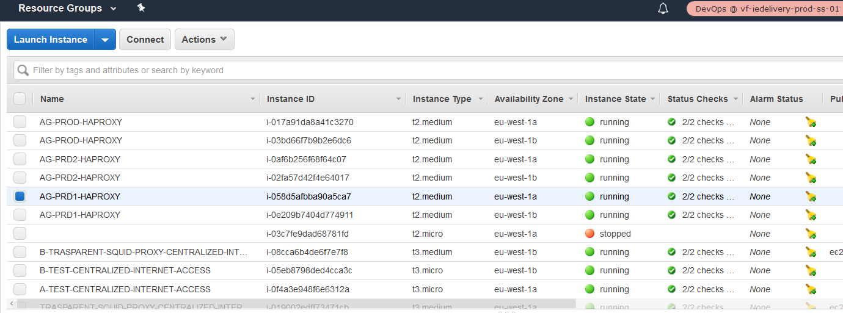

#### If we want to check the configuration:

* Go to vf-iedelivery-sharedservices-vpc. In the module lbproxy, you will find the folder haproxyconfig, with different config files, one per environment (automation in place but not used yet for this).
* If you updated it, after that, run the lambda function created for s3 synchronization between haproxy and s3: [gdc-pcs-lambda_sync_haproxy_s3-PROD](https://eu-west-1.console.aws.amazon.com/lambda/home?region=eu-west-1#/functions/gdc-pcs-lambda_sync_haproxy_s3-PROD)
* Execute manually that lambda.  In future we will be triggering it, but now it is better to just run it when need it.
* There is an important variable that manage all the haproxy configuration, go to the file called variables.tf in root and in the folder vars, in PROD.tfvars, you will see the value for those variables. The variables define the haproxy configuration, and they are used to create nlb listeners, target groups and security group rules. They are also used to create dynamically the config for haproxy, but this is still in progress (waiting for gdc name resolution to use it). Any modification must be done to those variables too.

#### Checking backend server and logs:

sudo tail -f /var/log/haproxy-traffic.log | grep -v healthcheck

sudo tail -f /var/log/haproxy-traffic.log | grep -v prod_10120

sftp -vvv -oPort=22 [msieqnx@cch-sal-sftp.prd1.ieaws.vodafone.com](mailto:msieqnx@cch-sal-sftp.prd1.ieaws.vodafone.com)

sftp -vvv -oPort=10120 msieqnx@localhost

sftp -vvv -oPort=10120 -oHostName=localhost [msieqnx@cch-sal-sftp.prd1.ieaws.vodafone.com](mailto:msieqnx@cch-sal-sftp.prd1.ieaws.vodafone.com)

curl -v localhost:port → for this you will need to update the ACL of that port, adding 127.0.0.1 and the haproxy ip address.

curl -v backendserver:port

#### Info for checking Aws CW logs:

SS TGW network interfaces:

* eni-047a452678be00bf1      198.19.221.90
* **eni-09c180fd0b84780b1      198.19.221.36**

NLB haproxy-PRD1 network interfaces:

* eni-05f2f15057c4267b2 198.19.220.118
* eni-066e62d2e13ecb495      198.19.220.42

EC2 HAPROXY PRD1 network interfaces:

* eni-0974063289181051a      198.19.220.37
* eni-04d97f93ed0343a9a      198.19.220.104

sftp ip address: 10.181.72.20 and 10.181.66.190

Sftp-prd1 nlb:

* eni-06cc41f8608f4177d - 10.181.70.36
* eni-05543cb3fefe8dfc2 - 10.181.64.228

#### STATUS NOW:

Backend servers not working:

-          20101 - JINNY-APP-PROD-VF-IE.INTERNAL.VODAFONE.COM 10.163.187.4:6543 – NOT WORKING

-          20111 - SMSC-APP-SIT1-VF-IE.INTERNAL.VODAFONE.COM 10.163.184.4:1040 – NOT WORKING

-          20112 - SMSC-APP-SIT1-VF-IE.INTERNAL.VODAFONE.COM 10.163.184.4:1050 – NOT WORKING

-          20113 - SMSC-APP-SIT1-VF-IE.INTERNAL.VODAFONE.COM 10.163.184.4:1060 – NOT WORKING

-          20114 - SMSC-APP-SIT1-VF-IE.INTERNAL.VODAFONE.COM 10.163.184.4:1070 – NOT WORKING

DNS GDC NAME RESOLUTION IS NOT WORKIN.

## 02 VF IE SHARED SERVICES VPC (MYST)

SP documentation here: <https://confluence.sp.vodafone.com/x/UHACCg>

## 03 VF IE CENTRALIZED INTERNET ACCESS VPC

**Error rendering macro 'toc'**

java.lang.RuntimeException: com.ctc.wstx.exc.WstxUnexpectedCharException: Unexpected character ';' (code 59) expected '=' at [row,col {unknown-source}]: [1,14970]

### 1. INTRODUCTION

VFIE wants to centralize the internet access for all vpc's across aws accounts. In order to do that, a vpc called 'centralized internet access' will be created in VFIE SS account. The agreed solution is to use transparent proxies. In a transparent proxy deployment, the user's client software is unaware that it is communicating with a proxy. Users request Internet content as usual, without any special client configuration, and the proxy serves their requests. The transparent proxy intercepts incoming packets, establishes a connection with the origin server and returns requested content to the client. It returns content as if it came directly from the origin server.

The software uses for in the transparent proxy is Squid. **Squid** is a caching and forwarding HTTP web proxy. A client program (e.g. browser) either has to specify explicitly the proxy server it wants to use (typical for ISP customers), or it could be using a proxy without any extra configuration: "transparent caching", in which case all outgoing HTTP requests are intercepted by Squid and all responses are cached.

The delivery of this solution will be done in different releases:

1. Architecture release 1. The internet vpc will be composed of:
   * 1 Public subnet / AZ with a route to IGW.
   * 1 Private subnet /AZ with a route to ENI of transparent proxy.
   * 1 Transparent proxy in each Public Subnet.
   * 1 EC2 instance in each private subnet to test transparent proxy.
   * TGW attachment to internet VPC and TGW route table.
2. Architecture release 2. A network load balancer and an AutoScaling group, with the transparent proxy as the launch configuration, will be added to the public subnet provide high availability and resilience.
3. Architecture release 3. All resources (network load balancer, AutoScaling group and transparent proxy) will be moved to a private subnet, with a route to a NAT GW that will be created in the public subnet.

### 2. CONFIGURATION

The code will be stored in the management account (vf-iedelivery-mgmt). A code commit repository has been created (<https://git-codecommit.eu-west-1.amazonaws.com/v1/repos/vf-iedelivery-centralized-internet>), as well as a codepipeline (<https://eu-west-1.console.aws.amazon.com/codesuite/codepipeline/pipelines/vf-iedelivery-centralized-internet-prod-tf/view?region=eu-west-1>).

### 3. VPC CIDR

The Centralized Internet VPC will have the cidr: **10.181.22.0/23**

|  |  |  |  |  |  |
| --- | --- | --- | --- | --- | --- |
| Subnet | Subnet address | Netmask | Range of addresses | Useable IPs | Hosts |
|  | 10.181.22.0/27 | 255.255.255.224 | 10.181.22.0 -   10.181.22.31 | 10.181.22.1 -   10.181.22.30 | 30 |
| **Private (Nat)** | **10.181.22.32/27** | **255.255.255.224** | **10.181.22.32 - 10.181.22.63** | **10.181.22.33 -   10.181.22.62** | **30** |
| **Private (Nat)** | **10.181.22.64/27** | **255.255.255.224** | **10.181.22.64 -   10.181.22.95** | **10.181.22.65 -   10.181.22.94** | **30** |
| **Public** | **10.181.22.96/27** | **255.255.255.224** | **10.181.22.96 - 10.181.22.127** | **10.181.22.97 -   10.181.22.126** | **30** |
| **Public** | **10.181.22.128/27** | **255.255.255.224** | **10.181.22.128 - 10.181.22.159** | **10.181.22.129 -   10.181.22.158** | **30** |
| **Private** | **10.181.22.160/27** | **255.255.255.224** | **10.181.22.160 -   10.181.22.191** | **10.181.22.161 -   10.181.22.190** | **30** |
| **Private** | **10.181.22.192/27** | **255.255.255.224** | **10.181.22.192 -   10.181.22.223** | **10.181.22.193 -   10.181.22.222** | **30** |
| **Private (Nat)** | **10.181.22.224/27** | **255.255.255.224** | **10.181.22.224 -   10.181.22.255** | **10.181.22.225 -   10.181.22.254** | **30** |
| **Private (Nat)** | **10.181.23.0/27** | **255.255.255.224** | **10.181.23.0 -   10.181.23.31** | **10.181.23.1 -   10.181.23.30** | **30** |
|  | 10.181.23.32/27 | 255.255.255.224 | 10.181.23.32 -   10.181.23.63 | 10.181.23.33 -   10.181.23.62 | 30 |
|  | 10.181.23.64/27 | 255.255.255.224 | 10.181.23.64 -   10.181.23.95 | 10.181.23.65 -   10.181.23.94 | 30 |
|  | 10.181.23.96/27 | 255.255.255.224 | 10.181.23.96 -   10.181.23.127 | 10.181.23.97 -   10.181.23.126 | 30 |
|  | 10.181.23.128/25 | 255.255.255.128 | 10.181.23.128 -   10.181.23.255 | 10.181.23.129 -   10.181.23.254 | 126 |

### 4. Intercepting traffic

In each availability zone, the route table associated to the private subnet sends the outbound traffic to the Squid instance. Squid intercepts the requested domain, then applies the following filtering policy:

* For HTTP requests, Squid retrieves the host header field included in all HTTP/1.1 request messages. This specifies the Internet host being requested.
* For HTTPS requests, the HTTP traffic is encapsulated in a TLS connection between the instance in the private subnet and the remote host. Squid cannot retrieve the host header field because the header is encrypted. A feature called [SslBump](http://wiki.squid-cache.org/Features/SslBump) would allow Squid to decrypt the traffic, but this would not be transparent for the client because the certificate would be considered invalid in most cases. The feature I use instead, called [SslPeekAndSplice](http://wiki.squid-cache.org/Features/SslPeekAndSplice), retrieves the Server Name Indication (SNI) from the TLS initiation. The SNI contains the requested Internet host. As a result, Squid can make filtering decisions without decrypting the HTTPS traffic.
* **Note 1:** Some older client-side software stacks do not support SNI. Here are the minimum versions of some important stacks and programming languages that support SNI: Python 2.7.9 and 3.2, Java 7 JSSE, wget 1.14, OpenSSL 0.9.8j, cURL 7.18.1
* **Note 2:** TLS 1.3 introduced an optional extension that allows the client to encrypt the SNI, which may prevent Squid from intercepting the requested domain.

The Peek and Splice feature looks at the TLS Client Hello message and SNI info (if any), sends an identical or similar (to the extent possible) Client Hello message to the server, and then looks at the TLS Server Hello message.The final decision to splice, bump, or terminate the connection can be made at any of those steps (but what Squid does at step N affects its ability to splice or bump at step N+1!).

|  |  |  |
| --- | --- | --- |
| **Action** | **Applicable processing steps** | **Description** |
| **peek** | step1, step2 | When a peek rule matches during step1, Squid proceeds to step2 where it parses the TLS Client Hello and extracts SNI (if any). When a peek rule matches during step 2, Squid proceeds to step3 where it parses the TLS Server Hello and extracts server certificate while preserving the possibility of splicing the client and server connections; peeking at the server certificate usually precludes future bumping (see Limitations). |
| **splice** | step1, step2, and sometimes step3 | Become a TCP tunnel without decoding the connection. The client and the server exchange data as if there is no proxy in between. |
| **stare** | step1, step2 | When a stare rule matches during step1, Squid proceeds to step2 where it parses the TLS Client Hello and extracts SNI (if any). When a stare rule matches during step2, Squid proceeds to step3 where it parses the TLS Server Hello and extracts server certificate while preserving the possibility of bumping the client and server connections; staring at the server certificate usually precludes future splicing (see Limitations). |
| **bump** | step1, step2, and sometimes step3 | Establish a TLS connection with the server (using client SNI, if any) and establish a TLS connection with the client (using a mimicked server certificate). **However**, this is not what actually happens right now if a bump rule matches during step1. See bug [4327](http://bugs.squid-cache.org/show_bug.cgi?id=4327) |
| **terminate** | step1, step2, step3 | Close client and server connections. |

### 5. Certificate

To enable this module, Squid requires that you provide a certificate, though it will not be used to decode HTTPS traffic. The solution creates a certificate using OpenSSL.

*mkdir /etc/squid/ssl*

*cd /etc/squid/ssl*

*openssl genrsa -out squid.key 4096*

*openssl req -new -key squid.key -out squid.csr -subj "/C=XX/ST=XX/L=squid/O=squid/CN=squid"*

*openssl x509 -req -days 3650 -in squid.csr -signkey squid.key -out squid.crt*

*cat squid.key squid.crt >> squid.pem*

### 6.  Squid configuration

The following code shows the Squid configuration file. For HTTPS traffic, note the ssl_bump directives instructing Squid to “peek” (retrieve the SNI) and then “splice” (become a TCP tunnel without decoding) or “terminate” the connection depending on the requested host.

*# Handling HTTP requests  
http_port 3128  
http_port 3129 intercept  
acl allowed_http_sites dstdomain "/etc/squid/whitelist.txt"  
http_access allow allowed_http_sites  
  
# Handling HTTPS requests  
https_port 3130 cert=/etc/squid/ssl/squid.pem ssl-bump intercept  
acl SSL_port port 443  
http_access allow SSL_port  
acl allowed_https_sites ssl::server_name "/etc/squid/whitelist.txt"  
acl step1 at_step SslBump1  
acl step2 at_step SslBump2  
acl step3 at_step SslBump3  
ssl_bump peek step1 all  
ssl_bump peek step2 allowed_https_sites  
ssl_bump splice step3 allowed_https_sites  
ssl_bump terminate step2 all  
http_access deny all*

### 7.  White List

A S3 bucket (named [vf-iedelivery-centralized-internet-vpc-267040142128-123456](https://s3.console.aws.amazon.com/s3/buckets/vf-iedelivery-centralized-internet-vpc-267040142128-123456?region=eu-west-1)) has been created for storing the whitelist file and the squid config file. A lambda function has been implemented to create those files automatically. The text file located at /etc/squid/whitelist.txt contains the list of whitelisted domains, with one domain per line, that list is synchronized with S3. The allowed web domains are an input in terraform code.

The solution runs the following script every minute on the Squid instances to download and update the Squid configuration from S3. This makes it easy to maintain the Squid configuration from a central location. Note that it first validates the files with squid -k parse and then reload the configuration with squid -k reconfigure if no error was found.

*cp /etc/squid/* /etc/squid/old/*

*aws s3 sync s3://<s3-bucket> /etc/squid*

*squid -k parse && squid -k reconfigure || (cp /etc/squid/old/* /etc/squid/; exit 1)*

### 8. Iptables

Squid listens on port 3129 for HTTP traffic and 3130 for HTTPS. Because Squid cannot directly listen to 80 and 443, you have to redirect the incoming requests from instances in the private subnets to the Squid ports using iptables.

*sudo iptables -t nat -A PREROUTING -p tcp --dport 80 -j REDIRECT --to-port 3129  
sudo iptables -t nat -A PREROUTING -p tcp --dport 443 -j REDIRECT --to-port 3130*

### RELEASE 1

#### 

* 1.INTRODUCTION
* 2.DESIGN
* 3. CLOUDFORMATION PARAMETERS AND USER DATA
* 4. CONNECTIVITY TEST
  + 4.1 Connectivity from EC2 instance in private subnet in Internet VPC
  + 4.2 Connectivity from EC2 instance in private subnet in a cross-account VPC

#### 1.INTRODUCTION

For the first release, just one transparent proxy will be deployed per public subnet. This design DOES NOT provide high availability and IS NOT resilience, as there are just one point of failure. However, it will be used to test the proxy configuration and that the internet traffic from a instance in another account is route to the internet VPC and redirect to the corresponding web server.

The code is stored in the management account (vf-iedelivery-mgmt). A code commit repository has been created (<https://git-codecommit.eu-west-1.amazonaws.com/v1/repos/vf-iedelivery-centralized-internet>), as well as a codepipeline (<https://eu-west-1.console.aws.amazon.com/codesuite/codepipeline/pipelines/vf-iedelivery-centralized-internet-prod-tf/view?region=eu-west-1>).

Resources created via terraform code:

* Internet VPC with cidr 10.181.22.0/23
* IGW and NAT GW
* 1 public subnet per AZ
* 1 private subnet per AZ with internet access through NAT GW (it is not shown in below design because it is not used in this release)
* 1 private subnet per AZ.
* All corresponding route tables per subnet and routes.
* SSM endpoints (ssm, ec2, ec2messages, ssmmessages, s3 endpoints) and corresponding security groups and IAM role for EC2.
* CloudFormation stack with proxy configuration:
* S3 bucket vf-iedelivery-centralized-internet-vpc-267040142128-123456
* Lambda function (and corresponding IAM role for lambda) to add automatically proxy config file and whitelist as S3 object in above S3 bucket.
* Whitelist and squid config as Custom::S3Object. Configuration here.
* Security group to allow HTTP and HTTPS traffic from private instances (VFIE cidr = 10.181.0.0/16) to Proxy instances.
* Security group to allow outbound HTTP and HTTPS traffic in private instances.
* Proxy Instance with a network interface (public IP) and user data to install and start squid software.
* Test Instance in private subnets to test internet connectivity inside Internet VPC.
* New route added in private subnet route table: 0.0.0.0/0 → Proxy instance

Additionally, the transit gateway repository (<https://eu-west-1.console.aws.amazon.com/codesuite/codecommit/repositories/vf-iedelivery-transit-gateway/browse?region=eu-west-1>) has been also modified to add:

* New TGW VPC attachment to Centralized Internet VPC, where the vpc id is "vpc-066cf10e6e20a84cc" and subnets ids (private subnets) are "subnet-059861dbd8424d4dd" and "subnet-06adf1cd74fc855fc".
* Corresponding TGW Route table for Centralized Internet VPC, that has route to all environments but SS VPC. Meaning Centralized Internet VPC can send traffic to test, pre-prod and prod.
* Test, pre-prod and prod VPC default routes (0.0.0.0/0) point now to Internet VPC.
* Internet VPC route tables have been modified to add routes with destination prod, pre-prod and test cidr and target TGW.

#### 2.DESIGN

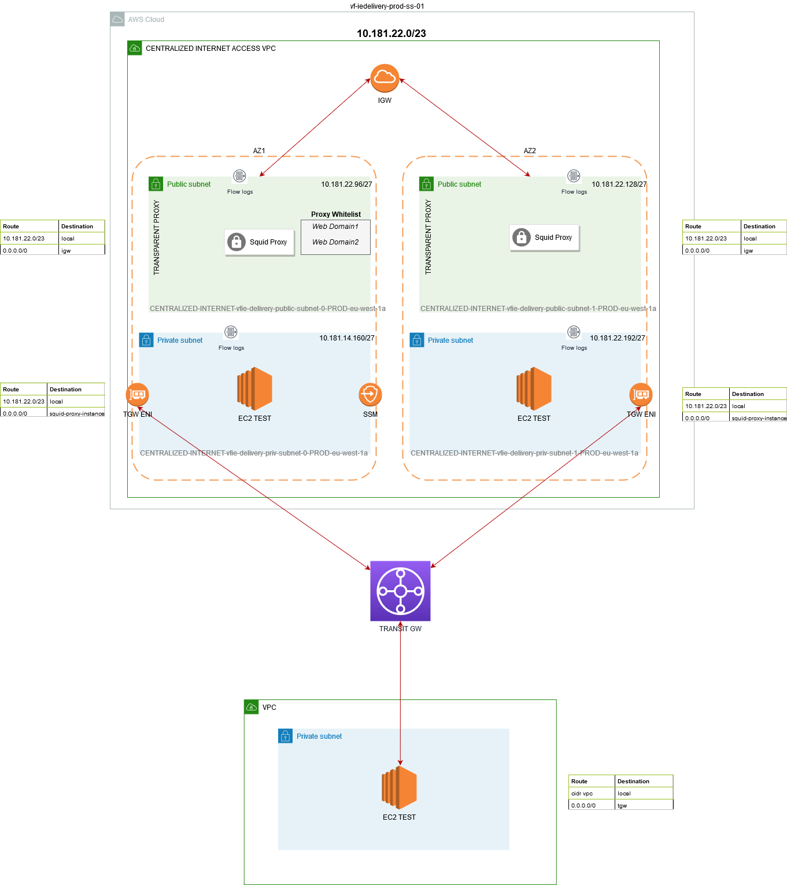

#### 3. CLOUDFORMATION PARAMETERS AND USER DATA

These are the parameters that terraform passes to the cloudformation stack

*parameters = {*  
*AmiId = var.hardened_linux_amazon_2_AMI*  
*InstanceType = "t3.medium"*  
*WhitelistDomains = ".amazon.com, .vodafone.com, .google.com, .amazonaws.com" #testing purposes*  
*VPC    = aws_vpc.internet_vpc.id*  
*VFIECidrBlock    = "10.181.0.0/16"*  
*PrivateSubnetA  =  element(aws_subnet.internet_subnet_priv.*.id , 0)*  
*PrivateSubnetB  =  element(aws_subnet.internet_subnet_priv.*.id , 1)*  
*PublicSubnetA   =  element(aws_subnet.internet_subnet_public.*.id , 0)*  
*PublicSubnetB   =  element(aws_subnet.internet_subnet_public.*.id , 1)*  
*LoggingBucket   = local.logging_bucket["name"]*  
*NATInstanceProfile = aws_iam_instance_profile.ec2_ssm.id*  
*SSMsecurityGroupId = aws_security_group.ssm_endpoint_sg.id*  
*PrivateRouteTableAId = element(aws_route_table.subnet_priv_route_table.*.id, 0)*  
*PrivateRouteTableBId = element(aws_route_table.subnet_priv_route_table.*.id, 1)*  
*}*

And this is the user data of the transparent proxy:

*#!/bin/bash -xe*  
*sudo yum update -y --security*

*#disable source / destination check in proxy instance*  
*instanceid=`curl -s* [*http://169.254.169.254/latest/meta-data/instance-id*](http://169.254.169.254/latest/meta-data/instance-id)*`*  
*aws ec2 modify-instance-attribute --no-source-dest-check --instance-id $instanceid --region eu-west-1*

*#Install and Start proxy*

*sudo yum install -y squid*  
*sudo systemctl start squid || service squid start*  
*sudo iptables -t nat -A PREROUTING -p tcp --dport 80 -j REDIRECT --to-port 3129*  
*sudo iptables -t nat -A PREROUTING -p tcp --dport 443 -j REDIRECT --to-port 3130*

*#create a certificate for the sslBump squid module*  
*sudo mkdir /etc/squid/ssl*  
*sudo openssl genrsa -out /etc/squid/ssl/squid.key 4096*  
*sudo openssl req -new -key /etc/squid/ssl/squid.key -out /etc/squid/ssl/squid.csr -subj "/C=XX/ST=XX/L=squid/O=squid/CN=squid"*  
*sudo openssl x509 -req -days 3650 -in /etc/squid/ssl/squid.csr -signkey /etc/squid/ssl/squid.key -out /etc/squid/ssl/squid.crt*  
*sudo touch /etc/squid/ssl/squid.pem*  
*sudo chmod 777 /etc/squid/ssl/squid.pem*  
*sudo cat /etc/squid/ssl/squid.key /etc/squid/ssl/squid.crt >> /etc/squid/ssl/squid.pem*

*#Refres the configuration from S3*

*sudo mkdir /etc/squid/old*  
*sudo touch /etc/squid/squid-conf-refresh.sh*  
*sudo chmod 777 /etc/squid/squid-conf-refresh.sh*  
*sudo cat > /etc/squid/squid-conf-refresh.sh << 'EOF'*  
*sudo cp /etc/squid/* /etc/squid/old/*  
*sudo aws s3 sync s3://${S3Bucket} /etc/squid*  
*sudo /usr/sbin/squid -k parse && /usr/sbin/squid -k reconfigure || (cp /etc/squid/old/* /etc/squid/; exit 1)*  
*EOF*  
*sudo chmod +x /etc/squid/squid-conf-refresh.sh*  
*sudo /etc/squid/squid-conf-refresh.sh*  
  
*# Schedule tasks*  
*sudo cat > ~/mycron << 'EOF'*  
*\* * * * * /etc/squid/squid-conf-refresh.sh*  
*0 0 * * * sleep $(($RANDOM % 3600)); yum -y update --security*  
*0 0 * * * /usr/sbin/squid -k rotate*  
*EOF*  
*sudo crontab ~/mycron*  
*sudo rm ~/mycron*

#### 4. CONNECTIVITY TEST

##### 4.1 Connectivity from EC2 instance in private subnet in Internet VPC

Accessing allowed domains:

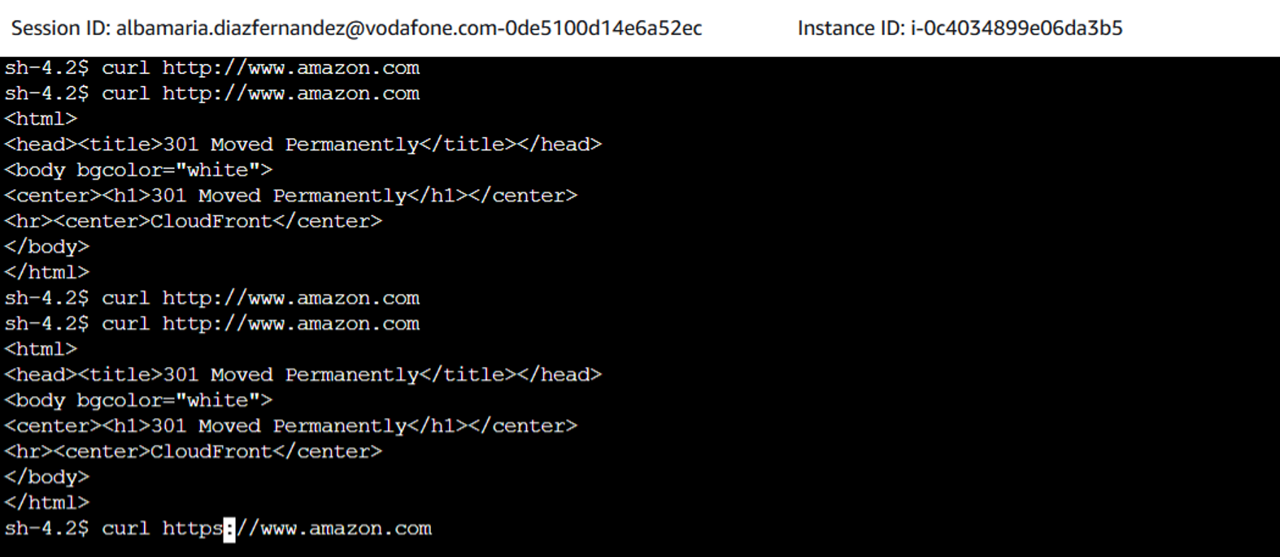

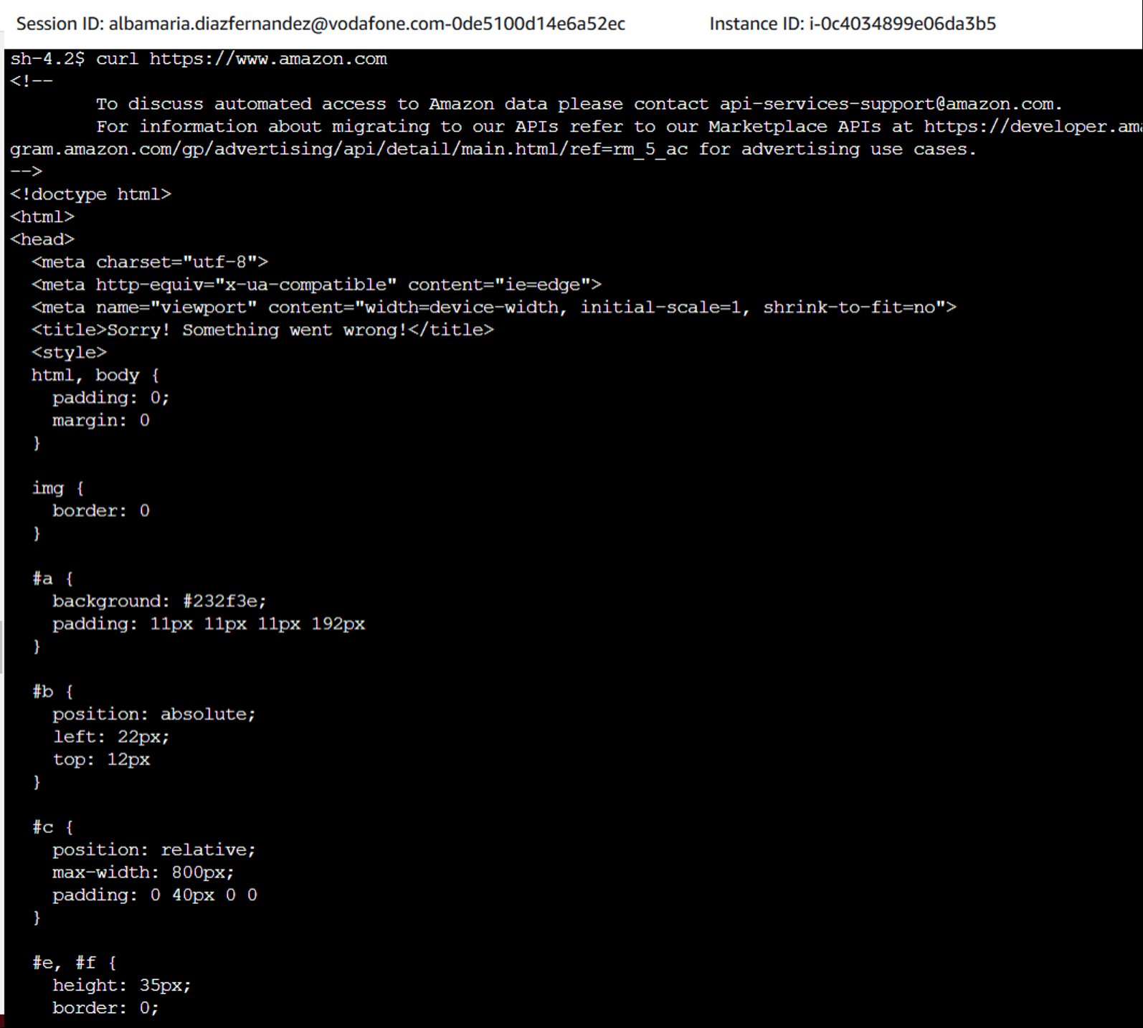

Trying to access not allowed domains:

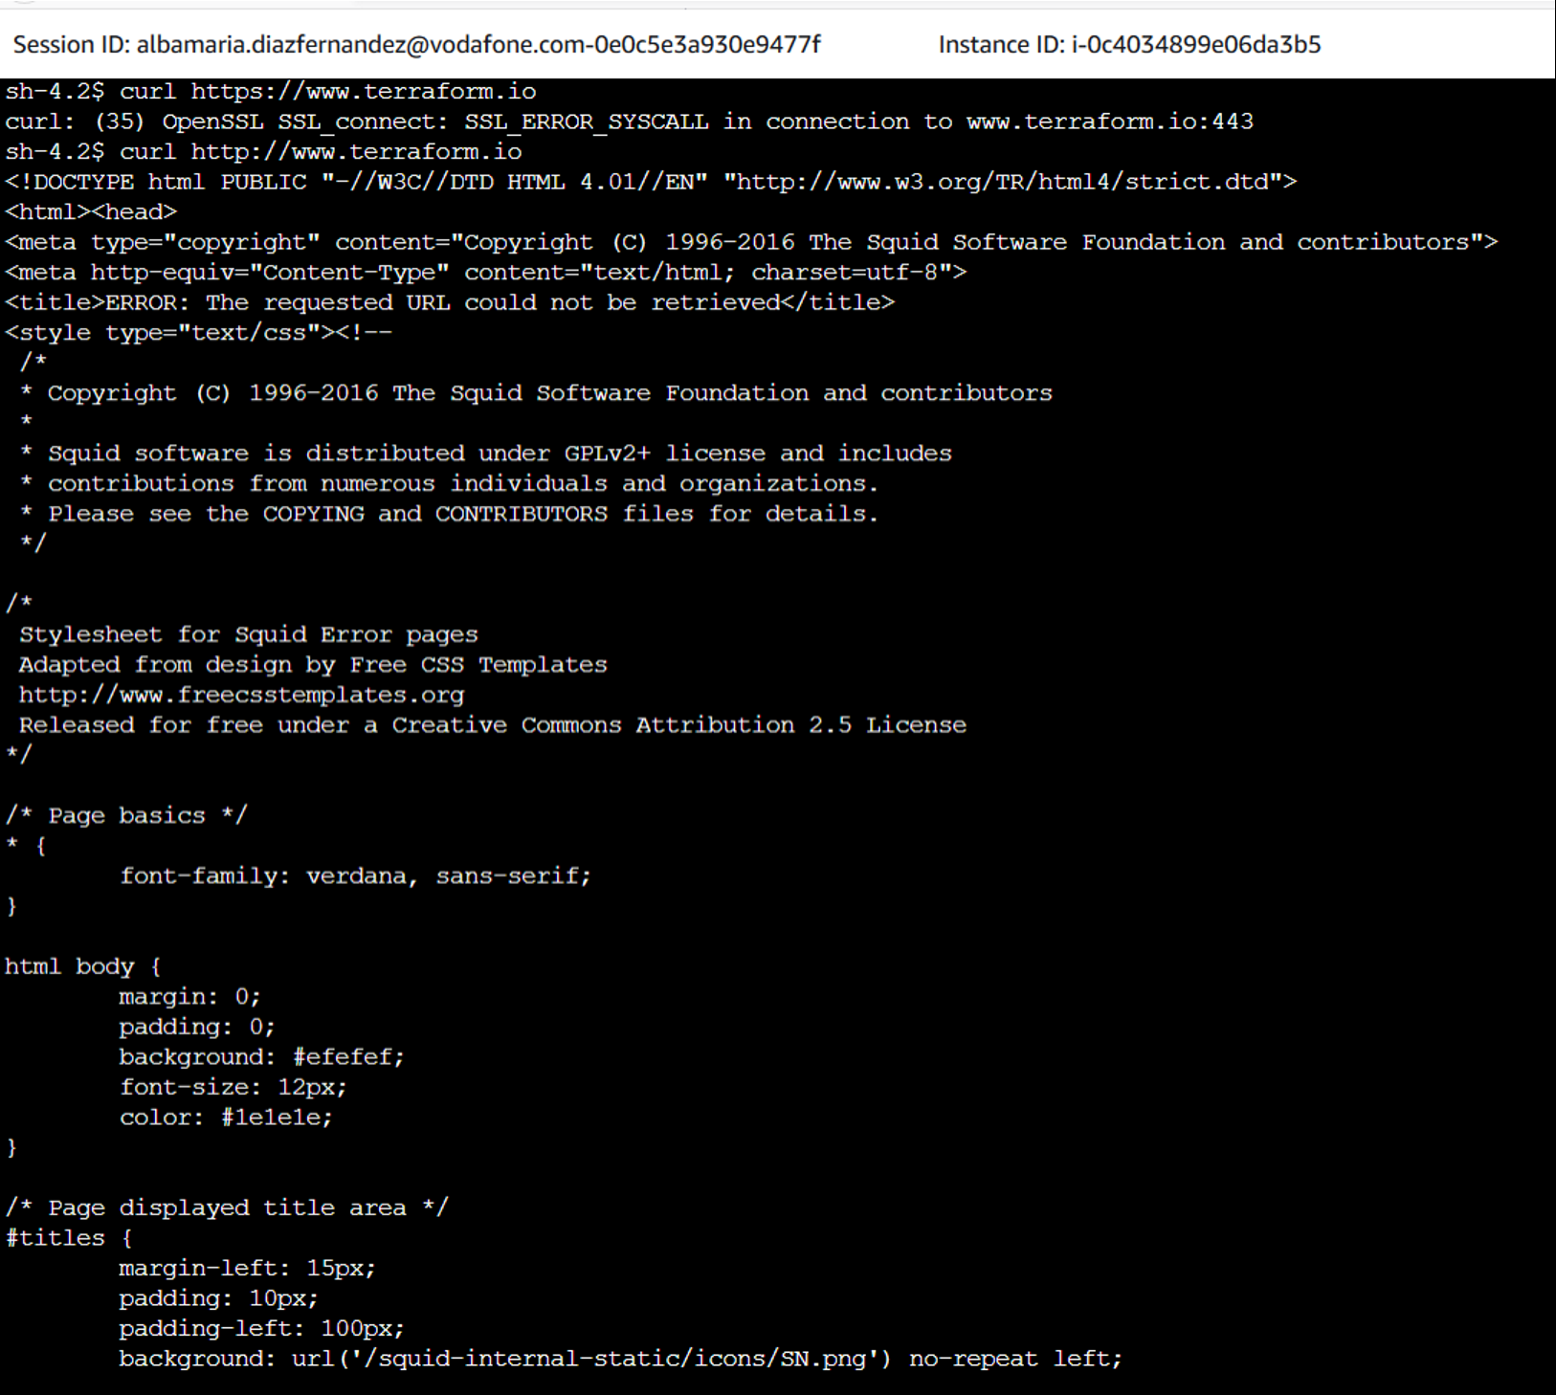

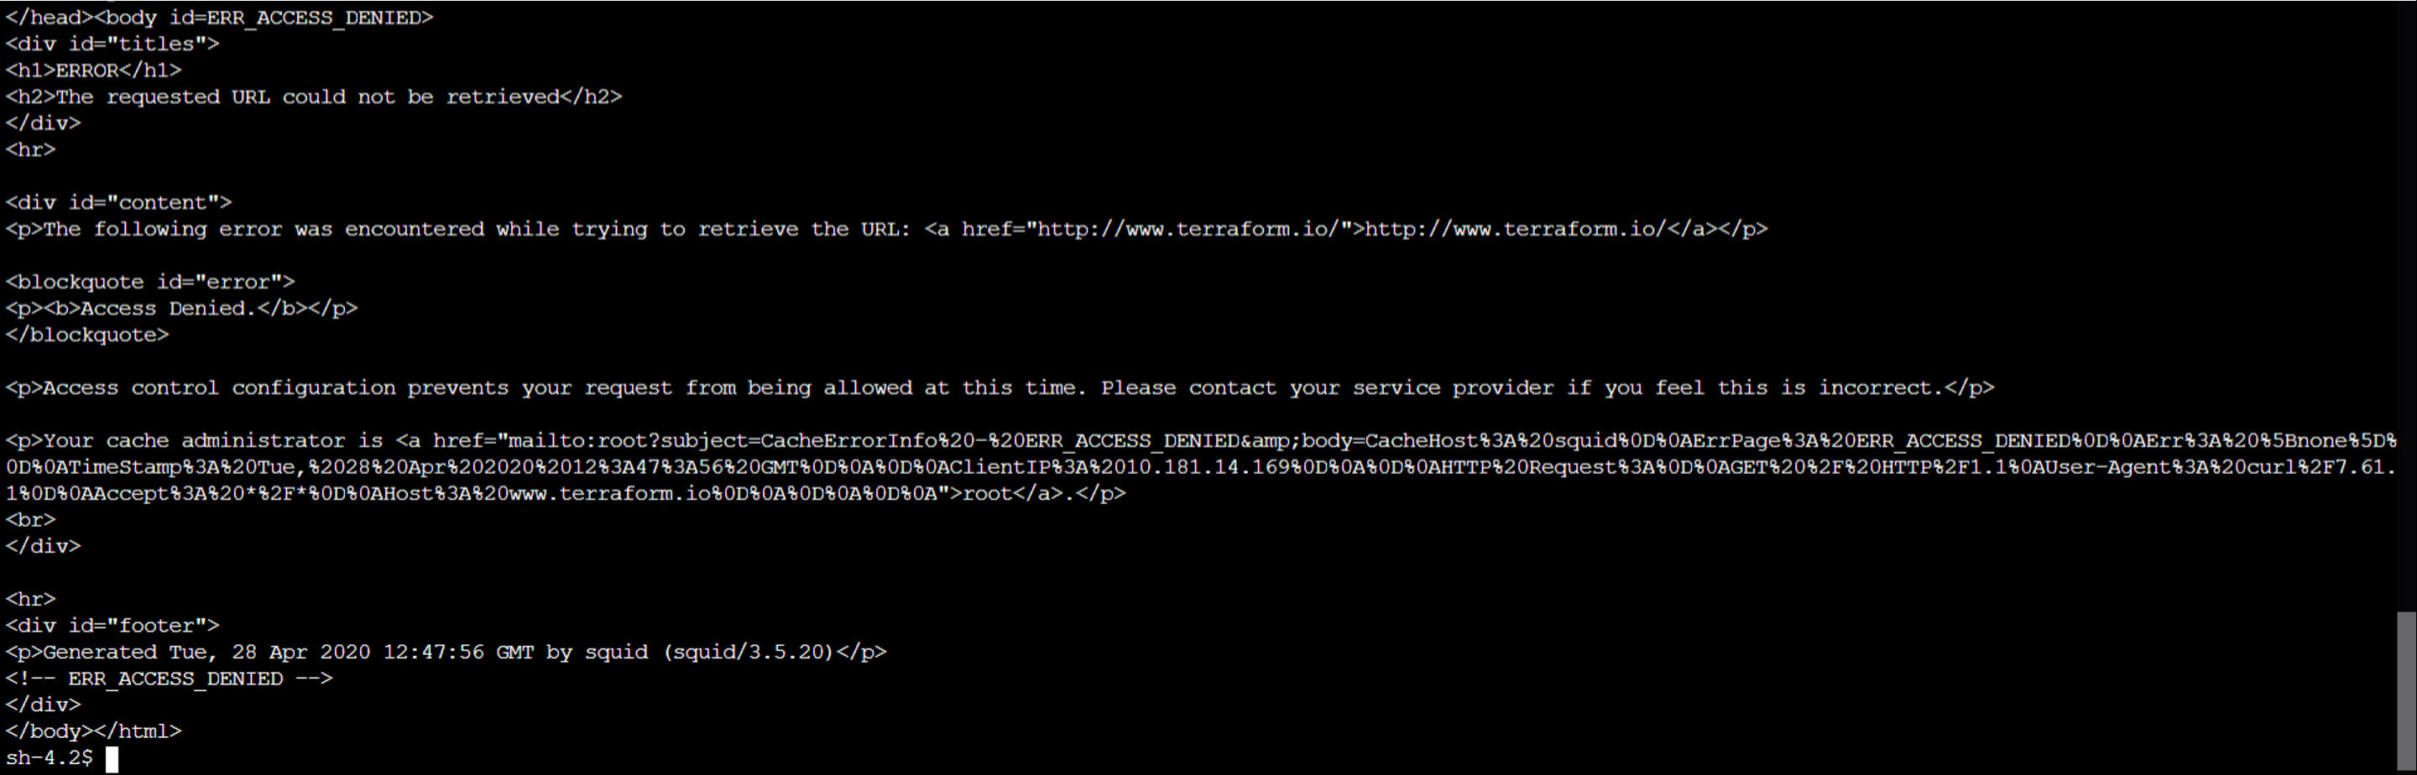

The connectivity from an EC2 in another AZ is the same.

##### 4.2 Connectivity from EC2 instance in private subnet in a cross-account VPC

A test EC2 instance has been used to check connectivity:

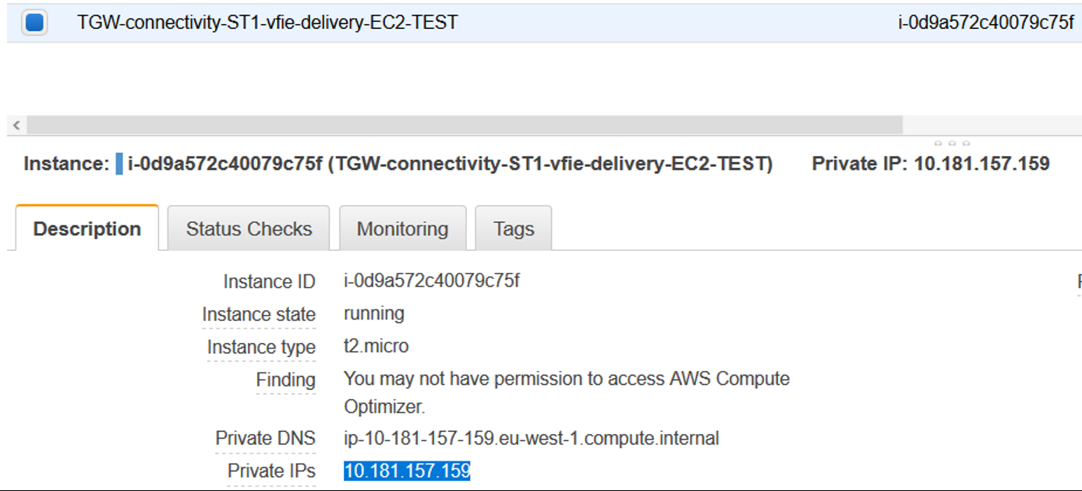

With route table:

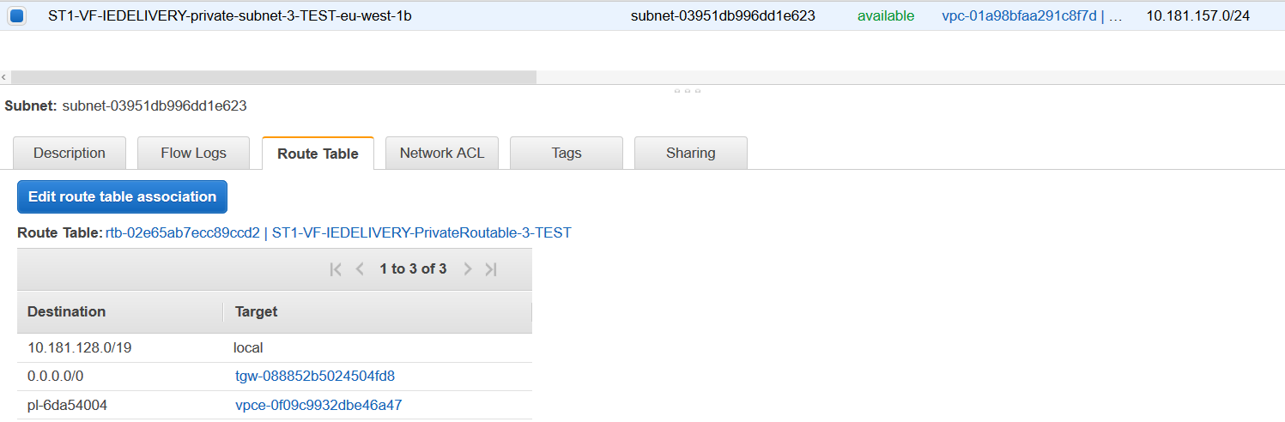

If we create an SSM session with that instance, and then we type "curl http://www.amazon.com", "curl https://www.amazon.com" and "curl http://terraform.io" (the first two are allowed, but the third one is not allowed), we will see similar results than in 4.1. We can analyse the traffic if we access the log group created for the internet vpc (<https://eu-west-1.console.aws.amazon.com/cloudwatch/home?region=eu-west-1#logStream:group=vpc/centralized-internet-vpc-log-group>). If we access Insights in CloudWatch and we filter with the ip address of the test EC2 instance (10.181.157.159) we can see the traffic, and that it has been accepted. We can also see to which eni the traffic has been routed.

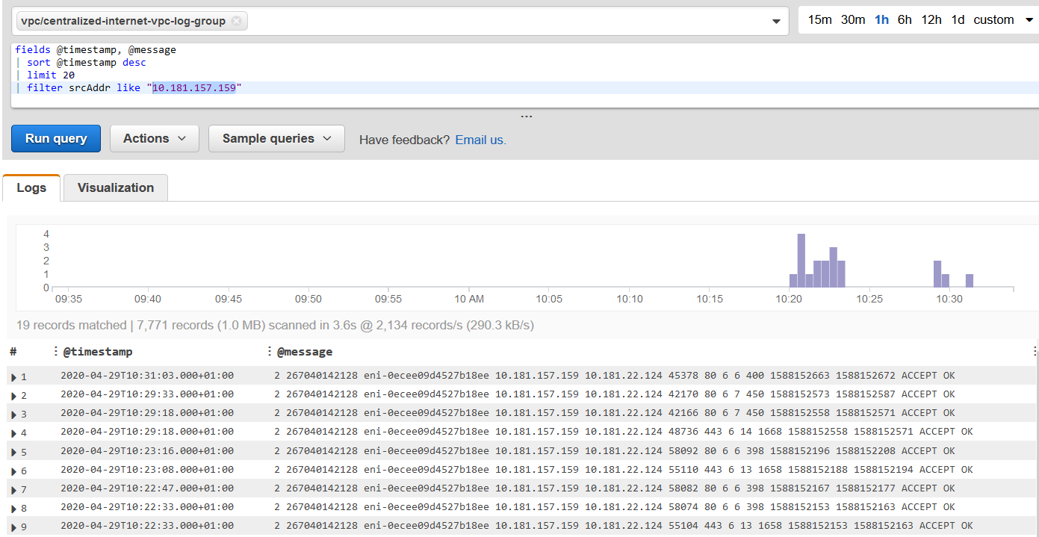

### 1.CHANGES

#### 1.1.Security

In order to increment the security for this architecture, the transparent proxies have been moving into a **private subnet with NAT GW access**. The corresponding connectivity tests have been done to check that everything works as expected.

#### 2.1.High Availability and Fault Tolerance - Solution 1

In order to provide High availability and fault tolerance, the following solution has been tested:

* Creation of a network load balancer with a listener on port 80 and protocol TCP.
* Target group for instance type (transparent proxy).
* Auto Scaling group with proxy configuration as launch configuration.

The main idea was to redirect the traffic from the private subnet where the traffic from the TGW came, to the transparent proxy instance, that will have a network load balancer in front. So, the route table for the private subnet with TGW ENI was modified, using as destination for the default route (0.0.0.0/0) the NLB ENI that is created by AWS when the NLB is created and deployed in a AZ.

**Problem**: the NLB ENI created by AWS is not meant to be used as the next hop in the route table, as it is used internally by the NLB when this resource is re-directing traffic between different AZ. AWS-managed ENI are not modifiable, so it is not possible to add any security group to this interface. The result is that, the traffic reaches the NLB ENI, but after that, it is dropped, so it never reached the transparent proxy.

#### 3.1. AWS Workspace

As a temporary solution for testing purposes, the project needs to deploy AWS Workspaces. Two additional private subnets with Internet Access through the NAT GW have been deployed. All the routing logic to connect the Internet VPC with the rest of environment vpc's have been implemented.

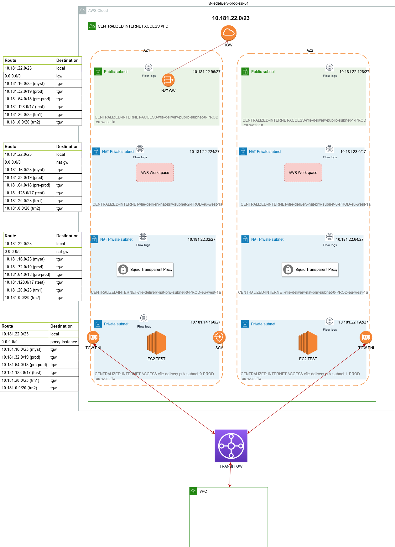

### Transparant Proxy Whitelist

|  |  |
| --- | --- |
| Whitelist |  |
| AWS Endpoints | .amazonaws.com |
| Yum | .aws.ce.redhat.com |
| Artifactory Repositories | .bintray.io |

## 04 VF IE PORT RANGES

To standardise the ranges being used by each application, the below port ranges have been assigned on a per application basis. This applies to application flows in both directions with ranges being assigned to on-prem applications as well.

Please add additional ranges as required when new applications are required.

|  |  |
| --- | --- |
| **PORTS** | |
| **APP** | **Port Range** |
| CCH | 10000 - 10999 |
| FSL VFIE Legacy | 11000 - 11099 |
| FSL AWS | 11100 - 11199 |
| MEH | 12000 - 12999 |
| UFE | 13000 - 13999 |
| CIAM | 14000 - 14999 |
| OSB | 15000 - 15999 |
| MFT | 16000 - 16999 |
| MEDIAROOM | 17000 - 17999 |
| GISMSH | 18000 - 18999 |
| TIBCO | 19000 - 19999 |
| I1 PROXY (JINNY / SMSC / RADIUS) | 20000 - 20999 |
| CDIRECT | 21000 - 21999 |
| MML | 22000 - 22999 |
| AUA | 23000 - 23999 |
| EPRS | 24000 - 24999 |
| MEDIATION ZONE | 25000 - 25999 |
| CIAM | 26000 - 26999 |
| BSS | 27000 - 27999 |
| LOTUS NOTES | 28000 - 28999 |
| TOOLING | 29000 - 29999 |
| VBOL | 30000 - 30999 |
| VTV | 31000 - 31999 |
| BOP | 32000 - 32999 |
| WRM a.k.a ROBIGA | 34000 - 34099 |
| VFGP DMaaS NiFi | 34100 - 34199 |
| LDR | 34200 - 34299 |
| MIS | 34300 - 34399 |
| LEA | 34400 - 34499 |
| MEC | 34500 - 34599 |
| WEDO/RA | 34600 - 34699 |
| ER-IF | 34700 - 34799 |
| HGW | 34800 - 34899 |
| SVA | 34900 - 34999 |
| DPC | 35000 - 35099 |
| DRCC OCI | 35100 - 35199 |
| TURBO CHARGING | 35200 - 35299 |
| DRA | 35300 - 35399 |
| PCRF | 35400 - 35499 |
| Technotree | 35500 - 35599 |
| NGIN | 35600 - 35699 |
| E///PG | 35700 - 35799 |
| NPT | 35800 - 35899 |
| ESIGN | 36000 - 36999 |
| OneApp | 37000 - 37099 |
| Singleserve | 37100 - 37199 |
| Bill Archive Manager | 37200 - 37299 |
| GNP | 38000 - 38099 |
| GNM | 38100 - 38199 |
| EVO | 40200 - 40299 |
| POLLERS | 40100 - 40199 |
| PORTAL | 48000 - 48099 |
| Security / Pentest | 60000-60999 |
| FinHub | 48100 - 48199 |
| WEF | 48200 - 48299 |
| entitee | 48300 - 48399 |
| mTAS | 48400 - 48499 |
| IP Works | 48500 - 48599 |
| Radius | 48600 - 48699 |
| Optenet | 48700 - 48799 |
| SecureNet | 48800 - 48899 |
| CaaS DXL | 49000 - 49099 |
| TaaS | 49100 - 49199 |
| Grafana | 49200 - 49299 |
| SOM | 49300 - 49399 |
| OMS | 49400 - 49499 |

## 05 VF IE NLB DESIGN

* Overview
* Solution Design
* DNS Configuration
  + Current Configuration
  + New Configuration
* NLB Configuration
  + Overview
  + Production
    - Summary
    - Target Groups
  + PRD1
    - Summary
    - Target Groups
  + PRD2
    - Summary
    - Target Groups
  + SIT1
    - Summary
    - Target Groups
  + SIT2
    - Summary
    - Target Groups
  + SIT3
    - Summary
    - Target Groups
  + SIT4
    - Summary
    - Target Groups
  + DEV1
    - Summary
    - Target Groups
* Open Queries

### Overview

The Shared Services NLBs provide access into all the VFIE AWS Hosted applications, and directs the communication based on the ports used in the flow. The NLB that is hit is based on the FQDN of the request with an NLB created per account.

Under the current implementation, there is an AWS hard limit of 50 ports per NLB which we are quickly approaching. There is no option to increase this limit so it has been proposed to create additional NLB's and break down the inbound and outboundPr flows based on the traffic type. This will greatly increase the bandwidth in regards ports in use. In the future, AWS may increase this port limit but this solution should cover us until this happens.

### Solution Design

Reference: [98c - Solution Design - VCI Public Cloud Services - Vodafone Global Confluence](https://confluence.sp.vodafone.com/pages/viewpage.action?spaceKey=GPCS&title=98c+-+Solution+Design) (PCS Internal)

### DNS Configuration

#### Current Configuration

|  |  |  |
| --- | --- | --- |
| Traffic Type | Wildcard DNS | Destination NLB |
| INBOUND | *.<ENV>.ieaws.vodafone.com | VF-IEDELIVERY-SS-<ENV>-NLB |
| OUTBOUND | <ENV>.haproxy.ieaws.vodafone.com | VF-IEDELIVERY-SS-<ENV>-NLB |

#### New Configuration

|  |  |  |  |  |
| --- | --- | --- | --- | --- |
| Traffic Type | Wildcard DNS | Destination NLB | Status | Comments |
| INBOUND GUI | *.<ENV>.ieaws.vodafone.com | VF-IEDELIVERY-SS-<ENV>-NLB | Existing |  |
| INBOUND API | *.<ENV>-apii.ieaws.vodafone.com  *.[sit3-apii.ieaws.vodafone.com](http://sit3-api.ieaws.vodafone.com) | VF-IEDELIVERY-SS-<ENV>-API-NLB  VF-IEDELIVERY-SS-<ENV>-APII-NLB | New |  |
| INBOUND SFTP | *.<ENV>-sftp.ieaws.vodafone.com  *.[sit3-sfti.ieaws.vodafone.com](http://sit3-apio.ieaws.vodafone.com) | VF-IEDELIVERY-SS-<ENV>-SFTP-NLB  VF-IEDELIVERY-SS-<ENV>-SFTI-NLB | New |  |
| INBOUND DB | *.<ENV>-DB.ieaws.vodafone.com  *.[sit3-dbi.ieaws.vodafone.com](http://sit3-api.ieaws.vodafone.com) | VF-IEDELIVERY-SS-<ENV>-DB-NLB  VF-IEDELIVERY-SS-<ENV>-DBI-NLB | New |  |
| OUTBOUND API | <ENV>-api-out.ssnlb.ieaws.vodafone.com | VF-IEDELIVERY-SS-<ENV>-API-OUT-NLB  VF-IEDELIVERY-SS-<ENV>-APIO-NLB | New |  |
| OUTBOUND SFTP | <ENV>-sftp-out.ssnlb.ieaws.vodafone.com | VF-IEDELIVERY-SS-<ENV>-SFTP-OUT-NLB  VF-IEDELIVERY-SS-<ENV>-SFTO-NLB | New |  |
| OUTBOUND DB | <ENV>-db-out.ssnlb.ieaws.vodafone.com | VF-IEDELIVERY-SS-<ENV>-DB-OUT-NLB  VF-IEDELIVERY-SS-<ENV>-DBO-NLB | New |  |

### NLB Configuration

#### Overview

Under the new design, the NLB's will be broken down into 7 distinct NLB's per environment. All inbound and outbound interfaces should go via these new NLB's.

#### Production

##### Summary

|  |  |
| --- | --- |
| **Destination NLB** | **Count** |
| VF-IEDELIVERY-SS-PROD-NLB | 8 |
| VF-IEDELIVERY-SS-PROD-API-NLB | 7 |
| VF-IEDELIVERY-SS-PROD-SFTP-NLB | 5 |
| VF-IEDELIVERY-SS-PROD-DB-NLB | 9 |
| VF-IEDELIVERY-SS-PROD-API-OUT-NLB | 15 |
| VF-IEDELIVERY-SS-PROD-SFTP-OUT-NLB | 9 |
| VF-IEDELIVERY-SS-PROD-DB-OUT-NLB | 5 |
| N/A | 3 (Needs removal?) |

##### Target Groups

|  |  |  |  |  |  |  |  |  |
| --- | --- | --- | --- | --- | --- | --- | --- | --- |
| **Name** | **Port** | **Protocol** | **Target type** | **Existing Load balancer** | **New Load balancer** | **Direction** | **Destination IP** | **Comment** |
| [SS-PROD-from-10301-to-443](https://eu-west-1.console.aws.amazon.com/ec2/home?region=eu-west-1#TargetGroup:targetGroupArn=arn:aws:elasticloadbalancing:eu-west-1:267040142128:targetgroup/SS-PROD-from-10301-to-443/8cce045b6e71e5a7) | 443 | TCP | IP | VF-IEDELIVERY-SS-PROD-NLB | N/A | INBOUND | N/A | Can be removed |
| [SS-PROD-from-10302-to-443](https://eu-west-1.console.aws.amazon.com/ec2/home?region=eu-west-1#TargetGroup:targetGroupArn=arn:aws:elasticloadbalancing:eu-west-1:267040142128:targetgroup/SS-PROD-from-10302-to-443/77d31edc50f477e3) | 443 | TCP | IP | VF-IEDELIVERY-SS-PROD-NLB | N/A | INBOUND | N/A | Can be removed |
| [SS-PROD-from-10303-to-443](https://eu-west-1.console.aws.amazon.com/ec2/home?region=eu-west-1#TargetGroup:targetGroupArn=arn:aws:elasticloadbalancing:eu-west-1:267040142128:targetgroup/SS-PROD-from-10303-to-443/bd6073c8ad5758d4) | 443 | TCP | IP | VF-IEDELIVERY-SS-PROD-NLB | N/A | INBOUND | N/A | Can be removed |
| [SS-PROD-from-30201-to-9443](https://eu-west-1.console.aws.amazon.com/ec2/home?region=eu-west-1#TargetGroup:targetGroupArn=arn:aws:elasticloadbalancing:eu-west-1:267040142128:targetgroup/SS-PROD-from-30201-to-9443/3959d1396fd79a61) | 9443 | TCP | IP | VF-IEDELIVERY-SS-PROD-NLB | VF-IEDELIVERY-SS-PROD-API-NLB | INBOUND | N/A |  |
| [SS-PROD-from-8011-to-8011](https://eu-west-1.console.aws.amazon.com/ec2/home?region=eu-west-1#TargetGroup:targetGroupArn=arn:aws:elasticloadbalancing:eu-west-1:267040142128:targetgroup/SS-PROD-from-8011-to-8011/53b1d66cdacceff9) | 8011 | TCP | IP | VF-IEDELIVERY-SS-PROD-NLB | VF-IEDELIVERY-SS-PROD-API-NLB | INBOUND | N/A |  |
| [SS-PROD-from-11001-to-7004](https://eu-west-1.console.aws.amazon.com/ec2/home?region=eu-west-1#TargetGroup:targetGroupArn=arn:aws:elasticloadbalancing:eu-west-1:267040142128:targetgroup/SS-PROD-from-11001-to-7004/af1a20f098cd6352) | 7004 | TCP | IP | VF-IEDELIVERY-SS-PROD-NLB | VF-IEDELIVERY-SS-PROD-API-OUT-NLB | OUTBOUND |  | FSL being migrated to AWS so temporary |
| [SS-PROD-from-12103-to-16443](https://eu-west-1.console.aws.amazon.com/ec2/home?region=eu-west-1#TargetGroup:targetGroupArn=arn:aws:elasticloadbalancing:eu-west-1:267040142128:targetgroup/SS-PROD-from-12103-to-16443/756172d063213aef) | 16443 | TCP | IP | VF-IEDELIVERY-SS-PROD-NLB | VF-IEDELIVERY-SS-PROD-API-OUT-NLB | OUTBOUND |  |  |
| [SS-PROD-from-13001-to-8005](https://eu-west-1.console.aws.amazon.com/ec2/home?region=eu-west-1#TargetGroup:targetGroupArn=arn:aws:elasticloadbalancing:eu-west-1:267040142128:targetgroup/SS-PROD-from-13001-to-8005/861b6b65f44f2a8c) | 8005 | TCP | IP | VF-IEDELIVERY-SS-PROD-NLB | VF-IEDELIVERY-SS-PROD-API-OUT-NLB | OUTBOUND |  |  |
| [SS-PROD-from-15101-to-30050](https://eu-west-1.console.aws.amazon.com/ec2/home?region=eu-west-1#TargetGroup:targetGroupArn=arn:aws:elasticloadbalancing:eu-west-1:267040142128:targetgroup/SS-PROD-from-15101-to-30050/aadb405576f192ff) | 30050 | TCP | IP | VF-IEDELIVERY-SS-PROD-NLB | VF-IEDELIVERY-SS-PROD-API-OUT-NLB | OUTBOUND |  |  |
| [SS-PROD-from-20101-to-6543](https://eu-west-1.console.aws.amazon.com/ec2/home?region=eu-west-1#TargetGroup:targetGroupArn=arn:aws:elasticloadbalancing:eu-west-1:267040142128:targetgroup/SS-PROD-from-20101-to-6543/9e1010afc24cc70c) | 6543 | TCP | IP | VF-IEDELIVERY-SS-PROD-NLB | VF-IEDELIVERY-SS-PROD-API-OUT-NLB | OUTBOUND |  |  |
| [SS-PROD-from-20111-to-1040](https://eu-west-1.console.aws.amazon.com/ec2/home?region=eu-west-1#TargetGroup:targetGroupArn=arn:aws:elasticloadbalancing:eu-west-1:267040142128:targetgroup/SS-PROD-from-20111-to-1040/44ebe0867f9ce3cf) | 1040 | TCP | IP | VF-IEDELIVERY-SS-PROD-NLB | VF-IEDELIVERY-SS-PROD-API-OUT-NLB | OUTBOUND |  |  |
| [SS-PROD-from-20112-to-1050](https://eu-west-1.console.aws.amazon.com/ec2/home?region=eu-west-1#TargetGroup:targetGroupArn=arn:aws:elasticloadbalancing:eu-west-1:267040142128:targetgroup/SS-PROD-from-20112-to-1050/0307563b6ec29ce6) | 1050 | TCP | IP | VF-IEDELIVERY-SS-PROD-NLB | VF-IEDELIVERY-SS-PROD-API-OUT-NLB | OUTBOUND |  |  |
| [SS-PROD-from-20113-to-1060](https://eu-west-1.console.aws.amazon.com/ec2/home?region=eu-west-1#TargetGroup:targetGroupArn=arn:aws:elasticloadbalancing:eu-west-1:267040142128:targetgroup/SS-PROD-from-20113-to-1060/f927481f472b0023) | 1060 | TCP | IP | VF-IEDELIVERY-SS-PROD-NLB | VF-IEDELIVERY-SS-PROD-API-OUT-NLB | OUTBOUND |  |  |
| [SS-PROD-from-20114-to-1070](https://eu-west-1.console.aws.amazon.com/ec2/home?region=eu-west-1#TargetGroup:targetGroupArn=arn:aws:elasticloadbalancing:eu-west-1:267040142128:targetgroup/SS-PROD-from-20114-to-1070/d16077da617a4f28) | 1070 | TCP | IP | VF-IEDELIVERY-SS-PROD-NLB | VF-IEDELIVERY-SS-PROD-API-OUT-NLB | OUTBOUND |  |  |
| [SS-PROD-from-29001-to-8090](https://eu-west-1.console.aws.amazon.com/ec2/home?region=eu-west-1#TargetGroup:targetGroupArn=arn:aws:elasticloadbalancing:eu-west-1:267040142128:targetgroup/SS-PROD-from-29001-to-8090/785619767644ee91) | 8090 | TCP | IP | VF-IEDELIVERY-SS-PROD-NLB | VF-IEDELIVERY-SS-PROD-API-OUT-NLB | OUTBOUND |  |  |
| [SS-PROD-from-29002-to-8090](https://eu-west-1.console.aws.amazon.com/ec2/home?region=eu-west-1#TargetGroup:targetGroupArn=arn:aws:elasticloadbalancing:eu-west-1:267040142128:targetgroup/SS-PROD-from-29002-to-8090/4f19e594acb1148b) | 8090 | TCP | IP | VF-IEDELIVERY-SS-PROD-NLB | VF-IEDELIVERY-SS-PROD-API-OUT-NLB | OUTBOUND |  |  |
| [SS-PROD-from-29003-to-8181](https://eu-west-1.console.aws.amazon.com/ec2/home?region=eu-west-1#TargetGroup:targetGroupArn=arn:aws:elasticloadbalancing:eu-west-1:267040142128:targetgroup/SS-PROD-from-29003-to-8181/6420d73ce843c1ac) | 8181 | TCP | IP | VF-IEDELIVERY-SS-PROD-NLB | VF-IEDELIVERY-SS-PROD-API-OUT-NLB | OUTBOUND |  |  |
| [SS-PROD-from-30053-to-30053](https://eu-west-1.console.aws.amazon.com/ec2/home?region=eu-west-1#TargetGroup:targetGroupArn=arn:aws:elasticloadbalancing:eu-west-1:267040142128:targetgroup/SS-PROD-from-30053-to-30053/4d6ea49c99cd499d) | 30053 | TCP | IP | VF-IEDELIVERY-SS-PROD-NLB | VF-IEDELIVERY-SS-PROD-API-OUT-NLB | OUTBOUND |  | OSB API - Should assign updtaed port to align with design - 15102? |
| [SS-PROD-from-10304-to-1521](https://eu-west-1.console.aws.amazon.com/ec2/home?region=eu-west-1#TargetGroup:targetGroupArn=arn:aws:elasticloadbalancing:eu-west-1:267040142128:targetgroup/SS-PROD-from-10304-to-1521/10acaaa4a0a129a9) | 1521 | TCP | IP | VF-IEDELIVERY-SS-PROD-NLB | VF-IEDELIVERY-SS-PROD-DB-NLB | INBOUND | N/A |  |
| [SS-PROD-from-10305-to-2484](https://eu-west-1.console.aws.amazon.com/ec2/home?region=eu-west-1#TargetGroup:targetGroupArn=arn:aws:elasticloadbalancing:eu-west-1:267040142128:targetgroup/SS-PROD-from-10305-to-2484/298e807e08282959) | 2484 | TCP | IP | VF-IEDELIVERY-SS-PROD-NLB | VF-IEDELIVERY-SS-PROD-DB-NLB | INBOUND | N/A |  |
| [SS-PROD-from-22102-to-33001](https://eu-west-1.console.aws.amazon.com/ec2/home?region=eu-west-1#TargetGroup:targetGroupArn=arn:aws:elasticloadbalancing:eu-west-1:267040142128:targetgroup/SS-PROD-from-22102-to-33001/c539c97dd86b2bd9) | 33001 | TCP | IP | VF-IEDELIVERY-SS-PROD-NLB | VF-IEDELIVERY-SS-PROD-DB-OUT-NLB | OUTBOUND |  |  |
| [SS-PROD-from-22103-to-33001](https://eu-west-1.console.aws.amazon.com/ec2/home?region=eu-west-1#TargetGroup:targetGroupArn=arn:aws:elasticloadbalancing:eu-west-1:267040142128:targetgroup/SS-PROD-from-22103-to-33001/d802a99eebd1ffb5) | 33001 | TCP | IP | VF-IEDELIVERY-SS-PROD-NLB | VF-IEDELIVERY-SS-PROD-DB-OUT-NLB | OUTBOUND |  |  |
| [SS-PROD-from-22104-to-33001](https://eu-west-1.console.aws.amazon.com/ec2/home?region=eu-west-1#TargetGroup:targetGroupArn=arn:aws:elasticloadbalancing:eu-west-1:267040142128:targetgroup/SS-PROD-from-22104-to-33001/c3f2a2d783197dea) | 33001 | TCP | IP | VF-IEDELIVERY-SS-PROD-NLB | VF-IEDELIVERY-SS-PROD-DB-OUT-NLB | OUTBOUND |  |  |
| [SS-PROD-from-22105-to-33001](https://eu-west-1.console.aws.amazon.com/ec2/home?region=eu-west-1#TargetGroup:targetGroupArn=arn:aws:elasticloadbalancing:eu-west-1:267040142128:targetgroup/SS-PROD-from-22105-to-33001/aad60cec0f9f29e2) | 33001 | TCP | IP | VF-IEDELIVERY-SS-PROD-NLB | VF-IEDELIVERY-SS-PROD-DB-OUT-NLB | OUTBOUND |  |  |
| [SS-PROD-from-22106-to-33001](https://eu-west-1.console.aws.amazon.com/ec2/home?region=eu-west-1#TargetGroup:targetGroupArn=arn:aws:elasticloadbalancing:eu-west-1:267040142128:targetgroup/SS-PROD-from-22106-to-33001/e77e15ac620fe3f3) | 33001 | TCP | IP | VF-IEDELIVERY-SS-PROD-NLB | VF-IEDELIVERY-SS-PROD-DB-OUT-NLB | OUTBOUND |  |  |
| [SS-PROD-from-10011-to-10011](https://eu-west-1.console.aws.amazon.com/ec2/home?region=eu-west-1#TargetGroup:targetGroupArn=arn:aws:elasticloadbalancing:eu-west-1:267040142128:targetgroup/SS-PROD-from-10011-to-10011/ba58a372dd0606cb) | 10011 | TCP | IP | VF-IEDELIVERY-SS-PROD-NLB | VF-IEDELIVERY-SS-PROD-NLB | INBOUND | N/A |  |
| [SS-PROD-from-30001-to-443](https://eu-west-1.console.aws.amazon.com/ec2/home?region=eu-west-1#TargetGroup:targetGroupArn=arn:aws:elasticloadbalancing:eu-west-1:267040142128:targetgroup/SS-PROD-from-30001-to-443/32f635c60b319ff3) | 443 | TCP | IP | VF-IEDELIVERY-SS-PROD-NLB | VF-IEDELIVERY-SS-PROD-NLB | INBOUND | N/A |  |
| [SS-PROD-from-443-to-443](https://eu-west-1.console.aws.amazon.com/ec2/home?region=eu-west-1#TargetGroup:targetGroupArn=arn:aws:elasticloadbalancing:eu-west-1:267040142128:targetgroup/SS-PROD-from-443-to-443/c104f975414da1c7) | 443 | TCP | IP | VF-IEDELIVERY-SS-PROD-NLB | VF-IEDELIVERY-SS-PROD-NLB | INBOUND | N/A |  |
| [SS-PROD-from-7001-to-7001](https://eu-west-1.console.aws.amazon.com/ec2/home?region=eu-west-1#TargetGroup:targetGroupArn=arn:aws:elasticloadbalancing:eu-west-1:267040142128:targetgroup/SS-PROD-from-7001-to-7001/14d1af3221f192e0) | 7001 | TCP | IP | VF-IEDELIVERY-SS-PROD-NLB | VF-IEDELIVERY-SS-PROD-NLB | INBOUND | N/A |  |
| [SS-PROD-from-8443-to-8443](https://eu-west-1.console.aws.amazon.com/ec2/home?region=eu-west-1#TargetGroup:targetGroupArn=arn:aws:elasticloadbalancing:eu-west-1:267040142128:targetgroup/SS-PROD-from-8443-to-8443/a834b91dd32a3a39) | 8443 | TCP | IP | VF-IEDELIVERY-SS-PROD-NLB | VF-IEDELIVERY-SS-PROD-NLB | INBOUND | N/A |  |
| [SS-PROD-from-9001-to-9001](https://eu-west-1.console.aws.amazon.com/ec2/home?region=eu-west-1#TargetGroup:targetGroupArn=arn:aws:elasticloadbalancing:eu-west-1:267040142128:targetgroup/SS-PROD-from-9001-to-9001/351b4d0ffba071fe) | 9001 | TCP | IP | VF-IEDELIVERY-SS-PROD-NLB | VF-IEDELIVERY-SS-PROD-NLB | INBOUND | N/A |  |
| [SS-PROD-from-10120-to-22](https://eu-west-1.console.aws.amazon.com/ec2/home?region=eu-west-1#TargetGroup:targetGroupArn=arn:aws:elasticloadbalancing:eu-west-1:267040142128:targetgroup/SS-PROD-from-10120-to-22/0875067176e6aec2) | 22 | TCP | IP | VF-IEDELIVERY-SS-PROD-NLB | VF-IEDELIVERY-SS-PROD-SFTP-NLB | INBOUND | N/A |  |
| [SS-PROD-from-30101-to-22](https://eu-west-1.console.aws.amazon.com/ec2/home?region=eu-west-1#TargetGroup:targetGroupArn=arn:aws:elasticloadbalancing:eu-west-1:267040142128:targetgroup/SS-PROD-from-30101-to-22/b9e31a77aa10c756) | 22 | TCP | IP | VF-IEDELIVERY-SS-PROD-NLB | VF-IEDELIVERY-SS-PROD-SFTP-NLB | INBOUND | N/A |  |
| [SS-PROD-from-27001-to-22](https://eu-west-1.console.aws.amazon.com/ec2/home?region=eu-west-1#TargetGroup:targetGroupArn=arn:aws:elasticloadbalancing:eu-west-1:267040142128:targetgroup/SS-PROD-from-27001-to-22/5be6a09717ad866d) | 22 | TCP | IP | VF-IEDELIVERY-SS-PROD-NLB | VF-IEDELIVERY-SS-PROD-SFTP-OUT-NLB | OUTBOUND |  |  |
| [SS-PROD-from-28001-to-22](https://eu-west-1.console.aws.amazon.com/ec2/home?region=eu-west-1#TargetGroup:targetGroupArn=arn:aws:elasticloadbalancing:eu-west-1:267040142128:targetgroup/SS-PROD-from-28001-to-22/09d65cfb96795404) | 22 | TCP | IP | VF-IEDELIVERY-SS-PROD-NLB | VF-IEDELIVERY-SS-PROD-SFTP-OUT-NLB | OUTBOUND |  |  |
| [SS-PROD-from-34501-to-22-SFTP](https://eu-west-1.console.aws.amazon.com/ec2/home?region=eu-west-1#TargetGroup:targetGroupArn=arn:aws:elasticloadbalancing:eu-west-1:267040142128:targetgroup/SS-PROD-from-34501-to-22-SFTP/7b7cdf78bcb3d1fa) | 22 | TCP | IP | VF-IEDELIVERY-SS-PROD-ONPREM-NLB | VF-IEDELIVERY-SS-PROD-SFTP-OUT-NLB | OUTBOUND |  | MEC |
| SS-PROD-from-32001-to-443 | 32001 | TCP | IP | N/A | VF-IEDELIVERY-SS-PROD-NLB | INBOUND | N/A | New for BSP - GUI |
| SS-PROD-from-32002-to-22 | 32002 | TCP | IP | N/A | VF-IEDELIVERY-SS-PROD-SFTP-NLB | INBOUND | N/A | New for BSP - SFTP |
| SS-PROD-from-32003-to-443 | 32003 | TCP | IP | N/A | VF-IEDELIVERY-SS-PROD-API-NLB | INBOUND | N/A | New for BSP - API |
| SS-PROD-from-32004-to-32004 | 32004 | TCP | IP | N/A | VF-IEDELIVERY-SS-PROD-DB-NLB | INBOUND | N/A | New for BSP - Postgres Access |
| SS-PROD-from-32005-to-32005 | 32005 | TCP | IP | N/A | VF-IEDELIVERY-SS-PROD-DB-NLB | INBOUND | N/A | New for BSP - MSSQL Access |
| SS-PROD-from-32006-to-32006 | 32006 | TCP | IP | N/A | VF-IEDELIVERY-SS-PROD-DB-NLB | INBOUND | N/A | New for BSP - DocumentDB Access |
| SS-PROD-from-34701-to-443 | 443 | TCP | IP | N/A | VF-IEDELIVERY-SS-PROD-DB-NLB | INBOUND | N/A | New for BSP - EVO |
| SS-PROD-from-34801-to-9499 | 9499 | TCP | IP | N/A | VF-IEDELIVERY-SS-PROD-DB-NLB | INBOUND | N/A | New for BSP - Poller |
| SS-PROD-from-587-to-587 | 587 | TCP | IP | N/A | VF-IEDELIVERY-SS-PROD-API-NLB | INBOUND | N/A | SES - New for Pega |
| SS-PROD-from-588-to-443 | 588 | TCP | IP | N/A | VF-IEDELIVERY-SS-PROD-API-NLB | INBOUND | N/A | SQS - New for Pega |
| SS-PROD-from-35001-to-22 | 22 | TCP | IP | N/A | VF-IEDELIVERY-SS-PROD-SFTP-NLB | INBOUND | N/A | New for DPC |
| SS-PROD-from-35002-to-35002 | 35002 | TCP | IP | N/A | VF-IEDELIVERY-SS-PROD-DB-NLB | INBOUND | N/A | New for DPC |
| SS-PROD-from-36001-to-443 | 36001 | TCP | IP | N/A | VF-IEDELIVERY-SS-PROD-API-NLB | INBOUND | N/A | New for eSign |
| SS-PROD-from-36002-to-36002 | 35002 | TCP | IP | N/A | VF-IEDELIVERY-SS-PROD-DB-NLB | INBOUND | N/A | New for eSign |
| SS-PROD-from-34001-to-443 | 443 | TCP | IP | N/A | VF-IEDELIVERY-SS-PROD-NLB | INBOUND | N/A | New for Robiga |
| SS-PROD-from-34002-to-443 | 443 | TCP | IP | N/A | VF-IEDELIVERY-SS-PROD-API-NLB | INBOUND | N/A | New for Robiga |
| SS-PROD-from-34022-to-22 | 22 | TCP | IP | N/A | VF-IEDELIVERY-SS-PROD-SFTP-NLB | INBOUND | N/A | New for Robiga |
| SS-PROD-from-34101-to-22 | 22 | TCP | IP | N/A | VF-IEDELIVERY-SS-PROD-SFTP-OUT-NLB | OUTBOUND | 139.47.233.128/26 | New for Robiga - VFGP NiFi |
| SS-PROD-from-34201-to-22 | 22 | TCP | IP | N/A | VF-IEDELIVERY-SS-PROD-SFTP-OUT-NLB | OUTBOUND | 10.163.229.20 | New for Robiga - LDR |
| SS-PROD-from-34301-to-22 | 22 | TCP | IP | N/A | VF-IEDELIVERY-SS-PROD-SFTP-OUT-NLB | OUTBOUND | 10.151.4.84 | New for Robiga - MIS |
| SS-PROD-from-34401-to-22 | 22 | TCP | IP | N/A | VF-IEDELIVERY-SS-PROD-SFTP-OUT-NLB | OUTBOUND | 10.162.123.158 | New for Robiga - LEA |
| SS-PROD-from-34501-to-22 | 22 | TCP | IP | N/A | VF-IEDELIVERY-SS-PROD-SFTP-OUT-NLB | OUTBOUND | 198.18.74.210 | New for Robiga - RAID8 |
| SS-PROD-from-25001-to-22 | 22 | TCP | IP | N/A | VF-IEDELIVERY-SS-PROD-SFTP-OUT-NLB | OUTBOUND | 198.18.74.201  198.18.74.220  198.18.74.221  198.18.74.222  198.18.74.223  198.18.74.224  198.18.74.225  198.18.74.226 | New for Robiga - MZ |
| SS-PROD-from-34703-to-5658 | 34703 | TCP | IP | N/A | VF-IEDELIVERY-SS-PROD-API-OUT-NLB | OUTBOUND | 10.163.72.59(dra6801) 10.163.72.60(dra6802) 10.163.72.192(dra7061) 10.163.72.193(dra7062) | New for ER-IF - CCS Direct |
| SS-PROD-from-34701-to-34701 | 34701 | TCP | IP | N/A | VF-IEDELIVERY-SS-PROD-DB-NLB | INBOUND | N/A | New for ER-IF - Oracle RDS access |
| SS-PROD-from-34704-to-443 | 443 | TCP | IP | N/A | VF-IEDELIVERY-SS-PROD-API-NLB | INBOUND | N/A | New For ER-IF - ErCore-ER-IF |
| SS-PROD-from-37000-to-443 | 443 | TCP | IP | N/A | VFIE-PROD-ONPREM-NLB | INBOUND | N/A | New For OneAPP (CIAM) To IDHUB |
| SS-PROD-from 38001 to 443 | 443 | TCP | IP |  | VF-IEDELIVERY-SS-PROD-NLB | INBOUND |  | ITR -6946  GNP  & GNM Number porting |
| SS-PROD-from 38002 to 443 | 443 |  |  |  | VF-IEDELIVERY-SS-PROD-APII-NLB | INBOUND |  | ITR -6946  GNP  & GNM Number porting |
| SS-PROD-from 38003 to 1433 | 1433 |  |  |  | VF-IEDELIVERY-SS-PROD-DB-NLB | INBOUND |  | ITR -6946  GNP  & GNM Number porting |
| SS-PROD-from 38004 to 22 | 22 |  |  |  | VF-IEDELIVERY-SS-PROD-SFTP-NLB | INBOUND |  | ITR -6946  GNP  & GNM Number porting |
| SS-PROD-from 38005 to 1434 | 1434 |  |  |  | VF-IEDELIVERY-SS-PROD-DB-NLB | INBOUND |  | ITR -6946  GNP  & GNM Number porting |
| SS-PROD-from 38101 to 443 | 443 | TCP | IP |  | VF-IEDELIVERY-SS-PROD-NLB | OUTBOUND |  | ITR -6946  GNP  & GNM Number porting |
| SS-PROD-from 38102 to 443 | 443 |  |  |  | VF-IEDELIVERY-SS-PROD-APII-NLB | OUTBOUND |  | ITR -6946  GNP  & GNM Number porting |
| SS-PROD-from 38103 to 1433 | 1433 |  |  |  | VF-IEDELIVERY-SS-PROD-DB-NLB | OUTBOUND |  | ITR -6946  GNP  & GNM Number porting |
| SS-PROD-from 38104 to 22 | 22 |  |  |  | VF-IEDELIVERY-SS-PROD-SFTP-NLB | OUTBOUND |  | ITR -6946  GNP  & GNM Number porting |
| SS-PROD-from 38105 to 1434 | 1434 |  |  |  | VF-IEDELIVERY-SS-PROD-DB-NLB | OUTBOUND |  | ITR -6946  GNP  & GNM Number porting |

#### PRD1

##### Summary

|  |  |
| --- | --- |
| **Destination NLB** | **Count** |
| VF-IEDELIVERY-SS-PRD1-NLB | 5 |
| VF-IEDELIVERY-SS-PRD1-API-NLB | 3 |
| VF-IEDELIVERY-SS-PRD1-SFTP-NLB | 3 |
| VF-IEDELIVERY-SS-PRD1-DB-NLB | 4 |
| VF-IEDELIVERY-SS-PRD1-API-OUT-NLB | 11 |
| VF-IEDELIVERY-SS-PRD1-SFTP-OUT-NLB | 2 |
| VF-IEDELIVERY-SS-PRD1-DB-OUT-NLB | 4 |
| N/A | 2 |

##### Target Groups

|  |  |  |  |  |  |  |  |  |
| --- | --- | --- | --- | --- | --- | --- | --- | --- |
| **Name** | **Port** | **Protocol** | **Target type** | **Load balancer** | **New Load balancer** | **Direction** | **Comment** |  |
| [SS-PRD1-from-10101-to-7443](https://eu-west-1.console.aws.amazon.com/ec2/home?region=eu-west-1#TargetGroup:targetGroupArn=arn:aws:elasticloadbalancing:eu-west-1:267040142128:targetgroup/SS-PRD1-from-10101-to-7443/9b0e46ee11fc4c01) | 7443 | TCP | IP | VF-IEDELIVERY-SS-PRD1-NLB | N/A | OUTBOUND | Can be deleted - Old SAL instance |  |
| [SS-PRD1-from-10102-to-9080](https://eu-west-1.console.aws.amazon.com/ec2/home?region=eu-west-1#TargetGroup:targetGroupArn=arn:aws:elasticloadbalancing:eu-west-1:267040142128:targetgroup/SS-PRD1-from-10102-to-9080/af538818cf6524e1) | 9080 | TCP | IP | VF-IEDELIVERY-SS-PRD1-NLB | N/A | OUTBOUND | Can be deleted - Old SAL instance |  |
| [SS-PRD1-from-30201-to-9443](https://eu-west-1.console.aws.amazon.com/ec2/home?region=eu-west-1#TargetGroup:targetGroupArn=arn:aws:elasticloadbalancing:eu-west-1:267040142128:targetgroup/SS-PRD1-from-30201-to-9443/7ecd3c89eea18c33) | 9443 | TCP | IP | VF-IEDELIVERY-SS-PRD1-NLB | VF-IEDELIVERY-SS-PRD1-API-NLB | INBOUND |  |  |
| [SS-PRD1-from-8011-to-8011](https://eu-west-1.console.aws.amazon.com/ec2/home?region=eu-west-1#TargetGroup:targetGroupArn=arn:aws:elasticloadbalancing:eu-west-1:267040142128:targetgroup/SS-PRD1-from-8011-to-8011/3171ac5fb638de00) | 8011 | TCP | IP | VF-IEDELIVERY-SS-PRD1-NLB | VF-IEDELIVERY-SS-PRD1-API-NLB | INBOUND |  |  |
| [SS-PRD1-from-11001-to-7004](https://eu-west-1.console.aws.amazon.com/ec2/home?region=eu-west-1#TargetGroup:targetGroupArn=arn:aws:elasticloadbalancing:eu-west-1:267040142128:targetgroup/SS-PRD1-from-11001-to-7004/f0e924fa4e4175e4) | 7004 | TCP | IP | VF-IEDELIVERY-SS-PRD1-NLB | VF-IEDELIVERY-SS-PRD1-API-OUT-NLB | OUTBOUND |  |  |
| [SS-PRD1-from-11002-to-7004](https://eu-west-1.console.aws.amazon.com/ec2/home?region=eu-west-1#TargetGroup:targetGroupArn=arn:aws:elasticloadbalancing:eu-west-1:267040142128:targetgroup/SS-PRD1-from-11002-to-7004/8461ed6fe7d72d7f) | 7004 | TCP | IP | VF-IEDELIVERY-SS-PRD1-NLB | VF-IEDELIVERY-SS-PRD1-API-OUT-NLB | OUTBOUND |  |  |
| [SS-PRD1-from-11003-to-7004](https://eu-west-1.console.aws.amazon.com/ec2/home?region=eu-west-1#TargetGroup:targetGroupArn=arn:aws:elasticloadbalancing:eu-west-1:267040142128:targetgroup/SS-PRD1-from-11003-to-7004/f62c08bbff23524c) | 7004 | TCP | IP | VF-IEDELIVERY-SS-PRD1-NLB | VF-IEDELIVERY-SS-PRD1-API-OUT-NLB | OUTBOUND |  |  |
| [SS-PRD1-from-12103-to-16443](https://eu-west-1.console.aws.amazon.com/ec2/home?region=eu-west-1#TargetGroup:targetGroupArn=arn:aws:elasticloadbalancing:eu-west-1:267040142128:targetgroup/SS-PRD1-from-12103-to-16443/ebd64387a684bac9) | 16443 | TCP | IP | VF-IEDELIVERY-SS-PRD1-NLB | VF-IEDELIVERY-SS-PRD1-API-OUT-NLB | OUTBOUND |  |  |
| [SS-PRD1-from-13001-to-8005](https://eu-west-1.console.aws.amazon.com/ec2/home?region=eu-west-1#TargetGroup:targetGroupArn=arn:aws:elasticloadbalancing:eu-west-1:267040142128:targetgroup/SS-PRD1-from-13001-to-8005/58fb6762655aa2ce) | 8005 | TCP | IP | VF-IEDELIVERY-SS-PRD1-NLB | VF-IEDELIVERY-SS-PRD1-API-OUT-NLB | OUTBOUND |  |  |
| [SS-PRD1-from-14001-to-443](https://eu-west-1.console.aws.amazon.com/ec2/home?region=eu-west-1#TargetGroup:targetGroupArn=arn:aws:elasticloadbalancing:eu-west-1:267040142128:targetgroup/SS-PRD1-from-14001-to-443/b553fad8e30f59ae) | 443 | TCP | IP | VF-IEDELIVERY-SS-PRD1-NLB | VF-IEDELIVERY-SS-PRD1-API-OUT-NLB | OUTBOUND |  |  |
| [SS-PRD1-from-15101-to-32007](https://eu-west-1.console.aws.amazon.com/ec2/home?region=eu-west-1#TargetGroup:targetGroupArn=arn:aws:elasticloadbalancing:eu-west-1:267040142128:targetgroup/SS-PRD1-from-15101-to-32007/1cc6f760e933d210) | 32007 | TCP | IP | VF-IEDELIVERY-SS-PRD1-NLB | VF-IEDELIVERY-SS-PRD1-API-OUT-NLB | OUTBOUND |  |  |
| [SS-PRD1-from-20101-to-6543](https://eu-west-1.console.aws.amazon.com/ec2/home?region=eu-west-1#TargetGroup:targetGroupArn=arn:aws:elasticloadbalancing:eu-west-1:267040142128:targetgroup/SS-PRD1-from-20101-to-6543/2d269b0d07d17ee2) | 6543 | TCP | IP | VF-IEDELIVERY-SS-PRD1-NLB | VF-IEDELIVERY-SS-PRD1-API-OUT-NLB | OUTBOUND |  |  |
| [SS-PRD1-from-20111-to-1040](https://eu-west-1.console.aws.amazon.com/ec2/home?region=eu-west-1#TargetGroup:targetGroupArn=arn:aws:elasticloadbalancing:eu-west-1:267040142128:targetgroup/SS-PRD1-from-20111-to-1040/ea19f9cee9441c0c) | 1040 | TCP | IP | VF-IEDELIVERY-SS-PRD1-NLB | VF-IEDELIVERY-SS-PRD1-API-OUT-NLB | OUTBOUND |  |  |
| [SS-PRD1-from-20112-to-1050](https://eu-west-1.console.aws.amazon.com/ec2/home?region=eu-west-1#TargetGroup:targetGroupArn=arn:aws:elasticloadbalancing:eu-west-1:267040142128:targetgroup/SS-PRD1-from-20112-to-1050/575e8263311a6683) | 1050 | TCP | IP | VF-IEDELIVERY-SS-PRD1-NLB | VF-IEDELIVERY-SS-PRD1-API-OUT-NLB | OUTBOUND |  |  |
| [SS-PRD1-from-10304-to-1521](https://eu-west-1.console.aws.amazon.com/ec2/home?region=eu-west-1#TargetGroup:targetGroupArn=arn:aws:elasticloadbalancing:eu-west-1:267040142128:targetgroup/SS-PRD1-from-10304-to-1521/0e3b043dce33311e) | 1521 | TCP | IP | VF-IEDELIVERY-SS-PRD1-NLB | VF-IEDELIVERY-SS-PRD1-DB-NLB | INBOUND |  |  |
| [SS-PRD1-from-10305-to-2484](https://eu-west-1.console.aws.amazon.com/ec2/home?region=eu-west-1#TargetGroup:targetGroupArn=arn:aws:elasticloadbalancing:eu-west-1:267040142128:targetgroup/SS-PRD1-from-10305-to-2484/f033d0ed5bb33ae8) | 2484 | TCP | IP | VF-IEDELIVERY-SS-PRD1-NLB | VF-IEDELIVERY-SS-PRD1-DB-NLB | INBOUND |  |  |
| [SS-PRD1-from-22102-to-33001](https://eu-west-1.console.aws.amazon.com/ec2/home?region=eu-west-1#TargetGroup:targetGroupArn=arn:aws:elasticloadbalancing:eu-west-1:267040142128:targetgroup/SS-PRD1-from-22102-to-33001/aba2828d5071b4ab) | 33001 | TCP | IP | VF-IEDELIVERY-SS-PRD1-NLB | VF-IEDELIVERY-SS-PRD1-DB-OUT-NLB | OUTBOUND |  |  |
| [SS-PRD1-from-22103-to-33001](https://eu-west-1.console.aws.amazon.com/ec2/home?region=eu-west-1#TargetGroup:targetGroupArn=arn:aws:elasticloadbalancing:eu-west-1:267040142128:targetgroup/SS-PRD1-from-22103-to-33001/d3788bf02ac361c7) | 33001 | TCP | IP | VF-IEDELIVERY-SS-PRD1-NLB | VF-IEDELIVERY-SS-PRD1-DB-OUT-NLB | OUTBOUND |  |  |
| [SS-PRD1-from-22104-to-33001](https://eu-west-1.console.aws.amazon.com/ec2/home?region=eu-west-1#TargetGroup:targetGroupArn=arn:aws:elasticloadbalancing:eu-west-1:267040142128:targetgroup/SS-PRD1-from-22104-to-33001/1920fc315c906150) | 33001 | TCP | IP | VF-IEDELIVERY-SS-PRD1-NLB | VF-IEDELIVERY-SS-PRD1-DB-OUT-NLB | OUTBOUND |  |  |
| [SS-PRD1-from-22105-to-33001](https://eu-west-1.console.aws.amazon.com/ec2/home?region=eu-west-1#TargetGroup:targetGroupArn=arn:aws:elasticloadbalancing:eu-west-1:267040142128:targetgroup/SS-PRD1-from-22105-to-33001/e4b84c7f8d1edc46) | 33001 | TCP | IP | VF-IEDELIVERY-SS-PRD1-NLB | VF-IEDELIVERY-SS-PRD1-DB-OUT-NLB | OUTBOUND |  |  |
| [SS-PRD1-from-10011-to-10011](https://eu-west-1.console.aws.amazon.com/ec2/home?region=eu-west-1#TargetGroup:targetGroupArn=arn:aws:elasticloadbalancing:eu-west-1:267040142128:targetgroup/SS-PRD1-from-10011-to-10011/52072a1e282a1811) | 10011 | TCP | IP | VF-IEDELIVERY-SS-PRD1-NLB | VF-IEDELIVERY-SS-PRD1-NLB | INBOUND |  |  |
| [SS-PRD1-from-30001-to-443](https://eu-west-1.console.aws.amazon.com/ec2/home?region=eu-west-1#TargetGroup:targetGroupArn=arn:aws:elasticloadbalancing:eu-west-1:267040142128:targetgroup/SS-PRD1-from-30001-to-443/e0e38123aad219e4) | 443 | TCP | IP | VF-IEDELIVERY-SS-PRD1-NLB | VF-IEDELIVERY-SS-PRD1-NLB | INBOUND |  |  |
| [SS-PRD1-from-7001-to-7001](https://eu-west-1.console.aws.amazon.com/ec2/home?region=eu-west-1#TargetGroup:targetGroupArn=arn:aws:elasticloadbalancing:eu-west-1:267040142128:targetgroup/SS-PRD1-from-7001-to-7001/f6b39c5c203a55b6) | 7001 | TCP | IP | VF-IEDELIVERY-SS-PRD1-NLB | VF-IEDELIVERY-SS-PRD1-NLB | INBOUND |  |  |
| [SS-PRD1-from-8443-to-8443](https://eu-west-1.console.aws.amazon.com/ec2/home?region=eu-west-1#TargetGroup:targetGroupArn=arn:aws:elasticloadbalancing:eu-west-1:267040142128:targetgroup/SS-PRD1-from-8443-to-8443/c442806faebf4fdb) | 8443 | TCP | IP | VF-IEDELIVERY-SS-PRD1-NLB | VF-IEDELIVERY-SS-PRD1-NLB | INBOUND |  |  |
| [SS-PRD1-from-9001-to-9001](https://eu-west-1.console.aws.amazon.com/ec2/home?region=eu-west-1#TargetGroup:targetGroupArn=arn:aws:elasticloadbalancing:eu-west-1:267040142128:targetgroup/SS-PRD1-from-9001-to-9001/984f63808a87a0b7) | 9001 | TCP | IP | VF-IEDELIVERY-SS-PRD1-NLB | VF-IEDELIVERY-SS-PRD1-NLB | INBOUND |  |  |
| [SS-PRD1-from-10120-to-22](https://eu-west-1.console.aws.amazon.com/ec2/home?region=eu-west-1#TargetGroup:targetGroupArn=arn:aws:elasticloadbalancing:eu-west-1:267040142128:targetgroup/SS-PRD1-from-10120-to-22/ebb22391abf22d0e) | 22 | TCP | IP | VF-IEDELIVERY-SS-PRD1-NLB | VF-IEDELIVERY-SS-PRD1-SFTP-NLB | INBOUND |  |  |
| [SS-PRD1-from-30101-to-22](https://eu-west-1.console.aws.amazon.com/ec2/home?region=eu-west-1#TargetGroup:targetGroupArn=arn:aws:elasticloadbalancing:eu-west-1:267040142128:targetgroup/SS-PRD1-from-30101-to-22/bad892e2da245c42) | 22 | TCP | IP | VF-IEDELIVERY-SS-PRD1-NLB | VF-IEDELIVERY-SS-PRD1-SFTP-NLB | INBOUND |  |  |
| [SS-PRD1-from-27001-to-22](https://eu-west-1.console.aws.amazon.com/ec2/home?region=eu-west-1#TargetGroup:targetGroupArn=arn:aws:elasticloadbalancing:eu-west-1:267040142128:targetgroup/SS-PRD1-from-27001-to-22/caf2a8cb36e47478) | 22 | TCP | IP | VF-IEDELIVERY-SS-PRD1-NLB | VF-IEDELIVERY-SS-PRD1-SFTP-OUT-NLB | OUTBOUND |  |  |
| [SS-PRD1-from-28001-to-22](https://eu-west-1.console.aws.amazon.com/ec2/home?region=eu-west-1#TargetGroup:targetGroupArn=arn:aws:elasticloadbalancing:eu-west-1:267040142128:targetgroup/SS-PRD1-from-28001-to-22/e5f8faec35f3f117) | 22 | TCP | IP | VF-IEDELIVERY-SS-PRD1-NLB | VF-IEDELIVERY-SS-PRD1-SFTP-OUT-NLB | OUTBOUND |  |  |
| SS-PRD1-from-35001-to-22 | 22 | TCP | IP | N/A | VF-IEDELIVERY-SS-PRD1-SFTP-NLB | INBOUND | New for DPC |  |
| SS-PRD1-from-35002-to-35002 | 35002 | TCP | IP | N/A | VF-IEDELIVERY-SS-PRD1-DB-NLB | INBOUND | New for DPC |  |
| SS-PRD1-from-36001-to-443 | 36001 | TCP | IP | N/A | VF-IEDELIVERY-SS-PRD1-API-NLB | INBOUND | New for eSign |  |
| SS-PRD1-from-36002-to-36002 | 35002 | TCP | IP | N/A | VF-IEDELIVERY-SS-PRD1-DB-NLB | INBOUND | New for eSign |  |
| SS-PRD1-from 38001 to 443 | 443 | TCP | IP |  | VF-IEDELIVERY-SS-PRD1-NLB | INBOUND |  | ITR -6946  GNP  & GNM Number porting |
| SS-PRD1-from 38002 to 443 | 443 |  |  |  | VF-IEDELIVERY-SS-PRD1-APII-NLB | INBOUND |  | ITR -6946  GNP  & GNM Number porting |
| SS-PRD1-from 38003 to 1433 | 1433 |  |  |  | VF-IEDELIVERY-SS-PRD1-DB-NLB | INBOUND |  | ITR -6946  GNP  & GNM Number porting |
| SS-PRD1-from 38004 to 22 | 22 |  |  |  | VF-IEDELIVERY-SS-PRD1-SFTP-NLB | INBOUND |  | ITR -6946  GNP  & GNM Number porting |
| SS-PRD1-from 38005 to 1434 | 1434 |  |  |  | VF-IEDELIVERY-SS-PRD1-DB-NLB | INBOUND |  | ITR -6946  GNP  & GNM Number porting |
|  |  |  |  |  |  |  |  |  |
|  |  |  |  |  |  |  |  |  |

#### PRD2

##### Summary

|  |  |
| --- | --- |
| **Destination NLB** | **Count** |
| VF-IEDELIVERY-SS-PRD2-NLB | 6 |
| VF-IEDELIVERY-SS-PRD2-API-NLB | 2 |
| VF-IEDELIVERY-SS-PRD2-SFTP-NLB | 3 |
| VF-IEDELIVERY-SS-PRD2-DB-NLB | 3 |
| VF-IEDELIVERY-SS-PRD2-API-OUT-NLB | 3 |
| VF-IEDELIVERY-SS-PRD2-SFTP-OUT-NLB | 1 |
| VF-IEDELIVERY-SS-PRD2-DB-OUT-NLB | 4 |
| N/A | 0 |

##### Target Groups

|  |  |  |  |  |  |  |  |  |
| --- | --- | --- | --- | --- | --- | --- | --- | --- |
| **Name** | **Port** | **Protocol** | **Target type** | **Load balancer** | **New Load balancer** | **Direction** | **Comment** |  |
| [SS-PRD2-from-30201-to-9443](https://eu-west-1.console.aws.amazon.com/ec2/home?region=eu-west-1#TargetGroup:targetGroupArn=arn:aws:elasticloadbalancing:eu-west-1:267040142128:targetgroup/SS-PRD2-from-30201-to-9443/e82221b23fcee59f) | 9443 | TCP | IP | VF-IEDELIVERY-SS-PRD2-NLB | VF-IEDELIVERY-SS-PRD2-API-NLB | INBOUND |  |  |
| [SS-PRD2-from-8011-to-8011](https://eu-west-1.console.aws.amazon.com/ec2/home?region=eu-west-1#TargetGroup:targetGroupArn=arn:aws:elasticloadbalancing:eu-west-1:267040142128:targetgroup/SS-PRD2-from-8011-to-8011/1f6640b4ad9bcf71) | 8011 | TCP | IP | VF-IEDELIVERY-SS-PRD2-NLB | VF-IEDELIVERY-SS-PRD2-API-NLB | INBOUND |  |  |
| [SS-PRD2-from-12103-to-16443](https://eu-west-1.console.aws.amazon.com/ec2/home?region=eu-west-1#TargetGroup:targetGroupArn=arn:aws:elasticloadbalancing:eu-west-1:267040142128:targetgroup/SS-PRD2-from-12103-to-16443/1c2753b478d35db3) | 16443 | TCP | IP | VF-IEDELIVERY-SS-PRD2-NLB | VF-IEDELIVERY-SS-PRD2-API-OUT-NLB | OUTBOUND |  |  |
| [SS-PRD2-from-13001-to-8005](https://eu-west-1.console.aws.amazon.com/ec2/home?region=eu-west-1#TargetGroup:targetGroupArn=arn:aws:elasticloadbalancing:eu-west-1:267040142128:targetgroup/SS-PRD2-from-13001-to-8005/13f911f0209af697) | 8005 | TCP | IP | VF-IEDELIVERY-SS-PRD2-NLB | VF-IEDELIVERY-SS-PRD2-API-OUT-NLB | OUTBOUND |  |  |
| [SS-PRD2-from-15101-to-33007](https://eu-west-1.console.aws.amazon.com/ec2/home?region=eu-west-1#TargetGroup:targetGroupArn=arn:aws:elasticloadbalancing:eu-west-1:267040142128:targetgroup/SS-PRD2-from-15101-to-33007/b0d114e1c69ae1a9) | 33007 | TCP | IP | VF-IEDELIVERY-SS-PRD2-NLB | VF-IEDELIVERY-SS-PRD2-API-OUT-NLB | OUTBOUND |  |  |
| [SS-PRD2-from-10304-to-1521](https://eu-west-1.console.aws.amazon.com/ec2/home?region=eu-west-1#TargetGroup:targetGroupArn=arn:aws:elasticloadbalancing:eu-west-1:267040142128:targetgroup/SS-PRD2-from-10304-to-1521/9b70a486a51f6d30) | 1521 | TCP | IP | VF-IEDELIVERY-SS-PRD2-NLB | VF-IEDELIVERY-SS-PRD2-DB-NLB | INBOUND |  |  |
| [SS-PRD2-from-10305-to-2484](https://eu-west-1.console.aws.amazon.com/ec2/home?region=eu-west-1#TargetGroup:targetGroupArn=arn:aws:elasticloadbalancing:eu-west-1:267040142128:targetgroup/SS-PRD2-from-10305-to-2484/f61fd01db884c156) | 2484 | TCP | IP | VF-IEDELIVERY-SS-PRD2-NLB | VF-IEDELIVERY-SS-PRD2-DB-NLB | INBOUND |  |  |
| [SS-PRD2-from-22102-to-33001](https://eu-west-1.console.aws.amazon.com/ec2/home?region=eu-west-1#TargetGroup:targetGroupArn=arn:aws:elasticloadbalancing:eu-west-1:267040142128:targetgroup/SS-PRD2-from-22102-to-33001/fbb745087b82eda7) | 33001 | TCP | IP | VF-IEDELIVERY-SS-PRD2-NLB | VF-IEDELIVERY-SS-PRD2-DB-OUT-NLB | OUTBOUND |  |  |
| [SS-PRD2-from-22103-to-33001](https://eu-west-1.console.aws.amazon.com/ec2/home?region=eu-west-1#TargetGroup:targetGroupArn=arn:aws:elasticloadbalancing:eu-west-1:267040142128:targetgroup/SS-PRD2-from-22103-to-33001/de213f90f6ff0aee) | 33001 | TCP | IP | VF-IEDELIVERY-SS-PRD2-NLB | VF-IEDELIVERY-SS-PRD2-DB-OUT-NLB | OUTBOUND |  |  |
| [SS-PRD2-from-22104-to-33001](https://eu-west-1.console.aws.amazon.com/ec2/home?region=eu-west-1#TargetGroup:targetGroupArn=arn:aws:elasticloadbalancing:eu-west-1:267040142128:targetgroup/SS-PRD2-from-22104-to-33001/2410a126fc7d3f87) | 33001 | TCP | IP | VF-IEDELIVERY-SS-PRD2-NLB | VF-IEDELIVERY-SS-PRD2-DB-OUT-NLB | OUTBOUND |  |  |
| [SS-PRD2-from-22105-to-33001](https://eu-west-1.console.aws.amazon.com/ec2/home?region=eu-west-1#TargetGroup:targetGroupArn=arn:aws:elasticloadbalancing:eu-west-1:267040142128:targetgroup/SS-PRD2-from-22105-to-33001/56204d5b71087d0b) | 33001 | TCP | IP | VF-IEDELIVERY-SS-PRD2-NLB | VF-IEDELIVERY-SS-PRD2-DB-OUT-NLB | OUTBOUND |  |  |
| [SS-PRD2-from-10011-to-10011](https://eu-west-1.console.aws.amazon.com/ec2/home?region=eu-west-1#TargetGroup:targetGroupArn=arn:aws:elasticloadbalancing:eu-west-1:267040142128:targetgroup/SS-PRD2-from-10011-to-10011/2062a87bb6549ba1) | 10011 | TCP | IP | VF-IEDELIVERY-SS-PRD2-NLB | VF-IEDELIVERY-SS-PRD2-NLB | INBOUND |  |  |
| [SS-PRD2-from-14001-to-443](https://eu-west-1.console.aws.amazon.com/ec2/home?region=eu-west-1#TargetGroup:targetGroupArn=arn:aws:elasticloadbalancing:eu-west-1:267040142128:targetgroup/SS-PRD2-from-14001-to-443/831123220ddfe34d) | 443 | TCP | IP | VF-IEDELIVERY-SS-PRD2-NLB | VF-IEDELIVERY-SS-PRD2-NLB | INBOUND |  |  |
| [SS-PRD2-from-30001-to-443](https://eu-west-1.console.aws.amazon.com/ec2/home?region=eu-west-1#TargetGroup:targetGroupArn=arn:aws:elasticloadbalancing:eu-west-1:267040142128:targetgroup/SS-PRD2-from-30001-to-443/691e95d28a98507f) | 443 | TCP | IP | VF-IEDELIVERY-SS-PRD2-NLB | VF-IEDELIVERY-SS-PRD2-NLB | INBOUND |  |  |
| [SS-PRD2-from-7001-to-7001](https://eu-west-1.console.aws.amazon.com/ec2/home?region=eu-west-1#TargetGroup:targetGroupArn=arn:aws:elasticloadbalancing:eu-west-1:267040142128:targetgroup/SS-PRD2-from-7001-to-7001/f5d1b9e32df95b7e) | 7001 | TCP | IP | VF-IEDELIVERY-SS-PRD2-NLB | VF-IEDELIVERY-SS-PRD2-NLB | INBOUND |  |  |
| [SS-PRD2-from-8443-to-8443](https://eu-west-1.console.aws.amazon.com/ec2/home?region=eu-west-1#TargetGroup:targetGroupArn=arn:aws:elasticloadbalancing:eu-west-1:267040142128:targetgroup/SS-PRD2-from-8443-to-8443/0b6d0824301b2e0c) | 8443 | TCP | IP | VF-IEDELIVERY-SS-PRD2-NLB | VF-IEDELIVERY-SS-PRD2-NLB | INBOUND |  |  |
| [SS-PRD2-from-9001-to-9001](https://eu-west-1.console.aws.amazon.com/ec2/home?region=eu-west-1#TargetGroup:targetGroupArn=arn:aws:elasticloadbalancing:eu-west-1:267040142128:targetgroup/SS-PRD2-from-9001-to-9001/f5631be35e71d473) | 9001 | TCP | IP | VF-IEDELIVERY-SS-PRD2-NLB | VF-IEDELIVERY-SS-PRD2-NLB | INBOUND |  |  |
| [SS-PRD2-from-10120-to-22](https://eu-west-1.console.aws.amazon.com/ec2/home?region=eu-west-1#TargetGroup:targetGroupArn=arn:aws:elasticloadbalancing:eu-west-1:267040142128:targetgroup/SS-PRD2-from-10120-to-22/a15fc9b05bf31219) | 22 | TCP | IP | VF-IEDELIVERY-SS-PRD2-NLB | VF-IEDELIVERY-SS-PRD2-SFTP-NLB | INBOUND |  |  |
| [SS-PRD2-from-30101-to-22](https://eu-west-1.console.aws.amazon.com/ec2/home?region=eu-west-1#TargetGroup:targetGroupArn=arn:aws:elasticloadbalancing:eu-west-1:267040142128:targetgroup/SS-PRD2-from-30101-to-22/20f32c579adfda94) | 22 | TCP | IP | VF-IEDELIVERY-SS-PRD2-NLB | VF-IEDELIVERY-SS-PRD2-SFTP-NLB | INBOUND |  |  |
| [SS-PRD2-from-27001-to-22](https://eu-west-1.console.aws.amazon.com/ec2/home?region=eu-west-1#TargetGroup:targetGroupArn=arn:aws:elasticloadbalancing:eu-west-1:267040142128:targetgroup/SS-PRD2-from-27001-to-22/c2b8a9e0ee3e2583) | 22 | TCP | IP | VF-IEDELIVERY-SS-PRD2-NLB | VF-IEDELIVERY-SS-PRD2-SFTP-OUT-NLB | OUTBOUND |  |  |
| SS-PRD2-from-35001-to-22 | 22 | TCP | IP | N/A | VF-IEDELIVERY-SS-PRD2-SFTP-NLB | INBOUND | New for DPC |  |
| SS-PRD2-from-35002-to-35002 | 35002 | TCP | IP | N/A | VF-IEDELIVERY-SS-PRD2-DB-NLB | INBOUND | New for DPC |  |
| SS-PRD2-from 38001 to 443 | 443 | TCP | IP |  | VF-IEDELIVERY-SS-PRD2-NLB | INBOUND |  | ITR -6946  GNP  & GNM Number porting |
| SS-PRD2-from 38002 to 443 | 443 |  |  |  | VF-IEDELIVERY-SS-PRD2-APII-NLB | INBOUND |  | ITR -6946  GNP  & GNM Number porting |
| SS-PRD2-from 38003 to 1433 | 1433 |  |  |  | VF-IEDELIVERY-SS-PRD2-DB-NLB | INBOUND |  | ITR -6946  GNP  & GNM Number porting |
| SS-PRD2-from 38004 to 22 | 22 |  |  |  | VF-IEDELIVERY-SS-PRD2-SFTP-NLB | INBOUND |  | ITR -6946  GNP  & GNM Number porting |
| SS-PRD2-from 38005 to 1434 | 1434 |  |  |  | VF-IEDELIVERY-SS-PRD2-DB-NLB | INBOUND |  | ITR -6946  GNP  & GNM Number porting |

#### SIT1

##### Summary

|  |  |
| --- | --- |
| **Destination NLB** | **Count** |
| VF-IEDELIVERY-SS-SIT1-NLB | 4 |
| VF-IEDELIVERY-SS-SIT1-API-NLB | 6 |
| VF-IEDELIVERY-SS-SIT1-SFTP-NLB | 3 |
| VF-IEDELIVERY-SS-SIT1-DB-NLB | 3 |
| VF-IEDELIVERY-SS-SIT1-API-OUT-NLB | 9 |
| VF-IEDELIVERY-SS-SIT1-SFTP-OUT-NLB | 0 |
| VF-IEDELIVERY-SS-SIT1-DB-OUT-NLB | 4 |
| N/A | 0 |

##### Target Groups

|  |  |  |  |  |  |  |  |  |
| --- | --- | --- | --- | --- | --- | --- | --- | --- |
| **Name** | **Port** | **Protocol** | **Target type** | **Load balancer** | **New Load balancer** | **Direction** | **Comment** |  |
| [SS-SIT1-from-30201-to-9443](https://eu-west-1.console.aws.amazon.com/ec2/home?region=eu-west-1#TargetGroup:targetGroupArn=arn:aws:elasticloadbalancing:eu-west-1:267040142128:targetgroup/SS-SIT1-from-30201-to-9443/35601aa1741b515a) | 9443 | TCP | IP | VF-IEDELIVERY-SS-SIT1-NLB | VF-IEDELIVERY-SS-SIT1-API-NLB | INBOUND |  |  |
| [SS-SIT1-from-587-to-587](https://eu-west-1.console.aws.amazon.com/ec2/home?region=eu-west-1#TargetGroup:targetGroupArn=arn:aws:elasticloadbalancing:eu-west-1:267040142128:targetgroup/SS-SIT1-from-587-to-587/0b963eba224dfee0) | 587 | TCP | IP | VF-IEDELIVERY-SS-SIT1-NLB | VF-IEDELIVERY-SS-SIT1-API-NLB | INBOUND | SES |  |
| [SS-SIT1-from-588-to-443](https://eu-west-1.console.aws.amazon.com/ec2/home?region=eu-west-1#TargetGroup:targetGroupArn=arn:aws:elasticloadbalancing:eu-west-1:267040142128:targetgroup/SS-SIT1-from-588-to-443/942236f27ef0cfad) | 588 | TCP | IP | VF-IEDELIVERY-SS-SIT1-NLB | VF-IEDELIVERY-SS-SIT1-API-NLB | INBOUND | SQS |  |
| [SS-SIT1-from-8011-to-8011](https://eu-west-1.console.aws.amazon.com/ec2/home?region=eu-west-1#TargetGroup:targetGroupArn=arn:aws:elasticloadbalancing:eu-west-1:267040142128:targetgroup/SS-SIT1-from-8011-to-8011/571241d575eaf839) | 8011 | TCP | IP | VF-IEDELIVERY-SS-SIT1-NLB | VF-IEDELIVERY-SS-SIT1-API-NLB | INBOUND |  |  |
| [SS-SIT1-from-10101-to-7443](https://eu-west-1.console.aws.amazon.com/ec2/home?region=eu-west-1#TargetGroup:targetGroupArn=arn:aws:elasticloadbalancing:eu-west-1:267040142128:targetgroup/SS-SIT1-from-10101-to-7443/40c986783103dd00) | 7443 | TCP | IP | VF-IEDELIVERY-SS-SIT1-NLB | VF-IEDELIVERY-SS-SIT1-API-OUT-NLB | OUTBOUND |  |  |
| [SS-SIT1-from-10102-to-9080](https://eu-west-1.console.aws.amazon.com/ec2/home?region=eu-west-1#TargetGroup:targetGroupArn=arn:aws:elasticloadbalancing:eu-west-1:267040142128:targetgroup/SS-SIT1-from-10102-to-9080/9348b5aab37697ca) | 9080 | TCP | IP | VF-IEDELIVERY-SS-SIT1-NLB | VF-IEDELIVERY-SS-SIT1-API-OUT-NLB | OUTBOUND |  |  |
| [SS-SIT1-from-13001-to-8005](https://eu-west-1.console.aws.amazon.com/ec2/home?region=eu-west-1#TargetGroup:targetGroupArn=arn:aws:elasticloadbalancing:eu-west-1:267040142128:targetgroup/SS-SIT1-from-13001-to-8005/8f351a598fb938e0) | 8005 | TCP | IP | VF-IEDELIVERY-SS-SIT1-NLB | VF-IEDELIVERY-SS-SIT1-API-OUT-NLB | OUTBOUND |  |  |
| [SS-SIT1-from-14001-to-443](https://eu-west-1.console.aws.amazon.com/ec2/home?region=eu-west-1#TargetGroup:targetGroupArn=arn:aws:elasticloadbalancing:eu-west-1:267040142128:targetgroup/SS-SIT1-from-14001-to-443/a4faa77b1e0ee394) | 443 | TCP | IP | VF-IEDELIVERY-SS-SIT1-NLB | VF-IEDELIVERY-SS-SIT1-API-OUT-NLB | OUTBOUND |  |  |
| [SS-SIT1-from-14002-to-443](https://eu-west-1.console.aws.amazon.com/ec2/home?region=eu-west-1#TargetGroup:targetGroupArn=arn:aws:elasticloadbalancing:eu-west-1:267040142128:targetgroup/SS-SIT1-from-14002-to-443/37b252720e3312e0) | 443 | TCP | IP | VF-IEDELIVERY-SS-SIT1-NLB | VF-IEDELIVERY-SS-SIT1-API-OUT-NLB | OUTBOUND |  |  |
| [SS-SIT1-from-15101-to-7007](https://eu-west-1.console.aws.amazon.com/ec2/home?region=eu-west-1#TargetGroup:targetGroupArn=arn:aws:elasticloadbalancing:eu-west-1:267040142128:targetgroup/SS-SIT1-from-15101-to-7007/25d7a9b3a1bde23e) | 7007 | TCP | IP | VF-IEDELIVERY-SS-SIT1-NLB | VF-IEDELIVERY-SS-SIT1-API-OUT-NLB | OUTBOUND |  |  |
| [SS-SIT1-from-20101-to-6543](https://eu-west-1.console.aws.amazon.com/ec2/home?region=eu-west-1#TargetGroup:targetGroupArn=arn:aws:elasticloadbalancing:eu-west-1:267040142128:targetgroup/SS-SIT1-from-20101-to-6543/4e40a1b02145c195) | 6543 | TCP | IP | VF-IEDELIVERY-SS-SIT1-NLB | VF-IEDELIVERY-SS-SIT1-API-OUT-NLB | OUTBOUND |  |  |
| [SS-SIT1-from-20111-to-1040](https://eu-west-1.console.aws.amazon.com/ec2/home?region=eu-west-1#TargetGroup:targetGroupArn=arn:aws:elasticloadbalancing:eu-west-1:267040142128:targetgroup/SS-SIT1-from-20111-to-1040/a1a7b2fb0562df3c) | 1040 | TCP | IP | VF-IEDELIVERY-SS-SIT1-NLB | VF-IEDELIVERY-SS-SIT1-API-OUT-NLB | OUTBOUND |  |  |
| [SS-SIT1-from-20112-to-1050](https://eu-west-1.console.aws.amazon.com/ec2/home?region=eu-west-1#TargetGroup:targetGroupArn=arn:aws:elasticloadbalancing:eu-west-1:267040142128:targetgroup/SS-SIT1-from-20112-to-1050/58eb5480c0df225b) | 1050 | TCP | IP | VF-IEDELIVERY-SS-SIT1-NLB | VF-IEDELIVERY-SS-SIT1-API-OUT-NLB | OUTBOUND |  |  |
| [SS-SIT1-from-10304-to-1521](https://eu-west-1.console.aws.amazon.com/ec2/home?region=eu-west-1#TargetGroup:targetGroupArn=arn:aws:elasticloadbalancing:eu-west-1:267040142128:targetgroup/SS-SIT1-from-10304-to-1521/6feeb16c6e72f44b) | 1521 | TCP | IP | VF-IEDELIVERY-SS-SIT1-NLB | VF-IEDELIVERY-SS-SIT1-DB-NLB | INBOUND |  |  |
| [SS-SIT1-from-10305-to-2484](https://eu-west-1.console.aws.amazon.com/ec2/home?region=eu-west-1#TargetGroup:targetGroupArn=arn:aws:elasticloadbalancing:eu-west-1:267040142128:targetgroup/SS-SIT1-from-10305-to-2484/c8f0b054713bbc04) | 2484 | TCP | IP | VF-IEDELIVERY-SS-SIT1-NLB | VF-IEDELIVERY-SS-SIT1-DB-NLB | INBOUND |  |  |
| [SS-SIT1-from-22102-to-33001](https://eu-west-1.console.aws.amazon.com/ec2/home?region=eu-west-1#TargetGroup:targetGroupArn=arn:aws:elasticloadbalancing:eu-west-1:267040142128:targetgroup/SS-SIT1-from-22102-to-33001/00d1c68bb7dddc87) | 33001 | TCP | IP | VF-IEDELIVERY-SS-SIT1-NLB | VF-IEDELIVERY-SS-SIT1-DB-OUT-NLB | OUTBOUND |  |  |
| [SS-SIT1-from-22103-to-33001](https://eu-west-1.console.aws.amazon.com/ec2/home?region=eu-west-1#TargetGroup:targetGroupArn=arn:aws:elasticloadbalancing:eu-west-1:267040142128:targetgroup/SS-SIT1-from-22103-to-33001/53e5284089c06aad) | 33001 | TCP | IP | VF-IEDELIVERY-SS-SIT1-NLB | VF-IEDELIVERY-SS-SIT1-DB-OUT-NLB | OUTBOUND |  |  |
| [SS-SIT1-from-22104-to-33015](https://eu-west-1.console.aws.amazon.com/ec2/home?region=eu-west-1#TargetGroup:targetGroupArn=arn:aws:elasticloadbalancing:eu-west-1:267040142128:targetgroup/SS-SIT1-from-22104-to-33015/bfa80151a816c0f1) | 33015 | TCP | IP | VF-IEDELIVERY-SS-SIT1-NLB | VF-IEDELIVERY-SS-SIT1-DB-OUT-NLB | OUTBOUND |  |  |
| [SS-SIT1-from-22105-to-33015](https://eu-west-1.console.aws.amazon.com/ec2/home?region=eu-west-1#TargetGroup:targetGroupArn=arn:aws:elasticloadbalancing:eu-west-1:267040142128:targetgroup/SS-SIT1-from-22105-to-33015/7da7a96970a6589c) | 33015 | TCP | IP | VF-IEDELIVERY-SS-SIT1-NLB | VF-IEDELIVERY-SS-SIT1-DB-OUT-NLB | OUTBOUND |  |  |
| [SS-SIT1-from-30001-to-443](https://eu-west-1.console.aws.amazon.com/ec2/home?region=eu-west-1#TargetGroup:targetGroupArn=arn:aws:elasticloadbalancing:eu-west-1:267040142128:targetgroup/SS-SIT1-from-30001-to-443/fd49146536c2f7df) | 443 | TCP | IP | VF-IEDELIVERY-SS-SIT1-NLB | VF-IEDELIVERY-SS-SIT1-NLB | INBOUND |  |  |
| [SS-SIT1-from-7001-to-7001](https://eu-west-1.console.aws.amazon.com/ec2/home?region=eu-west-1#TargetGroup:targetGroupArn=arn:aws:elasticloadbalancing:eu-west-1:267040142128:targetgroup/SS-SIT1-from-7001-to-7001/9d95cb7b65d7c82e) | 7001 | TCP | IP | VF-IEDELIVERY-SS-SIT1-NLB | VF-IEDELIVERY-SS-SIT1-NLB | INBOUND |  |  |
| [SS-SIT1-from-8443-to-8443](https://eu-west-1.console.aws.amazon.com/ec2/home?region=eu-west-1#TargetGroup:targetGroupArn=arn:aws:elasticloadbalancing:eu-west-1:267040142128:targetgroup/SS-SIT1-from-8443-to-8443/466d0a6c1fab6ab2) | 8443 | TCP | IP | VF-IEDELIVERY-SS-SIT1-NLB | VF-IEDELIVERY-SS-SIT1-NLB | INBOUND |  |  |
| [SS-SIT1-from-10120-to-22](https://eu-west-1.console.aws.amazon.com/ec2/home?region=eu-west-1#TargetGroup:targetGroupArn=arn:aws:elasticloadbalancing:eu-west-1:267040142128:targetgroup/SS-SIT1-from-10120-to-22/d161a9a8408a621f) | 22 | TCP | IP | VF-IEDELIVERY-SS-SIT1-NLB | VF-IEDELIVERY-SS-SIT1-SFTP-NLB | INBOUND |  |  |
| [SS-SIT1-from-30101-to-22](https://eu-west-1.console.aws.amazon.com/ec2/home?region=eu-west-1#TargetGroup:targetGroupArn=arn:aws:elasticloadbalancing:eu-west-1:267040142128:targetgroup/SS-SIT1-from-30101-to-22/4cb98faf46feb68c) | 22 | TCP | IP | VF-IEDELIVERY-SS-SIT1-NLB | VF-IEDELIVERY-SS-SIT1-SFTP-NLB | INBOUND |  |  |
| SS-SIT1-from-35001-to-22 | 22 | TCP | IP | N/A | VF-IEDELIVERY-SS-SIT1-SFTP-NLB | INBOUND | New for DPC |  |
| SS-SIT1-from-35002-to-35002 | 35002 | TCP | IP | N/A | VF-IEDELIVERY-SS-SIT1-DB-NLB | INBOUND | New for DPC |  |
| SS-SIT1-from-587-to-587 | 587 | TCP | IP | N/A | VF-IEDELIVERY-SS-SIT1-API-NLB | INBOUND | SES - New for Pega |  |
| SS-SIT1-from-588-to-443 | 588 | TCP | IP | N/A | VF-IEDELIVERY-SS-SIT1-API-NLB | INBOUND | SQS - New for Pega |  |
| SS-SIT1-from 38001 to 443 | 443 | TCP | IP |  | VF-IEDELIVERY-SS-SIT1-NLB | INBOUND |  | ITR -6946  GNP  & GNM Number porting |
| SS-SIT1-from 38002 to 443 | 443 |  |  |  | VF-IEDELIVERY-SS-SIT1-APII-NLB | INBOUND |  | ITR -6946  GNP  & GNM Number porting |
| SS-SIT1-from 38003 to 1433 | 1433 |  |  |  | VF-IEDELIVERY-SS-SIT1-DB-NLB | INBOUND |  | ITR -6946  GNP  & GNM Number porting |
| SS-SIT1-from 38004 to 22 | 22 |  |  |  | VF-IEDELIVERY-SS-SIT1-SFTP-NLB | INBOUND |  | ITR -6946  GNP  & GNM Number porting |
| SS-SIT1-from 38005 to 1434 | 1434 |  |  |  | VF-IEDELIVERY-SS-SIT1-DB-NLB | INBOUND |  | ITR -6946  GNP  & GNM Number porting |

#### SIT2

##### Summary

|  |  |
| --- | --- |
| **Destination NLB** | **Count** |
| VF-IEDELIVERY-SS-SIT2-NLB | 3 |
| VF-IEDELIVERY-SS-SIT2-API-NLB | 3 |
| VF-IEDELIVERY-SS-SIT2-SFTP-NLB | 3 |
| VF-IEDELIVERY-SS-SIT2-DB-NLB | 4 |
| VF-IEDELIVERY-SS-SIT2-API-OUT-NLB | 12 |
| VF-IEDELIVERY-SS-SIT2-SFTP-OUT-NLB | 0 |
| VF-IEDELIVERY-SS-SIT2-DB-OUT-NLB | 4 |
| N/A | 0 |

##### Target Groups

|  |  |  |  |  |  |  |  |  |
| --- | --- | --- | --- | --- | --- | --- | --- | --- |
| **Name** | **Port** | **Protocol** | **Target type** | **Load balancer** | **New Load balancer** | **Direction** | **Comment** |  |
| [SS-SIT2-from-30201-to-9443](https://eu-west-1.console.aws.amazon.com/ec2/home?region=eu-west-1#TargetGroup:targetGroupArn=arn:aws:elasticloadbalancing:eu-west-1:267040142128:targetgroup/SS-SIT2-from-30201-to-9443/bc54cacfe07684e5) | 9443 | TCP | IP | VF-IEDELIVERY-SS-SIT2-NLB | VF-IEDELIVERY-SS-SIT2-API-NLB | INBOUND |  |  |
| [SS-SIT2-from-8011-to-8011](https://eu-west-1.console.aws.amazon.com/ec2/home?region=eu-west-1#TargetGroup:targetGroupArn=arn:aws:elasticloadbalancing:eu-west-1:267040142128:targetgroup/SS-SIT2-from-8011-to-8011/f94dcb0e7454b558) | 8011 | TCP | IP | VF-IEDELIVERY-SS-SIT2-NLB | VF-IEDELIVERY-SS-SIT2-API-NLB | INBOUND |  |  |
| [SS-SIT2-from-10101-to-7443](https://eu-west-1.console.aws.amazon.com/ec2/home?region=eu-west-1#TargetGroup:targetGroupArn=arn:aws:elasticloadbalancing:eu-west-1:267040142128:targetgroup/SS-SIT2-from-10101-to-7443/52ac2c3dbb0e6c02) | 7443 | TCP | IP | VF-IEDELIVERY-SS-SIT2-NLB | VF-IEDELIVERY-SS-SIT2-API-OUT-NLB | OUTBOUND |  |  |
| [SS-SIT2-from-10102-to-9443](https://eu-west-1.console.aws.amazon.com/ec2/home?region=eu-west-1#TargetGroup:targetGroupArn=arn:aws:elasticloadbalancing:eu-west-1:267040142128:targetgroup/SS-SIT2-from-10102-to-9443/ab85f6854bf5fcf4) | 9443 | TCP | IP | VF-IEDELIVERY-SS-SIT2-NLB | VF-IEDELIVERY-SS-SIT2-API-OUT-NLB | OUTBOUND |  |  |
| [SS-SIT2-from-11001-to-7004](https://eu-west-1.console.aws.amazon.com/ec2/home?region=eu-west-1#TargetGroup:targetGroupArn=arn:aws:elasticloadbalancing:eu-west-1:267040142128:targetgroup/SS-SIT2-from-11001-to-7004/635a30affe76cabb) | 7004 | TCP | IP | VF-IEDELIVERY-SS-SIT2-NLB | VF-IEDELIVERY-SS-SIT2-API-OUT-NLB | OUTBOUND |  |  |
| [SS-SIT2-from-11002-to-7004](https://eu-west-1.console.aws.amazon.com/ec2/home?region=eu-west-1#TargetGroup:targetGroupArn=arn:aws:elasticloadbalancing:eu-west-1:267040142128:targetgroup/SS-SIT2-from-11002-to-7004/f7b54aba57f9b6ef) | 7004 | TCP | IP | VF-IEDELIVERY-SS-SIT2-NLB | VF-IEDELIVERY-SS-SIT2-API-OUT-NLB | OUTBOUND |  |  |
| [SS-SIT2-from-11003-to-7004](https://eu-west-1.console.aws.amazon.com/ec2/home?region=eu-west-1#TargetGroup:targetGroupArn=arn:aws:elasticloadbalancing:eu-west-1:267040142128:targetgroup/SS-SIT2-from-11003-to-7004/10951aa326774f1e) | 7004 | TCP | IP | VF-IEDELIVERY-SS-SIT2-NLB | VF-IEDELIVERY-SS-SIT2-API-OUT-NLB | OUTBOUND |  |  |
| [SS-SIT2-from-13001-to-8005](https://eu-west-1.console.aws.amazon.com/ec2/home?region=eu-west-1#TargetGroup:targetGroupArn=arn:aws:elasticloadbalancing:eu-west-1:267040142128:targetgroup/SS-SIT2-from-13001-to-8005/bb4195180ec9c2d2) | 8005 | TCP | IP | VF-IEDELIVERY-SS-SIT2-NLB | VF-IEDELIVERY-SS-SIT2-API-OUT-NLB | OUTBOUND |  |  |
| [SS-SIT2-from-14001-to-443](https://eu-west-1.console.aws.amazon.com/ec2/home?region=eu-west-1#TargetGroup:targetGroupArn=arn:aws:elasticloadbalancing:eu-west-1:267040142128:targetgroup/SS-SIT2-from-14001-to-443/9d287aa563cfcd21) | 443 | TCP | IP | VF-IEDELIVERY-SS-SIT2-NLB | VF-IEDELIVERY-SS-SIT2-API-OUT-NLB | OUTBOUND |  |  |
| [SS-SIT2-from-14002-to-443](https://eu-west-1.console.aws.amazon.com/ec2/home?region=eu-west-1#TargetGroup:targetGroupArn=arn:aws:elasticloadbalancing:eu-west-1:267040142128:targetgroup/SS-SIT2-from-14002-to-443/8f01dfa50b487fb5) | 443 | TCP | IP | VF-IEDELIVERY-SS-SIT2-NLB | VF-IEDELIVERY-SS-SIT2-API-OUT-NLB | OUTBOUND |  |  |
| [SS-SIT2-from-15101-to-11007](https://eu-west-1.console.aws.amazon.com/ec2/home?region=eu-west-1#TargetGroup:targetGroupArn=arn:aws:elasticloadbalancing:eu-west-1:267040142128:targetgroup/SS-SIT2-from-15101-to-11007/26db4585b6adeba3) | 11007 | TCP | IP | VF-IEDELIVERY-SS-SIT2-NLB | VF-IEDELIVERY-SS-SIT2-API-OUT-NLB | OUTBOUND |  |  |
| [SS-SIT2-from-20101-to-6543](https://eu-west-1.console.aws.amazon.com/ec2/home?region=eu-west-1#TargetGroup:targetGroupArn=arn:aws:elasticloadbalancing:eu-west-1:267040142128:targetgroup/SS-SIT2-from-20101-to-6543/1065c53805346ea9) | 6543 | TCP | IP | VF-IEDELIVERY-SS-SIT2-NLB | VF-IEDELIVERY-SS-SIT2-API-OUT-NLB | OUTBOUND |  |  |
| [SS-SIT2-from-20111-to-1040](https://eu-west-1.console.aws.amazon.com/ec2/home?region=eu-west-1#TargetGroup:targetGroupArn=arn:aws:elasticloadbalancing:eu-west-1:267040142128:targetgroup/SS-SIT2-from-20111-to-1040/eb5a64e6c9ecf8a1) | 1040 | TCP | IP | VF-IEDELIVERY-SS-SIT2-NLB | VF-IEDELIVERY-SS-SIT2-API-OUT-NLB | OUTBOUND |  |  |
| [SS-SIT2-from-20112-to-1050](https://eu-west-1.console.aws.amazon.com/ec2/home?region=eu-west-1#TargetGroup:targetGroupArn=arn:aws:elasticloadbalancing:eu-west-1:267040142128:targetgroup/SS-SIT2-from-20112-to-1050/91b71e14f6999509) | 1050 | TCP | IP | VF-IEDELIVERY-SS-SIT2-NLB | VF-IEDELIVERY-SS-SIT2-API-OUT-NLB | OUTBOUND |  |  |
| [SS-SIT2-from-10304-to-1521](https://eu-west-1.console.aws.amazon.com/ec2/home?region=eu-west-1#TargetGroup:targetGroupArn=arn:aws:elasticloadbalancing:eu-west-1:267040142128:targetgroup/SS-SIT2-from-10304-to-1521/fc3cb5be35599de4) | 1521 | TCP | IP | VF-IEDELIVERY-SS-SIT2-NLB | VF-IEDELIVERY-SS-SIT2-DB-NLB | INBOUND |  |  |
| [SS-SIT2-from-10305-to-2484](https://eu-west-1.console.aws.amazon.com/ec2/home?region=eu-west-1#TargetGroup:targetGroupArn=arn:aws:elasticloadbalancing:eu-west-1:267040142128:targetgroup/SS-SIT2-from-10305-to-2484/bfced0c1c0fb0df2) | 2484 | TCP | IP | VF-IEDELIVERY-SS-SIT2-NLB | VF-IEDELIVERY-SS-SIT2-DB-NLB | INBOUND |  |  |
| [SS-SIT2-from-22102-to-33001](https://eu-west-1.console.aws.amazon.com/ec2/home?region=eu-west-1#TargetGroup:targetGroupArn=arn:aws:elasticloadbalancing:eu-west-1:267040142128:targetgroup/SS-SIT2-from-22102-to-33001/a3ac718cf97ec153) | 33001 | TCP | IP | VF-IEDELIVERY-SS-SIT2-NLB | VF-IEDELIVERY-SS-SIT2-DB-OUT-NLB | OUTBOUND |  |  |
| [SS-SIT2-from-22103-to-33001](https://eu-west-1.console.aws.amazon.com/ec2/home?region=eu-west-1#TargetGroup:targetGroupArn=arn:aws:elasticloadbalancing:eu-west-1:267040142128:targetgroup/SS-SIT2-from-22103-to-33001/5d0fb80dfe3c0446) | 33001 | TCP | IP | VF-IEDELIVERY-SS-SIT2-NLB | VF-IEDELIVERY-SS-SIT2-DB-OUT-NLB | OUTBOUND |  |  |
| [SS-SIT2-from-22104-to-33016](https://eu-west-1.console.aws.amazon.com/ec2/home?region=eu-west-1#TargetGroup:targetGroupArn=arn:aws:elasticloadbalancing:eu-west-1:267040142128:targetgroup/SS-SIT2-from-22104-to-33016/e924b65620320369) | 33016 | TCP | IP | VF-IEDELIVERY-SS-SIT2-NLB | VF-IEDELIVERY-SS-SIT2-DB-OUT-NLB | OUTBOUND |  |  |
| [SS-SIT2-from-22105-to-33016](https://eu-west-1.console.aws.amazon.com/ec2/home?region=eu-west-1#TargetGroup:targetGroupArn=arn:aws:elasticloadbalancing:eu-west-1:267040142128:targetgroup/SS-SIT2-from-22105-to-33016/4fea31ebc45f8c07) | 33016 | TCP | IP | VF-IEDELIVERY-SS-SIT2-NLB | VF-IEDELIVERY-SS-SIT2-DB-OUT-NLB | OUTBOUND |  |  |
| [SS-SIT2-from-30001-to-443](https://eu-west-1.console.aws.amazon.com/ec2/home?region=eu-west-1#TargetGroup:targetGroupArn=arn:aws:elasticloadbalancing:eu-west-1:267040142128:targetgroup/SS-SIT2-from-30001-to-443/4469f52376866069) | 443 | TCP | IP | VF-IEDELIVERY-SS-SIT2-NLB | VF-IEDELIVERY-SS-SIT2-NLB | INBOUND |  |  |
| [SS-SIT2-from-7001-to-7001](https://eu-west-1.console.aws.amazon.com/ec2/home?region=eu-west-1#TargetGroup:targetGroupArn=arn:aws:elasticloadbalancing:eu-west-1:267040142128:targetgroup/SS-SIT2-from-7001-to-7001/89cb5662f96b8c82) | 7001 | TCP | IP | VF-IEDELIVERY-SS-SIT2-NLB | VF-IEDELIVERY-SS-SIT2-NLB | INBOUND |  |  |
| [SS-SIT2-from-8443-to-8443](https://eu-west-1.console.aws.amazon.com/ec2/home?region=eu-west-1#TargetGroup:targetGroupArn=arn:aws:elasticloadbalancing:eu-west-1:267040142128:targetgroup/SS-SIT2-from-8443-to-8443/f0cf9aea53b85af7) | 8443 | TCP | IP | VF-IEDELIVERY-SS-SIT2-NLB | VF-IEDELIVERY-SS-SIT2-NLB | INBOUND |  |  |
| [SS-SIT2-from-10120-to-22](https://eu-west-1.console.aws.amazon.com/ec2/home?region=eu-west-1#TargetGroup:targetGroupArn=arn:aws:elasticloadbalancing:eu-west-1:267040142128:targetgroup/SS-SIT2-from-10120-to-22/12969fa3ab37abd9) | 22 | TCP | IP | VF-IEDELIVERY-SS-SIT2-NLB | VF-IEDELIVERY-SS-SIT2-SFTP-NLB | INBOUND |  |  |
| [SS-SIT2-from-30101-to-22](https://eu-west-1.console.aws.amazon.com/ec2/home?region=eu-west-1#TargetGroup:targetGroupArn=arn:aws:elasticloadbalancing:eu-west-1:267040142128:targetgroup/SS-SIT2-from-30101-to-22/09e1469e3b060db5) | 22 | TCP | IP | VF-IEDELIVERY-SS-SIT2-NLB | VF-IEDELIVERY-SS-SIT2-SFTP-NLB | INBOUND |  |  |
| SS-SIT2-from-35001-to-22 | 22 | TCP | IP | N/A | VF-IEDELIVERY-SS-SIT2-SFTP-NLB | INBOUND | New for DPC |  |
| SS-SIT2-from-35002-to-35002 | 35002 | TCP | IP | N/A | VF-IEDELIVERY-SS-SIT2-DB-NLB | INBOUND | New for DPC |  |
| SS-SIT2-from-36001-to-443 | 36001 | TCP | IP | N/A | VF-IEDELIVERY-SS-SIT2-API-NLB | INBOUND | New for eSign |  |
| SS-SIT2-from-36002-to-36002 | 35002 | TCP | IP | N/A | VF-IEDELIVERY-SS-SIT2-DB-NLB | INBOUND | New for eSign |  |
| SS-SIT2-from 38001 to 443 | 443 | TCP | IP |  | VF-IEDELIVERY-SS-SIT2-NLB | INBOUND |  | ITR -6946  GNP  & GNM Number porting |
| SS-SIT2-from 38002 to 443 | 443 |  |  |  | VF-IEDELIVERY-SS-SIT2-APII-NLB | INBOUND |  | ITR -6946  GNP  & GNM Number porting |
| SS-SIT2-from 38003 to 1433 | 1433 |  |  |  | VF-IEDELIVERY-SS-SIT2-DB-NLB | INBOUND |  | ITR -6946  GNP  & GNM Number porting |
| SS-SIT2-from 38004 to 22 | 22 |  |  |  | VF-IEDELIVERY-SS-SIT2-SFTP-NLB | INBOUND |  | ITR -6946  GNP  & GNM Number porting |
| SS-SIT2-from 38005 to 1434 | 1434 |  |  |  | VF-IEDELIVERY-SS-SIT2-DB-NLB | INBOUND |  | ITR -6946  GNP  & GNM Number porting |

#### SIT3

##### Summary

|  |  |
| --- | --- |
| **Destination NLB** | **Count** |
| VF-IEDELIVERY-SS-SIT3-NLB | 5 |
| VF-IEDELIVERY-SS-SIT3-API-NLB | 5 |
| VF-IEDELIVERY-SS-SIT3-SFTP-NLB | 5 |
| VF-IEDELIVERY-SS-SIT3-DB-NLB | 9 |
| VF-IEDELIVERY-SS-SIT3-API-OUT-NLB | 17 |
| VF-IEDELIVERY-SS-SIT3-SFTP-OUT-NLB | 7 |
| VF-IEDELIVERY-SS-SIT3-DB-OUT-NLB | 4 |
| N/A | 0 |

##### Target Groups

|  |  |  |  |  |  |  |  |  |
| --- | --- | --- | --- | --- | --- | --- | --- | --- |
| **Name** | **Port** | **Protocol** | **Target type** | **Load balancer** | **New Load balancer** | **Direction** | **Destination IP's** | **Comment** |
| [SS-SIT3-from-30201-to-9443](https://eu-west-1.console.aws.amazon.com/ec2/home?region=eu-west-1#TargetGroup:targetGroupArn=arn:aws:elasticloadbalancing:eu-west-1:267040142128:targetgroup/SS-SIT3-from-30201-to-9443/c5b143800bfa3703) | 9443 | TCP | IP | VF-IEDELIVERY-SS-SIT3-NLB | VF-IEDELIVERY-SS-SIT3-API-NLB | INBOUND | N/A |  |
| [SS-SIT3-from-8011-to-8011](https://eu-west-1.console.aws.amazon.com/ec2/home?region=eu-west-1#TargetGroup:targetGroupArn=arn:aws:elasticloadbalancing:eu-west-1:267040142128:targetgroup/SS-SIT3-from-8011-to-8011/442056105196d3c8) | 8011 | TCP | IP | VF-IEDELIVERY-SS-SIT3-NLB | VF-IEDELIVERY-SS-SIT3-API-NLB | INBOUND | N/A |  |
| [SS-SIT3-from-10101-to-7443](https://eu-west-1.console.aws.amazon.com/ec2/home?region=eu-west-1#TargetGroup:targetGroupArn=arn:aws:elasticloadbalancing:eu-west-1:267040142128:targetgroup/SS-SIT3-from-10101-to-7443/b1a1ef4aaef62c7f) | 7443 | TCP | IP | VF-IEDELIVERY-SS-SIT3-NLB | VF-IEDELIVERY-SS-SIT3-API-OUT-NLB | OUTBOUND |  |  |
| [SS-SIT3-from-10102-to-9443](https://eu-west-1.console.aws.amazon.com/ec2/home?region=eu-west-1#TargetGroup:targetGroupArn=arn:aws:elasticloadbalancing:eu-west-1:267040142128:targetgroup/SS-SIT3-from-10102-to-9443/82768c0ea0239336) | 9443 | TCP | IP | VF-IEDELIVERY-SS-SIT3-NLB | VF-IEDELIVERY-SS-SIT3-API-OUT-NLB | OUTBOUND |  |  |
| [SS-SIT3-from-11001-to-7004](https://eu-west-1.console.aws.amazon.com/ec2/home?region=eu-west-1#TargetGroup:targetGroupArn=arn:aws:elasticloadbalancing:eu-west-1:267040142128:targetgroup/SS-SIT3-from-11001-to-7004/a84a3173efa64fc8) | 7004 | TCP | IP | VF-IEDELIVERY-SS-SIT3-NLB | VF-IEDELIVERY-SS-SIT3-API-OUT-NLB | OUTBOUND |  |  |
| [SS-SIT3-from-11002-to-7004](https://eu-west-1.console.aws.amazon.com/ec2/home?region=eu-west-1#TargetGroup:targetGroupArn=arn:aws:elasticloadbalancing:eu-west-1:267040142128:targetgroup/SS-SIT3-from-11002-to-7004/a249c104bdfc34ba) | 7004 | TCP | IP | VF-IEDELIVERY-SS-SIT3-NLB | VF-IEDELIVERY-SS-SIT3-API-OUT-NLB | OUTBOUND |  |  |
| [SS-SIT3-from-11003-to-7004](https://eu-west-1.console.aws.amazon.com/ec2/home?region=eu-west-1#TargetGroup:targetGroupArn=arn:aws:elasticloadbalancing:eu-west-1:267040142128:targetgroup/SS-SIT3-from-11003-to-7004/94377bbd6df0cd90) | 7004 | TCP | IP | VF-IEDELIVERY-SS-SIT3-NLB | VF-IEDELIVERY-SS-SIT3-API-OUT-NLB | OUTBOUND |  |  |
| [SS-SIT3-from-13001-to-8005](https://eu-west-1.console.aws.amazon.com/ec2/home?region=eu-west-1#TargetGroup:targetGroupArn=arn:aws:elasticloadbalancing:eu-west-1:267040142128:targetgroup/SS-SIT3-from-13001-to-8005/d283f0311f7f9d97) | 8005 | TCP | IP | VF-IEDELIVERY-SS-SIT3-NLB | VF-IEDELIVERY-SS-SIT3-API-OUT-NLB | OUTBOUND |  |  |
| [SS-SIT3-from-14001-to-443](https://eu-west-1.console.aws.amazon.com/ec2/home?region=eu-west-1#TargetGroup:targetGroupArn=arn:aws:elasticloadbalancing:eu-west-1:267040142128:targetgroup/SS-SIT3-from-14001-to-443/14f94e895b88edc4) | 443 | TCP | IP | VF-IEDELIVERY-SS-SIT3-NLB | VF-IEDELIVERY-SS-SIT3-API-OUT-NLB | OUTBOUND |  |  |
| [SS-SIT3-from-14002-to-443](https://eu-west-1.console.aws.amazon.com/ec2/home?region=eu-west-1#TargetGroup:targetGroupArn=arn:aws:elasticloadbalancing:eu-west-1:267040142128:targetgroup/SS-SIT3-from-14002-to-443/e03a6e7235d80d33) | 443 | TCP | IP | VF-IEDELIVERY-SS-SIT3-NLB | VF-IEDELIVERY-SS-SIT3-API-OUT-NLB | OUTBOUND |  |  |
| [SS-SIT3-from-15101-to-9007](https://eu-west-1.console.aws.amazon.com/ec2/home?region=eu-west-1#TargetGroup:targetGroupArn=arn:aws:elasticloadbalancing:eu-west-1:267040142128:targetgroup/SS-SIT3-from-15101-to-9007/117d259f380c4601) | 9007 | TCP | IP | VF-IEDELIVERY-SS-SIT3-NLB | VF-IEDELIVERY-SS-SIT3-API-OUT-NLB | OUTBOUND |  |  |
| [SS-SIT3-from-20101-to-6543](https://eu-west-1.console.aws.amazon.com/ec2/home?region=eu-west-1#TargetGroup:targetGroupArn=arn:aws:elasticloadbalancing:eu-west-1:267040142128:targetgroup/SS-SIT3-from-20101-to-6543/947558439f6dd99b) | 6543 | TCP | IP | VF-IEDELIVERY-SS-SIT3-NLB | VF-IEDELIVERY-SS-SIT3-API-OUT-NLB | OUTBOUND |  |  |
| [SS-SIT3-from-20111-to-1040](https://eu-west-1.console.aws.amazon.com/ec2/home?region=eu-west-1#TargetGroup:targetGroupArn=arn:aws:elasticloadbalancing:eu-west-1:267040142128:targetgroup/SS-SIT3-from-20111-to-1040/e13b57af227f985d) | 1040 | TCP | IP | VF-IEDELIVERY-SS-SIT3-NLB | VF-IEDELIVERY-SS-SIT3-API-OUT-NLB | OUTBOUND |  |  |
| [SS-SIT3-from-20112-to-1050](https://eu-west-1.console.aws.amazon.com/ec2/home?region=eu-west-1#TargetGroup:targetGroupArn=arn:aws:elasticloadbalancing:eu-west-1:267040142128:targetgroup/SS-SIT3-from-20112-to-1050/8216b9be4ec2a8f9) | 1050 | TCP | IP | VF-IEDELIVERY-SS-SIT3-NLB | VF-IEDELIVERY-SS-SIT3-API-OUT-NLB | OUTBOUND |  |  |
| [SS-SIT3-from-443-to-443](https://eu-west-1.console.aws.amazon.com/ec2/home?region=eu-west-1#TargetGroup:targetGroupArn=arn:aws:elasticloadbalancing:eu-west-1:267040142128:targetgroup/SS-SIT3-from-443-to-443/0831322e33b2b452) | 443 | TCP | IP | VF-IEDELIVERY-SS-SIT3-NLB | VF-IEDELIVERY-SS-SIT3-API-OUT-NLB | OUTBOUND |  |  |
| [SS-SIT3-from-10304-to-1521](https://eu-west-1.console.aws.amazon.com/ec2/home?region=eu-west-1#TargetGroup:targetGroupArn=arn:aws:elasticloadbalancing:eu-west-1:267040142128:targetgroup/SS-SIT3-from-10304-to-1521/0786ea2ada1e1109) | 1521 | TCP | IP | VF-IEDELIVERY-SS-SIT3-NLB | VF-IEDELIVERY-SS-SIT3-DB-NLB | INBOUND | N/A |  |
| [SS-SIT3-from-10305-to-2484](https://eu-west-1.console.aws.amazon.com/ec2/home?region=eu-west-1#TargetGroup:targetGroupArn=arn:aws:elasticloadbalancing:eu-west-1:267040142128:targetgroup/SS-SIT3-from-10305-to-2484/abc0e2c714390846) | 2484 | TCP | IP | VF-IEDELIVERY-SS-SIT3-NLB | VF-IEDELIVERY-SS-SIT3-DB-NLB | INBOUND | N/A |  |
| [SS-SIT3-from-22102-to-33001](https://eu-west-1.console.aws.amazon.com/ec2/home?region=eu-west-1#TargetGroup:targetGroupArn=arn:aws:elasticloadbalancing:eu-west-1:267040142128:targetgroup/SS-SIT3-from-22102-to-33001/59e8bf90d0d57892) | 33001 | TCP | IP | VF-IEDELIVERY-SS-SIT3-NLB | VF-IEDELIVERY-SS-SIT3-DB-OUT-NLB | OUTBOUND |  |  |
| [SS-SIT3-from-22103-to-33001](https://eu-west-1.console.aws.amazon.com/ec2/home?region=eu-west-1#TargetGroup:targetGroupArn=arn:aws:elasticloadbalancing:eu-west-1:267040142128:targetgroup/SS-SIT3-from-22103-to-33001/1bb0009646107a5a) | 33001 | TCP | IP | VF-IEDELIVERY-SS-SIT3-NLB | VF-IEDELIVERY-SS-SIT3-DB-OUT-NLB | OUTBOUND |  |  |
| [SS-SIT3-from-22104-to-33017](https://eu-west-1.console.aws.amazon.com/ec2/home?region=eu-west-1#TargetGroup:targetGroupArn=arn:aws:elasticloadbalancing:eu-west-1:267040142128:targetgroup/SS-SIT3-from-22104-to-33017/24c96624fb0ef66c) | 33017 | TCP | IP | VF-IEDELIVERY-SS-SIT3-NLB | VF-IEDELIVERY-SS-SIT3-DB-OUT-NLB | OUTBOUND |  |  |
| [SS-SIT3-from-22105-to-33017](https://eu-west-1.console.aws.amazon.com/ec2/home?region=eu-west-1#TargetGroup:targetGroupArn=arn:aws:elasticloadbalancing:eu-west-1:267040142128:targetgroup/SS-SIT3-from-22105-to-33017/aa6e60c097f29194) | 33017 | TCP | IP | VF-IEDELIVERY-SS-SIT3-NLB | VF-IEDELIVERY-SS-SIT3-DB-OUT-NLB | OUTBOUND |  |  |
| [SS-SIT3-from-30001-to-443](https://eu-west-1.console.aws.amazon.com/ec2/home?region=eu-west-1#TargetGroup:targetGroupArn=arn:aws:elasticloadbalancing:eu-west-1:267040142128:targetgroup/SS-SIT3-from-30001-to-443/0653f02a5aabf00e) | 443 | TCP | IP | VF-IEDELIVERY-SS-SIT3-NLB | VF-IEDELIVERY-SS-SIT3-NLB | INBOUND | N/A |  |
| [SS-SIT3-from-7001-to-7001](https://eu-west-1.console.aws.amazon.com/ec2/home?region=eu-west-1#TargetGroup:targetGroupArn=arn:aws:elasticloadbalancing:eu-west-1:267040142128:targetgroup/SS-SIT3-from-7001-to-7001/31114e600c2f5f4c) | 7001 | TCP | IP | VF-IEDELIVERY-SS-SIT3-NLB | VF-IEDELIVERY-SS-SIT3-NLB | INBOUND | N/A |  |
| [SS-SIT3-from-8443-to-8443](https://eu-west-1.console.aws.amazon.com/ec2/home?region=eu-west-1#TargetGroup:targetGroupArn=arn:aws:elasticloadbalancing:eu-west-1:267040142128:targetgroup/SS-SIT3-from-8443-to-8443/3b687401d6197c18) | 8443 | TCP | IP | VF-IEDELIVERY-SS-SIT3-NLB | VF-IEDELIVERY-SS-SIT3-NLB | INBOUND | N/A |  |
| [SS-SIT3-from-10120-to-22](https://eu-west-1.console.aws.amazon.com/ec2/home?region=eu-west-1#TargetGroup:targetGroupArn=arn:aws:elasticloadbalancing:eu-west-1:267040142128:targetgroup/SS-SIT3-from-10120-to-22/2698e33001d4c758) | 22 | TCP | IP | VF-IEDELIVERY-SS-SIT3-NLB | VF-IEDELIVERY-SS-SIT3-SFTP-NLB | INBOUND | N/A |  |
| [SS-SIT3-from-30101-to-22](https://eu-west-1.console.aws.amazon.com/ec2/home?region=eu-west-1#TargetGroup:targetGroupArn=arn:aws:elasticloadbalancing:eu-west-1:267040142128:targetgroup/SS-SIT3-from-30101-to-22/eef6352241883447) | 22 | TCP | IP | VF-IEDELIVERY-SS-SIT3-NLB | VF-IEDELIVERY-SS-SIT3-SFTP-NLB | INBOUND | N/A |  |
| [SS-SIT3-from-34501-to-22-SFTP](https://eu-west-1.console.aws.amazon.com/ec2/home?region=eu-west-1#TargetGroup:targetGroupArn=arn:aws:elasticloadbalancing:eu-west-1:267040142128:targetgroup/SS-SIT3-from-34501-to-22-SFTP/8180b1582b792925) | 22 | TCP | IP | VF-IEDELIVERY-SS-SIT3-VL-NLB | VF-IEDELIVERY-SS-SIT3-SFTP-OUT-NLB | OUTBOUND |  |  |
| SS-SIT3-from-35001-to-22 | 22 | TCP | IP | N/A | VF-IEDELIVERY-SS-SIT3-SFTP-NLB | INBOUND | N/A | New for DPC |
| SS-SIT3-from-35002-to-35002 | 35002 | TCP | IP | N/A | VF-IEDELIVERY-SS-SIT3-DB-NLB | INBOUND | N/A | New for DPC |
| SS-SIT3-from-32001-to-443 | 32001 | TCP | IP | N/A | VF-IEDELIVERY-SS-SIT3-API-NLB | INBOUND | N/A | New for BSP - GUI |
| SS-SIT3-from-32002-to-22 | 32002 | TCP | IP | N/A | VF-IEDELIVERY-SS-SIT3-SFTP-NLB | INBOUND | N/A | New for BSP - SFTP |
| SS-SIT3-from-32003-to-443 | 32003 | TCP | IP | N/A | VF-IEDELIVERY-SS-SIT3-API-NLB | INBOUND | N/A | New for BSP - API |
| SS-SIT3-from-32004-to-32004 | 32004 | TCP | IP | N/A | VF-IEDELIVERY-SS-SIT3-DB-NLB | INBOUND | N/A | New for BSP - Postgres Access |
| SS-SIT3-from-32005-to-32005 | 32005 | TCP | IP | N/A | VF-IEDELIVERY-SS-SIT3-DB-NLB | INBOUND | N/A | New for BSP - MSSQL Access |
| SS-SIT3-from-32006-to-32006 | 32006 | TCP | IP | N/A | VF-IEDELIVERY-SS-SIT3-DB-NLB | INBOUND | N/A | New for BSP - DocumentDB Access |
| SS-SIT3-from-34701-to-443 | 443 | TCP | IP | N/A | VF-IEDELIVERY-SS-SIT3-DB-NLB | INBOUND | N/A | New for BSP - EVO |
| SS-SIT3-from-34801-to-9499 | 9499 | TCP | IP | N/A | VF-IEDELIVERY-SS-SIT3-DB-NLB | INBOUND | N/A | New for BSP - Poller |
| SS-SIT3-from-36001-to-443 | 443 | TCP | IP | N/A | VF-IEDELIVERY-SS-SIT3-API-NLB | INBOUND | N/A | New for eSign |
| SS-SIT3-from-36002-to-36002 | 36002 | TCP | IP | N/A | VF-IEDELIVERY-SS-SIT3-DB-NLB | INBOUND | N/A | New for eSign |
| SS-SIT3-from-34001-to-443 | 443 | TCP | IP | N/A | VF-IEDELIVERY-SS-SIT3-API-NLB | INBOUND | N/A | New for Robiga |
| SS-SIT3-from-34002-to-443 | 443 | TCP | IP | N/A | VF-IEDELIVERY-SS-SIT3-API-NLB | INBOUND | N/A | New for Robiga |
| SS-SIT3-from-34022-to-22 | 22 | TCP | IP | N/A | VF-IEDELIVERY-SS-SIT3-SFTP-NLB | INBOUND | N/A | New for Robiga |
| SS-SIT3-from-38000-to-443 | 443 | TCP | IP | VFIE-SIT3-ONPREM-NLB | VFIE-SIT3-ONPREM-NLB | INBOUND | N/A | New for OneApp (CIAM) to IDHUB |
| SS-SIT3-from 38001 to 443 | 443 | TCP | IP |  | VF-IEDELIVERY-SS-SIT3-NLB | INBOUND |  | ITR -6946  GNP  & GNM Number porting |
| SS-SIT3-from 38002 to 443 | 443 |  |  |  | VF-IEDELIVERY-SS-SIT3-APII-NLB | INBOUND |  | ITR -6946  GNP  & GNM Number porting |
| SS-SIT3-from 38003 to 1433 | 1433 |  |  |  | VF-IEDELIVERY-SS-SIT3-DBI-NLB | INBOUND |  | ITR -6946  GNP  & GNM Number porting |
| SS-SIT3-from 38004 to 22 | 22 |  |  |  | VF-IEDELIVERY-SS-SIT3-SFTP-NLB | INBOUND |  | ITR -6946  GNP  & GNM Number porting |
| SS-SIT3-from 38005 to 1434 | 1434 |  |  |  | VF-IEDELIVERY-SS-SIT3-DB-NLB | INBOUND |  | ITR -6946  GNP  & GNM Number porting |

#### SIT4

##### Summary

|  |  |
| --- | --- |
| **Destination NLB** | **Count** |
| VF-IEDELIVERY-SS-SIT4-NLB | 3 |
| VF-IEDELIVERY-SS-SIT4-API-NLB | 2 |
| VF-IEDELIVERY-SS-SIT4-SFTP-NLB | 3 |
| VF-IEDELIVERY-SS-SIT4-DB-NLB | 3 |
| VF-IEDELIVERY-SS-SIT4-API-OUT-NLB | 11 |
| VF-IEDELIVERY-SS-SIT4-SFTP-OUT-NLB | 0 |
| VF-IEDELIVERY-SS-SIT4-DB-OUT-NLB | 4 |
| N/A | 1 |

##### Target Groups

|  |  |  |  |  |  |  |  |  |
| --- | --- | --- | --- | --- | --- | --- | --- | --- |
| **Name** | **Port** | **Protocol** | **Target type** | **Load balancer** | **New Load balancer** | **Direction** | **Comment** |  |
| [SS-SIT4-10101-M3Xb-TEMP](https://eu-west-1.console.aws.amazon.com/ec2/home?region=eu-west-1#TargetGroup:targetGroupArn=arn:aws:elasticloadbalancing:eu-west-1:267040142128:targetgroup/SS-SIT4-10101-M3Xb-TEMP/a7bfcd9f6136e99f) | 10101 | TCP | Instance | None associated | N/A | N/A | Delete |  |
| [SS-SIT4-from-30201-to-9443](https://eu-west-1.console.aws.amazon.com/ec2/home?region=eu-west-1#TargetGroup:targetGroupArn=arn:aws:elasticloadbalancing:eu-west-1:267040142128:targetgroup/SS-SIT4-from-30201-to-9443/88a9abcca5cb076d) | 9443 | TCP | IP | VF-IEDELIVERY-SS-SIT4-NLB | VF-IEDELIVERY-SS-SIT4-API-NLB | INBOUND |  |  |
| [SS-SIT4-from-8011-to-8011](https://eu-west-1.console.aws.amazon.com/ec2/home?region=eu-west-1#TargetGroup:targetGroupArn=arn:aws:elasticloadbalancing:eu-west-1:267040142128:targetgroup/SS-SIT4-from-8011-to-8011/d6b2531c4b994a23) | 8011 | TCP | IP | VF-IEDELIVERY-SS-SIT4-NLB | VF-IEDELIVERY-SS-SIT4-API-NLB | INBOUND |  |  |
| [SS-SIT4-from-10101-to-7443](https://eu-west-1.console.aws.amazon.com/ec2/home?region=eu-west-1#TargetGroup:targetGroupArn=arn:aws:elasticloadbalancing:eu-west-1:267040142128:targetgroup/SS-SIT4-from-10101-to-7443/57eefd3fc97d32ec) | 7443 | TCP | IP | VF-IEDELIVERY-SS-SIT4-NLB | VF-IEDELIVERY-SS-SIT4-API-OUT-NLB | OUTBOUND |  |  |
| [SS-SIT4-from-10102-to-9080](https://eu-west-1.console.aws.amazon.com/ec2/home?region=eu-west-1#TargetGroup:targetGroupArn=arn:aws:elasticloadbalancing:eu-west-1:267040142128:targetgroup/SS-SIT4-from-10102-to-9080/d150e944f835afcf) | 9080 | TCP | IP | VF-IEDELIVERY-SS-SIT4-NLB | VF-IEDELIVERY-SS-SIT4-API-OUT-NLB | OUTBOUND |  |  |
| [SS-SIT4-from-11001-to-7004](https://eu-west-1.console.aws.amazon.com/ec2/home?region=eu-west-1#TargetGroup:targetGroupArn=arn:aws:elasticloadbalancing:eu-west-1:267040142128:targetgroup/SS-SIT4-from-11001-to-7004/97d8e16530f3f1d4) | 7004 | TCP | IP | VF-IEDELIVERY-SS-SIT4-NLB | VF-IEDELIVERY-SS-SIT4-API-OUT-NLB | OUTBOUND |  |  |
| [SS-SIT4-from-11002-to-7004](https://eu-west-1.console.aws.amazon.com/ec2/home?region=eu-west-1#TargetGroup:targetGroupArn=arn:aws:elasticloadbalancing:eu-west-1:267040142128:targetgroup/SS-SIT4-from-11002-to-7004/931672cc5733a413) | 7004 | TCP | IP | VF-IEDELIVERY-SS-SIT4-NLB | VF-IEDELIVERY-SS-SIT4-API-OUT-NLB | OUTBOUND |  |  |
| [SS-SIT4-from-11003-to-7004](https://eu-west-1.console.aws.amazon.com/ec2/home?region=eu-west-1#TargetGroup:targetGroupArn=arn:aws:elasticloadbalancing:eu-west-1:267040142128:targetgroup/SS-SIT4-from-11003-to-7004/9f6fea5ed844b22c) | 7004 | TCP | IP | VF-IEDELIVERY-SS-SIT4-NLB | VF-IEDELIVERY-SS-SIT4-API-OUT-NLB | OUTBOUND |  |  |
| [SS-SIT4-from-12103-to-16443](https://eu-west-1.console.aws.amazon.com/ec2/home?region=eu-west-1#TargetGroup:targetGroupArn=arn:aws:elasticloadbalancing:eu-west-1:267040142128:targetgroup/SS-SIT4-from-12103-to-16443/cb4d34c67ce2cf0d) | 16443 | TCP | IP | VF-IEDELIVERY-SS-SIT4-NLB | VF-IEDELIVERY-SS-SIT4-API-OUT-NLB | OUTBOUND |  |  |
| [SS-SIT4-from-13001-to-8005](https://eu-west-1.console.aws.amazon.com/ec2/home?region=eu-west-1#TargetGroup:targetGroupArn=arn:aws:elasticloadbalancing:eu-west-1:267040142128:targetgroup/SS-SIT4-from-13001-to-8005/583133bb4e5e21d8) | 8005 | TCP | IP | VF-IEDELIVERY-SS-SIT4-NLB | VF-IEDELIVERY-SS-SIT4-API-OUT-NLB | OUTBOUND |  |  |
| [SS-SIT4-from-15101-to-14010](https://eu-west-1.console.aws.amazon.com/ec2/home?region=eu-west-1#TargetGroup:targetGroupArn=arn:aws:elasticloadbalancing:eu-west-1:267040142128:targetgroup/SS-SIT4-from-15101-to-14010/aae08d82041f2863) | 14010 | TCP | IP | VF-IEDELIVERY-SS-SIT4-NLB | VF-IEDELIVERY-SS-SIT4-API-OUT-NLB | OUTBOUND |  |  |
| [SS-SIT4-from-20101-to-6543](https://eu-west-1.console.aws.amazon.com/ec2/home?region=eu-west-1#TargetGroup:targetGroupArn=arn:aws:elasticloadbalancing:eu-west-1:267040142128:targetgroup/SS-SIT4-from-20101-to-6543/8d3317007ce88b23) | 6543 | TCP | IP | VF-IEDELIVERY-SS-SIT4-NLB | VF-IEDELIVERY-SS-SIT4-API-OUT-NLB | OUTBOUND |  |  |
| [SS-SIT4-from-20111-to-1040](https://eu-west-1.console.aws.amazon.com/ec2/home?region=eu-west-1#TargetGroup:targetGroupArn=arn:aws:elasticloadbalancing:eu-west-1:267040142128:targetgroup/SS-SIT4-from-20111-to-1040/beb2185f25c2873f) | 1040 | TCP | IP | VF-IEDELIVERY-SS-SIT4-NLB | VF-IEDELIVERY-SS-SIT4-API-OUT-NLB | OUTBOUND |  |  |
| [SS-SIT4-from-20112-to-1050](https://eu-west-1.console.aws.amazon.com/ec2/home?region=eu-west-1#TargetGroup:targetGroupArn=arn:aws:elasticloadbalancing:eu-west-1:267040142128:targetgroup/SS-SIT4-from-20112-to-1050/366ba070a2125d3e) | 1050 | TCP | IP | VF-IEDELIVERY-SS-SIT4-NLB | VF-IEDELIVERY-SS-SIT4-API-OUT-NLB | OUTBOUND |  |  |
| [SS-SIT4-from-10304-to-1521](https://eu-west-1.console.aws.amazon.com/ec2/home?region=eu-west-1#TargetGroup:targetGroupArn=arn:aws:elasticloadbalancing:eu-west-1:267040142128:targetgroup/SS-SIT4-from-10304-to-1521/49cecbf4df630c93) | 1521 | TCP | IP | VF-IEDELIVERY-SS-SIT4-NLB | VF-IEDELIVERY-SS-SIT4-DB-NLB | INBOUND |  |  |
| [SS-SIT4-from-10305-to-2484](https://eu-west-1.console.aws.amazon.com/ec2/home?region=eu-west-1#TargetGroup:targetGroupArn=arn:aws:elasticloadbalancing:eu-west-1:267040142128:targetgroup/SS-SIT4-from-10305-to-2484/943ea3ff67047633) | 2484 | TCP | IP | VF-IEDELIVERY-SS-SIT4-NLB | VF-IEDELIVERY-SS-SIT4-DB-NLB | INBOUND |  |  |
| [SS-SIT4-from-22102-to-33001](https://eu-west-1.console.aws.amazon.com/ec2/home?region=eu-west-1#TargetGroup:targetGroupArn=arn:aws:elasticloadbalancing:eu-west-1:267040142128:targetgroup/SS-SIT4-from-22102-to-33001/c985515436f53504) | 33001 | TCP | IP | VF-IEDELIVERY-SS-SIT4-NLB | VF-IEDELIVERY-SS-SIT4-DB-OUT-NLB | OUTBOUND |  |  |
| [SS-SIT4-from-22103-to-33001](https://eu-west-1.console.aws.amazon.com/ec2/home?region=eu-west-1#TargetGroup:targetGroupArn=arn:aws:elasticloadbalancing:eu-west-1:267040142128:targetgroup/SS-SIT4-from-22103-to-33001/04fc656b915f0199) | 33001 | TCP | IP | VF-IEDELIVERY-SS-SIT4-NLB | VF-IEDELIVERY-SS-SIT4-DB-OUT-NLB | OUTBOUND |  |  |
| [SS-SIT4-from-22104-to-33016](https://eu-west-1.console.aws.amazon.com/ec2/home?region=eu-west-1#TargetGroup:targetGroupArn=arn:aws:elasticloadbalancing:eu-west-1:267040142128:targetgroup/SS-SIT4-from-22104-to-33016/bc4da9f3d4031ca4) | 33016 | TCP | IP | VF-IEDELIVERY-SS-SIT4-NLB | VF-IEDELIVERY-SS-SIT4-DB-OUT-NLB | OUTBOUND |  |  |
| [SS-SIT4-from-22105-to-33016](https://eu-west-1.console.aws.amazon.com/ec2/home?region=eu-west-1#TargetGroup:targetGroupArn=arn:aws:elasticloadbalancing:eu-west-1:267040142128:targetgroup/SS-SIT4-from-22105-to-33016/b35558997bf0125d) | 33016 | TCP | IP | VF-IEDELIVERY-SS-SIT4-NLB | VF-IEDELIVERY-SS-SIT4-DB-OUT-NLB | OUTBOUND |  |  |
| [SS-SIT4-from-30001-to-443](https://eu-west-1.console.aws.amazon.com/ec2/home?region=eu-west-1#TargetGroup:targetGroupArn=arn:aws:elasticloadbalancing:eu-west-1:267040142128:targetgroup/SS-SIT4-from-30001-to-443/02c574e78fd30132) | 443 | TCP | IP | VF-IEDELIVERY-SS-SIT4-NLB | VF-IEDELIVERY-SS-SIT4-NLB | INBOUND |  |  |
| [SS-SIT4-from-7001-to-7001](https://eu-west-1.console.aws.amazon.com/ec2/home?region=eu-west-1#TargetGroup:targetGroupArn=arn:aws:elasticloadbalancing:eu-west-1:267040142128:targetgroup/SS-SIT4-from-7001-to-7001/30ea52d0ef2e1519) | 7001 | TCP | IP | VF-IEDELIVERY-SS-SIT4-NLB | VF-IEDELIVERY-SS-SIT4-NLB | INBOUND |  |  |
| [SS-SIT4-from-8443-to-8443](https://eu-west-1.console.aws.amazon.com/ec2/home?region=eu-west-1#TargetGroup:targetGroupArn=arn:aws:elasticloadbalancing:eu-west-1:267040142128:targetgroup/SS-SIT4-from-8443-to-8443/e93c2b166dd11f60) | 8443 | TCP | IP | VF-IEDELIVERY-SS-SIT4-NLB | VF-IEDELIVERY-SS-SIT4-NLB | INBOUND |  |  |
| [SS-SIT4-from-10120-to-22](https://eu-west-1.console.aws.amazon.com/ec2/home?region=eu-west-1#TargetGroup:targetGroupArn=arn:aws:elasticloadbalancing:eu-west-1:267040142128:targetgroup/SS-SIT4-from-10120-to-22/b82fa850d8e16754) | 22 | TCP | IP | VF-IEDELIVERY-SS-SIT4-NLB | VF-IEDELIVERY-SS-SIT4-SFTP-NLB | INBOUND |  |  |
| [SS-SIT4-from-30101-to-22](https://eu-west-1.console.aws.amazon.com/ec2/home?region=eu-west-1#TargetGroup:targetGroupArn=arn:aws:elasticloadbalancing:eu-west-1:267040142128:targetgroup/SS-SIT4-from-30101-to-22/61f0466c46985c12) | 22 | TCP | IP | VF-IEDELIVERY-SS-SIT4-NLB | VF-IEDELIVERY-SS-SIT4-SFTP-NLB | INBOUND |  |  |
| SS-SIT4-from-35001-to-22 | 22 | TCP | IP | N/A | VF-IEDELIVERY-SS-SIT4-SFTP-NLB | INBOUND | New for DPC |  |
| SS-SIT4-from-35002-to-35002 | 35002 | TCP | IP | N/A | VF-IEDELIVERY-SS-SIT4-DB-NLB | INBOUND | New for DPC |  |
| SS-SIT4-from 38001 to 443 | 443 | TCP | IP |  | VF-IEDELIVERY-SS-SIT4-NLB | INBOUND |  | ITR -6946  GNP  & GNM Number porting |
| SS-SIT4-from 38002 to 443 | 443 |  |  |  | VF-IEDELIVERY-SS-SIT4-APII-NLB | INBOUND |  | ITR -6946  GNP  & GNM Number porting |
| SS-SIT4-from 38003 to 1433 | 1433 |  |  |  | VF-IEDELIVERY-SS-SIT4-DB-NLB | INBOUND |  | ITR -6946  GNP  & GNM Number porting |
| SS-SIT4-from 38004 to 22 | 22 |  |  |  | VF-IEDELIVERY-SS-SIT4-SFTP-NLB | INBOUND |  | ITR -6946  GNP  & GNM Number porting |
| SS-SIT4-from 38005 to 1434 | 1434 |  |  |  | VF-IEDELIVERY-SS-SIT4-DB-NLB | INBOUND |  | ITR -6946  GNP  & GNM Number porting |

#### DEV1

##### Summary

|  |  |
| --- | --- |
| **Destination NLB** | **Count** |
| VF-IEDELIVERY-SS-DEV1-NLB | 2 |
| VF-IEDELIVERY-SS-DEV1-API-NLB | 1 |
| VF-IEDELIVERY-SS-DEV1-SFTP-NLB | 1 |
| VF-IEDELIVERY-SS-DEV1-DB-NLB | 3 |
| VF-IEDELIVERY-SS-DEV1-API-OUT-NLB | 9 |
| VF-IEDELIVERY-SS-DEV1-SFTP-OUT-NLB | 0 |
| VF-IEDELIVERY-SS-DEV1-DB-OUT-NLB | 2 |
| N/A | 0 |

##### Target Groups

|  |  |  |  |  |  |  |  |
| --- | --- | --- | --- | --- | --- | --- | --- |
| **Name** | **Port** | **Protocol** | **Target type** | **Load balancer** | **New Load balancer** | **Direction** | **Comment** |
| [SS-DEV1-from-48012-to-48012](https://eu-west-1.console.aws.amazon.com/ec2/home?region=eu-west-1#TargetGroup:targetGroupArn=arn:aws:elasticloadbalancing:eu-west-1:267040142128:targetgroup/SS-DEV1-from-48012-to-48012/2d1d24b2fdc1a6b3) | 48012 | TCP | IP | VF-IEDELIVERY-SS-DEV1-NLB | ~~VF-IEDELIVERY-SS-DEV1-API-NLB~~  VF-IEDELIVERY-SS-DEV1-APII-NLB | INBOUND |  |
| [SS-DEV1-from-10101-to-7443](https://eu-west-1.console.aws.amazon.com/ec2/home?region=eu-west-1#TargetGroup:targetGroupArn=arn:aws:elasticloadbalancing:eu-west-1:267040142128:targetgroup/SS-DEV1-from-10101-to-7443/a43e6e3b1c409b96) | 7443 | TCP | IP | VF-IEDELIVERY-SS-DEV1-NLB | ~~VF-IEDELIVERY-SS-DEV1-API-OUT-NLB~~  VF-IEDELIVERY-SS-DEV1-APIO-NLB | OUTBOUND |  |
| [SS-DEV1-from-10102-to-9443](https://eu-west-1.console.aws.amazon.com/ec2/home?region=eu-west-1#TargetGroup:targetGroupArn=arn:aws:elasticloadbalancing:eu-west-1:267040142128:targetgroup/SS-DEV1-from-10102-to-9443/083d987b54b90e10) | 9443 | TCP | IP | VF-IEDELIVERY-SS-DEV1-NLB | ~~VF-IEDELIVERY-SS-DEV1-API-OUT-NLB~~  VF-IEDELIVERY-SS-DEV1-APIO-NLB | OUTBOUND |  |
| [SS-DEV1-from-13001-to-8005](https://eu-west-1.console.aws.amazon.com/ec2/home?region=eu-west-1#TargetGroup:targetGroupArn=arn:aws:elasticloadbalancing:eu-west-1:267040142128:targetgroup/SS-DEV1-from-13001-to-8005/37189a4d4a878e64) | 8005 | TCP | IP | VF-IEDELIVERY-SS-DEV1-NLB | ~~VF-IEDELIVERY-SS-DEV1-API-OUT-NLB~~  VF-IEDELIVERY-SS-DEV1-APIO-NLB | OUTBOUND |  |
| [SS-DEV1-from-15101-to-9007](https://eu-west-1.console.aws.amazon.com/ec2/home?region=eu-west-1#TargetGroup:targetGroupArn=arn:aws:elasticloadbalancing:eu-west-1:267040142128:targetgroup/SS-DEV1-from-15101-to-9007/de1947710ee38232) | 9007 | TCP | IP | VF-IEDELIVERY-SS-DEV1-NLB | ~~VF-IEDELIVERY-SS-DEV1-API-OUT-NLB~~  VF-IEDELIVERY-SS-DEV1-APIO-NLB | OUTBOUND |  |
| [SS-DEV1-from-20101-to-6543](https://eu-west-1.console.aws.amazon.com/ec2/home?region=eu-west-1#TargetGroup:targetGroupArn=arn:aws:elasticloadbalancing:eu-west-1:267040142128:targetgroup/SS-DEV1-from-20101-to-6543/26f251fc6bff6395) | 6543 | TCP | IP | VF-IEDELIVERY-SS-DEV1-NLB | ~~VF-IEDELIVERY-SS-DEV1-API-OUT-NLB~~  VF-IEDELIVERY-SS-DEV1-APIO-NLB | OUTBOUND |  |
| [SS-DEV1-from-20111-to-1040](https://eu-west-1.console.aws.amazon.com/ec2/home?region=eu-west-1#TargetGroup:targetGroupArn=arn:aws:elasticloadbalancing:eu-west-1:267040142128:targetgroup/SS-DEV1-from-20111-to-1040/dbaa5627e98c49c7) | 1040 | TCP | IP | VF-IEDELIVERY-SS-DEV1-NLB | ~~VF-IEDELIVERY-SS-DEV1-API-OUT-NLB~~  VF-IEDELIVERY-SS-DEV1-APIO-NLB | OUTBOUND |  |
| [SS-DEV1-from-20112-to-1050](https://eu-west-1.console.aws.amazon.com/ec2/home?region=eu-west-1#TargetGroup:targetGroupArn=arn:aws:elasticloadbalancing:eu-west-1:267040142128:targetgroup/SS-DEV1-from-20112-to-1050/d9eec956f42bae38) | 1050 | TCP | IP | VF-IEDELIVERY-SS-DEV1-NLB | ~~VF-IEDELIVERY-SS-DEV1-API-OUT-NLB~~  VF-IEDELIVERY-SS-DEV1-APIO-NLB | OUTBOUND |  |
| [SS-DEV1-from-22104-to-33017](https://eu-west-1.console.aws.amazon.com/ec2/home?region=eu-west-1#TargetGroup:targetGroupArn=arn:aws:elasticloadbalancing:eu-west-1:267040142128:targetgroup/SS-DEV1-from-22104-to-33017/bc652364269b6aa9) | 33017 | TCP | IP | VF-IEDELIVERY-SS-DEV1-NLB | ~~VF-IEDELIVERY-SS-DEV1-API-OUT-NLB~~  VF-IEDELIVERY-SS-DEV1-APIO-NLB | OUTBOUND |  |
| [SS-DEV1-from-22105-to-33017](https://eu-west-1.console.aws.amazon.com/ec2/home?region=eu-west-1#TargetGroup:targetGroupArn=arn:aws:elasticloadbalancing:eu-west-1:267040142128:targetgroup/SS-DEV1-from-22105-to-33017/26ec4134a6961670) | 33017 | TCP | IP | VF-IEDELIVERY-SS-DEV1-NLB | ~~VF-IEDELIVERY-SS-DEV1-API-OUT-NLB~~  VF-IEDELIVERY-SS-DEV1-APIO-NLB | OUTBOUND |  |
| [SS-DEV1-from-10304-to-1521](https://eu-west-1.console.aws.amazon.com/ec2/home?region=eu-west-1#TargetGroup:targetGroupArn=arn:aws:elasticloadbalancing:eu-west-1:267040142128:targetgroup/SS-DEV1-from-10304-to-1521/a1b80afc14ddfba0) | 1521 | TCP | IP | VF-IEDELIVERY-SS-DEV1-NLB | ~~VF-IEDELIVERY-SS-DEV1-DB-NLB~~  VF-IEDELIVERY-SS-DEV1-DBI-NLB | INBOUND |  |
| [SS-DEV1-from-10305-to-2484](https://eu-west-1.console.aws.amazon.com/ec2/home?region=eu-west-1#TargetGroup:targetGroupArn=arn:aws:elasticloadbalancing:eu-west-1:267040142128:targetgroup/SS-DEV1-from-10305-to-2484/96956e0723a086d0) | 2484 | TCP | IP | VF-IEDELIVERY-SS-DEV1-NLB | ~~VF-IEDELIVERY-SS-DEV1-DB-NLB~~  VF-IEDELIVERY-SS-DEV1-DBI-NLB | INBOUND |  |
| [SS-DEV1-from-22102-to-33001](https://eu-west-1.console.aws.amazon.com/ec2/home?region=eu-west-1#TargetGroup:targetGroupArn=arn:aws:elasticloadbalancing:eu-west-1:267040142128:targetgroup/SS-DEV1-from-22102-to-33001/24f9748b5b37bd33) | 33001 | TCP | IP | VF-IEDELIVERY-SS-DEV1-NLB | ~~VF-IEDELIVERY-SS-DEV1-DB-OUT-NLB~~  VF-IEDELIVERY-SS-DEV1-DBO-NLB | OUTBOUND |  |
| [SS-DEV1-from-22103-to-33001](https://eu-west-1.console.aws.amazon.com/ec2/home?region=eu-west-1#TargetGroup:targetGroupArn=arn:aws:elasticloadbalancing:eu-west-1:267040142128:targetgroup/SS-DEV1-from-22103-to-33001/9243feac33bc31d2) | 33001 | TCP | IP | VF-IEDELIVERY-SS-DEV1-NLB | ~~VF-IEDELIVERY-SS-DEV1-DB-OUT-NLB~~  VF-IEDELIVERY-SS-DEV1-DBO-NLB | OUTBOUND |  |
| [SS-DEV1-from-7001-to-7001](https://eu-west-1.console.aws.amazon.com/ec2/home?region=eu-west-1#TargetGroup:targetGroupArn=arn:aws:elasticloadbalancing:eu-west-1:267040142128:targetgroup/SS-DEV1-from-7001-to-7001/0f1c02ede3dc2d47) | 7001 | TCP | IP | VF-IEDELIVERY-SS-DEV1-NLB | VF-IEDELIVERY-SS-DEV1-NLB | INBOUND |  |
| [SS-DEV1-from-8443-to-8443](https://eu-west-1.console.aws.amazon.com/ec2/home?region=eu-west-1#TargetGroup:targetGroupArn=arn:aws:elasticloadbalancing:eu-west-1:267040142128:targetgroup/SS-DEV1-from-8443-to-8443/1f3099de1b5b3d07) | 8443 | TCP | IP | VF-IEDELIVERY-SS-DEV1-NLB | VF-IEDELIVERY-SS-DEV1-NLB | INBOUND |  |
| SS-DEV1-from-35001-to-22 | 22 | TCP | IP | N/A | ~~VF-IEDELIVERY-SS-DEV1-SFTP-NLB~~  VF-IEDELIVERY-SS-DEV1-SFTI-NLB | INBOUND | New for DPC |
| SS-DEV1-from-35002-to-35002 | 35002 | TCP | IP | N/A | ~~VF-IEDELIVERY-SS-DEV1-DB-NLB~~  VF-IEDELIVERY-SS-DEV1-DBI-NLB | INBOUND | New for DPC |
| SS-DEV1-from 38001 to 443 | 443 | TCP | IP |  | VF-IEDELIVERY-SS-PROD-NLB | INBOUND | ITR -6946  GNP  & GNM Number porting |
| SS-DEV1-from 38002 to 443 | 443 |  |  |  | VF-IEDELIVERY-SS-DEV1-APII-NLB | INBOUND | ITR -6946  GNP  & GNM Number porting |
| SS-DEV1-from 38003 to 1433 | 1433 |  |  |  | VF-IEDELIVERY-SS-DEV1-DB-NLB | INBOUND | ITR -6946  GNP  & GNM Number porting |
| SS-DEV1-from 38004 to 22 | 22 |  |  |  | VF-IEDELIVERY-SS-DEV1-SFTP-NLB | INBOUND | ITR -6946  GNP  & GNM Number porting |
| SS-DEV1-from 38005 to 1434 | 1434 |  |  |  | VF-IEDELIVERY-SS-DEV1-DB-NLB | INBOUND | ITR -6946  GNP  & GNM Number porting |
|  |  |  |  |  |  |  |  |
| SS-DEV1-from 38101 to 443 | 443 | TCP | IP |  | VF-IEDELIVERY-SS-PROD-NLB | OUTBOUND | ITR -6946  GNP  & GNM Number porting |
| SS-DEV1-from 38002 to 443 | 443 |  |  |  | VF-IEDELIVERY-SS-DEV1-APII-NLB | OUTBOUND | ITR -6946  GNP  & GNM Number porting |
| SS-DEV1-from 38003 to 1433 | 1433 |  |  |  | VF-IEDELIVERY-SS-DEV1-DB-NLB | OUTBOUND | ITR -6946  GNP  & GNM Number porting |
| SS-DEV1-from 38004 to 22 | 22 |  |  |  | VF-IEDELIVERY-SS-DEV1-SFTP-NLB | OUTBOUND | ITR -6946  GNP  & GNM Number porting |
| SS-DEV1-from 38005 to 1434 | 1434 |  |  |  | VF-IEDELIVERY-SS-DEV1-DB-NLB | OUTBOUND | ITR -6946  GNP  & GNM Number porting |
|  |  |  |  |  |  |  |  |

**Route 53:**

|  |  |  |  |  |  |  |  |
| --- | --- | --- | --- | --- | --- | --- | --- |
| Non EKS Environment | Route 53 Private Hosted Zone | Record Name | Type | Existing Value | Existing NLB | New Value | Comments |
| SIT1 | NA | NA | NA | NA |  |  | EKS SIT1 not required |
| SIT2 | [internal.vidafone.com](http://internal.vidafone.com) | [portal.publish.sit2.equinox.vf-ie.internal.vodafone.com](http://portal.publish.sit2.equinox.vf-ie.internal.vodafone.com) | CNAME | [ns-1536.awsdns-00.co.uk](http://ns-1536.awsdns-00.co.uk). awsdns- [hostmaster.amazon.com](http://hostmaster.amazon.com). 1 7200 900 1209600 86400 | VF-IEDELIVERY-SS-SIT2-NLB |  | Do we need this for EKS SIT2? - [Noelm Gilchrist, Vodafone (External)](https://confluence.sp.vodafone.com/display/~noelm.gilchrist%40vodafone.com) |
| SIT3 | [internal.vidafone.com](http://internal.vidafone.com) | *[vf-ie.internal.vodafone.com](http://vf-ie.internal.vodafone.com) | CNAME | [sit3.haproxy.ieaws.vodafone.com](http://sit3.haproxy.ieaws.vodafone.com) | VF-IEDELIVERY-SS-SIT3-NLB |  | Do we need this for EKS SIT2? - [Noelm Gilchrist, Vodafone (External)](https://confluence.sp.vodafone.com/display/~noelm.gilchrist%40vodafone.com) |
| [internal.vidafone.com](http://internal.vidafone.com) | [ieesbbvr.dc-dublin.de/servicebalance/servicebalanceservice.internal.vodafone.com](http://ieesbbvr.dc-dublin.de/servicebalance/servicebalanceservice.internal.vodafone.com) | CNAME | [sit3.haproxy.ieaws.vodafone.com](http://sit3.haproxy.ieaws.vodafone.com) | VF-IEDELIVERY-SS-SIT3-NLB |  | What is this for? - [Noelm Gilchrist, Vodafone (External)](https://confluence.sp.vodafone.com/display/~noelm.gilchrist%40vodafone.com) |
| SIT4 | NA | NA | No CNAME |  |  |  | EKS SIT1 not required |
| PRD1 | [internal.vidafone.com](http://internal.vidafone.com) | *[vf-ie.internal.vodafone.com](http://vf-ie.internal.vodafone.com) | CNAME | [prd1.haproxy.ieaws.vodafone.com](http://prd1.haproxy.ieaws.vodafone.com) | VF-IEDELIVERY-SS-PRD1-NLB |  | Do we need this for EKS SIT2? - [Noelm Gilchrist, Vodafone (External)](https://confluence.sp.vodafone.com/display/~noelm.gilchrist%40vodafone.com) |
| PRD2 | [internal.vidafone.com](http://internal.vidafone.com) | *[vf-ie.internal.vodafone.com](http://vf-ie.internal.vodafone.com) | CNAME | [prd2.haproxy.ieaws.vodafone.com](http://prd2.haproxy.ieaws.vodafone.com) | VF-IEDELIVERY-SS-PRD2-NLB |  | Do we need this for EKS SIT2? - [Noelm Gilchrist, Vodafone (External)](https://confluence.sp.vodafone.com/display/~noelm.gilchrist%40vodafone.com) |
| PROD | [internal.vidafone.com](http://internal.vidafone.com) | *[vf-ie.internal.vodafone.com](http://vf-ie.internal.vodafone.com) | CNAME | [prod.haproxy.ieaws.vodafone.com](http://prod.haproxy.ieaws.vodafone.com) | VF-IEDELIVERY-SS-PROD-NLB |  | Do we need this for EKS SIT2? - [Noelm Gilchrist, Vodafone (External)](https://confluence.sp.vodafone.com/display/~noelm.gilchrist%40vodafone.com) |
| [internal.vidafone.com](http://internal.vidafone.com) | [esb.app.prod.equinox.vf-ie.internal.vodafone.com](http://esb.app.prod.equinox.vf-ie.internal.vodafone.com) | CNAME | [prod.haproxy.ieaws.vodafone.com](http://prod.haproxy.ieaws.vodafone.com) | VF-IEDELIVERY-SS-PROD-NLB |  | What is this for? - [Noelm Gilchrist, Vodafone (External)](https://confluence.sp.vodafone.com/display/~noelm.gilchrist%40vodafone.com) |

|  |  |  |  |  |  |
| --- | --- | --- | --- | --- | --- |
|  | Task | Environment | Owner | Status | Comment |
| 1 | Review NLB Design |  | PCS | OPEN | POC in progress in DEV1, then we will present infront of PCS TDF for review. |
| 2 | Review open queries around existing interfaces |  | Noel Gilchrist | OPEN |  |
| 3 | Build new NLBs | DEV1 | PCS | OPEN | New NLB's are configured for DEV1 |
| 4 | PCS TDF Review | All | PCS | OPEN | 13/03: Scheduled a TDF review on 15/03. |
| 5 | Build new NLBs | EKS SIT3 | PCS | OPEN | 13/03 : PCS will start working on after approval on TDF review |
| 6 | Submit DNS Request for updated domains |  | Noel Gilchrist | OPEN |  |
| 7 | Review ongoing project requirements |  | Noel Gilchrist | OPEN |  |
| 8 | Add new Project Requirements to NLB Design |  | Noel Gilchrist | OPEN |  |
| 9 | Deploy new project requirements as per new NLB design |  | PCS | OPEN |  |
| 10 | Add new Route53 entries for Outbound interfaces |  | PCS | OPEN |  |
| 11 | Migrate Outbound NLB interfaces to new NLBs |  | PCS / VFIE | OPEN |  |
| 12 | Migrate inbound NLB interfaces to new NLBs |  | PCS / VFIE | OPEN |  |

### Open Queries

|  |  |  |  |  |
| --- | --- | --- | --- | --- |
| # | Query | Comment | Owner | Status |
| 1 |  |  |  |  |
| 2 |  |  |  |  |
| 3 |  |  |  |  |
| 4 |  |  |  |  |
| 5 |  |  |  |  |

# 01 VF IE SANDBOX VPC

SANDBOX TRN1 VPC

|  |  |  |  |  |  |
| --- | --- | --- | --- | --- | --- |
| Subnet | Subnet address | Netmask | Range of addresses | Useable IPs | Hosts |
|  | 10.181.20.0/27 | 255.255.255.224 | 10.181.20.0 -   10.181.20.31 | 10.181.20.1 -   10.181.20.30 | 30 |
|  | 10.181.20.32/27 | 255.255.255.224 | 10.181.20.32 - 10.181.20.63 | 10.181.20.33 -   10.181.20.62 | 30 |
| Priv (NAT) | 10.181.20.64/27 | 255.255.255.224 | 10.181.20.64 -   10.181.20.95 | 10.181.20.65 -   10.181.20.94 | 30 |
| Priv (NAT) | 10.181.20.96/27 | 255.255.255.224 | 10.181.20.96 - 10.181.20.127 | 10.181.20.97 -   10.181.20.126 | 30 |
| Public | 10.181.20.128/27 | 255.255.255.224 | 10.181.20.128 - 10.181.20.159 | 10.181.20.129 -   10.181.20.158 | 30 |
| Public | 10.181.20.160/27 | 255.255.255.224 | 10.181.20.160 -   10.181.20.191 | 10.181.20.161 -   10.181.20.190 | 30 |
| Data | 10.181.20.192/27 | 255.255.255.224 | 10.181.20.192 -   10.181.20.223 | 10.181.20.193 -   10.181.20.222 | 30 |
| Data | 10.181.20.224/27 | 255.255.255.224 | 10.181.20.224 -   10.181.20.255 | 10.181.20.225 -   10.181.20.254 | 30 |
| Data | 10.181.21.0/27 | 255.255.255.224 | 10.181.21.0 -   10.181.21.31 | 10.181.21.1 -   10.181.21.30 | 30 |
|  | 10.181.21.32/27 | 255.255.255.224 | 10.181.21.32 -   10.181.21.63 | 10.181.21.33 -   10.181.21.62 | 30 |
| Web | 10.181.21.64/27 | 255.255.255.224 | 10.181.21.64 -   10.181.21.95 | 10.181.21.65 -   10.181.21.94 | 30 |
| Web | 10.181.21.96/27 | 255.255.255.224 | 10.181.21.96 -   10.181.21.127 | 10.181.21.97 -   10.181.21.126 | 30 |
|  | 10.181.21.128/27 | 255.255.255.224 | 10.181.21.128 -   10.181.21.159 | 10.181.21.129 -   10.181.21.158 | 30 |
|  | 10.181.21.160/27 | 255.255.255.224 | 10.181.21.160 -   10.181.21.191 | 10.181.21.161 -   10.181.21.190 | 30 |
|  | 10.181.21.192/27 | 255.255.255.224 | 10.181.21.192 -   10.181.21.223 | 10.181.21.193 -   10.181.21.222 | 30 |
|  | 10.181.21.224/27 | 255.255.255.224 | 10.181.21.224 -   10.181.21.255 | 10.181.21.225 -   10.181.21.254 | 30 |

# 02 VF IE TEST VPCs

## 1. Introduction

* Code: Terraform
* Repository: <https://git-codecommit.eu-west-1.amazonaws.com/v1/repos/vf-iedelivery-infrastructure>
* Branch: test
* AWS account: vf-iedelivery-mgmt -  831341508773
* CI/CD: CodePipeline <https://eu-west-1.console.aws.amazon.com/codesuite/codepipeline/pipelines/vf-iedelivery-infrastructure-test-tf/view?region=eu-west-1>

Each VPC will be composed of:

* 1 Web tier subnet per AZ. Subnet IP range: '/23'
* 1 Presentation tier subnet per AZ. Subnet IP range: '/23'
* 1 Database tier subnet per AZ. Subnet IP range: '/23'
* 1 Private subnet for other purposes per AZ. Subnet IP range: '/27' (*to be modified to /24)
* VPC Flow logs enabled
* 1 different route table for each subnet.

## 2. Design of TEST VPC's

These are the subnet CIDR ranges that were chosen for test environment:

|  |  |  |  |  |  |
| --- | --- | --- | --- | --- | --- |
| VPC | Subnet address | Netmask | Range of addresses | Useable IPs | Hosts |
| **ST1** | **10.181.128.0/19** | 255.255.224.0 | 10.181.128.0 - 10.181.159.255 | 10.181.128.1 - 10.181.159.254 | 8190 |
| **ST2** | **10.181.160.0/19** | 255.255.224.0 | 10.181.160.0 - 10.181.191.255 | 10.181.160.1 - 10.181.191.254 | 8190 |
| **ST3** | **10.181.192.0/19** | 255.255.224.0 | 10.181.192.0 - 10.181.223.255 | 10.181.192.1 - 10.181.223.254 | 8190 |
| **ST4** | **10.181.224.0/19** | 255.255.224.0 | 10.181.224.0 - 10.181.255.255 | 10.181.224.1 - 10.181.255.254 | 8190 |

The following diagram shows the state for the infrastructure deployed in AWS VF IE test account by PCS. In each VPC, 3 subnets per AZ were created: web tier, presentation tier and database tier. Additionally, although in the diagram is not shown for simplicity reasons, in each VPC there are also others 2 private subnets that can be used for other purposes (endpoints, ENI, etc.).

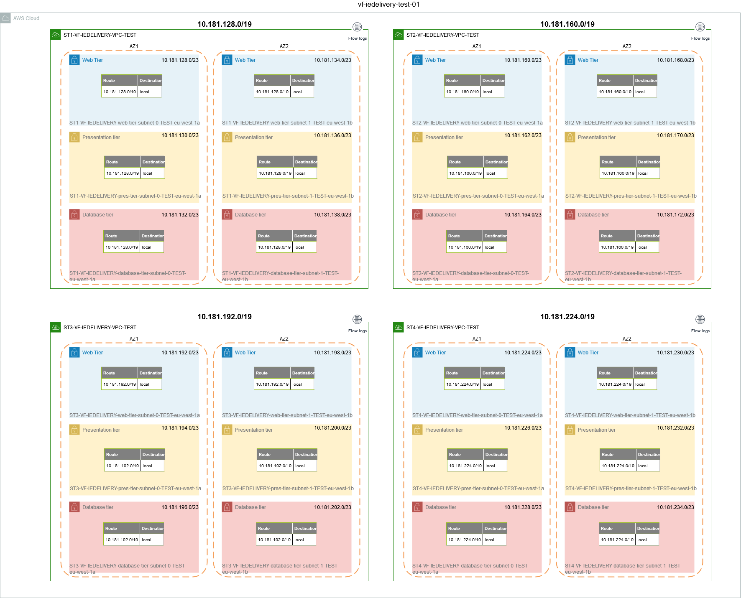

The network was split following this pattern. This table shows the subdivision for ST4, where the first six subnets with range /23 were used for web, presentation and database tiers. "**10.181.254.64/27**" and "**10.181.254.96/27"** were used for private subnets that can be used for other purposes.

|  |  |  |  |  |  |
| --- | --- | --- | --- | --- | --- |
| Subnet address | Purpose | Netmask | Range of addresses | Useable IPs | Hosts |
| **10.181.224.0/23** | Web | 255.255.254.0 | 10.181.224.0 -   10.181.225.255 | 10.181.224.1 -   10.181.225.254 | 510 |
| **10.181.226.0/23** | Presentation | 255.255.254.0 | 10.181.226.0 -   10.181.227.255 | 10.181.226.1 -   10.181.227.254 | 510 |
| **10.181.228.0/23** | Database | 255.255.254.0 | 10.181.228.0 -   10.181.229.255 | 10.181.228.1 -   10.181.229.254 | 510 |
| **10.181.230.0/23** | Web | 255.255.254.0 | 10.181.230.0 -   10.181.231.255 | 10.181.230.1 -   10.181.231.254 | 510 |
| **10.181.232.0/23** | Presentation | 255.255.254.0 | 10.181.232.0 -   10.181.233.255 | 10.181.232.1 -   10.181.233.254 | 510 |
| **10.181.234.0/23** | Database | 255.255.254.0 | 10.181.234.0 -   10.181.235.255 | 10.181.234.1 -   10.181.235.254 | 510 |
| 10.181.236.0/23 | - | 255.255.254.0 | 10.181.236.0 -   10.181.237.255 | 10.181.236.1 -   10.181.237.254 | 510 |
| 10.181.238.0/23 | - | 255.255.254.0 | 10.181.238.0 -   10.181.239.255 | 10.181.238.1 -   10.181.239.254 | 510 |
| 10.181.240.0/23 | - | 255.255.254.0 | 10.181.240.0 -   10.181.241.255 | 10.181.240.1 -   10.181.241.254 | 510 |
| 10.181.242.0/23 | - | 255.255.254.0 | 10.181.242.0 -   10.181.243.255 | 10.181.242.1 -   10.181.243.254 | 510 |
| 10.181.244.0/23 | - | 255.255.254.0 | 10.181.244.0 -   10.181.245.255 | 10.181.244.1 -   10.181.245.254 | 510 |
| 10.181.246.0/23 | - | 255.255.254.0 | 10.181.246.0 -   10.181.247.255 | 10.181.246.1 -   10.181.247.254 | 510 |
| 10.181.248.0/23 | - | 255.255.254.0 | 10.181.248.0 -   10.181.249.255 | 10.181.248.1 -   10.181.249.254 | 510 |
| 10.181.250.0/23 | - | 255.255.254.0 | 10.181.250.0 -   10.181.251.255 | 10.181.250.1 -   10.181.251.254 | 510 |
| 10.181.252.0/23 | - | 255.255.254.0 | 10.181.252.0 -   10.181.253.255 | 10.181.252.1 -   10.181.253.254 | 510 |
| 10.181.254.0/26 | - | 255.255.255.192 | 10.181.254.0 -   10.181.254.63 | 10.181.254.1 -   10.181.254.62 | 62 |
| **10.181.254.64/27** | Other | 255.255.255.224 | 10.181.254.64 -   10.181.254.95 | 10.181.254.65 -   10.181.254.94 | 30 |
| **10.181.254.96/27** | Other | 255.255.255.224 | 10.181.254.96 - 10.181.254.127 | 10.181.254.97 -   10.181.254.126 | 30 |
| 10.181.254.128/26 | - | 255.255.255.192 | 10.181.254.128 - 10.181.254.191 | 10.181.254.129 -   10.181.254.190 | 62 |
| 10.181.254.192/26 | - | 255.255.255.192 | 10.181.254.192 -   10.181.254.255 | 10.181.254.193 -   10.181.254.254 | 62 |
| 10.181.255.0/25 | - | 255.255.255.128 | 10.181.255.0 -   10.181.255.127 | 10.181.255.1 -   10.181.255.126 | 126 |
| 10.181.255.128/25 | - | 255.255.255.128 | 10.181.255.128 -   10.181.255.255 | 10.181.255.129 -   10.181.255.254 | 126 |

## 00 VF IE SIT4 - HOW TO

* PHASE 1
  + 1.DNS
  + 2. OFMW AMI
  + 3. EC2 SSH KEY PAIR
  + 4. VARIABLES
* PHASE 2
  + 1. VPC (already created)
  + 2. EC2 SERVERS and route53 records
  + 3. Security groups
  + 4. EFS volumes
  + 5. ALB
  + 6.RDS
  + 7. SFTP and OCM

**This is a guide about how to create a new environment for VFIE project, specifically for CCH-SAL, environment sit4.**

### PHASE 1

First of all, we are going to do any configuration that the environment needs (before starting to create any new resource). Please, take into account that VPC's and subnets were firstly created, and are not part of the scope of this guide.

All environments need:

* DNS hosted zones:
  + Public hosted zone: subdomain of ieaws.vodafone.com that is defined is SS account.
  + Private hosted zone to route the traffic with gdc as destination to haproxy.
* AMI. Customized AMI's are created in SS and shared with all tenant accounts. The tenant account will need to copy those AMI's to Ireland region.
  + OFMW 1213
  + OFMW 1221
* SSH Keys. Right now they are created manually and added to SSM parameter store. (TO BE REVIEWED THIS PROCESS)
* Variables.

#### 1.DNS

* codecommit repository: vf-iedelivery-dns
* documentation for dns: https://confluence.sp.vodafone.com/x/1HUlCg

First, create the public domain in test account vf-iedelivery-test-01. Example for sit4:

|  |
| --- |
| #    PUBLIC HOSTED ZONE IN TEST FOR SUB-DOMAIN sit4.ieaws.vodafone.com  resource "aws_route53_zone" "vfie_subdomain_sit4" {    provider = "aws.test"    name = "sit4.ieaws.vodafone.com"    comment = "vf ie subdomain delegation for sit4"    tags = merge(      local.common_tags,      {        "Name"    = "VFIE SUBDOMAIN sit4"      },    )  } |

Then, create NS record in SS domain (ieaws.vodafone.com) in vf-iedelivery-prod-ss-01.Example for sit4:

|  |
| --- |
| #TEST NS RECORDS  resource "aws_route53_record" "vfie_subdomain_sit4_ss" {    provider = "aws.SS"    zone_id = aws_route53_zone.vfie_subdomain.zone_id    name    = "sit4.ieaws.vodafone.com"    type    = "NS"    ttl     = "60"    records = [      aws_route53_zone.vfie_subdomain_sit4.name_servers.0,      aws_route53_zone.vfie_subdomain_sit4.name_servers.1,      aws_route53_zone.vfie_subdomain_sit4.name_servers.2,      aws_route53_zone.vfie_subdomain_sit4.name_servers.3,    ]  } |

Once SIT4 Haproxy is ready (at the moment not yet created), we will add the following:

* Data resource for SIT4 VPC

|  |
| --- |
| data "aws_vpc" "sit4-vpc" {    provider = "aws.test"    filter {          name   = "tag:Name"          values = ["SIT4-VF-IEDELIVERY-VPC-TEST"]    }  } |

* Private hosted zone to route traffic with gdc destination to SS:

|  |
| --- |
| #    PRIVATE HOSTED ZONE IN sit4 FOR RESOLVE GDC DOMAINS  resource "aws_route53_zone" "vfie_priv_sit4_gdc_nlb" {    provider = "aws.test"    name = "internal.vodafone.com"    comment = "private hosted zone to send traffic to gdc - sit4 vpc"    tags = merge(      local.common_tags,      {        "Name"    = "sit4 SS NLB"      },    )    vpc {      vpc_id = data.aws_vpc.sit4-vpc.id    }  } |

* DNS record to point to SIT4 HAproxy:

|  |
| --- |
| #    ROUTING TRAFFIC TO sit4 SS NLB  resource "aws_route53_record" "vfie_priv_sit4_gdc_nlb_record" {    provider = "aws.test"    zone_id = aws_route53_zone.vfie_priv_sit4_gdc_nlb.zone_id    name    = "*vf-ie.internal.vodafone.com"    type    = "CNAME"    ttl     = "60"    records        = ["sit4.haproxy.ieaws.vodafone.com"]  } |

#### 2. OFMW AMI

We need to make sure ofmw 1213 and 1221 ami's have been shared with test account. Go to vf-iedelivery-prod-ss-01, in ec2 tab, check AMI:

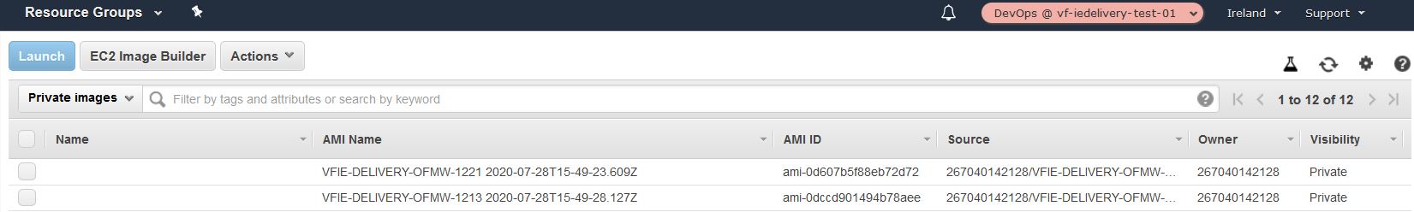

#### 3. EC2 SSH KEY PAIR

Create a ssh key pair (example key name sit4-cch-sal) and add the private content into a ssm parameter (secure string, example /test/sit4/cch-sal/ec2/ssh-key). This is done in test account vf-iedelivery-test-01.

#### 4. VARIABLES

The following example is just for sit4 environment and with the assumption each environment will have the same number of nodes:

|  |
| --- |
| variable "DEPLOY_ROLE" {}  variable "ENV" {    description = "Name of the environment"  }  variable "PROJECT" {    description = "Name of the project, used in a lot of the resource naming"  }    variable "account_id" {    default = ""  }  variable "sit4_main_cidr_block" {    default = ""  }  variable "sit4_private_subnets" {    default = []  }  variable "sit4_web_subnets" {    default = []  }  variable "sit4_database_subnets" {    default = []  }  variable "sit4_presentation_subnets" {    default = []  }  variable "hosted_zone_sit4"{    default = ""  }  variable "ec2_key_pair_name_sit4"{    default = ""  }  variable "sit4_domain_names_acm_8011"{    description = "List of domains to associate with a ACM certificate. Maximum 50"    type = "list"    default = [""]  }  variable "sit4_domain_names_acm_7001"{    description = "List of domains to associate with a ACM certificate. Maximum 50"    type = "list"    default = [""]  }  #----------------CIDR  variable "cidr_sit4"{    description = "ip address range for sit4"    default     = ["10.181.224.0/19"]  }  variable "cidr_workspaces"{    description = "ip address range for workspaces"    default     = ["10.181.22.0/23"]  }  variable "cidr_myst"{    description = "ip address range for myst"    default     = ["10.181.16.0/23"]  }  variable "cidr_ss_vpc_test"{    description = "ip address range for ss ss test"    default     = ["198.19.220.128/26", "198.19.220.192/26"]  }    #-----------------DOMAINS VARIABLES----------------  variable "cch_ob_odi_nodes" {    type    = number    default = 0  }  variable "cch_ob_osb_nodes" {    type    = number    default = 0  }  variable "cch_ob_soa_nodes" {    type    = number    default = 0  }  variable "cch_ob_ums_osb_nodes" {    type    = number    default = 0  }  variable "cch_ob_ums_soa_nodes" {    type    = number    default = 0  }  variable "cch_ib_sal_osb_nodes" {    type    = number    default = 0  }  variable "cch_ib_sal_soa_nodes" {    type    = number    default = 0  }  variable "cch_portal_nodes" {    type    = number    default = 0  }  variable "pb_osb_nodes" {    type    = number    default = 0  }  variable "pb_odi_nodes" {    type    = number    default = 0  }  variable "oal_osb_nodes" {    type    = number    default = 0  }  variable "oal_soa_nodes" {    type    = number    default = 0  }  variable "cch_sal_web_nodes" {    type    = number    default = 0  } |

For sit4, in vars folder, the file TEST.tfvars have the following values:

|  |
| --- |
| ENV = "TEST"  PROJECT = "vfie-delivery"  account_id = "046978237480"  ec2_key_pair_name_sit4     = "sit4-cch-sal"  hosted_zone_sit4 = "sit4.ieaws.vodafone.com."  sit4_main_cidr_block = "10.181.224.0/19"  sit4_private_subnets       = ["10.181.254.64/27", "10.181.254.96/27", "10.181.252.0/24", "10.181.253.0/24"]  sit4_web_subnets      = ["10.181.224.0/23", "10.181.230.0/23"]  sit4_presentation_subnets     = ["10.181.226.0/23", "10.181.232.0/23"]  sit4_database_subnets = ["10.181.228.0/23", "10.181.234.0/23"]  cch_ob_odi_nodes = 1  cch_ob_osb_nodes = 1  cch_ob_soa_nodes = 1  cch_ob_ums_osb_nodes = 1  cch_ob_ums_soa_nodes = 1  cch_ib_sal_osb_nodes = 1  cch_ib_sal_soa_nodes = 1  cch_portal_nodes = 1  pb_osb_nodes     = 1  pb_odi_nodes     = 1  oal_osb_nodes    = 1  oal_soa_nodes    = 1  cch_sal_web_nodes = 1 |

### PHASE 2

This is the order we will follow:

1. servers, security groups, efs volume and logging.
2. ALB
3. RDS
4. SFTP and OCM log groups and iam. Later, SFTP and OCM fargate and nlb.
5. monitoring

#### 1. VPC (already created)

The VPC and its components will be creating using a terraform module called 'vpc'.

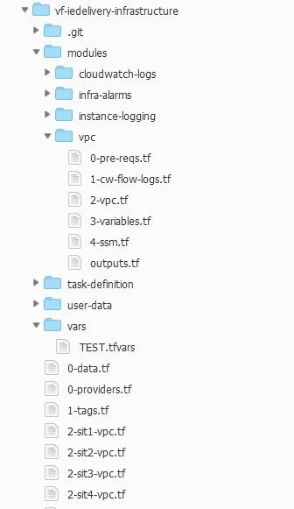

For sit4, in the file called 2-sit4-vpc.tf (root path), we declare the vpc module for the environment sit4:

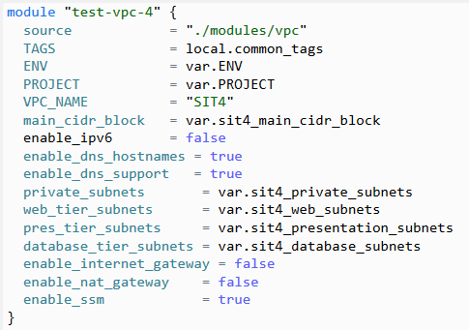

We define how the specific VPC is going to be like with the following variables:

* VPC_NAME : this will define the environment (sit1, sit2, sit3, sit4, prd1, prd2, prod). It will be part of the naming convention for all resources.
* main_cidr_block
* enable_dns_hostnames and enable_dns_support (always true)
* private_subnets, web_tier_subnets, pres_tier_subnets, database_tier_subnets. Public_subnets are empty.
* enable_internet_gateway = false as there will not be locally internet connectivity, but a centralized one through SS account.
* enable_nat_gateway = false
* enable_ssm = true; in case we need to connect to the servers through SSM

Please, see the code for the vpc module here :<https://eu-west-1.console.aws.amazon.com/codesuite/codecommit/repositories/vf-iedelivery-infrastructure/browse/refs/heads/test/--/modules/vpc?region=eu-west-1> (vf-iedelivery-mgmt account).

The module will create:

* VPC and subnets
* Route tables
* SSM endpoints and security groups
* VPC flow logs to s3 and CW

#### 2. EC2 SERVERS and route53 records

Here

#### 3. Security groups

Here

Note: we will be commenting out the lines where the sftp-ocm nlb appears until this is created.

#### 4. EFS volumes

Here

#### 5. ALB

Here

#### 6.RDS

Here

#### 7. SFTP and OCM

Note: ECR permissions once IAM roles are created (must be done before ecs services are created). Update account id in task definition for ocm.

### 01 SIT4 SERVERS

In the file called 2-sit4-vpc.tf we will define all ec2 instances, user data, route53 records for the instances and logging.

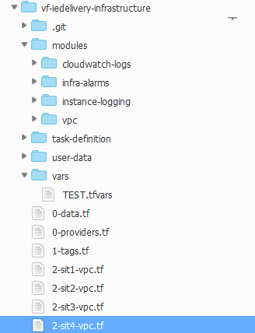

First of all, the AMI will be read in terraform as a data resource. It is define in the root directory, in the file called 0-data.tf. This data will read the latest AMI in the target account (test in this case). WARNING: target account (test) must be the OWNER of the AMI. Meaning: if the AMI was shared with target account, a copy of it must be created in Irland region.

|  |
| --- |
| data "aws_route53_zone" "sit4HostedZone" {    name         = var.hosted_zone_sit4  }    #-----data specific ami  data "aws_ami" "ofmw1213" {    most_recent      = true    owners           = ["self"]    filter {      name   = "name"      values = ["VFIE-DELIVERY-OFMW-1213*"]    }  }  #-----data specific ami  data "aws_ami" "ofmw1221" {    most_recent      = true    owners           = ["self"]    filter {      name   = "name"      values = ["VFIE-DELIVERY-OFMW-1221*"]    }  }  #-----data hardened ami rhel7.7  data "aws_ami" "rhel_hardened_ami" {    most_recent      = true    owners           = ["self"]    filter {      name   = "name"      values = ["vf-gdc-rhel-7.7-hvm-*"]    }  } |

Let's take the example for one OFMW domain, CCH_OB_ODI.

#### User data

|  |
| --- |
| data "template_file" "sit4-cch-ob-odi-admin" {    depends_on   = [aws_efs_file_system.sit4-cch-ob-odi, aws_efs_file_system.sit4-cch-ob-multidomain-share, aws_efs_file_system.sit4-software]    template     = "${file("${path.module}/user-data/user-data-ob.sh")}"    vars = {      SoftwareEFS = aws_efs_file_system.sit4-software.id      Region      = "eu-west-1"      ssm_parameter = module.sit4-cch-ob-odi-logging.MOD_CWAGENT_BASE_CONFIG_SSM_PARAM_ADMIN.name      DomainEFS   = aws_efs_file_system.sit4-cch-ob-odi.id #EFS ID OF INSTANCE      CchObMultiDomainEFS = aws_efs_file_system.sit4-cch-ob-multidomain-share.id    }  }  # User data for Managed servers  data "template_file" "sit4-cch-ob-odi-managed" {    depends_on   = [aws_efs_file_system.sit4-cch-ob-odi, aws_efs_file_system.sit4-cch-ob-multidomain-share, aws_efs_file_system.sit4-software]    template     = "${file("${path.module}/user-data/user-data-ob.sh")}"    vars = {      SoftwareEFS = aws_efs_file_system.sit4-software.id      Region      = "eu-west-1"      ssm_parameter = module.sit4-cch-ob-odi-logging.MOD_CWAGENT_BASE_CONFIG_SSM_PARAM_MANAGED.name      DomainEFS   = aws_efs_file_system.sit4-cch-ob-odi.id #EFS ID OF INSTANCE      CchObMultiDomainEFS = aws_efs_file_system.sit4-cch-ob-multidomain-share.id    }  } |

We have two different type of user data per domain because of the application logging (done by sinplepoint). The template file used is the same, you can find it in the folder user-data.

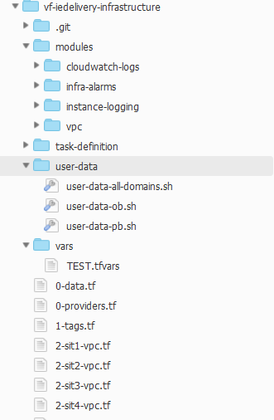

Once that's defined, we declare the **admin server** ec2 instance:

|  |
| --- |
| resource "aws_instance" "sit4-cch-ob-odi-as" {    depends_on             = [aws_efs_file_system.sit4-cch-ob-odi,aws_security_group.sit4-cch-ob-odi-as, aws_security_group.sit4-cch-ob-odi  ]    ami                    = data.aws_ami.ofmw1213.id    instance_type          = "m5.large"    monitoring             = true    subnet_id              = module.test-vpc-4.subnet_presentation_ids[0]    iam_instance_profile   = module.test-vpc-4.iam_instance_profile_ec2_ssm_id    # user_data              = data.template_file.sit4-cch-ob-odi.rendered    user_data              = data.template_file.sit4-cch-ob-odi-admin.rendered    key_name               = var.ec2_key_pair_name_sit4    vpc_security_group_ids = [aws_security_group.sit4-ec2-monitoring.id,aws_security_group.sit4-cch-ob-odi-as.id, aws_security_group.sit4-cch-ob-odi.id, aws_security_group.sit4-ssm-jumpbox.id]    tags                    = merge(                              local.common_tags,                                {                                "Name" = "sit4-cch-ob-odi-as"                              },                            )    root_block_device{               volume_type = "gp2"               volume_size = 60               encrypted  = true    }      lifecycle {     ignore_changes = [user_data,ami]    }  } |

And the route53 record:

|  |
| --- |
| resource "aws_route53_record" "cch-ob-odi-as" {    zone_id = data.aws_route53_zone.sit4HostedZone.zone_id    name    = "cch-ob-odi-as.sit4.ieaws.vodafone.com"    type    = "A"    ttl     = "300"    records = [aws_instance.sit4-cch-ob-odi-as.private_ip]  } |

And then the nodes:

|  |
| --- |
| #EC2 sit4-cch-ob-odiX  cch-ob-odiX.sit4.ieaws.vodafone.com  resource "aws_instance" "sit4-cch-ob-odi" {    depends_on             = [aws_efs_file_system.sit4-cch-ob-odi,aws_security_group.sit4-cch-ob-odi-ms, aws_security_group.sit4-cch-ob-odi]    count                  = var.cch_ob_odi_nodes    ami                    = data.aws_ami.ofmw1213.id    instance_type          = "m5.large"    monitoring             = true    subnet_id              = count.index%2==0 ? module.test-vpc-4.subnet_presentation_ids[0]: module.test-vpc-4.subnet_presentation_ids[1]    iam_instance_profile   = module.test-vpc-4.iam_instance_profile_ec2_ssm_id    user_data              = data.template_file.sit4-cch-ob-odi-managed.rendered    key_name               = var.ec2_key_pair_name_sit4    vpc_security_group_ids = [aws_security_group.sit4-ec2-monitoring.id,aws_security_group.sit4-cch-ob-odi-ms.id, aws_security_group.sit4-cch-ob-odi.id,aws_security_group.sit4-ssm-jumpbox.id]    tags                    = merge(                              local.common_tags,                                {                                "Name" = "sit4-cch-ob-odi${count.index+1}"                              },                            )    root_block_device{               volume_type = "gp2"               volume_size = 60               encrypted  = true    }    lifecycle {     ignore_changes = [user_data,ami]    }  }  resource "aws_route53_record" "cch-ob-odi-node" {    zone_id = data.aws_route53_zone.sit4HostedZone.zone_id    count   = var.cch_ob_odi_nodes    name    = "cch-ob-odi${count.index+1}.sit4.ieaws.vodafone.com"    type    = "A"    ttl     = "300"    records = [aws_instance.sit4-cch-ob-odi[count.index].private_ip]  } |

Finally, the part of application logging (done and managed by singlepoint):

|  |
| --- |
| #logging  module "sit4-cch-ob-odi-logging" {    source = "./modules/cloudwatch-logs"    TAGS   = local.common_tags    VPC_NAME ="SIT4"    Environment ="sit4"    OFMWDomain = "cch-ob-odi"    ManagedServerTemplate = "odi"  ## can be standard, odi or ohs    enable_odi = "1"    enable_ohs = "0"  } |

### 02 SIT4 SECURITY GROUPS

* 1.OFMW domain ec2 security groups
* 2.OFMW domain efs security groups
* 3.OFMW OHS domain ec2 security groups
* 4.RDS ORACLE SECURITY GROUPS
* 5.OCM AND SFTP SECURITY GROUPS
* 6. ssm jumpbox and monitoring

This section will explain the terraform code for all the security groups. The requirements are specified here: <https://confluence.sp.vodafone.com/x/smnzCQ>

The file with all the security groups for sit4 can be found here: <https://eu-west-1.console.aws.amazon.com/codesuite/codecommit/repositories/vf-iedelivery-infrastructure/browse/refs/heads/test/--/3-sit4-securitygroups.tf?region=eu-west-1>

#### 1.OFMW domain ec2 security groups

Each OFMW domain will have associate these security groups:

* environment-domain-as (admin server). Example: sit4-cch-ob-odi-as
* environment-domain-ms (node server). Example: sit4-cch-ob-odi-ms
* environment-domain. Example: sit4-cch-ob-odi
* environment-ec2-monitoring*(new!). Example: sit4-ec2-monitoring

Security groups definition for CCH_OB_ODI domain:

|  |
| --- |
| ################  # CCH_OB_ODI SECURITY GROUPS  ################  #sit4-cch-ob-odi  resource "aws_security_group" "sit4-cch-ob-odi" {    name        = "sit4-cch-ob-odi"    description = "Security group for sit4-cch-ob-odi"    vpc_id = module.test-vpc-4.vpc_id    tags = merge(      local.common_tags,      {        "Name"    = "sit4-cch-ob-odi"      },    )    }  resource "aws_security_group_rule" "sit4-cch-ob-odi_i_1" {    type              = "ingress"    from_port         = 22    to_port           = 22    protocol          = "tcp"    cidr_blocks       = var.cidr_myst    description       = "allow inbound from Myst VPC."    security_group_id = aws_security_group.sit4-cch-ob-odi.id  }  resource "aws_security_group_rule" "sit4-cch-ob-odi_i_2" {    type              = "ingress"    from_port         = 0    to_port           = 0    protocol          = "-1"    self              = true    description       = "allow inbound within SG."    security_group_id = aws_security_group.sit4-cch-ob-odi.id  }  resource "aws_security_group_rule" "sit4-cch-ob-odi_eg_1" {    type              = "egress"    from_port         = 0    to_port           = 0    protocol          = "-1"    self              = true    description       = "allow outbound within SG."    security_group_id = aws_security_group.sit4-cch-ob-odi.id  }  resource "aws_security_group_rule" "sit4-cch-ob-odi_eg_2" {    type              = "egress"    from_port         = 2049    to_port           = 2049    protocol          = "tcp"    source_security_group_id = aws_security_group.sit4-cch-ob-odi-efs.id    description       = "allow inbound from sit4-cch-ob-odi-efs"    security_group_id = aws_security_group.sit4-cch-ob-odi.id  }  resource "aws_security_group_rule" "sit4-cch-ob-odi_eg_3" {    type              = "egress"    from_port         = 1521    to_port           = 1521    protocol          = "tcp"    source_security_group_id = aws_security_group.sit4-rds-oracle-db.id    description       = "allow inbound from sit4-rds-oracle-db"    security_group_id = aws_security_group.sit4-cch-ob-odi.id  }  resource "aws_security_group_rule" "sit4-cch-ob-odi_eg_4" {    type              = "egress"    from_port         = 2049    to_port           = 2049    protocol          = "tcp"    source_security_group_id = aws_security_group.sit4-cch-ob-multidomain-share.id    description       = "allow inbound from sit4-cch-ob-multidomain-share"    security_group_id = aws_security_group.sit4-cch-ob-odi.id  }  resource "aws_security_group_rule" "sit4-cch-ob-odi_eg_5" {    type              = "egress"    from_port         = 2049    to_port           = 2049    protocol          = "tcp"    source_security_group_id = aws_security_group.sit4-software.id    description       = "allow inbound from sit4-software "    security_group_id = aws_security_group.sit4-cch-ob-odi.id  }  resource "aws_security_group_rule" "sit4-cch-ob-odi_eg_6_SMSC" {    type              = "egress"    from_port         = 20111    to_port           = 20111    protocol          = "tcp"    cidr_blocks       = var.cidr_ss_vpc_test    description       = "allow outbound from SMSC-IF355.01"    security_group_id = aws_security_group.sit4-cch-ob-odi.id  }  resource "aws_security_group_rule" "sit4-cch-ob-odi_eg_7_SMSC" {    type              = "egress"    from_port         = 20112    to_port           = 20112    protocol          = "tcp"    cidr_blocks       = var.cidr_ss_vpc_test    description       = "allow outbound from SMSC-IF355.01"    security_group_id = aws_security_group.sit4-cch-ob-odi.id  }  resource "aws_security_group_rule" "sit4-cch-ob-odi_eg_8_SMSC" {    type              = "egress"    from_port         = 20113    to_port           = 20113    protocol          = "tcp"    cidr_blocks       = var.cidr_ss_vpc_test    description       = "allow outbound from SMSC-IF355.01"    security_group_id = aws_security_group.sit4-cch-ob-odi.id  }  resource "aws_security_group_rule" "sit4-cch-ob-odi_eg_9_SMSC" {    type              = "egress"    from_port         = 20114    to_port           = 20114    protocol          = "tcp"    cidr_blocks       = var.cidr_ss_vpc_test    description       = "allow outbound from SMSC-IF355.01"    security_group_id = aws_security_group.sit4-cch-ob-odi.id  }    #sit4-cch-ob-odi-as  resource "aws_security_group" "sit4-cch-ob-odi-as" {    name        = "sit4-cch-ob-odi-as"    description = "Security group for sit4-cch-ob-odi-as"    vpc_id = module.test-vpc-4.vpc_id    tags = merge(      local.common_tags,      {        "Name"    = "sit4-cch-ob-odi-as"      },    )    }  resource "aws_security_group_rule" "sit4-cch-ob-odi-as_i_1" {    type              = "ingress"    from_port         = 7001    to_port           = 7001    protocol          = "tcp"    source_security_group_id = aws_security_group.sit4-cch-sal-web.id    description       = "allow inbound from sit4-cch-sal-web"    security_group_id = aws_security_group.sit4-cch-ob-odi-as.id  }    resource "aws_security_group_rule" "sit4-cch-ob-odi-as_eg_1" {    type              = "egress"    from_port         = 443    to_port           = 443    protocol          = "tcp"    cidr_blocks       = var.cidr_myst    description       = "allow outbound to Artifactory ALB."    security_group_id = aws_security_group.sit4-cch-ob-odi-as.id  }  #sit4-cch-ob-odi-ms  resource "aws_security_group" "sit4-cch-ob-odi-ms" {    name        = "sit4-cch-ob-odi-ms"    description = "Security group for sit4-cch-ob-odi-ms"    vpc_id = module.test-vpc-4.vpc_id    tags = merge(      local.common_tags,      {        "Name"    = "sit4-cch-ob-odi-ms"      },    )    }  resource "aws_security_group_rule" "sit4-cch-ob-odi-ms_i_1" {    type              = "ingress"    from_port         = 15101    to_port           = 15101    protocol          = "tcp"    source_security_group_id = aws_security_group.sit4-cch-sal-web.id    description       = "allow inbound from sit4-cch-sal-web."    security_group_id = aws_security_group.sit4-cch-ob-odi-ms.id  } |

#### 2.OFMW domain efs security groups

|  |
| --- |
| #sit4-cch-ob-odi-efs  resource "aws_security_group" "sit4-cch-ob-odi-efs" {    name        = "sit4-cch-ob-odi-efs"    description = "Security group for sit4-cch-ob-odi-efs"    vpc_id = module.test-vpc-4.vpc_id    tags = merge(      local.common_tags,      {        "Name"    = "sit4-cch-ob-odi-efs"      },    )    } |

#### 3.OFMW OHS domain ec2 security groups

|  |
| --- |
| ################  # CCH_SAL_WEB SECURITY GROUPS  ################    #sit4-cch-sal-alb  resource "aws_security_group" "sit4-cch-sal-alb" {    name        = "sit4-cch-sal-alb"    description = "Security group for sit4-cch-sal-alb"    vpc_id = module.test-vpc-4.vpc_id    tags = merge(      local.common_tags,      {        "Name"    = "sit4-cch-sal-alb"      },    )    }  #WORKSPACES  resource "aws_security_group_rule" "sit4-cch-sal-alb_i_1" {    type              = "ingress"    from_port         = 7001    to_port           = 7001    protocol          = "tcp"    cidr_blocks       = var.cidr_workspaces    description       = "allow inbound from Internet VPC (workspaces)."    security_group_id = aws_security_group.sit4-cch-sal-alb.id  }  resource "aws_security_group_rule" "sit4-cch-sal-alb_i_2" {    type              = "ingress"    from_port         = 443    to_port           = 443    protocol          = "tcp"    cidr_blocks       = var.cidr_workspaces    description       = "allow inbound from Internet VPC (workspaces)."    security_group_id = aws_security_group.sit4-cch-sal-alb.id  }  resource "aws_security_group_rule" "sit4-cch-sal-alb_i_3" {    type              = "ingress"    from_port         = 8011    to_port           = 8011    protocol          = "tcp"    cidr_blocks       = var.cidr_workspaces    description       = "allow inbound from Internet VPC (workspaces)."    security_group_id = aws_security_group.sit4-cch-sal-alb.id  }  #HAPROXY  resource "aws_security_group_rule" "sit4-cch-sal-alb_i_4" {    type              = "ingress"    from_port         = 443    to_port           = 443    protocol          = "tcp"    cidr_blocks       = var.cidr_ss_vpc_test    description       = "allow inbound from HAPROXY."    security_group_id = aws_security_group.sit4-cch-sal-alb.id  }  resource "aws_security_group_rule" "sit4-cch-sal-alb_i_5" {    type              = "ingress"    from_port         = 7001    to_port           = 7001    protocol          = "tcp"    cidr_blocks       = var.cidr_ss_vpc_test    description       = "allow inbound from HAPROXY."    security_group_id = aws_security_group.sit4-cch-sal-alb.id  }  resource "aws_security_group_rule" "sit4-cch-sal-alb_i_6" {    type              = "ingress"    from_port         = 8011    to_port           = 8011    protocol          = "tcp"    cidr_blocks       = var.cidr_ss_vpc_test    description       = "allow inbound from HAPROXY."    security_group_id = aws_security_group.sit4-cch-sal-alb.id  }  #DOMAINS  resource "aws_security_group_rule" "sit4-cch-sal-alb_i_7" {    type              = "ingress"    from_port         = 7001    to_port           = 7001    protocol          = "tcp"    source_security_group_id = aws_security_group.sit4-cch-ob-odi.id    description       = "allow inbound from sit4-cch-ob-odi."    security_group_id = aws_security_group.sit4-cch-sal-alb.id  }  resource "aws_security_group_rule" "sit4-cch-sal-alb_i_7b" {    type              = "ingress"    from_port         = 8011    to_port           = 8011    protocol          = "tcp"    source_security_group_id = aws_security_group.sit4-cch-ob-odi.id    description       = "allow inbound from sit4-cch-ob-odi."    security_group_id = aws_security_group.sit4-cch-sal-alb.id  }    resource "aws_security_group_rule" "sit4-cch-sal-alb_i_8" {    type              = "ingress"    from_port         = 7001    to_port           = 7001    protocol          = "tcp"    source_security_group_id = aws_security_group.sit4-cch-ob-osb.id    description       = "allow inbound from sit4-cch-ob-osb."    security_group_id = aws_security_group.sit4-cch-sal-alb.id  }  resource "aws_security_group_rule" "sit4-cch-sal-alb_i_9" {    type              = "ingress"    from_port         = 8011    to_port           = 8011    protocol          = "tcp"    source_security_group_id = aws_security_group.sit4-cch-ob-osb.id    description       = "allow inbound from sit4-cch-ob-osb."    security_group_id = aws_security_group.sit4-cch-sal-alb.id  }    resource "aws_security_group_rule" "sit4-cch-sal-alb_i_10" {    type              = "ingress"    from_port         = 7001    to_port           = 7001    protocol          = "tcp"    source_security_group_id = aws_security_group.sit4-cch-ob-soa.id    description       = "allow inbound from sit4-cch-ob-soa."    security_group_id = aws_security_group.sit4-cch-sal-alb.id  }  resource "aws_security_group_rule" "sit4-cch-sal-alb_i_11" {    type              = "ingress"    from_port         = 8011    to_port           = 8011    protocol          = "tcp"    source_security_group_id = aws_security_group.sit4-cch-ob-soa.id    description       = "allow inbound from sit4-cch-ob-soa."    security_group_id = aws_security_group.sit4-cch-sal-alb.id  }  resource "aws_security_group_rule" "sit4-cch-sal-alb_i_12" {    type              = "ingress"    from_port         = 7001    to_port           = 7001    protocol          = "tcp"    source_security_group_id = aws_security_group.sit4-cch-ob-ums-osb.id    description       = "allow inbound from sit4-cch-ob-ums-osb."    security_group_id = aws_security_group.sit4-cch-sal-alb.id  }  resource "aws_security_group_rule" "sit4-cch-sal-alb_i_13" {    type              = "ingress"    from_port         = 8011    to_port           = 8011    protocol          = "tcp"    source_security_group_id = aws_security_group.sit4-cch-ob-ums-osb.id    description       = "allow inbound from sit4-cch-ob-ums-osb."    security_group_id = aws_security_group.sit4-cch-sal-alb.id  }  resource "aws_security_group_rule" "sit4-cch-sal-alb_i_14" {    type              = "ingress"    from_port         = 7001    to_port           = 7001    protocol          = "tcp"    source_security_group_id = aws_security_group.sit4-cch-ob-ums-soa.id    description       = "allow inbound from sit4-cch-ob-ums-soa."    security_group_id = aws_security_group.sit4-cch-sal-alb.id  }    resource "aws_security_group_rule" "sit4-cch-sal-alb_i_15" {    type              = "ingress"    from_port         = 8011    to_port           = 8011    protocol          = "tcp"    source_security_group_id = aws_security_group.sit4-cch-ob-ums-soa.id    description       = "allow inbound from sit4-cch-ob-ums-soa."    security_group_id = aws_security_group.sit4-cch-sal-alb.id  }  resource "aws_security_group_rule" "sit4-cch-sal-alb_i_16" {    type              = "ingress"    from_port         = 7001    to_port           = 7001    protocol          = "tcp"    source_security_group_id = aws_security_group.sit4-cch-ib-sal-osb.id    description       = "allow inbound from sit4-cch-ib-sal-osb."    security_group_id = aws_security_group.sit4-cch-sal-alb.id  }    resource "aws_security_group_rule" "sit4-cch-sal-alb_i_17" {    type              = "ingress"    from_port         = 8011    to_port           = 8011    protocol          = "tcp"    source_security_group_id = aws_security_group.sit4-cch-ib-sal-osb.id    description       = "allow inbound from sit4-cch-ib-sal-osb."    security_group_id = aws_security_group.sit4-cch-sal-alb.id  }  resource "aws_security_group_rule" "sit4-cch-sal-alb_i_18" {    type              = "ingress"    from_port         = 7001    to_port           = 7001    protocol          = "tcp"    source_security_group_id = aws_security_group.sit4-cch-ib-sal-soa.id    description       = "allow inbound from sit4-cch-ib-sal-soa."    security_group_id = aws_security_group.sit4-cch-sal-alb.id  }  resource "aws_security_group_rule" "sit4-cch-sal-alb_i_19" {    type              = "ingress"    from_port         = 8011    to_port           = 8011    protocol          = "tcp"    source_security_group_id = aws_security_group.sit4-cch-ib-sal-soa.id    description       = "allow inbound from sit4-cch-ib-sal-soa."    security_group_id = aws_security_group.sit4-cch-sal-alb.id  }  resource "aws_security_group_rule" "sit4-cch-sal-alb_i_20" {    type              = "ingress"    from_port         = 7001    to_port           = 7001    protocol          = "tcp"    source_security_group_id = aws_security_group.sit4-cch-portal.id    description       = "allow inbound from sit4-cch-portal."    security_group_id = aws_security_group.sit4-cch-sal-alb.id  }  resource "aws_security_group_rule" "sit4-cch-sal-alb_i_21" {    type              = "ingress"    from_port         = 443    to_port           = 443    protocol          = "tcp"    source_security_group_id = aws_security_group.sit4-cch-portal.id    description       = "allow inbound from sit4-cch-portal."    security_group_id = aws_security_group.sit4-cch-sal-alb.id  }  resource "aws_security_group_rule" "sit4-cch-sal-alb_i_22" {    type              = "ingress"    from_port         = 7001    to_port           = 7001    protocol          = "tcp"    source_security_group_id = aws_security_group.sit4-pb-osb.id    description       = "allow inbound from sit4-pb-osb."    security_group_id = aws_security_group.sit4-cch-sal-alb.id  }  resource "aws_security_group_rule" "sit4-cch-sal-alb_i_23" {    type              = "ingress"    from_port         = 8011    to_port           = 8011    protocol          = "tcp"    source_security_group_id = aws_security_group.sit4-pb-osb.id    description       = "allow inbound from sit4-pb-osb."    security_group_id = aws_security_group.sit4-cch-sal-alb.id  }  resource "aws_security_group_rule" "sit4-cch-sal-alb_i_24" {    type              = "ingress"    from_port         = 7001    to_port           = 7001    protocol          = "tcp"    source_security_group_id = aws_security_group.sit4-pb-odi.id    description       = "allow inbound from sit4-pb-odi."    security_group_id = aws_security_group.sit4-cch-sal-alb.id  }  resource "aws_security_group_rule" "sit4-cch-sal-alb_i_24b" {    type              = "ingress"    from_port         = 8011    to_port           = 8011    protocol          = "tcp"    source_security_group_id = aws_security_group.sit4-pb-odi.id    description       = "allow inbound from sit4-pb-odi."    security_group_id = aws_security_group.sit4-cch-sal-alb.id  }    resource "aws_security_group_rule" "sit4-cch-sal-alb_i_25" {    type              = "ingress"    from_port         = 7001    to_port           = 7001    protocol          = "tcp"    source_security_group_id = aws_security_group.sit4-oal-osb.id    description       = "allow inbound from sit4-oal-osb."    security_group_id = aws_security_group.sit4-cch-sal-alb.id  }  resource "aws_security_group_rule" "sit4-cch-sal-alb_i_26" {    type              = "ingress"    from_port         = 8011    to_port           = 8011    protocol          = "tcp"    source_security_group_id = aws_security_group.sit4-oal-osb.id    description       = "allow inbound from sit4-oal-osb."    security_group_id = aws_security_group.sit4-cch-sal-alb.id  }  resource "aws_security_group_rule" "sit4-cch-sal-alb_i_27" {    type              = "ingress"    from_port         = 7001    to_port           = 7001    protocol          = "tcp"    source_security_group_id = aws_security_group.sit4-oal-soa.id    description       = "allow inbound from sit4-oal-soa."    security_group_id = aws_security_group.sit4-cch-sal-alb.id  }  resource "aws_security_group_rule" "sit4-cch-sal-alb_i_28" {    type              = "ingress"    from_port         = 8011    to_port           = 8011    protocol          = "tcp"    source_security_group_id = aws_security_group.sit4-oal-soa.id    description       = "allow inbound from sit4-oal-soa."    security_group_id = aws_security_group.sit4-cch-sal-alb.id  }  resource "aws_security_group_rule" "sit4-cch-sal-alb_i_29" {    type              = "ingress"    from_port         = 7001    to_port           = 7001    protocol          = "tcp"    source_security_group_id = aws_security_group.sit4-cch-sal-web.id    description       = "allow inbound from sit4-cch-sal-web."    security_group_id = aws_security_group.sit4-cch-sal-alb.id  }  resource "aws_security_group_rule" "sit4-cch-sal-alb_i_29b" {    type              = "ingress"    from_port         = 7777    to_port           = 7777    protocol          = "tcp"    source_security_group_id = aws_security_group.sit4-cch-sal-web.id    description       = "allow inbound from sit4-cch-sal-web."    security_group_id = aws_security_group.sit4-cch-sal-alb.id  }  resource "aws_security_group_rule" "sit4-cch-sal-alb_i_30" {    type              = "ingress"    from_port         = 7001    to_port           = 7001    protocol          = "tcp"    source_security_group_id = aws_security_group.sit4-cch-sal-client-monitoring.id    description       = "allow inbound from sit4-cch-sal-client-monitoring."    security_group_id = aws_security_group.sit4-cch-sal-alb.id  }  resource "aws_security_group_rule" "sit4-cch-sal-alb_i_30b" {    type              = "ingress"    from_port         = 8011    to_port           = 8011    protocol          = "tcp"    source_security_group_id = aws_security_group.sit4-cch-sal-client-monitoring.id    description       = "allow inbound from sit4-cch-sal-client-monitoring."    security_group_id = aws_security_group.sit4-cch-sal-alb.id  }    resource "aws_security_group_rule" "sit4-cch-sal-alb_eg_1" {    type              = "egress"    from_port         = 7777    to_port           = 7777    protocol          = "tcp"    source_security_group_id = aws_security_group.sit4-cch-sal-web-ms.id    description       = "allow outbound to sit4-cch-sal-web-ms."    security_group_id = aws_security_group.sit4-cch-sal-alb.id  }  resource "aws_security_group_rule" "sit4-cch-sal-alb_eg_2" {    type              = "egress"    from_port         = 7001    to_port           = 7001    protocol          = "tcp"    source_security_group_id = aws_security_group.sit4-cch-sal-web-as.id    description       = "allow outbound to sit4-cch-sal-web-as."    security_group_id = aws_security_group.sit4-cch-sal-alb.id  }  #sit4-cch-sal-web  resource "aws_security_group" "sit4-cch-sal-web" {    name        = "sit4-cch-sal-web"    description = "Security group for sit4-cch-sal-web"    vpc_id = module.test-vpc-4.vpc_id    tags = merge(      local.common_tags,      {        "Name"    = "sit4-cch-sal-web"      },    )    }  resource "aws_security_group_rule" "sit4-cch-sal-web_i_1" {    type              = "ingress"    from_port         = 22    to_port           = 22    protocol          = "tcp"    cidr_blocks       = var.cidr_myst    description       = "allow inbound from Myst VPC."    security_group_id = aws_security_group.sit4-cch-sal-web.id  }  resource "aws_security_group_rule" "sit4-cch-sal-web_i_2" {    type              = "ingress"    from_port         = 0    to_port           = 0    protocol          = "-1"    self              = true    security_group_id = aws_security_group.sit4-cch-sal-web.id  }  resource "aws_security_group_rule" "sit4-cch-sal-web_eg_1" {    type              = "egress"    from_port         = 0    to_port           = 0    protocol          = "-1"    self              = true    description       = "allow outbound within SG."    security_group_id = aws_security_group.sit4-cch-sal-web.id  }  resource "aws_security_group_rule" "sit4-cch-sal-web_eg_2" {    type              = "egress"    from_port         = 2049    to_port           = 2049    protocol          = "tcp"    source_security_group_id = aws_security_group.sit4-cch-sal-web-efs.id    description       = "allow inbound from sit4-cch-sal-web-efs"    security_group_id = aws_security_group.sit4-cch-sal-web.id  }  resource "aws_security_group_rule" "sit4-cch-sal-web_eg_3" {    type              = "egress"    from_port         = 1521    to_port           = 1521    protocol          = "tcp"    source_security_group_id = aws_security_group.sit4-rds-oracle-db.id    description       = "allow inbound from sit4-rds-oracle-db"    security_group_id = aws_security_group.sit4-cch-sal-web.id  }  resource "aws_security_group_rule" "sit4-cch-sal-web_eg_4" {    type              = "egress"    from_port         = 2049    to_port           = 2049    protocol          = "tcp"    source_security_group_id = aws_security_group.sit4-software.id    description       = "allow inbound from sit4-software"    security_group_id = aws_security_group.sit4-cch-sal-web.id  }  #sit4-cch-sal-web-as  resource "aws_security_group" "sit4-cch-sal-web-as" {    name        = "sit4-cch-sal-web-as"    description = "Security group for sit4-cch-sal-web-as"    vpc_id = module.test-vpc-4.vpc_id    tags = merge(      local.common_tags,      {        "Name"    = "sit4-cch-sal-web-as"      },    )    }  resource "aws_security_group_rule" "sit4-cch-sal-web-as_i_1" {    type              = "ingress"    from_port         = 7001    to_port           = 7001    protocol          = "tcp"    source_security_group_id = aws_security_group.sit4-cch-sal-alb.id    description       = "allow inbound from sit4-cch-sal-alb ."    security_group_id = aws_security_group.sit4-cch-sal-web-as.id  }  resource "aws_security_group_rule" "sit4-cch-sal-web-as_i_2" {    type              = "ingress"    from_port         = 7001    to_port           = 7001    protocol          = "tcp"    cidr_blocks       = var.cidr_workspaces    description       = "allow inbound from Internet VPC (workspaces)."    security_group_id = aws_security_group.sit4-cch-sal-web-as.id  }  #sit4-cch-sal-web-ms  resource "aws_security_group" "sit4-cch-sal-web-ms" {    name        = "sit4-cch-sal-web-ms"    description = "Security group for sit4-cch-sal-web-ms"    vpc_id = module.test-vpc-4.vpc_id    tags = merge(      local.common_tags,      {        "Name"    = "sit4-cch-sal-web-ms"      },    )    }  resource "aws_security_group_rule" "sit4-cch-sal-web-ms_i_1" {    type              = "ingress"    from_port         = 7777    to_port           = 7777    protocol          = "tcp"    source_security_group_id = aws_security_group.sit4-cch-sal-alb.id    description       = "allow inbound from sit4-cch-sal-alb ."    security_group_id = aws_security_group.sit4-cch-sal-web-ms.id  }  #DOMAINS  resource "aws_security_group_rule" "sit4-cch-sal-web-ms_e_7" {    type              = "egress"    from_port         = 7001    to_port           = 7001    protocol          = "tcp"    source_security_group_id = aws_security_group.sit4-cch-ob-odi.id    description       = "allow inbound from sit4-cch-ob-odi."    security_group_id = aws_security_group.sit4-cch-sal-web-ms.id  }  resource "aws_security_group_rule" "sit4-cch-sal-web-ms_e_7b" {    type              = "egress"    from_port         = 15101    to_port           = 15101    protocol          = "tcp"    source_security_group_id = aws_security_group.sit4-cch-ob-odi.id    description       = "allow inbound from sit4-cch-ob-odi."    security_group_id = aws_security_group.sit4-cch-sal-web-ms.id  }    resource "aws_security_group_rule" "sit4-cch-sal-web-ms_e_8" {    type              = "egress"    from_port         = 7001    to_port           = 7001    protocol          = "tcp"    source_security_group_id = aws_security_group.sit4-cch-ob-osb.id    description       = "allow inbound from sit4-cch-ob-osb."    security_group_id = aws_security_group.sit4-cch-sal-web-ms.id  }  resource "aws_security_group_rule" "sit4-cch-sal-web-ms_e_9" {    type              = "egress"    from_port         = 8011    to_port           = 8011    protocol          = "tcp"    source_security_group_id = aws_security_group.sit4-cch-ob-osb.id    description       = "allow inbound from sit4-cch-ob-osb."    security_group_id = aws_security_group.sit4-cch-sal-web-ms.id  }    resource "aws_security_group_rule" "sit4-cch-sal-web-ms_e_10" {    type              = "egress"    from_port         = 7001    to_port           = 7001    protocol          = "tcp"    source_security_group_id = aws_security_group.sit4-cch-ob-soa.id    description       = "allow inbound from sit4-cch-ob-soa."    security_group_id = aws_security_group.sit4-cch-sal-web-ms.id  }  resource "aws_security_group_rule" "sit4-cch-sal-web-ms_e_11" {    type              = "egress"    from_port         = 8001    to_port           = 8001    protocol          = "tcp"    source_security_group_id = aws_security_group.sit4-cch-ob-soa.id    description       = "allow inbound from sit4-cch-ob-soa."    security_group_id = aws_security_group.sit4-cch-sal-web-ms.id  }  resource "aws_security_group_rule" "sit4-cch-sal-web-ms_e_12" {    type              = "egress"    from_port         = 7001    to_port           = 7001    protocol          = "tcp"    source_security_group_id = aws_security_group.sit4-cch-ob-ums-osb.id    description       = "allow inbound from sit4-cch-ob-ums-osb."    security_group_id = aws_security_group.sit4-cch-sal-web-ms.id  }  resource "aws_security_group_rule" "sit4-cch-sal-web-ms_e_13" {    type              = "egress"    from_port         = 8011    to_port           = 8011    protocol          = "tcp"    source_security_group_id = aws_security_group.sit4-cch-ob-ums-osb.id    description       = "allow inbound from sit4-cch-ob-ums-osb."    security_group_id = aws_security_group.sit4-cch-sal-web-ms.id  }  resource "aws_security_group_rule" "sit4-cch-sal-web-ms_e_14" {    type              = "egress"    from_port         = 7001    to_port           = 7001    protocol          = "tcp"    source_security_group_id = aws_security_group.sit4-cch-ob-ums-soa.id    description       = "allow inbound from sit4-cch-ob-ums-soa."    security_group_id = aws_security_group.sit4-cch-sal-web-ms.id  }    resource "aws_security_group_rule" "sit4-cch-sal-web-ms_e_15" {    type              = "egress"    from_port         = 8001    to_port           = 8001    protocol          = "tcp"    source_security_group_id = aws_security_group.sit4-cch-ob-ums-soa.id    description       = "allow inbound from sit4-cch-ob-ums-soa."    security_group_id = aws_security_group.sit4-cch-sal-web-ms.id  }  resource "aws_security_group_rule" "sit4-cch-sal-web-ms_e_16" {    type              = "egress"    from_port         = 7001    to_port           = 7001    protocol          = "tcp"    source_security_group_id = aws_security_group.sit4-cch-ib-sal-osb.id    description       = "allow inbound from sit4-cch-ib-sal-osb."    security_group_id = aws_security_group.sit4-cch-sal-web-ms.id  }    resource "aws_security_group_rule" "sit4-cch-sal-web-ms_e_17" {    type              = "egress"    from_port         = 8011    to_port           = 8011    protocol          = "tcp"    source_security_group_id = aws_security_group.sit4-cch-ib-sal-osb.id    description       = "allow inbound from sit4-cch-ib-sal-osb."    security_group_id = aws_security_group.sit4-cch-sal-web-ms.id  }  resource "aws_security_group_rule" "sit4-cch-sal-web-ms_e_18" {    type              = "egress"    from_port         = 7001    to_port           = 7001    protocol          = "tcp"    source_security_group_id = aws_security_group.sit4-cch-ib-sal-soa.id    description       = "allow inbound from sit4-cch-ib-sal-soa."    security_group_id = aws_security_group.sit4-cch-sal-web-ms.id  }  resource "aws_security_group_rule" "sit4-cch-sal-web-ms_e_19" {    type              = "egress"    from_port         = 8001    to_port           = 8001    protocol          = "tcp"    source_security_group_id = aws_security_group.sit4-cch-ib-sal-soa.id    description       = "allow inbound from sit4-cch-ib-sal-soa."    security_group_id = aws_security_group.sit4-cch-sal-web-ms.id  }  resource "aws_security_group_rule" "sit4-cch-sal-web-ms_e_20" {    type              = "egress"    from_port         = 7001    to_port           = 7001    protocol          = "tcp"    source_security_group_id = aws_security_group.sit4-cch-portal.id    description       = "allow inbound from sit4-cch-portal."    security_group_id = aws_security_group.sit4-cch-sal-web-ms.id  }  resource "aws_security_group_rule" "sit4-cch-sal-web-ms_e_21" {    type              = "egress"    from_port         = 7003    to_port           = 7003    protocol          = "tcp"    source_security_group_id = aws_security_group.sit4-cch-portal.id    description       = "allow inbound from sit4-cch-portal."    security_group_id = aws_security_group.sit4-cch-sal-web-ms.id  }  resource "aws_security_group_rule" "sit4-cch-sal-web-ms_e_22" {    type              = "egress"    from_port         = 7001    to_port           = 7001    protocol          = "tcp"    source_security_group_id = aws_security_group.sit4-pb-osb.id    description       = "allow inbound from sit4-pb-osb."    security_group_id = aws_security_group.sit4-cch-sal-web-ms.id  }  resource "aws_security_group_rule" "sit4-cch-sal-web-ms_e_23" {    type              = "egress"    from_port         = 8011    to_port           = 8011    protocol          = "tcp"    source_security_group_id = aws_security_group.sit4-pb-osb.id    description       = "allow inbound from sit4-pb-osb."    security_group_id = aws_security_group.sit4-cch-sal-web-ms.id  }  resource "aws_security_group_rule" "sit4-cch-sal-web-ms_e_24" {    type              = "egress"    from_port         = 7001    to_port           = 7001    protocol          = "tcp"    source_security_group_id = aws_security_group.sit4-pb-odi.id    description       = "allow inbound from sit4-pb-odi."    security_group_id = aws_security_group.sit4-cch-sal-web-ms.id  }  resource "aws_security_group_rule" "sit4-cch-sal-web-ms_e_24b" {    type              = "egress"    from_port         = 15101    to_port           = 15101    protocol          = "tcp"    source_security_group_id = aws_security_group.sit4-pb-odi.id    description       = "allow inbound from sit4-pb-odi."    security_group_id = aws_security_group.sit4-cch-sal-web-ms.id  }    resource "aws_security_group_rule" "sit4-cch-sal-web-ms_e_25" {    type              = "egress"    from_port         = 7001    to_port           = 7001    protocol          = "tcp"    source_security_group_id = aws_security_group.sit4-oal-osb.id    description       = "allow inbound from sit4-oal-osb."    security_group_id = aws_security_group.sit4-cch-sal-web-ms.id  }  resource "aws_security_group_rule" "sit4-cch-sal-web-ms_e_26" {    type              = "egress"    from_port         = 8011    to_port           = 8011    protocol          = "tcp"    source_security_group_id = aws_security_group.sit4-oal-osb.id    description       = "allow inbound from sit4-oal-osb."    security_group_id = aws_security_group.sit4-cch-sal-web-ms.id  }  resource "aws_security_group_rule" "sit4-cch-sal-web-ms_e_27" {    type              = "egress"    from_port         = 7001    to_port           = 7001    protocol          = "tcp"    source_security_group_id = aws_security_group.sit4-oal-soa.id    description       = "allow inbound from sit4-oal-soa."    security_group_id = aws_security_group.sit4-cch-sal-web-ms.id  }  resource "aws_security_group_rule" "sit4-cch-sal-web-ms_e_28" {    type              = "egress"    from_port         = 8001    to_port           = 8001    protocol          = "tcp"    source_security_group_id = aws_security_group.sit4-oal-soa.id    description       = "allow inbound from sit4-oal-soa."    security_group_id = aws_security_group.sit4-cch-sal-web-ms.id  }  resource "aws_security_group_rule" "sit4-cch-sal-web-ms_e_29" {    type              = "egress"    from_port         = 7001    to_port           = 7001    protocol          = "tcp"    source_security_group_id = aws_security_group.sit4-cch-sal-web.id    description       = "allow inbound from sit4-cch-sal-web."    security_group_id = aws_security_group.sit4-cch-sal-web-ms.id  }  resource "aws_security_group_rule" "sit4-cch-sal-web-ms_e_29b" {    type              = "egress"    from_port         = 7777    to_port           = 7777    protocol          = "tcp"    source_security_group_id = aws_security_group.sit4-cch-sal-web.id    description       = "allow inbound from sit4-cch-sal-web."    security_group_id = aws_security_group.sit4-cch-sal-web-ms.id  } |

#### 4.RDS ORACLE SECURITY GROUPS

|  |
| --- |
| #sit4-rds-oracle-db  resource "aws_security_group" "sit4-rds-oracle-db" {    name        = "sit4-rds-oracle-db"    description = "Security group for sit4-rds-oracle-db"    vpc_id = module.test-vpc-4.vpc_id    tags = merge(      local.common_tags,      {        "Name"    = "sit4-rds-oracle-db"      },    )    }  resource "aws_security_group_rule" "sit4-rds-oracle-db_i_1" {    type              = "ingress"    from_port         = 1521    to_port           = 1521    protocol          = "tcp"    source_security_group_id = aws_security_group.sit4-cch-ob-odi.id    description       = "allow inbound from sit4-cch-ob-odi."    security_group_id = aws_security_group.sit4-rds-oracle-db.id  }    resource "aws_security_group_rule" "sit4-rds-oracle-db_i_2" {    type              = "ingress"    from_port         = 1521    to_port           = 1521    protocol          = "tcp"    source_security_group_id = aws_security_group.sit4-cch-ob-osb.id    description       = "allow inbound from sit4-cch-ob-osb."    security_group_id = aws_security_group.sit4-rds-oracle-db.id  }  resource "aws_security_group_rule" "sit4-rds-oracle-db_i_3" {    type              = "ingress"    from_port         = 1521    to_port           = 1521    protocol          = "tcp"    source_security_group_id = aws_security_group.sit4-cch-ob-soa.id    description       = "allow inbound from sit4-cch-ob-soa."    security_group_id = aws_security_group.sit4-rds-oracle-db.id  }  resource "aws_security_group_rule" "sit4-rds-oracle-db_i_4" {    type              = "ingress"    from_port         = 1521    to_port           = 1521    protocol          = "tcp"    source_security_group_id = aws_security_group.sit4-cch-ob-ums-osb.id    description       = "allow inbound from sit4-cch-ob-ums-osb."    security_group_id = aws_security_group.sit4-rds-oracle-db.id  }  resource "aws_security_group_rule" "sit4-rds-oracle-db_i_5" {    type              = "ingress"    from_port         = 1521    to_port           = 1521    protocol          = "tcp"    source_security_group_id = aws_security_group.sit4-cch-ob-ums-soa.id    description       = "allow inbound from sit4-cch-ob-ums-soa."    security_group_id = aws_security_group.sit4-rds-oracle-db.id  }  resource "aws_security_group_rule" "sit4-rds-oracle-db_i_6" {    type              = "ingress"    from_port         = 1521    to_port           = 1521    protocol          = "tcp"    source_security_group_id = aws_security_group.sit4-cch-ib-sal-osb.id    description       = "allow inbound from sit4-cch-ib-sal-osb."    security_group_id = aws_security_group.sit4-rds-oracle-db.id  }  resource "aws_security_group_rule" "sit4-rds-oracle-db_i_7" {    type              = "ingress"    from_port         = 1521    to_port           = 1521    protocol          = "tcp"    source_security_group_id = aws_security_group.sit4-cch-ib-sal-soa.id    description       = "allow inbound from sit4-cch-ib-sal-soa."    security_group_id = aws_security_group.sit4-rds-oracle-db.id  }  resource "aws_security_group_rule" "sit4-rds-oracle-db_i_8" {    type              = "ingress"    from_port         = 1521    to_port           = 1521    protocol          = "tcp"    source_security_group_id = aws_security_group.sit4-cch-portal.id    description       = "allow inbound from sit4-cch-portal."    security_group_id = aws_security_group.sit4-rds-oracle-db.id  }  resource "aws_security_group_rule" "sit4-rds-oracle-db_i_9" {    type              = "ingress"    from_port         = 1521    to_port           = 1521    protocol          = "tcp"    source_security_group_id = aws_security_group.sit4-pb-osb.id    description       = "allow inbound from sit4-pb-osb."    security_group_id = aws_security_group.sit4-rds-oracle-db.id  }  resource "aws_security_group_rule" "sit4-rds-oracle-db_i_10" {    type              = "ingress"    from_port         = 1521    to_port           = 1521    protocol          = "tcp"    source_security_group_id = aws_security_group.sit4-pb-odi.id    description       = "allow inbound from sit4-pb-odi."    security_group_id = aws_security_group.sit4-rds-oracle-db.id  }  resource "aws_security_group_rule" "sit4-rds-oracle-db_i_11" {    type              = "ingress"    from_port         = 1521    to_port           = 1521    protocol          = "tcp"    source_security_group_id = aws_security_group.sit4-oal-osb.id    description       = "allow inbound from sit4-oal-osb."    security_group_id = aws_security_group.sit4-rds-oracle-db.id  }  resource "aws_security_group_rule" "sit4-rds-oracle-db_i_12" {    type              = "ingress"    from_port         = 1521    to_port           = 1521    protocol          = "tcp"    source_security_group_id = aws_security_group.sit4-oal-soa.id    description       = "allow inbound from sit4-oal-soa."    security_group_id = aws_security_group.sit4-rds-oracle-db.id  }  resource "aws_security_group_rule" "sit4-rds-oracle-db_i_13" {    type              = "ingress"    from_port         = 1521    to_port           = 1521    protocol          = "tcp"    source_security_group_id = aws_security_group.sit4-cch-sal-web.id    description       = "allow inbound from sit4-cch-sal-web."    security_group_id = aws_security_group.sit4-rds-oracle-db.id  }  resource "aws_security_group_rule" "sit4-rds-oracle-db_i_14" {    type              = "ingress"    from_port         = 1521    to_port           = 1521    protocol          = "tcp"    source_security_group_id = aws_security_group.sit4-cch-sal-ocm.id    description       = "allow inbound from sit4-cch-sal-ocm."    security_group_id = aws_security_group.sit4-rds-oracle-db.id  }  resource "aws_security_group_rule" "sit4-rds-oracle-db_i_15" {    type              = "ingress"    from_port         = 2484    to_port           = 2484    protocol          = "tcp"    source_security_group_id = aws_security_group.sit4-cch-sal-ocm.id    description       = "allow inbound from sit4-cch-sal-ocm.."    security_group_id = aws_security_group.sit4-rds-oracle-db.id  }  resource "aws_security_group_rule" "sit4-rds-oracle-db_i_16" {    type              = "ingress"    from_port         = 1521    to_port           = 1521    protocol          = "tcp"    source_security_group_id = aws_security_group.sit4-cch-sal-client-monitoring.id    description       = "allow inbound from sit4-cch-sal-client-monitoring."    security_group_id = aws_security_group.sit4-rds-oracle-db.id  }  resource "aws_security_group_rule" "sit4-rds-oracle-db_e_1_MML" {    type              = "egress"    from_port         = 22102    to_port           = 22102    protocol          = "tcp"    cidr_blocks       = var.cidr_ss_vpc_test    description       = "allow outbound from haproxy MML"    security_group_id = aws_security_group.sit4-rds-oracle-db.id  }  resource "aws_security_group_rule" "sit4-rds-oracle-db_e_2_MML" {    type              = "egress"    from_port         = 22103    to_port           = 22103    protocol          = "tcp"    cidr_blocks       = var.cidr_ss_vpc_test    description       = "allow outbound from haproxy MML"    security_group_id = aws_security_group.sit4-rds-oracle-db.id  }  resource "aws_security_group_rule" "sit4-rds-oracle-db_e_3_MML" {    type              = "egress"    from_port         = 22104    to_port           = 22104    protocol          = "tcp"    cidr_blocks       = var.cidr_ss_vpc_test    description       = "allow outbound from haproxy MML"    security_group_id = aws_security_group.sit4-rds-oracle-db.id  }    #rds-oracle-logger-db  resource "aws_security_group" "sit4-rds-oracle-logger-db" {    name        = "sit4-rds-oracle-logger-db"    description = "Security group for sit4-rds-oracle-logger-db"    vpc_id = module.test-vpc-4.vpc_id    tags = merge(      local.common_tags,      {        "Name"    = "sit4-rds-oracle-logger-db"      },    )    }  resource "aws_security_group_rule" "sit4-rds-oracle-logger-db_i_1" {    type              = "ingress"    from_port         = 1521    to_port           = 1521    protocol          = "tcp"    source_security_group_id = aws_security_group.sit4-cch-ob-osb.id    description       = "allow inbound from sit4-cch-ob-osb."    security_group_id = aws_security_group.sit4-rds-oracle-logger-db.id  }  resource "aws_security_group_rule" "sit4-rds-oracle-logger-db_i_2" {    type              = "ingress"    from_port         = 1521    to_port           = 1521    protocol          = "tcp"    source_security_group_id = aws_security_group.sit4-cch-ob-ums-osb.id    description       = "allow inbound from sit4-cch-ob-ums-osb."    security_group_id = aws_security_group.sit4-rds-oracle-logger-db.id  }  resource "aws_security_group_rule" "sit4-rds-oracle-logger-db_i_3" {    type              = "ingress"    from_port         = 1521    to_port           = 1521    protocol          = "tcp"    source_security_group_id = aws_security_group.sit4-cch-ib-sal-osb.id    description       = "allow inbound from sit4-cch-ib-sal-osb."    security_group_id = aws_security_group.sit4-rds-oracle-logger-db.id  }  resource "aws_security_group_rule" "sit4-rds-oracle-logger-db_i_4" {    type              = "ingress"    from_port         = 1521    to_port           = 1521    protocol          = "tcp"    source_security_group_id = aws_security_group.sit4-pb-osb.id    description       = "allow inbound from sit4-pb-osb."    security_group_id = aws_security_group.sit4-rds-oracle-logger-db.id  }  resource "aws_security_group_rule" "sit4-rds-oracle-logger-db_i_5" {    type              = "ingress"    from_port         = 1521    to_port           = 1521    protocol          = "tcp"    source_security_group_id = aws_security_group.sit4-oal-osb.id    description       = "allow inbound from sit4-oal-osb."    security_group_id = aws_security_group.sit4-rds-oracle-logger-db.id  }  resource "aws_security_group_rule" "sit4-rds-oracle-logger-db_i_6" {    type              = "ingress"    from_port         = 1521    to_port           = 1521    protocol          = "tcp"    source_security_group_id = aws_security_group.sit4-cch-portal.id    description       = "allow inbound from sit4-cch-portal."    security_group_id = aws_security_group.sit4-rds-oracle-logger-db.id  }  resource "aws_security_group_rule" "sit4-rds-oracle-logger-db_i_7" {    type              = "ingress"    from_port         = 1521    to_port           = 1521    protocol          = "tcp"    source_security_group_id = aws_security_group.sit4-cch-sal-ocm.id    description       = "allow inbound from sit4-cch-sal-ocm."    security_group_id = aws_security_group.sit4-rds-oracle-logger-db.id  }  resource "aws_security_group_rule" "sit4-rds-oracle-logger-db_i_8" {    type              = "ingress"    from_port         = 2484    to_port           = 2484    protocol          = "tcp"    source_security_group_id = aws_security_group.sit4-cch-sal-ocm.id    description       = "allow inbound from sit4-cch-sal-ocm."    security_group_id = aws_security_group.sit4-rds-oracle-logger-db.id  }  resource "aws_security_group_rule" "sit4-rds-oracle-logger-db_i_9" {    type              = "ingress"    from_port         = 1521    to_port           = 1521    protocol          = "tcp"    source_security_group_id = aws_security_group.sit4-cch-sal-client-monitoring.id    description       = "allow inbound from sit4-cch-sal-client-monitoring."    security_group_id = aws_security_group.sit4-rds-oracle-logger-db.id  } |

#### 5.OCM AND SFTP SECURITY GROUPS

|  |
| --- |
| ###################  # OCM AND SFTP FARGATE SECURITY ROLES  ###################  #cch-sal-sftp SecurityGroup  resource "aws_security_group" "sit4-cch-sal-sftp" {    name        = "sit4-cch-sal-sftp"    description = "Security group for CCH-SAL-SFTP."    vpc_id = module.test-vpc-4.vpc_id    tags = merge(      local.common_tags,      {        "Name"    = "sit4-cch-sal-sftp-tf"      },    )  }  resource "aws_security_group_rule" "sit4-cch-sal-sftp_ig" {    depends_on = [aws_security_group.sit4-cch-sal-sftp]    type      = "ingress"    from_port = 22    to_port   = 22    protocol  = "tcp"    cidr_blocks = var.sit4_web_subnets    description = "allow ingress traffic from Web Tier"    security_group_id = aws_security_group.sit4-cch-sal-sftp.id  }  resource "aws_security_group_rule" "sit4-cch-sal-sftp_ig1" {    depends_on = [aws_security_group.sit4-cch-sal-sftp]    type      = "ingress"    from_port = 22    to_port   = 22    protocol  = "tcp"    cidr_blocks       = var.cidr_workspaces    description = "allow ingress traffic from Workspaces"    security_group_id = aws_security_group.sit4-cch-sal-sftp.id  }  resource "aws_security_group_rule" "sit4-cch-sal-sftp_eg_1" {    type      = "egress"    from_port = 2049    to_port   = 2049    protocol  = "tcp"    source_security_group_id = aws_security_group.sit4-cch-sal-sftp-efs.id    description = "allow egress traffic on 2049 to VPC"    security_group_id = aws_security_group.sit4-cch-sal-sftp.id  }  resource "aws_security_group_rule" "sit4-cch-sal-sftp_eg_2" {    type      = "egress"    from_port = 443    to_port   = 443    protocol  = "tcp"    cidr_blocks       = ["0.0.0.0/0"]    description = "allow egress traffic on 433"    security_group_id = aws_security_group.sit4-cch-sal-sftp.id  }  resource "aws_security_group_rule" "sit4-cch-sal-sftp_eg_3" {    type              = "egress"    from_port         = 2049    to_port           = 2049    protocol          = "tcp"    source_security_group_id = aws_security_group.sit4-pb-multidomain-share.id    description       = "allow outbound to sit4-pb-multidomain-share."    security_group_id = aws_security_group.sit4-cch-sal-sftp.id  }  resource "aws_security_group_rule" "sit4-cch-sal-sftp_eg_4" {    type              = "egress"    from_port         = 2049    to_port           = 2049    protocol          = "tcp"    source_security_group_id = aws_security_group.sit4-cch-ob-multidomain-share.id    description       = "allow outbound to sit4-cch-ob-multidomain-share."    security_group_id = aws_security_group.sit4-cch-sal-sftp.id  }  ###################  #cch-sal-sftp-efs SecurityGroup  resource "aws_security_group" "sit4-cch-sal-sftp-efs" {    name        = "sit4-cch-sal-sftp-efs"    description = "Security group for CCH-SAL-SFTP-EFS."    vpc_id = module.test-vpc-4.vpc_id    tags = merge(      local.common_tags,      {        "Name"    = "sit4-cch-sal-sftp-efs-tf"      },    )  }  resource "aws_security_group_rule" "sit4-cch-sal-sftp-efs_ig" {    type      = "ingress"    from_port = 2049    to_port   = 2049    protocol  = "tcp"    source_security_group_id = aws_security_group.sit4-cch-sal-sftp.id    description = "allow ingress NFS traffic from cch-sal-sftp"    security_group_id = aws_security_group.sit4-cch-sal-sftp-efs.id  }    resource "aws_security_group_rule" "sit4-cch-sal-sftp-efs_ig_2" {    type      = "ingress"    from_port = 2049    to_port   = 2049    protocol  = "tcp"    source_security_group_id = aws_security_group.sit4-ssm-jumpbox.id    description = "allow ingress NFS traffic from ssm-jumpbox"    security_group_id = aws_security_group.sit4-cch-sal-sftp-efs.id  }      ###################  # cch-sal-ocm SecurityGroup  resource "aws_security_group" "sit4-cch-sal-ocm" {    name        = "sit4-cch-sal-ocm"    description = "Security group for CCH-SAL-OCM."    vpc_id = module.test-vpc-4.vpc_id    tags = merge(      local.common_tags,      {        "Name"    = "sit4-cch-sal-ocm-tf"      },    )    }  resource "aws_security_group_rule" "sit4-cch-sal-ocm_ig3" {     depends_on = [local.sit4_nlb_cidr_blocks]     type      = "ingress"     from_port = 1521     to_port   = 1521     protocol  = "tcp"     cidr_blocks       = local.sit4_nlb_cidr_blocks     description = "allow ingress traffic from NLB"     security_group_id = aws_security_group.sit4-cch-sal-ocm.id  }  resource "aws_security_group_rule" "sit4-cch-sal-ocm_ig4" {     depends_on = [local.sit4_nlb_cidr_blocks]     type      = "ingress"     from_port = 2484     to_port   = 2484     protocol  = "tcp"     cidr_blocks       = local.sit4_nlb_cidr_blocks     description = "allow ingress traffic from NLB"     security_group_id = aws_security_group.sit4-cch-sal-ocm.id  }    resource "aws_security_group_rule" "sit4-cch-sal-ocm_eg_1" {    type      = "egress"    from_port = 443    to_port   = 443    protocol  = "tcp"    cidr_blocks       = ["0.0.0.0/0"]    description = "allow egress traffic on 433"    security_group_id = aws_security_group.sit4-cch-sal-ocm.id  }  resource "aws_security_group_rule" "sit4-cch-sal-ocm_eg_2" {    type      = "egress"    from_port = 2049    to_port   = 2049    protocol  = "tcp"    source_security_group_id = aws_security_group.sit4-cch-sal-ocm-efs.id    description = "allow egress traffic on 2049 to VPC"    security_group_id = aws_security_group.sit4-cch-sal-ocm.id  }  resource "aws_security_group_rule" "sit4-cch-sal-ocm_eg_3" {    type      = "egress"    from_port = 1521    to_port   = 1521    protocol  = "tcp"    source_security_group_id = aws_security_group.sit4-rds-oracle-db.id    description = "allow egress traffic on 1521 to rds oracle"    security_group_id = aws_security_group.sit4-cch-sal-ocm.id  }  resource "aws_security_group_rule" "sit4-cch-sal-ocm_eg_4" {    type      = "egress"    from_port = 2484    to_port   = 2484    protocol  = "tcp"    source_security_group_id = aws_security_group.sit4-rds-oracle-db.id    description = "allow egress traffic on 2484 to rds oracle"    security_group_id = aws_security_group.sit4-cch-sal-ocm.id  }  resource "aws_security_group_rule" "sit4-cch-sal-ocm_eg_3b" {    type      = "egress"    from_port = 1521    to_port   = 1521    protocol  = "tcp"    source_security_group_id = aws_security_group.sit4-rds-oracle-logger-db.id    description = "allow egress traffic on 1521 to rds-oracle-logger-db"    security_group_id = aws_security_group.sit4-cch-sal-ocm.id  }  resource "aws_security_group_rule" "sit4-cch-sal-ocm_eg_4b" {    type      = "egress"    from_port = 2484    to_port   = 2484    protocol  = "tcp"    source_security_group_id = aws_security_group.sit4-rds-oracle-logger-db.id    description = "allow egress traffic on 2484 to rds-oracle-logger-db"    security_group_id = aws_security_group.sit4-cch-sal-ocm.id  }  ###################  #cch-sal-ocm-efs SecurityGroup  resource "aws_security_group" "sit4-cch-sal-ocm-efs" {    name        = "sit4-cch-sal-ocm-efs"    description = "Security group for CCH-SAL-OCM-EFS."    vpc_id = module.test-vpc-4.vpc_id    tags = merge(      local.common_tags,      {        "Name"    = "sit4-cch-sal-ocm-efs-tf"      },    )    }  resource "aws_security_group_rule" "sit4-cch-sal-ocm-efs_ig" {    depends_on = [aws_security_group.sit4-cch-sal-ocm-efs]    type      = "ingress"    from_port = 2049    to_port   = 2049    protocol  = "tcp"    source_security_group_id = aws_security_group.sit4-cch-sal-ocm.id    description = "allow ingress NFS traffic from SIT4 cch-sal-ocm"    security_group_id = aws_security_group.sit4-cch-sal-ocm-efs.id  }  resource "aws_security_group_rule" "sit4-cch-sal-ocm-efs_ig_2" {    depends_on = [aws_security_group.sit4-cch-sal-ocm-efs]    type      = "ingress"    from_port = 2049    to_port   = 2049    protocol  = "tcp"    source_security_group_id = aws_security_group.sit4-ssm-jumpbox.id    description = "allow ingress NFS traffic from SIT4 ssm-jumpbox"    security_group_id = aws_security_group.sit4-cch-sal-ocm-efs.id  } |

#### 6. ssm jumpbox and monitoring

|  |
| --- |
| #------------ssm-jumpbox------------  resource "aws_security_group" "sit4-ssm-jumpbox" {    name        = "sit4-ssm-jumpbox"    description = "Security group for ssm-jumpbox"    vpc_id = module.test-vpc-4.vpc_id    tags = merge(      local.common_tags,      {        "Name"    = "sit4-ssm-jumpbox"      },    )    }  resource "aws_security_group_rule" "sit4-ssm-jumpbox_eg1" {    type      = "egress"    from_port = 443    to_port   = 443    protocol  = "tcp"    cidr_blocks       = ["0.0.0.0/0"]    description = "allow egress traffic on 433"    security_group_id = aws_security_group.sit4-ssm-jumpbox.id  }  resource "aws_security_group_rule" "sit4-ssm-jumpbox_eg2" {    type      = "egress"    from_port = 2049    to_port   = 2049    protocol  = "tcp"    cidr_blocks = var.cidr_sit4    description = "allow egress traffic on 433"    security_group_id = aws_security_group.sit4-ssm-jumpbox.id  }    #------------ec2-monitoring------------  resource "aws_security_group" "sit4-ec2-monitoring" {    name        = "sit4-ec2-monitoring"    description = "Security group for sit4-ec2-monitoring"    vpc_id = module.test-vpc-4.vpc_id    tags = merge(      local.common_tags,      {        "Name"    = "sit4-ec2-monitoring"      },    )    }  resource "aws_security_group_rule" "sit4-ec2-monitoring_ig_1" {    type      = "ingress"    from_port = 7001    to_port   = 7001    protocol  = "tcp"    source_security_group_id = aws_security_group.sit4-cch-sal-client-monitoring.id    description = "allow ingress sit4-cch-sal-client-monitoring"    security_group_id = aws_security_group.sit4-ec2-monitoring.id  }  resource "aws_security_group_rule" "sit4-ec2-monitoring_ig_2" {    type      = "ingress"    from_port = 8001    to_port   = 8001    protocol  = "tcp"    source_security_group_id = aws_security_group.sit4-cch-sal-client-monitoring.id    description = "allow ingress sit4-cch-sal-client-monitoring"    security_group_id = aws_security_group.sit4-ec2-monitoring.id  }  resource "aws_security_group_rule" "sit4-ec2-monitoring_ig_3" {    type      = "ingress"    from_port = 8011    to_port   = 8011    protocol  = "tcp"    source_security_group_id = aws_security_group.sit4-cch-sal-client-monitoring.id    description = "allow ingress sit4-cch-sal-client-monitoring"    security_group_id = aws_security_group.sit4-ec2-monitoring.id  }  resource "aws_security_group_rule" "sit4-ec2-monitoring_ig_4" {    type      = "ingress"    from_port = 15101    to_port   = 15101    protocol  = "tcp"    source_security_group_id = aws_security_group.sit4-cch-sal-client-monitoring.id    description = "allow ingress sit4-cch-sal-client-monitoring"    security_group_id = aws_security_group.sit4-ec2-monitoring.id  }    resource "aws_security_group_rule" "sit4-ec2-monitoring_eg1" {    type      = "egress"    from_port = 29001    to_port   = 29001    protocol  = "tcp"    cidr_blocks       = var.cidr_ss_vpc_test    description = "allow egress traffic for ss vpc"    security_group_id = aws_security_group.sit4-ec2-monitoring.id  }  resource "aws_security_group_rule" "sit4-ec2-monitoring_eg2" {    type      = "egress"    from_port = 29003    to_port   = 29003    protocol  = "tcp"    cidr_blocks       = var.cidr_ss_vpc_test    description = "allow egress traffic for ss vpc"    security_group_id = aws_security_group.sit4-ec2-monitoring.id  }    #------------ec2-monitoring------------  resource "aws_security_group" "sit4-cch-sal-client-monitoring" {    name        = "cch-sal-client-monitoring"    description = "Security group for cch-sal-client-monitoringg"    vpc_id = module.test-vpc-4.vpc_id    tags = merge(      local.common_tags,      {        "Name"    = "sit4-cch-sal-client-monitoring"      },    )    }  resource "aws_security_group_rule" "sit4-cch-sal-client-monitoring_eg1" {    type      = "egress"    from_port = 7001    to_port   = 7001    protocol  = "tcp"    source_security_group_id = aws_security_group.sit4-ec2-monitoring.id    description = "allow egress traffic for ec2-monitoring"    security_group_id = aws_security_group.sit4-cch-sal-client-monitoring.id  }  resource "aws_security_group_rule" "sit4-cch-sal-client-monitoring_eg2" {    type      = "egress"    from_port = 8001    to_port   = 8001    protocol  = "tcp"    source_security_group_id = aws_security_group.sit4-ec2-monitoring.id    description = "allow egress traffic for ec2-monitoring"    security_group_id = aws_security_group.sit4-cch-sal-client-monitoring.id  }  resource "aws_security_group_rule" "sit4-cch-sal-client-monitoring_eg3" {    type      = "egress"    from_port = 8011    to_port   = 8011    protocol  = "tcp"    source_security_group_id = aws_security_group.sit4-ec2-monitoring.id    description = "allow egress traffic for ec2-monitoring"    security_group_id = aws_security_group.sit4-cch-sal-client-monitoring.id  }  resource "aws_security_group_rule" "sit4-cch-sal-client-monitoring_eg4" {    type      = "egress"    from_port = 15101    to_port   = 15101    protocol  = "tcp"    source_security_group_id = aws_security_group.sit4-ec2-monitoring.id    description = "allow egress traffic for ec2-monitoring"    security_group_id = aws_security_group.sit4-cch-sal-client-monitoring.id  }  resource "aws_security_group_rule" "sit4-cch-sal-client-monitoring_eg5" {    type      = "egress"    from_port = 7001    to_port   = 7001    protocol  = "tcp"    source_security_group_id = aws_security_group.sit4-cch-sal-alb.id    description = "allow egress traffic for cch-sal-alb"    security_group_id = aws_security_group.sit4-cch-sal-client-monitoring.id  }  resource "aws_security_group_rule" "sit4-cch-sal-client-monitoring_eg6" {    type      = "egress"    from_port = 8011    to_port   = 8011    protocol  = "tcp"    source_security_group_id = aws_security_group.sit4-cch-sal-alb.id    description = "allow egress traffic for cch-sal-alb"    security_group_id = aws_security_group.sit4-cch-sal-client-monitoring.id  }  resource "aws_security_group_rule" "sit4-cch-sal-client-monitoring_eg7" {    type      = "egress"    from_port = 1521    to_port   = 1521    protocol  = "tcp"    source_security_group_id = aws_security_group.sit4-rds-oracle-db.id    description = "allow egress traffic for rds-oracle-db"    security_group_id = aws_security_group.sit4-cch-sal-client-monitoring.id  }  resource "aws_security_group_rule" "sit4-cch-sal-client-monitoring_eg8" {    type      = "egress"    from_port = 1521    to_port   = 1521    protocol  = "tcp"    source_security_group_id = aws_security_group.sit4-rds-oracle-logger-db.id    description = "allow egress traffic for rds-oracle-logger-db"    security_group_id = aws_security_group.sit4-cch-sal-client-monitoring.id  }  resource "aws_security_group_rule" "sit4-cch-sal-client-monitoring_eg9" {    type      = "egress"    from_port = 443    to_port   = 443    protocol  = "tcp"    cidr_blocks = ["0.0.0.0/0"]    description = "allow egress traffic to internet"    security_group_id = aws_security_group.sit4-cch-sal-client-monitoring.id  } |

### 03 EFS Volumes

This section described the efs volumes created for sit4. They are defined in the file called "4-sit4-efs-volumes.tf".

#### 1.Domain EFS volume

 Example: CCH_OB_ODI

|  |
| --- |
| #---------------------CCH_OB_ODI-----------------------------------------  resource "aws_efs_file_system" "sit4-cch-ob-odi" {    creation_token = "sit4-cch-ob-odi"    encrypted      = true    tags =  merge(      local.common_tags,      {        "Purpose" = "EFS file system for sit4-cch-ob-odi"        "Name"    = "sit4-cch-ob-odi"      },    )  }  resource "aws_efs_mount_target" "sit4-cch-ob-odiMountTarget1" {    file_system_id = "${aws_efs_file_system.sit4-cch-ob-odi.id}"    subnet_id      = module.test-vpc-4.subnet_database_ids[0]    security_groups = [aws_security_group.sit4-cch-ob-odi-efs.id]  }  resource "aws_efs_mount_target" "sit4-cch-ob-odiMountTarget2" {    file_system_id = "${aws_efs_file_system.sit4-cch-ob-odi.id}"    subnet_id      = module.test-vpc-4.subnet_database_ids[1]    security_groups = [aws_security_group.sit4-cch-ob-odi-efs.id]  } |

#### 2.multidomain and all domains EFS volumes

|  |
| --- |
| #---------------------multidomain PB ODI AND PB OSB-----------------------------------------  resource "aws_efs_file_system" "sit4-pb-multidomain-share" {    creation_token = "sit4-pb-multidomain-share"    encrypted      = true    tags =  merge(      local.common_tags,      {        "Purpose" = "EFS file system for sit4-pb-multidomain-share"        "Name"    = "sit4-pb-multidomain-share"      },    )  }  resource "aws_efs_mount_target" "sit4-pb-multidomain-shareMountTarget1" {    file_system_id = "${aws_efs_file_system.sit4-pb-multidomain-share.id}"    subnet_id      = module.test-vpc-4.subnet_database_ids[0]    security_groups = [aws_security_group.sit4-pb-multidomain-share.id]  }  resource "aws_efs_mount_target" "sit4-pb-multidomain-shareMountTarget2" {    file_system_id = "${aws_efs_file_system.sit4-pb-multidomain-share.id}"    subnet_id      = module.test-vpc-4.subnet_database_ids[1]    security_groups = [aws_security_group.sit4-pb-multidomain-share.id]  }  #---------------------multidomain CCH_OB_ODI AND CCH_OB_OSB-----------------------------------------  resource "aws_efs_file_system" "sit4-cch-ob-multidomain-share" {    creation_token = "sit4-cch-ob-multidomain-share"    encrypted      = true    tags =  merge(      local.common_tags,      {        "Purpose" = "EFS file system for sit4-cch-ob-multidomain-share"        "Name"    = "sit4-cch-ob-multidomain-share"      },    )  }  resource "aws_efs_mount_target" "sit4-cch-ob-multidomain-shareMountTarget1" {    file_system_id = "${aws_efs_file_system.sit4-cch-ob-multidomain-share.id}"    subnet_id      = module.test-vpc-4.subnet_database_ids[0]    security_groups = [aws_security_group.sit4-cch-ob-multidomain-share.id]  }  resource "aws_efs_mount_target" "sit4-cch-ob-multidomain-shareMountTarget2" {    file_system_id = "${aws_efs_file_system.sit4-cch-ob-multidomain-share.id}"    subnet_id      = module.test-vpc-4.subnet_database_ids[1]    security_groups = [aws_security_group.sit4-cch-ob-multidomain-share.id]  }    #---------------------ALL DOMAINS -----------------------------------------  resource "aws_efs_file_system" "sit4-software" {    creation_token = "sit4-software"    encrypted      = true    tags =  merge(      local.common_tags,      {        "Purpose" = "EFS file system for sit4-software"        "Name"    = "sit4-software"      },    )  }  resource "aws_efs_mount_target" "sit4-softwareMountTarget1" {    file_system_id = "${aws_efs_file_system.sit4-software.id}"    subnet_id      = module.test-vpc-4.subnet_database_ids[0]    security_groups = [aws_security_group.sit4-software.id]  }  resource "aws_efs_mount_target" "sit4-softwareMountTarget2" {    file_system_id = "${aws_efs_file_system.sit4-software.id}"    subnet_id      = module.test-vpc-4.subnet_database_ids[1]    security_groups = [aws_security_group.sit4-software.id]  } |

#### 3.SFPT and OCM EFS volumes

|  |
| --- |
| resource "aws_efs_file_system" "sit4-cch-sal-sftp" {    creation_token = "sit4-cch-sal-sftp"    encrypted      = true    tags =  merge(      local.common_tags,      {        "Purpose" = "EFS file system for Sandbox SIT4 CCH-SAL-SFTP"        "Name"    = "sit4-cch-sal-sftp"      },    )  }  resource "aws_efs_mount_target" "sit4-cch-sal-sftpEFSMountTarget1" {    file_system_id = "${aws_efs_file_system.sit4-cch-sal-sftp.id}"    subnet_id      = module.test-vpc-4.subnet_database_ids[0]    security_groups = [aws_security_group.sit4-cch-sal-sftp-efs.id]  }  resource "aws_efs_mount_target" "sit4-cch-sal-sftpEFSMountTarget2" {    file_system_id = "${aws_efs_file_system.sit4-cch-sal-sftp.id}"    subnet_id      = module.test-vpc-4.subnet_database_ids[1]    security_groups = [aws_security_group.sit4-cch-sal-sftp-efs.id]  }  #---------------------CCH-SAL-OCM-----------------------------------------    resource "aws_efs_file_system" "sit4-cch-sal-ocm" {    creation_token = "sit4-cch-sal-ocm"    encrypted      = true    tags =  merge(      local.common_tags,      {        "Purpose" = "EFS file system for SIT4 CCH-SAL-OCM"        "Name"    = "sit4-cch-sal-ocm"      },    )  }  resource "aws_efs_mount_target" "sit4-cch-sal-ocmEFSMountTarget1" {    file_system_id = "${aws_efs_file_system.sit4-cch-sal-ocm.id}"    subnet_id      = module.test-vpc-4.subnet_database_ids[0]    security_groups = [aws_security_group.sit4-cch-sal-ocm-efs.id]  }  resource "aws_efs_mount_target" "sit4-cch-sal-ocmEFSMountTarget2" {    file_system_id = "${aws_efs_file_system.sit4-cch-sal-ocm.id}"    subnet_id      = module.test-vpc-4.subnet_database_ids[1]    security_groups = [aws_security_group.sit4-cch-sal-ocm-efs.id]  } |

### 04 ALB

1.Aplication LB and its certificate

|  |
| --- |
| ################  # APPLICATION LOAD BALANCER  ################  resource "aws_lb" "sit4-cch-alb" {    name               = "sit4-cch-alb"    internal           = true    load_balancer_type = "application"    security_groups    = [aws_security_group.sit4-cch-sal-alb.id]    subnets            = [module.test-vpc-4.subnet_web_ids[0], module.test-vpc-4.subnet_web_ids[1]]    enable_deletion_protection = true    #access_logs {    #  bucket  = local.logging_bucket["name"]    #  prefix  = "alb/serviceapp"    #  enabled = true    #}    tags = merge(      local.common_tags,      {        "Purpose" = "SIT4 ALB CCH"        "Name"    = "sit4-cch-alb"      },    )  }  resource "aws_route53_record" "sit4-cch-alb_record" {    depends_on = [aws_lb.sit4-cch-alb]    zone_id = data.aws_route53_zone.sit4HostedZone.zone_id    name    = "cch-sal-alb.${var.hosted_zone_sit4}"    type    = "A"      alias {      name                   = aws_lb.sit4-cch-alb.dns_name      zone_id                = aws_lb.sit4-cch-alb.zone_id      evaluate_target_health = true    }  }  ################  # CERTIFICATE  ################  #ACM certificate  resource "aws_acm_certificate" "sit4-cch-alb-cert" {    depends_on = [aws_route53_record.sit4-cch-alb_record]    domain_name       = "sit4-cch-alb.sit4.ieaws.vodafone.com"    validation_method = "DNS"    tags = merge(      local.common_tags,      {        "Purpose" = "ACM for SIT4 CCH ALB"        "Name"    = "SIT4-CCH-ALB"      },    )    lifecycle {      create_before_destroy = true    }  }    resource "aws_route53_record" "sit4-cch-alb-cert-validation" {    depends_on = [aws_acm_certificate.sit4-cch-alb-cert]    #name    = aws_acm_certificate.sit4-cch-alb-cert.domain_validation_options.0.resource_record_name    #type    = aws_acm_certificate.sit4-cch-alb-cert.domain_validation_options.0.resource_record_type    #zone_id = data.aws_route53_zone.sit4HostedZone.zone_id    #records = [aws_acm_certificate.sit4-cch-alb-cert.domain_validation_options.0.resource_record_value]    #ttl     = 60      for_each = {      for dvo in aws_acm_certificate.sit4-cch-alb-cert.domain_validation_options : dvo.domain_name => {        name   = dvo.resource_record_name        record = dvo.resource_record_value        type   = dvo.resource_record_type      }    }    allow_overwrite = true    name            = each.value.name    records         = [each.value.record]    ttl             = 60    type            = each.value.type    zone_id         = data.aws_route53_zone.sit4HostedZone.zone_id    }  resource "aws_acm_certificate_validation" "sit4-cch-alb-cert" {    depends_on = [aws_acm_certificate.sit4-cch-alb-cert]    certificate_arn         = aws_acm_certificate.sit4-cch-alb-cert.arn    #validation_record_fqdns = [aws_route53_record.sit4-cch-alb-cert-validation.fqdn]    validation_record_fqdns  = [for record in aws_route53_record.sit4-cch-alb-cert-validation : record.fqdn]  } |

2.Listeners

|  |
| --- |
| ################  # LISTENER  ################  #listener 8011  resource "aws_lb_listener" "listener_8011" {    depends_on = [aws_acm_certificate.sit4-cch-alb-cert]    load_balancer_arn = "${aws_lb.sit4-cch-alb.arn}"    port              = "8011"    protocol          = "HTTPS"    ssl_policy        = "ELBSecurityPolicy-2016-08"    certificate_arn   = aws_acm_certificate_validation.sit4-cch-alb-cert.certificate_arn    default_action {      type             = "fixed-response"        fixed_response {        content_type = "text/plain"        message_body = "Invalid host"        status_code  = "500"      }      }  }  #listener 7001  resource "aws_lb_listener" "listener_7001" {    depends_on = [aws_acm_certificate.sit4-cch-alb-cert]    load_balancer_arn = "${aws_lb.sit4-cch-alb.arn}"    port              = "7001"    protocol          = "HTTPS"    ssl_policy        = "ELBSecurityPolicy-2016-08"    certificate_arn   = aws_acm_certificate_validation.sit4-cch-alb-cert.certificate_arn    default_action {      type             = "fixed-response"        fixed_response {        content_type = "text/plain"        message_body = "Invalid host"        status_code  = "500"      }      }  }  #listener 443  resource "aws_lb_listener" "listener_443" {    depends_on = [aws_acm_certificate.sit4-cch-alb-cert]    load_balancer_arn = "${aws_lb.sit4-cch-alb.arn}"    port              = "443"    protocol          = "HTTPS"    ssl_policy        = "ELBSecurityPolicy-2016-08"    certificate_arn   = aws_acm_certificate_validation.sit4-cch-alb-cert.certificate_arn    default_action {      type             = "fixed-response"        fixed_response {        content_type = "text/plain"        message_body = "Invalid host"        status_code  = "500"      }      }  } |

3.Target groups

|  |
| --- |
| ################  # TARGET GROUPS  ################  #sit4-cch-sal-web-as  resource "aws_lb_target_group" "sit4-cch-sal-web-as" {    name        = "sit4-cch-sal-web-as"    port        = 7777    protocol    = "HTTP"    target_type = "instance"    vpc_id      = module.test-vpc-4.vpc_id      health_check {      interval = 30      path = "/healthcheck"      protocol = "HTTP"      timeout = 10      healthy_threshold = 2      unhealthy_threshold = 10      matcher = "200"    }      tags = merge(      local.common_tags,      {        "Purpose" = "Target group for sit4-cch-sal-web-as"      },    )  }  resource "aws_lb_target_group_attachment" "sit4-cch-sal-web-as-target" {    count   = var.cch_sal_web_nodes    target_group_arn = "${aws_lb_target_group.sit4-cch-sal-web-as.arn}"    target_id        = "${aws_instance.sit4-cch-sal-web[count.index].id}"  }    #sit4-cch-sal-web-ms  resource "aws_lb_target_group" "sit4-cch-sal-web-ms" {    name        = "sit4-cch-sal-web-ms"    port        = 7777    protocol    = "HTTP"    target_type = "instance"    vpc_id      = module.test-vpc-4.vpc_id      health_check {      interval = 30      path = "/healthcheck"      protocol = "HTTP"      timeout = 10      healthy_threshold = 2      unhealthy_threshold = 10      matcher = "200"    }      tags = merge(      local.common_tags,      {        "Purpose" = "Target group for sit4-cch-sal-web-ms"      },    )  }  resource "aws_lb_target_group_attachment" "sit4-cch-sal-web-ms-target-1" {    count   = var.cch_sal_web_nodes    target_group_arn = "${aws_lb_target_group.sit4-cch-sal-web-ms.arn}"    target_id        = "${aws_instance.sit4-cch-sal-web[count.index].id}"  } |

4.ACM cerfificate multi domain

|  |
| --- |
| #---------------------------ACM CERTIFICATE MULTI DOMAIN----------------------------------------------------------  locals{    validation_sit4_fqdns_8011 = [for s in aws_route53_record.sit4-multidomain-8011-cert-cert-record : s.fqdn]    validation_sit4_fqdns_7001 = [for s in aws_route53_record.sit4-multidomain-7001-cert-cert-record : s.fqdn]    }  #-----------------------8011-----------------------  resource "aws_acm_certificate" "sit4-multidomain-8011-cert" {    depends_on = [aws_route53_record.cch-ob-osb, aws_route53_record.cch-ob-soa, aws_route53_record.cch-ob-ums-osb, aws_route53_record.cch-ob-ums-soa, aws_route53_record.cch-ib-sal-osb, aws_route53_record.cch-ib-sal-soa, aws_route53_record.pb-osb, aws_route53_record.oal-osb, aws_route53_record.oal-soa, aws_route53_record.pb-odi, aws_route53_record.cch-ob-odi]    domain_name       = var.sit4_domain_names_acm_8011[0]    subject_alternative_names = slice(var.sit4_domain_names_acm_8011, 1, length(var.sit4_domain_names_acm_8011))      validation_method = "DNS"    tags = merge(      local.common_tags,      {        "Purpose" = "ACM for multidomains ALB 8011"        "Name"    = "sit4-multidomain-8011-cert"      },    )    lifecycle {      ignore_changes = [subject_alternative_names]    }  }  resource "aws_route53_record" "sit4-multidomain-8011-cert-cert-record" {    #count   = length(var.sit4_domain_names_acm_8011)    #name    = lookup(aws_acm_certificate.sit4-multidomain-8011-cert.domain_validation_options[count.index], "resource_record_name")    #type    = lookup(aws_acm_certificate.sit4-multidomain-8011-cert.domain_validation_options[count.index], "resource_record_type")    #zone_id = data.aws_route53_zone.sit4HostedZone.zone_id    #records = [lookup(aws_acm_certificate.sit4-multidomain-8011-cert.domain_validation_options[count.index], "resource_record_value")]    #ttl     = 60    for_each = {      for dvo in aws_acm_certificate.sit4-multidomain-8011-cert.domain_validation_options : dvo.domain_name => {        name   = dvo.resource_record_name        record = dvo.resource_record_value        type   = dvo.resource_record_type      }    }    allow_overwrite = true    name            = each.value.name    records         = [each.value.record]    ttl             = 60    type            = each.value.type    zone_id         = data.aws_route53_zone.sit4HostedZone.zone_id      }  resource "aws_acm_certificate_validation" "sit4-multidomain-8011-cert-validation" {    certificate_arn         = aws_acm_certificate.sit4-multidomain-8011-cert.arn    validation_record_fqdns = local.validation_sit4_fqdns_8011    }  resource "aws_lb_listener_certificate" "sit4-multidomain-8011-cert_listenerCert" {    listener_arn    = aws_lb_listener.listener_8011.arn    certificate_arn = aws_acm_certificate_validation.sit4-multidomain-8011-cert-validation.certificate_arn  }    #-----------------------7001-----------------------  resource "aws_acm_certificate" "sit4-multidomain-7001-cert" {    depends_on = [aws_route53_record.cch-ob-osb-lb-as, aws_route53_record.cch-ob-odi-lb-as, aws_route53_record.cch-ob-soa-lb-as, aws_route53_record.cch-ob-ums-osb-lb-as, aws_route53_record.cch-ob-ums-soa-lb-as, aws_route53_record.cch-ib-sal-osb-lb-as, aws_route53_record.cch-ib-sal-soa-lb-as, aws_route53_record.pb-osb-lb-as, aws_route53_record.pb-odi-lb-as, aws_route53_record.oal-osb-lb-as, aws_route53_record.oal-soa-lb-as, aws_route53_record.cch-portal-lb-as, aws_route53_record.cch-sal-web-lb-as]    domain_name       = var.sit4_domain_names_acm_7001[0]    subject_alternative_names = slice(var.sit4_domain_names_acm_7001, 1, length(var.sit4_domain_names_acm_7001))      validation_method = "DNS"    tags = merge(      local.common_tags,      {        "Purpose" = "ACM for multidomains ALB 7001"        "Name"    = "sit4-multidomain-7001-cert"      },    )    lifecycle {      ignore_changes = [subject_alternative_names]    }  }  resource "aws_route53_record" "sit4-multidomain-7001-cert-cert-record" {    #count   = length(var.sit4_domain_names_acm_7001)    #name    = lookup(aws_acm_certificate.sit4-multidomain-7001-cert.domain_validation_options[count.index], "resource_record_name")    #type    = lookup(aws_acm_certificate.sit4-multidomain-7001-cert.domain_validation_options[count.index], "resource_record_type")    #zone_id = data.aws_route53_zone.sit4HostedZone.zone_id    #records = [lookup(aws_acm_certificate.sit4-multidomain-7001-cert.domain_validation_options[count.index], "resource_record_value")]    #ttl     = 60    for_each = {      for dvo in aws_acm_certificate.sit4-multidomain-7001-cert.domain_validation_options : dvo.domain_name => {        name   = dvo.resource_record_name        record = dvo.resource_record_value        type   = dvo.resource_record_type      }    }    allow_overwrite = true    name            = each.value.name    records         = [each.value.record]    ttl             = 60    type            = each.value.type    zone_id         = data.aws_route53_zone.sit4HostedZone.zone_id    }  resource "aws_acm_certificate_validation" "sit4-multidomain-7001-cert-validation" {    certificate_arn         = aws_acm_certificate.sit4-multidomain-7001-cert.arn    validation_record_fqdns = local.validation_sit4_fqdns_7001  }  resource "aws_lb_listener_certificate" "sit4-multidomain-7001-cert_listenerCert" {    listener_arn    = aws_lb_listener.listener_7001.arn    certificate_arn = aws_acm_certificate_validation.sit4-multidomain-7001-cert-validation.certificate_arn  } |

5.Listener rule example

|  |
| --- |
| ################  # LISTENER RULE FOR LISTENER 8011-----------------------------------------------------------------------------------  ################    #CCH-OB-OSB  resource "aws_lb_listener_rule" "cch-ob-osb_listener8011" {    listener_arn = aws_lb_listener.listener_8011.arn    priority     = 7    action {      type             = "forward"      target_group_arn = aws_lb_target_group.sit4-cch-sal-web-ms.arn    }    condition {      host_header {        values = ["cch-ob-osb.sit4.ieaws.vodafone.com"]      }    }  }  resource "aws_route53_record" "cch-ob-osb" {    zone_id = data.aws_route53_zone.sit4HostedZone.zone_id    name    = "cch-ob-osb.${var.hosted_zone_sit4}"    type    = "A"      alias {      name                   = aws_lb.sit4-cch-alb.dns_name      zone_id                = aws_lb.sit4-cch-alb.zone_id      evaluate_target_health = true    }  } |

### 05 RDS

We will create two rds databases: cch-sal and cch-sal-logger. For the admin password, we will be using a random string.

#### 1.CCH-SAL db instance and route53 record

|  |
| --- |
| resource "random_password" "sit4_master_password_cch_sal" {    length  = 10    special = false  }    resource "aws_db_instance" "sit4-cch-sal-rds" {    identifier            = "sit4-cchsal"    name                  = "cchsal"    engine                = "oracle-ee" #https://docs.aws.amazon.com/AmazonRDS/latest/APIReference/API_CreateDBInstance.html    engine_version        = "12.1.0.2.v20"    instance_class        = "db.m5.large"    license_model         = "bring-your-own-license"    character_set_name    = "AL32UTF8"    multi_az              = true      username              = "admin"    password              = random_password.sit4_master_password_cch_sal.result    port                  = "1521"    allocated_storage     = "700"    max_allocated_storage = "7168"    storage_encrypted     = true    storage_type          = "gp2"      maintenance_window              = "mon:04:00-mon:05:00"    backup_window                   = "01:00-02:00"    backup_retention_period         = 30    copy_tags_to_snapshot           = true    auto_minor_version_upgrade      = false    allow_major_version_upgrade     = false    deletion_protection             = true    skip_final_snapshot             = true    delete_automated_backups        = false      enabled_cloudwatch_logs_exports = ["trace", "audit", "alert", "listener"]    performance_insights_enabled    = true    performance_insights_retention_period = 731    monitoring_interval             = 60    monitoring_role_arn             = aws_iam_role.sit4-RDSEnhancedMonitoringRole.arn      vpc_security_group_ids      = [aws_security_group.sit4-rds-oracle-db.id]    db_subnet_group_name        = aws_db_subnet_group.sit4-cch-sal-rds.name    parameter_group_name        = aws_db_parameter_group.sit4-cch-sal-rds.name    option_group_name           = aws_db_option_group.sit4-cch-sal-rds.name      tags                        = merge(                                  local.common_tags,                                  {                                    "Name" = "sit4-cch-sal-rds"                                  },                                )      lifecycle {     ignore_changes = [identifier, name, enabled_cloudwatch_logs_exports]    }  }  #ROUTE 53 RECORD  resource "aws_route53_record" "sit4-cch-sal-rds" {    zone_id = data.aws_route53_zone.sit4HostedZone.zone_id    name    = "cch-sal-db.${var.hosted_zone_sit4}"    type    = "CNAME"    ttl     = "300"    records = [aws_db_instance.sit4-cch-sal-rds.address]  } |

#### 2.CCH-SAL db parameter group, option group and subnet group

|  |
| --- |
| resource "aws_db_parameter_group" "sit4-cch-sal-rds" {    name   = "sit4-cch-sal-parametergroup-oracle-ee"    description = "sit4-cch-sal-parametergroup-oracle-ee"    family = "oracle-ee-12.1"    tags   = merge(              local.common_tags,              {                  "Name" = "sit4-cch-sal-parameter-group"              },              )  }  resource "aws_db_option_group" "sit4-cch-sal-rds" {    name                 = "sit4-cch-sal-optiongroup-oracle-ee"    engine_name          = "oracle-ee"    major_engine_version = "12.1"    tags                 = merge(                            local.common_tags,                            {                                "Name" = "sit4-cch-sal-optiongroup-oracle-ee"                            },                            )    option{          option_name = "Timezone"          option_settings {            name  = "TIME_ZONE"            value = "Europe/Dublin"          }    }    option{          option_name = "OEM"          vpc_security_group_memberships = [aws_security_group.sit4-rds-oracle-db.id]          port = 5500    }    option{          option_name = "SSL"          vpc_security_group_memberships = [aws_security_group.sit4-rds-oracle-db.id]          port = 2484          option_settings {            name  = "FIPS.SSLFIPS_140"            value = "FALSE"          }          option_settings {            name  = "SQLNET.CIPHER_SUITE"            value = "SSL_RSA_WITH_AES_256_CBC_SHA"          }          option_settings {            name  = "SQLNET.SSL_VERSION"            value = "1.2 or 1.0"          }    }  }  resource "aws_db_subnet_group" "sit4-cch-sal-rds" {    name       = "sit4-cch-sal"    subnet_ids = module.test-vpc-4.subnet_database_ids    description = "sit4-cch-sal"    tags       = merge(                local.common_tags,                {                  "Name" = "sit4-cch-sal"                },                )  } |

3.CCH-SAL-LOGGER db instance and route53 record

|  |
| --- |
| #-------------------------LOGGER ORACLE DB  resource "random_password" "sit4-master_password_logger" {    length  = 10    special = false  }    resource "aws_db_instance" "sit4-logger-rds" {    identifier            = "sit4-logger"    name                  = "logger"    engine                = "oracle-ee" #https://docs.aws.amazon.com/AmazonRDS/latest/APIReference/API_CreateDBInstance.html    engine_version        = "12.1.0.2.v20"    instance_class        = "db.m5.large"    license_model         = "bring-your-own-license"    character_set_name    = "AL32UTF8"    multi_az              = true      username              = "admin"    password              = random_password.sit4-master_password_logger.result    port                  = "1521"    allocated_storage     = "700"    max_allocated_storage = "7168"    storage_encrypted     = true    storage_type          = "gp2"    maintenance_window              = "mon:04:00-mon:05:00"    backup_window                   = "01:00-02:00"    backup_retention_period         = 30    copy_tags_to_snapshot           = true    auto_minor_version_upgrade      = false    allow_major_version_upgrade     = false    deletion_protection             = true    skip_final_snapshot             = true    delete_automated_backups        = false      enabled_cloudwatch_logs_exports = ["trace", "audit", "alert", "listener"]    performance_insights_enabled    = true    performance_insights_retention_period = 731    monitoring_interval             = 60    monitoring_role_arn             = aws_iam_role.sit4-RDSEnhancedMonitoringRole.arn      vpc_security_group_ids      = [aws_security_group.sit4-rds-oracle-logger-db.id]    db_subnet_group_name        = aws_db_subnet_group.sit4-logger-rds.name    parameter_group_name        = aws_db_parameter_group.sit4-logger-rds.name    option_group_name           = aws_db_option_group.sit4-logger-rds.name      tags                        = merge(                                  local.common_tags,                                  {                                    "Name" = "sit4-cch-sal-rds"                                  },                                )      lifecycle {     ignore_changes = [identifier, name, enabled_cloudwatch_logs_exports]    }  }  #ROUTE 53 RECORD  resource "aws_route53_record" "sit4-logger-rds" {    zone_id = data.aws_route53_zone.sit4HostedZone.zone_id    name    = "logger-db.${var.hosted_zone_sit4}"    type    = "CNAME"    ttl     = "300"    records = [aws_db_instance.sit4-logger-rds.address]  } |

4.CCH-SAL-LOGGER db parameter group, option group and subnet group

|  |
| --- |
| resource "aws_db_parameter_group" "sit4-logger-rds" {    name   = "sit4-logger-parametergroup-oracle-ee"    description = "sit4-logger-parametergroup-oracle-ee"    family = "oracle-ee-12.1"    tags   = merge(              local.common_tags,              {                  "Name" = "sit4-logger-parameter-group"              },              )  }  resource "aws_db_option_group" "sit4-logger-rds" {    name                 = "sit4-logger-optiongroup-oracle-ee"    engine_name          = "oracle-ee"    major_engine_version = "12.1"    tags                 = merge(                            local.common_tags,                            {                                "Name" = "sit4-logger-optiongroup-oracle-ee"                            },                            )    option{          option_name = "Timezone"          option_settings {            name  = "TIME_ZONE"            value = "Europe/Dublin"          }    }    option{          option_name = "OEM"          vpc_security_group_memberships = [aws_security_group.sit4-rds-oracle-db.id]          port = 5500    }    option{          option_name = "SSL"          vpc_security_group_memberships = [aws_security_group.sit4-rds-oracle-db.id]          port = 2484          option_settings {            name  = "FIPS.SSLFIPS_140"            value = "FALSE"          }          option_settings {            name  = "SQLNET.CIPHER_SUITE"            value = "SSL_RSA_WITH_AES_256_CBC_SHA"          }          option_settings {            name  = "SQLNET.SSL_VERSION"            value = "1.2 or 1.0"          }    }  }  resource "aws_db_subnet_group" "sit4-logger-rds" {    name       = "sit4-logger"    description = "sit4-logger"    subnet_ids = module.test-vpc-4.subnet_database_ids    tags       = merge(                local.common_tags,                {                  "Name" = "sit4-logger"                },                )  } |

# 03 VF IE PRE-PROD VPCs

## 1. Introduction

* Code: Terraform
* Repository: <https://git-codecommit.eu-west-1.amazonaws.com/v1/repos/vf-iedelivery-infrastructure>
* Branch: pre-prod
* AWS account: vf-iedelivery-mgmt -  831341508773
* CI/CD: CodePipeline <https://eu-west-1.console.aws.amazon.com/codesuite/codepipeline/pipelines/vf-iedelivery-infrastructure-preprod-tf/view?region=eu-west-1>

Each VPC will be composed of:

* 1 Web tier subnet per AZ. Subnet IP range: '/23'
* 1 Presentation tier subnet per AZ. Subnet IP range: '/23'
* 1 Database tier subnet per AZ. Subnet IP range: '/23'
* 1 Private subnet for other purposes per AZ. Subnet IP range: '/24'
* VPC Flow logs enabled
* 1 different route table for each subnet.

## 2. Design of PRE-PROD VPC's

These are the subnet CIDR ranges that were chosen for pre-prod environment:

|  |  |  |  |  |  |
| --- | --- | --- | --- | --- | --- |
| **VPC** | **Subnet address** | **Netmask** | **Range of addresses** | **Useable IPs** | **Hosts** |
| **PRD1** | 10.181.64.0/19 | 255.255.224.0 | 10.181.64.0 - 10.181.95.255 | 10.181.64.1 - 10.181.95.254 | 8190 |
| **PRD2** | 10.181.96.0/19 | 255.255.224.0 | 10.181.96.0 - 10.181.127.255 | 10.181.96.1 - 10.181.127.254 | 8190 |

The following diagram shows the state for the infrastructure deployed in AWS VF IE pre-prod account by PCS. In each VPC, 3 subnets per AZ were created: web tier, presentation tier and database tier. Additionally, there are also others 2 private subnets that can be used for other purposes (endpoints, ENI, etc.).

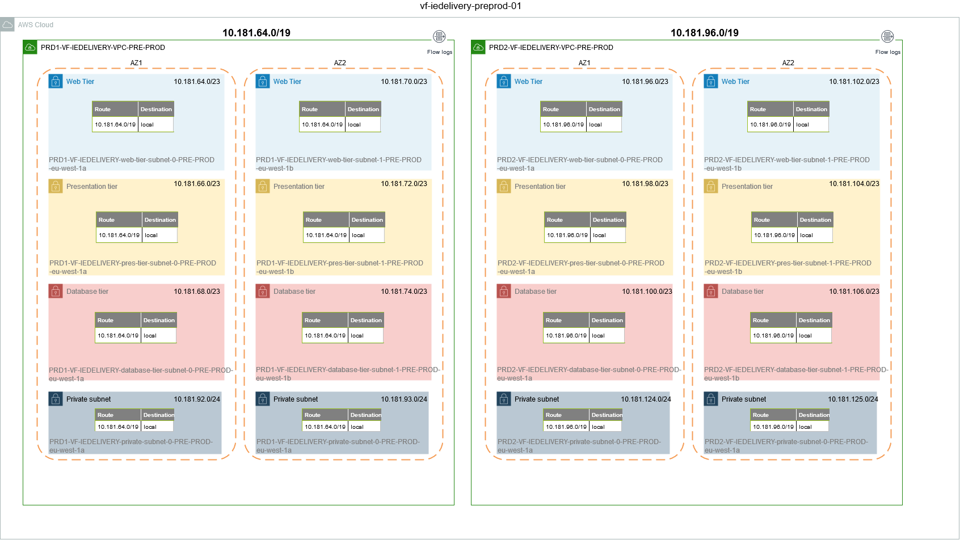

## 3. Subnet CIDR range

### PRD1

|  |  |  |  |  |  |
| --- | --- | --- | --- | --- | --- |
| Subnet | Subnet address | Netmask | Range of addresses | Useable IPs | Hosts |
| Web | 10.181.64.0/23 | 255.255.254.0 | 10.181.64.0 - 10.181.65.255 | 10.181.64.1 - 10.181.65.254 | 510 |
| Pres | 10.181.66.0/23 | 255.255.254.0 | 10.181.66.0 - 10.181.67.255 | 10.181.66.1 - 10.181.67.254 | 510 |
| Database | 10.181.68.0/23 | 255.255.254.0 | 10.181.68.0 - 10.181.69.255 | 10.181.68.1 - 10.181.69.254 | 510 |
| Web | 10.181.70.0/23 | 255.255.254.0 | 10.181.70.0 - 10.181.71.255 | 10.181.70.1 - 10.181.71.254 | 510 |
| Pres | 10.181.72.0/23 | 255.255.254.0 | 10.181.72.0 - 10.181.73.255 | 10.181.72.1 - 10.181.73.254 | 510 |
| Database | 10.181.74.0/23 | 255.255.254.0 | 10.181.74.0 - 10.181.75.255 | 10.181.74.1 - 10.181.75.254 | 510 |
|  | 10.181.76.0/23 | 255.255.254.0 | 10.181.76.0 - 10.181.77.255 | 10.181.76.1 - 10.181.77.254 | 510 |
|  | 10.181.78.0/23 | 255.255.254.0 | 10.181.78.0 - 10.181.79.255 | 10.181.78.1 - 10.181.79.254 | 510 |
|  | 10.181.80.0/23 | 255.255.254.0 | 10.181.80.0 - 10.181.81.255 | 10.181.80.1 - 10.181.81.254 | 510 |
|  | 10.181.82.0/23 | 255.255.254.0 | 10.181.82.0 - 10.181.83.255 | 10.181.82.1 - 10.181.83.254 | 510 |
|  | 10.181.84.0/23 | 255.255.254.0 | 10.181.84.0 - 10.181.85.255 | 10.181.84.1 - 10.181.85.254 | 510 |
|  | 10.181.86.0/23 | 255.255.254.0 | 10.181.86.0 - 10.181.87.255 | 10.181.86.1 - 10.181.87.254 | 510 |
|  | 10.181.88.0/23 | 255.255.254.0 | 10.181.88.0 - 10.181.89.255 | 10.181.88.1 - 10.181.89.254 | 510 |
|  | 10.181.90.0/23 | 255.255.254.0 | 10.181.90.0 - 10.181.91.255 | 10.181.90.1 - 10.181.91.254 | 510 |
| Priv | 10.181.92.0/24 | 255.255.255.0 | 10.181.92.0 - 10.181.92.255 | 10.181.92.1 - 10.181.92.254 | 254 |
| Priv | 10.181.93.0/24 | 255.255.255.0 | 10.181.93.0 - 10.181.93.255 | 10.181.93.1 - 10.181.93.254 | 254 |
|  | 10.181.94.0/24 | 255.255.255.0 | 10.181.94.0 - 10.181.94.255 | 10.181.94.1 - 10.181.94.254 | 254 |
|  | 10.181.95.0/24 | 255.255.255.0 | 10.181.95.0 - 10.181.95.255 | 10.181.95.1 - 10.181.95.254 | 254 |

### PRD2

|  |  |  |  |  |  |
| --- | --- | --- | --- | --- | --- |
| Subnet | Subnet address | Netmask | Range of addresses | Useable IPs | Hosts |
| Web | 10.181.96.0/23 | 255.255.254.0 | 10.181.96.0 - 10.181.97.255 | 10.181.96.1 - 10.181.97.254 | 510 |
| Pres | 10.181.98.0/23 | 255.255.254.0 | 10.181.98.0 - 10.181.99.255 | 10.181.98.1 - 10.181.99.254 | 510 |
| Datab | 10.181.100.0/23 | 255.255.254.0 | 10.181.100.0 - 10.181.101.255 | 10.181.100.1 - 10.181.101.254 | 510 |
| Web | 10.181.102.0/23 | 255.255.254.0 | 10.181.102.0 - 10.181.103.255 | 10.181.102.1 - 10.181.103.254 | 510 |
| Pres | 10.181.104.0/23 | 255.255.254.0 | 10.181.104.0 - 10.181.105.255 | 10.181.104.1 - 10.181.105.254 | 510 |
| Datab | 10.181.106.0/23 | 255.255.254.0 | 10.181.106.0 - 10.181.107.255 | 10.181.106.1 - 10.181.107.254 | 510 |
|  | 10.181.108.0/23 | 255.255.254.0 | 10.181.108.0 - 10.181.109.255 | 10.181.108.1 - 10.181.109.254 | 510 |
|  | 10.181.110.0/23 | 255.255.254.0 | 10.181.110.0 - 10.181.111.255 | 10.181.110.1 - 10.181.111.254 | 510 |
|  | 10.181.112.0/23 | 255.255.254.0 | 10.181.112.0 - 10.181.113.255 | 10.181.112.1 - 10.181.113.254 | 510 |
|  | 10.181.114.0/23 | 255.255.254.0 | 10.181.114.0 - 10.181.115.255 | 10.181.114.1 - 10.181.115.254 | 510 |
|  | 10.181.116.0/23 | 255.255.254.0 | 10.181.116.0 - 10.181.117.255 | 10.181.116.1 - 10.181.117.254 | 510 |
|  | 10.181.118.0/23 | 255.255.254.0 | 10.181.118.0 - 10.181.119.255 | 10.181.118.1 - 10.181.119.254 | 510 |
|  | 10.181.120.0/23 | 255.255.254.0 | 10.181.120.0 - 10.181.121.255 | 10.181.120.1 - 10.181.121.254 | 510 |
|  | 10.181.122.0/23 | 255.255.254.0 | 10.181.122.0 - 10.181.123.255 | 10.181.122.1 - 10.181.123.254 | 510 |
| Priv | 10.181.124.0/24 | 255.255.255.0 | 10.181.124.0 - 10.181.124.255 | 10.181.124.1 - 10.181.124.254 | 254 |
| Priv | 10.181.125.0/24 | 255.255.255.0 | 10.181.125.0 - 10.181.125.255 | 10.181.125.1 - 10.181.125.254 | 254 |
|  | 10.181.126.0/24 | 255.255.255.0 | 10.181.126.0 - 10.181.126.255 | 10.181.126.1 - 10.181.126.254 | 254 |
|  | 10.181.127.0/24 | 255.255.255.0 | 10.181.127.0 - 10.181.127.255 | 10.181.127.1 - 10.181.127.254 | 254 |

# 04 VF IE DNS

## 

* 1.Route53 Hosted Zones
* 2.AWS TO GDC
* 3.GDC TO AWS
* 4.TGW
* 5.SS VPC
* 6. AWS Address Resolution

## 1.Route53 Hosted Zones

This section describes the public and private hosted zones that are going to be created for VF IE. In order to maintain the IaC centralized, a codecommit repository has been created: <https://eu-west-1.console.aws.amazon.com/codesuite/codecommit/repositories/vf-iedelivery-dns/browse?region=eu-west-1> . To automate the changes, a cross-account codepipeline has been created: <https://eu-west-1.console.aws.amazon.com/codesuite/codepipeline/pipelines/vf-iedelivery-dns--cross-account-prod-tf/view?region=eu-west-1>

|  |  |  |  |  |  |  |  |
| --- | --- | --- | --- | --- | --- | --- | --- |
| Environment | AWS Tenant | Domain | Type | Account | VPC | Purpose | Created? |
| Shared Services | SS | ieaws.vodafone.com | Public | vf-iedelivery-prod-ss-01 |  | Public hosted zone for VFIE project. Infoblox public zone has been **delegated** to this zone. | Yes |
| Shared Services | SS | [ieaws.vodafone.com](http://ieaws.vodafone.com) | Private | vf-iedelivery-prod-ss-01 | SS VPC | Private hosted zone for VFIE project. Infoblox private zone has been **delegated** to this zone. | Yes, delegation in progress. |
| Shared Services | SS | ? | Public | vf-iedelivery-prod-ss-01 |  | Shared Services CI/CD | No |
| Sandbox | snd1 | snd1.ieaws.vodafone.com | Public | vf-iedelivery-sandbox-01 |  | Sub-domain of VFIE for sandbox. Workload Sandbox | Yes |
| Sandbox | snd1-ss | snd1-ss.ieaws.vodafone.com | Public | vf-iedelivery-sandbox-01 |  | Sub-domain of VFIE for sandbox.  Shared Services Sandbox | Yes |
| TEST | sit1 | sit1.ieaws.vodafone.com | Public | vf-iedelivery-test-01 |  | Sub-domain of VFIE for test. | No |
| TEST | sit1 | [internal.vodafone.com](http://internal.vodafone.com/) | Private | vf-iedelivery-test-01 | ST1 VPC | Routing for AWS TEST to GDC connections. We will add records with a wildcard for prod gdc services, pointing to SS TEST NLB. | No |
| TEST | sit2 | sit2.ieaws.vodafone.com | Public | vf-iedelivery-test-01 |  | Sub-domain of VFIE for test. | No |
| TEST | sit2 | [internal.vodafone.com](http://internal.vodafone.com/) | Private | vf-iedelivery-test-01 | ST2 VPC | Routing for AWS TEST to GDC connections. We will add records with a wildcard for prod gdc services, pointing to SS TEST NLB. | No |
| TEST | sit3 | sit3.ieaws.vodafone.com | Public | vf-iedelivery-test-01 |  | Sub-domain of VFIE for test. | No |
| TEST | sit3 | [internal.vodafone.com](http://internal.vodafone.com/) | Private | vf-iedelivery-test-01 | ST3 VPC | Routing for AWS TEST to GDC connections. We will add records with a wildcard for prod gdc services, pointing to SS TEST NLB. | No |
| TEST | sit4 | sit4.ieaws.vodafone.com | Public | vf-iedelivery-test-01 |  | Sub-domain of VFIE for test. | No |
| TEST | sit4 | [internal.vodafone.com](http://internal.vodafone.com/) | Private | vf-iedelivery-test-01 | ST4 VPC | Routing for AWS TEST to GDC connections. We will add records with a wildcard for prod gdc services, pointing to SS TEST NLB. | No |
| PRE-PROD | prd1 | prd1.[ieaws.vodafone.com](http://ieaws.vodafone.com) | Public | vf-iedelivery-preprod-01 |  | Sub-domain of VFIE for pre-prod. | Yes |
| PRE-PROD | prd1 | [internal.vodafone.com](http://internal.vodafone.com) | Private | vf-iedelivery-preprod-01 | PRD1 VPC | Routing for AWS PREPROD to GDC connections. We will add records with a wildcard for prod gdc services, pointing to SS PREPROD NLB. | Yes |
| PRE-PROD | prd2 | prd2.[ieaws.vodafone.com](http://ieaws.vodafone.com/) | Public | vf-iedelivery-preprod-01 |  | Sub-domain of VFIE for pre-prod | Yes |
| PRE-PROD | prd2 | [internal.vodafone.com](http://internal.vodafone.com) | Private | vf-iedelivery-preprod-01 | PRD2 VPC | Routing for AWS PREPROD to GDC connections. We will add records with a wildcard for prod gdc services, pointing to SS PREPROD NLB. | Yes |
| PROD | prod | prod.ieaws.vodafone.com | Public | vf-iedelivery-prod-01 |  | Sub-domain of VFIE for prod | Yes |
| PROD | prod | internal.vodafone.com | Private | vf-iedelivery-prod-01 | Prod VPC | Routing for AWS PROD to GDC connections. We will add records with a wildcard for prod gdc services, pointing to SS PROD NLB. | Yes |

## 2.AWS TO GDC

This section will provide the details needed to understand the communication between a client in AWS tenant and a server in GDC datacenter. The diagram just shows the case for AWS Prod tenant, but the same pattern will be followed for other AWS environments.

In this scenario, the client is on the right side, in AWS Prod VPC (prod account). There will be a list of ports where the HAProxy will be listening to (the list can be updated during the build phase). The client will try to connect with a gdc service, with a name convention like 'prod-vf-ie.internal.vodafone.com'. This is a list with some examples:

* FSL-APP-PROD-VF-IE.INTERNAL.VODAFONE.COM
* FSL-GTW-PROD-VF-IE.INTERNAL.VODAFONE.COM
* MEH-APP-PROD-VF-IE.INTERNAL.VODAFONE.COM
* PORTAL-APP-PROD-VF-IE.INTERNAL.VODAFONE.COM
* OSB-APP-PROD-VF-IE.INTERNAL.VODAFONE.COM
* MFT-APP-PROD-VF-IE.INTERNAL.VODAFONE.COM
* MEDIAROOM-APP-PROD-VF-IE.INTERNAL.VODAFONE.COM
* GISMSH-APP-PROD-VF-IE.INTERNAL.VODAFONE.COM
* TIBCO-APP-PROD-VF-IE.INTERNAL.VODAFONE.COM
* JINNY-APP-PROD-VF-IE.INTERNAL.VODAFONE.COM
* SMSC-APP-PROD-VF-IE.INTERNAL.VODAFONE.COM
* RADIUS-APP-PROD-VF-IE.INTERNAL.VODAFONE.COM
* MML-APP-PROD-VF-IE.INTERNAL.VODAFONE.COM
* AUA-APP-PROD-VF-IE.INTERNAL.VODAFONE.COM
* NPT-APP-PROD-VF-IE.INTERNAL.VODAFONE.COM

Prod VPC has a private hosted zone, internal.vodafone.com, where a cname record, pointing '*prod-vf-ie.internal.vodafone.com' (wildcard) to the SS PROD NLB. In this record an alias name of the SS PROD NLB is used, in order to avoid problems if the NLB changed in the SS VPC. This alias name for the SS NLB will be maintained. The AWS client will send the traffic to SS PROD NLB, that will redirect the request to an HAProxy in SS VPC. Then, HAProxy can have in its config file either a gdc ip address, or a gdc server domain name. If it is a gdc server domain name, the Route53 resolver outbound endpoint will be used. In the configuration for the outbound endpoint, a Forward Rule has been created, with the Infoblox name server ip address, to send the dns queries of internal.vodafone.com. For the case of an ip address, we don't need further configuration, as once VIF is stablished, BGP propagate the corresponding routes to SS VPC.

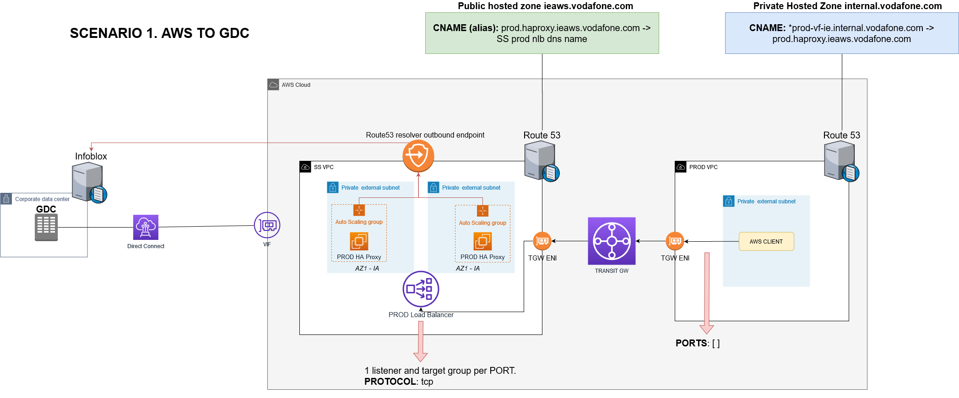

## 3.GDC TO AWS

This section will provide the details needed to understand the communication between a client in GDC datacenter and a server in AWS tenant. The diagram just shows the case for AWS Prod tenant, but the same pattern will be followed for other AWS environments.

First of all, the private zone in Infoblox has a delegation of 'ieaws.vodafone.com' that points to the Private Hosted Zone in SS VPC. In this Private hosted zone, we will be populating the services that we offer in AWS, as this will be the visibility that GDC will have about AWS. We will add alias records, pointing the published service, for example, service1.prod.ieaws.vodafone.com, to the SS PROD NLB. So, when a client in GDC wants to connect to a server in AWS, it will query the private zone in Infoblox, and then it will get as a response the SS PROD NLB. Once the request reaches SS PROD NLB and it's redirected to an HAProxy, the HAProxy will use the Public Hosted zone for 'ieaws.vodafone.com' to resolve the service1 published in PROD. In PROD VPC, a subdomain called 'prod.ieaws.vodafone.com' has been created, and the corresponding NS records has been added the public hosted zone 'ieaws.vodafone.com' in SS VPC. In this subdomain, we will add the CNAME for the services publishes, with the real resolution, for example, a LB in prod. This will be the response that the HAProxy will get.

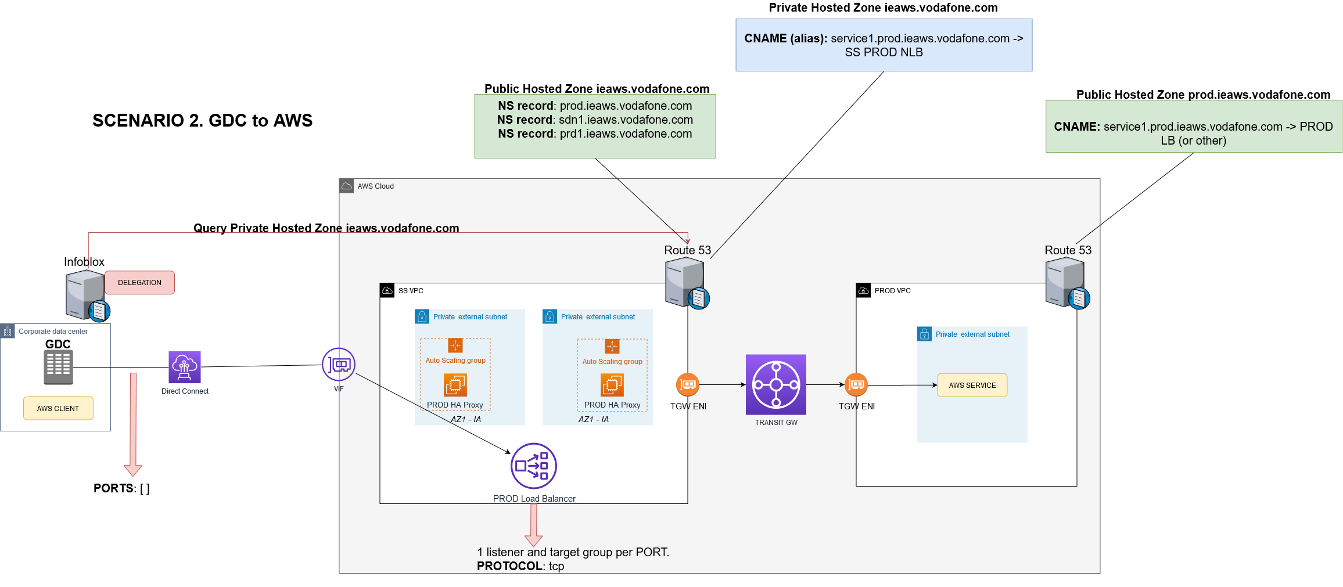

## 4.TGW

All communications are going to depend on the routing of the TGW. Please, see the documentation and implementation here.

## 5.SS VPC

Please, see the documentation about the SS VPC here.

## 6. AWS Address Resolution

|  |  |  |
| --- | --- | --- |
| FQDN | CNAME | LB Address |
| [pb-osb-lb-as.prod.ieaws.vodafone.com](http://pb-osb-lb-as.prod.ieaws.vodafone.com) | [prod.ieaws.vodafone.com](http://prod.ieaws.vodafone.com) | [SS-VF-IEDELIVERY-PROD-NLB-07ed30b5f822b162.elb.eu-west-1.amazonaws.com](http://SS-VF-IEDELIVERY-PROD-NLB-07ed30b5f822b162.elb.eu-west-1.amazonaws.com) |
| [pb-osb.prod.ieaws.vodafone.com](http://pb-osb.prod.ieaws.vodafone.com) |
| [pb-odi-lb-as.prod.ieaws.vodafone.com](http://pb-odi-lb-as.prod.ieaws.vodafone.com) |
| [cch-ib-osb-lb-as.prod.ieaws.vodafone.com](http://cch-ib-osb-lb-as.prod.ieaws.vodafone.com) |
| [cch-ib-osb.prod.ieaws.vodafone.com](http://cch-ib-osb.prod.ieaws.vodafone.com) |
| [cch-ib-soa-lb-as.prod.ieaws.vodafone.com](http://cch-ib-soa-lb-as.prod.ieaws.vodafone.com) |
| [cch-ib-soa.prod.ieaws.vodafone.com](http://cch-ib-soa.prod.ieaws.vodafone.com) |
| [cch-ob-ums-osb-lb-as.prod.ieaws.vodafone.com](http://cch-ob-ums-osb-lb-as.prod.ieaws.vodafone.com) |
| [cch-ob-ums-osb.prod.ieaws.vodafone.com](http://cch-ob-ums-osb.prod.ieaws.vodafone.com) |
| [cch-ob-ums-soa-lb-as.prod.ieaws.vodafone.com](http://cch-ob-ums-soa-lb-as.prod.ieaws.vodafone.com) |
| [cch-ob-ums-soa.prod.ieaws.vodafone.com](http://cch-ob-ums-soa.prod.ieaws.vodafone.com) |
| [cch-ob-osb-lb-as.prod.ieaws.vodafone.com](http://cch-ob-osb-lb-as.prod.ieaws.vodafone.com) |
| [cch-ob-osb.prod.ieaws.vodafone.com](http://cch-ob-osb.prod.ieaws.vodafone.com) |
| [cch-ob-soa-lb-as.prod.ieaws.vodafone.com](http://cch-ob-soa-lb-as.prod.ieaws.vodafone.com) |
| [cch-ob-soa.prod.ieaws.vodafone.com](http://cch-ob-soa.prod.ieaws.vodafone.com) |
| [cch-ob-odi-lb-as.prod.ieaws.vodafone.com](http://cch-ob-odi-lb-as.prod.ieaws.vodafone.com) |
| [cch-portal-lb-as.prod.ieaws.vodafone.com](http://cch-portal-lb-as.prod.ieaws.vodafone.com) |
| [cch-portal.prod.ieaws.vodafone.com](http://cch-portal.prod.ieaws.vodafone.com) |
| [oal-osb-lb-as.prod.ieaws.vodafone.com](http://oal-osb-lb-as.prod.ieaws.vodafone.com) |
| [oal-osb.prod.ieaws.vodafone.com](http://oal-osb.prod.ieaws.vodafone.com) |
| [oal-soa-lb-as.prod.ieaws.vodafone.com](http://oal-soa-lb-as.prod.ieaws.vodafone.com) |
| [oal-soa.prod.ieaws.vodafone.com](http://oal-soa.prod.ieaws.vodafone.com) |
| [cch-sal-sftp.prd1.ieaws.vodafone.com](http://cch-sal-sftp.prd1.ieaws.vodafone.com) |
| [jenkins.ieaws.vodafone.com](http://jenkins.ieaws.vodafone.com) |
| [artifactory.ieaws.vodafone.com](http://artifactory.ieaws.vodafone.com) |
| [myst.ieaws.vodafone.com](http://myst.ieaws.vodafone.com) |
| [ocm.ieaws.vodafone.com](http://ocm.ieaws.vodafone.com) |
| [pb-osb-lb-as.prd2.ieaws.vodafone.com](http://pb-osb-lb-as.prd2.ieaws.vodafone.com) | [prd2.ieaws.vodafone.com](http://prd2.ieaws.vodafone.com) | [SS-VF-IEDELIVERY-PRD2-NLB-0896a285b4124ae4.elb.eu-west-1.amazonaws.com](http://SS-VF-IEDELIVERY-PRD2-NLB-0896a285b4124ae4.elb.eu-west-1.amazonaws.com) |
| [pb-osb.prd2.ieaws.vodafone.com](http://pb-osb.prd2.ieaws.vodafone.com) |
| [pb-odi-lb-as.prd2.ieaws.vodafone.com](http://pb-odi-lb-as.prd2.ieaws.vodafone.com) |
| [cch-ib-osb-lb-as.prd2.ieaws.vodafone.com](http://cch-ib-osb-lb-as.prd2.ieaws.vodafone.com) |
| [cch-ib-osb.prd2.ieaws.vodafone.com](http://cch-ib-osb.prd2.ieaws.vodafone.com) |
| [cch-ib-soa-lb-as.prd2.ieaws.vodafone.com](http://cch-ib-soa-lb-as.prd2.ieaws.vodafone.com) |
| [cch-ib-soa.prd2.ieaws.vodafone.com](http://cch-ib-soa.prd2.ieaws.vodafone.com) |
| [cch-ob-ums-osb-lb-as.prd2.ieaws.vodafone.com](http://cch-ob-ums-osb-lb-as.prd2.ieaws.vodafone.com) |
| [cch-ob-ums-osb.prd2.ieaws.vodafone.com](http://cch-ob-ums-osb.prd2.ieaws.vodafone.com) |
| [cch-ob-ums-soa-lb-as.prd2.ieaws.vodafone.com](http://cch-ob-ums-soa-lb-as.prd2.ieaws.vodafone.com) |
| [cch-ob-ums-soa.prd2.ieaws.vodafone.com](http://cch-ob-ums-soa.prd2.ieaws.vodafone.com) |
| [cch-ob-osb-lb-as.prd2.ieaws.vodafone.com](http://cch-ob-osb-lb-as.prd2.ieaws.vodafone.com) |
| [cch-ob-osb.prd2.ieaws.vodafone.com](http://cch-ob-osb.prd2.ieaws.vodafone.com) |
| [cch-ob-soa-lb-as.prd2.ieaws.vodafone.com](http://cch-ob-soa-lb-as.prd2.ieaws.vodafone.com) |
| [cch-ob-soa.prd2.ieaws.vodafone.com](http://cch-ob-soa.prd2.ieaws.vodafone.com) |
| [cch-ob-odi-lb-as.prd2.ieaws.vodafone.com](http://cch-ob-odi-lb-as.prd2.ieaws.vodafone.com) |
| [cch-portal-lb-as.prd2.ieaws.vodafone.com](http://cch-portal-lb-as.prd2.ieaws.vodafone.com) |
| [cch-portal.prd2.ieaws.vodafone.com](http://cch-portal.prd2.ieaws.vodafone.com) |
| [oal-osb-lb-as.prd2.ieaws.vodafone.com](http://oal-osb-lb-as.prd2.ieaws.vodafone.com) |
| [oal-osb.prd2.ieaws.vodafone.com](http://oal-osb.prd2.ieaws.vodafone.com) |
| [oal-soa-lb-as.prd2.ieaws.vodafone.com](http://oal-soa-lb-as.prd2.ieaws.vodafone.com) |
| [oal-soa.prd2.ieaws.vodafone.com](http://oal-soa.prd2.ieaws.vodafone.com) |
| [cch-sal-sftp.prd2.ieaws.vodafone.com](http://cch-sal-sftp.prd2.ieaws.vodafone.com) |
| [pb-osb-lb-as.prd1.ieaws.vodafone.com](http://pb-osb-lb-as.prd1.ieaws.vodafone.com) | [prd1.ieaws.vodafone.com](http://prd1.ieaws.vodafone.com) | [SS-VF-IEDELIVERY-PRD1-NLB-fff2438b7fa415c1.elb.eu-west-1.amazonaws.com](http://SS-VF-IEDELIVERY-PRD1-NLB-fff2438b7fa415c1.elb.eu-west-1.amazonaws.com) |
| [pb-osb.prd1.ieaws.vodafone.com](http://pb-osb.prd1.ieaws.vodafone.com) |
| [pb-odi-lb-as.prd1.ieaws.vodafone.com](http://pb-odi-lb-as.prd1.ieaws.vodafone.com) |
| [cch-ib-osb-lb-as.prd1.ieaws.vodafone.com](http://cch-ib-osb-lb-as.prd1.ieaws.vodafone.com) |
| [cch-ib-osb.prd1.ieaws.vodafone.com](http://cch-ib-osb.prd1.ieaws.vodafone.com) |
| [cch-ib-soa-lb-as.prd1.ieaws.vodafone.com](http://cch-ib-soa-lb-as.prd1.ieaws.vodafone.com) |
| [cch-ib-soa.prd1.ieaws.vodafone.com](http://cch-ib-soa.prd1.ieaws.vodafone.com) |
| [cch-ob-ums-osb-lb-as.prd1.ieaws.vodafone.com](http://cch-ob-ums-osb-lb-as.prd1.ieaws.vodafone.com) |
| [cch-ob-ums-osb.prd1.ieaws.vodafone.com](http://cch-ob-ums-osb.prd1.ieaws.vodafone.com) |
| [cch-ob-ums-soa-lb-as.prd1.ieaws.vodafone.com](http://cch-ob-ums-soa-lb-as.prd1.ieaws.vodafone.com) |
| [cch-ob-ums-soa.prd1.ieaws.vodafone.com](http://cch-ob-ums-soa.prd1.ieaws.vodafone.com) |
| [cch-ob-osb-lb-as.prd1.ieaws.vodafone.com](http://cch-ob-osb-lb-as.prd1.ieaws.vodafone.com) |
| [cch-ob-osb.prd1.ieaws.vodafone.com](http://cch-ob-osb.prd1.ieaws.vodafone.com) |
| [cch-ob-soa-lb-as.prd1.ieaws.vodafone.com](http://cch-ob-soa-lb-as.prd1.ieaws.vodafone.com) |
| [cch-ob-soa.prd1.ieaws.vodafone.com](http://cch-ob-soa.prd1.ieaws.vodafone.com) |
| [cch-ob-odi-lb-as.prd1.ieaws.vodafone.com](http://cch-ob-odi-lb-as.prd1.ieaws.vodafone.com) |
| [cch-portal-lb-as.prd1.ieaws.vodafone.com](http://cch-portal-lb-as.prd1.ieaws.vodafone.com) |
| [cch-portal.prd1.ieaws.vodafone.com](http://cch-portal.prd1.ieaws.vodafone.com) |
| [oal-osb-lb-as.prd1.ieaws.vodafone.com](http://oal-osb-lb-as.prd1.ieaws.vodafone.com) |
| [oal-osb.prd1.ieaws.vodafone.com](http://oal-osb.prd1.ieaws.vodafone.com) |
| [oal-soa-lb-as.prd1.ieaws.vodafone.com](http://oal-soa-lb-as.prd1.ieaws.vodafone.com) |
| [oal-soa.prd1.ieaws.vodafone.com](http://oal-soa.prd1.ieaws.vodafone.com) |
| [cch-sal-sftp.prd1.ieaws.vodafone.com](http://cch-sal-sftp.prd1.ieaws.vodafone.com) |

## DNS TROUBLESHOOTING

Steps to follow to see the traffic and the routing logic to troubleshoot dns.

### POINT 1: GDC domain name resolution

We are using a Route53 resolver outbound endpoint to send gdc queries to Infoblox.

**IP addresses used in AWS** side to send queries:

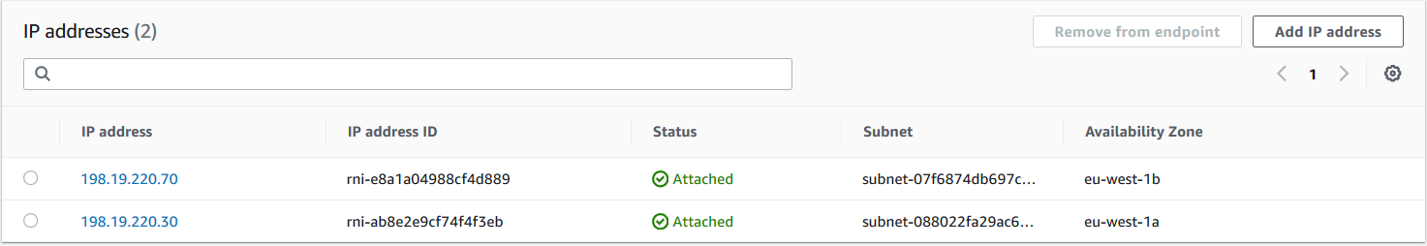

Rules created:

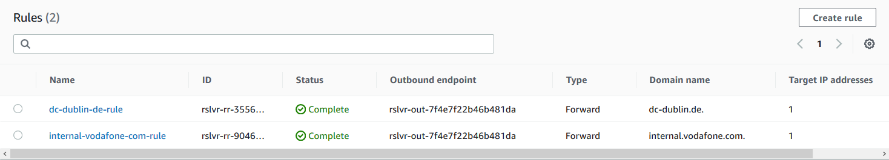

GDC Target IP address (Infoblox dns server):

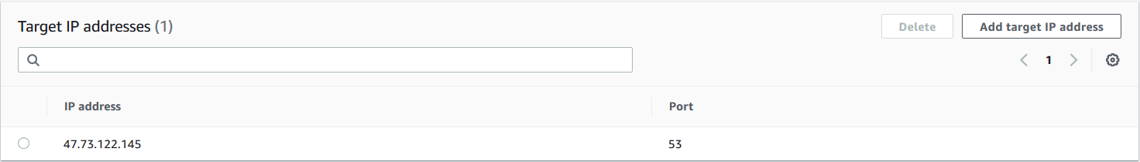

#### RESOLVER METRICS

We can see the Route53 Resolver metrics here: https://eu-west-1.console.aws.amazon.com/cloudwatch/home?region=eu-west-1#metricsV2:graph=~(view~'timeSeries~stacked~false~metrics~(~(~'AWS*2fRoute53Resolver~'OutboundQueryVolume~'EndpointId~'rslvr-out-7f4e7f22b46b481da))~region~'eu-west-1);query=~'*7bAWS*2fRoute53Resolver*2cEndpointId*7d (aws account: vf-iedelivery-prod-ss-01)

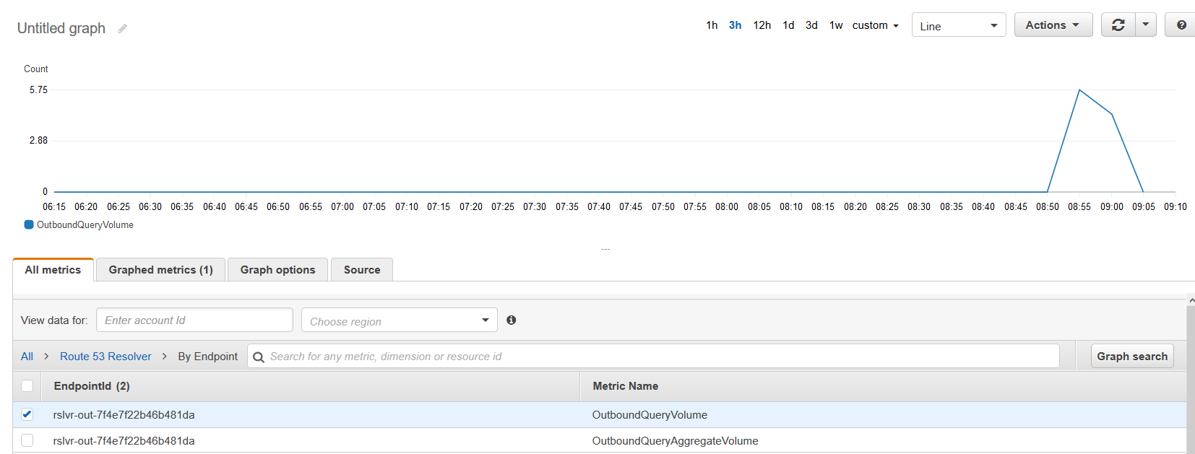

#### HAPROXY DNS TEST

We can login one of our HAProxy ec2 instances. Right now, we are testing prd1.

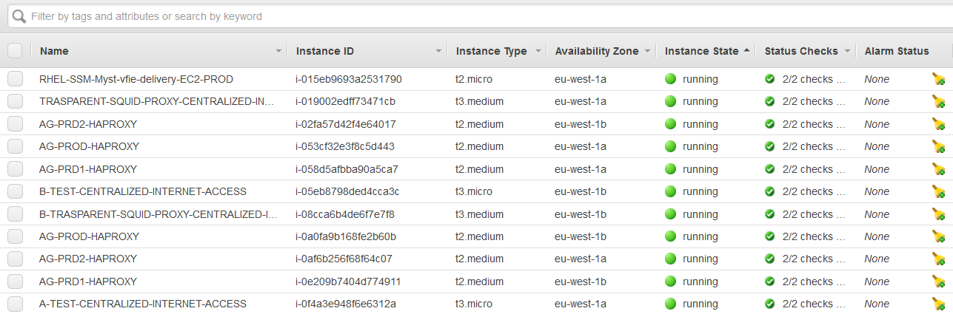

Results at the moment (it's failing):

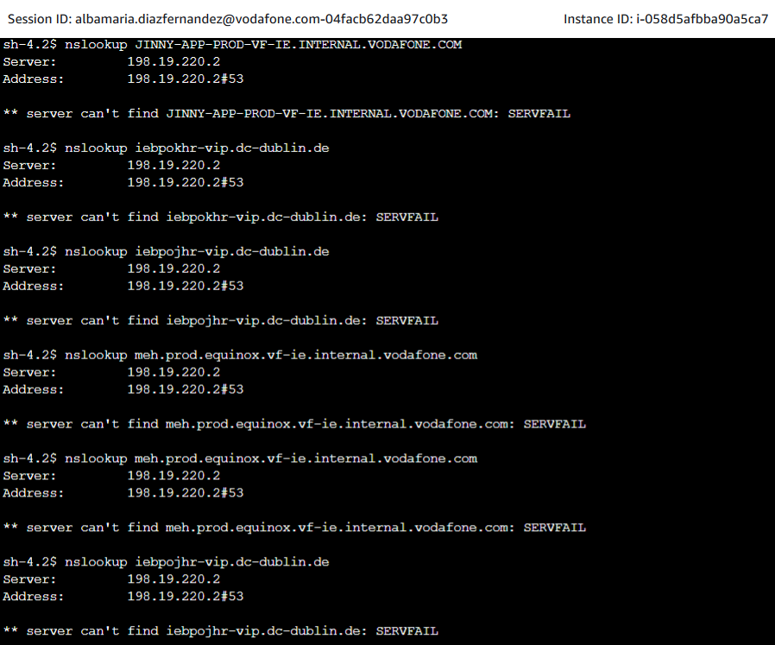

#### RESOLVER ENDPOINT IP ADDRESS LOGS

All logs from SS VPC are sent to the log group called VPC/SS. For the first IP Address 198.19.220.70, we can see the traffic going from route53 endpoint to gdc infoblox server. However, **we don't see any reply back.**

**URL:**[**https://eu-west-1.console.aws.amazon.com/cloudwatch/home?region=eu-west-1#logsV2:logs-insights$3FqueryDetail$3D$257E$2528end$257E0$257Estart$257E-3600$257EtimeType$257E$2527RELATIVE$257Eunit$257E$2527seconds$257EeditorString$257E$2527filter*20*40logStream*20*3d*20*27eni-0a082115a31aca3f8-all*27*20and*20*28srcAddr*20*3d*20*27198.19.220.70*27*20or*20dstAddr*20*3d*20*27198.19.220.70*27*29*0a*20*7c*20fields*20*40timestamp*2c*20*40message$257EisLiveTail$257Efalse$257EqueryId$257E$2527beffca0c-b9f1-4356-9da3-0093f32d5928$257Esource$257E$2528$257E$2527vpc*2fSS$2529$2529**](https://eu-west-1.console.aws.amazon.com/cloudwatch/home?region=eu-west-1#logsV2:logs-insights$3FqueryDetail$3D$257E$2528end$257E0$257Estart$257E-3600$257EtimeType$257E$2527RELATIVE$257Eunit$257E$2527seconds$257EeditorString$257E$2527filter*20*40logStream*20*3d*20*27eni-0a082115a31aca3f8-all*27*20and*20*28srcAddr*20*3d*20*27198.19.220.70*27*20or*20dstAddr*20*3d*20*27198.19.220.70*27*29*0a*20*7c*20fields*20*40timestamp*2c*20*40message$257EisLiveTail$257Efalse$257EqueryId$257E$2527beffca0c-b9f1-4356-9da3-0093f32d5928$257Esource$257E$2528$257E$2527vpc*2fSS$2529$2529)

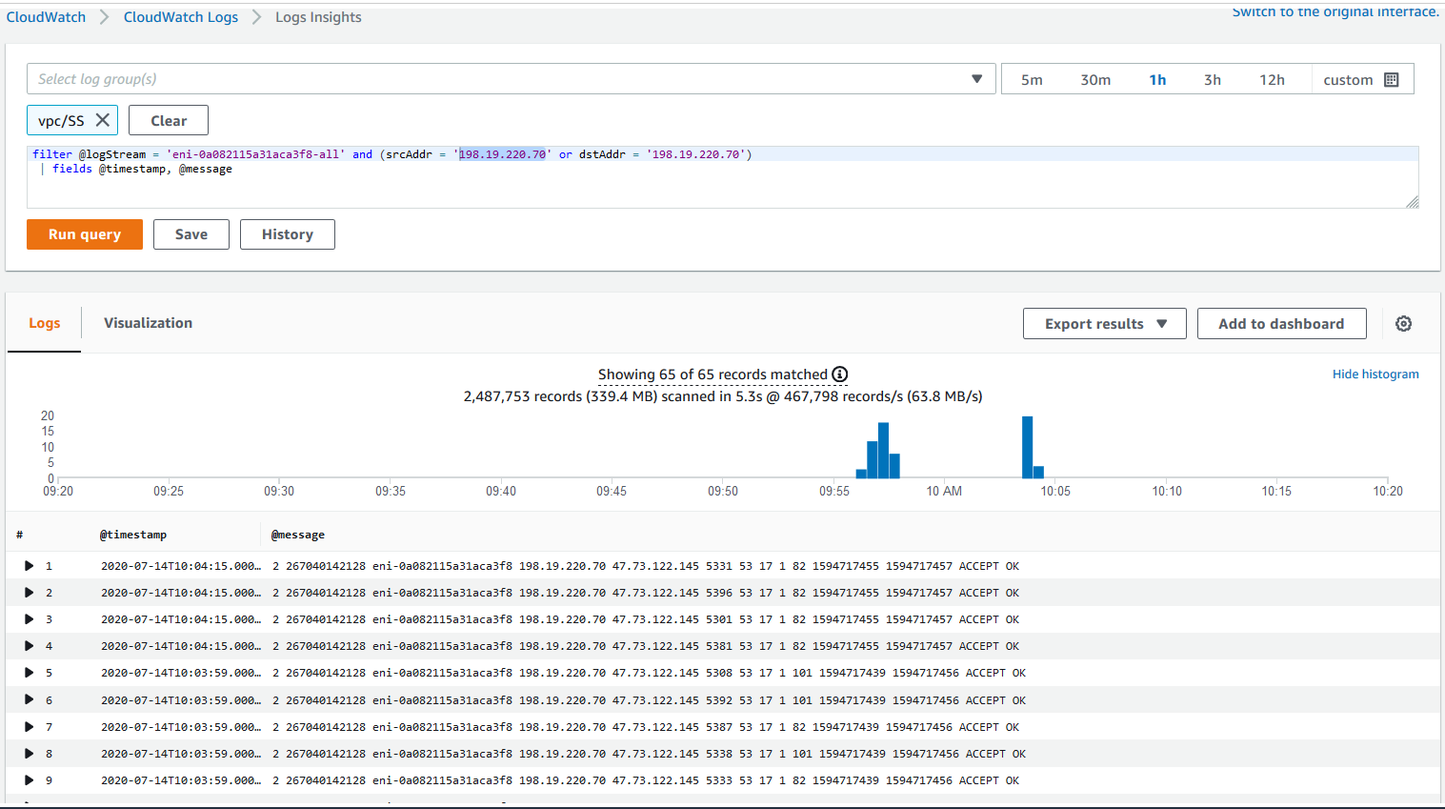

**TGW ROUTING**

We have created in Network manager a Global network for VFIE. We can review the route analyzer for this case:

Query:

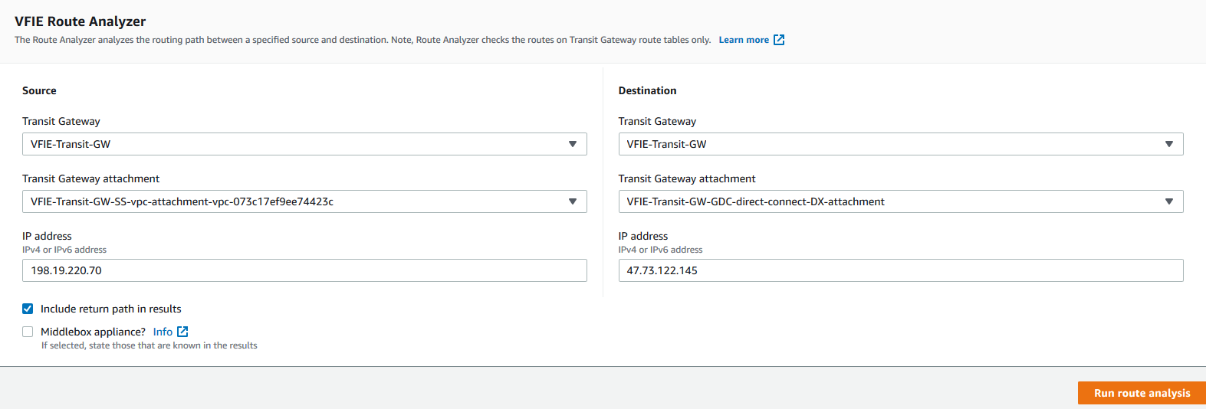

Result:

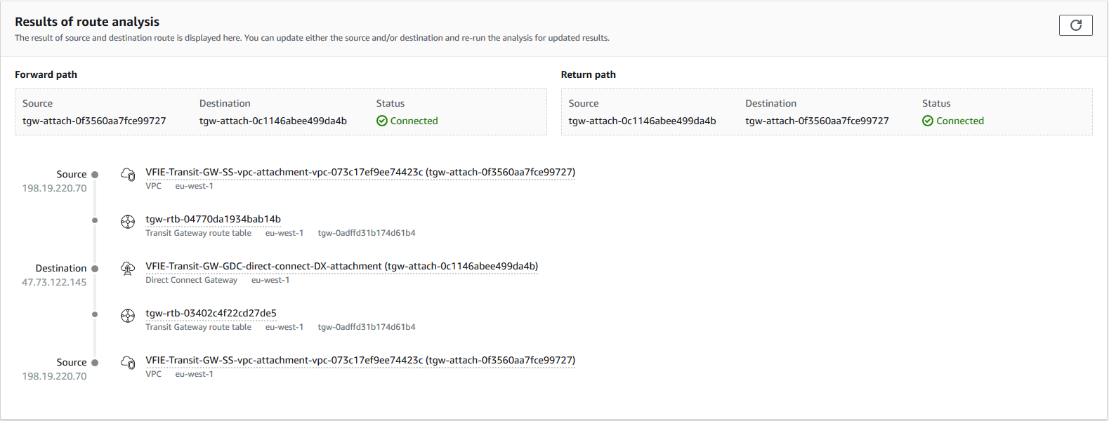

# 04 VF IE PROD VPC

## 1. Introduction

* Code: Terraform
* Repository: <https://git-codecommit.eu-west-1.amazonaws.com/v1/repos/vf-iedelivery-infrastructure>
* Branch: master
* AWS account: vf-iedelivery-mgmt -  831341508773
* CI/CD: CodePipeline <https://eu-west-1.console.aws.amazon.com/codesuite/codepipeline/pipelines/vf-iedelivery-infrastructure-prod-tf/view?region=eu-west-1>

Each VPC will be composed of:

* 1 Web tier subnet per AZ. Subnet IP range: '/23'
* 1 Presentation tier subnet per AZ. Subnet IP range: '/23'
* 1 Database tier subnet per AZ. Subnet IP range: '/23'
* 1 Private subnet for other purposes per AZ. Subnet IP range: '/24'
* VPC Flow logs enabled
* 1 different route table for each subnet.

## 2. Design of PROD VPC

These are the subnet CIDR ranges that were chosen for prod environment:

|  |  |  |  |  |  |
| --- | --- | --- | --- | --- | --- |
| VPC | Subnet address | Netmask | Range of addresses | Useable IPs | Hosts |
| **PROD** | **10.181.32.0/19** | 255.255.224.0 | 10.181.32.0 - 10.181.63.255 | 10.181.32.1 - 10.181.63.254 | 8190 |

The following diagram shows the state for the infrastructure deployed in AWS VF IE prod account by PCS. In each VPC, 3 subnets per AZ were created: web tier, presentation tier and database tier. Additionally, there are also others 2 private subnets that can be used for other purposes (endpoints, ENI, etc.).

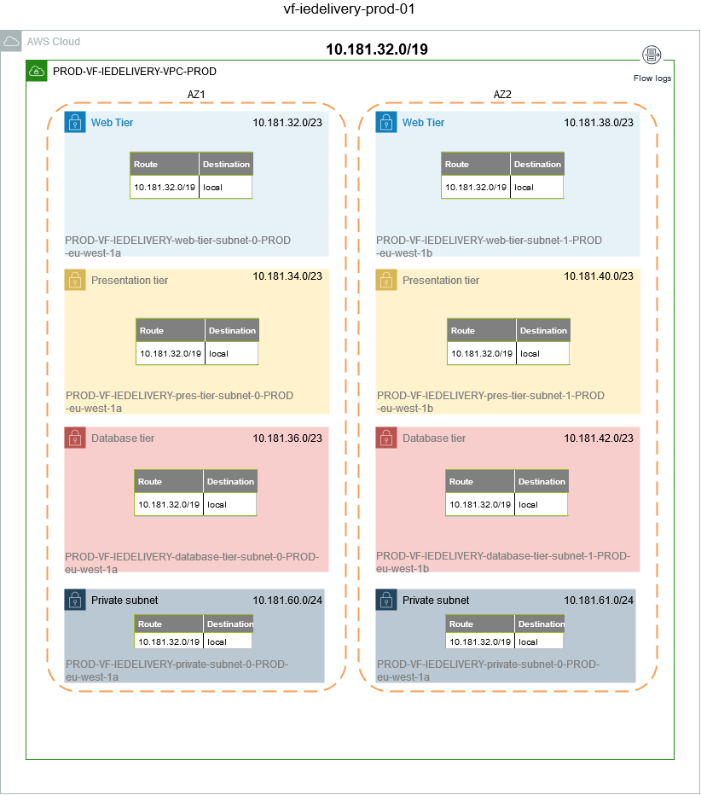

## 3. Subnet CIDR range

|  |  |  |  |  |  |
| --- | --- | --- | --- | --- | --- |
| **subnet** | **Subnet address** | **Netmask** | **Range of addresses** | **Useable IPs** | **Hosts** |
| Web | 10.181.32.0/23 | 255.255.254.0 | 10.181.32.0 -   10.181.33.255 | 10.181.32.1 -   10.181.33.254 | 510 |
| Pres | 10.181.34.0/23 | 255.255.254.0 | 10.181.34.0 -   10.181.35.255 | 10.181.34.1 -   10.181.35.254 | 510 |
| Datab | 10.181.36.0/23 | 255.255.254.0 | 10.181.36.0 -   10.181.37.255 | 10.181.36.1 -   10.181.37.254 | 510 |
| Web | 10.181.38.0/23 | 255.255.254.0 | 10.181.38.0 -   10.181.39.255 | 10.181.38.1 -   10.181.39.254 | 510 |
| Pres | 10.181.40.0/23 | 255.255.254.0 | 10.181.40.0 -   10.181.41.255 | 10.181.40.1 -   10.181.41.254 | 510 |
| Datab | 10.181.42.0/23 | 255.255.254.0 | 10.181.42.0 -   10.181.43.255 | 10.181.42.1 -   10.181.43.254 | 510 |
|  | 10.181.44.0/23 | 255.255.254.0 | 10.181.44.0 -   10.181.45.255 | 10.181.44.1 -   10.181.45.254 | 510 |
|  | 10.181.46.0/23 | 255.255.254.0 | 10.181.46.0 -   10.181.47.255 | 10.181.46.1 -   10.181.47.254 | 510 |
|  | 10.181.48.0/23 | 255.255.254.0 | 10.181.48.0 -   10.181.49.255 | 10.181.48.1 -   10.181.49.254 | 510 |
|  | 10.181.50.0/23 | 255.255.254.0 | 10.181.50.0 -   10.181.51.255 | 10.181.50.1 -   10.181.51.254 | 510 |
|  | 10.181.52.0/23 | 255.255.254.0 | 10.181.52.0 -   10.181.53.255 | 10.181.52.1 -   10.181.53.254 | 510 |
|  | 10.181.54.0/23 | 255.255.254.0 | 10.181.54.0 -   10.181.55.255 | 10.181.54.1 -   10.181.55.254 | 510 |
|  | 10.181.56.0/23 | 255.255.254.0 | 10.181.56.0 -   10.181.57.255 | 10.181.56.1 -   10.181.57.254 | 510 |
|  | 10.181.58.0/23 | 255.255.254.0 | 10.181.58.0 -   10.181.59.255 | 10.181.58.1 -   10.181.59.254 | 510 |
| Priv | 10.181.60.0/24 | 255.255.255.0 | 10.181.60.0 -   10.181.60.255 | 10.181.60.1 -   10.181.60.254 | 254 |
| Priv | 10.181.61.0/24 | 255.255.255.0 | 10.181.61.0 -   10.181.61.255 | 10.181.61.1 -   10.181.61.254 | 254 |
|  | 10.181.62.0/24 | 255.255.255.0 | 10.181.62.0 -   10.181.62.255 | 10.181.62.1 -   10.181.62.254 | 254 |
|  | 10.181.63.0/24 | 255.255.255.0 | 10.181.63.0 -   10.181.63.255 | 10.181.63.1 -   10.181.63.254 | 254 |

# 05 VFIE INFRA MONITORING

## 1.     Logging and Monitoring created by default when an AWS account is created via PCS:

* **CloudTrail** ( AWS documentation: <https://docs.aws.amazon.com/awscloudtrail/latest/userguide/cloudtrail-concepts.html> )
  + What is cloudtrail? Actions taken by a user, role, or an AWS service are recorded as events in CloudTrail. Events include both API and non-API account activity taken in the AWS Management Console, AWS Command Line Interface, and AWS SDKs and APIs. You can use CloudTrail to view, search, download, archive, analyze, and respond to account activity across your AWS infrastructure. There are two types of events that can be logged in CloudTrail: management events and data events. By default, trails log management events, but not data events. Management events are also known as control plane operations, like configuring security, registering devices, configuring rules for routing data, setting up logging, etc. Data events are also known as data plane operations, example: amazon s3 object-level API activity and AWS Lambda function execution activity.
  + A dedicated CloudTrail is set up and sent directly to Cyber Defence. Details:
    - Log Group name: gdc-pcs-cloudtrail
    - IAM role: gdc-pcs-cloudtrail-role-DO-NOT-DELETE
    - Trail name: pcacsec1-ct1
* **GuardDuty** ( AWS documentation: <https://docs.aws.amazon.com/guardduty/latest/ug/guardduty_findings.html> )
  + What is GuardDuty? Amazon GuardDuty is a continuous security monitoring service that analyzes and processes the following data sources: VPC Flow Logs, AWS CloudTrail event logs, and DNS logs. It uses threat intelligence feeds, such as lists of malicious IP addresses and domains, and machine learning to identify unexpected and potentially unauthorized and malicious activity within your AWS environment.
  + GuarDuty is **enabled** using the IAM role **AWSServiceRoleForAmazonGuardDuty**
  + Actions with Findings :
    - Locating and Analyzing GuardDuty Findings
    - Archiving, Downloading, and Providing Feedback on GuardDuty Findings
    - Filtering Findings
    - Suppression Rules
* **AWS Config** (AWS documentation: Compliance Engine (<https://confluence.sp.vodafone.com/x/G2NhC> )
* **Compliance Engine** (<https://confluence.sp.vodafone.com/x/G2NhC> )
* AWS Config manages and schedules the evaluation of the rules within each Application Account across all enabled regions. Each rule is linked to a Lambda Function which implements the custom logic for checking. The Lambda is invoked by AWS Config and the function checks compliance by assuming a pre-defined role in the application account. The compliance state of each rule is recorded in AWS Config.
* Continuous monitoring, continuous assessment
* CloudWatch Alarms
  + VPC_ROUTE_TABLE_CHANGE_LOG_METRIC_ALARM
  + VPC_SECURITY_GROUP_CHANGE_LOG_METRIC_ALARM
  + IAM_POLICY_CHANGE_LOG_METRIC_ALARM
  + NETWORK_GATEWAY_CHANGE_LOG_METRIC_ALARM
  + VPC_CHANGE_LOG_METRIC_ALARM
  + S3_BUCKET_POLICY_CHANGE_LOG_METRIC_ALARM
  + CONSOLE_AUTHENTICATION_FAILURE_LOG_METRIC_ALARM
  + CONFIG_CHANGE_LOG_METRIC_ALARM
  + NETWORK_ACL_CHANGE_LOG_METRIC_ALARM
  + CMK_DELETION_CHANGE_LOG_METRIC_ALARM
* A report is created 4 times per week (Monday, Tuesday, Thursday and Friday) and send it to the security risk team. Owners of the AWS accounts will be in the distribution list to received weekly this report.

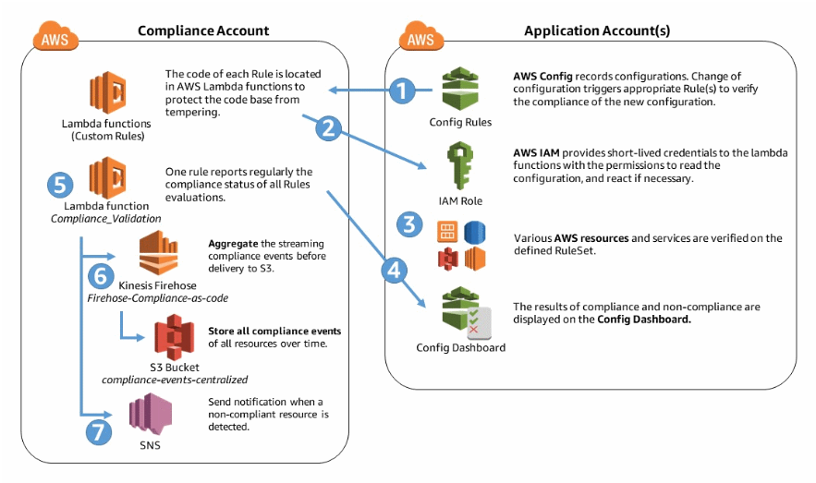

## 2.     Logging and Monitoring created when PCS receives the demand and manages the account:

* **CloudWatch** ( AWS documentation: <https://docs.aws.amazon.com/AmazonCloudWatch/latest/monitoring/WhatIsCloudWatch.html> )
  + It is not setup automatically. It will be configured once the infrastructure is deployed.
  + The infrastructure will be monitored via CloudWatch, with instances running the CloudWatch Agent to report more metrics back to CloudWatch. CloudWatch Alarms will be created in the specified environments (prod, pre-prod, etc.) and they will send an alert to SNS topics in the management account.
  + Example of EC2 metrics: CPU Usage, (RAM) Memory Usage, Disk Space Usage, Instance Status Check…
* **S3 Access Logs**
  + Deployed by stacksets (already placed for VFIE). For each VFIE account, the following has been created:
    - S3 bucket: vf-iedelivery-${AWS::AccountId}-logs
    - S3 logging bucket: s3-access-logs-vf-iedelivery-${AWS::AccountId}-logs
* **IAM**
  + There is a dedicated IAM role created called TPCsec that Cyber Defence can use to assume role into any account created through PCS
* **VPC Flow Logs**
  + When you create a VPC you create flow logs that get sent to the S3 logging bucket for the account, and should ideally get sent to a CloudWatch log group also. There is a compliance engine rule checking that each created VPC has flow logs enabled.
* **Session Manager Logs**
  + Not set up automatically -  Session Manager logging that sends Session Manager logs to the S3 logging bucket also.

## 3. Centralized logging / monitoring ( https://confluence.sp.vodafone.com/x/FmNhC )

PCS provides centralised logging of all AWS infrastructure resources into S3 buckets into Group Technology Security accounts. These logs are fed back to the GTS SIEM/SOC solution (ArcSight). This is a default for all PCS managed accounts

-          This is a diagram of the centralized logging overview:

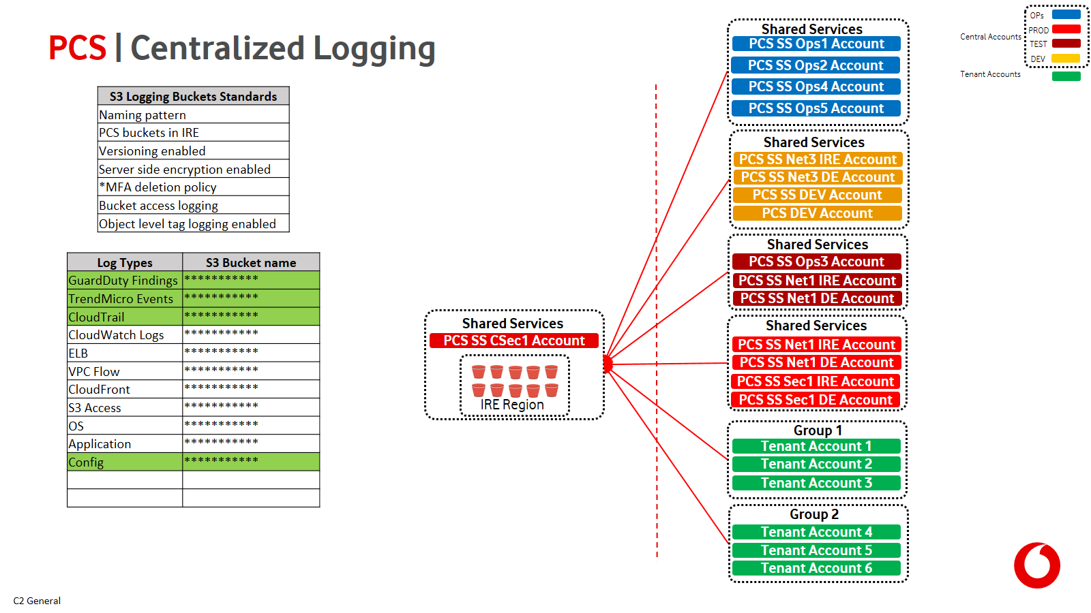

-          This is a diagram of the ArcSight Integration with PCS centralised Logging

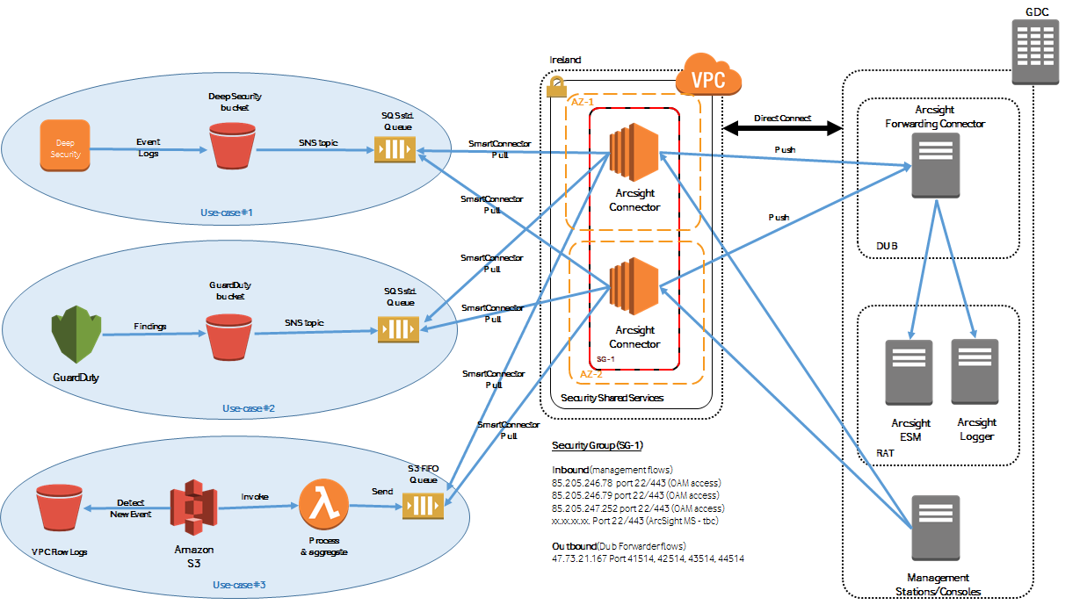

## AWS LOGGING

### VPC Flow Logs

2 VPC Flow Logs are created per VPC per environment: one goes to CloudWatch to allow for filters and easier investigation, encrypted via KMS, the other goes directly into the S3 logging buckets that are created via the StackSets i.e. vf-iedelivery-<ACCOUNT_ID>-logs

### Instance Logs - CloudWatch Agent

#### Configuration: module instance-logging

The deployment of the CloudWatch Agent Config is fully managed by Terraform. A module has been created within the vf-iedelivery-infrastrucutre repo → modules/instance-logging that creates the CloudWatch Agent SSM Parameter, the JSON config of the CloudWatch agent, the CloudWatch Log Group for instance logs and the KMS Customer Master Key used to encrypt this log group.

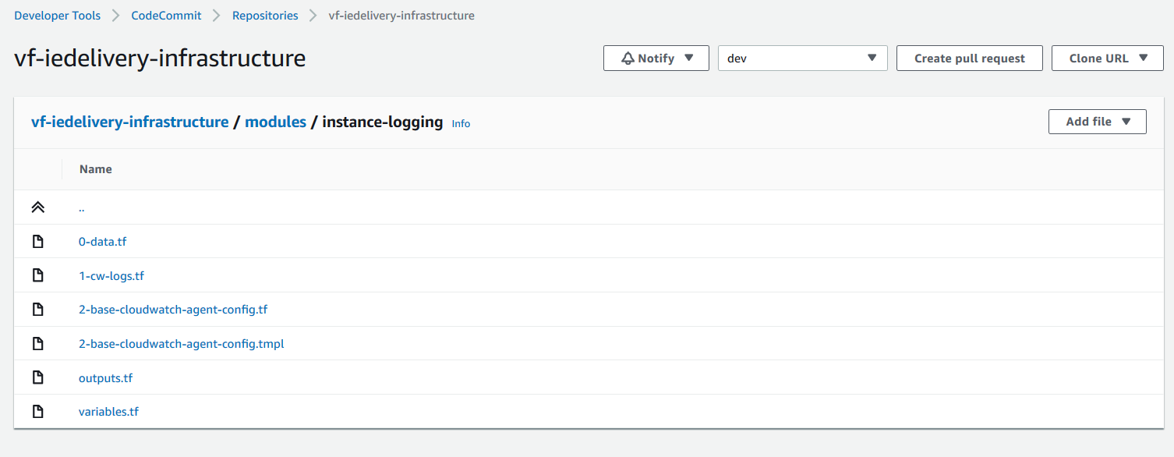

Resources created in 1-cw-logs.tf (see code [here](https://eu-west-1.console.aws.amazon.com/codesuite/codecommit/repositories/vf-iedelivery-infrastructure/browse/refs/heads/dev/--/modules/instance-logging/1-cw-logs.tf?region=eu-west-1) ):

* **Cloudwatch group** encrypted with kms key and name "instancelogs-${var.TAGS["Environment"]}-${var.TAGS["Project"]}"
* **kms key** with policy taken from <https://docs.aws.amazon.com/AmazonCloudWatch/latest/logs/encrypt-log-data-kms.html>
* **kms alias** with name "alias/${aws_cloudwatch_log_group.log_group.name}-key"
* **ssm parameter** to store the key arn with name "/${var.TAGS["Environment"]}/${aws_cloudwatch_log_group.log_group.name}-key-cmk-arn"

 Resources created in 2-base-cloudwatch-agent-config.tf (see [here](https://eu-west-1.console.aws.amazon.com/codesuite/codecommit/repositories/vf-iedelivery-infrastructure/browse/refs/heads/dev/--/modules/instance-logging/2-base-cloudwatch-agent-config.tf?region=eu-west-1)):

* ssm parameter with the cw agent configuration using template file for more flexibility

Template file for cw agent config (see aws documentation [here](https://docs.aws.amazon.com/AmazonCloudWatch/latest/monitoring/CloudWatch-Agent-Configuration-File-Details.html)):

|  |
| --- |
| ${jsonencode(  {    "agent": {      "metrics_collection_interval": 60,      "omit_hostname": true,      "run_as_user": "root"    },    "logs": {      "logs_collected": {        "files": {          "collect_list": [            {              "file_path": "/var/log/messages",              "log_group_name": "${instance_log_group_name}",              "log_stream_name": "{instance_id}-messages"            },            {              "file_path": "/var/log/secure",              "log_group_name": "${instance_log_group_name}",              "log_stream_name": "{instance_id}-secure"            },            {              "file_path": "/opt/aws/amazon-cloudwatch-agent/logs/amazon-cloudwatch-agent.log",              "log_group_name": "${instance_log_group_name}",              "log_stream_name": "{instance_id}-cw-agent"            },            {              "file_path": "/var/log/amazon/ssm/amazon-ssm-agent.log",              "log_group_name": "${instance_log_group_name}",              "log_stream_name": "{instance_id}-ssm-agent"            },            {              "file_path": "/var/log/amazon/ssm/errors.log",              "log_group_name": "${instance_log_group_name}",              "log_stream_name": "{instance_id}-ssm-agent-errors"            }          ]        }      }    },    "metrics": {      "namespace": "CWAgentLinux",      "append_dimensions": {        "InstanceId": "$${aws:InstanceId}",        "ImageID": "$${aws:ImageId}"      },      "metrics_collected": {        "disk": {          "measurement": [            "disk_used_percent",            "disk_inodes_free"          ],          "ignore_file_system_types": [            "devtmpfs",            "tmpfs",            "overlay"          ],          "drop_device": true,          "metrics_collection_interval": 60,          "resources": [            "*"          ]        },        "cpu": {         "measurement": [          "cpu_usage_idle",          "cpu_usage_iowait",          "cpu_usage_user",          "cpu_usage_system"         ],         "metrics_collection_interval": 60,         "resources": [            "*"          ]        },        "mem": {          "measurement": [            "mem_used_percent"          ],          "metrics_collection_interval": 60        },        "diskio": {          "measurement": [            "diskio_io_time"          ],          "metrics_collection_interval": 60        },        "swap": {          "measurement": [            "swap_used_percent"          ],          "metrics_collection_interval": 60        }      }    }  }  )} |

Configuration: user-data

When instances are created, they are bootstrapped with a user-data.sh script that contains an AWS CLI Run Command call to configure the CloudWatch Agent on the instances:

*Note: It has been tested in sandbox, to be tested in pre-prod before adding it to the AWS AMI Builder as part of the SSM document

|  |
| --- |
| #!/bin/bash -xe    cd /tmp  wget https://s3.amazonaws.com/amazoncloudwatch-agent/redhat/amd64/latest/amazon-cloudwatch-agent.rpm  sudo rpm -U ./amazon-cloudwatch-agent.rpm  instance_id=$(wget -q -O - http://169.254.169.254/latest/meta-data/instance-id)  sudo /opt/aws/amazon-cloudwatch-agent/bin/amazon-cloudwatch-agent-ctl -a fetch-config -m ec2 -s -c ssm:${ssm_parameter}  sudo userdel -r cwagent |

Documentation about installing aws cloudwatch agent: <https://docs.aws.amazon.com/AmazonCloudWatch/latest/monitoring/download-cloudwatch-agent-commandline.html> and <https://docs.aws.amazon.com/AmazonCloudWatch/latest/monitoring/install-CloudWatch-Agent-commandline-fleet.html>

1. The configuration file that we are going to use it is stored on a ssm parameter.
2. In this command, -a fetch-config causes the agent to load the latest version of the CloudWatch agent configuration file, and -s starts the agent. Enter one the following commands. Replace configuration-file-path with the path to the agent configuration file. This file is called config.json is you created it with the wizard, and might be called amazon-cloudwatch-agent.json if you created it manually.

## AWS Monitoring: CW alarms

Alarm name convention in PCS: <Priority>_<Project-Name>_<Environment>_<Resource-Type>_<Alarm-Type>_<Resource-ID>

### EC2 Monitoring: alarms and notifications

### RDS monitoring: alarms and notifications

# 06 VF IE FIREWALL RULES

## Production

|  |  |  |  |  |  |  |  |  |  |  |  |  |  |  |  |
| --- | --- | --- | --- | --- | --- | --- | --- | --- | --- | --- | --- | --- | --- | --- | --- |
| **Firewall Communication Matrix** | | | | | | | | | | | | | | | |
| Status | Source | | Destination | | | Network Address Translation | | Protocol | Environment | Service Grouping | Track | Remark | FW INC | ROUTING INC | CCP |
| Source IP Address | Source Hostname | Destination IP Address | Destination Hostname | Port(s) | Src/Dst | IP address |
| PRODUCTION | | | | | | | | | | | | | | | |
| VERIFIED | 10.109.100.24 10.109.100.25 10.109.100.181 10.109.100.186 |  | 198.19.220.0/27 198.19.220.64/27 | AWS Prod Subnets | 10101-10120 |  |  | TCP | PROD |  |  | Portal to CCH Sync | INC000037574948 | INC000037574942 | <https://ccp.vodafone.com/commsmatrix/aggr/142130> |
| VERIFIED | 10.109.100.11 10.109.100.12 10.109.100.13 10.109.100.14 10.109.100.15 10.109.100.16 10.109.100.17 10.109.100.38 10.109.100.39 |  | 198.19.220.0/27 198.19.220.64/27 | AWS Prod Subnets | 10101-10120 |  |  | TCP | PROD |  |  | UFE to CCH Sync | INC000037574948 | INC000037574942 | <https://ccp.vodafone.com/commsmatrix/aggr/142130> |
| IMPLEMENTED | 10.151.4.79 10.151.4.82 10.151.4.92 10.151.4.95 10.162.114.10 10.162.114.11 10.162.114.12 10.162.114.13 10.162.114.15 10.162.114.16 10.162.114.18 10.162.114.19 10.162.114.26 10.162.114.25 |  | 198.19.220.0/27 198.19.220.64/27 | AWS Prod Subnets | 10101-10120 |  |  | TCP | PROD |  |  | GISMSH/Tibco to CCH Sync | INC000037574948 | INC000037574942 | <https://ccp.vodafone.com/commsmatrix/aggr/142130> |
| IMPLEMENTED | 10.109.100.239 10.109.100.240 10.109.100.241 | OSB | 198.19.220.0/27 198.19.220.64/27 | AWS Prod Subnets | 10101-10120 |  |  | TCP | PROD |  |  | OSB to CCH Sync | INC000037574948 | INC000037574942 | <https://ccp.vodafone.com/commsmatrix/aggr/142130> |
| IMPLEMENTED | 10.109.179.146 10.109.179.147 | MFT | 198.19.220.0/27 198.19.220.64/27 | AWS Prod Subnets | 10111-10139 |  |  | TCP | PROD |  |  | OSB to CCH Batch | INC000037574948 | INC000037574942 | <https://ccp.vodafone.com/commsmatrix/aggr/142130> |
| IMPLEMENTED | 198.18.74.197 192.125.247.100 | ConnectDirect | 198.19.220.0/27 198.19.220.64/27 | AWS Prod Subnets | 10111-10139 |  |  | TCP | PROD |  |  | OSB to CCH FS | INC000037574948 | INC000037574942 | <https://ccp.vodafone.com/commsmatrix/aggr/142130> |
| VERIFIED | 198.19.220.0/27 198.19.220.64/27 | AWS Prod Subnets | 10.163.184.4 |  | 20111 20112 20113 20114 20101 |  |  | TCP | PROD |  |  | CCH Sync to SMSC | INC000037574948 | INC000037574942 | <https://ccp.vodafone.com/commsmatrix/aggr/142130> |
| VERIFIED | 198.19.220.0/27 198.19.220.64/27 | AWS Prod Subnets | 10.163.187.4 |  | 20111 20112 20113 20114 20101 |  |  | TCP | PROD |  |  | CCH Sync to JINNY | INC000037574948 | INC000037574942 | <https://ccp.vodafone.com/commsmatrix/aggr/142130> |
| VERIFIED | 198.19.220.0/27 198.19.220.64/27 | AWS Prod Subnets | 10.78.48.57 | OSB VIP | 30050 |  |  | TCP | PROD |  |  | CCH Sync to OSB | INC000037574948 | INC000037574942 | <https://ccp.vodafone.com/commsmatrix/aggr/142130> |
| VERIFIED | 198.19.220.0/27 198.19.220.64/27 | AWS Prod Subnets | 198.18.67.253 | MEH VIP | 22 16080 16443 |  |  | TCP | PROD |  |  | CCH Sync to MEH | INC000037574948 | INC000037574942 | <https://ccp.vodafone.com/commsmatrix/aggr/142130> |
| VERIFIED | 198.19.220.0/27 198.19.220.64/27 | AWS Prod Subnets | 10.109.101.125 10.109.101.126 10.109.101.127 10.109.101.122 10.109.101.123 10.109.101.124 | MML SCAN | 33000 33001 |  |  | TCP | PROD |  |  | CCH Sync to MML DB | INC000037574948 | INC000037574942 | <https://ccp.vodafone.com/commsmatrix/aggr/142130> |
| IMPLEMENTED | 10.74.120.112/28 | VFIE Websense Proxy Cleanzone Range | 198.19.220.0/25 | AWS Prod Subnets | 10101-10120 10201-10220 10301-10320 10401-10420 |  |  | TCP | PROD |  |  | Websense Proxy to Weblogic Admin GUI's | INC000037574948 | INC000037574942 | <https://ccp.vodafone.com/commsmatrix/aggr/142130> |
| IMPLEMENTED | 10.74.120.112/28 | VFIE Websense Proxy Cleanzone Range | 46.108.156.0/27 | AWS Mgmt Subnets | 9000-9030 |  |  | TCP | PROD |  |  | Websense Proxy to DevOps Tool GUI's | INC000037574948 | INC000037574942 | <https://ccp.vodafone.com/commsmatrix/aggr/142130> |
| IMPLEMENTED | 198.19.220.0/27 198.19.220.64/27 | AWS Prod Subnets | 198.18.67.252 | MEH VIP | 22 16443 |  |  | TCP | PROD |  |  | CCH Sync to MEH | INC000037600491 | INC000037600476 | <https://ccp.vodafone.com/commsmatrix/aggr/143431> |
| IMPLEMENTED | 198.19.220.0/25 | AWS Prod Subnets | 47.73.21.74 | [vglm12vr.dc-dublin.de](http://vglm12vr.dc-dublin.de) | 8090 |  |  | TCP | PROD |  |  | CCH to AppDynamics Controller | INC000037600491 | INC000037600476 | <https://ccp.vodafone.com/commsmatrix/aggr/143431> |
| IMPLEMENTED | 10.74.120.112/28 | VFIE Websense Proxy Cleanzone Range | 198.19.220.0/25 | AWS Prod Subnets | 7001 443 8800-8810 |  |  | TCP | PROD |  |  | Websense Proxy to Weblogic Admin GUI's | INC000037600491 | INC000037600476 | <https://ccp.vodafone.com/commsmatrix/aggr/143431> |
| IMPLEMENTED | 10.109.98.0/24 | Dublin VDI Subnet | 198.19.220.0/25 | AWS Prod Subnets | 33000 33001 443 7001 8800-8810 |  |  | TCP | PROD |  |  | VDI Subnet to OCM & Weblogic Admin GUI | INC000037600491 | INC000037600476 | <https://ccp.vodafone.com/commsmatrix/aggr/143431> |
| IN PROGRESS | 10.163.78.0/23 | Dublin VDI Subnet | 198.19.220.0/25 | AWS Prod Subnets | 33000 33001 443 7001 8800-8810 |  |  | TCP | PROD |  |  | VDI Subnet to OCM & Weblogic Admin GUI | INC000037600491 | INC000037600476 | <https://ccp.vodafone.com/commsmatrix/aggr/143431> |
| IMPLEMENTED | 10.78.177.156 | IEJENKVR | 198.19.220.0/25 | AWS Prod Subnets | 33000 33001 443 7001 8011 8800-8810 |  |  | TCP | PROD |  |  | Nagios monitoring to OCM & Weblogic Admin GUI | INC000037600491 | INC000037600476 | <https://ccp.vodafone.com/commsmatrix/aggr/143431> |
| VERIFIED | 10.109.100.24 10.109.100.25 10.109.100.181 10.109.100.186 10.109.100.11 10.109.100.12 10.109.100.13 10.109.100.14 10.109.100.15 10.109.100.16 10.109.100.17 10.109.100.38 10.109.100.39 10.109.100.239 10.109.100.240 10.109.100.241 | UFE/Portal/OSB | 198.19.220.0/27 198.19.220.64/27 | AWS Prod Subnets | 8011 |  |  | TCP | PROD |  |  | UFE/Portal/OSB to CCH Sync | INC000037600491 | INC000037600476 | <https://ccp.vodafone.com/commsmatrix/aggr/143431> |
| IMPLEMENTED | 10.151.4.79 10.151.4.82 10.151.4.92 10.151.4.95 10.162.114.10 10.162.114.11 10.162.114.12 10.162.114.13 10.162.114.15 10.162.114.16 10.162.114.18 10.162.114.19 10.162.114.26 10.162.114.25 |  | 198.19.220.0/27 198.19.220.64/27 | AWS Prod Subnets | 8011 |  |  | TCP | PROD |  |  | Tibco/GISMSH to CCH Sync | INC000037600491 | INC000037600476 | <https://ccp.vodafone.com/commsmatrix/aggr/143431> |
| VERIFIED | 198.18.65.56 198.18.65.57 |  | 198.19.220.0/27 198.19.220.64/27 | AWS Prod Subnets | 10111-10139 |  |  | TCP | PROD |  |  | NIFI to CCH Batch | INC000037600491 | INC000037600476 | <https://ccp.vodafone.com/commsmatrix/aggr/143431> |
| VERIFIED | 37.25.160.19 | R2 HAProxy | 198.19.220.0/27 198.19.220.64/27 | AWS Prod Subnets | 7001 |  |  | TCP | PROD |  |  | R2 Proxy to CCH | INC000037632263 | INC000037632426 | <https://ccp.vodafone.com/commsmatrix/aggr/144029> |
| VERIFIED | 198.19.220.0/27 98.19.220.64/27 | AWS Prod Subnets | 10.163.187.4 | JINNY | 6543 |  |  | TCP | PROD |  |  | CCH Sync to JINNY | INC000037632263 | INC000037632426 | <https://ccp.vodafone.com/commsmatrix/aggr/144029> |
| VERIFIED | 198.19.220.0/27 98.19.220.64/27 | AWS Prod Subnets | 10.78.48.57 | OSB VIP | 35000 35001 |  |  | TCP | PROD |  |  | CCH Sync to OSB | INC000037632263 | INC000037632426 | <https://ccp.vodafone.com/commsmatrix/aggr/144029> |
| IMPLEMENTED | 47.73.21.74 47.73.21.75 | Sitescope | 198.19.220.0/27 98.19.220.64/27 | AWS Prod Subnets | 8011 7001 10120 |  |  | TCP | PROD |  |  | Sitescope to CCH Prod |  |  | <https://ccp.vodafone.com/commsmatrix/aggr/146163> |
| IMPLEMENTED | 176.125.13.67 176.125.13.68 176.125.13.69 176.125.13.70 | Sitescope | 198.19.220.0/27 198.19.220.64/27 | AWS Prod Subnets | 8011 7001 10120 |  |  | TCP | PROD |  |  | Sitescope to CCH Prod |  |  | <https://ccp.vodafone.com/commsmatrix/aggr/146163> |
| IMPLEMENTED | 198.19.220.0/24 46.108.156.0/27 | AWS SS VPC | 47.73.122.145 47.73.122.171 47.73.81.108 | Infoblox DNS server | 53 |  |  | TCP | PROD |  |  | AWS to Infloblox |  |  | <https://ccp.vodafone.com/commsmatrix/aggr/146163> |
| IMPLEMENTED | 198.19.220.0/27 198.19.220.64/27 | AWS Prod Subnets | 10.163.184.4 | SMSC | 1040 1050 1060 1070 |  |  | TCP | PROD |  |  | CCH Sync to SMSC | INC000037576265 |  | <https://ccp.vodafone.com/commsmatrix/aggr/144029> |
| IN PROGRESS | 198.19.220.0/27 198.19.220.64/27 | AWS Prod Subnets | 10.109.100.242 10.109.100.243 10.109.100.244 | Bill-AMDD Svr | 22 |  |  | TCP | PROD |  |  | CCH Sync to AMDD | INC000037764880 |  | <https://ccp.vodafone.com/user/commsmatrix/145944> |
| IMPLEMENTED | 47.73.43.205 47.73.43.235 145.230.15.70 47.73.122.145 47.73.122.171 195.233.113.167 47.73.81.81 47.73.81.108 | DNS Resolvers On-premise | 198.19.220.0/24 | AWS DNS server | 53 |  |  | TCP | PROD |  |  | GDC DNS to AWS DNS | INC000037681800 |  | <https://ccp.vodafone.com/commsmatrix/aggr/144961> |
| IMPLEMENTED | 198.19.220.0/25 | AWS Prod Subnets | 10.162.66.40 | Lotus Notes | 22 |  |  | TCP | PROD |  |  | CCH to Lotus Notes (SFTP) | INC000037576265 |  | <https://ccp.vodafone.com/commsmatrix/aggr/144029> |
| IMPLEMENTED | 10.109.98.0/24 | Dublin VDI Subnet | 198.18.75.195 | I1PROXY-VIP | 3022 |  |  | TCP | PROD |  |  | VDI Subnet to File Transfer server | INC000037764880 |  | <https://ccp.vodafone.com/user/commsmatrix/145944> |
| IN PROGRESS | 10.163.78.0/23 | Dublin VDI Subnet | 198.18.75.195 | I1PROXY-VIP | 3022 |  |  | TCP | PROD |  |  | VDI Subnet to File Transfer server | INC000037764880 |  | <https://ccp.vodafone.com/user/commsmatrix/145944> |
| IMPLEMENTED | 198.18.65.7 198.18.65.8 198.18.65.9 198.18.65.10 198.18.65.11 198.18.65.12 | MEH PROD | 198.19.220.0/27 198.19.220.64/27 | CCH PROD Subnets | 8011 |  |  | TCP | PROD |  |  | MEH to AWS |  |  |  |
| IMPLEMENTED | 198.19.220.0/27 198.19.220.64/27 | CCH PROD Subnets | 47.73.21.74 | vglm12vr.dc-dublin.de | 8181 |  |  | TCP | PROD |  |  | AWS to AppD |  |  |  |

## PRE-PRODUCTION

|  |  |  |  |  |  |  |  |  |  |  |  |  |  |  |  |
| --- | --- | --- | --- | --- | --- | --- | --- | --- | --- | --- | --- | --- | --- | --- | --- |
| **Firewall Communication Matrix** | | | | | | | | | | | | | | | |
| Status | Source | | Destination | | | Network Address Translation | | Protocol | Environment | Service Grouping | Track | Remark | FW INC | ROUTING INC | CCP |
| Source IP Address | Source Hostname | Destination IP Address | Destination Hostname | Port(s) | Src/Dst | IP address |
| **PRE-PRODUCTION** | | | | | | | | | | | | | | | |
| VERIFIED | 10.109.100.179 10.109.100.180 10.109.100.184 10.109.100.185 |  | 198.19.220.32/27 198.19.220.96/27 | AWS Prod Subnets | 10101-10120 |  |  | TCP | PROD |  |  | Portal to CCH Sync | INC000037575317 |  | <https://ccp.vodafone.com/commsmatrix/aggr/142149> |
| VERIFIED | 10.109.100.135 10.109.100.136 10.109.100.137 10.109.100.138 10.109.100.139 10.109.100.140 10.109.100.141 10.109.100.34 10.109.100.35 10.109.100.142 10.109.100.143 10.109.100.144 10.109.100.145 10.109.100.146 10.109.100.147 10.109.100.148 10.109.100.36 10.109.100.37 |  | 198.19.220.32/27 198.19.220.96/27 | AWS Prod Subnets | 10101-10120 |  |  | TCP | PROD |  |  | UFE to CCH Sync | INC000037575317 |  | <https://ccp.vodafone.com/commsmatrix/aggr/142149> |
| VERIFIED | 10.162.122.16 10.162.122.17 10.162.114.20 10.162.114.21 |  | 198.19.220.32/27 198.19.220.96/27 | AWS Prod Subnets | 10101-10120 |  |  | TCP | PROD |  |  | TIBCO to CCH Sync | INC000037575317 |  | <https://ccp.vodafone.com/commsmatrix/aggr/142149> |
| VERIFIED | 10.162.111.89 10.162.111.92 10.162.111.81 10.162.111.82 |  | 198.19.220.32/27 198.19.220.96/27 | AWS Prod Subnets | 10101-10120 |  |  | TCP | PROD |  |  | GISMSH to CCH Sync | INC000037575317 |  | <https://ccp.vodafone.com/commsmatrix/aggr/142149> |
| VERIFIED | 10.109.100.96 10.109.100.97 10.109.100.98 10.109.100.99 | OSB | 198.19.220.32/27 198.19.220.96/27 | AWS Prod Subnets | 10101-10120 |  |  | TCP | PROD |  |  | OSB to CCH Sync | INC000037575317 |  | <https://ccp.vodafone.com/commsmatrix/aggr/142149> |
| VERIFIED | 10.109.100.118 10.109.100.119 | MFT | 198.19.220.32/27 198.19.220.96/27 | AWS Prod Subnets | 10101-10120 |  |  | TCP | PROD |  |  | MFT to CCH Batch | INC000037575317 |  | <https://ccp.vodafone.com/commsmatrix/aggr/142149> |
| VERIFIED | 198.19.220.32/27 198.19.220.96/27 | AWS Prod Subnets | 10.163.187.4 |  | 6543 |  |  | TCP | PROD |  |  | CCH Sync to JINNY | INC000037575317 |  | <https://ccp.vodafone.com/commsmatrix/aggr/142149> |
| VERIFIED | 198.19.220.32/27 198.19.220.96/27 | AWS Prod Subnets | 10.163.184.4 |  | 1040 1050 1060 1070 |  |  | TCP | PROD |  |  | CCH Sync to SMSC | INC000037575317 |  | <https://ccp.vodafone.com/commsmatrix/aggr/142149> |
| VERIFIED | 198.19.220.32/27 198.19.220.96/27 | AWS Prod Subnets | 10.78.48.83 10.78.48.84 | OSB VIP | 32007 33001 33002 33004 7002 5556 |  |  | TCP | PROD |  |  | CCH Sync to OSB | INC000037575317 |  | <https://ccp.vodafone.com/commsmatrix/aggr/142149> |
| VERIFIED | 198.19.220.32/27 198.19.220.96/27 | AWS Prod Subnets | 198.18.67.253 | MEH VIP | 22 16080 16443 |  |  | TCP | PROD |  |  | CCH Sync to MEH | INC000037575317 |  | <https://ccp.vodafone.com/commsmatrix/aggr/142149> |
| VERIFIED | 198.19.220.32/27 198.19.220.96/27 | AWS Prod Subnets | 10.109.101.41 10.109.101.42 10.109.101.43 10.109.101.44 10.109.101.45 10.109.100.118 10.109.100.119 | MML SCAN | 33000 33001 |  |  | TCP | PROD |  |  | CCH Sync to MML DB | INC000037575317 |  | <https://ccp.vodafone.com/commsmatrix/aggr/142149> |
| VERIFIED | 10.109.100.179 10.109.100.180 10.109.100.184 10.109.100.185 |  | 198.19.220.32/27 198.19.220.96/27 | AWS Prod Subnets | 8011 |  |  | TCP | PROD |  |  | Portal to CCH Sync | INC000037607345 |  | <https://ccp.vodafone.com/commsmatrix/aggr/143432> |
| VERIFIED | 10.109.100.135 10.109.100.136 10.109.100.137 10.109.100.138 10.109.100.139 10.109.100.140 10.109.100.141 10.109.100.34 10.109.100.35 10.109.100.142 10.109.100.143 10.109.100.144 10.109.100.145 10.109.100.146 10.109.100.147 10.109.100.148 10.109.100.36 10.109.100.37 |  | 198.19.220.32/27 198.19.220.96/27 | AWS Prod Subnets | 8011 |  |  | TCP | PROD |  |  | UFE to CCH Sync | INC000037607345 |  | <https://ccp.vodafone.com/commsmatrix/aggr/143432> |
| VERIFIED | 10.162.122.16 10.162.122.17 10.162.114.20 10.162.114.21 |  | 198.19.220.32/27 198.19.220.96/27 | AWS Prod Subnets | 8011 |  |  | TCP | PROD |  |  | TIBCO to CCH Sync | INC000037607345 |  | <https://ccp.vodafone.com/commsmatrix/aggr/143432> |
| VERIFIED | 10.162.111.89 10.162.111.92 10.162.111.81 10.162.111.82 |  | 198.19.220.32/27 198.19.220.96/27 | AWS Prod Subnets | 8011 |  |  | TCP | PROD |  |  | GISMSH to CCH Sync | INC000037607345 |  | <https://ccp.vodafone.com/commsmatrix/aggr/143432> |
| VERIFIED | 10.109.100.96 10.109.100.97 10.109.100.98 10.109.100.99 | OSB | 198.19.220.32/27 198.19.220.96/27 | AWS Prod Subnets | 8011 |  |  | TCP | PROD |  |  | OSB to CCH Sync | INC000037607345 |  | <https://ccp.vodafone.com/commsmatrix/aggr/143432> |
| VERIFIED | 198.18.65.31 |  | 198.19.220.32/27 198.19.220.96/27 | AWS Preprod Subnets | 10111-10139 |  |  | TCP | PREPROD |  |  | NiFi to CCH Sync | INC000037607070 | INC000037612452 | <https://ccp.vodafone.com/commsmatrix/aggr/144028> |
| VERIFIED | 198.19.220.32/27 198.19.220.96/27 | AWS Preprod Subnets | 10.162.229.54 | SMSC | 1040 1050 1060 1070 |  |  | TCP | PREPROD |  |  | CCH Sync to SMSC | INC000037607070 | INC000037612452 | <https://ccp.vodafone.com/commsmatrix/aggr/144028> |
| VERIFIED | 37.25.160.19 | R2 HAProxy | 198.19.220.32/27 198.19.220.96/27 | AWS Preprod Subnets | 8011 7001 10120 |  |  | TCP | PREPROD |  |  | R2 Proxy to CCH | INC000037607070 | INC000037612452 | <https://ccp.vodafone.com/commsmatrix/aggr/144028> |
| VERIFIED | 198.19.220.32/27 198.19.220.96/27 | AWS Preprod Subnets | 10.78.48.83 10.78.48.84 | OSB VIP | 35001 35000 |  |  | TCP | PREPROD |  |  | CCH Sync to OSB | INC000037607070 | INC000037612452 | <https://ccp.vodafone.com/commsmatrix/aggr/144028> |
| IMPLEMENTED | 198.18.74.197 192.125.247.100 | ConnectDirect | 198.19.220.32/27 198.19.220.96/27 | AWS Preprod Subnets | 10120 |  |  | TCP | PREPROD |  |  | ConnectDirect to CCH Sync | INC000037764880 |  | <https://ccp.vodafone.com/user/commsmatrix/145944> |
| IN PROGRESS | 198.19.220.32/27 198.19.220.96/27 | AWS Preprod Subnets | 10.109.100.104 10.109.100.105 10.109.100.106 10.109.100.107 10.109.100.108 10.109.100.109 | Bill-AMDD Svr | 22 |  |  | TCP | PREPROD |  |  | CCH Sync to AMDD | INC000037764880 |  | <https://ccp.vodafone.com/user/commsmatrix/145944> |
| VERIFIED | 37.25.160.48 37.25.160.49 37.25.160.50 37.25.160.61 | Loadrunner | 198.19.220.32/27 198.19.220.96/27 | AWS Preprod Subnets | 8011 7001 10120 |  |  | TCP | PREPROD |  |  | Loadrunner to CCH Sync |  |  | <https://ccp.vodafone.com/commsmatrix/aggr/146163> |
| VERIFIED | 198.19.220.32/27 198.19.220.96/27 | AWS Preprod Subnets | 37.25.160.48 37.25.160.49 37.25.160.50 37.25.160.61 | Loadrunner | 30050 30051 35000 35001 |  |  | TCP | PREPROD |  |  | CCH Sync to Loadrunner |  |  | <https://ccp.vodafone.com/commsmatrix/aggr/146163> |
| VERIFIED | 198.18.65.3 198.18.65.4 198.18.65.5 198.18.65.6 | MEH PREPROD | 198.19.220.32/27 198.19.220.96/27 | CCH PREPROD Subnets | 8011 |  |  | TCP | PREPROD |  |  | MEH to AWS |  |  |  |
| IN PROGRESS | 198.19.220.32/27 198.19.220.96/27 | CCH PREPROD Subnets | 10.109.100.98 10.109.100.99 10.78.48.84 | PRD2 OSB | 33007 |  |  | TCP | PREPROD |  |  | AWS to PRD2 OSB |  |  |  |
| IN PROGRESS | 198.19.220.32/27 198.19.220.96/27 | AWS Preprod Subnets | 10.109.101.81 10.109.101.82 10.109.101.83 10.109.101.84 10.109.101.39 10.109.101.40 10.109.101.41 10.109.101.42 | MML DB Link | 33000 33001 |  |  | TCP | PREPROD |  |  | CCH DB to MML DB (DB Link) | INC000037808948 |  | <https://ccp.vodafone.com/user/commsmatrix/146319> |

# 07 VFIE EC2 Image Builder

* + INTRODUCTION
  + PREREQUISITES
  + COMPONENTS
    - Image pipeline
    - Image recipe
    - Source image
    - Build components
    - Test components
    - Document
  + IMPLEMENTATION
    - CLOUDFORMATION STACK
    - SSM DOCUMENTS
    - AWS CONSOLE RESOURCES
  + HOW TO: NEW AMI
    - PERMISSIONS TO NEW AMI

## INTRODUCTION

VFIE needs a customized image for the ec2 servers. For cch-sal application, we have 13 different domains (cch-ob-osb, cch-ob-odi, etc.), where each domain has one admin server and several nodes (documentation [here](https://confluence.sp.vodafone.com/pages/viewpage.action?pageId=166947250#id-00VF-IECCH/SALApplication-EC2Instances)). We are going to use AWS EC2 image builder for creating, managing and deploying customized, secure and up-to-date server images, that are pre-installed and pre-configured with software and settings to meet the IT requirements. These requirements are needed for the target OFMW servers to support Myst provisioning, such as Myst Agent, Oracle Java, SQL Plus, oracle users, etc (documentation [here](https://confluence.sp.vodafone.com/pages/viewpage.action?pageId=166947250#id-00VF-IECCH/SALApplication-Baseinformation)).

With AWS EC2 image builder, you follow these steps.

1. **Select source image.** You select a source OS image, for example, an existing AMI.
2. **Create image recipe.** You add components to create an image recipe for your image pipeline. Components are the building blocks that are consumed by an image recipe, for example, packages for installation, security hardening steps, and tests. The selected OS and components make up an image recipe. Components are installed in the order in which they are specified and cannot be reordered after selection.
3. **Output.** Image Builder creates an OS image in the selected output format.
4. **Distribute.** You distribute your image to selected AWS Regions after it passes tests in the image pipeline.

The images that you build from the golden image are in your AWS account. You can configure your image pipeline to produce updated and patched versions of your AMI by entering a build schedule. When the build is complete, you can receive notification via [Amazon Simple Notification Service (SNS)](https://docs.aws.amazon.com/sns/latest/dg/welcome.html). In addition to producing a final image, Image Builder generates an image recipe that can be used with existing version control systems and continuous integration/continuous deployment (CI/CD) pipelines for repeatable automation. You can share and create new versions of your image recipe.

## PREREQUISITES

* EC2 Image Builder service linked role
  + Documentation: <https://docs.aws.amazon.com/imagebuilder/latest/userguide/image-builder-service-linked-role.html>
  + Image Builder uses the service-linked role named **AWSServiceRoleForImageBuilder** to allow EC2 Image Builder to access AWS resources on your behalf.
* Configuration requirements
  + Instances used to build images and run tests using Image Builder must have access to the **Systems Manager service**. All build activity is orchestrated by SSM Automation. The SSM Agent will be installed on the source image if it is not already present, and it will be removed before the image is created.
  + Select a public subnet with internet access in advance setting for the image pipeline. The security groups associated with the launched instance (via AWS builder image) must have opened ports 443 and 80.  
    Launch
* AWS IAM
  + The IAM role that you associate with your instance profile must have permissions to run the build and test components included in your image. The following IAM role policies must be attached to the IAM role that is associated with the instance profile: **EC2InstanceProfileForImageBuilder** and **AmazonSSMManagedInstanceCore**.
  + If you configure logging, the instance profile specified in your infrastructure configuration must have s3:PutObject permissions for the target bucket (arn:aws:s3:::BucketName/*)

## COMPONENTS

### Image pipeline

An image pipeline is the automation configuration for building secure OS images on AWS. The Image Builder image pipeline is associated with an image recipe that defines the build, validation, and test phases for an image build lifecycle. An image pipeline can be associated with an infrastructure configuration that defines where your image is built. You can define attributes, such as instance type, subnets, security groups, logging, and other infrastructure-related configurations. You can also associate your image pipeline with a distribution configuration to define how you would like to deploy your image.

VFIE CCH-SAL: We will have different image pipelines depending on how many customized images the application needs. At the moment, we create the following images: OFMW_1213 and OFMW_1221. We also use an image pipeline for HAproxy image, see documentation here. Right now, we don't have any schedule for the pipelines, we run them manually. We will be adding automation later on.

### Image recipe

An Image Builder image recipe is a document that defines the source image and the components to be applied to the source image to produce the desired configuration for the output image. You can use an image recipe to duplicate builds. Image Builder image recipes can be shared, branched, and edited using the console wizard, the AWS CLI, or the API. You can use image recipes with your version control software to maintain shareable versioned image recipes.

VFIE CCH-SAL: Our source/parent image is PCS hardened AMI for rhel 7 and SSM documents are defined by SinglePoint and PCS. PCS added SSM documents for monitoring  (CW Agent) and activating TrendMicro. Singlepoint added SSM documents for the application. Each time we have a new AMI or an update on any SSM document, a new version of the recipe and of the pipeline needs to be created.

### Source image

The source image is the selected image and OS used in your image recipe document along with the components. The source image and the component definitions combined produce the desired configuration for the output image.

VFIE CCH-SAL: Our source/parent image is **PCS hardened AMI for rhel 7** (documentation [here](https://confluence.sp.vodafone.com/x/xFFhC)). This AMI has already SSM Agent installed. We will need to add automation when new hardened AMI are published.

### Build components

Build components are orchestration documents that define a sequence of steps for downloading, installing, and configuring software packages. They also define validation and security hardening steps. A component is defined using a YAML document format (as described in the following Document entry).

VFIE CCH-SAL: We have different SSM documents. For each image pipeline, we will use a SSM document for OFMW base, and a specific SSM document, like OFMW 1213 or OFMW 1221. In addition, PCS included another SSM document to install CW Agent and activate Trend Micro.

### Test components

Test components are orchestration documents that define tests to run on software packages. A component is defined using a YAML document format (see the following definition for Document).

VFIE CCH-SAL: Not used at the moment.

### Document

A declarative document that uses the YAML format to list the execution steps for build, validation, and test of an AMI on an instance. The document is input to a configuration management application, which runs locally on an Amazon EC2 instance to execute the document steps.

VFIE CCH-SAL: Each document is defined in our codecommit repository, in terraform. They are stored in a folder, and they are pushed to S3 bucket, via a pipeline (repository pipeline). Terraform will trigger a new object version to s3 if it detects a change in the ssm document. Right now, we will need MANUALLY to update the version of the ssm document, recipe and pipeline in the CF template managed by terraform.

## IMPLEMENTATION

The terraform code for this is stored in the codecommit repository vf-iedelivery-centralized-internet: <https://eu-west-1.console.aws.amazon.com/codesuite/codecommit/repositories/vf-iedelivery-centralized-internet/browse?region=eu-west-1> . The reason of creating here the code is that AWS image builder will create images that will be shared, so it makes sense to create those customized images in our vfie shared services account. In addition, we need internet access, and to avoid problems with transparent proxy in other vpc, we will be using Internet VPC.

Right now, terraform does not support AWS Image builder, as it is a new service, so we will be managing a CloudFormation stack in terraform.

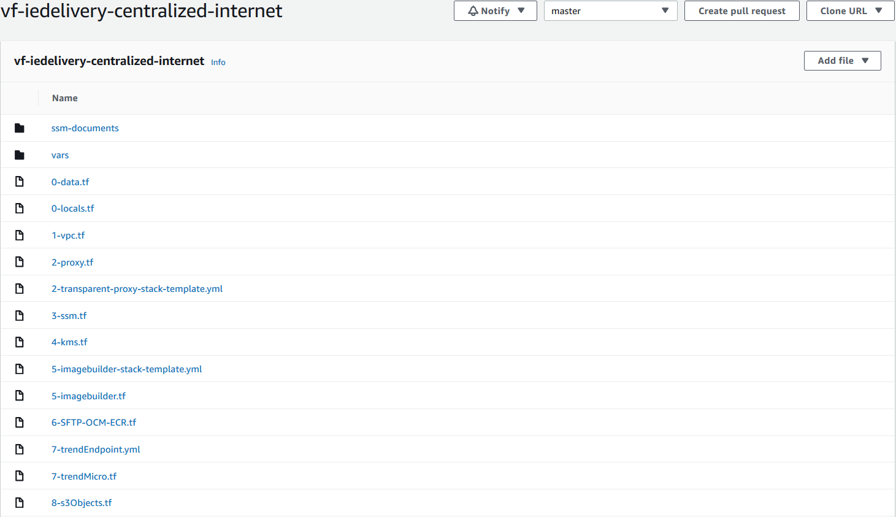

Key files here:

* ssm-documents folder: we will be storing recipe components here. Those components will be pushed to an s3 bucket.
* 5-imagebuilder-stack-template.yml : CF template
* 5-imagebuilder.tf : CF stack
* 8-s3Objects.tf: ssm files to be pushed to S3 bucket
* 0-data.tf: resources that have been already created and are going to be used. Example: subnet with internet access
* 0-locals.tf: variables used.

### CLOUDFORMATION STACK

The cloudformation stack will have as **variables**:

    - **OFMWBASEDOCUMENT** = SSM document shared for all OFMW domains (created by SinglePoint)  
-  **OFMW1213DOCUMENT** = SSM document just for OFMW 1213 (created by SinglePoint)  
   -  **OFMW1221DOCUMENT** =SSM document just for OFMW 1221 (created by SinglePoint)  
    - **PCSSSMDOCUMENT** = SSM document created by PCS with Trend Micro activation and AWS CloudWatch Agent  
    - **haproxyDOCUMENT** =  SSM document created by PCS with HAproxy configuration (sfw installation and version update)  
    - **SubnetId** = Subnets where the image created by AWS EC2 image builder will be launch. IMPORTANT: it needs internet access!   
    - **SecurityGroupId** =  Security group that will be attached to the image launched by AWS EC2 image builder. IMPORTANT: it needs 443 and 80 outbound rules  
    - **InstanceProfileName** = IAM instance profile that EC2 image builder will associated with the launched instance when creating new image (see requisites above). IMPORTANT: SSM, S3 and Image builder access  
    - **AMIid** = Parent AMI for OFMW 1213 and OFMW 1221. It is a PCS hardened RHEL7 AMI (latest one)  
  - **HAProxyAMIid** =  Parent AMI for HAproxy. It is a PCS hardened Amazon Linux 2 AMI (latest one)

For each customized image that we want to create, we will be defining the following resources:

* SNS topic
* Image Builder Component (as many as we need = SSM documents)
* Image Recipe with the components for the image and the source AMI
* Image pipeline with the image recipe and the image infrastructure configuration
* Image infrastructure configuration, where we define: instance profile, instance type, s3 bucket to send the logs, security groups to associate with the image launched by AWS when creating the image, SNS topic and subnet Id (with internet access).
* Image: This resource is not mandatory, but it will remove the need to manually run the pipeline when we deploy a new change in the CF template

Example of the code for OFMW 1213:

|  |
| --- |
| SNSTopic1213:      Type: AWS::SNS::Topic      Properties:        Subscription:          - Endpoint: "albamaria.diazfernandez@vodafone.com"            Protocol: "email"        TopicName: "VFIEdelivery-AMI-1213"      ImageComponentBase:      Type: AWS::ImageBuilder::Component      Properties:        ChangeDescription: 'initial version'        Description: 'VFIE delivery OFMW Base OS Nitro SSM DOCUMENT'        Name: 'VFIE-DELIVERY-OFMW-BASE-OS-NITRO-SSM-DOCUMENT'        Platform: 'Linux'        Version: '1.0.1'        Uri: !Ref OFMWBASEDOCUMENT    ImageComponentPCS:      Type: AWS::ImageBuilder::Component      Properties:        ChangeDescription: 'initial version'        Description: 'VFIE delivery OFMW PCS trend Micro and CW Agent'        Name: 'VFIE-DELIVERY-PCS-TRENDMICRO-CW-AGENT-SSM-DOCUMENT'        Platform: 'Linux'        Version: '1.0.1'        Uri: !Ref PCSSSMDOCUMENT          #OFMW1213 COMPONENT    ImageComponent1213:      Type: AWS::ImageBuilder::Component      Properties:        ChangeDescription: 'forth version'        Description: 'VFIE delivery OFMW 1213 SSM DOCUMENT'        Name: 'VFIE-DELIVERY-OFMW-1213-BUILD'        Platform: 'Linux'        Version: '1.0.5'        Uri: !Ref OFMW1213DOCUMENT        ImageRecipe1213:      Type: AWS::ImageBuilder::ImageRecipe      Properties:        Components:          - ComponentArn: !GetAtt ImageComponentBase.Arn          - ComponentArn: !GetAtt ImageComponent1213.Arn          - ComponentArn: !GetAtt ImageComponentPCS.Arn        Description: 'VFIE delivery OFMW Image recipe'        Name: 'VFIE-DELIVERY-OFMW-1213'        ParentImage: !Ref AMIid        Version: '1.0.6'        ImagePipeline1213:      Type: AWS::ImageBuilder::ImagePipeline      Properties:        Description: 'VFIE delivery OFMW 1213 Image pipeline'        #DistributionConfigurationArn: String        ImageRecipeArn: !GetAtt ImageRecipe1213.Arn        #ImageTestsConfiguration:        #  ImageTestsConfiguration        InfrastructureConfigurationArn: !GetAtt ImageInfraConfig1213.Arn        Name: 'VFIE-DELIVERY-OFMW-1213'        #Schedule:        #  Schedule        Status: 'ENABLED'        #Tags:        #  Key : Value      ImageInfraConfig1213:      Type: AWS::ImageBuilder::InfrastructureConfiguration      Properties:        Description: 'VFIE delivery OFMW Image 1213 infrastructure config'        InstanceProfileName: !Ref InstanceProfileName        InstanceTypes:          - 't3a.medium'        #KeyPair: String        Logging:          S3Logs:            S3BucketName: 's3-access-logs-vf-iedelivery-267040142128-logs'            S3KeyPrefix: 'OFMW1213logs'        Name: 'VFIE-DELIVERY-OFMW-1213-IMAGE-INFRA'        SecurityGroupIds:          - !Ref SecurityGroupId          - sg-0b85489e5b93501d8        SnsTopicArn: !Ref SNSTopic1213        SubnetId: !Ref SubnetId        #Tags:        #  Key : Value        #TerminateInstanceOnFailure: Boolean      Image1213:      Type: AWS::ImageBuilder::Image      Properties:        ImageRecipeArn: !GetAtt ImageRecipe1213.Arn        InfrastructureConfigurationArn: !GetAtt ImageInfraConfig1213.Arn        Tags:          Name : "Image-OMFW-1213" |

**Note: IF ANY CHANGE, UPDATE MANUALLY THE VERSION OF THE COMPONENTS AND IMAGE RECIPE!!**

### SSM DOCUMENTS

These are the ssm documents used:

* haproxy.yml
* OFMW_1213.yml
* OFMW_1221.yml
* OFMW_base.yml
* PCS_SSM.yml

These files will be pushed to an s3 bucket in ss account. The s3 bucket is defined in the local variables (0-locals.tf):

* s3_bucket = "vf-iedelivery-centralized-internet-vpc-267040142128-123456"
* s3_bucket_URI = "s3://${local.s3_bucket}"

We can see the terraform code for s3 objects in 8-s3Objetcs.tf. For each resource, we will be defining the s3 bucket, key for the object, source of the content and the etag, to trigger any changes (update version).

Example:

|  |
| --- |
| #uploading files to s3 bucket  resource "aws_s3_bucket_object" "PCS-SSM-DOCUMENT" {    bucket = local.s3_bucket    key    = "PCS_SSM.yml"    source = "${path.module}/ssm-documents/PCS_SSM.yml"    etag = "${filemd5("${path.module}/ssm-documents/PCS_SSM.yml")}" #triggered changes  }    #uploading files to s3 bucket  resource "aws_s3_bucket_object" "OFMW-BASE-SSM-DOCUMENT" {    bucket = local.s3_bucket    key    = "OFMW_base.yml"    source = "${path.module}/ssm-documents/OFMW_base.yml"    etag = "${filemd5("${path.module}/ssm-documents/OFMW_base.yml")}" #triggered changes  } |

### AWS CONSOLE RESOURCES

IMAGE COMPONENTS

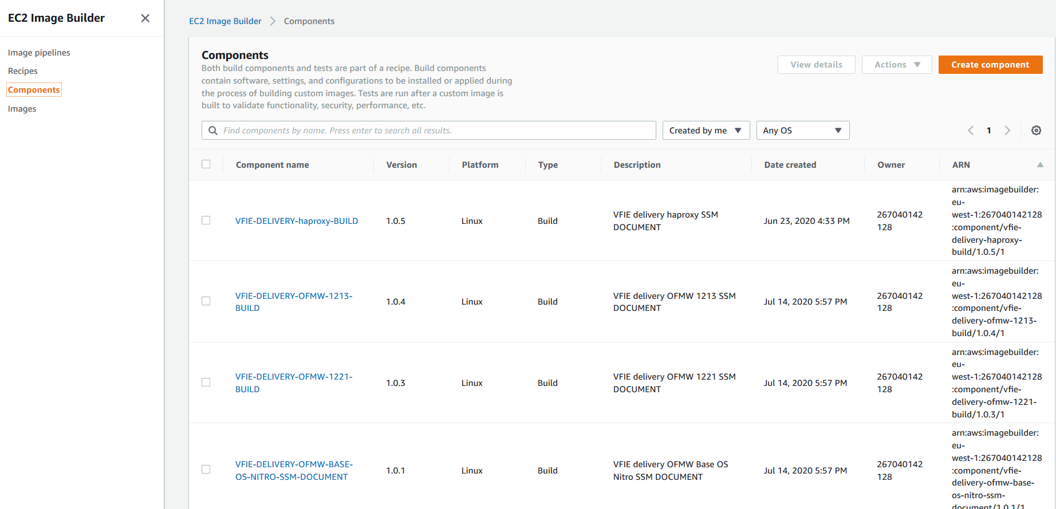

IMAGE RECIPES

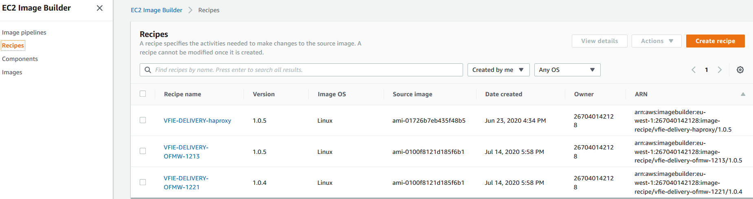

IMAGE PIPELINES

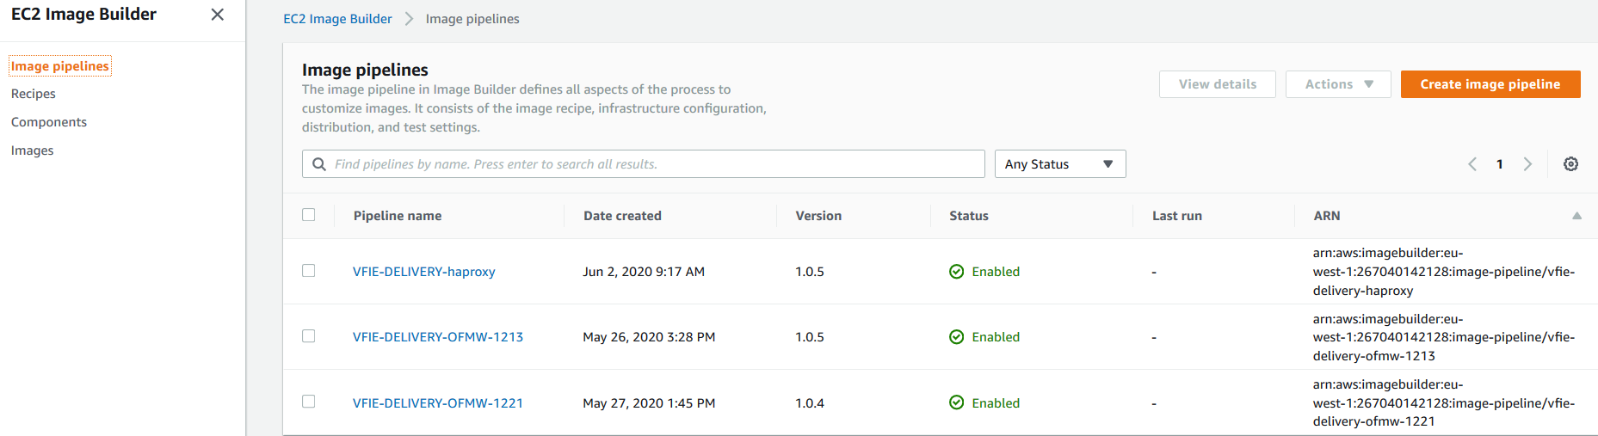

IMAGE CREATED

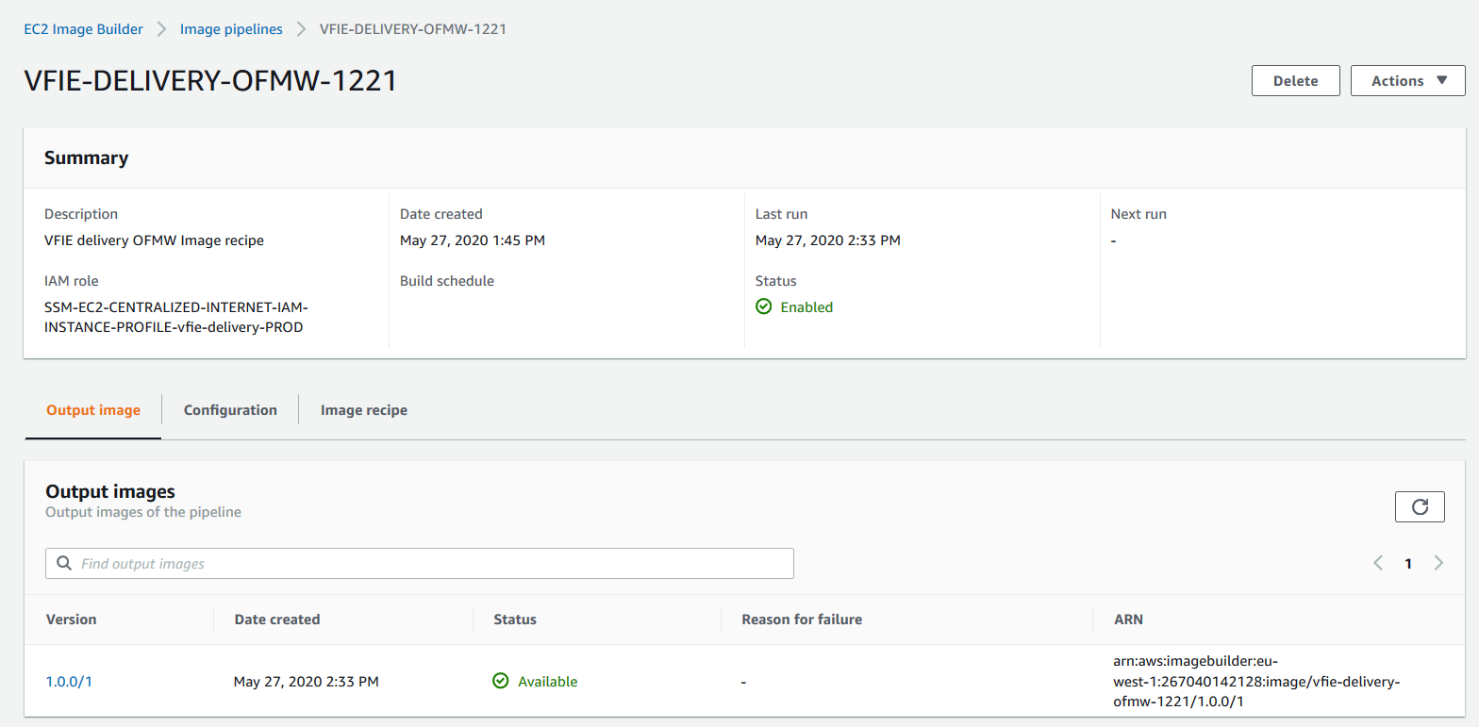

## HOW TO: NEW AMI

* In shared services account:
  + When a new hardened AMI is released, it needs to be copied (and ebs volume encrypted) to eu-west-1 region. This now is done MANUALLY.
  + Image pipeline needs to be run. In terraform, we have a data resource for hardened ami that will read the latest one. However, we will need to update the VERSION of the AWS EC2 image builder MANUALLY. For this case, if there is no modifications for SSM documents (image components, we just need to update version of image recipe. In case of modification for image component, update the file in terraform, and in the cloudformation template, update the version of that component and the one for the image recipe need to be updated.
  + Run vf-iedelivery-centralized-internet pipeline. It will take around 30 min for the image pipeline to create an image.
* In tenant accounts:
  + Once we have in ss account the new image created, terraform will add launch permissions to the most recent AMI and ebs volume permissions for each ebs volume. If the pipeline reaches the timeout (or the image creation fails) before the new image are created, MANUALLY needs to be run again (vf-iedelivery-centralized-internet), so the part of adding permissions to ami and ebs are executed.
  + Once in tenant account we have access to new AMI, we will need to copy (encrypting ebs volume) to eu-west-region-1. This is done MANUALLY.
  + In our repository (vf-iedelivery-infrastructure), we have a terraform data resource to read the latest AMI. If we release a change in the corresponding codepipeline (for vf-iedelivery-mgmt-ENVIRONMENT), we will update that AMI. We should ignore AMI changes until we want to upgrade it.
* EBS VOLUMES:
  + <https://aws.amazon.com/blogs/security/how-to-share-encrypted-amis-across-accounts-to-launch-encrypted-ec2-instances/> IF ANY EBS VOLUME IS ENCRYPTED WITH DEFAULT EBS KEY, IT NEEDS TO BE COPIED WITH A CUSTOM CKM. THEN, FOLLOW THIS DOCUMENTATION.

### PERMISSIONS TO NEW AMI

|  |
| --- |
| #-----data specific ami  data "aws_ami" "ofmw1213" {    most_recent      = true    owners           = ["self"]    filter {      name   = "name"      values = ["VFIE-DELIVERY-OFMW-1213 *"]    }  }  data "aws_ami" "ofmw1221" {    most_recent      = true    owners           = ["self"]    filter {      name   = "name"      values = ["VFIE-DELIVERY-OFMW-1221 *"]    }  }    #----ami launch permissions  resource "aws_ami_launch_permission" "ofmw1213" {    count = length(var.ram_principals)    image_id   = data.aws_ami.ofmw1213.id #latest one    account_id = var.ram_principals[count.index]    lifecycle {    ignore_changes = [image_id]    }  }  resource "aws_ami_launch_permission" "ofmw1221" {    count = length(var.ram_principals)    image_id   = data.aws_ami.ofmw1221.id #latest one    account_id = var.ram_principals[count.index]    lifecycle {    ignore_changes = [image_id]    }  }  #----ebs volume snapshot permissions for root volume  resource "aws_snapshot_create_volume_permission" "ofmw1213" {    count = length(var.ram_principals)    snapshot_id = data.aws_ami.ofmw1213.root_snapshot_id    account_id  = var.ram_principals[count.index]    lifecycle {    ignore_changes = [snapshot_id]    }  }  resource "aws_snapshot_create_volume_permission" "ofmw1221" {    count = length(var.ram_principals)    snapshot_id = data.aws_ami.ofmw1221.root_snapshot_id    account_id  = var.ram_principals[count.index]    lifecycle {    ignore_changes = [snapshot_id]    }  }  #----ebs volume snapshot permissions forebs volume 1  resource "aws_snapshot_create_volume_permission" "ofmw1213_1" {    count = length(var.ram_principals)    snapshot_id = element(data.aws_ami.ofmw1213.block_device_mappings.*.ebs.snapshot_id,1)    account_id  = var.ram_principals[count.index]    lifecycle {    ignore_changes = [snapshot_id]    }  }  resource "aws_snapshot_create_volume_permission" "ofmw1221_1" {    count = length(var.ram_principals)    snapshot_id = element(data.aws_ami.ofmw1221.block_device_mappings.*.ebs.snapshot_id,1)    account_id  = var.ram_principals[count.index]    lifecycle {    ignore_changes = [snapshot_id]    }  }  #----ebs volume snapshot permissions forebs volume 2  resource "aws_snapshot_create_volume_permission" "ofmw1213_2" {    count = length(var.ram_principals)    snapshot_id = element(data.aws_ami.ofmw1213.block_device_mappings.*.ebs.snapshot_id,2)    account_id  = var.ram_principals[count.index]    lifecycle {    ignore_changes = [snapshot_id]    }  }  resource "aws_snapshot_create_volume_permission" "ofmw1221_2" {    count = length(var.ram_principals)    snapshot_id = element(data.aws_ami.ofmw1221.block_device_mappings.*.ebs.snapshot_id,2)    account_id  = var.ram_principals[count.index]    lifecycle {    ignore_changes = [snapshot_id]    }  } |

# 08 VFIE OVERALL NETWORK DESIGN

The Overall Network Design covers the integration with the VFIE and GDC networks from AWS.

* Network Diagram
* Advertised Subnets
* GDC & VFIE Integration Points
  + TNSNAMES.ORA (PROD)
  + GUI URL List

## Network Diagram

**PROD**

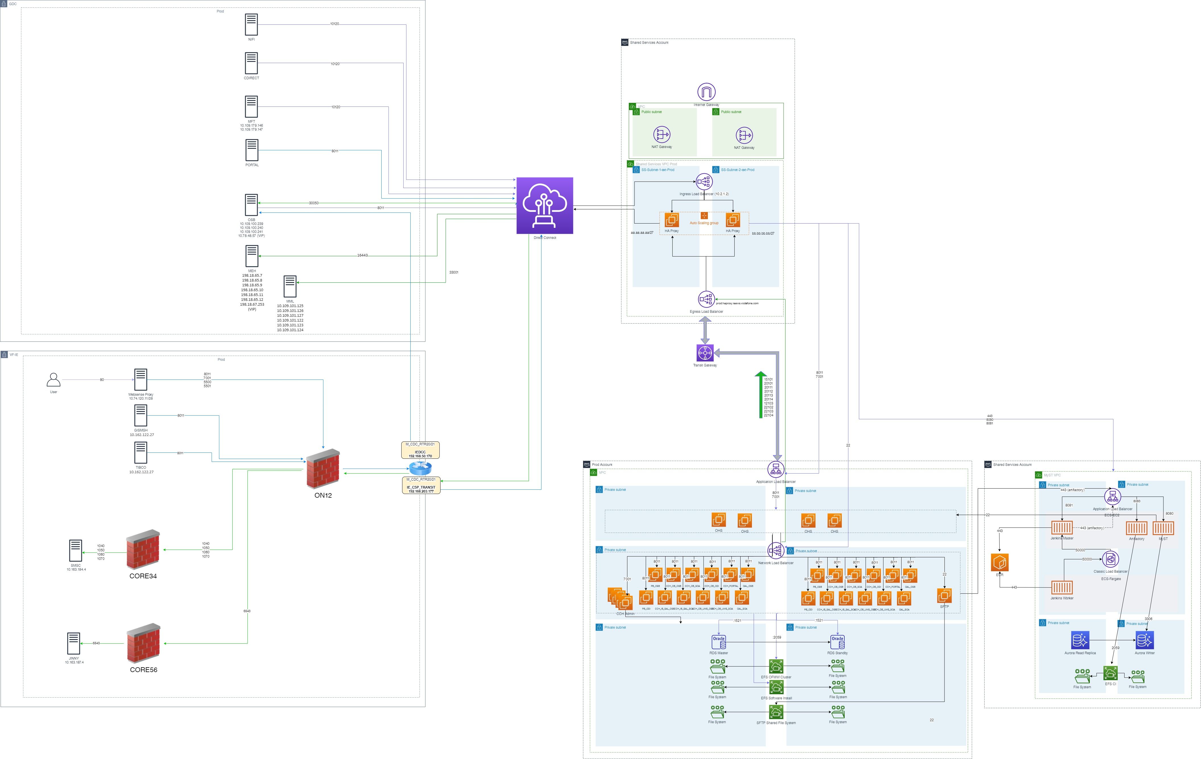

## Advertised Subnets

**IE_CSP_TRANSIT**

The IE_CSP_TRANSIT VRF is a direct connection between VFIE and AWS, bypassing the GDC Firewalls and Routers. Once a subnet is advertised on this VRF via the M Routers (m_cdc_rtr20 & 21), the traffic will be routed directly to AWS.

* 10.163.78.0/23
* 10.151.4.0/24
* 10.162.114.0/24
* 10.74.120.112/28
* 10.162.122.0/24
* 10.162.111.0/24
* 10.163.187.0/24
* 10.163.184.0/24
* 10.162.229.0/24
* 10.162.66.0/24
* 10.180.54.0/24
* 10.162.124.0/24

To ensure that VFIE Traffic is routed correctly to the right interface on the M routers for IE_CSP_TRANSIT, routing has been added on ON12 for the associated AWS subnets as below

|  |  |  |  |  |  |  |
| --- | --- | --- | --- | --- | --- | --- |
| PURPOSE | Destination | Mask | Next Hop IP | Next Hop Desc | Next Hop Owner | Install on |
| VFIE AWS Dedicated Subnet | 198.19.220.0 | /24 | 192.168.50.170 | m_cdc_rtr20/21 | NSU | ON12 |

## GDC & VFIE Integration Points

### TNSNAMES.ORA (PROD)

|  |
| --- |
| prod-cchsal = (DESCRIPTION= (CONNECT_DATA=(SERVICE_NAME=CCHSAL)) (SOURCE_ROUTE=yes) (ADDRESS=(PROTOCOL=tcps)(HOST=cch-sal-utilities.prod.ieaws.vodafone.com)(PORT=10305)) (ADDRESS=(PROTOCOL=tcps)(HOST=cch-sal-db.prod.ieaws.vodafone.com)(PORT=2484)) )  prod-cchsal-logger = (DESCRIPTION= (CONNECT_DATA=(SERVICE_NAME=LOGGER)) (SOURCE_ROUTE=yes) (ADDRESS=(PROTOCOL=tcps)(HOST=cch-sal-utilities.prod.ieaws.vodafone.com)(PORT=10305)) (ADDRESS=(PROTOCOL=tcps)(HOST=logger-db.prod.ieaws.vodafone.com)(PORT=2484)) ) |

### GUI URL List

|  |  |
| --- | --- |
| **URL** | **Description** |
| [https://jenkins.prod.ieaws.vodafone.com:10301](https://jenkins.prod.ieaws.vodafone.com:10301/) | Jenkins |
| [https://artifactory.prod.ieaws.vodafone.com:10302](https://artifactory.prod.ieaws.vodafone.com:10302/) | Jfrog Artifactory |
| <https://myst.prod.ieaws.vodafone.com:10303/console> | MyST |
| [https://pb-osb-lb-as.prod.ieaws.vodafone.com:7001/console](https://pb-osb-lb-as.prd1.ieaws.vodafone.com:7001/console) | PB_OSB |
| [https://pb-odi-lb-as.prod.ieaws.vodafone.com:7001/console](https://pb-odi-lb-as.snd1.ieaws.vodafone.com:7001/console) | PB_ODI |
| [https://cch-ib-sal-osb-lb-as.prod.ieaws.vodafone.com:7001/console](https://cch-ib-sal-osb-lb-as.prd1.ieaws.vodafone.com:7001/console) | CCH_IB_SAL_OSB |
| [https://cch-ib-sal-soa-lb-as.prod.ieaws.vodafone.com:7001/console](https://cch-ib-sal-soa-lb-as.prd1.ieaws.vodafone.com:7001/console) | CCH_IB_SAL_SOA |
| [https://cch-ob-ums-osb-lb-as.prod.ieaws.vodafone.com:7001/console](https://cch-ob-ums-osb-lb-as.prd1.ieaws.vodafone.com:7001/console/login/LoginForm.jsp) | CCH_OB_UMS_OSB |
| [https://cch-ob-ums-soa-lb-as.prod.ieaws.vodafone.com:7001/console](https://cch-ob-ums-soa-lb-as.prd1.ieaws.vodafone.com:7001/console) | CCH_OB_UMS_SOA |
| [https://cch-ob-osb-lb-as.prod.ieaws.vodafone.com:7001/console](https://cch-ob-osb-lb-as.prd1.ieaws.vodafone.com:7001/console) | CCH_OB_OSB |
| [https://cch-ob-soa-lb-as.prod.ieaws.vodafone.com:7001/console](https://cch-ob-soa-lb-as.prd1.ieaws.vodafone.com:7001/console) | CCH_OB_SOA |
| [https://cch-ob-odi-lb-as.prod.ieaws.vodafone.com:7001/console](https://cch-ob-odi-lb-as.prd1.ieaws.vodafone.com:7001/console) | CCH_OB_ODI |
| [https://cch-portal-lb-as.prod.ieaws.vodafone.com:7001/console](https://cch-portal-lb-as.prd1.ieaws.vodafone.com:7001/console) | CCH_PORTAL |
| [https://oal-osb-lb-as.prod.ieaws.vodafone.com:7001/console](https://oal-osb-lb-as.prd1.ieaws.vodafone.com:7001/console) | OAL_OSB |
| [https://oal-soa-lb-as.prod.ieaws.vodafone.com:7001/console](https://oal-soa-lb-as.prd1.ieaws.vodafone.com:7001/console) | OAL_SOA |

# 09 VFIE SQUID PROXY

The Squid Proxy sits in the Internet Gateway and controls which domains can be accessed on the internet via a whitelist. Below is a list of the current domains accessible.

|  |  |
| --- | --- |
| Domain | Status |
| .[amazon.com](http://amazon.com) | Deployed |
| .[vodafone.com](http://vodafone.com) | Deployed |
| .[amazonaws.com](http://amazonaws.com) | Deployed |
| .[bintray.io](http://bintray.io) | Deployed |
| .[redhat.com](http://redhat.com) | Deployed |
| .[cdn.amazonlinux.com](http://cdn.amazonlinux.com) | Deployed |
| .[download.mono-project.com](http://download.mono-project.com) | Deployed |
| .[mirrors.fedoraproject.org](http://mirrors.fedoraproject.org) | Deployed |
| .[dl.yarnpkg.com](http://dl.yarnpkg.com) | Deployed |
| .qualys.eu | Deployed |
| .[hana.ondemand.com](http://hana.ondemand.com) | Deployed |
| .[mft.aon.com](http://mft.aon.com) | Deployed |
| .[zellis.com](http://zellis.com) | Deployed |
| .[westeurope.cloudapp.azure.com](http://westeurope.cloudapp.azure.com) | Deployed |
| .[maven.org](http://maven.org) | Deployed |
| .[adobe.com](http://adobe.com) | Deployed |
| .[apache.org](http://apache.org) | Deployed |
| .[google.com](http://google.com) | Deployed |
| .[amazoncognito.com](http://amazoncognito.com) | Deployed |
| .[omniture.com](http://omniture.com) | Deployed |
| .atomz.com | Deployed |
| .[npmjs.org](http://npmjs.org) | Deployed |
| .[nodejs.org](http://nodejs.org) | Deployed |
| .github.com | Deployed |
| .[googleapis.com](http://googleapis.com) | IN PROGRESS |

Any additional domains that need to be added to the whitelist should be requested either via Service Catalogue or via an ongoing project.

# 10 VFIE Network Integration

Below are the existing integration points between applications deployed in AWS and VFIE/VCI based systems

|  |  |  |  |  |  |  |  |  |  |  |  |  |  |  |  |  |  |  |  |  |  |
| --- | --- | --- | --- | --- | --- | --- | --- | --- | --- | --- | --- | --- | --- | --- | --- | --- | --- | --- | --- | --- | --- |
| **Source** | **Destination** | **Route** | **Type** | **PROD** | | **PRD2** | | **PRD1** | | **SIT4** | | **SIT3** | | **SIT2** | | **SIT1** |  | **DEV1** | | **DEV2** | |
| * **Portal Gowing Core** * **VBU VBOL API** * **VBU API** | **Amdocs OSB** | VCI Network | WS | [esb.prod.dox.equinox.vodafone.ie](http://esb.prod.dox.equinox.vodafone.ie)  [**prod.haproxy.ieaws.vodafone.com**](http://prod.haproxy.ieaws.vodafone.com)**(haproxy)** | 30050 **15101** | [esb.app.prd2.equinox.vf-ie.internal.vodafone.com](http://esb.app.prd2.equinox.vf-ie.internal.vodafone.com)  [**prd2.haproxy.ieaws.vodafone.com**](http://prd2.haproxy.ieaws.vodafone.com)**(haproxy)** | 33007  **15101** | [esb.app.prd1.equinox.vf-ie.internal.vodafone.com](http://esb.app.prd1.equinox.vf-ie.internal.vodafone.com)  [**prd1.haproxy.ieaws.vodafone.com**](http://prd1.haproxy.ieaws.vodafone.com)**(haproxy)** | 32007  **15101** | [ieesbbvr.dc-dublin.de](http://ieesbbvr.dc-dublin.de)  [**sit4.haproxy.ieaws.vodafone.com**](http://sit4.haproxy.ieaws.vodafone.com)**(haproxy)** | 14010  **15101** | [ieesbbvr.dc-dublin.de](http://ieesbbvr.dc-dublin.de)  [**sit3.haproxy.ieaws.vodafone.com**](http://sit3.haproxy.ieaws.vodafone.com)**(haproxy)** | 9007  **15101** | [ieesbbvr.dc-dublin.de](http://ieesbbvr.dc-dublin.de)  [**sit2.haproxy.ieaws.vodafone.com**](http://sit2.haproxy.ieaws.vodafone.com)**(haproxy)** | 11007  **15101** | [ieesbavr.dc-dublin.de](http://ieesbavr.dc-dublin.de)  [**sit1.haproxy.ieaws.vodafone.com**](http://sit1.haproxy.ieaws.vodafone.com)**(haproxy)** | 7007  **15101** | [ieesbbvr.dc-dublin.de](http://ieesbbvr.dc-dublin.de)  [**dev1.haproxy.ieaws.vodafone.com**](http://dev1.haproxy.ieaws.vodafone.com)**(haproxy)** | 9007  **15101** | [ieesbbvr.dc-dublin.de](http://ieesbbvr.dc-dublin.de)  [**dev2.haproxy.ieaws.vodafone.com**](http://dev2.haproxy.ieaws.vodafone.com)**(haproxy)** | 9007  **15101** |
| * **CIAM Webgate** | **Portal AEM Dispatcher** | VCI Network | WS | [**portal-dispatcher.prod.ieaws.vodafone.com**](http://portal-dispatcher.prod.ieaws.vodafone.com) | **8443** | [**portal-dispatcher.prd2.ieaws.vodafone.com**](http://portal-dispatcher.prd2.ieaws.vodafone.com) | **8443** | [**portal-dispatcher.prd1.ieaws.vodafone.com**](http://portal-dispatcher.prd1.ieaws.vodafone.com) | **8443** | [**portal-dispatcher.sit4.ieaws.vodafone.com**](http://portal-dispatcher.sit4.ieaws.vodafone.com) | **8443** | [**portal-dispatcher.sit3.ieaws.vodafone.com**](http://portal-dispatcher.sit3.ieaws.vodafone.com) | **8443** | [**portal-dispatcher.sit2.ieaws.vodafone.com**](http://portal-dispatcher.sit2.ieaws.vodafone.com) | **8443** | [**portal-dispatcher.sit1.ieaws.vodafone.com**](http://portal-dispatcher.sit1.ieaws.vodafone.com) | **8443** | N/A - Dev CIAM hosted in AWS |  | N/A - Dev CIAM hosted in AWS |  |
| * **Portal Gowing Core** | **CCHSAL OAL OSB** | AWS | WS | [oal-osb.prod.ieaws.vodafone.com](http://oal-osb.prod.ieaws.vodafone.com) | 8011 | [oal-osb.prd2.ieaws.vodafone.com](http://oal-osb.prd2.ieaws.vodafone.com) | 8011 | [oal-osb.prd1.ieaws.vodafone.com](http://oal-osb.prd1.ieaws.vodafone.com) | 8011 | [ie2135yr.dc-dublin.de](http://ie2135yr.dc-dublin.de)  [**sit4.haproxy.ieaws.vodafone.com**](http://sit4.haproxy.ieaws.vodafone.com)**(haproxy)** | 7443  **10101** | [iesalcvr.dc-dublin.de](http://iesalcvr.dc-dublin.de)  [**sit3.haproxy.ieaws.vodafone.com**](http://sit3.haproxy.ieaws.vodafone.com)**(haproxy)** | 7443  **10101** | [iesalmvr.dc-dublin.de](http://iesalmvr.dc-dublin.de)  [**sit2.haproxy.ieaws.vodafone.com**](http://sit2.haproxy.ieaws.vodafone.com)**(haproxy)** | 7443  **10101** | [iesalavr.dc-dublin.de](http://iesalavr.dc-dublin.de)  [**sit1.haproxy.ieaws.vodafone.com**](http://sit1.haproxy.ieaws.vodafone.com)**(haproxy)** | 7443  **10101** | [ieesbbvr.dc-dublin.de](http://ieesbbvr.dc-dublin.de)  [**dev1.haproxy.ieaws.vodafone.com**](http://dev1.haproxy.ieaws.vodafone.com)**(haproxy)** | 7443  **10101** | [ieesbbvr.dc-dublin.de](http://ieesbbvr.dc-dublin.de)  [**dev2.haproxy.ieaws.vodafone.com**](http://dev2.haproxy.ieaws.vodafone.com)**(haproxy)** | 7443  **10101** |
| * **Portal Gowing Core** | **FSL Gateway** | VFIE Network | WS | 89.19.69.178  [**prod.haproxy.ieaws.vodafone.com**](http://prod.haproxy.ieaws.vodafone.com)**(haproxy)** | 7004  **11001** | 89.19.71.65  [**prd2.haproxy.ieaws.vodafone.com**](http://prd2.haproxy.ieaws.vodafone.com)**(haproxy)** | 7004  **11001** | 89.19.71.65  [**prd1.haproxy.ieaws.vodafone.com**](http://prd1.haproxy.ieaws.vodafone.com)**(haproxy)** | 7004  **11001** | 89.19.71.65  [**sit4.haproxy.ieaws.vodafone.com**](http://sit4.haproxy.ieaws.vodafone.com)**(haproxy)** | 7004  **11001** | 89.19.71.65  [**sit3.haproxy.ieaws.vodafone.com**](http://sit3.haproxy.ieaws.vodafone.com)**(haproxy)** | 7004  **11001** | 89.19.71.65  [**sit2.haproxy.ieaws.vodafone.com**](http://sit2.haproxy.ieaws.vodafone.com)**(haproxy)** | 7004  **11001** | 89.19.71.65  [**sit1.haproxy.ieaws.vodafone.com**](http://sit1.haproxy.ieaws.vodafone.com)**(haproxy)** | 7004  **11001** | 89.19.71.65  [**dev1.haproxy.ieaws.vodafone.com**](http://dev1.haproxy.ieaws.vodafone.com)**(haproxy)** | 7004  **11001** | 89.19.71.65  [**dev2.haproxy.ieaws.vodafone.com**](http://dev2.haproxy.ieaws.vodafone.com)**(haproxy)** | 7004  **11001** |
| * **Portal Gowing Core** | **UFE DB (Process Continuity DB)** | VCI Network | TCP | [ieufoab-scan.dc-dublin.de](http://ieufoab-scan.dc-dublin.de)  IEUFOAHR-VIP - 10.109.101.13 IEUFOBHR-VIP - 10.109.101.14  [**prod.haproxy.ieaws.vodafone.com**](http://prod.haproxy.ieaws.vodafone.com)**(haproxy)** | 33000  33001  **22104**  **22105** | [ieufoab-scan.dc-dublin.de](http://ieufoab-scan.dc-dublin.de)  IEUFOAHR-VIP - 10.109.101.13 IEUFOBHR-VIP - 10.109.101.14  [**prd2.haproxy.ieaws.vodafone.com**](http://prd2.haproxy.ieaws.vodafone.com)**(haproxy)** | 33000  33001  **22104**  **22105** | [ieufoab-scan.dc-dublin.de](http://ieufoab-scan.dc-dublin.de)  IEUFOAHR-VIP - 10.109.101.13 IEUFOBHR-VIP - 10.109.101.14  [**prd1.haproxy.ieaws.vodafone.com**](http://prd1.haproxy.ieaws.vodafone.com)**(haproxy)** | 33000  33001  **22104**  **22105** | IEORN1-SCAN 10.106.184.[34,35,36]  IEORN1HR-VIP - 10.106.184.32 IEORN2HR-VIP - 10.106.184.33  [**sit4.haproxy.ieaws.vodafone.com**](http://sit4.haproxy.ieaws.vodafone.com)**(haproxy)** | 33000  33001  33016  **22104**  **22105** | [ieorn2-scan.dc-dublin.de](http://ieorn2-scan.dc-dublin.de)  IEORN3HR-VIP - 10.106.184.39 IEORN4HR-VIP - 10.106.184.40  [**sit3.haproxy.ieaws.vodafone.com**](http://sit3.haproxy.ieaws.vodafone.com)**(haproxy)** | 33000  33001  33017  **22104**  **22105** | [ieorn2-scan.dc-dublin.de](http://ieorn2-scan.dc-dublin.de)  IEORN3HR-VIP - 10.106.184.39 IEORN4HR-VIP - 10.106.184.40  [**sit2.haproxy.ieaws.vodafone.com**](http://sit2.haproxy.ieaws.vodafone.com)**(haproxy)** | 33000  33001  33016  **22104**  **22105** | [ieorn2-scan.dc-dublin.de](http://ieorn2-scan.dc-dublin.de)  IEORN3HR-VIP - 10.106.184.39 IEORN4HR-VIP - 10.106.184.40  [**sit1.haproxy.ieaws.vodafone.com**](http://sit1.haproxy.ieaws.vodafone.com)**(haproxy)** | 33000  33001  33015  **22104**  **22105** | n/a - basket will be stored locally. Portal will not be able to recover basket from UFE | n/a | n/a - basket will be stored locally. Portal will not be able to recover basket from UFE | n/a |
| * **Portal Gowing Core** | **UFE (Omnichannel Catalog)** | VCI Network | WS | [app.prod.ufe.equinox.vodafone.ie](http://app.prod.ufe.equinox.vodafone.ie)  [**prod.haproxy.ieaws.vodafone.com**](http://prod.haproxy.ieaws.vodafone.com)**(haproxy)** | 8005  **13001** | [app.prd2.ufe.equinox.vodafone.ie](http://app.prd2.ufe.equinox.vodafone.ie)  [**prd2.haproxy.ieaws.vodafone.com**](http://prd2.haproxy.ieaws.vodafone.com)**(haproxy)** | 8005  **13001** | [app.prd1.ufe.equinox.vodafone.ie](http://app.prd1.ufe.equinox.vodafone.ie)  [**prd1.haproxy.ieaws.vodafone.com**](http://prd1.haproxy.ieaws.vodafone.com)**(haproxy)** | 8005  **13001** | [app.ufe.sit4.equinox.vf-ie.internal.vodafone.com](http://app.ufe.sit4.equinox.vf-ie.internal.vodafone.com)  [**sit4.haproxy.ieaws.vodafone.com**](http://sit4.haproxy.ieaws.vodafone.com)**(haproxy)** | 8005  **13001** | [app.sitint3.ufe.equinox.vodafone.ie](http://app.sitint3.ufe.equinox.vodafone.ie)  [**sit3.haproxy.ieaws.vodafone.com**](http://sit3.haproxy.ieaws.vodafone.com)**(haproxy)** | 8005  **13001** | [app.sitint2.ufe.equinox.vodafone.ie](http://app.sitint3.ufe.equinox.vodafone.ie)  [**sit2.haproxy.ieaws.vodafone.com**](http://sit2.haproxy.ieaws.vodafone.com)**(haproxy)** | 8005  **13001** | [app.sitint1.ufe.equinox.vodafone.ie](http://app.sitint1.ufe.equinox.vodafone.ie)  [**sit1.haproxy.ieaws.vodafone.com**](http://sit1.haproxy.ieaws.vodafone.com)**(haproxy)** | 8005  **13001** | [app.sitint3.ufe.equinox.vodafone.ie](http://app.sitint3.ufe.equinox.vodafone.ie)  [**dev1.haproxy.ieaws.vodafone.com**](http://dev1.haproxy.ieaws.vodafone.com)**(haproxy)** | 8005  **13001** | [app.sitint3.ufe.equinox.vodafone.ie](http://app.sitint3.ufe.equinox.vodafone.ie)  [**dev2.haproxy.ieaws.vodafone.com**](http://dev2.haproxy.ieaws.vodafone.com)**(haproxy)** | 8005  **13001** |
| * **Portal AEM Dispatcher** * **Portal Gowing Core** | **AWS Cognito** | Internet Gateway | TCP | *.[amazoncognito.com](http://amazoncognito.com)  *.[amazonaws.com](http://amazonaws.com)  *[clearmobile.ie](http://clearmobile.ie) | 443 | *.[amazoncognito.com](http://amazoncognito.com)  *.[amazonaws.com](http://amazonaws.com)  *[clearmobile.ie](http://clearmobile.ie) | 443 | *.[amazoncognito.com](http://amazoncognito.com)  *.[amazonaws.com](http://amazonaws.com)  *[clearmobile.ie](http://clearmobile.ie) | 443 | *.[amazoncognito.com](http://amazoncognito.com)  *.[amazonaws.com](http://amazonaws.com)  *[clearmobile.ie](http://clearmobile.ie) | 443 | *.[amazoncognito.com](http://amazoncognito.com)  *.[amazonaws.com](http://amazonaws.com)  *[clearmobile.ie](http://clearmobile.ie) | 443 | *.[amazoncognito.com](http://amazoncognito.com)  *.[amazonaws.com](http://amazonaws.com)  *[clearmobile.ie](http://clearmobile.ie) | 443 | *.[amazoncognito.com](http://amazoncognito.com)  *.[amazonaws.com](http://amazonaws.com)  *[clearmobile.ie](http://clearmobile.ie) | 443 | *.[amazoncognito.com](http://amazoncognito.com)  *.[amazonaws.com](http://amazonaws.com)  *[clearmobile.ie](http://clearmobile.ie) | 443 | *.[amazoncognito.com](http://amazoncognito.com)  *.[amazonaws.com](http://amazonaws.com)  *[clearmobile.ie](http://clearmobile.ie) | 443 |
| * **Portal AEM Dispatcher** | **Google API** | Internet Gateway | WS | www.google.com | 443 | www.google.com | 443 | www.google.com | 443 | www.google.com | 443 | www.google.com | 443 | www.google.com | 443 | www.google.com | 443 | [www.google.com](http://www.google.com) | 443 | [www.google.com](http://www.google.com) | 443 |
| * **Portal AEM Publish** * **Portal AEM Author** | **Adobe Cloud (Adobe Search&Promote)** | Internet Gateway | WS | [my.omniture.com](http://my.omniture.com)  [api3.omniture.com](http://api3.omniture.com) | 443 | [my.omniture.com](http://my.omniture.com)  [api3.omniture.com](http://api3.omniture.com) | 443 | [my.omniture.com](http://my.omniture.com)  [api3.omniture.com](http://api3.omniture.com) | 443 | [my.omniture.com](http://my.omniture.com)  [api3.omniture.com](http://api3.omniture.com) | 443 | [my.omniture.com](http://my.omniture.com)  [api3.omniture.com](http://api3.omniture.com) | 443 | [my.omniture.com](http://my.omniture.com)  [api3.omniture.com](http://api3.omniture.com) | 443 | [my.omniture.com](http://my.omniture.com)  [api3.omniture.com](http://api3.omniture.com) | 443 | [my.omniture.com](http://my.omniture.com)  [api3.omniture.com](http://api3.omniture.com) | 443 | [my.omniture.com](http://my.omniture.com)  [api3.omniture.com](http://api3.omniture.com) | 443 |
| * **Portal Gowing Core** | **Group DxL Cluster** | Internet Gateway | WS | [eu2.api.vodafone.com](http://eu2.api.vodafone.com) | 443 | [eu2-stagingref.api.vodafone.com](http://eu2-stagingref.api.vodafone.com) | 443 | [eu2-stagingref.api.vodafone.com](http://eu2-stagingref.api.vodafone.com) | 443 | [eu2-stagingref.api.vodafone.com](http://eu2-stagingref.api.vodafone.com) | 443 | [eu2-stagingref.api.vodafone.com](http://eu2-stagingref.api.vodafone.com) | 443 | [eu2-stagingref.api.vodafone.com](http://eu2-stagingref.api.vodafone.com) | 443 | [eu2-stagingref.api.vodafone.com](http://eu2-stagingref.api.vodafone.com) | 443 | [eu2-stagingref.api.vodafone.com](http://eu2-stagingref.api.vodafone.com) | 443 | [eu2-stagingref.api.vodafone.com](http://eu2-stagingref.api.vodafone.com) | 443 |
| * **Portal Gowing Core** | **VF Group APIX** | Internet Gateway | WS | [api.developer.vodafone.com](http://api.developer.vodafone.com) | 443 | apistagingref.developer.vodafone.com | 443 | apistagingref.developer.vodafone.com | 443 | apistagingref.developer.vodafone.com | 443 | apistagingref.developer.vodafone.com | 443 | apistagingref.developer.vodafone.com | 443 | apistagingref.developer.vodafone.com | 443 | [apistagingref.developer.vodafone.com](http://apistagingref.developer.vodafone.com) | 443 | [apistagingref.developer.vodafone.com](http://apistagingref.developer.vodafone.com) | 443 |
| * **Portal Gowing Core** | **CCHSAL IB SAL OSB** | AWS | WS | cch-ib-sal-osb.prod.ieaws.vodafone.com | 8011 | cch-ib-sal-osb.prd2.ieaws.vodafone.com | 8011 | cch-ib-sal-osb.prd1.ieaws.vodafone.com | 8011 | [ie2135yr.dc-dublin.de](http://ie2135yr.dc-dublin.de)  [**sit4.haproxy.ieaws.vodafone.com**](http://sit4.haproxy.ieaws.vodafone.com)**(haproxy)** | 9080  10102 | iesalcvr.dc-dublin.de **sit3.haproxy.ieaws.vodafone.com (haproxy)** | 9443  10102 | iesalmvr.dc-dublin.de **sit2.haproxy.ieaws.vodafone.com (haproxy)** | 9443  10102 | iesalavr.dc-dublin.de **sit1.haproxy.ieaws.vodafone.com (haproxy)** | 9080  10102 | [iesalcvr.dc-dublin.de](http://iesalcvr.dc-dublin.de) [**dev1.haproxy.ieaws.vodafone.com**](http://dev1.haproxy.ieaws.vodafone.com)**(haproxy)** | 9443  10102 | [iesalcvr.dc-dublin.de](http://iesalcvr.dc-dublin.de) [**dev2.haproxy.ieaws.vodafone.com**](http://dev2.haproxy.ieaws.vodafone.com)**(haproxy)** | 9443  10102 |
| * **Portal Gowing Core** | **Vesta API** | Internet Gateway | WS | [vestaauth.vodafone.ie](http://vestaauth.vodafone.ie)  [vestatopup.vodafone.ie](http://vestatopup.vodafone.ie) | 443  443 | [uat-vestaauth.vodafone.ie](http://uat-vestaauth.vodafone.ie)  [uat-vestatopup.vodafone.ie](http://uat-vestatopup.vodafone.ie) | 443  443 | [uat-vestaauth.vodafone.ie](http://uat-vestaauth.vodafone.ie)  [uat-vestatopup.vodafone.ie](http://uat-vestatopup.vodafone.ie) | 443  443 | [uat-vestaauth.vodafone.ie](http://uat-vestaauth.vodafone.ie)  [uat-vestatopup.vodafone.ie](http://uat-vestatopup.vodafone.ie) | 443  443 | [uat-vestaauth.vodafone.ie](http://uat-vestaauth.vodafone.ie)  [uat-vestatopup.vodafone.ie](http://uat-vestatopup.vodafone.ie) | 443  443 | [uat-vestaauth.vodafone.ie](http://uat-vestaauth.vodafone.ie)  [uat-vestatopup.vodafone.ie](http://uat-vestatopup.vodafone.ie) | 443  443 | [uat-vestaauth.vodafone.ie](http://uat-vestaauth.vodafone.ie)  [uat-vestatopup.vodafone.ie](http://uat-vestatopup.vodafone.ie) | 443  443 | [uat-vestaauth.vodafone.ie](http://uat-vestaauth.vodafone.ie)  [uat-vestatopup.vodafone.ie](http://uat-vestatopup.vodafone.ie) | 443  443 | [uat-vestaauth.vodafone.ie](http://uat-vestaauth.vodafone.ie)  [uat-vestatopup.vodafone.ie](http://uat-vestatopup.vodafone.ie) | 443  443 |

# 11 VFIE - Frankfurt Transit Gateway Solution

* Overview
* Network Design
  + SIT3 Design (encompasses PROD)
  + Overall Design
  + Network Design
* AWS Design
  + Network Load Balancer
    - Dublin Shared Services NLB
    - Frankfurt Shared Services NLB
  + Target Groups
    - Dublin Target Groups
    - Frankfurt Target Groups
  + Transit Gateway
  + Endpoints
* Supporting Documentation
  + DXL / TAAS Roadmap
  + TAAS Documentation
    - Overview
    - Multi-region implementation
  + CAAS NEL mServices

## Overview

To allow for VFIE services to be consumed by applications hosted in the Frankfurt AWS region, a Transit Gateway solution has been built between AWS Frankfurt and AWS Dublin, utilising the VFIE Shared Services account. The Frankfurt Transit Gateway will reside in the VFIE Shared Services AWS account **vf-iedelivery-prod-ss (267040142128)** and will cover all environments.

This solution is being used for the following services:

* DXL
  + DXL → Digital Product Catalogue (AWS)
* TAAS
  + TaaS → Amdocs OSB (VCI Network)
  + TaaS → Server-Side-Rendering (SSR) (AWS)
* CAAS NEL mServices
  + CAAS → HGW (VFIE Network)

## Network Design

[DRAWIO Design File](https://confluence.sp.vodafone.com/download/attachments/414081375/AWS%20Frankfurt%20Transit%20Gateway%20-%20V1.0.drawio?api=v2&modificationDate=1685457442465&version=1)

### SIT3 Design (encompasses PROD)

This design covers a single environment so that the simplified architecture can be viewed and the flows traced

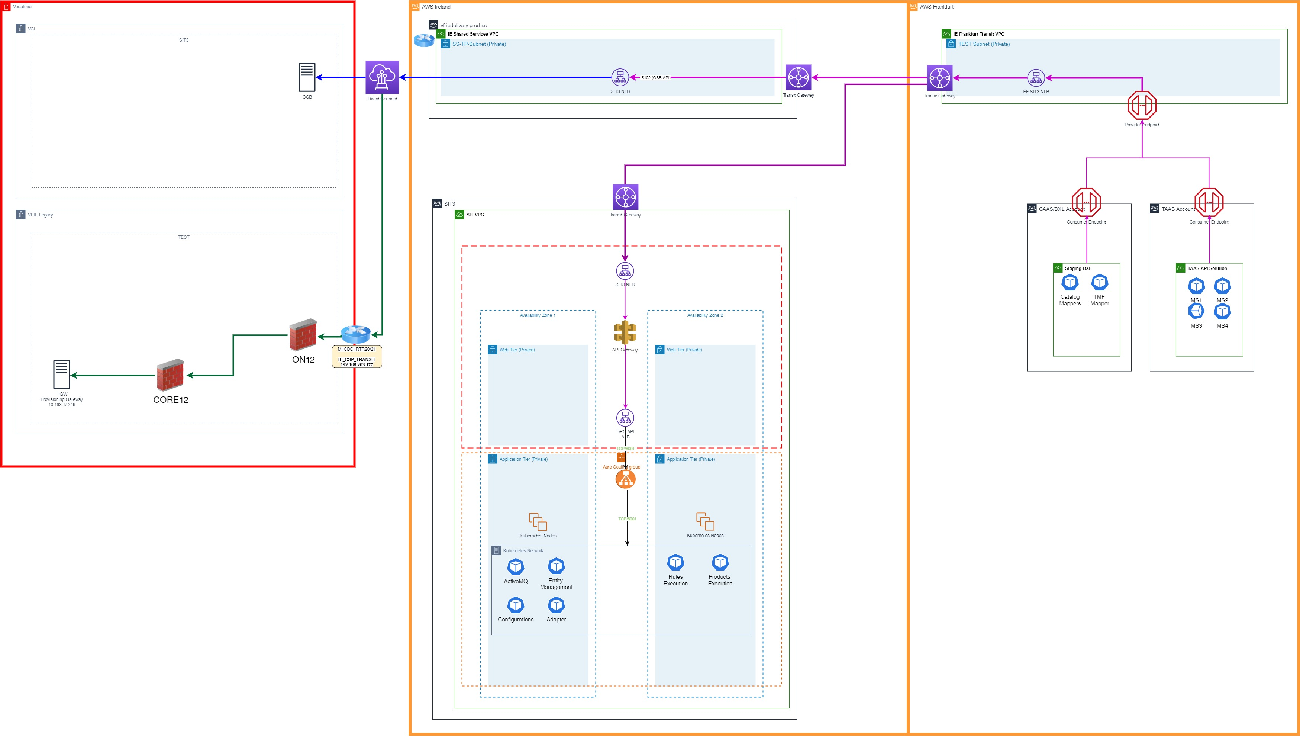

### Overall Design

This design covers the overall solution implemented for every environment

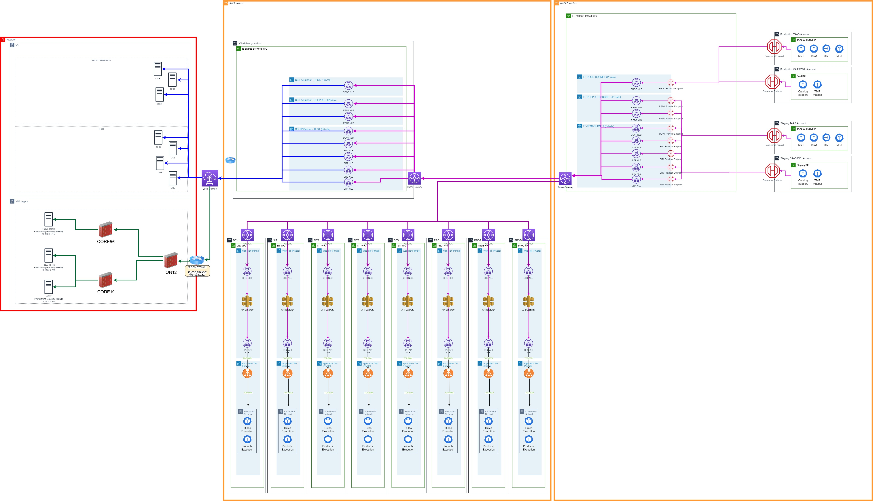

### Network Design

The following is the Subnet Design for the new **IE Frankfurt Transit VPC 10.190.0.0/22**

|  |  |  |
| --- | --- | --- |
| Purpose | Name | Subnet |
| Production | FF-PROD-SUBNET | 10.190.0.0/24 |
| Preprod | FF-PREPROD-SUBNET | 10.190.1.0/24 |
| Test/Dev | FF-TEST-SUBNET | 10.190.2.0/24 |

## AWS Design

### Network Load Balancer

#### Dublin Shared Services NLB

|  |  |  |  |
| --- | --- | --- | --- |
| NLB Name | Environment | Subnets (for the different AZs) | Comments |
| VF-IEDELIVERY-SS-DEV1-APIO-NLB | DEV1 | 198.19.220.128/26, 198.19.220.192/26 |  |
| VF-IEDELIVERY-SS-SIT1-APIO-NLB | SIT1 | 198.19.220.128/26, 198.19.220.192/26 |  |
| VF-IEDELIVERY-SS-SIT2-APIO-NLB | SIT2 | 198.19.220.128/26, 198.19.220.192/26 |  |
| VF-IEDELIVERY-SS-SIT3-APIO-NLB | SIT3 | 198.19.220.128/26, 198.19.220.192/26 |  |
| VF-IEDELIVERY-SS-SIT4-APIO-NLB | SIT4 | 198.19.220.128/26, 198.19.220.192/26 |  |
| VF-IEDELIVERY-SS-PRD1-APIO-NLB | PRD1 | 198.19.220.32/27, 198.19.220.96/27 |  |
| VF-IEDELIVERY-SS-PRD2-APIO-NLB | PRD2 | 198.19.220.32/27, 198.19.220.96/27 |  |
| VF-IEDELIVERY-SS-PROD-APIO-NLB | PROD | 198.19.220.0/27, 198.19.220.64/27 |  |

#### Frankfurt Shared Services NLB

The NLB will be created in the new **IE Frankfurt Transit VPC**for each VFIE environment.

|  |  |  |  |
| --- | --- | --- | --- |
| NLB Name | Environment | Subnets (for the different AZs) | Comments |
| VF-IEDELIVERY-FKT-DEV1-NLB | DEV1 | 10.190.2.0/26, 10.190.2.64/26, 10.190.2.128/26 |  |
| VF-IEDELIVERY-FKT-SIT1-NLB | SIT1 | 10.190.2.0/26, 10.190.2.64/26,  10.190.2.128/26 |  |
| VF-IEDELIVERY-FKT-SIT2-NLB | SIT2 | 10.190.2.0/26, 10.190.2.64/26, 10.190.2.128/26 |  |
| VF-IEDELIVERY-FKT-SIT3-NLB | SIT3 | 10.190.2.0/26, 10.190.2.64/26, 10.190.2.128/26 |  |
| VF-IEDELIVERY-FKT-SIT4-NLB | SIT4 | 10.190.2.0/26,  10.190.2.64/26,  10.190.2.128/26 |  |
| VF-IEDELIVERY-FKT-PRD1-NLB | PRD1 | 10.190.1.0/26, 10.190.1.64/26,  10.190.1.128/26 |  |
| VF-IEDELIVERY-FKT-PRD2-NLB | PRD2 | 10.190.1.0/26,  10.190.1.64/26,  10.190.1.128/26 |  |
| VF-IEDELIVERY-FKT-PROD-NLB | PROD | 10.190.0.0/26,  10.190.0.64/26, 10.190.0.128/26 |  |

### Target Groups

#### Dublin Target Groups

|  |  |  |  |  |  |  |
| --- | --- | --- | --- | --- | --- | --- |
| **Name** | **Port** | **Protocol** | **Target type** | **Load balancer** | **Direction** | **Comment** |
| SS-<ENV>-from-15101-to-30050 | 30050 | TCP | IP | VF-IEDELIVERY-SS-<ENV>-APIO-NLB | OUTBOUND | Route to Amdocs OSB (VCI Network) |
| SS-<ENV>-from-34801-to-8181 | 8181 | TCP | IP | VF-IEDELIVERY-SS-<ENV>-APIO-NLB | OUTBOUND | Route to HGW (VFIE Legacy Network) |

#### Frankfurt Target Groups

|  |  |  |  |  |  |  |
| --- | --- | --- | --- | --- | --- | --- |
| **Name** | **Port** | **Protocol** | **Target type** | **Load balancer** | **Direction** | **Comment** |
| FF-TRANSIT-<ENV>-from-15101-to-15101 | 15101 | TCP | IP | VF-IEDELIVERY-FKT-<ENV>-NLB | OUTBOUND | Route to Shared Services NLB on port 15101 for Amdocs OSB |
| FF-TRANSIT-<ENV>-from-35002-to-443 | 443 | TCP | IP | VF-IEDELIVERY-FKT-<ENV>-NLB | OUTBOUND | Route to Workload account NLB for DPC API |
| FF-TRANSIT-<ENV>-from-34801-to-34801 | 34801 | TCP | IP | VF-IEDELIVERY-FKT-<ENV>-NLB | OUTBOUND | Route to Shared Services NLB on port 34801 for HGW |

### Transit Gateway

### Endpoints

## Supporting Documentation

### DXL / TAAS Roadmap

The current DXL integration will support the solution for the next 6-12 months. As part of the VF Group roadmap, all VF OpCo's are to move their Digital Microservices over to the new TAAS solution once it has been made available. VFIE are one of the first OpCo's to trial TAAS and should start this integration inside the next 3 months. TAAS is currently deployed in AWS Frankfurt, and will use the above Transit Gateway solution in parallel to DXL to integrate with VFIE Web Services.

As part of the TAAS Roadmap, the TAAS solution will be deployed to multiple AWS regions to simplify the integration for all VF OpCo's. Once this happens, the VFIE Microservices will be migrated from TAAS Frankfurt to TAAS Dublin, and the Transit Gateway solution should not be required unless a new service requires this connectivity in the interim.

### TAAS Documentation

#### Overview

[01. Introduction to TaaS - Cloud Engineering - Vodafone Global Confluence](https://confluence.sp.vodafone.com/display/CTW/01.+Introduction+to+TaaS)

#### Multi-region implementation

[CE-DP-003 - Edge Networking - Cloud Engineering - Vodafone Global Confluence](https://confluence.sp.vodafone.com/display/CTW/CE-DP-003+-+Edge+Networking)

### CAAS NEL mServices

The NEL mServices are currently deployed in CAAS but will be migrated to TAAS once available. This service requires the ability to query the VFIE HGW to retrieve the IMSI associated with an API. To achieve this, they will use the VFIE Transit Gateway implemented between the Dublin and Frankfurt Shared Services accounts for Vodafone Ireland, and then use the IE_CSP_TRANSIT VRF to connect back into the VFIE Legacy network to the HGW exposed API.

## 01 - VFIE TAAS Integration

### Overview

The VF Group managed TAAS solution integrates with the VFIE Shared Services Account to reach the VFIE on-prem exposed APIs. As the TAAS environment is based in AWS Frankfurt, it is necessary to route the traffic via the Frankfurt Transit Gateway already built in the VFIE Shared Services account.

### Design

#### Network Design

The design for this connectivity was already taken into account when building the Frankfurt Transit Gateway solution.



#### AWS Design

##### TAAS Account Details

|  |  |  |  |  |
| --- | --- | --- | --- | --- |
| **Account Number** | **Names** | **Environment** | **OU Name** | **Purpose** |
| 619368790323 | IE-Digital-Network-Non-Prod | Non-Prod | cep-ie-digital-non-prod | Ireland - On Premise |
| 868855661286 | IE-Digital-Network-Prod | Prod | cep-ie-digital-prod | Ireland - On Premise |

##### VFIE Shared Services NLB Endpoints (Frankfurt)

|  |  |  |  |  |
| --- | --- | --- | --- | --- |
| NLB Name | Environment | Subnets (for the different AZs) | Port | Comments |
| VF-IEDELIVERY-FKT-SIT3-NLB | SIT3 | 10.190.2.0/26, 10.190.2.64/26, 10.190.2.128/26 | 15101 |  |
| VF-IEDELIVERY-FKT-PROD-NLB | PROD | 10.190.0.0/26,  10.190.0.64/26, 10.190.0.128/26 | 15101 |  |

### Connectivity

### Supporting Documentation

11 VFIE - Frankfurt Transit Gateway Solution

## 02 - VFIE mTAS - CaaS NEL Integration

* Overview
* Design
  + Network Design
  + AWS Design
    - CAAS Account Details
    - VFIE Shared Services NLB Endpoints (Frankfurt)
  + Target Groups
    - Dublin Target Groups
    - Frankfurt Target Groups
  + CAAS Provider Endpoints
    - SIT3
    - PROD
* Connectivity
  + Test
  + Production
* Supporting Documentation

### Overview

The VF-IE mTAS solution hosted in the Legacy VFIE Network needs to communicate with the VF Group Caas NEL (DXL) endpoints. As the CAAS environment is based in AWS Frankfurt, it is necessary to route the traffic via the Frankfurt Transit Gateway already built in the VFIE Shared Services account.

### Design

#### Network Design

The connectivity will go via the IE_CSP_TRANSIT, over the Frankfurt Transit Gateway and on to the CAAS Endpoints.

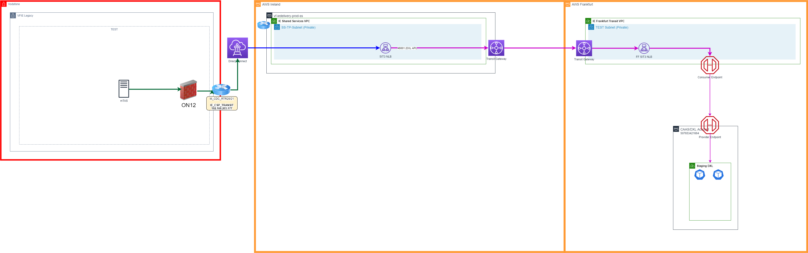

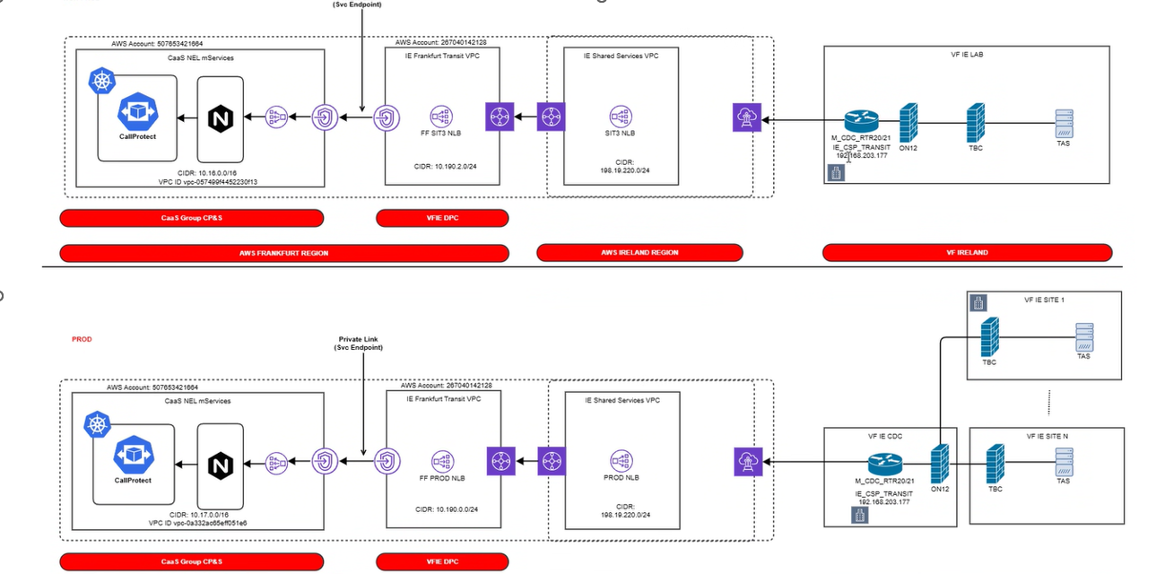

#### AWS Design

##### CAAS Account Details

|  |  |  |  |  |
| --- | --- | --- | --- | --- |
| **Account Number** | **Names** | **Environment** | **OU Name** | **Purpose** |
| 507653421664 | CaaS NEL mServices | Non-Prod |  |  |
| 507653421664 | CaaS NEL mServices | Prod |  |  |

##### VFIE Shared Services NLB Endpoints (Frankfurt)

|  |  |  |  |  |
| --- | --- | --- | --- | --- |
| NLB Name | Environment | Subnets (for the different AZs) | Port | Comments |
| VF-IEDELIVERY-FKT-SIT3-NLB | SIT3 | 10.190.2.0/26, 10.190.2.64/26, 10.190.2.128/26 | 49001 |  |
| VF-IEDELIVERY-FKT-PROD-NLB | PROD | 10.190.0.0/26,  10.190.0.64/26, 10.190.0.128/26 | 49001 |  |

#### Target Groups

##### Dublin Target Groups

|  |  |  |  |  |  |  |
| --- | --- | --- | --- | --- | --- | --- |
| **Name** | **Port** | **Protocol** | **Target type** | **Load balancer** | **Direction** | **Comment** |
| SS-<ENV>-from-49001-to-49001 | 49001 | TCP | IP | VF-IEDELIVERY-SS-<ENV>-APII-NLB | INBOUND | Route to Frankfurt NLB |

##### Frankfurt Target Groups

|  |  |  |  |  |  |  |
| --- | --- | --- | --- | --- | --- | --- |
| **Name** | **Port** | **Protocol** | **Target type** | **Load balancer** | **Direction** | **Comment** |
| FF-TRANSIT-<ENV>-from-49001-to-443 | 443 | TCP | IP | VF-IEDELIVERY-FKT-<ENV>-NLB | INBOUND | Route to CaaS NEL (DXL) |

#### CAAS Provider Endpoints

##### SIT3

|  |  |
| --- | --- |
| **Service Name** | com.amazonaws.vpce.eu-central-1.vpce-svc-09d053703cdfae563 |
| **Port** | 443 |
| **Allowed Principles** | 267040142128 |

##### PROD

|  |  |
| --- | --- |
| **Service Name** | com.amazonaws.vpce.eu-central-1.vpce-svc-064fbba0a0f83a7e6 |
| **Port** | 443 |
| **Allowed Principles** | 267040142128 |

### Connectivity

#### Test

|  |  |  |  |  |  |  |  |  |  |  |  |
| --- | --- | --- | --- | --- | --- | --- | --- | --- | --- | --- | --- |
| **Firewall Rules** | | | | | | | | | | | |
|  | **Source** | | | **Closest Fwall** | **Destination** | | | **Closest Fwall** | **Service** | | **Install On** |
| **Rule Purpose** | **Hostname** | **IP Address** | **Subnet Mask** | **Firewall** | **Host Name** | **IP Address** | **Subnet Mask** | **Firewall** | **Protocol** | **Port** |
| mTAS to DXL | IE680vMTAS01-LAB | 10.151.152.6 | /32 |  | AWS Test Subnet | 198.19.220.128/25 | /27 | ON12 | HTTPS | 49001 |  |

#### Production

|  |  |  |  |  |  |  |  |  |  |  |  |
| --- | --- | --- | --- | --- | --- | --- | --- | --- | --- | --- | --- |
| **Firewall Rules** | | | | | | | | | | | |
|  | **Source** | | | **Closest Fwall** | **Destination** | | | **Closest Fwall** | **Service** | | **Install On** |
| **Rule Purpose** | **Hostname** | **IP Address** | **Subnet Mask** | **Firewall** | **Host Name** | **IP Address** | **Subnet Mask** | **Firewall** | **Protocol** | **Port** |
| VOLTE MTAS 680  Fixed MTAS 680 | IE680vMTAS01  IE680vMTAS02 | 10.151.166.5  10.151.166.6 | /32 |  | AWS Prod Subnet 1  AWS Prod Subnet 2 | 198.19.220.64  198.19.220.0 | /27  /27 | ON12 | HTTPS | 49001 |  |
| VOLTE MTAS 706  Fixed MTAS 706 | IE706vMTAS01  IE706vMTAS02 | 10.151.47.6  10.151.47.5 | /32 |  | AWS Prod Subnet 1  AWS Prod Subnet 2 | 198.19.220.64  198.19.220.0 | /27  /27 | ON12 | HTTPS | 49001 |  |

### Supporting Documentation

11 VFIE - Frankfurt Transit Gateway Solution

## 03 - VFIE OSB - CAAS / TAAS Integration

* Overview
* Design
  + Network Design
  + AWS Design
    - CAAS Account Details
    - TAAS Account Details
    - VFIE Shared Services NLB Endpoints (Frankfurt)
  + Target Groups
    - Dublin Target Groups
    - Frankfurt Target Groups
    - VFIE Subnets
* TAAS Route 53
  + TEST
  + PREPROD
  + PROD
* Supporting Documentation
* PROJECT DELIVERY RACI/TASK LIST - Flow1

### Overview

As part of the PMX programme, we're looking to optimise the network path from DXL/TAAS to the OSB via the AWS backbone instead of going via the internet as currently happens. Based on that, we're utilising the existing VFIE Frankfurt Transit Gateway solution to define the new design below, and implement a more robust solution.

### Design

#### Network Design

The connectivity will go from the TAAS / CAAS endpoints, over the Frankfurt Transit Gateway, via the IE_CSP_TRANSIT, and on to either the DRCC OCI OSB or the VCI OSB. As DRCC OCI OSB uses borrowed Oracle IP addresses, this needs to be routed via the Shared Services NAT Gateway as the OSB IP address cannot be placed behind an NLB.

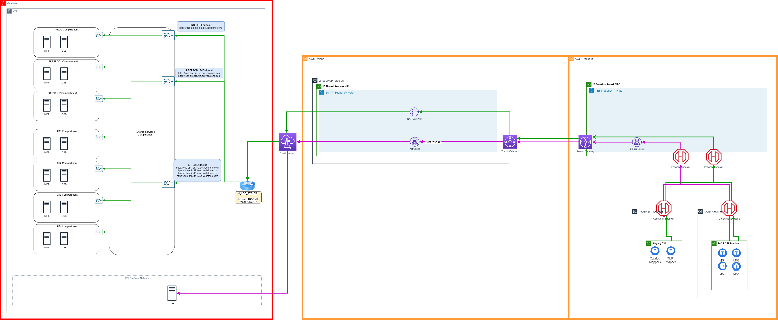

#### AWS Design

##### CAAS Account Details

|  |  |  |  |  |
| --- | --- | --- | --- | --- |
| **Account Number** | **Names** | **Environment** | **OU Name** | **Purpose** |
| 507653421664 | CaaS NEL mServices | Non-Prod |  |  |
| 507653421664 | CaaS NEL mServices | Prod |  |  |

##### TAAS Account Details

|  |  |  |  |  |
| --- | --- | --- | --- | --- |
| **Account Number** | **Names** | **Environment** | **OU Name** | **Purpose** |
| 924279027542 | ie-digital-network-non-prod | Non-Prod |  |  |
| 118291558653 | ie-digital-app01-non-prod | Non-Prod |  |  |
| 606544231873 | ie-digital-app01-prod | Prod |  |  |
| 521557890114 | ie-digital-network-prod | Prod |  |  |

##### VFIE Shared Services NLB Endpoints (Frankfurt)

|  |  |  |  |  |
| --- | --- | --- | --- | --- |
| NLB Name | Environment | Subnets (for the different AZs) | Port | Comments |
| VF-IEDELIVERY-FKT-SIT3-NLB | SIT3 | 10.190.2.0/26, 10.190.2.64/26, 10.190.2.128/26 | 15101 |  |
| VF-IEDELIVERY-FKT-PROD-NLB | PROD | 10.190.0.0/26,  10.190.0.64/26, 10.190.0.128/26 | 15101 |  |

#### Target Groups

##### Dublin Target Groups

|  |  |  |  |  |  |  |
| --- | --- | --- | --- | --- | --- | --- |
| **Name** | **Port** | **Protocol** | **Target type** | **Load balancer** | **Direction** | **Comment** |
| SS-PROD-from-15101-to-30050 | 30050 | TCP | IP | VF-IEDELIVERY-SS-PROD-APII-NLB | INBOUND | Route to Amdocs OSB (VCI Network) |
| SS-SIT3-from-15101-to-9007 | 9007 | TCP | IP | VF-IEDELIVERY-SS-PROD-APII-NLB | INBOUND | Route to Amdocs OSB (VCI Network) |

##### Frankfurt Target Groups

|  |  |  |  |  |  |  |
| --- | --- | --- | --- | --- | --- | --- |
| **Name** | **Port** | **Protocol** | **Target type** | **Load balancer** | **Direction** | **Comment** |
| FF-TRANSIT-PROD-from-15101-to-15101 | 15101 | TCP | IP | VF-IEDELIVERY-FKT-PROD-NLB | INBOUND | Route to Shared Services NLB on port 15101 for Amdocs OSB |
| FF-TRANSIT-SIT3-from-15101-to-15101 | 15101 | TCP | IP | VF-IEDELIVERY-FKT-SIT3-NLB | INBOUND | Route to Shared Services NLB on port 15101 for Amdocs OSB |

##### VFIE Subnets

|  |  |  |  |
| --- | --- | --- | --- |
| Source | Env | Account No. | CIDR |
| Vodafone | Shared Services (Dublin) | 267040142128 | 198.19.220.0/24 |
| DRCC OCI | SIT | ON-PREM |  |
| DRCC OCI | PROD | ON-PREM | 167.234.165.32/27 |

### TAAS Route 53

#### TEST

|  |  |  |
| --- | --- | --- |
| **Record Name** | **CNAME /Consumer Endpoint/IP** | **Environment** |
| ieesbbvr.dc-dublin.de |  | On-prem |
| osb-api.sit1.ie.oci.vodafone.com | 104.242.241.213 | DRCC OCI |
| osb-api.sit2.ie.oci.vodafone.com | 104.242.241.213 | DRCC OCI |
| osb-api.sit3.ie.oci.vodafone.com | 104.242.241.213 | DRCC OCI |

#### PREPROD

|  |  |  |
| --- | --- | --- |
| **Record Name** | **CNAME /Consumer Endpoint/IP** | **Environment** |
| osb-api.prd1.ie.oci.vodafone.com |  | DRCC OCI |
| osb-api.prd2.ie.oci.vodafone.com |  | DRCC OCI |

#### PROD

|  |  |  |
| --- | --- | --- |
| **Record Name** | **CNAME /Consumer Endpoint/IP** | **Environment** |
| esb.prod.dox.equinox.vodafone.ie |  | On-prem |
| osb-api.prod.ie.oci.vodafone.com | 167.234.165.112 | DRCC OCI |

### Supporting Documentation

11 VFIE - Frankfurt Transit Gateway Solution

### PROJECT DELIVERY RACI/TASK LIST - Flow1

|  |  |  |  |  |  |  |  |  |  |
| --- | --- | --- | --- | --- | --- | --- | --- | --- | --- |
| **Components** | **Environments** | **Activity** | **Accountable** | **Responsible** | **Consulted** | **Approximate** **Start Date** | **Approximate** **Completion Date** | **Comments** | **Status** |
| Confluence Initial Review | All | VFIE Pre-requisite documentation to be provided for PCS TDF Internal Review | VFIE | VFIE,  Caas /Taas , PCS | Security | 08 Sep 2025 |  |  | InProgress |
| Security Alignment | All | Security review | VFIE | VFIE | Security, Caas /Taas,   PCS |  |  |  |  |
| Confluence Final  Documentation | All | Document the set up and design as per each teams scope | VFIE | VFIE, Caas /Taas , PCS | Security |  | Go Live | Ongoing until demand is handed over to PCMS. | InProgress |
| PCS Build | NON-PROD | Need to whitelist the TaaS accounts: 924279027542 and 118291558653 | PCS | PCS | Caas /Taas,  Security, VFIE | 10 Sep 2025 | 11 Sep 2025 |  | Open |
| TaaS / CaaS Build | NON-PROD | Create Consumer Endpoints and Route 53 entries: [ieesbbvr.dc-dublin.de](http://ieesbbvr.dc-dublin.de)  port: 15101  Please use the below:  Endpoint Services: com.amazonaws.vpce.eu-central-1.vpce-svc-0861763c45ff82100 | VFIE | TaaS / CaaS |  | 11 Sep 2025 | 19 Sep 2025 |  | Open |
| End to End Testing | NON-PROD |  | VFIE | VFIE | PCS. TaaS | 22 Sep 2025 | 23 Sep 2025 |  | Open |
|  |  |  | **Prod** |  |  |  |  |  |  |
| PCS Build | Prod | Need to whitelist the Taas  accounts:606544231873 and 521557890114 | PCS | PCS | Caas /Taas,  Security, VFIE | 24 Sep 2025 | 25 Sep 2025 |  | Open |
| TaaS / CaaS Build | Prod | Create Consumer Endpoints and Route 53 entries:  [ieesbbvr.dc-dublin.de](http://ieesbbvr.dc-dublin.de)  Port: 15101  Please use the below:  Endpoint Services:  com.amazonaws.vpce.eu-central-1.vpce-svc-080e2602b4bc0790a | VFIE | TaaS / CaaS |  | 26 Sep 2025 | 30 Sep 2025 |  | Open |
| End to End Testing | Prod |  | VFIE | VFIE | PCS, Taas | 01 Oct 2025 | 02 Oct 2025 |  | Open |
| Hand Over Relevant Support Teams | All | L1,L2,L3 | VFIE, | VFIE, CaaS / TaaS, PCS | Security |  |  |  |  |
|  |  |  |  |  |  |  |  |  |  |

## 04 - VFIE CIAM Webgate - CAAS Integration

### Overview

As part of the WEF programme, the WEF Auth Microsite needs to integrate with the CIAM Webgate endpoint via the WEF BFF for authentication purposes. In Production, it has the option to go via the internet to connect to n.vodafone.ie, but as the non-production environments are not exposed to the internet, we need to route these calls via the VFIE Frankfurt Transit Gateway solution. We need to implement this connectivity across all envs.

### Design

#### Network Design

The connectivity will go from CAAS endpoints, over the Frankfurt Transit Gateway, via the IE_CSP_TRANSIT, and on to the VCI hosted CIAM Webgate.

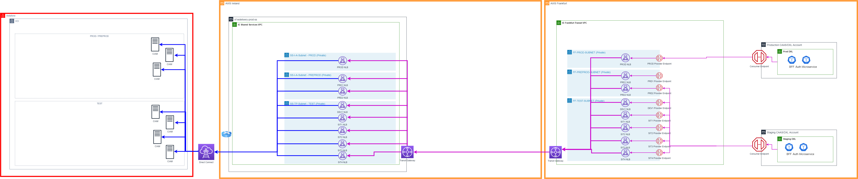

##### Frankfurt VPC

The following is the Subnet Design for the new **IE Frankfurt Transit VPC 10.190.0.0/22**

|  |  |  |
| --- | --- | --- |
| Purpose | Name | Subnet |
| Production | FF-PROD-SUBNET | 10.190.0.0/24 |
| Preprod | FF-PREPROD-SUBNET | 10.190.1.0/24 |
| Test/Dev | FF-TEST-SUBNET | 10.190.2.0/24 |

### AWS Design

#### Network Load Balancer

##### Dublin Shared Services NLB

|  |  |  |  |
| --- | --- | --- | --- |
| NLB Name | Environment | Subnets (for the different AZs) | Comments |
| VF-IEDELIVERY-SS-DEV1-APIO-NLB | DEV1 | 198.19.220.128/26, 198.19.220.192/26 | Not Needed for this project |
| VF-IEDELIVERY-SS-SIT1-APIO-NLB | SIT1 | 198.19.220.128/26, 198.19.220.192/26 | Not Needed for this project |
| VF-IEDELIVERY-SS-SIT2-APIO-NLB | SIT2 | 198.19.220.128/26, 198.19.220.192/26 | REQUIRED |
| VF-IEDELIVERY-SS-SIT3-APIO-NLB | SIT3 | 198.19.220.128/26, 198.19.220.192/26 | REQUIRED |
| VF-IEDELIVERY-SS-SIT4-APIO-NLB | SIT4 | 198.19.220.128/26, 198.19.220.192/26 | REQUIRED |
| VF-IEDELIVERY-SS-PRD1-APIO-NLB | PRD1 | 198.19.220.32/27, 198.19.220.96/27 | Not Needed for this project |
| VF-IEDELIVERY-SS-PRD2-APIO-NLB | PRD2 | 198.19.220.32/27, 198.19.220.96/27 | REQUIRED |
| VF-IEDELIVERY-SS-PROD-APIO-NLB | PROD | 198.19.220.0/27, 198.19.220.64/27 | REQUIRED |

##### Frankfurt Shared Services NLB

The NLB will be created in the new **IE Frankfurt Transit VPC**for each VFIE environment.

|  |  |  |  |
| --- | --- | --- | --- |
| NLB Name | Environment | Subnets (for the different AZs) | Comments |
| VF-IEDELIVERY-FKT-DEV1-NLB | DEV1 | 10.190.2.0/26, 10.190.2.64/26, 10.190.2.128/26 | Not Needed for this project |
| VF-IEDELIVERY-FKT-SIT1-NLB | SIT1 | 10.190.2.0/26, 10.190.2.64/26,  10.190.2.128/26 | Not Needed for this project |
| VF-IEDELIVERY-FKT-SIT2-NLB | SIT2 | 10.190.2.0/26, 10.190.2.64/26, 10.190.2.128/26 | REQUIRED |
| VF-IEDELIVERY-FKT-SIT3-NLB | SIT3 | 10.190.2.0/26, 10.190.2.64/26, 10.190.2.128/26 | REQUIRED |
| VF-IEDELIVERY-FKT-SIT4-NLB | SIT4 | 10.190.2.0/26,  10.190.2.64/26,  10.190.2.128/26 | REQUIRED |
| VF-IEDELIVERY-FKT-PRD1-NLB | PRD1 | 10.190.1.0/26, 10.190.1.64/26,  10.190.1.128/26 | Not Needed for this project |
| VF-IEDELIVERY-FKT-PRD2-NLB | PRD2 | 10.190.1.0/26,  10.190.1.64/26,  10.190.1.128/26 | REQUIRED |
| VF-IEDELIVERY-FKT-PROD-NLB | PROD | 10.190.0.0/26,  10.190.0.64/26, 10.190.0.128/26 | REQUIRED |

#### Target Groups

##### Dublin Target Groups

|  |  |  |  |  |  |  |
| --- | --- | --- | --- | --- | --- | --- |
| **Name** | **Port** | **Protocol** | **Target type** | **Load balancer** | **Direction** | **Comment** |
| SS-<ENV>-from-14001-to-443 | 443 | TCP | IP | VF-IEDELIVERY-SS-<ENV>-APIO-NLB | OUTBOUND | Route to CIAM Webgate (VCI Network) |

##### Destination Endpoints

|  |  |  |  |  |
| --- | --- | --- | --- | --- |
| **ENV** | **IP** | **PORT** | **FQDN** | **STATUS** |
| **SIT1** | 37.25.163.15 | 443 | [publish.sit1.portal.equinox.vodafone.ie](http://publish.sit1.portal.equinox.vodafone.ie) | N/A |
| **SIT2** | 37.25.163.18 | 443 | [portal.publish.sit2.equinox.vf-ie.internal.vodafone.com](http://portal.publish.sit2.equinox.vf-ie.internal.vodafone.com) | N/A |
| **SIT3** | 37.25.163.19 | 443 | [portal.publish.sit3.equinox.vf-ie.internal.vodafone.com](http://portal.publish.sit3.equinox.vf-ie.internal.vodafone.com) | COMPLETE |
| **SIT4** | 37.25.163.17 | 443 | [portal.publish.sit4.equinox.vf-ie.internal.vodafone.com](http://portal.publish.sit4.equinox.vf-ie.internal.vodafone.com) | COMPLETE |
| **PRD1** | 47.73.62.148 | 443 | [publish.prd1.portal.equinox.vodafone.ie](http://publish.prd1.portal.equinox.vodafone.ie) | COMPLETE |
| **PRD2** | 47.73.62.155 | 443 | [publish.prd2.portal.equinox.vodafone.ie](http://publish.prd2.portal.equinox.vodafone.ie) | COMPLETE |
| **PROD** | 47.73.62.156 | 443 |  | COMPLETE |

##### Frankfurt Target Groups

|  |  |  |  |  |  |  |
| --- | --- | --- | --- | --- | --- | --- |
| **Name** | **Port** | **Protocol** | **Target type** | **Load balancer** | **Direction** | **Comment** |
| FF-TRANSIT-<ENV>-from-14001-to-14001 | 14001 | TCP | IP | VF-IEDELIVERY-FKT-<ENV>-NLB | OUTBOUND | Route to Shared Services NLB on port 14001 for CIAM Webgate |

##### CAAS Account Details

|  |  |  |  |  |
| --- | --- | --- | --- | --- |
| **Account Number** | **Names** | **Environment** | **Subnets** | **Purpose** |
| 507653421664 | CaaS NEL mServices | Non-Prod | 10.1.78.0/24 10.25.0.0/16 10.1.84.0/24 |  |
| 507653421664 | CaaS NEL mServices | Prod | 10.1.81.0/24 10.26.0.0/16 10.1.82.0/24 10.1.83.0/24 |  |

##### Provider  Endpoint

|  |  |  |  |
| --- | --- | --- | --- |
| **NLB Name** | **Environment** | **Provider Endpoint for Frankfurt (by PCS)** | **New Provider Endpoints direct to Dublin (by PCS)** |
| VF-IEDELIVERY-FKT-SIT3-NLB | SIT3 | com.amazonaws.vpce.eu-central-1.vpce-svc-0861763c45ff82100 | com.amazonaws.vpce.eu-west-1.vpce-svc-0a5267858cf4d81e8 |
| VF-IEDELIVERY-FKT-PRD2-NLB | PRD2 | com.amazonaws.vpce.eu-central-1.vpce-svc-07b8a20af7b145597 | com.amazonaws.vpce.eu-west-1.vpce-svc-04988aa29cf6d0fb7 |
| VF-IEDELIVERY-FKT-PROD-NLB | PROD | com.amazonaws.vpce.eu-central-1.vpce-svc-080e2602b4bc0790a | com.amazonaws.vpce.eu-west-1.vpce-svc-084880c4008c0722f |
| VF-IEDELIVERY-FKT-SIT4-NLB | SIT4 |  | com.amazonaws.vpce.eu-west-1.vpce-svc-06fb9e11ddd71df90 |
| VF-IEDELIVERY-FKT-SIT2-NLB | SIT2 | com.amazonaws.vpce.eu-central-1.vpce-svc-06e3250521aa69033 | com.amazonaws.vpce.eu-west-1.vpce-svc-0895c2fb5af227ef4 |

### Firewall Connectivity

[GIANT - WEF Authentication - AWS to the CIAM Webgate SIT4.xlsx](https://confluence.sp.vodafone.com/download/attachments/691220129/GIANT%20-%20WEF%20Authentication%20-%20AWS%20to%20the%20CIAM%20Webgate%20SIT4.xlsx?api=v2&modificationDate=1762356727107&version=1) - done

[GIANT - ITR-8600 AWS to the CIAM Webgate SIT3, PRD2, Prod.xlsx](https://confluence.sp.vodafone.com/download/attachments/691220129/GIANT%20-%20ITR-8600%20AWS%20to%20the%20CIAM%20Webgate%20SIT3%2C%20PRD2%2C%20Prod.xlsx?api=v2&modificationDate=1762356727709&version=1) - done

[GIANT - WEF Authentication - AWS to the CIAM Webgate SIT2.xlsx](https://confluence.sp.vodafone.com/download/attachments/691220129/GIANT%20-%20WEF%20Authentication%20-%20AWS%20to%20the%20CIAM%20Webgate%20SIT2.xlsx?api=v2&modificationDate=1762357960974&version=1) - CCP 244082, INC000097162749 for the firewall rules.

For expediting the firewall rules: Siddhesh Deoji, Vodafone <[Siddhesh.Deoji@vodafone.com](mailto:Siddhesh.Deoji@vodafone.com)>; Prafulla Bachhav, Vodafone <[prafulla.bachhav@vodafone.com](mailto:prafulla.bachhav@vodafone.com)>; DL-GDC-DCOPS-NTW-FW-Implementation <[DL-GDC-DCOPS-NTW-FW-Implementation@vodafone.com](mailto:DL-GDC-DCOPS-NTW-FW-Implementation@vodafone.com)

### Connectivity Set-up Example

**SIT3:**

728642754198 - CaaS account

 com.amazonaws.vpce.eu-west-1.vpce-svc-0a5267858cf4d81e8  - servicename

[vpce-0f29e328831c3a658-pij1giii.vpce-svc-0a5267858cf4d81e8.eu-west-1.vpce.amazonaws.com](http://vpce-0f29e328831c3a658-pij1giii.vpce-svc-0a5267858cf4d81e8.eu-west-1.vpce.amazonaws.com) - dns  for the endpoint

### CaaS Ticket

SIT3: <https://cps.jira.agile.vodafone.com/browse/GAT-45473>

PRD2: <https://cps.jira.agile.vodafone.com/browse/GAT-45574>

Prod: <https://cps.jira.agile.vodafone.com/browse/GAT-45603>

SIT4: <https://cps.jira.agile.vodafone.com/browse/GAT-45874>

SIT2: <https://cps.jira.agile.vodafone.com/browse/GAT-45983>

### Supporting Documentation

11 VFIE - Frankfurt Transit Gateway Solution

## 05 - VFIE WEF SSR - TaaS Integration

### Overview

As part of the WEF migration to the TaaS platform, the WEF Microsites require connectvity to the Server Side Rendering Service (SSR) which is hosted in a VFIE managed AWS Account. The SSR service is built in the eu-west-1 (Ireland) AWS region. All traffic will be routed via the VFIE Frankfurt Transit Gateway solution. The solution implement will provide a route for traffic from ALL environments.

### Design

#### Network Design

The connectivity is achieved via consumer endpoints in the DXL TaaS AWS accounts, over the Frankfurt Transit Gateway to a consumer endpoint configured in VF IE Shared Services AWS account in DUB which consumes from the SSR Endpoint Service in SSR AWS accounts (Test/dev, preprod & prod).

More detailed description of the traffic flow between IE TaaS WEF and SSR is available - [04. TaaS to Server-side Rendering Service Connectivity](https://confluence.sp.vodafone.com/spaces/DDEI/pages/720038227/04.+TaaS+to+Server-side+Rendering+Service+Connectivity)

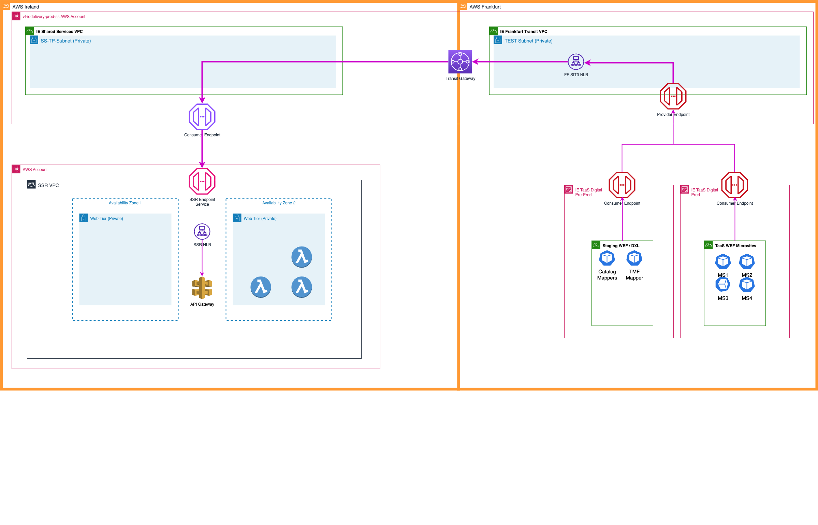

##### Frankfurt VPC

The following is the Subnet Design for the new **IE Frankfurt Transit VPC 10.190.0.0/22**

|  |  |  |
| --- | --- | --- |
| Purpose | Name | Subnet |
| Production | FF-PROD-SUBNET | 10.190.0.0/24 |
| Preprod | FF-PREPROD-SUBNET | 10.190.1.0/24 |
| Test/Dev | FF-TEST-SUBNET | 10.190.2.0/24 |

### AWS Design

#### Network Load Balancer

##### Dublin Shared Services NLB

|  |  |  |  |
| --- | --- | --- | --- |
| NLB Name | Environment | Subnets (for the different AZs) | Comments |
| VF-IEDELIVERY-SS-DEV1-APIO-NLB | DEV1 | 198.19.220.128/26, 198.19.220.192/26 | Not Needed for this project |
| VF-IEDELIVERY-SS-SIT1-APIO-NLB | SIT1 | 198.19.220.128/26, 198.19.220.192/26 | Not Needed for this project |
| VF-IEDELIVERY-SS-SIT2-APIO-NLB | SIT2 | 198.19.220.128/26, 198.19.220.192/26 | Not Needed for this project |
| VF-IEDELIVERY-SS-SIT3-APIO-NLB | SIT3 | 198.19.220.128/26, 198.19.220.192/26 | REQUIRED |
| VF-IEDELIVERY-SS-SIT4-APIO-NLB | SIT4 | 198.19.220.128/26, 198.19.220.192/26 | REQUIRED |
| VF-IEDELIVERY-SS-PRD1-APIO-NLB | PRD1 | 198.19.220.32/27, 198.19.220.96/27 | Not Needed for this project |
| VF-IEDELIVERY-SS-PRD2-APIO-NLB | PRD2 | 198.19.220.32/27, 198.19.220.96/27 | Not Needed for this project |
| VF-IEDELIVERY-SS-PROD-APIO-NLB | PROD | 198.19.220.0/27, 198.19.220.64/27 | REQUIRED |

##### Frankfurt Shared Services NLB

The NLB will be created in the new **IE Frankfurt Transit VPC**for each VFIE environment.

|  |  |  |  |
| --- | --- | --- | --- |
| NLB Name | Environment | Subnets (for the different AZs) | Comments |
| VF-IEDELIVERY-FKT-DEV1-NLB | DEV1 | 10.190.2.0/26, 10.190.2.64/26, 10.190.2.128/26 | Not Needed for this project |
| VF-IEDELIVERY-FKT-SIT1-NLB | SIT1 | 10.190.2.0/26, 10.190.2.64/26,  10.190.2.128/26 | Not Needed for this project |
| VF-IEDELIVERY-FKT-SIT2-NLB | SIT2 | 10.190.2.0/26, 10.190.2.64/26, 10.190.2.128/26 | Not Needed for this project |
| VF-IEDELIVERY-FKT-SIT3-NLB | SIT3 | 10.190.2.0/26, 10.190.2.64/26, 10.190.2.128/26 | REQUIRED |
| VF-IEDELIVERY-FKT-SIT4-NLB | SIT4 | 10.190.2.0/26,  10.190.2.64/26,  10.190.2.128/26 | Not Needed for this project |
| VF-IEDELIVERY-FKT-PRD1-NLB | PRD1 | 10.190.1.0/26, 10.190.1.64/26,  10.190.1.128/26 | Not Needed for this project |
| VF-IEDELIVERY-FKT-PRD2-NLB | PRD2 | 10.190.1.0/26,  10.190.1.64/26,  10.190.1.128/26 | REQUIRED |
| VF-IEDELIVERY-FKT-PROD-NLB | PROD | 10.190.0.0/26,  10.190.0.64/26, 10.190.0.128/26 | REQUIRED |

#### Target Groups

##### Dublin Target Groups

|  |  |  |  |  |  |  |
| --- | --- | --- | --- | --- | --- | --- |
| **Name** | **Port** | **Protocol** | **Target type** | **Load balancer** | **Direction** | **Comment** |
| SS-<ENV>-from-48002-to-443 | 443 | TCP | IP | VF-IEDELIVERY-SS-<ENV>-NLB | OUTBOUND | Route to Server Side Rendering (SSR) in AWS |

##### Destination Endpoints

|  |  |  |  |  |
| --- | --- | --- | --- | --- |
| **ENV** | **IP** | **PORT** | **FQDN** | **STATUS** |
| **SIT1** |  |  |  |  |
| **SIT2** |  |  |  |  |
| **SIT3** |  |  |  |  |
| **SIT4** |  |  |  |  |
| **PRD1** |  |  |  |  |
| **PRD2** |  |  |  |  |
| **PROD** |  |  |  |  |

##### Frankfurt Target Groups

|  |  |  |  |  |  |  |
| --- | --- | --- | --- | --- | --- | --- |
| **Name** | **Port** | **Protocol** | **Target type** | **Load balancer** | **Direction** | **Comment** |
| FF-TRANSIT-<ENV>-from-48200-to-xxxx | 14001 | TCP | IP | VF-IEDELIVERY-FKT-<ENV>-NLB | OUTBOUND | Route to Shared Services NLB on port 48002 for SSR |

|  |  |  |  |  |
| --- | --- | --- | --- | --- |
|  |  |  |  |  |
|  |  |  |  |  |
|  |  |  |  |  |

##### Provider  Endpoint

|  |  |  |  |
| --- | --- | --- | --- |
| **NLB Name** | **Environment** | **Provider Endpoint for Frankfurt (by PCS)** | **New Provider Endpoints direct to Dublin (by PCS)** |
| VF-IEDELIVERY-FKT-SIT3-NLB | SIT3 | com.amazonaws.vpce.eu-central-1.vpce-svc-0861763c45ff82100 |  |
| VF-IEDELIVERY-FKT-PRD2-NLB | PRD2 | com.amazonaws.vpce.eu-central-1.vpce-svc-07b8a20af7b145597 |  |
| VF-IEDELIVERY-FKT-PROD-NLB | PROD | com.amazonaws.vpce.eu-central-1.vpce-svc-080e2602b4bc0790a |  |

# 12 VFIE NAT Gateway

* Overview
* High Level Design
* Subnets
  + AWS Shared Services Subnets
  + Destination Subnets
* NAT Gateway
* Routing Tables
* High-Level Implementation Steps

## Overview

Vodafone Ireland utilise an on-prem DRCC OCI implementation which uses IP Subnets provided by Oracle. As Oracle still own the associated subnets, it's not possible to add them as targets for an NLB as VF do not own them. To get around this issue, it has been agreed to use NAT Gateways in the Shared Services account to route the traffic for the OCI subnets to the VCI network.

***Existing VPC's and Subnets will be used***

## High Level Design

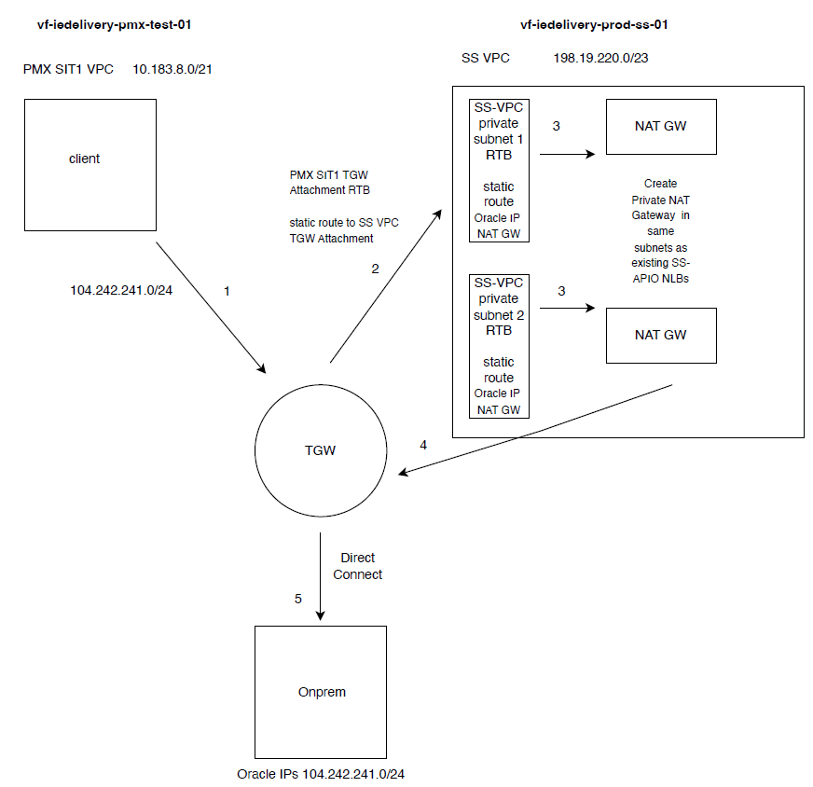

**Traffic Flow**

Step 1: Client requests from PMX SIT1 VPC to on-premise Oracle IPs are routed to the TGW.  
Step 2: TGW routes traffic to SS VPC.  
The PMX SIT1 TGW Attachment Route Table will have a static route to the SS VPC TGW Attachment ID.  
Step 3: Traffic in the SS VPC subnets is routed to the NAT Gateways.  
SS-VPC TGW private Subnet 1 and Subnet 2 Route Tables will have static routes for the destination  
Oracle IP range and target as NAT Gateway.  
Step 4: NAT Gateway routes traffic back to the TGW.  
Step 5: TGW sends traffic through Direct Connect to on-premise Oracle IPs.

## Subnets

### AWS Shared Services Subnets

|  |  |  |  |  |
| --- | --- | --- | --- | --- |
| **ENV** | **Subnet** | **Security Zone** | **AZ** | **Existing** |
| TEST | 198.19.220.128/26 | T-P | 1 | Yes |
| 198.19.220.192/26 | T-P | 2 | Yes |
| PROD | 198.19.220.0/27 | I-A | 1 | Yes |
| 198.19.220.64/27 | I-A | 2 | Yes |
| PREPROD | 198.19.220.32/27 | I-A | 1 | Yes |
| 198.19.220.96/27 | I-A | 2 | Yes |

### Destination Subnets

|  |  |  |  |
| --- | --- | --- | --- |
| **ENV** | **Subnet** | **Security Zone** | **DRCC OCI Region** |
| TEST | 104.242.242.112/28 | T-A | Dublin 2 |
| 104.242.241.208/28 | T-A | Dublin 2 |
| 104.242.241.192/28 | T-P | Dublin 2 |
| 104.242.241.108/28 | T-P | Dublin 2 |
| 104.242.242.160/29 | T-P | Dublin 2 |
| 104.242.242.176/28 | T-P | Dublin 2 |
| 104.242.242.96/28 | T-A | Dublin 2 |
| 104.242.242.168/29 | T-A | Dublin 2 |
| 104.242.243.16/28 | T-A | Dublin 2 |
| 104.242.243.80/28 | T-A | Dublin 2 |
| 104.242.243.96/28 | T-A | Dublin 2 |
| 104.242.242.144/28 | T-P | Dublin 2 |
| PROD | 104.242.241.224/28 | E1 (I) | Dublin 2 |
| 104.242.241.240/28 | E2 (A) | Dublin 2 |
| 167.234.175.224/28 | E1 (I) | Dublin 1 |
| 104.242.242.128/28 | E1 (I) | Dublin 2 |
| 167.234.167.96/28 | E1 (I) | Ratingen 2 |
| 158.179.248.64/28 | E2 (A) | Ratingen 2 |
| 167.234.167.112/30 | E2 (A) | Ratingen 2 |
| 167.234.165.0/27 | E1 (I) | Dublin 1 |
| 158.179.251.160/28 | E2 (A) | Dublin 1 |
| 158.179.251.176/28 | E2 (A) | Dublin 1 |
| 158.179.251.208/30 | E2 (A) | Dublin 1 |
| 167.234.165.32/27 | E2 (A) | Dublin 1 |
| 167.234.165.64/27 | E1 (I) | Dublin 2 |
| 158.179.251.212/30 | E2 (A) | Dublin 2 |
| 158.179.251.224/28 | E2 (A) | Dublin 2 |
| 158.179.251.240/28 | E2 (A) | Dublin 2 |
| 167.234.165.96/27 | E2 (A) | Dublin 2 |
| PREPROD | 167.234.167.192/28 | E1 (I) | Ratingen 2 |
| 158.179.248.188/30 | E2 (A) | Ratingen 2 |
| 167.234.167.208/28 | E2 (A) | Ratingen 2 |
| 167.234.164.224/28 | E1 (I) | Dublin 1 |
| 158.179.235.88/30 | E2 (A) | Dublin 1 |
| 167.234.164.240/28 | E2 (A) | Dublin 1 |
| 167.234.165.128/28 | E1 (I) | Dublin 1 |
| 158.179.235.92/30 | E2 (A) | Dublin 1 |
| 167.234.165.144/28 | E2 (A) | Dublin 1 |
| 158.179.234.0/28 | E2 (A) | Dublin 2 |
| 158.179.234.16/28 | E2 (A) | Dublin 2 |
| 158.179.251.216/30 | E2 (A) | Dublin 2 |
| 158.179.234.32/28 | E1 (I) | Dublin 2 |
| 158.179.234.48/28 | E2 (A) | Dublin 2 |
| 158.179.251.220/30 | E2 (A) | Dublin 2 |

## NAT Gateway

|  |  |  |  |  |
| --- | --- | --- | --- | --- |
| **ENV** | **Subnet** | **Security Zone** | **AZ** | **NAT Gateway** |
| TEST | 198.19.220.128/26 | T-P | 1 | NAT-GW-TEST-TP1 |
| 198.19.220.192/26 | T-P | 2 | NAT-GW-TEST-TP2 |
| PROD | 198.19.220.0/27 | I-A | 1 | NAT-GW-PROD-IA1 |
| 198.19.220.64/27 | I-A | 2 | NAT-GW-PROD-IA2 |
| PREPROD | 198.19.220.32/27 | I-A | 1 | NAT-GW-PRE-IA1 |
| 198.19.220.96/27 | I-A | 2 | NAT-GW-PRE-IA2 |

## Routing Tables

## High-Level Implementation Steps

**Create Private NAT Gateways:** Ensure NAT Gateways are created in Test, Pre-Prod and Production subnets as per **Section 4. NAT Gateway**

**Update Route Tables:**

* PMX <ENV> TGW Attachment Route Table: Add a route to the SS VPC TGW Attachment.
* SS-VPC TGW Subnet Route Table: Add a route for the Oracle IP range destination with the target set to the NAT Gateway.